International Financial Management A1

Name-Sabina Ioana Murgu
Student Number-2018269
Name of Module- International Financial Management
Module Code- LCBB6002
Module Lecturer- Dr Konstantina Mari, Dr Rexon Nting, Zainab Atta

Table of Contents
Introduction 3
Importance of International Financial Management to Unilever 3
Challenges Facing Unilever in Different International Financial Management- 3
Unilever's Dividend Distribution Policy 5
Efficient Market Hypothesis Theory in Unilever's 7
Unilever's Methods of Appraising Projects 8
Empirical Evidence Supporting the Analysis 8
Conclusion 8
References 9

Introduction
Unilever is a multinational corporation that operates in the fast-moving consumer goods sector. It was established in 1929 year by the merger of two enterprises, Lever Brothers and Margarine Unie. The firm sells its goods and services over one ninety nations, and it has used mixed portfolio, including Dove, Knorr, Lipton, and Axe. International Financial Management (IFM) is crucial for Unilever, given its global operations and presence in various markets. In this essay, we will analyzed and evaluated the importance of IFM for Unilever; challenges will also be discussed which the company may be facing in different international financial markets. Relevant IFM theories will assess Unilever's dividend distribution policy, methods of appraising projects, and the efficient market hypothesis theory in the context of its business operations which will be also made.

Importance of International Financial Management to Unilever
It is important to Unilever due to its multinational economy as well as business operations and presence in various markets. The company requires effective management of its financial resources across the globe, including currencies, rates of interest, and market risks. For instance, when Unilever acquired Best Foods, an American company, in 2000, it faced currency risk due to the acquisition's size and the exchange rate fluctuations (Krasodomska et al. 2021). To overcome this risk, the firm employed several strategies of IFM, such as currency hedging, to reduce the potential loss from exchange rate movements.
Moreover, Unilever uses this to optimize its capital structure by balancing debt and equity. The capital structure of a company depends on several factors such as its strength of financial, regulations & policies of tax, and conditions of the market. In the year 2020, it raised €1.5 billion in an issue of bond with a maturity of twelve years. It is used to refinancing the debt and for the purposes of general corporation (Surtee and Alagidede 2022). The bond issue helped the company optimize its capital structure and reduce financing costs, demonstrating the importance of IFM in its operations.

Challenges Facing Unilever in Different International Financial Management-
General Challenges-
Exchange rate risk: Multinational corporations operate in several countries, each with its own currency (Satria et al. 2021). Changes in rates of exchange can have an important impact on the company's performance, as they affect the value of assets and obligations denominated in currencies of foreign.
Political and regulatory risk: MNCs possess risks in the various countries where they operate their activities (Malo-Alain et al. 2021). Changes in government policies, regulations, or economic conditions can affect business operations and profitability.
Capital allocation across borders: Multinational enterprises must decide how to allocate their capital across different countries and projects, considering factors such as risk, return, and conditions of the local market (Satria et al. 2021
Challenges Faced by Unilever-
Multiple challenges and issues in the market such as interest, currency, and risk of market. Currency risk is the exposure to fluctuations in exchange rates that affect the company's earnings and cash flows (Surtee and Alagidede 2022). Unilever mitigates currency risk by employing suitable strategies such as hedging currencies, which involves buying or selling currency contracts to lock in rates of exchange.
Interest rate risk is the exposure to fluctuations in rates of various interest items which affects the company's costs of borrowing and returns of investment. Unilever handles that risk by using swaps interest rates that would include exchanging payments of constant-rate interest for payments of floating-rate interest or vice versa (Satria et al. 2021). This helps the company manage its borrowing costs and reduce interest rate exposure.
Market risk is the exposure to fluctuations in the market of finances, such as changes in rates, stock costs or commodity prices (Surtee and Alagidede 2022). The company overcomes the market risk by diversifying its portfolio of operations and products allowing it to withstand the volatility of the market. For example, during the Covid-19 pandemic, Unilever's used mixed portfolio, which includes food and cleaning products, helped the company navigate the volatile market conditions.

Unilever's Dividend Distribution Policy
This multinational company provides shareholders with a stable and growing dividend over time. The firm has a long history of paying shareholder dividends and has increased its share of the dividend every year for the past twenty years. The company paid a dividend of €1.63 per share in the year 2021. From the previous year it is increased by 4%. 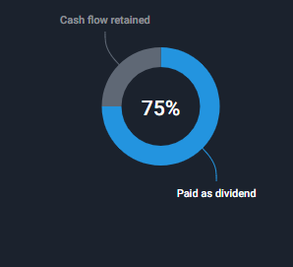
(Source- Simpler Wall, 2023).
The above images show the total amount that is paid by the company in the form of dividends from the total income earnings of the current year. The payout ratio of Unilever is 55.5%, and the total cash paid to investors during the year 2022 was 75%.
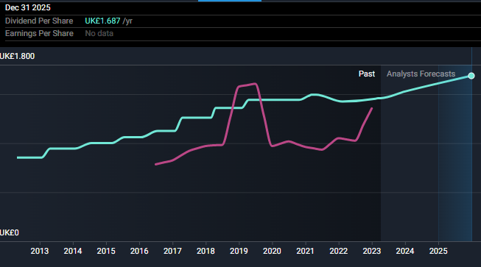
(Source- Simpler Wall, 2023).
This graph represents the stability and growth of payments of Unilever. In December 2015 it is expected that the company dividend per share is UK €1.687. In the current financial year 2023, the yield of dividends is 3.5 %, and per share is UK €1.453 (Simpler Wall 2023). It is demonstrated that the payment of dividends has been volatile over the past ten years. Additionally, it shows that the company dividend is growing over the previous accounting period (Sebastian et al. 2021). The pink line depicts the earnings per share of Unilever for the day. It started decreasing in the financial year 2019 from the value of UK €1.442 till the year 2022 with the amount fluctuates. It starts increasing in the mid of the 2022 financial period indicating that Unilever's earnings per stock increased for various reasons such as providing good quality goods and services at a reasonable price (Marsani et al. 2022).
The IFM theory relevant to Unilever's policy of distribution of dividend name is the dividend irrelevance theory, which suggests that a firm's dividend policy does not affect its share price, and investors are indifferent between receiving dividends and retaining earnings (Marsani et al. 2022). It reflects this theory, as the company focuses on providing a growing and stable dividend rather than trying to influence the stock price through announcements of dividends.

Efficient Market Hypothesis Theory in Unilever's
This theory suggests that several financial areas are efficient and that the costs of assets reflect all the important data. It could be used to assess the accuracy and reliability of the accounting and financial information it uses to decide on investment (Marsani et al. 2022). Analyzing the efficiency of the market in which it operates facilitates whether it is possible to outperform the market by critically analyzing the various financial data.
The EMH theory suggests that prices of stock demonstrate all available information about the company, and shareholders cannot outperform the market by analyzing the company's financial and quantitative information (Madura 2020).
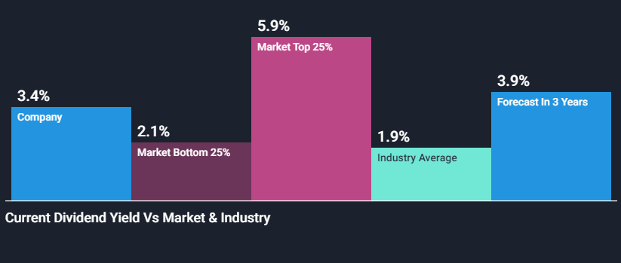
(Source- Simpler Wall, 2023).
This table of dividend yield versus Market & Industry shows that the dividend of Unilever is more than the market bottom which is 25 % in this respect the total payers of divined is 2.11% in the current market so it is called the notable dividend. In contrast to the market top, the Unilever dividend is low (Simpler Wall, 2023). This graph is helpful for the investors to understand the company's performance in respect of the competitors and the standard of the market. In the upcoming future, it is expected that it will be increased, and the rate will be 3.9%.
However, some critics of this theory argue that firm investors can still gain an advantage by analyzing non-financial factors such as brand reputation, management quality, and trends in the market (Sebastian et al. 2021). For example, Unilever's strong brand reputation and diversified product portfolio may provide an advantage of competition over its competitors, which could lead to higher stock prices.

Unilever's Methods of Appraising Projects
The company uses several methods for projects of appraisal, including discounted cash flow analysis, NPV, and IRR (Coburn and Stirling 2019). These techniques allow the company to assess the potential profitability of its projects of investment and compare them with alternative investment opportunities.
The theory of IFM relevant to this method is the CAPM (capital asset pricing model)which helps the company determine the required return for its investments based on the risk-free rate, MRP(marginal revenue product), and the share beta. Unilever can use CAPM to assess the risk and return of its investment ventures and determine whether they meet the company's investment criteria or not.

Empirical Evidence Supporting the Analysis
It shows that Unilever's IFM techniques and strategies have been effective in managing rates, currency, and the market as well as all financial risks (Zhao et al. 2019). For example, in 2019, the company's currency hedging strategy helped it mitigate the negative impact of fluctuations of currency on its earnings, while in 2020, its diversified and mixed portfolio helped it weather the market volatility caused by the pandemic.
Additionally, the dividend distribution policy of Unilever provides a certain rate of dividend to its all category of shareholders from previous years and it is depicted in its annual reports. Moreover, Unilever's project appraisal methods, such as the DCF analysis and NPV, have helped the company identify profitable investment opportunities and optimize its capital structure.

Conclusion
In conclusion, IFM is critical to Unilever's multinational operations and presence in various markets, along with this it is important for the firm to manage its financial operations at the global level. Unilever faces various hurdles and challenges in different international financial markets as explained above. These financial operations risks are mitigated by using the theories of IFM. The project appraisal techniques use international financial management theories such as CAPM to determine the required rate of return for investments. Empirical evidence supports the effectiveness of the given company by employing the IFM strategies, demonstrating the significance of IFM to the company's operations.

References
- Burzoni, M., Frittelli, M., Hou, Z., Maggis, M., and Obłój, J. (2019). Pointwise arbitrage pricing theory in discrete time. Mathematics of Operations Research, 44(3), 1034-1057.
- Coburn, J., and Stirling, A. (2019). Multicriteria mapping as a problem structuring method for project front-ending. Problem Structuring Approaches for the Management of Projects: Demonstrating Successful Practice, 63-90.
- Krasodomska, J., Simnett, R., and Street, D. L. (2021). Extended external reporting assurance: Current practices and challenges. Journal of International Financial Management and Accounting, 32(1), 104-142.
- Madura, J. (2020). International financial management. Cengage Learning.
- Malo-Alain, A., Aldoseri, M., and Melegy, M. (2021). Measuring the effect of international financial reporting standards on quality of accounting performance and efficiency of investment decisions. Accounting, 7(1), 249-256.
- Marsani, M. F., Shabri, A., Badyalina, B., Jan, N. A. M., and Kasihmuddin, M. S. M. (2022). Efficient Market Hypothesis for Malaysian Extreme Stock Return: Peaks Over A Threshold Method. MATEMATIKA: Malaysian Journal of Industrial and Applied Mathematics, 141-155.
- Satria, H., Alamsyahbana, M. I., Chartady, R., Fauzi, F., and Saputra, N. C. (2021). Corporate Governance, Characteristics on Dividend Policy: Evidence From Indonesia. Ilomata International Journal of Tax and Accounting, 2(4), 323-331.
- Sebastian, P. A., Abdulrachman, D. P., and Hendriyeni, N. S. (2021). The relevance of efficiency market theory to changes in valuation in food and beverages companies listed on the Indonesia stock exchange. In Contemporary Research on Business and Management (pp. 64-67). CRC Press.
- Simpler Wall ST. (2023). Unilever (LON:ULVR) shareholders have earned a 27% return over the last year [online]. Available at: https://simplywall.st/stocks/gb/household/lse-ulvr/unilever-shares/news/unilever-lonulvr-shareholders-have-earned-a-27-return-over-t. Accessed: 11/04/2023
- Surtee, T. G., and Alagidede, I. P. (2022). A novel approach to using Modern Portfolio Theory. Borsa Istanbul Review.
- Zhao, Q., Li, Z., Zhao, Z., and Ma, J. (2019). Industrial policy and innovation capability of strategic emerging industries: empirical evidence from chinese new energy vehicle industry. Sustainability, 11(10), 2785.

