

LOCATION: Swansea | LLEOLIAD: abertawe
LEVEL 4 | LEFEL 4
EXAMINATION PERIOD | CYFNOD ARHOLIADAU
may 2019 | mai 2019

MODULE CODE: M4X00386
ENGINEERING SCIENCE 2
TIME: 2 HOURS
answer all questions

Equipment or materials required – Calculator, Thermodynamics Tables

FORMULAE BOOKLET FOR ELECTRICAL ENGINEERING

$$Q=CV$$ | $$Q=It$$ | $$V=IR$$ | $$V=V_{0}e^{-\frac{t}{RC}}$$ | $$I=I_{0}e^{-\frac{t}{RC}}$$
$$Q=Q_{0}e^{-\frac{t}{RC}}$$ | $$P=IV$$ | $$P=I^{2}R$$ | $$P=\frac{V^{2}}{R}$$ | $$E=\frac{1}{2}CV^{2}$$
$$E=\frac{1}{2}QV$$ | $$ρ=\frac{RA}{l}$$ | $$R_{T}=R_{1}+R_{2}+R_{3}$$ | $$\frac{1}{R_{T}}=\frac{1}{R_{1}}+\frac{1}{R_{2}}+\frac{1}{R_{3}}$$ | $$V=ε-Ir$$
$$V_{rms}=\frac{V_{0}}{\sqrt{2}}$$ | $$I_{rms}=\frac{I_{0}}{\sqrt{2}}$$ | $$V_{rms}=I_{rms}R$$

FORMULAE BOOKLET FOR THERMODYNAMICS

- BASIC CONCEPT:
The change in the energy content of a body or any other system is equal to the difference between the energy input and the energy output, and the energy balance is expressed as:
$$∆E=E_{in}-E_{out}$$

E₂ – E₁

WORK:
Work done by the system is considered: POSITIVE
Work done on the system is considered: NEGATIVE

HEAT:
Heat transfer into the system is considered: POSITIVE.
Heat transfer out of the system is considered: NEGATIVE.

- CLOSED SYSTEMS:
Non-flow energy equation:
$$∆U=Q-W$$

- ENTHALPY:
$H=U+P.V$ (J)

Where:
- U = internal energy
- P = pressure
- V = volume

- FLOW WORK:
The flow work, or flow energy, or again displacement energy:

$$W_{flow}=P×V$$

- OPEN SYSTEMS / Steady-flow systems
- Mass Balance:
$$\sum_{in}{\dot{m}=}\sum_{out}{\dot{m} (kg/s)}$$

- Energy Balance:

$$\dot{Q}-\dot{W}=\sum_{out}{\dot{m}.\left(h+\frac{1}{2}.c^{2}+g.z\right)}-\sum_{in}{\dot{m}.\left(h+\frac{1}{2}.c^{2}+g.z\right)}$$
- CONTINITY OF MASS FLOW:
$$\dot{m}=mass flow in {kg}/{s A=cross sectional area in m^{2}}$$
$$v=specific volume in {m^{3}}/{kg} c=velocity in m/s$$
Consider the volume of substance passing the section per second = $\dot{V}$ in m³/s
$\dot{V}=\dot{m}.v also \dot{V}=A.c$ (Continuity equation)
Therefore:
$$\dot{m}.v=A.c$$
From which
$$\dot{m}=\frac{A.c}{v}$$

- OPEN SYSTEMS / Unsteady-flow systems
- Mass Balance:
$$m_{i}-m_{e}={\left(m_{2}-m_{1}\right)}_{CV}$$

Where:
- i = inlet, and e = exit.
- 1 = initial state, and 2 = final state of the control volume.
- Often one or more terms in this equation are zero.
- Energy Balance: (when kinetic and potential energy changes associated with the control volume and fluid streams are negligible)

$$Q-W=\sum_{out}{mh-\sum_{in}{mh+}}{\left(m_{2}u_{2}-m_{1}u_{1}\right)}_{CV}$$

- IDEAL GAS:
We defined an ideal gas as a gas whose temperature, pressure, and specific volume are related by:

$$P.v=R.T$$

where:
- R is the gas constant (kJ/kg.K) or (kPa.m³/kg.K)
- P the absolute pressure (kPa)
- T the absolute temperature (K)
- v is the specific volume (m³/kg)
The change in internal energy or enthalpy for an ideal gas during a process from state 1 to state 2 are defined as:
$$u_{2}-u_{1}=c_{v}\left(T_{2}-T_{1}\right) ({kJ}/{kg})$$
$$h_{2}-h_{1}=c_{p}\left(T_{2}-T_{1}\right) ({kJ}/{kg})$$
where:
- c_{v} is the specific heat at constant volume
- c_{p} is the specific heat at constant pressure

Reminder:
$$°C=K-273 K=°C+273$$
ELECTRICAL ENGINEERING

- QUESTION ONE (10 marks)

Figure 1 shows the circuit in question 1 where internal resistance is not neglected.

a) Given that the reading on A₁ is 4.5A and R₁ = 2R₂, what is the reading on A₂ [2]
b) Calculate the value of R₁ and R₂ given that the potential difference across R₂ is 13.6V [2]
c) Calculate the power used by R₁ [2]
c) Given that the total resistance of the circuit is 10Ω, calculate the emf of the battery [4]

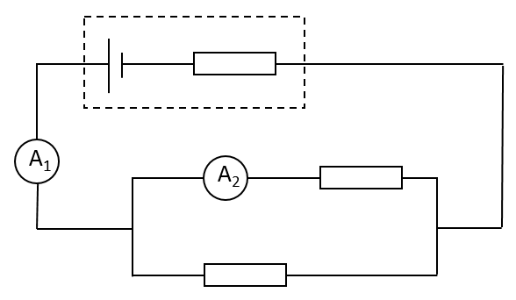
Figure 1

r

R₁

R₂

- QUESTION TWO (20 marks)

Figure 2 shows an ac waveform that is displayed on an oscilloscope screen.

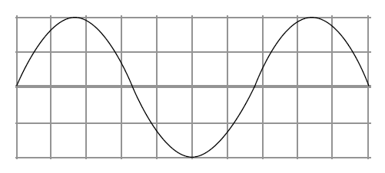
Figure 2

a) The time base of the oscilloscope is set at 1.5ms per division and the y-gain at 1.5V per division.
i Calculate the frequency of the waveform [2]
ii Calculate the peak voltage [2]
iii Calculate the period [2]
iv Calculate the rms voltage [2]

b) State and explain the effect on the oscilloscope if the time base is switched off [2]
c) In the UK, domestic users are supplied with mains electricity at a root mean square voltage of 230V.
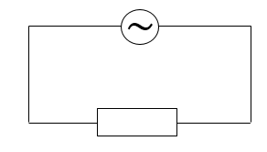
Figure 3

i State what is meant by root mean square voltage [2]
ii Calculate the peak value of the supply voltage [2]
iii For the circuit shown in figure 3, calculate I_{rms} if the peak current is 5A [2]
iv If V_{rms} is 110V, calculate the peak voltage and the value of resistor R [4]

- QUESTION THREE (20 marks)

a) Figure 4 shows a capacitor which was charged to a pd of 12V and discharged through a 150kΩ resistor.
i Calculate the discharge current [3]
ii Use the graph to determine the time constant of the circuit, giving the answer to an appropriate number of significant figures [5]
iii Calculate the capacitance of the capacitor [3]
iv Show that the capacitor lost approximately 90% of its energy in 2.3s [3]

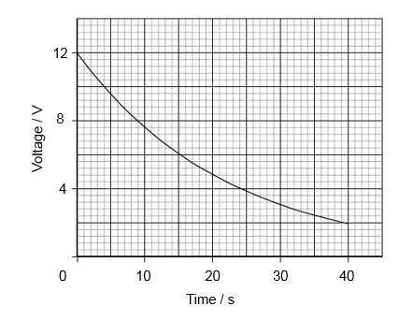
Figure 4

b) In order to produce a time delay, a set of traffic lights contains a capacitor identical to the one used in part (a). The capacitor is charged from a 24V supply and then discharged through a 150kΩ resistor.
i State and explain the effect of this higher pd on the energy stored by the capacitor [3]
ii State and explain the effect of this higher pd on the time taken for the capacitor to lose 90% of its energy [3]

THERMODYNAMICS

- QUESTION FOUR / Closed System (10 marks)

A domestic refrigerator is loaded with food and the door closed. During a certain period the machine consumes 1 kWh of energy and the internal energy of the system drops by 5×10³ kJ. Find the net heat transferred in the system.

- QUESTION FIVE / Opens System, Steady-Flow Process (20 marks)

An adiabatic turbine receives 20.6×10³ kg of steam per hour as shown in Figure 5. The steam enters the turbine as superheated water at a velocity of 3×10³ m/min, an elevation of 10 m, a pressure of 2 MPa, and a temperature of 400°C. It leaves the turbine as saturated liquid-vapour mixture with a quality of 0.9 at a velocity of 10.8×10³ m/min, an elevation of 6 m, and a pressure of 15 kPa. Determine the power output of the turbine.

STEAM
TURBINE
$${\dot{W}}_{out}=?$$
Superheated water
$${\dot{m}}_{1}=20.6×{10}^{3}{kg}/h$$
$$P_{1}=2 MPa$$
$$T_{1}=400°C$$
$$c_{1}=3×{10}^{3}m/{min}$$
$$z_{1}=10 m$$

Saturated water
Liquid-vapour mixture x = 0.9
$$P_{2}=15 kPa$$
$$c_{2}=10.8×{10}^{3}m/{min}$$
$$z_{2}=6 m$$

Figure 5: Steam turbine schematic

Assumptions:
- The turbine operates under steady-flow conditions.
- The system is adiabatic and thus there is no heat transfer.
- The properties of the fluid can be found in Tables A-5 and A-6.
- In a saturated liquid-vapour mixture, the mass fraction of vapour is called the quality and is expressed as:
$$x=\frac{m_{vapour}}{m_{total}}$$
Quality may have values between 0 (saturated liquid) and 1 (saturated vapour). It has no meaning in the compressed liquid or superheated vapour regions. In the saturated mixture region, the average value of any intensive property y is determined from:
$$y=y_{f}+x.y_{fg}$$
where f stands for saturated liquid, g for saturated vapour and y stands for v, u or h.

- QUESTION SIX / Open System, Unsteady-Flow Process (20 marks)

A tank with an internal volume of 0.1 m³ contains nitrogen gas at 200 kPa and 25°C as shown in Figure 6. The tank is connected to a supply line containing nitrogen at 800 kPa and 25°C. A valve is opened allowing nitrogen to flow into the tank until the pressure reaches 800 kPa. Determine,
- The final nitrogen temperature T₂ in the tank if the internal energy of nitrogen at initial and final stages are 221.41 kJ/kg and 282.34 kJ/kg respectively, [4]
- The mass of nitrogen that has entered the tank during the process, [8]
- The heat transfer between the tank and the surroundings during the process. [8]

Nitrogen P_{i} = 800 kPa, T_{i} = 25°C

Initial time Final time
P₁ = 200 kPa P₂ = 800 kPa
T₁ = 25°C T₂ = ?
u₁ = 221.42 kJ/kg u₂ = 282.34 kJ/kg

Figure 6: nitrogen tank connected to a supply line schematic.

Assumptions:
- Nitrogen can be considered as an ideal gas.
- Gas constant and specific heat values can be found in Table A-2.
- Kinetic and potential energies are negligible.
- There are no work interactions involved.

Diwedd/End

