
Developing workplace critical thinking
[Shahida Miah 1710331]



May 3, 2019
University of Wales Trinity Saint David

Executive Summary
The purpose of this report is to analyse the value, belief and attitude of the chosen organisation Tesco. Tesco being the British multinational grocery store selling food, clothes, electronics, insurances and banking founded by Jack Cohen in the 1919s. Tesco have many employees and have a guideline of value and belief and a certain attitude towards employees and customers to drive the success of the business. Tesco have displayed the values on the website visible to the public and implement this throughout all stores, although there have been many contradicting views on review sites from employees and customers regarding how much of these values are being followed.
Tesco have shown the use of management theories within the organisation to motivate, reward and give recognition, having nearly 7,000 stores the company follow many models to keep in line ways to encourage employees to work towards high productivity. Tesco also have shown that staff have many financial benefits as well as non-financial benefits that please may workers values and beliefs and a happy environment.
To conclude the report, it was found that values, belief and attitude are followed but some stores do have issues in following these guidelines, many employees’ values are not fitted in well. Customers also have shown disappointment to certain contradiction on the values not being met such as, not being treated fairly. Other management theories were found that can further improve the service such as thorough training and understanding behaviour.
In aligning the values, belief and attitude of the researcher, Tesco do have some compatibility in the principles however, the company that fits better is Apple organisation which have values that impresses the researcher, also it is an environment the researcher would feel most comfortable working due to the opportunity offered by the company.

Table of Contents
Executive Summary 1
Introduction 3 to 9
Conclusion 10
Reference List 11 to 13
Appendices 14

Introduction
An individual develops self-value, belief and attitude which are contributed from personal experiences, family and friends explained Sielearning (2009), these attributes influences on how the world is viewed and behaviour in personal and professional life. According to Mind Tool (2019), having a set of values in a workplace works as a guideline about the way work should be accomplished and direct an employee to make the correct decision, this also aids in organisational performance.
Attitude also plays a vital part in having productive staff explained Belcher (2019), having skills is not enough as obtaining the right attitude helps to implement in positive manner. Attitude in a workplace consist of respecting others, committing to a job, innovating ideas and helping others. However, every decision and communication made in a workplace is influenced by belief stated Intentional Workplace (2011) and is the most powerful component.
Implementing management theories in a workplace can increase the quality, service and productivity. Combination of theories are followed by organisations depending on the purpose and which is more beneficial for the company needs (EDUCBA 2019).

Main Findings
Looking at the chosen organisation Tesco’s, founded by Jack Cohen in 1919 are now selling range of products from groceries to insurances (FactSite 2019). According to Our Tesco’s (2019), the core values consist of, serving shoppers a little better every day, no one tries harder for customers, Tesco treat people how Tesco wants to be treated and every little help makes a big difference.
The belief of Tesco stated Study Moose (2019) is, customers will return if offers are good and employees will work hard if reward is given, Tesco’s success depends on these people. According to Tesco PLC (2019), Tesco’s attitude is to try and understand the customers and meet the needs, to act responsibly for the communities, trusting, respecting one another, listening, supporting, being kind, sharing knowledge and experiences.
As one of the core values being to serve customers better every day, Tesco Privacy Centre (2019) explained, how personal data is used to understand how Tesco can offer a personalised and better experience, this value also reflects the belief of customers coming back due to good offers.
However, in implementing the Pearson’s RED critical thinking model as according to Course Hero (2019), this method recognises assumptions, evaluates an argument and draws a conclusion. To separate assumptions in this case, Trust Pilot (2019) stated by a customer, how Tesco are a “rip off” for over pricing and leaving stock on the shop floor in the way of customers. Another reviewer said how Tesco is a preferred supermarket over Morrison as food was better quality along with polite staff.
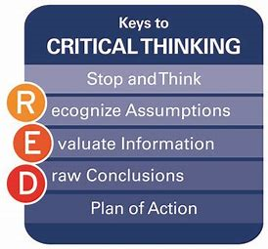

In evaluation of the information, for Tesco’s to serve customers better, employees need to be fully trained and motivated to fulfil customers’ needs explained Times 100, (2019). Tesco believe the more motivated workforce the more positive impact on customers, therefore Times 100 (2019) revealed how Tesco use the Frederick Winslow Taylor’s theory developed in 1911. Taylor believed salary was the main motivator. Tesco has taken the approach of rewarding by results, although Tesco do offer non-financial incentives, but most rewards consist of free shares, employee discounts, gym membership and pension schemes. Times 100 (2019) also states, surveys undertaken at Tesco for staff to put across any viewpoints to lead to staff satisfaction.
Although Frederick Taylor theory has many advantages as according to Wise Step (2019), this method enhances production, management has control, inaccuracy is decreased, production cost is lower along with better pay system and easy decision-making process. However, Wise Step (2019) also state the limitation, which are, management taking complete control leaving employees less room to develop, a costly system, demotivate staff, employees become like machines, not ideal for teams, work is divided, chances of financial loss, stressful and time consuming.
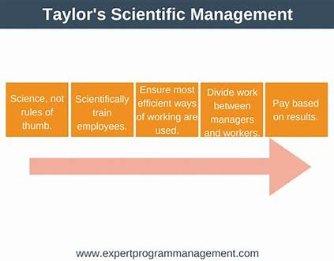

In drawing the conclusion, the researcher believes the application of the Kirkpatrick four level developed by Donald Kirkpatrick in 1959 and then updated a further two times explained Mind Tool (2019). This developmental vehicle could help Tesco’s with training as Mind Tool (2019) also stated, the four levels that are Reaction, Learning, Behaviour and Results, can help offer training and analyse how effective it has been. Employees then can put what is learnt into practice and follow the core values effectively, rather than working like a machine only for reward.
The Kirkpatrick’s model has many advantages explained Edwin (2019), these are; it is an easy and quick way to gain insight about training, the employees and management can acknowledge skills possessed and abilities in need of enhancing, see if workers have the right attitude to utilise obtained skill and understand if required skills has improved productivity. However, Edwin (2019) stated the limitations being; the reactions of the training levels can be too quick, too much time, effort and money involved, and employees must regularly review if skills are being used.

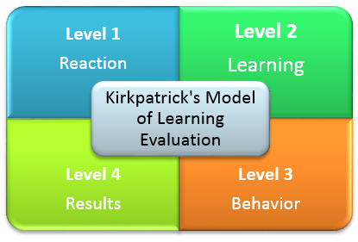

Looking at the researchers own values and beliefs, working in a place like Tesco’s would not be an issue as the researcher has worked in this organisation in the past. Working at Tesco may offer rewards systems but as according to Cole and Kelly (2011), Maslow’s Hierarchy of needs developed by Abraham Maslow in 1930s which has five levels is also implemented. This theory states how people are satisfied when needs are met, as Tesco’s 100(2019) explained, Tesco fulfil the basic needs by giving a place to work right up to offering a self-developmental plan which completes the self-actualisation level. This fits well with the researcher’s value as there is an opportunity to grow with the company rather than simply getting rewarded with no growth. The objective of the manager is more focusing in rewarding employees through different ways to encourage staff to work efficiently as well as appreciating hard work, this fits well with the researcher as acknowledgement is the key to success of all businesses.
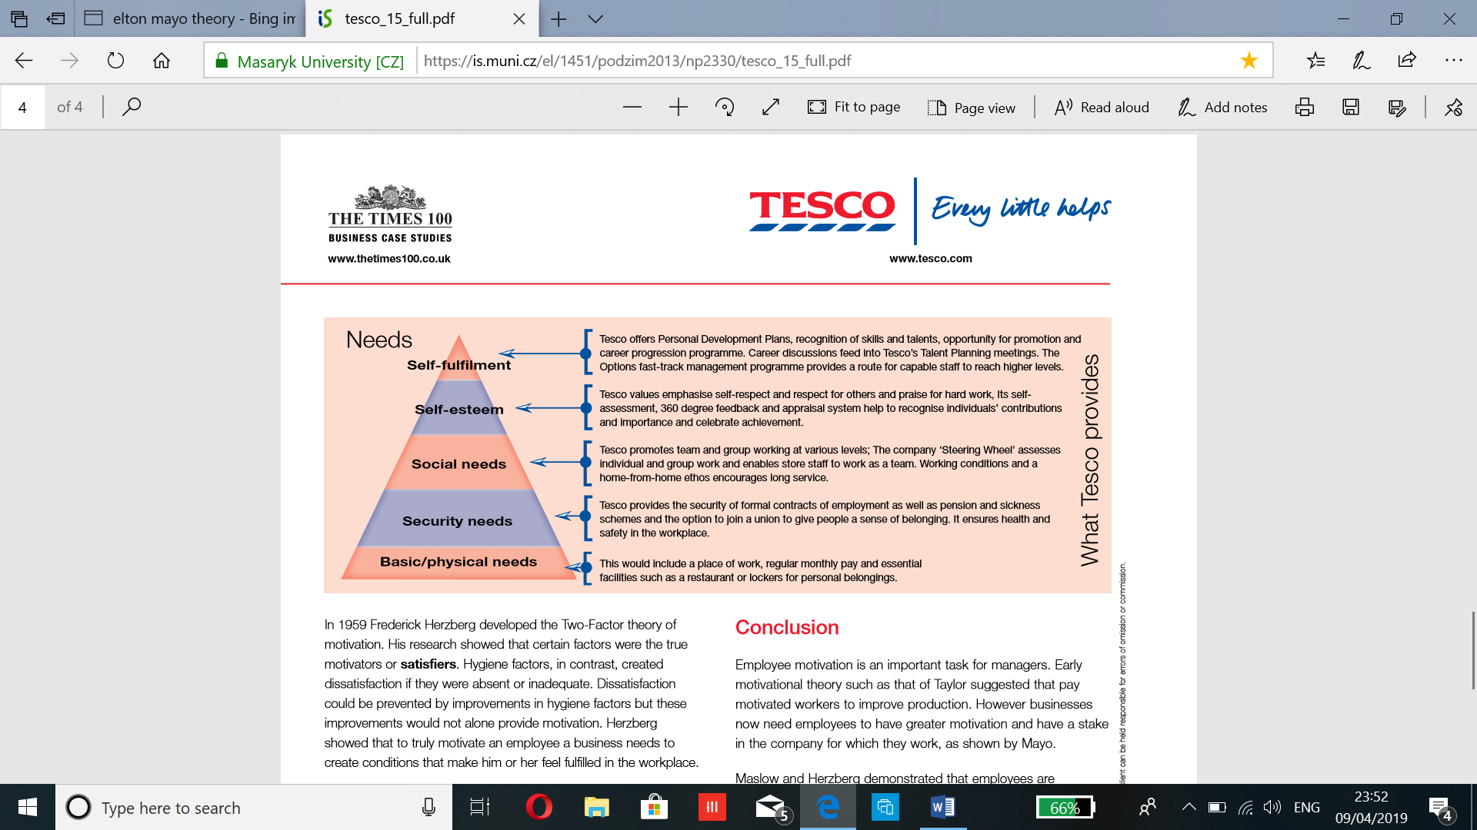
However, the technology Apple is somewhere the researcher would feel more comfortable to work in as the values are best suited. According to Kosoff (2016) cited by Glassdoor, employees have many financial benefits such as good salary and discounts on products also for family too. Glassdoor, (2019) explained, health insurance was also offered to even part timers, in the USA staff are given dental, vision and health checks. These elements attract the researcher to work in an organisation that give workers the importance of recognition through financial rewards but also understands the importance of employee’s wellness. Apple value and belief are available to view in the appendices.
One of Tesco’s core values is, the organisation like to treat people how Tesco would like to be treated. According to BBC News (2013), Tesco do not implement this value with the workers. In Harlow, one of the distribution centres was being shut down therefore employees where offered redeployment 20 miles away and further. Workers was not happy and felt Tesco was treating employees “like scum”.
However, in separating assumptions from an argument, Tesco Complaint (2017) explained, that a staff expressed managers where mistreated by not allowing workers to have water bottles on duty. The management constantly talk about safety law, human right and quick to apply disciplinary for genuinely being off sick. According to Stones (2013), Tesco was also criticised for treating suppliers unfairly by breaching the code of practice for groceries, although a Tesco’s spokesperson state that this is just a speculation.
In evaluation, according to Trust Pilot (2019), a customer complained of receiving online shopping with fresh produce and bakery with very little date, when customer service was called the member in charge was not very helpful and dismissive. Another customer also complained about online customers being treated unfairly by using these shoppers to get rid of unwanted old stock.
In the evaluation so far, Tesco seem to not treat customers, employees or suppliers fairly at all. However, Adzuna (2019) stated by current employees that Tesco do offer great schemes and programmes. The company have good opportunities, although the pay is not ideal but still is a wonderful place to work at. Unfortunately, other reviews highlight’s negative points such as, management being useless, and staff treated inadequately.
To draw a conclusion, according to Nicholson (2019), the importance of treating employees fairly is mainly to reduce staff turnover rate, also having to trust and respect is vital to increase productivity. Imani (2019) stated, treating employees unfairly reduces employee morale which effects customers.
Tesco implement the Frederick Herzberg theory developed in 1959 stated Tesco 100 (2019), this is a two-factor theory. This model identifies the hygiene factors being; delegation, good working condition, staff making decision together, pay rise, holding forums for discussions and administering policies, these encourages motivation, although this model is applied, the fair treatment seems to remain the problem.
However, according to Kunchala (2017), the limitation of the Herzberg theory is that it overlooks productivity and concentrates on satisfaction, employees that are implementing this theory on normally blame dissatisfaction on external factors and hold themselves responsible for satisfaction.
Applying the Douglas McGregor’s theory developed in the 1960s stated by Tools Hero (2019), this is a model that explains how a manager’s belief can lead to two perception of Theory Y which are people that are lazy, different needs and no interest in work. Theory Y is hard workers, focused and like responsibility. According to Whathumanresource.com (2019), managers with the influence of knowing how to connect, motivate and treat staff well, employees then would have a more positive approach which is theory.
The limitation is explained by Study Guide (2019), Douglas McGregor’s theory to be an outdated theory which few organisation implement. This Theory is accused of not being innovative and a controlled supervision method.
In aligning the value of the researcher, it is strongly believed that to be treated fairly then others must be treated the same way. Tesco may use various theories and methods to encourage recognition and productivity but looking at the review site as many employees state the style of leadership is yet to change. With the current findings of indications of the management problems in the organisation, the researcher would not like to work were managers cannot have decent behaviour towards employees. However, when the researcher did work at Tesco, this kind of discrimination did not take place and felt the managers were kind and supportive. This may be different depending on the store or even the current years with what the evidence shows and would not be a career option. The company’s mission is manipulated by misbehaviour of management towards staff and the implementation of models only seem to work in certain stores. The researchers own value is that being comfortable at a workplace is vital and that involves having a good relationship with managers, if management mistreat people then it is only a matter of time employees will leave. If the current situation is as bad as evidence reveal, then this is against the researcher’s value.
Apple being the preferred company the researcher would rather work at as the organisation treat employees with respect according to Kosoff, (2016), Apples work environment is much more mature. Working in Apple help employees to commute to work with great leadership, aiding in hard workers through relevant training rather than being micromanaged. The researcher would want to work where there is an opportunity for growth as Apple offer education whilst working.
Tesco’s attitude may be to understand the need of customers and to act responsibly however, in separating assumptions from facts, Study Moose (2019) stated, Tesco’s is a large and competitive market and need to monitor customer service which can be a challenge. Study Moose (2019) also explained, Tesco’s use mystery shoppers to act as normal customers to see if there is any scope of improvements. Tesco use customer questionnaire to see views along with any suggestion boxes for staff as well, on how to improve services. The company do not use focus groups for feedback which can aid towards customer service.
In analysing further assumptions, Attitude (2015) explain, how Tesco had to apologise for staff making comments to a gay couple about dying alone and not deserving to have children. The employee that made this comment had strong belief and attitude against homosexuality. Tesco’s were prompted to change policies and procedures; the company promised an internal investigation (Attitude 2015).
To evaluate the attitudes of Tesco, Glassdoor (2019) a review site, highlighted issues with employees against the management. Some workers stated how the managers need to listen to co-workers, another said the management do not give clear messages. Glassdoor (2019) does have some positive comments such as, there is great opportunities and supportive managers. From these reviews it does not seem Tesco’s managers are acting responsibly.
Tesco PLC (2014) corporate online strongly state how values are followed through policies and welcome stakeholders to give feedback to improve performances that may impact any aspects of value, belief and attitude. To evaluate further, Tesco PLC (2019), made some corporate changes to be able to understand the customers needs and make shopping trips simple. The company introduced different service desks which allow workers to concentrate on good service.
According to BBC News (2017), Tesco also introduced green labels to cut the cost of energy efficient products, this step was taken for the environmental impact also falls with acting responsibly for the community. However, according to BBC News (2019) Tesco face a drop of profits, the organisation brands have dropped in customer relevance and does not hold the status it did in last five years.
To draw the conclusion, although Tesco’s main issue with attitude is giving a negative impact on the organisation which seems to underly with the management. According to Browne (2019), a good relationship between the management and staff can make all the difference, this can aid in attitude, motivation and productivity leaving customers satisfied. A poor attitude can only create bad work habits along with unhappy workers and clients.
Elton’s Mayo’s theory is implemented by Tesco’s explained Tesco 100 (2019), this was developed after the Hawthorn studies in the 1930s, it was discovered after splitting two groups, one with improved lighting and with reduced which then came to a conclusion that social factor was the main element to motivation. Tesco 100 (2019) stated, the motivation aspect was several fundamental factors such as; good communication, great teamwork and showing interest in others. This method can improve the attitude of workers in respecting the well-being of others. In the application of the Mayo’s theory, Tesco use the appraisal system and newsletter along with the 360-degree feedback system to value and give opportunity for employees to have a positive outlook and attitude.
Although Elton Mayo’s do have positive aspects explained Large SEO Tools (2019) such as; great freedom and teamwork the limitations are that the responsibility is increased which leads to stress and pressure leaving management with less control.
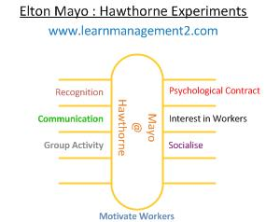

To conclude further, Tesco could also implement the Attribute Theory to enhance the Elton Mayo theory and attitude of workers. This was introduced by Heider in 1958, according to Cole and Kelly (2011), this model aid to make sense of the social society and find explanation on other people’s behaviour which could be internal or external factors. Attribution theory help to judge the cause of the problem and put in place performance management. However, Kipenji (2019) states the limitation to this model is that it takes away the accountability of owning up to the owns choices and misses the point of the workers efforts.
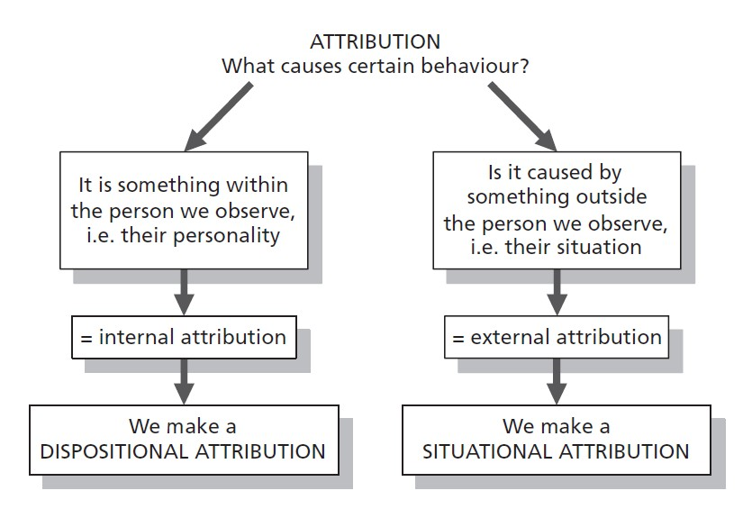
In aligning the attitude of the researcher, it is strongly believed to fulfil customers needs and act responsibly towards the communities it is vital to have a good relationship with the management which increases staff morale. The evidence does state that there are issues with management in some stores but there is also performance management in place to improve what can be done. Although Tesco does have a rocky status now, the company do still have a good reputation and try to do what is best to improve it. The researcher feels to work in Tesco would not go against the attitude obtained as every organisation faces challenges but not all companies want to do something about it. According to Tesco 100 (2019), Tesco offer lifestyle and career breaks to individual that are in need to move away for a while also provide self-assessments for employees to reach full potential. Other programmes such as appraisals and the 360-degree feedback system also to aid development.
The researcher has a great compatibility on the attitude of the researcher when it is compared to Apple organisation. According to Retail Customer Experience, (2012), all employees working with customers or at the back of store all staff offer the best customer experience as all workers have the same goal. Employees provide products depending on the need of customers. Customers can also press the smart button for a member of staff to approach with assistance. Apple do not push for sales and ensure customers are cared for. These attitudes only display that Apple not only understands the importance of treating employees and customers well, but also acts towards these attitudes.

Conclusion

To conclude it has been discovered that the large company Tesco had mixed reviews as according to Trust Pilot (2019), customers described Tesco’s being overpriced and others explained Tesco being better quality in products. Tesco 100 (2019) displayed the usage of Frederick Taylors model to motivate which directs the organisation to follow the value and belief that was stated by Tesco Privacy Centre (2019) which is “To serve customers better every day”. However, the researcher found the Kirkpatrick model stated by Edwin (2019) to aid workers in sufficient and insightful training to be able to follow these values and belief more adequately.

One of Tesco’s values of Tesco treating people fairly was argued by BBC News (2013) stating workers were treated unfairly due to shut down of stores. Tesco Complaint 92017) also stated that management was not being fair to staff. Customers took review sites Trust Pilot (2019) explaining bad customers service. Although Frederick Herzberg model was implemented according to Tesco 100 (2019), the researcher found Douglas MacGregor’s theory application can help managers to connect with staff and employees (Humanresource.com 2019).

Tesco’s attitude of acting responsibly was tested when the company had to apologise on behalf of a staff for making hate comments to a gay couple (Attitude 2015). However, Glassdoor (2019) explained, the mix reviews of managers acting responsibly in some stores, and others stating managers not listening to staff. Although Tesco PLC (2014) strongly state that values are followed through policies and feedback system are used to improve on attitudes. According to Tesco 100 (2019) Tesco follow the Elton Mayo’s model to motivate which can impact towards the attitude. However, the researcher found the Attribution theory stated by Cole and Kelly (2011) can help to understand behaviour.

To conclude further, the researcher aligned the own values, belief and attitude and found that Tesco is a good company to work for and does have some matches to the components of principles held. However, Apple organisation offer more similar values by offering great customer experience according to Retail Customer Experience (2012). Kosoff (2016) explained, Apple has a more mature work environment.

Reference List
Fact Site. (2019), The History of Tesco, [Online]. Available: https://www.thefactsite.com/history-of-tescos/. [Accessed 7th April 2019].

Our Tesco. (2019), Our Core Purpose and Values, [Online]. Available: https://www.ourtesco.com/working-at-tesco/our-company/our-values/. [Accessed 7th April 2019].

Study Moose. (2019), Customer Service Tesco’s Customer Expectation Essay, [Online]. Available: https://studymoose.com/customer-service-tescos-customer-expectations-essay. [Accessed 7th April 2019].

Tesco plc. (2019), Core Purpose and Values, [Online]. Available: https://www.tescoplc.com/about-us/core-purpose-and-values/. [Accessed 7th April 2019].

Course Hero. (2019), Pearson's RED Critical Thinking Model, [Online]. Available: https://www.coursehero.com/file/18081036/the-red-model/. [Accessed 7th April 2019].

Trust Pilot. (2019), Tesco, [Online]. Available: https://uk.trustpilot.com/review/www.tesco.com. [Accessed 7th April 2019].

Wise Step. (2019), Scientific Management Theory advantages and Disadvantages, [Online]. Available: https://content.wisestep.com/advantage-disadvantage-scientific-management-theory/. [Accessed 7th April 2019].

Times 100. (2019), Motivational Theory in Practice at Tesco, [Online]. Available: https://is.muni.cz/el/1451/podzim2013/np2330/tesco_15_full.pdf. [Accessed 7th April 2019].

Mind Tool. (2019), Kirkpatrick's Four-Level Training Evaluation Model, [Online]. Available: https://www.mindtools.com/pages/article/kirkpatrick.htm. [Accessed 8th April 2019].
Cole, G.A and Kelly, P. (2011), Management Theory and Practice, (7th Ed). China: R.R, Donnelley.
Study Moose. (2019), Customer Service at Tesco Essay, [Online]. Available: https://studymoose.com/customer-services-at-tesco-essay. [Accessed 8th April 2019].
Attitude. (2015), Tesco Employee tells Couple that all Gay People Should Die Alone, [Online]. Available: https://attitude.co.uk/article/tesco-employee-tells-couple-that-all-gay-people-should-die-alone/5122/. [Accessed 8th April 2019].
Edwin, H. (2019), Is Kirkpatrick’s Model of Evaluating a Training Program the Best? [Online]. Available: https://blog.commlabindia.com/elearning-design/kirkpatrick-model-of-evaluation. [Accessed 9th April 2019].
Glassdoor. (2019), Tesco Review, [Online]. Available: https://www.glassdoor.co.uk/Reviews/Tesco-Reviews-E10250.htm. [Accessed 9th April 2019].
Tesco PLC. (2004), Corporate Responsibility Review, [Online]. Available: https://www.tescoplc.com/media/1146/cr_report_2004.pdf. [Accessed 9th April 2019].
Tesco PLC. (2019), New Releases, [Online]. Available: https://www.tescoplc.com/news/news-releases/2017/tesco-continues-changes-to-improve-customers-shopping-trip/. [Accessed 9th April 2019].
BBC News. (2017), Tesco boss unveils green pledges, [Online]. Available: http://news.bbc.co.uk/1/hi/business/6276351.stm. [Accessed 9th April 2019].
BBC News. (2019), Tesco, [Online]. Available: https://www.bbc.co.uk/news/topics/c77jz3mdmlvt/tesco. [Accessed 9th April 2019].
Browne, C. (2019), How to Better Employee Work Attitude & Performance, [Online]. Available: https://smallbusiness.chron.com/better-employee-work-attitude-performance-25457.html. [Accessed 9th April 2019].
Large SEO Tools. (2019), Elton Mayo Theory Advantage and Disadvantage, [Online]. Available: http://www.largeseotools.org/2019/01/07/elton-mayo-theory-advantages-and-disadvantages/. [Accessed 9th April 2019].
Kipenji, O. (2019), Disadvantages of Attribution Theory; Distracts the Attention from our own Responsibility, [Online]. Available: https://www.12manage.com/forum.asp?TB=heider_attribution_theory&S=20. [Accessed 9th April 2019].
BBC News. (2013), Tesco 'treating staff like scum' over Harlow depot, [Online]. Available: https://www.bbc.co.uk/news/uk-england-essex-21900237. [Accessed 10th April 2019].
Tesco Complaint. (2007), Tesco Won’t Even give Water to Staff, [Online]. Available: https://tesco-complaint.blogspot.com/2007/09/no-water-for-tesco-staff.html. [Accessed 10th April 2019].
Stones, M. (2013), Tesco Denies Squeezing its Suppliers after Analyst Criticism, [Online]. Available: https://www.foodmanufacture.co.uk/Article/2013/12/02/Tesco-denies-treating-its-suppliers-unfairly. [Accessed 11th April 2019].
Trust Pilot. (2019), Tesco, [Online], https://uk.trustpilot.com/review/www.tesco.com. [Accessed 11th April 2019].
Adzuna. (2019), Tesco Reviews, [Online]. Available: https://www.adzuna.co.uk/jobs/company/tesco/reviews. [Accessed 11th April 2019].
Nicholson, N. (2019), Why Treating Employees Fairly is Important, [Online]. Available: https://hr.sparkhire.com/talent-management/why-treating-employees-fairly-is-important/. [Accessed 11th April 2019].
Imani, F. (2019), How to Treat Employees Fairly in the Workplace, [Online]. Available: https://work.chron.com/treat-employees-fairly-workplace-3070.html. [Accessed 12th April 2019].
Kunchala, K.S. (2017), Implication, Limitations Suggest of Two-Factor Theory of Motivation, [Online]. Available: https://www.mbahelp24.com/implications-limitations-suggestions-two-factor-theory-motivation/. [Accessed 12th April 2019].
Tools Hero. (2019), McGregor Theory X and Y, [Online]. Available: https://www.toolshero.com/leadership/mcgregor-theory/. [Accessed 12th April 2019].
Whatishumanresource.com. (2019), Douglas Murray McGregor, [Online]. Available: http://www.whatishumanresource.com/mcgregors-theory-x-and-theory-y. [Accessed 12th April 2019].
Management Study Guide. (2019), Theory X and Theory Y, [Online]. Available: https://www.managementstudyguide.com/theory-x-y-motivation.htm. [Accessed 12th April 2019].
Kosoff, M. (2016), Apple employees reveal the 19 best things about working for the world's most valuable company, [Online]. Available: https://www.businessinsider.com/best-things-about-working-at-apple-2016-1?r=US&IR=T. [Accessed 23rd April 2019].
Glassdoor, (2016), Apple, [Online]. Available: https://www.glassdoor.co.uk/Benefits/Apple-US-Benefits-EI_IE1138.0,5_IL.6,8_IN1.htm?countryRedirect=true. [Accessed 23rd April 2019].

Sielearning. (2009), Personal values, belief and attitudes, [Online]. Available: https://sielearning.tafensw.edu.au/MCS/CHCAOD402A/chcaod402a_csw/knowledge/values/values.htm. [Accessed 25th April 2009].

Mind Tool. (2019), Understanding Workplace Values, [Online]. Available: https://www.mindtools.com/pages/article/understanding-workplace-values.htm. [Accessed 24th April 2019].

Belcher, L.M. (2019), Five Attitudes That Are Important in Workplaces, [Online]. Available: https://smallbusiness.chron.com/five-attitudes-important-workplaces-19114.html. [Accessed 24th April 2019].

Intentional Workplace. (2019), The Power of Beliefs at Work, [Online]. Available: https://intentionalworkplace.com/2011/05/20/the-power-of-beliefs-at-work/. [Accessed 25th April 2019].

EDUCBA. (2019), How to Apply Management Theories at Workplace, [Online]. Available: https://www.educba.com/how-to-apply-management-theories-at-workplace/. [Accessed 25th April 2019].

Sabutey, F. (2017), The 7 Core Values Which Made Apple the Most Valuable Brand in the World, [Online}. Available: https://www.expandgh.com/7-core-values-which-made-apple-most-valuable brand-in-the-world/. [Accessed 27th April 2019}.

Young, C. (2012), Five Core Apple Beliefs Every Company Should Have, [Online]. Available: https://www.therainmakergroupinc.com/blog/bid/118523/five-core-apple-beliefs-every-company-should-have. [Accessed 27th April 2019].

Appendices

The Values of Apple
- ‘We believe that we’re on the face of the Earth to make great products that will change the world.
- We believe in the simple, not the complex.
- We believe that we need to own and control the primary technologies behind the products we make.
- We participate only in markets where we can make a significant contribution.
- We believe in saying no to thousands of projects so that we can really focus on the few that are truly important and meaningful to us.
- We believe in deep collaboration and cross-pollination of our groups, which allow us to innovate in a way that others cannot.
- We don’t settle for anything less than excellence in every group in the company, and we have the self-honesty to admit when we’re wrong and the courage to change’ (Sabutey, 2017).

Apple’s Belief
- Clear Direction
- Individual Accountability
- Sense of Urgency
- Constant Feedback
- Clarity of Mission (Young 2012).

