30-11-2020
Professional Career Development
(BMSW4005_BIRM)
Daniel Gordillo rosales (1913306)
Teacher: Abdi rahman

Personal Development Plan

Personal development plans describe route of action to be taken to improve performance. Also, permits workers to keep themselves informed of changes in their profession or field.
PDP outline the strengths of the workers and show the areas where is need an improvement, also provide an action plan to helps in areas of weakness and keep growing in areas of strength.
Also permit to the workers to answer some questions:
- How can I keep growing and learn in the next year?
- How can I grow in terms of career for the future?
- How can I avoid performance problems faced in the past?
- Where am I now and where would I like to be in terms of my career path?
No matter how high up and how simple or complex is the job, there is always space for improvement.
Development plans focus on the short-term and on specific roles and positions. Can also focus on knowledge and skills needed for more long-term career aspirations and career development.
Specifically, good development plans focus on developing career competencies including the following groups:

Reflective
Reflection or motivation refers to reflecting on values, passions and motivations with regards to one’s career. Reflection on qualities refers to reflection on skills, shortcomings and strengths needed to one’s career.
Communicative
Networking refers to the awareness and the ability to expand this network for career-related purposes.
Behavioural
Work exploration refers to constantly searching and exploring for career-related and work-related opportunities outside and inside the company.
Satisfaction
The incorporation of development plans and identification of weaknesses and strengths also helps workers to be more probable satisfied with the actions of the management system.
Improve
A good development plan helps employees find performance standards and includes suggested actions to overcome their performance if they are deficient.
Sustain
Provides tools to the employees to continue, find and surpass expectations regarding their current position.

Prepare
A good development plan includes suggested actions so that workers can benefit themselves to get more opportunities for the future and their careers.
Enrich
Even if career opportunities on the inside of the organization are not mostly available. A good plan provides employees with opportunities to learn new skills.
Value
A Personal development plan is an important part of the performance management system. Including this component stablish the way for the development process by helping managers understand its value.
End Product
The objectives of the plan should not include only the end product, as the new skill to be learned, also the conclusion and evidences will be saved and record to know either the new skill has indeed been acquired.
Needs
An extra important attribute of the development plan is that it should keep the needs of both, the worker and the company always in mid.
Organization
The election of what particular skills will be boosted depends by the needs of the company, principally when the organization is investing a lot of resources in the plan.
Ultimately, the manager and the worker need to recognize and agree on which new skills or development would help to enrich the employee’s work experience.
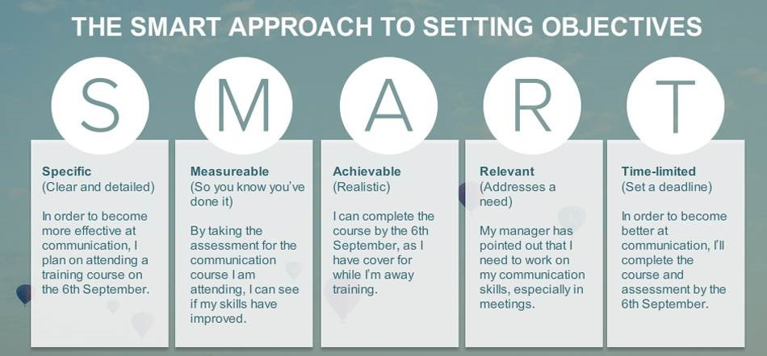

My Personal Development Plan
Defining your dream life vision
Core values
1. Enjoyment of life:
Having fun enjoying, valuing and making the most out of life in every phase.
2. Honesty
Being honest in everything I do and surround myself with people that I respect as honest people. Encourage others, to be honest and transparent.
3. Relationships
Keep creating new relationships with interesting and positive people.
4. Positive
Be positive and upbeat! Approach things with a positive attitude.
5. Discipline
Believe in myself and push through hard times. Achieve more through self-discipline
6. Independence
Knowing that I can live a fulfilled life on my own and being independent in that way. Alson being financially independent, not having a boss and working independent/remotely.
7. My mission Statement
Live a fulfilled and positive life that I love and by example, motive other in a transparent and honest way to do the same by working on themselves.
Goal settings
Boosts my business skill to the next level
What exactly do I want?
I will improve my business skills in sales, networking and profit which will impower me to be highly successful with my next company.
Reasons
I will make the best of my year in Birmingham and suck up the Start-up and Business-Mentality which is so unique in the world.
Being an expert in culinary skills and sales, building a great network over there and getting sense of business hospitality, will be super beneficial for my own next projects and companies.
I want this so much because I know that this is a once in a lifetime change and so that I can jumpstart my next company with an insane momentum.

Sense-specific description
I will see all the contact information I have gotten through networking, attending master classes, meeting interesting and successful people in United Kingdom. I will see the prospects in the restaurant and their joy and respect after they try my food. I will hear the prise of my partner and family telling me I am doing so well and that they are highly satisfied and proud of my work.
I will feel great about my new understanding of cuisine and that I have a very precise image of what kind of business model I will want to use in my project.
Target State
Current state
I am a good Chef who has a good network in the Weast midlands, UK. And a Rough knowledge about business hospitality and how they work. I’m not good enough with excel, Gps and profits.
Desired State
I will have a huge network from people all over the world, with very specific knowledge about things that I can contact them about when I have questions or need help. My skill with Excel and Stocks will improve and I will be doing costing and GPS like a Pro. I have much knowledge about hospitality businesses because I met so many people and talked to owners, head chefs and managers about their experience and expertise in this industry.
Proof
Contact cards and information of people who I met along my journey. Number of prospects qualified and a high number of total sales. Cards, master classes and nametags which I got at events where I met and talked to interesting, helpful and wise people about business and innovation.
Resources
Endurance / discipline / competitiveness / determination
Endurance / discipline: Just like with previous training achievements, semester abroad, successes during my studies, masterclasses, and bulk mode.
Feeling of success because. I saw the results and stuck to my plan, kept working at it and in the end got what I was looking for, due to steady endurance.
Competitiveness/determination: Just like with sports (e.g. I won many football tournament) same as at Culinary competitions.
Feeling of success because I gave everything I had and, in the end, also got the well-deserved win.

How would I have to be, to reach this goal?
I am an open-minded networker and can easily start interesting conversations. I approach people and am fast at learning from my previous mistakes. Also, I’m not scared of contacting people “out of my league” and know how to spark a conversation with them. I’m highly consistent and don’t let anything bring me down. I recover rapidly and put everything I learnt from my mentors. I’m start-up guy with a vision and there is nothing that will change this. I’ll spend my time wisely and meet people who are beneficial to me and whom I even can help in return. I’m driven, open and likeable and connect fast with the people I meet.
What currently stops me from reaching my goal:
- Get more fluent in my speaking and improve my vocabulary
- Lack of practice in socializing
- Need to adapt to UK culture
Role Models
My mother: Fighter, impeccable, overcoming.
Steli Efti: Great speaker, motivational, inspirational.
Virgilio Martinez: Innovator, traditional, curious, willing to take a risk.
Keanu Reeves: Humble, inspiring, philanthropist.

Create Project Action Steps
The following are the steps it must be done to start my business

Project
Successfully Launch Start-up
Action Steps:

- Define Brand/company Name
- Register Domains and company
- Draft out website Structure and order System
- Outsource Programming and launch Website
- Apply to incubator with Business plan
- Define the Menu and the context
- Officially register Brand

Define Resources and habits
Supportive Goals Checklist 2020

2020 | JAN | FEB | MAR | APR | MAY | JUN | JUL | AUG | SEPT | OCT | NOV | DEC
Generate min EUR 2.000 regularly

Create relationships and spend time with achievers

Consume videos, blogs and books on personal development

Share my personal development and learning

Be more present with parents, family and friends

Create social moments with my partner

So basically, I have this table print it out in and stick in my wardrobe so every day when I wake up, first thing to do is mark what I have done so far, every month. And at the same time push and motive myself to complete it all.
Reflection (regularly)
As many times as possible I appraise my Personal Development Plan and adjust doing changes or re-examine any of the earlier steps looking for improvements. Also reaffirm my commitment with the Personal develop Plan.

Development, Learning and Training

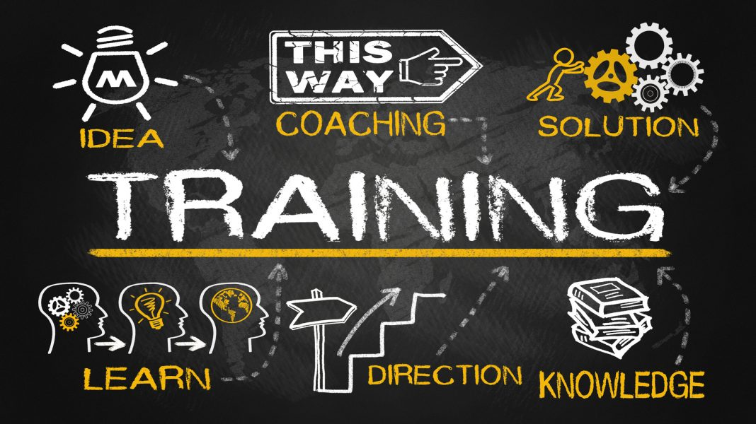

Learning. Include purchase both, tactic and specific knowledge, the workers get all of this through informal and formal training activities and different experiences.
Training. Is the meticulous process of give employees with the skills, knowledge and abilities, necessaries to do their job.
Workers can acquire the Knowledge, Skills and abilities (KSA's) by being part of classes, either in the classroom or online.
Taking part of role plays or simulations or with a combination of these and other methods.
Companies also invest a lot of resources to develop their workers for other jobs.
Normally at a higher level.

Training and development help the companies to acquire their employees the support needed to get the competitive advantage.
That’s why the wise managers make sure that their employees participate in both.

Appreciating the potential value of learning and development is only part of the equation. Effective managers understand that learning and development activities must be carried out properly to be effective.

Training process
Successful training programs is a result of the following process:
This process includes needs, assessment, design, implementation and evaluation.
MISSION, VISION AND VALUES | ASSESSMENT Organization analysis | DESIGN  Instructional objectives | IMPLEMENT  Training  methods | EVALUATION Reactions and results

Every part of the training process is essential, as a manager the intake you provide for each part will be important to its success.
If your organization has a training department, you'll come up with information to the department to be use in the planning of the program.
Training has a huge potential to improve the production of your workers, but it is often expensive and cost a lot of time to do it.
Therefore, a good managers running a training needs assessment to understand where training actions can have the most impact in your organization.
Needs assessment
Recognize, where a breach exist between what workers should be doing at work and what they are really doing.
The next step is to run a task analysis.
The objective of the task analysis is to found breaches between:
1. The Knowledge, Skills and Abilities required to do the work and support the objectives of the organization.
2. The actually KSA of your workers.
This analysis decides which workers need to be part of the training programs. The conclusion is made it from a diversity of sources, like:
Employee skill, Observation, Supervisor recommendation and Performance evaluation.
Individual production records and skills tests also helps to define which workers need training.
All this information helps managers to know where in the company need training, what the training initiative may be, and which workers should be part of the process and training programs.
A perfect understanding of the objectives of the training at the beginning of the design process would help to make sure that the training program would be successful, giving guidance and supports to the goals of the organization.

Instructional system design

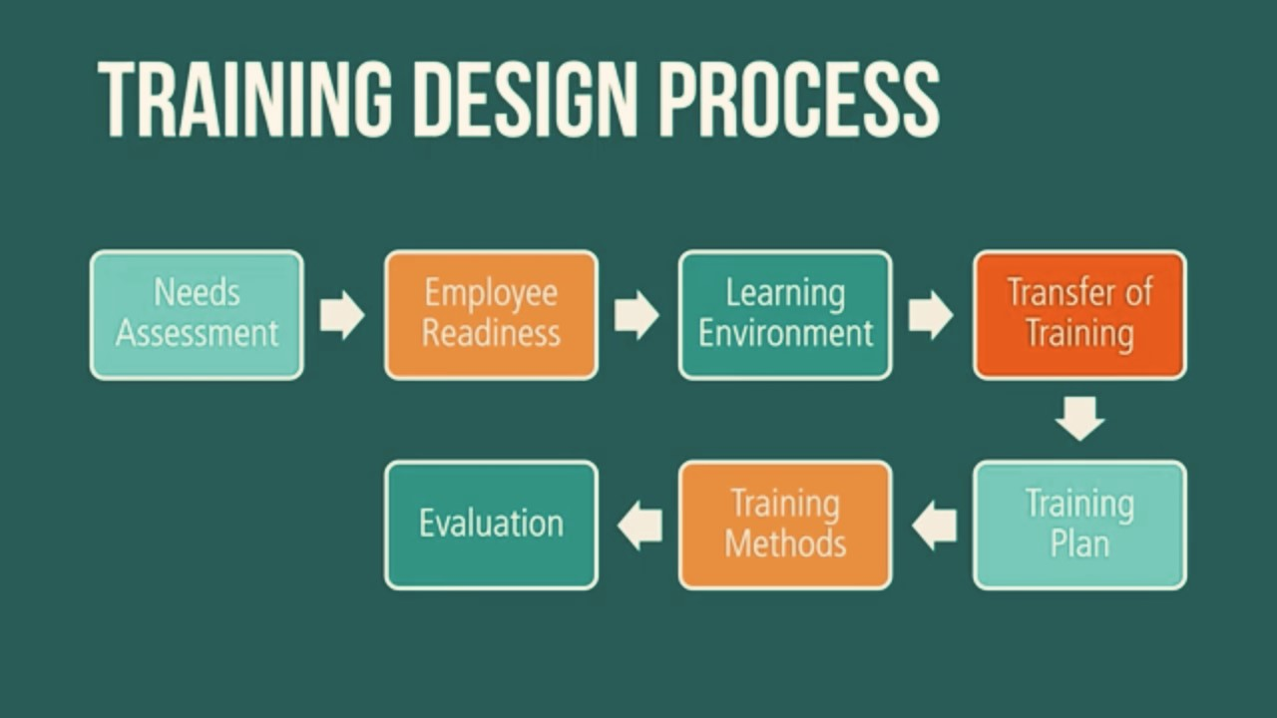

Instructional system design allude to a process for designing and developing training programs.
Sometimes call as the ADDIE model because it includes Design, Analysis, Evaluation, Development and Implementation.
Steps:

- Needs assessment which is important to identify whether training is needed.
- Ensure that workers have the stimulation and basic skills to control the training content.
- Produce a learning environment that has the attributes necessary for learning to happen.
- To ensure that the employees apply the training ideas to their jobs.
- Evaluation and developing plan includes identifying what types of results is expected to influence.
- Select the training method based on the learning environment and learning objectives.
- Assess the program and make changes or re-examine any of the previous steps in the process to upgrade the training.
Managers:
- May be part of an active role to identify training needs and help to guarantee that employees use training in their jobs.
- Workers are willing to share knowledge between them and with another groups.
- Need to allow and motivate employees to share their knowledge, recognize problems and permit the company to improve and investigate continuously.

Hands-On Training method
Are training methods that need the employee to be actively involved in learning, these methods include Case studies, Behaviour modelling, simulations, role-playing, business games and On-The-Job.
These methods are perfect for develop specific skills, comprehending how skills behaviour and skills can be learn on the job, completing a task or dealing with interpersonal issues.
On-The-Job training known as OJT. Allude to inexperienced employees, learning during job by observing colleagues or managers performing and then trying to do their job in the same way.
Also being part of different forms including self-directed and apprenticeships and learning programs.
Self-directed learning programs. The workers are taking responsibilities for all aspects of learning: like, when it is conducted and Who will deliver it.
Apprenticeship. Is a training method in which both in the classroom and on the job are used, the usually time of an apprenticeship is four years, but this can reach from two to six years.
Simulations. Represents a real-life situation with employers decisions, resulting in outcomes that mirror what would happen if they were in their work.
Case Studies. Description about how workers or an organization dealt with a hard situations.
Business games. Require employees to found information, analyse it and make decisions. Business games are usually used for management skill development.
Role-playing. It is about the experiences in which employees act in a role such as a client, manager or dissatisfied employee and explore what is about and complex in that role.
Behaviour modelling. Presents employees with an example which demonstrates key behaviours to provides and replicate. Give them the opportunity to practice the key behaviours.
Also helps to reaffirm the transfer of training to happen by using application planning,

Reflection of my Experience
When I started this module, I know that would help me a lot to reaffirm my feelings about this career. As a head chef I'm looking to expend my ideas about business and help to improve my team and who is working around me.
The teacher was always very helpful and communicative with all of us give us always a reason to carry on and don't give up, telling us his own histories and examples. And pushing us with the example.
The other students were very friendly's and participative, giving me always another way or point to analyse the situations. Did expect much cause was online this module but the teacher and the module surpassed my expectative.
I did a resume of every week after class and in the following a leave you all my notes about it.
- With the Personal development Plan, personal reflection and career development. I Gain confidence and competence as effective worker and show more security with my colleges, also stablish my goals.
- We also understand the skills and knowledge to be efficient at work.
- We learn and use the tools about how to Improve Self-awareness (unconsciousness, consciousness, self-awareness and meta-self-awareness)
- Self-evaluation process and tools to improve it, like: Personal and learning test also Swot analysis and the Johari Window
Focusing in two of them first the Johari Window which divide in:
Open self. Information about you that other and yourself know.
Hidden self. Information about you that you know but other do not.
Blind Self. Information about you that you do not know but others do.
Unknown self. Information about you that neither you or others know.
the objective of this tool is to enlarge the open self and reduce the unknow self.
And second the Personal Tests:
Which measure an individual’s predisposition to act and behave in particular ways.
Example: MBTI Myers Briggs Type Indicator
We also studied about Learning Styles:
Kolb, Honey & Mumford, Neil Fleming´s. The last one was my favourite cause for me is the easiest to understand:
Auditory Learning (music, lectures, discussions)
Reading and writing (making list, reading textbooks, taking notes)
Kinaesthetic learning (movement, hands-on activities, experiments)

We also in this module did explored Employment opportunities, get to know more about us, like careers aspirations and to don't limited ourselves to one option, always research.
Selection Process. Tips about how to improve our Cv and interviews. Creating our personal Brand like reputation, networking, and a good profile.
For this week we created a job advertisement, Cover letter and a CV and in the following week we had a mock interview with our tutor who acted as a Manager of the company we applied for.
Career development
Help us to distinguish between a career and a job and determinate the next steps we should take to develop ourselves.
Careers development process. Discover yourself, explore options, make choices, and take action.
Employment Legislation. Help us to understand the purpose of employment regulation.
. How the legal standards set
. Where the employment law come in to play
In Area as: Recruitment, Contract, Holidays and pay, Data protection, Working time, discrimination, health and safety, discipline.
And finally, Alternatives after the graduation.
The options like Further education, finding employment, become self-employment or take a gap year for like for example do voluntary work.
Danielle Warr helped me a lot about this part of the module and with my CV. I would like to say thank you to her and to my tutor Abdi Rahman who recommended us to book an appointment with Danielle to discuss about our different academy opportunities for the future.
In conclusion, the module of Professional Career Development was very interested cause I didn’t know exactly what skills I wanted to develop and the most important were kind of soft skills, like strategic thinking, communication, and gave me the idea of the kind of things that I enjoy doing more. Also, the other students were funny, participates and always speaking about their jobs and experiences. That helped me a lot to develop my work.
I discover the thing that motive it me, interest me, environments, people’s style of working and how to make compatible with each other. This model is quite a difficult process sometimes but once you have it is about learning about yourself, development, awareness and teamwork.
Finally, just say Thank you Teacher for your support and to be always positive does not matter what.

References
Alder, G.S. (2007), ‘Examining the relationship between feedback and performance in a monitored environment: a clarification and extension of feedback intervention study’, Journal of High Technology Management Research, 17, 157-74.
Beausaert, S., Segers, M., van der Rijt, J. and Gijselaers, W. (2011), ‘The Use of Personal Development Plans in the Workplace: A Literature Review’, in P. Van den Bossche, W. Gjselaers and R. Milter (eds). Building Learning Experiences in a Changing World, Advances in Business Education and Training III (Dordrecht: Springer), pp. 235-65
Boud, D. (2001), ‘Knowledge at work: Issues of Learning’, in D. Boud and S. Solomon (eds), Work-based Learning. A New Higher Education? (Buckingham: Open University Press), pp. 34-43.
London, M. and Smither, J. W. (1999), ‘Empowered self-development and continuous learning’, Human Resource Management, 38, 3-15.
Association of Graduate Recruiters (1995) Skills for graduates in the 21st Century, Cambridge: The Association of Graduate Recruiters.
Anderson, J. C., Dooley, K. and Runtusanatham, M. 1994. Training for Effective Continuous Quality Improvement. Quality Progress, 27 (12): 57-61
Bansal, P. 2005. ‘Evolving Sustainably: A Longitudinal Study of Corporate Sustainable Development’. Strategic Management Journal, 26(3): 197-218.
Castellanos, R. M. M. and Martin, M. Y. S. 2001. ‘Training as a Source of Competitive Advantage: Performance Impact and the Role of Firm Strategy’, The Spanish Case. The International Journal of Human Resource Management, 22(3): 574-594.
Ng, I. and Dastmalchian, A. 2011. ‘Perceived Training Benefits and Training Bundles: A Canadian Study’. The International Journal of Human Resource Management, 22(4): 829-842.
Baker, D. F. (2001), ‘The Development of Collective Efficacy in Small Task Groups’, Small Group Research, Vol. 32 No, 4, pp. 451-474.
McBain, R. (2007), ‘The Practice of Engagement’. Strategic HR Review, Vol. 6 No, 6, pp. 16-19.

