WEEK 1 (week beginning October 2)
Origin Narratives: From Columbus to the Puritans
In Focus:
Visions of a New England
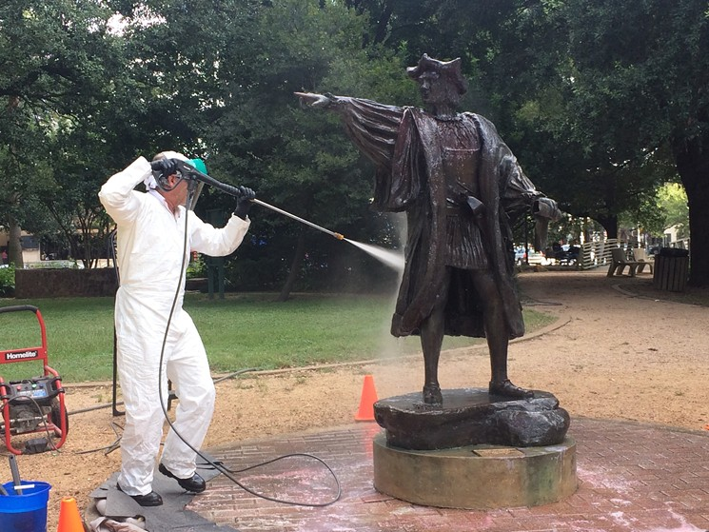
Cle
Cl
Cleaning of vandalised Columbus statue, Houston, Texas, August 2017

This week establishes some of the key ‘foundation myths’ of American society. In particular, we concentrate on the ‘discovery’ and conquest of the Americas by the Spanish Empire, plus the founding of English settler societies in New England and Virginia. In particular, the lecture and ‘in focus’ sessions will introduce students to some of the key concepts and events associated with the settlement of English-speaking colonies of what became the United States of America. We shall examine how emigrants conceptualised their voyage to the ‘New World’ and the type of society they believed they were forging in New England. These are juxtaposed against Native American origin stories.

- Reading and preparation:
Required lecture reading:
- ‘The Creation of the Whites’ story – Yuchi and Hitchiti versions
- Chronology and maps
- William Bradford, Of Plymouth Plantation extracts
- John Winthrop, ‘A Model of Christian Charity’
Recommended lecture reading:
- Thomas Harriot, A Brief and True Report of the New Found Land of Virginia (1588)
Recommended background reading:
Below is a list of relevant chapters from books. Numerous copies are available in the UWTSD Lampeter library. Note: while doing so will help illuminate and contextualise their understanding of the themes and content of the lecture and workshop, it is not expected that students will complete all of the below reading. Likewise, there is crossover between the content of the recommended reading so students may choose to limit their preparation to one of the above texts. This applies for all subsequent weeks.
- George B, Tindall and David Emory Shi, America: A Narrative History (New York: WW Norton & Co, 2010), chapters 1–5
- Malcolm Bradbury, and Howard Temperley, eds. Introduction to American Studies (London: Longman, 1998), , chapters 1–3
- Eric Foner, Give Me Liberty! An American History (New York: WW Norton & Co, 2014) , chapters 1–4

- Background information
Below are some pertinent details relating to each of this week’s readings.

William Bradford, extracts from Of Plymouth Plantation, originally written 1630
Of Plymouth Plantation is the journal of William Bradford, the leader of the Plymouth Colony in Massachusetts. Written between 1630 and 1651, the journal describes the story of the ‘Pilgrim Fathers’ from 1608 until 1647. Most notably, it includes an account of the Pilgrims transatlantic journey aboard the Mayflower, and their impressions of ‘New World’ society upon their arrival in North America. It also contains documentation of the so-called Mayflower Compact. Pay particular attention to the sections headed ‘The Separatist Interpretation of the Reformation,’ (pages 166–167) and ‘The Remainder of Anno 1620’ (pp. 169–172) in the document available on Moodle.
For further information, consult the Heath Anthology website biography of Bradford http://college.cengage.com/english/lauter/heath/4e/students/author_pages/colonial/bradford_wi.html.

John Winthrop, ‘A Model of Christian Charity,’ delivered 1630
‘A Model of Christian Charity’ was a sermon delivered aboard the sailing ship Arbella during its voyage to the New World in 1630. Its author, John Winthrop, was the first Governor of the Massachusetts Bay Colony, which was the second major settlement in New England (following the Plymouth Colony, established 1620). Granted a Royal Charter by King Charles I of England, in 1629 Winthrop led a party of around four hundred settlers from the Isle of White to what became the state of Massachusetts, landing at Salem (first settled by Europeans in 1626) before establishing the city of Boston in 1630. ‘A Model of Christian Charity’ gives a sense of the beliefs which were held by Winthrop and his fellow émigrés, and the sermon is also regarded as a foundational text in the national mythology of the United States. Pay particular attention to the second section of the sermon, pages 156–158 in the document available on Moodle.

Yuchi and Hichiti stories
Extra information provided on relevant Word document.

Thomas Harriot, A Brief and True Report of the New Found Land of Virginia, originally published 1588
A Brief and True Report of the New Found Land of Virginia is a pamphlet which recounts a 585 voyage to Roanoke in the English settlement of Virginia by Thomas Harriot (1560-1621), an Oxford-trained naturalist and mathematician. Harriot was a member of the second expedition to Roanoke, which had been landed at by Sir Walter Raleigh the previous year. A Brief and True Report documented the flora, faunae and topography of Virginia, as well as the peoples who inhabited the area, and was illustrated with images by John White (these are also included in the version available on Moodle).
For further information, consult the Heath Anthology website biography of Harriot: http://college.cengage.com/english/lauter/heath/4e/students/author_pages/colonial/harriot_th.html.

- Questions to consider:
Below are a set of questions which will provide the basis for our lecture and workshop discussions. Thinking about them will also help frame your understanding of the assigned readings

Yuchi and Hitchiti ‘Creation of the Whites’ stories
- How do these stories explain the origin of white settlement of the Americas? And what can you intuit about how the Yuchi and Hitchiti describe the origins of their own tribes by contrast?

- Are there any notable differences between the two creation stories?

- What insights might these stories provide about the history of encounters between white Europeans and indigenous Americans?

Bradford, Of Plymouth Plantation
- What religious reasons does Bradford list as motivations for the Pilgrims migration from England and to the New World?

- What are the key features of the ‘Mayflower Compact’?
- How does the compact explain the Pilgrims motivation for settling in the New World?
- What are some of the secular attributes of the compact?
- What sort of governance does the compact endorse?

- How does Bradford describe the experiences of the Pilgrims once they had settled in the New World?

Winthrop ‘Model of Christian Charity’
- What is Winthrop’s ‘Model of Christian Charity’ and what does it tell us about how the settlers of New England saw themselves?
- Can you surmise anything about the situation in (old) England which Winthrop and his followers were leaving behind?
- How are the new and old worlds differentiated?
- How might this text be viewed as a contributor to American national mythology?

Non-essential reading:
Harriot, Brief and True Report
- What does A Brief and True Report describe and how?
- What features of Virginia does Harriot judge to be most salient, and why?
- What rhetorical effects are employed by Harriot? And how does the textual description complement (or not) White’s engravings?
- How is the indigenous population described?

- What is the purpose of A Brief and True Report?
- Why do you think Harriot chose to write the text?
- Who was his intended audience?
- What impression do you think A Brief and True Report was supposed to make on its readers?

