UNIVERSITY OF WALES TRINITY SAINT DAVID
LONDON CAMPUS
Assignment 2
Learning in the Digital Era
Video Link: https://drive.google.com/file/d/1EbM41m2SLe-oG6OIbyfbOBcEVDSxAR9f/view?usp=drive_link

Module Name: Learning in the Digital Era
Module Code: ACCA 4025

Student Name:Shahana Nimmi Parvin
Student ID: 2509124
Group: Group 3

Lecturer’s Name: Dr Fahad Ahmed

Table of Contents
Introduction 2
Main Body 2
Conclusion 10
References 11

Introduction
This report for the Learning in the Digital Era module presents a comprehensive self-evaluation and strategic plan for personal and professional growth. It details the results of various psychological and aptitude assessments, including team roles, personality types, and multiple intelligences, to identify core strengths and areas for improvement. Furthermore, the document outlines a Personal Development Plan (PDP) and a reflective analysis using Gibbs' Reflective Cycle to establish a clear foundation for success in a digital professional environment.

Main Body
This section provides a detailed analysis of my individual profile, combining the results from the Shaper team role, Thinking personality type, and green personality colour assessments. It further outlines my Personal Development Plan (PDP) and explores the importance of resilience and optimism in maintaining professional well-being.
Link:https://drive.google.com/file/d/1EbM41m2SLe-oG6OIbyfbOBcEVDSxAR9f/view?usp=drive_link
Slide 1: Cover Page
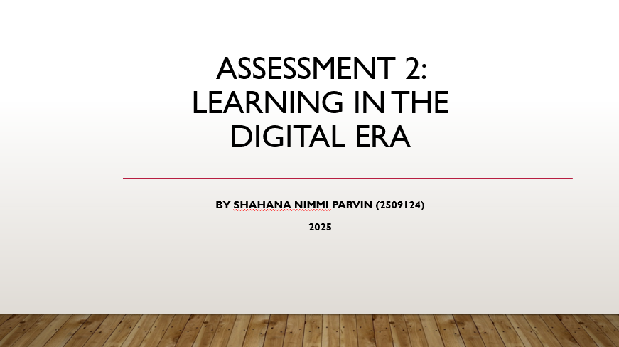

Slide 2: Contents
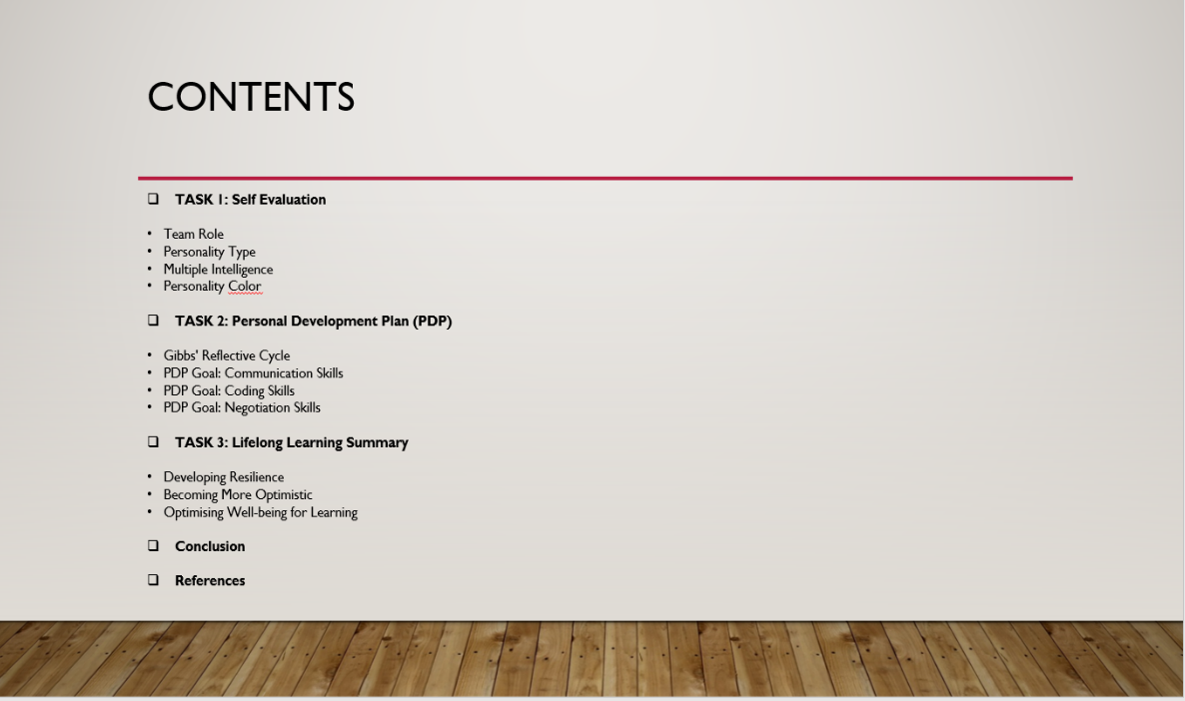

Slide 3 Introduction
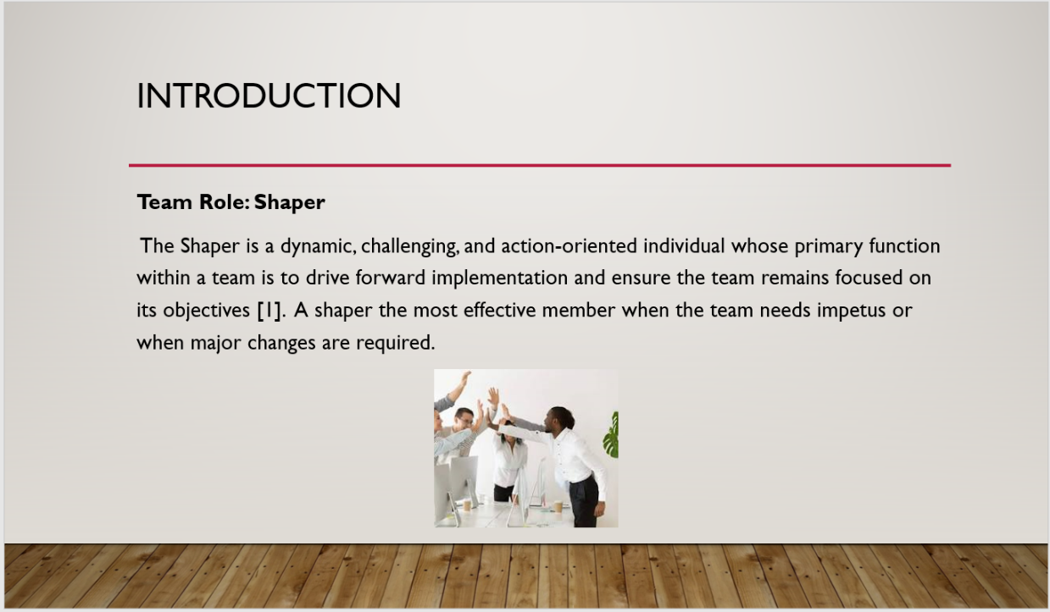

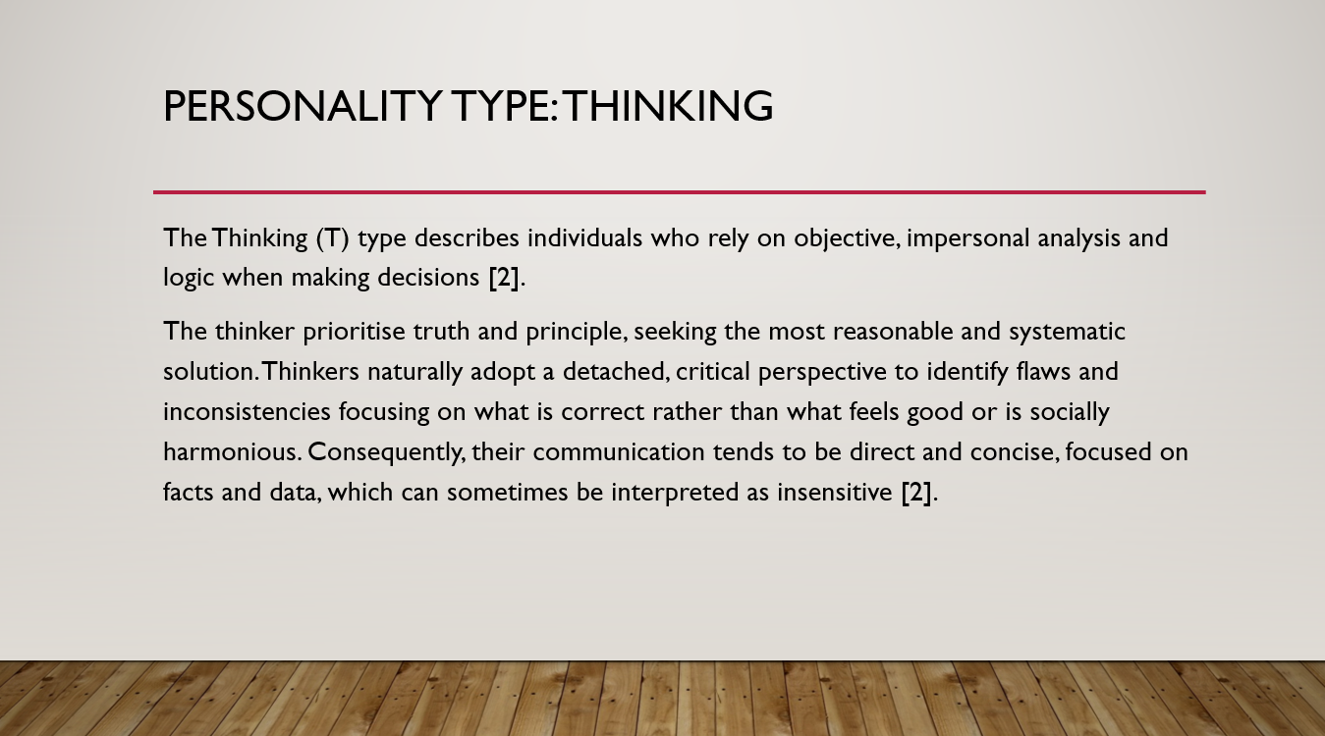
Slide 4: Personality Type

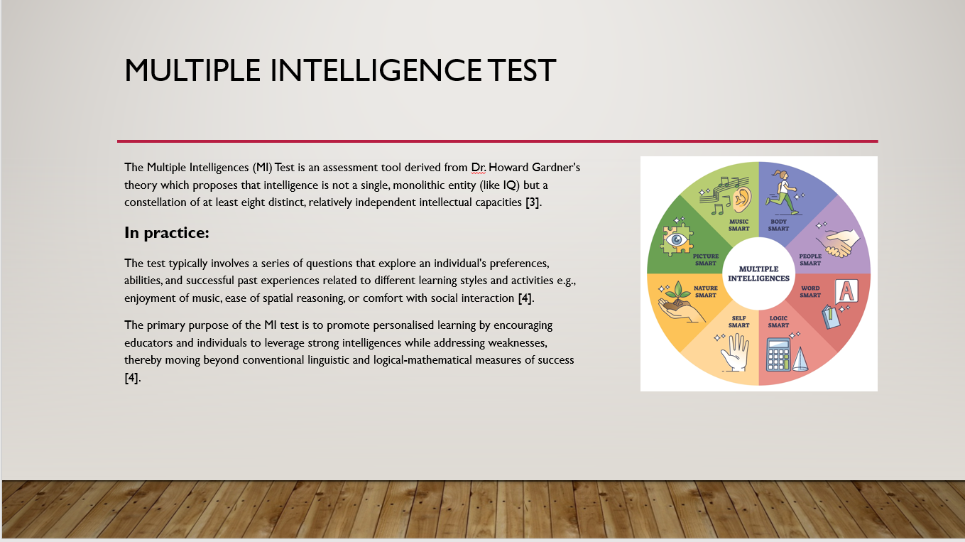
Slide 5: Multiple Intelligence Test

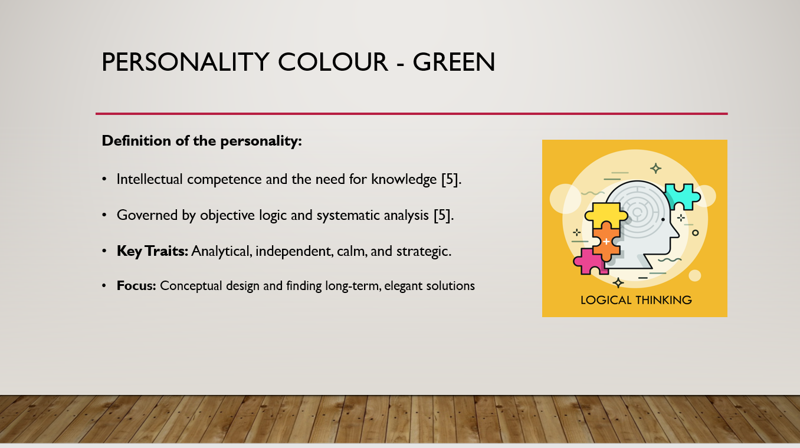
Slide 6: Personality Colour – Green

Slide 7: Self-Evaluation
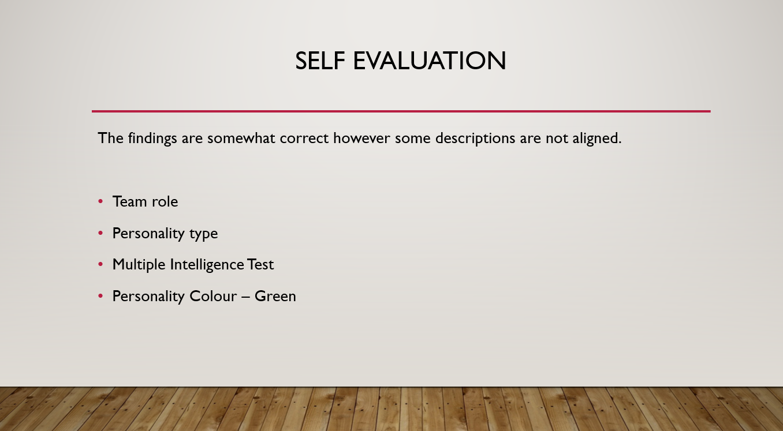

Based on my evaluation, I concluded that a key strength was decisive problem-solving as a shaper and a thinking personality type, my greatest strength is the ability to drive a team toward its objectives by making objective, logic-based decisions under pressure. My ‘green’ personality color further supports this through a focus on intellectual competence and systematic analysis to find long-term, elegant solutions.
In terms of weakness, I would say perception of insensitivity because my communication style tends to be direct, concise, and focused strictly on facts and data, it can sometimes be interpreted by others as insensitive or detached. This aligns with the thinking trait of prioritizing truth over social harmony, which may occasionally hinder team cohesion if not balanced with emotional intelligence.

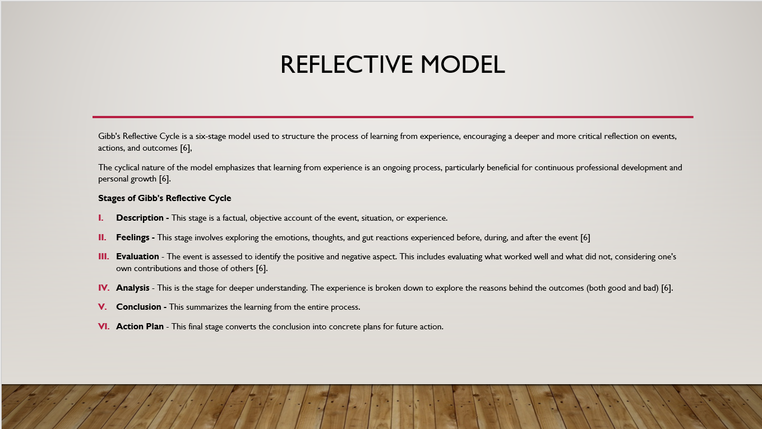
Slide 8: GIBB’s REFLECTIVE MODEL
Gibbs' Reflective Cycle is a six-stage framework designed to structure the learning process from experience, encouraging a deeper and more critical reflection on specific events and outcomes. The cyclical nature of this model emphasizes that learning from experience is an ongoing process, which is particularly beneficial for continuous professional development and personal growth. The stages involve:
- Description: Providing a factual account of the experience.
- Feelings: Exploring the emotional reactions during the event.
- Evaluation: Identifying what worked well and what did not.
- Analysis: Breaking down the experience to understand the reasons behind the outcomes.
- Conclusion: Summarizing the learning derived from the entire process.
- Action Plan: Creating concrete plans for future actions based on reflection.
Application in Assignment 2: I plan to apply this model by reflecting on the results of my self-evaluation assessments. Specifically, I will use the six stages to describe my reaction to being identified as a ‘Shaper’, evaluate how my ‘Thinking’ personality type influences my decision-making, and analyze how these traits impact my team interactions. Finally, I will use the Action Plan stage to refine the goals within my Personal Development Plan (PDP) to ensure I am ready for the digital era.

Slide 9: Professional Development Plan
The Personal Development Plan serves as a strategic roadmap to bridge the gap between my current capabilities and the skills required for success in the digital era. By utilizing the results of my self-evaluation, I have identified three core goals: Communication, Coding and Negotiation to enhance my professional profile.

Communication Skills: To refine my ‘Thinking’ personality trait by learning to deliver direct facts in a way that is more empathetic and less prone to being interpreted as insensitive.

Coding Skills: To leverage my ‘Green’ personality color's focus on intellectual competence and logical analysis to gain technical proficiency in digital tools.

Negotiation Skills: To utilize my ‘Shaper’ team role's drive for results while learning to find mutually beneficial solutions that maintain team harmony.

This plan outlines the specific resources needed to achieve these milestones and establishes a clear method for examining my progress through continuous reflection.
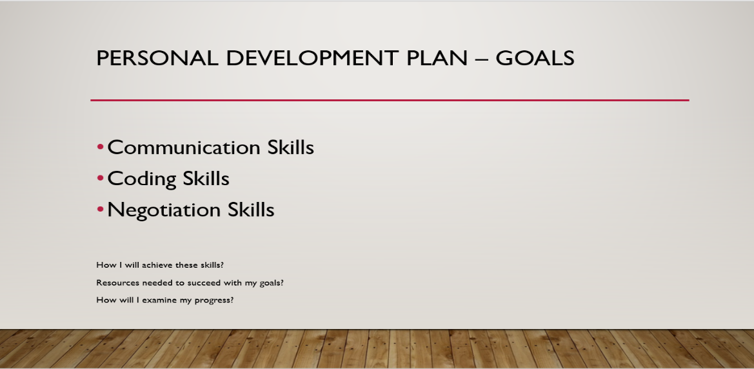

Slide 10: UNIT 4 TOPIC SUMMARY
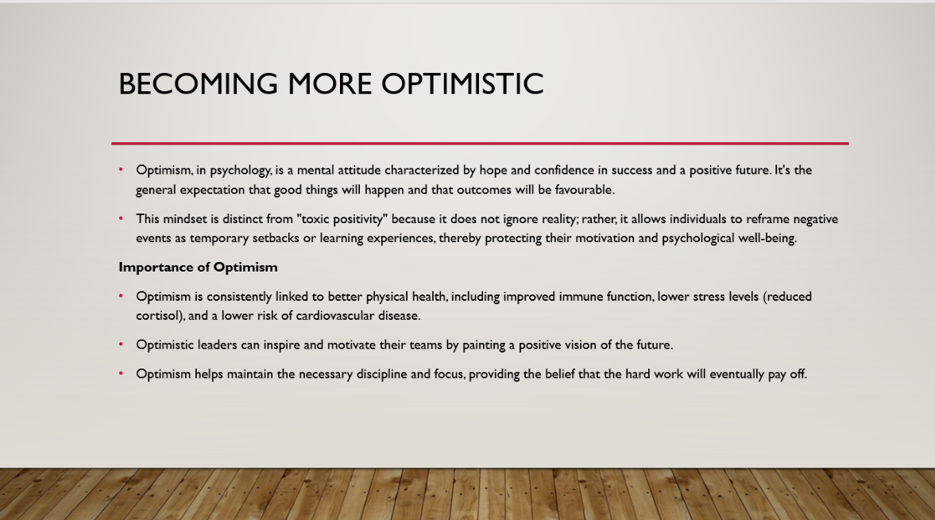
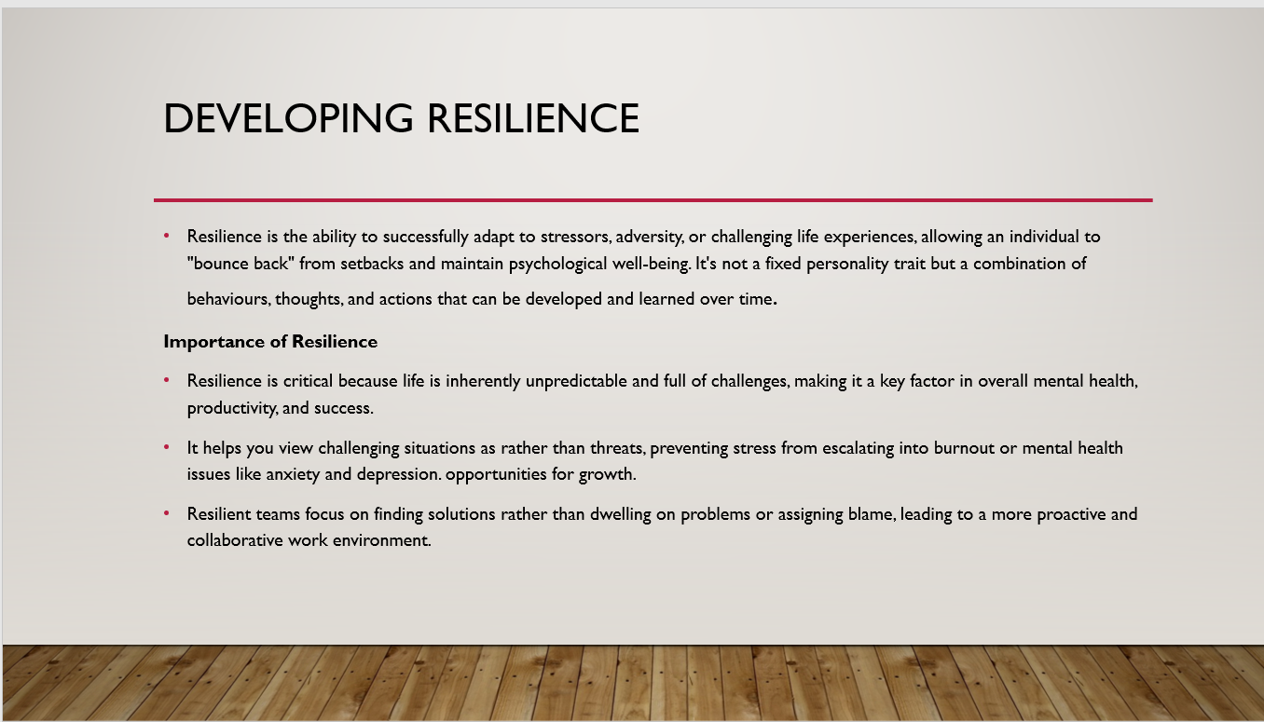

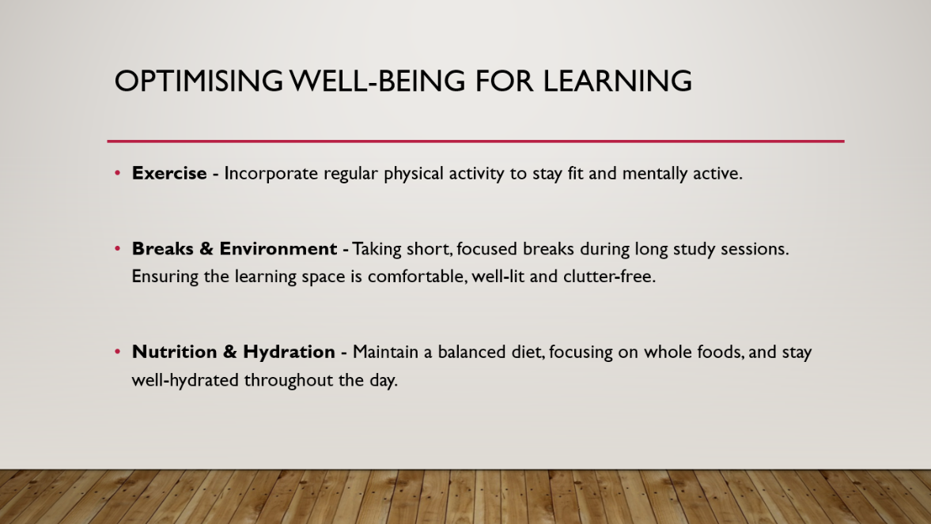

For this section, I will choose ‘Optimism’. It is defined as a mental attitude characterized by hope and confidence in achieving success and a positive future. Unlike ‘toxic positivity,’ a truly optimistic mindset involves reframing negative events as temporary setbacks or learning opportunities, which protects an individual's psychological well-being.
The Importance of Optimism:
- Physical and Mental Health: Optimism is consistently linked to better physical health, including lower stress levels and improved immune function.
- Leadership: Optimistic leaders inspire their teams by painting a positive vision of the future, helping to maintain motivation during challenges.
- Discipline: This mindset provides the necessary focus and belief that hard work will eventually pay off, ensuring long-term persistence.

Slide 10: Conclusion

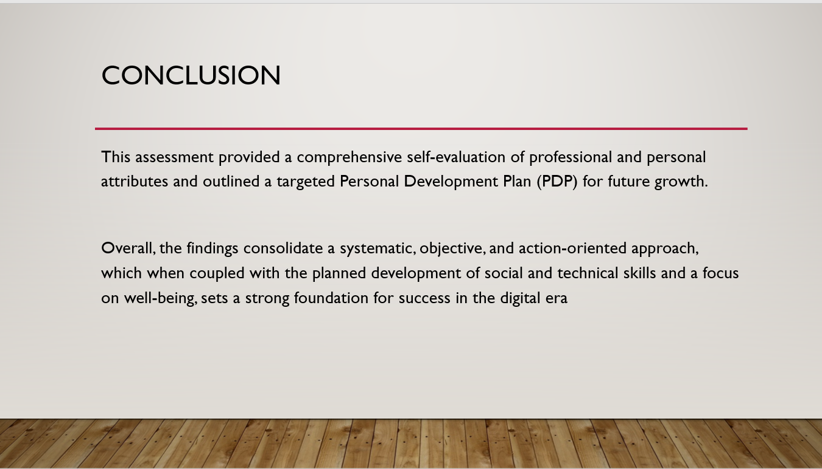

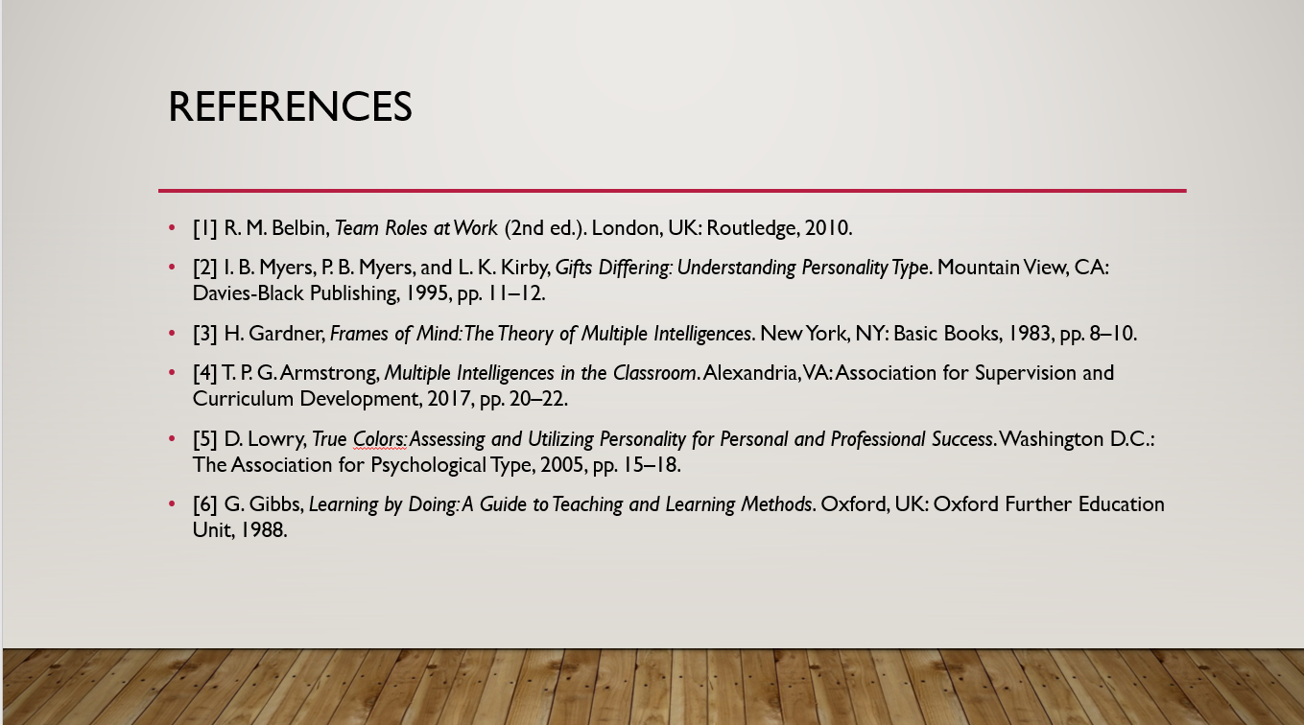
Slide 11: References

Conclusion
In summary, this report has provided a comprehensive self-evaluation of my professional and personal attributes as identified through various digital era assessment tools. By integrating the results of my shaper team role, thinking personality type, and green personality color, I have established a clear baseline of my current strengths and areas for development.
The Personal Development Plan and the application of Gibbs’ Reflective cycle ensure that my growth is systematic, objective, and action oriented. By focusing on the development of technical skills like coding alongside social competencies like negotiation and communication, I am positioning myself to be a resilient and optimistic professional. Ultimately, this reflective process sets a strong foundation for long-term success and well-being within the digital landscape.

References
[1] R. M. Belbin, Team Roles at Work (2nd ed.). London, UK: Routledge, 2010.
[2] I. B. Myers, P. B. Myers, and L. K. Kirby, Gifts Differing: Understanding Personality Type. Mountain View, CA: Davies-Black Publishing, 1995, pp. 11–12.
[3] H. Gardner, Frames of Mind: The Theory of Multiple Intelligences. New York, NY: Basic Books, 1983, pp. 8–10.
[4] T. P. G. Armstrong, Multiple Intelligences in the Classroom. Alexandria, VA: Association for Supervision and Curriculum Development, 2017, pp. 20–22.
[5] D. Lowry, True Colors: Assessing and Utilizing Personality for Personal and Professional Success. Washington D.C.: The Association for Psychological Type, 2005, pp. 15–18.
[6] G. Gibbs, Learning by Doing: A Guide to Teaching and Learning Methods. Oxford, UK: Oxford Further Education Unit, 1988.

