Synthesize a solution to a potential real life scenario

Internet Technology and Security

Author: Jessica Williams
Student Number: 1809781
Date: 10/01/2019

TABLE OF CONTENTS
1 Abstract 3
2 Introduction 4
2.1 Background 4
2.2 Assumptions 4
3 Related Work 6
4 Problem formulation 8
4.1 Types of data retained 8
4.2 Potential risks of data leakages 9
4.3 Use of different brands and operating systems 9
5 Implementation 10
6 Results, Findings and discussions 12
7 Conclusion, recommendations and future work 13
8 Abbreviations 14
9 References 15
10 Appendix 16
10.1 Appendix A- 16
10.2 Appendix B- 21
10.3 Appendix C- 25
10.4 Appendix D- 28

Abstract
This report is targeted for Hyper-fort. The document will describe what Bring Your Own Device (BYOD) and Bring Your Own Technology (BYOT) is. It states the assumptions made regarding the company. Related work will explore research conducted to describe some of the legal requirements and the use of Mobile Device Management (MDM) including the MobileIron application. A problem formulation has been created to evaluate some of the problems that the company may experience. The mitigation steps have also been included within the section. An implementation section will document the steps Hyper-fort are to enforce for a BYOT framework. The results section will summarise the findings throughout. The document will finish with a conclusion, recommendations and future work.

Introduction

Background

In recent years there has been an increase in demand for employees and visitors to bring their own devices and connect to company networks.
Within the workplace, BYOD is when an employee brings their own smart phones, iPad’s, laptops, USB sticks etc to the workplace. BYOT is the use of such devices within the workplace. The increasing demands and trend for using such devices has increased pressure on business owners to implement a BYOD/BYOT framework [1].
The scope of the document will outline the devices owned by the company or by the individual which require access to corporate networks, systems and data.
BYOT can aid in achieving business goals. As an estimate of Hyper-fort being 95% wireless the demands to move towards BYOD/BYOT will only continue to increase. However with the increased pressure and demands for companies to allow such access there is significant security risks involved. Setting out a comprehensive framework will require all aspects of the company’s enterprise network.
As a consultancy firm with a global presence a flexible approach of allowing employees to work the way they want with what technology they want at any time and place will be promoted through the use of BYOT.
Some of the advantages to BYOT are [2]:
- Users have personal choice of what device they use for work purposes.
- It is believed to improve employee productivity.
- Can decrease the amount of equipment required for the company to purchase.
- Allow users to work remotely whenever or wherever they may be.

Assumptions

During the creation of this document the following assumptions have been made:
- It is a large company that uses cloud services to deliver IT services to staff and clients.
- Around 95% of the company is wireless.
- Hyper-fort has a large online presence.
- An enterprise network is already set up for employees to use.
- There are Wi-Fi hotspots around the building.
- Hyper-fort has a specialised I.T support department.
- Sufficient funds and resource are available for a BYOT framework to be implemented.
- The company holds personal data for employees and clients.
- The users connecting to a MDM will be employees and administrative staff.
- Clients only require access to Wi-Fi points to access the internet.
- All devices using BYOT are iOS, Android or Windows operating systems only.

Related Work
A crucial part of BYOD is the awareness of what devices are logged onto your network and monitoring the information available to the user. Assigning access rights to the user, device and connection will promote company control of their network.
Authorisation, Authentication and Accounting is a framework for controlling access to computer resources, auditing and enforcing policies [3].
Authentication is the identification of the user. Setting up user authentication will allow and deny users access to the network.
Authorisation is the permissions granted to the user to conduct certain tasks. This can be set up for senior managers, employees and clients. Specific authentication processes will link the permissions granted to users for their authorisation level.
Accounting monitors the system time, data sent and received by the user and can be beneficial with the analysis of the policy. Capacity issues can also be targeted within the accounting as the server can identify trends and demands [3].

The amount of access and support granted to users can be determined with the business aims and objectives. A survey identified in “MANAGEMENT ISSUES FOR BRING YOUR OWN DEVICE” communicates 95% of companies allow employees to use their own devices where 36% offer full support and 48% support selected devices [4]. The company will be responsible for the application and connection to MobileIron not the whole phone. MobileIron is exampled below.

There are many legal requirements the company will have to consider when implementing a BYOT framework.

The compliance of licensing requirements of the devices will need to be clarified. Consideration around whether the licences are funded by the organisation or individual will need to be identified [5]. The arguments for licencing being funded by the individual is the increased user demands to use their own devices. If they choose to use their devices they should have the responsibility of ensuring the device is compliant. The argument against this approach is that the users are connecting to the businesses enterprise network. The network holds sensitive and personal data and if it’s not managed correctly can lead to severe consequences e.g. malware attacks, personal data being leaked, reputation etc. As identified within appendix B, compliancy software will be the responsibility of the company.

It is a General Data Protection Regulation (GDPR) requirement that data controls are in place for technical and organisational measures against unauthorised and unlawful processing of personal data [6]. The awareness of the user responsibilities should be agreed before connecting to the company network. A number of policies have been created to ensure device security, management and loss is covered. Please see appendix for security policies.

Restrictions can be applied to what data users can access. For instance, clients only have access to the company Wi-Fi. Employees and administrative staff can have different policies which limit the amount of access they received. Procedures can also be put in place to manage the control access and in some cases specific data may never be appropriately accessed through BYOT.

There are many tools out there such as MDM which can help manage such concerns. MDM can help companies deploy, secure, monitor and integrate BYOT into their workplace. It allows enterprises to efficiently manage mobile devices wirelessly without interpreting users [7].
Some of the advantages for MDM is listed below:
- Security Management – if a device is stolen or missing data can be remotely removed and cleaned from the company or personal device [7].
- Policy Management- sets out regulations such as password protection, automatic screen locks, and inability to screenshot or take photos to protect the company data [7].
- Software Distribution- standardised applications can be installed on devices without having to do every mobile device individually [7].
- Inventory Management- reporting and tracking of data on how users are interacting with applications and data [7].

Although there are many advantages to MDM there are also some disadvantages:
- User Acceptance- MDM may discourage users from using their own technology as they may have concerns with the company accessing their personal devices [8].
- Collaboration- IT department may experience user frustration from the requirements associated with MDM. These divides could lead to future IT problems [8].
- Resource- MDM increases the development, support and distribution costs to the company [8].

MDM allows companies to implement BYOT policies to improve employee productivity and enhance customer experiences along with securing their data [8]. Ensuring the right policies are in place before users are able to access the company enterprise network will mitigate some of the disadvantages.

MobileIron is the chosen solution for MDM. It governs access to resources such as email, calendar and other central applications. Configuration of mobile devices can also be utilised to ensure the user has the correct access rights [9]. It provides automated device setup, documents editing tools and provides visual privacy policy guidelines [10].

As Hyper-fort uses cloud services additional security measures are required to protect business data. MobileIron has the ability to verify users with multi-factor authentication steps and applies risk-based policies which match the user’s environments. Reinforcing such security measures will have to be user friendly. According to MobileIron, users are able to use a one-touch enrolment and have functions such as password-less sign on from secure endpoints [11]

MobileIron is recorded to be the choice for 17,000 businesses [11]. The package for MobileIron can vary from businesses size and requirements. As made in the assumptions earlier, Hyper-fort has the funding for MobileIron. Users are able to download the application free from their app store. The company can purchase e.g. 200 licences for MobileIron which will be up to managers to who the licences are granted to. If employees leave the company the licence is revoked and available for another user.

Clients will not have access to MobileIron and will only have access to public resources.

Problem formulation
The decision to incorporate BYOT is not straight forward. There are many advantages, disadvantages and legal requirements when it comes to such frameworks.

As described on BCS [12] research has been conducted by Fortinet which found among 3,200 people ages 21 to 31 across 20 countries that 51% said they would ignore policies banning use of their own devices at work. This finding re-iterated the increasing demands that many organisations including Hyper-fort are facing for users to BYOT.

The finding identified above is one problem, it backs up the argument of distrust from companies and IT departments towards users of their network. Another challenge the company may experience is the personal use of the device within the working environment.
Users of the company network should follow the policies provided to ensure security is not breeched. Setting out clear policies to follow and ensuring the correct steps in protecting the company is protected will reduce these trust issues and limit the amount of personal use on the device.

The following section will assess and evaluate some of the legal requirements alongside the advantages and disadvantages a BYOT framework can have to the company, network and wider economy. Three potential problems are examined below.

Types of data retained
When connecting the user device through the company network the user will be required to access data. Allowing certain data to be retrained on the user’s device has potential security risks for data leaks. Cached data such as documents and emails can be accessed by the user without being on the network. Allowing for offline resources. Screenshots of data and copy and paste functions can be enabled and disabled in MDM according to the user profiles. Disabling these features will limit the company treats to internal and external attacks as the employee will not be able to store the data on their devices.

Connecting through a MDM such as MobileIron will allow the user to cache information such as user details which include passwords, downloaded data and access to systems. This data can be retained and when connecting to the company Wi-Fi will automatically connect the user dependant on their security setting installed through MobileIron.

Storing such data can pose threats. Out of date information may be stored for the user which could deny access to applications and data. The impact could be reflected on more demand for the IT department to deal with. Due to the nature of BYOT personal and business devices may be used, the amount of storage on the device may be a limitation to retaining data. Employees will be responsible for the maintenance and specification of their personal devices, however these factors may not hit the requirement for a BYOD.

Clients connecting to Wi-Fi hotspots could have their log in credentials saved once connected to the network. When they are out of range the connection will not be available. A capped availability of 30 minutes can be put in place for internet use while in range.

General security concerns are associated to retraining data such as loss of device, compliance of device and the availability of information. Please see Lost Device and Employee Leaver Policy for more information (appendix C).

Setting out clear MDM policies and ensuring clients and employees accept the regulations before connecting to the network will improve security measures. The availability for IT departments to report on the authorisation, authentication and accounting aspects of the framework can allow risk assessments and reviews to be conducted in regards to retraining data.

Potential risks of data leakages
Some of the potential risks of data leaks are unauthorised access to confidential data, breaches of GDPR, negative impact of company reputation and loss of data.

It is said that over 2,124 reports have been raised against human error compared to 292 being deliberate cyber incidents. Allowing users to access data more accessibly can contribute to the potential risks of data leakages [13].
To control the impact that human error may have for data leakages, regular training and awareness of policies and expectations held within the GDPR will educate staff and clients of the individual expectations they are agreeing to.

Clients connecting to the network may not be aware of their responsibilities towards the company. They pose a threat to leaking personal data due to their lack of awareness. To overcome this, clients can be notified of the policies when choosing to accept the connection to the company Wi-Fi. The security parameters will allow the client to access websites such as social media and company promotional sites. Restricted groups will limit the company’s personal data available to the client and can only allow access to the public data.

Use of different brands and operating systems
Following a survey on YouGov, the top twenty Mobile phones are all Android/iOS devices [14]. This demonstrates that there are multiple devices available to the public, although they may be different models of devices the most common run Android or iOS software. With that being said there are multiple versions of these operating systems and other devices may use systems such as Windows.

This is a consideration when choosing an MDM. MobileIron is compatible with a minimum requirement of Android 5, iOS 10 and Windows 8. All users of the software must ensure their device meets the minimum requirements to use MobileIron. This sets a standard for the organisation for compliancy throughout. Also this prevents potential ransomware attacks as devices will have the latest security updates. Please see Ransomware report (appendix D) for further information on the impact and backup strategy.

Please refer to policies in the appendix for more information regarding Mobile Security, Mobile Device and Lost Mobiles.

These policies highlight the brands and operating systems which are going to be utilised for BYOT.

Implementation

The steps set out in policies (appendix A, B, C) identify the scope, requirements and procedure to follow when connecting to a MDM.

Given the nature of the employees being a consultancy firm with presence throughout the world the scope of access may be greater than anticipated. One way of sizing the accessibility is communication to the mail environment. This can detect all devices which are connected to your corporate network [15].

The scope of clients accessing the company’s network will also need to be considered. When setting up a BYOD procedure access can be restricted to a certain amount of users when trying to access the companies Wi-Fi.

The identification and scope of users required to connect to a BYOD program will allow the use of the most suitable technology. In the first instance the company may not be able to determine the entire scope. Scaling can monitor the enrolment however a review of the scale can be conducted when the policy is being rolled out. A staged approach to allowing access to such network can also be set up.

Setting up a MDM such as MobileIron can implement the restrictions a user will be able to access.
The below diagram illustrates the proposed architecture.

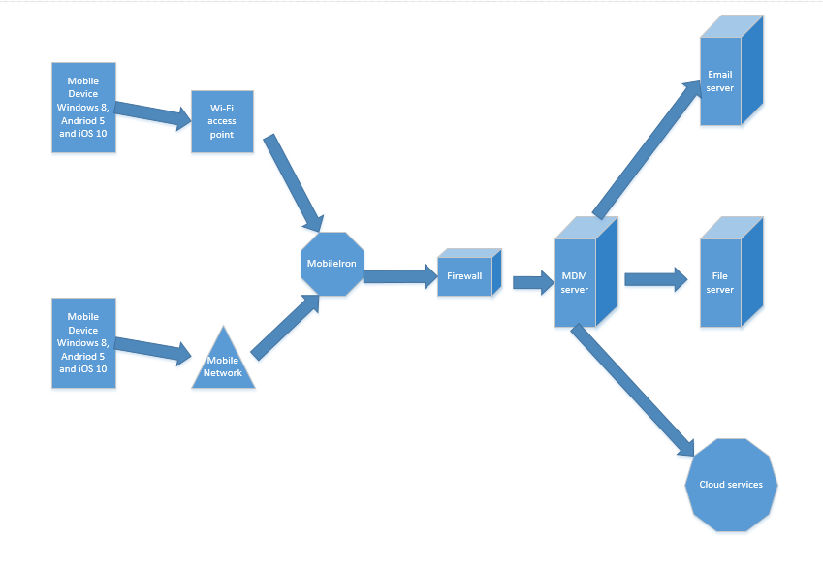
A user’s mobile device will connect to the Wi-Fi or their mobile network once connected they will open up MobileIron and log in with their user credentials. Authentication will pass through the firewall to the MDM server. The MDM server will check the compliance and authentication to allow the user access to their appropriate files. In this example- email, files and cloud services.

The use of Packet Tracer has been used to demonstrate how BYOT will be implemented to the enterprises network.

The company network consists of a router which is secured by a firewall. It has three tiers where the multilayer switch 0 is connected to tier two- multilayer switch 1, 2 and 3. These multi switches connect to switches 1, 2 and 3 of tier three. PC’s will connect to tier three. To incorporate BYOT an access point has been added where the user will connect to access point 0 via their smartphones. Security has been enabled on all of the switches and router. In the Packet Tracer the User Access Verification password is: cisco and the second layer of password will enable admin users to configure the switch, the password is: class.

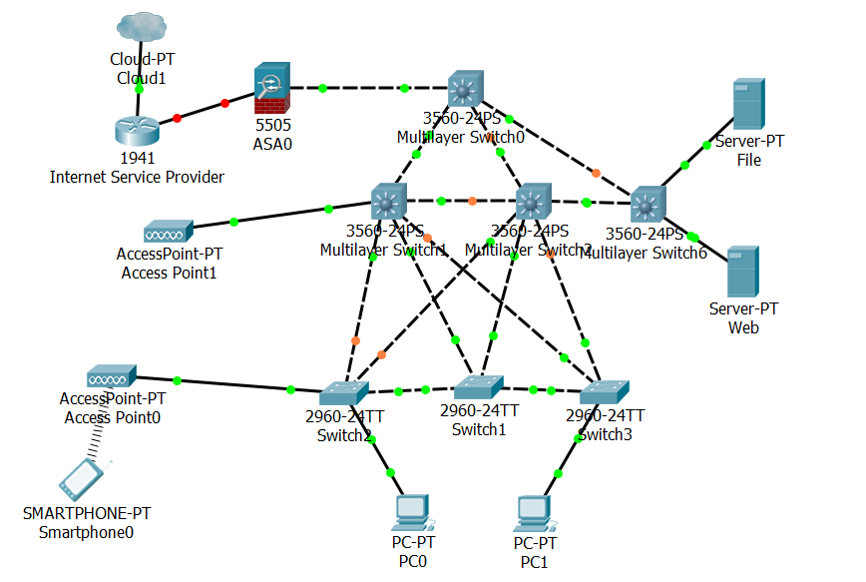

Results, Findings and discussions
From the results, it is appropriate to advise that Hyper-fort can benefit from implementing a BYOT framework. BYOT will promote growth for the nature of the business as global presence will make it easier for employees and clients to access data.

The findings are based on the assumptions made regarding the company.

The advantages have been identified for BYOT within section 2. There are also disadvantages that may be considered [2]:

- Increased support costs to the company- diminished due to the decrease in equipment costs.
- Loss, theft and damage of device- Lost policy is put in place to follow.
- Security breaches to company network- Security policy, Device Policy and Lost Policy ensures no security breaches are experienced.

Implementation of the policies, user training and an MDM system in place will promote security when connecting to the company’s enterprise network.

There are many arguments for and against the use of BYOT however ensuring a framework is in place and is managed by the company then the demands experienced can be accepted within a controlled process.

Conclusion, recommendations and future work
To conclude, the research taken around a BYOT framework has identified many areas of concern with legal implications if unfulfilled. However the advantages have outweighed these concerns as mitigation steps can be taken by Hyper-fort, employees and clients.

It is recommended that all policies (appendix A, B, C) identified are implemented. Ensuring an MDM system is in place for its employees such as MobileIron will protect the company’s enterprise network.

It is also recommended that the scope of users accessing the company’s network is also monitored. Create restrictions for clients connecting to the company Wi-Fi and allowing certain amount of users to access MobileIron within the rollout.

Once rolled out review the scope, requirements and compliancy BYOT and MDM is having. Use the reporting tools available through MobileIron to access these aspects.

A BYOT framework will always require future work depending on the stage the company is at. Hyper-fort should implement the policies, select a MDM and roll out their framework. Once role out is taking place a review is to be conducted to ensure the right steps are being taken to mitigate any concerns, legal requirements and impact it’s having on the company, its employees and clients.

Abbreviations
Term | Definition
BYOT | Bring Your Own Technology
BYOD | Bring Your Own Device
GDPR | General Data Protection Regulation
MDM | Mobile Device Management

References

[1] | I. Wigmore, “BYOD (bring your own device),” October 2012. [Online]. Available: https://whatis.techtarget.com/definition/BYOD-bring-your-own-device. [Accessed 3 December 2018].
[2] | P. Adams, “The advantages and disadvantages of BYOD,” Field Service News , [Online]. Available: http://fieldservicenews.com/advantages-disadvantages-byod/. [Accessed 06 January 2019].
[3] | M. Rouse, “Search Security,” authentication, authorization, and accounting (AAA), [Online]. Available: https://searchsecurity.techtarget.com/definition/authentication-authorization-and-accounting. [Accessed 3 December 2018].
[4] | J. R. R.-. M. A. Martin Brodin, “MANAGEMENT ISSUES FOR BRING YOUR OWN DEVICE,” Research Gate , June 2015. [Online]. Available: https://www.researchgate.net/publication/277007698_Management_issues_for_Bring_Your_Own_Device_BYOD/download. [Accessed 3 December 2018].
[5] | “Bring Your Own Devices (BYOD) Information Governance Guidance,” 4 November 2015. [Online]. Available: https://www.igt.hscic.gov.uk/Resources/BYOD.pdf. [Accessed 05 January 2019].
[6] | I. Cooley, “GDPR – bring your own device (BYOD),” AAT Comment , 19 Feb 2018. [Online]. Available: https://www.aatcomment.org.uk/gdpr-bring-your-own-device-byod/. [Accessed 05 January 2019].
[7] | “What is Mobile Device Management (MDM) ?,” ASUS, 22 August 2016. [Online]. Available: https://www.asus.com/support/FAQ/1018796. [Accessed 05 January 2019].
[8] | M. Resnick, “Weighing pros and cons of mobile application management,” Tech Target, [Online]. Available: https://searchmobilecomputing.techtarget.com/tip/Weighing-pros-and-cons-of-mobile-application-management. [Accessed 05 January 2019].
[9] | W. C. Medicine, “What is MobileIron?,” Weill Cornell Medicine, [Online]. Available: https://its.weill.cornell.edu/faq/what-is-mobileiron. [Accessed 05 January 2019].
[10] | F. Online, “20 Best Mobile Device Management Software in 2019,” Finances Online , 14 December 2018. [Online]. Available: https://financesonline.com/mobile-device-management/. [Accessed 06 January 2019].
[11] | MobileIron, “Cloud security needs a new approach,” MobileIron, [Online]. Available: https://www.mobileiron.com/en/cloud-security-overview-2fa. [Accessed 05 January 2019].
[12] | B. T. C. I. f. IT, “BYOD,CYOD,BYOT,BYOA and more,” BCS, June 2014. [Online]. Available: https://www.bcs.org/content/conWebDoc/52926. [Accessed 03 January 2019].
[13] | E. Targett, “Revealed: Human Error, Not Hackers, to Blame for Vast Majority of Data Breaches,” Computure Business Review, 03 September 2018. [Online]. Available: https://www.cbronline.com/news/kroll-foi-ico. [Accessed 05 January 2019].
[14] | YouGov, “The most popular phone models in the UK,” YouGov, [Online]. Available: https://yougov.co.uk/topics/utilities/survey-results(popup:ratings/retail/phone-models/all). [Accessed 06 January 2019].
[15] | I. Security, “Ten rules for bring your own device (BYOD),” January 2018. [Online]. Available: https://www-01.ibm.com/common/ssi/cgi-bin/ssialias?htmlfid=WGW03341USEN&. [Accessed 03 January 2019].

Appendix
Please note- the documents have been copy and pasted in. The formatting may not be the same as the table of contents.

Appendix A-

Mobile Device Policy

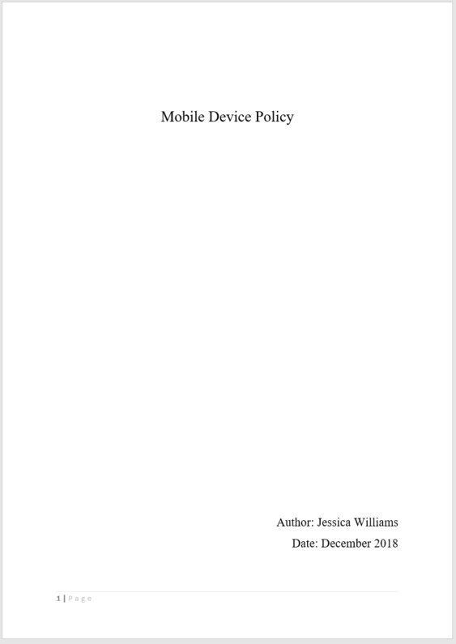

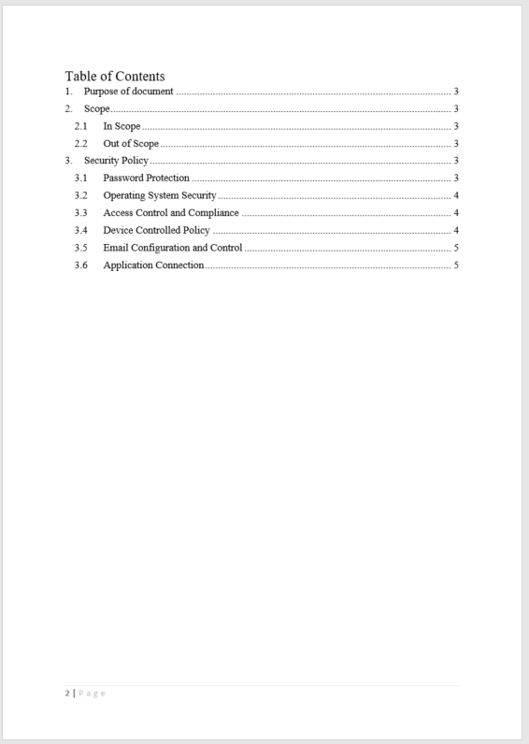

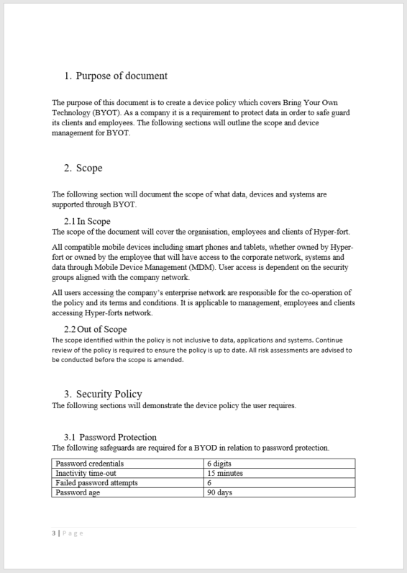

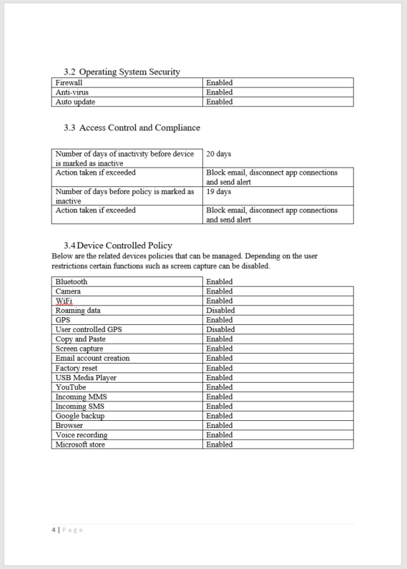

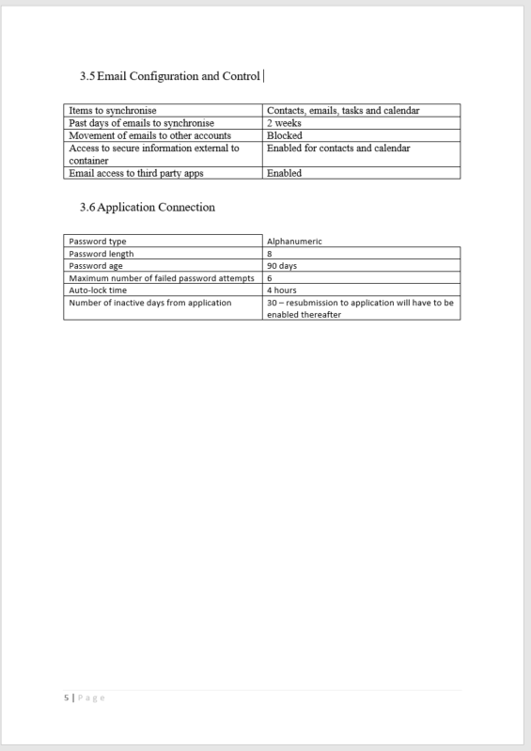

Appendix B-

Mobile Device Security Policy

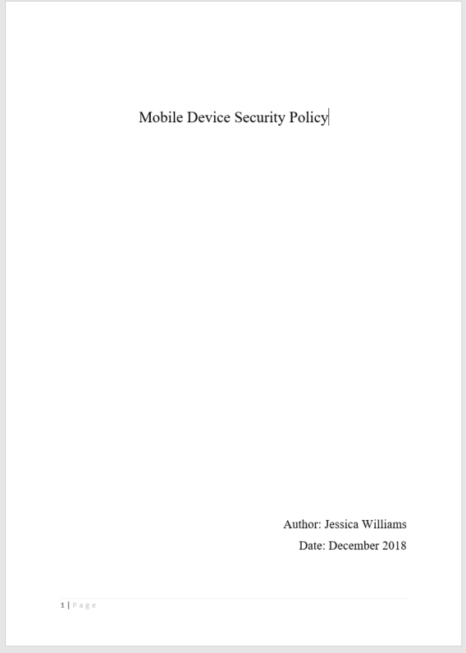

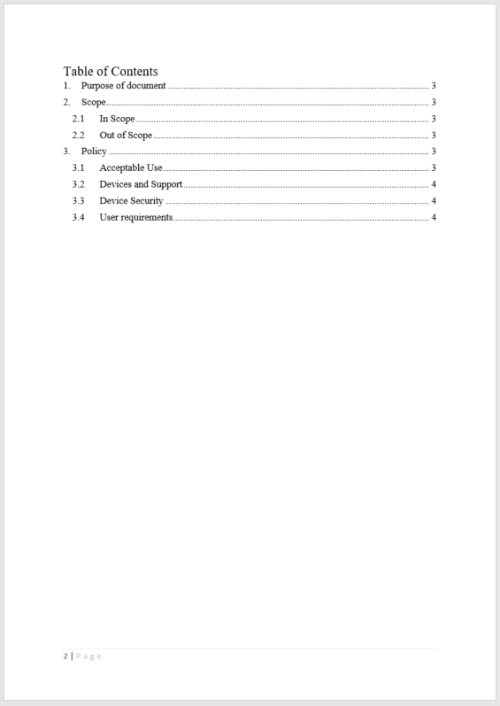

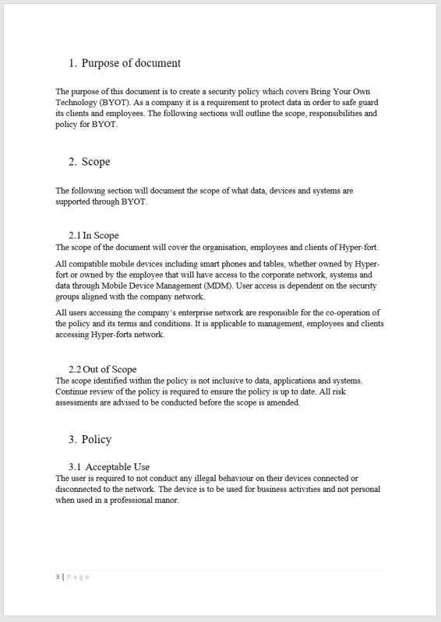

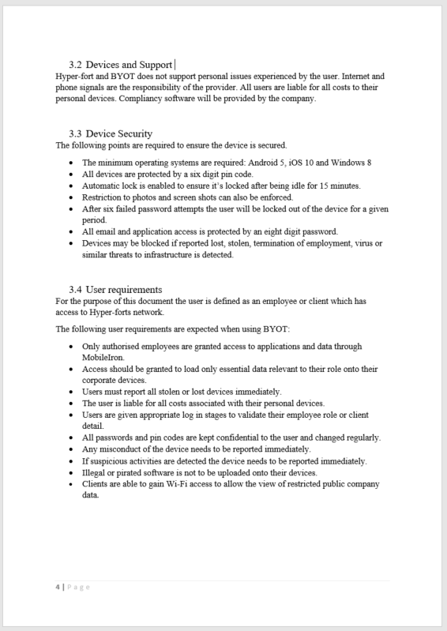

Appendix C-

Lost Device and Employee Leaver Policy

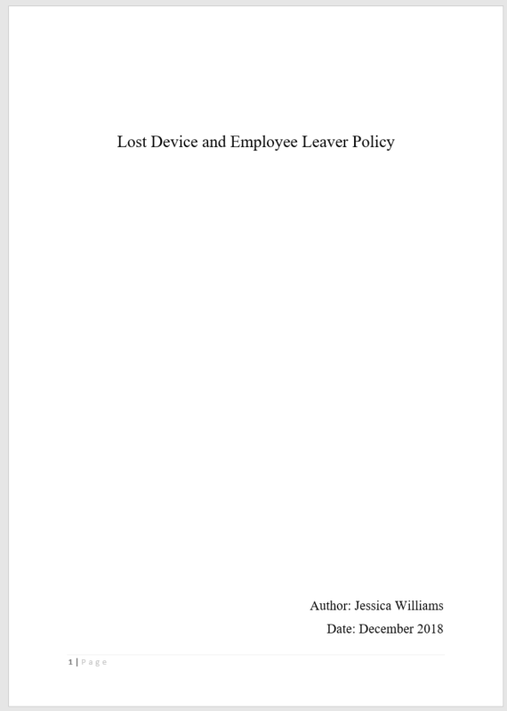


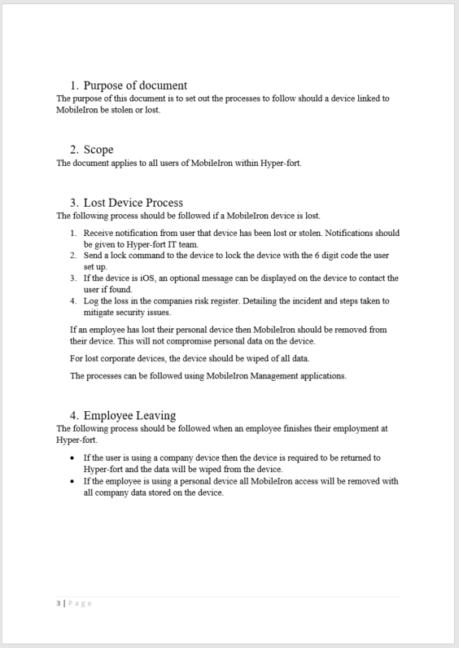

Appendix D-

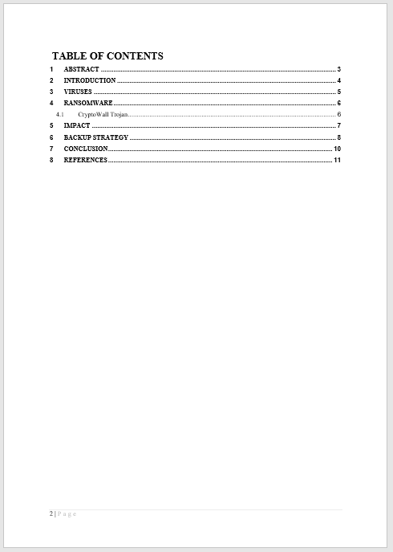





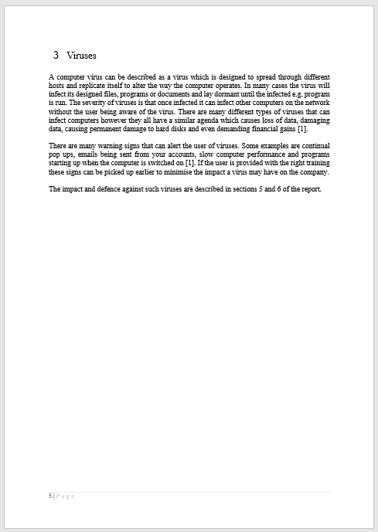

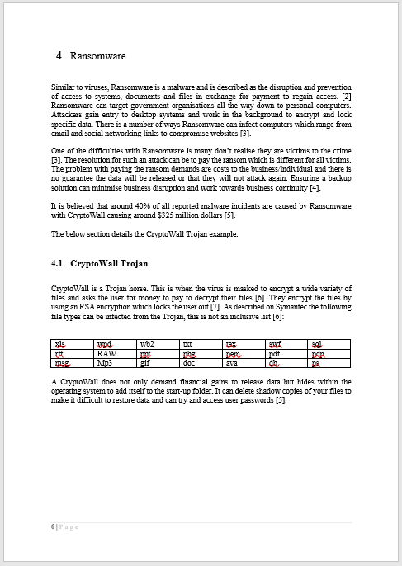

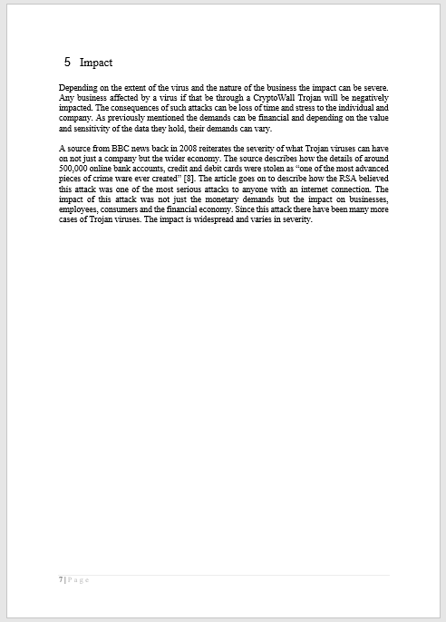

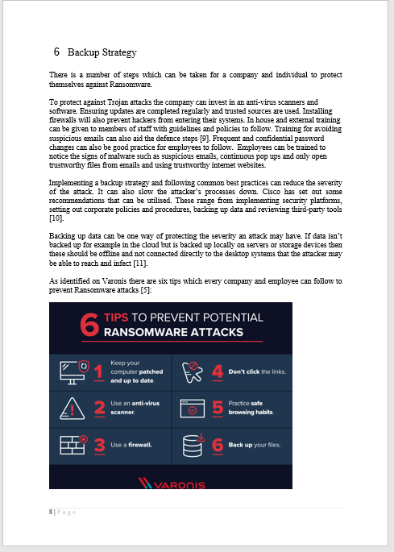

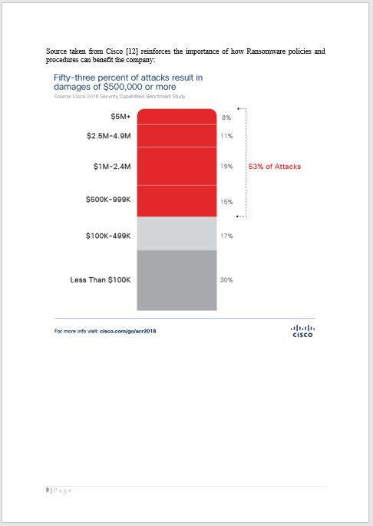

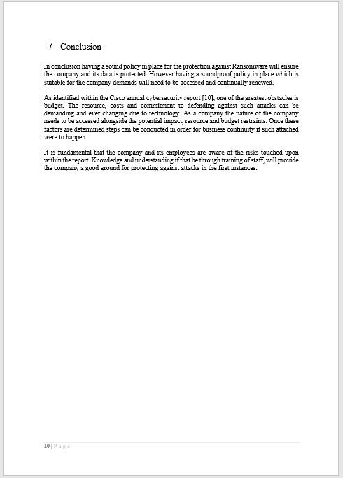

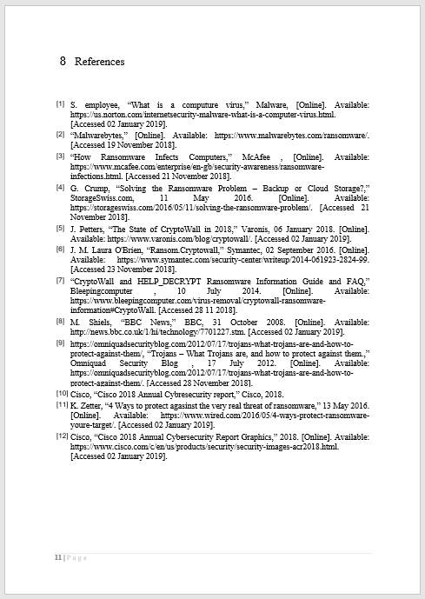

marking criteria and Student FEEDBACK

This section details the assessment criteria. The extent to which these are demonstrated by you determines your mark. The marks available for each criterion are shown. Lecturers will use the space provided to comment on the achievement of the task(s), including those areas in which you have performed well and areas that would benefit from development/improvement.

Common Assessment Criteria Applied (Assignment 1) | Marks available | Marks  awarded
1. Research-informed Literature
Extent of research and/or own reading, selection of credible sources, application of appropriate referencing conventions.
Very good literature offered on various areas such as BYOD, MDM solutions, legal concerns while implementing a BYOT solution. (Grade mark: 86.67%) | 15 | 13
2. Knowledge and Understanding of Subject
Extent of knowledge and understanding of concepts and underlying principles associated with the discipline.
The report demonstrates a very good level of knowledge and Understanding of the subject area. (Grade mark: 86.67%) | 15 | 13
3. Analysis
Analysis, evaluation and synthesis; logic, argument and judgement; analytical reflection; organisation of ideas and evidence
Good overall analysis of most aspects. However it would have been nice to do a quick comparison in order to justify your choice of MobileIron as the solution. (Grade mark: 80.00%) | 40 | 32
4. Practical Application and Deployment
Deployment of methods, materials, tools and techniques; application of concepts; formulation of innovative and creative solutions to solve problems.
Hierarchical desing is demonstrated with a good level of security configurations. More redundancy could be implemented at the network edge, and although APs are included in the design, the WLAN controlers are absent and the discussed solution is not seen in the PT submission. (Grade mark: 75.00%) | 20 | 15
5. Skills for Professional Practice
Attributes in professional practice: individual and collaborative working; deployment of appropriate media; presentation and organisation.
The report is well organised and written well. There are possible improvements and some minor restructuring that can be made, in particular at the begining of the paper. (Grade mark: 70.00%) | 10 | 7

Assignment Mark (Assessment marks are subject to ratification at the Exam Board. These comments and marks are to give feedback on module work and are for guidance only until they are confirmed. ) | Late Submission Penalties (tick if appropriate) |  | 80%
 | Up to four weeks late |  | 80%
 | First Attempt? |  | 80%

