

MSC PUBLIC HEALTH AND SOCIAL CARE IN PRACTICE

QUALITY ASSURANCE AND SERVICE IMPROVEMENTS
LCHS7006

Component 2: Service Improvement Report

STRENGTHENING PATIENT SAFETY THROUGH QUALITY IMPROVEMENT: LUCY LETBY CASE AT COUNTESS OF CHESTER HOSPITAL

Lecturer Name:Dilhara Mampitiya

Student Name:Noman Vajoddin Malek

Student ID:2522651

Executive Summary

This report gives a critical analysis of how poorly the governance of the Countess of Chester Hospital was in the Lucy Letby case and how these failings impact on patient safety in the National Health Service (NHS). The analysis points to a lack of leadership and clinical governance, communication and whistle blowing systems and organisational learning that were identified as a problem time and time again but the intervention was not timely enough to make a difference. Root causes have been investigated using the Fishbone Diagram, 5 Whys Analysis and Donabedian Model, and these factors indicate that patient harm was successional organisational failure and not isolated clinical events.
A SWOT and PESTLE analysis is also used to look at the internal and external threats to good governance and the improvement of the quality of its services. The report suggests a number of measures to improve clinical governance, to develop a culture of real-time patient safety surveillance, to enhance the learning capability of the workforce and to ensure continuous patient safety performance monitoring. The Plan-Do-Study-Act (PDSA) implementation strategy is recommended as assisting especially with respect to sustainable organisational change. Taken together, these evidence-based recommendations will help to boost governance, patient safety, increase organisational accountability and rebuild trust in NHS health services.

Abbreviations

KPIs: Key performance indicators
NHS: National Health Service
PDSA: Plan-Do-Study-Act
PESTLE: Political, Economic, Social, Technological, Legal, and Environmental
SWOT: Strengths, Weaknesses, Opportunities, and Threats

Table of Contents

1. Introduction 5
1.1 Background 5
1.2 Problem Statement 5
1.3 Aim 5
1.4 Objectives 6
2. Analysis of the Quality Issue 6
2.1 Nature of the Quality Issue 6
2.2 Governance and Organisational Failures 6
2.3 Impact on Healthcare Quality 7
3. Root Cause Analysis 7
3.1 Fishbone Diagram 7
3.2 5 Whys Analysis 8
3.3 Donabedian Model 9
3.4 Critical Evaluation 9
4. Strategic Analysis 10
4.1 SWOT Analysis 10
4.2 PESTLE Analysis 11
5. Evidence-Based Service Improvement Recommendations 12
5.1 Strengthening clinical governance 12
5.2 Real-Time patient safety surveillance 12
5.3 Strengthening the culture of speaking-up 12
5.4 Improving capability of the workforce 13
5.5 Continuous Monitoring 13
5.6 Implementation Strategy 13
6. Conclusion 14
References 15

1. Introduction

1.1 Background
Good Governance, clinical accountability and an organisation culture of learning are essential for delivering safe, quality, patient-centred health care. Clear lines of reporting, robust risk governance frameworks, and effective governance are essential in understanding the context of patient safety events and avoiding avoidable harm in healthcare organisations. Good systems in organisations are, therefore, needed for identifying risks early and facilitating communication-ready interactions so that they can effectively respond. The role of quality improvement is doubly strategic within the context of the National Health Service (NHS), with a key focus on improving governance, patient outcomes and encouraging openness, accountability and continuous improvement (Shepard, 2025). As understood in component 1, Lucy Letby is one of the largest patient safety disasters to hit the NHS. Between June 2015 and June 2016, there was more than one unexplained neonatal death and sudden collapse within the neonatal unit, although concerns raised by consultants were not followed swiftly with organization change.
The inquiry that followed cast doubts on the murder of seven babies and attempted deaths of seven more, and revealed the epidemic of governance deficiencies, safeguarding, leadership, communication and the culture of the organisation (Youtube, 2025). It also involved the impact of governance's failure to detect these common warning signs, which resulted from a lack of timely protective actions, poor organisation learning and a decrease in patient safety. This incident has led to much discussion on clinical governance, whistleblowing and leadership accountability in patient safety culture within NHS organisations. It has helped to increase awareness of the importance of anticipating, multi-disciplinary, evidence-informed risk minimisation and decision-making in order to avoid harm in a complex health service. Lessons learned from the case are applicable and can be transferred beyond the organisation, providing useful information around how the healthcare system can be even more resilient in the area of Governance and Quality Assurance. This report reveals, within frameworks and tools recognised throughout the field as evidence of a quality, failings in organisational structures within the context of the Lucy Letby case.

1.2 Problem Statement
The most prominent quality issue was a lack of vigilant identification of rising patient safety concerns and timely action despite repeated warnings. Poor governance, communication issues, failure to escalate and minimising organisational learning were all issues which meant that avoidable harm continued, leading to poor safeguarding of vulnerable neonatal patients.

1.3 Aim
This report has critically examined the failings in the establishment of quality care in the Lucy Letby case by using theories of quality within service provision. It also considered a strategic approach to service improvement, and concluded with suggestions for improvements of patient safety within NHS organisations as a way of creating evidence.

1.4 Objectives
- To critically examine poor quality assurance issues in the Lucy Letby case
- To assess the root causes of the organisation in accordance with recognised quality improvement frameworks
- To perform strategic analysis of factors which can influence patient safety
- To build an implementation plan and appropriate evidence-based recommendations for sustainable improvement of services

2. Analysis of the Quality Issue

2.1 Nature of the Quality Issue
The Lucy Letby case clearly revealed that major incidents affecting patient safety will often be caused by systemic problems in the organisation rather than by individual doctors. While the criminal behaviour caused patient harm, the wider quality problem was that governance systems failed to detect abnormal clinical patterns, investigate concerns in an objective way, and take action to protect patients (Youtube, 2025). NHS England expressed support for organisations to improve patient safety reporting, for open organisational cultures, and to ensure that concerns are investigated with a timely response as opposed to a defensive response. Consequently, the study is one of the most serious cases of failure in NHS patient safety history, given that seven murders and seven attempted murders were conviction crimes used to address the governance failings that were found (Gov.UK, 2023). In addition, the incidents took place over a period of 13 months, from June 2015 to June 2016, showing persistence in how far risks are found to be progressing overall without organisational protection (NHS, 2023).

2.2 Governance and Organisational Failures
The Lancet (2023) states that the main take-home message of the Lucy Letby case is from a systems perspective, not one of any individual wrongdoing. Robust governance structures must be in place to identify new safety threats, facilitate cross-disciplinary review and act promptly to prevent patient harm from becoming critical. Thompson (2023) also notes lapses in leadership accountability about the clinical governance processes that could have led them to enquire immediately into a cluster of otherwise unexplained deaths in infants. In addition to this, Chakravorty (2023) stated the lack of whistleblower protection as a cause of the quality failure to persist for long. Further organisation and governance failures were exposed at the next statutory public inquiry (Gov.UK, 2023). Additionally, the case highlighted the need to have transparent reporting alongside earlier escalation and improved patient safety systems in NHS organisations (PSL, 2023).

2.3 Impact on Healthcare Quality
Jesudason (2024) believes that leaders can help prevent more future NHS disasters by reducing organisational defensiveness and encouraging transparency and independent challenge, with evidence-based decisions for action. However, Oliver (2023) argued that it is not possible to blame patient safety concerns exclusively on the clinicians or managers but requires shared accountability from the entire organisation in sustainable governance. The case also sparked national discussion about what should constitute proper interpretation of the statistical evidence and organisational responsibility, and there were calls for a statutory inquiry on that issue from independent experts (Davis, 2023). The governance weaknesses collectively indicated that weak leadership, communication, whistleblowing systems and poor organisational cultures result in poor patient safety, warranting comprehensive quality improvement strategies to strengthen governance, transparency and continuous learning within the organisation.

3. Root Cause Analysis

3.1 Fishbone Diagram
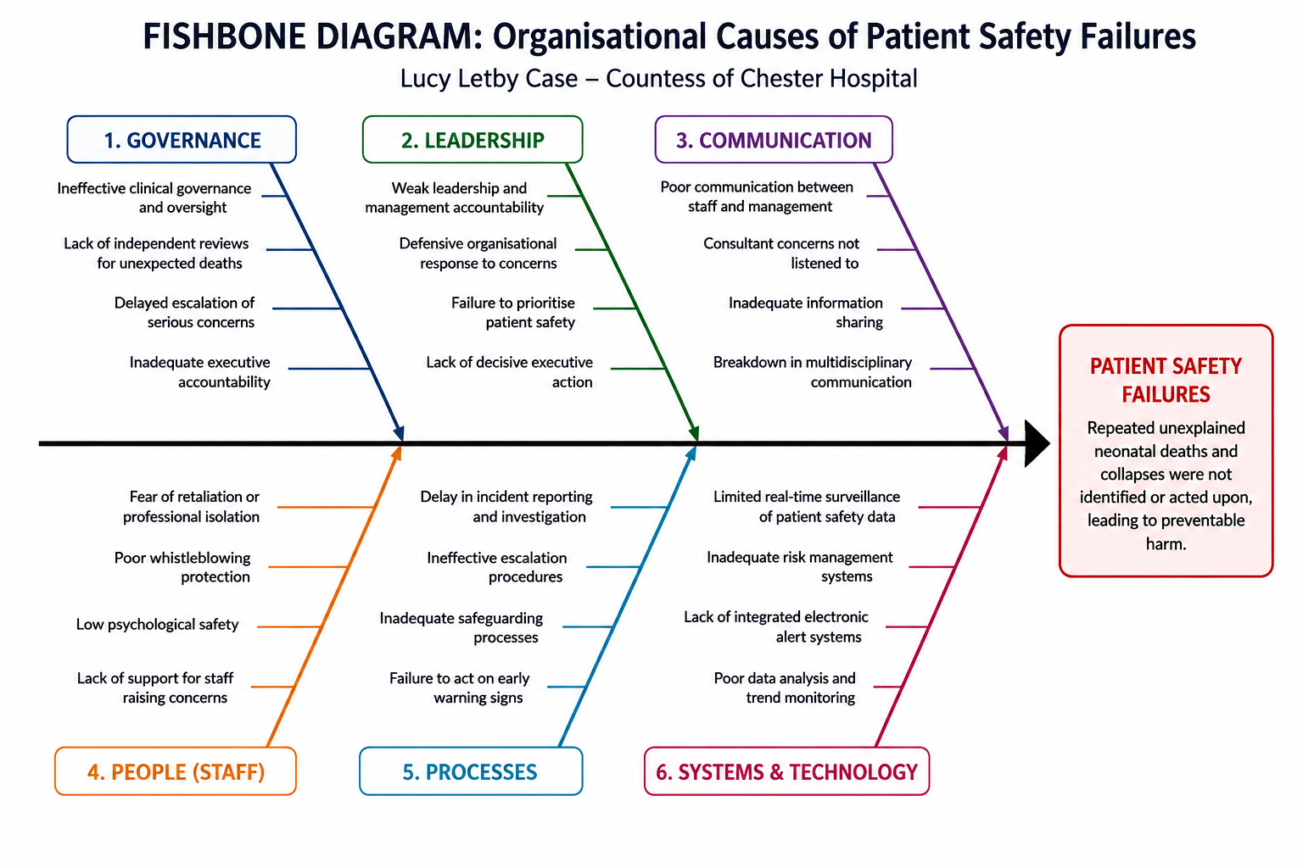
Figure 1: Fishbone (Ishikawa) Diagram of Organisational Causes of Patient Safety Failures in the Lucy Letby Case
(Source: Self-Developed)
The Fishbone Diagram not only recognises the many factors contributing to patient safety failures, but also establishes all possible connections between these factors. In Lucy Letby's case, governance issues occurred due to ineffective leadership, communication, safeguarding, reporting, and organisational culture. These factors affected the hospital's capacity to identify the escalating risks and take timely interventions with decreased capacity (Davis, 2023). Glasper (2024) suggests that rather than referring to individual moments of failure, instances of safeguarding failures need to be treated as organisational failings, thereby encouraging learning and integrated governance. Leadership also played a role in the quality failure, as several consultants' concerns were not followed up by concrete measures by the executive. As Sayers (2024) explains, defensive organisational cultures tend to be more concerned with harping on the reputation of the organisation rather than transparent investigation; this stalls accountability and improvements to services. Furthermorte, Capper et al. (2024) established that threats of punishment for raising concerns and lack of managerial support were found to reduce the likelihood of healthcare professionals raising concerns. These went hand in hand to enable patient harm to persist, unabated, until ‘organisational intervention' was made in time.

3.2 5 Whys Analysis
The 5 Whys Analysis identifies the underlying organisational causes of patient safety failures by repeatedly asking why adverse events occurred. Applied to the case of Lucy Letby, it finds that the deaths of multiple babies flourished due to delayed investigations of consultant concerns and delayed action by leadership. Lewis (2023) argued that poor managerial accountability led to a lack of organisational responsiveness to the continuous rise in patient safety issues. According to Kirkup and Titcombe (2023), organisations need to engage with whistleblowers, as they have first-hand knowledge of emerging risks that may not yet be detected by formal governance processes. Thomas (2025) also states that leadership needs to foster the expression of their voice and independent investigation of concerns. A follow-up statutory inquiry further identified governance and accountability issues, as well, (Gov.UK, 2023). Governance, leadership, and organisational learning were the key upstream issues causing the quality failure overall.

3.3 Donabedian Model
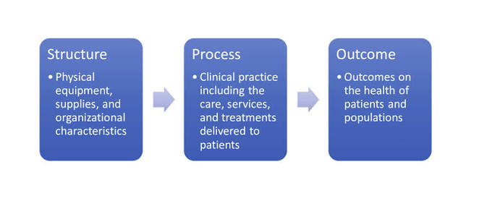
Figure 2: Donabedian Model
(Source: Zelasko et al., 2020)
The Donabedian Model uses components of care structure, clinical processes and patient outcomes to assess health care quality (Zelasko et al., 2020). In the Lucy Letby case, structural issues involved ineffective governance, uncoordinated communication and limited executive oversight. According to Mpungu (2025), forensic preparedness and integrated health information systems are therefore critical to the detection of abnormal clinical patterns before harm is incurred by patients. Concerns raised by consultants were not realised into timely organisational actions due to process failures, such as delayed reporting of incidents, poor escalation procedures and inadequate safeguarding. Likewise, the statutory inspection pointed to a lack of leadership, governance and reporting systems (Gov.UK, 2023). In both instances, avoidable patient harm, damage to reputation and loss of public confidence were caused by weaknesses in structures and procedures. As a result, better governance, more streamlined clinical processes, and an ongoing focus on patient safety outcomes are needed to ensure sustainable quality improvement.

3.4 Critical Evaluation
The Fishbone Diagram, 5 Whys Analysis and Donabedian Model altogether provided valuable insights into patient safety failures, but no single framework fully explains the complexity of the Lucy Letby case. Glasper (2024) states that the failures in safeguarding are caused by interactions between the culture of an organisation, leadership and governance, not any one single aspect of operation. The Fishbone Diagram is used for recognising several contributing factors, while the 5 Whys Analysis focuses on root causes of failures within an organisation. Jesudason (2024) argued that in order to avoid any future NHS disasters and incidents, there is a need to understand that leadership, governance and organisational culture all work together to affect patient safety. Although the Donabedian Model links organisational structures, processes and outcomes, it gives limited attention to leadership behaviour and whistleblowing. Organisational accountability is essential, and collaboration is necessary, for sustainable improvements in quality and enhanced patient safety (Oliver, 2023).

4. Strategic Analysis

4.1 SWOT Analysis
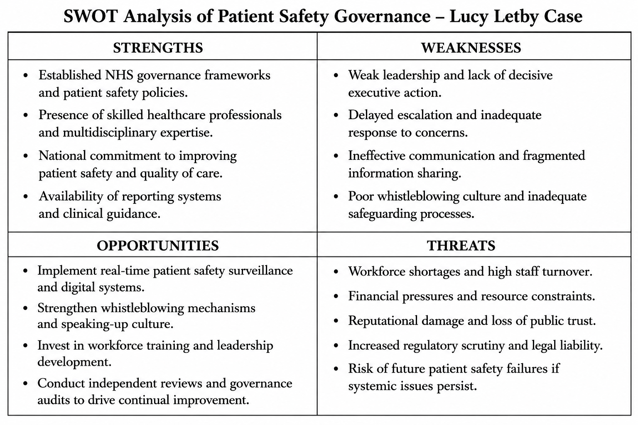
Table 1: SWOT Analysis
This SWOT analysis shows that companies that need to improve patient safety must act on both the challenges in the outside world and the internal governance weak points. There are effective clinical governance structures in the organisational policies on patient safety, which underpin quality improvement. Jesudason (2024) states that the policies are effective if the leaders advocate transparency, independent scrutiny and evidence-based decision-making. Key weaknesses include poorly joined-up communication, slow escalation to the highest level and flawed safeguarding arrangements. Poor managerial accountability led to delayed action on consultant issues, thereby resulting in extended patient safety issues (Lewis, 2023). There is scope to enhance governance using electronic surveillance systems, capacity building of leaders and strengthening whistleblowing mechanisms. According to Mpungu (2025), big data analytics in healthcare can enhance the detection of abnormal clinical patterns, thereby boosting the healthcare organisation's responsiveness. External risk factors are a lack of personnel, financial pressures, and a lack of public trust. Following the verdict, a statutory enquiry was established, bringing further spotlight onto NHS governance (Gov.UK, 2023).

4.2 PESTLE Analysis
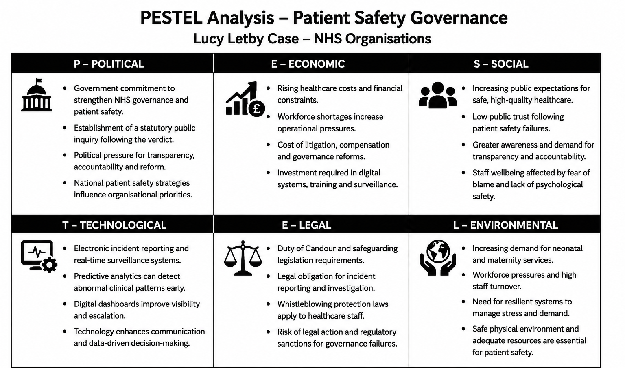
Table 2: PESTEL Analysis
The PESTLE analysis illustrated how external factors affect NHS organisations in relation to governance, patient safety and service improvement. Political factors have created pressure on healthcare organisations to improve accountability and transparency. The government has announced it will have a statutory public inquiry following the Lucy Letby verdict, as they try to improve NHS governance (Gov.UK, 2023). Economic concerns range from the shortage of a workforce to increased health care expenses and litigation and governance expenses. In his argument, Jesudason (2024) stated that focusing on preventive governance is more of a sustainable investment than mitigating the long-term impacts of patient safety failures. The increasing demands for transparency and safe care accorded to the public push social factors. Weak whistleblowing cultures stifle staff reporting of concerns and restrict organisational learning and confidence of the public in the organisation (Bright, 2025).
Advancements in technology offer opportunities to reinforce patient safety through electronic reporting systems, predictive analytics and healthcare big data. As highlighted by Mpungu (2025), these technologies allow for early detection of abnormal clinical patterns and differentiate an organisation's responsiveness. Legal factors call for compliance with safeguarding legislation, with the Duty of Candour and whistleblowing protections. Kirkup and Titcombe (2023) suggest that greater legal protection drives early reporting and accountability issues. Factors affecting the environment are workforce pressure and rising demand for neonatal services. In order to avoid environmental pressures diminishing patient care, resilient governance and robust safety cultures are crucial (The Lancet, 2023).

5. Evidence-Based Service Improvement Recommendations

5.1 Strengthening clinical governance
Improving clinical governance is a key element of making NHS organisations more accountable, transparent and patient safe (Fukami and FUKAMI, 2024). Healthcare organisations should consider the introduction of mandatory independent review of unexpected neonatal death, the creation of executive oversight of serious incidents, and more frequent governance audits to expediently investigate newly identified risks. To maximise objectivity and reduce organisational bias, governance committees need to include multidisciplinary professionals and clinical experts outside the organisation. Thompson (2023) recommends that the prolonged organisational failure would have been lessened with the intervention of the executive as well as an independent investigation in the earlier stages. Better governance structures would lead to better accountability, escalate concerns about patient safety in a timely fashion, foster ongoing organisational learning and improve the safety of patients in NHS healthcare organisations.

5.2 Real-Time patient safety surveillance
Expected improvements in healthcare organizations require some safety monitoring tools that would cover real-time patient deaths, clinical incidents, and abnormal patient outcomes (Alizadeh-Dizaj et al., 2025). Reporting systems typically look back and there are fewer chances to identify new risks. The use of electronic incident reporting integrated with digital dashboards/analytics and set up to automate alerts would allow hospitals or healthcare organisations to identify any suspicious clinical trend much quicker and take action. The timely sharing of patient safety information can also support the communication link between frontline healthcare providers and decision-makers at the policy and strategic level. Mpungu (2025) explained how big data technologies in healthcare enhance forensic readiness by being more sensitive to outlier clinical trends than conventional reporting mechanisms. Digital surveillance systems would thereby help to improve both organisational responsiveness and evidence-based decision-making and also reduce the need for reactive investigation following adverse serious patient safety issues.

5.3 Strengthening the culture of speaking-up
The need for a speaking-up culture becomes all the more crucial for promoting effective organisational learning and preventing future patient safety incidents. Whistle-blowing must be treated confidentially and there needs to be an anonymous whistle-blowing system and executive support made visible for employees to have concerns without repercussions. Leaders should regularly foster staff involvement and psychological safety, to ensure transparency. Capper et al. (2024) noted that there is a high level of impact with regard to supportive organisational cultures in maternity and neonatal services. Thomas (2025) recommended that leaders need to proactively encourage staff to speak up through regular staff engagement and investigate concerns being reported to them, thereby further strengthening patient safety and facilitating continuous quality improvement.

5.4 Improving capability of the workforce
Ongoing education of the workforce is required to help health professionals to identify, report and address patient safety issues appropriately. Essential education programmes shall prioritise clinical governance, safeguarding, human factors, leadership and communication and incident investigations. Multidisciplinary teamwork and decision-making in high-risk scenarios should also be improved by scenario-based simulation exercises. Risk review, threat assessment and effective rapid response to any patient safety concerns should be a part of leadership development programmes. Organizational education, competency assessment and refresher training need to be strengthened. However, patient safety must be ensured for all professional groups. The protection of education enhances awareness of patient safety risks and fosters interprofessional working (Glasper, 2024). This would foster a proactive patient safety culture, thus contributing to improved governance and organisational resilience.

5.5 Continuous Monitoring
Sustainable organisational change is essential to a quality improvement programme and regular monitoring is essential. Key performance indicators (KPIs) should be set in healthcare organisations that look at incident reporting, escalation response time, mortality reviews, governance audit and employee safety culture. As part of this regular review, leaders can identify emerging risks quickly, evaluate the effectiveness of any interventions and make remedial changes at the earliest opportunity. The Lancet (2023) highlighted proactive monitoring is crucial and calls on healthcare organisations to identify any weak safety signals before they become a disaster. NHS England also reiterated the need for better organisational learning as a result of the decision (NHS, 2023). The use of continuous monitoring strengthens governance and accountability, and improves sustainability of patient safety.

5.6 Implementation Strategy
Implementations must be undertaken via a quality improvement process that is structured and enables continuous review and organisational learning. The Plan-Do-Study-Act (PDSA) cycle will be helpful in making governance changes over time and gradually, and will allow to document outcomes (Elliott, 2024). Before putting digital surveillance to use, organisations like the NHS should establish priorities for governance, clarify plans for leadership with measurable performance indicators and then enhance workforce training and whistle-blowing procedures. There should be standardised interventions for neonatal services, trends of incidents, staff feedback and in terms of governance review. Jesudason (2024) said leadership commitment, continuous learning inside the organisation, and evidence-based decision-making are the tenets of sustainable quality improvement. Accountability to be enhanced by ongoing Board checks, external audit and clear reporting. This would create a national model of clinical governance, enshrining and reinforcing sustainable service improvement and patient safety in NHS healthcare organisations.

6. Conclusion
The above discussions showed the severity of the patient safety incidents both via patient and via governance, leadership, communication and organisational culture as raised by the Lucy Letby incident. Poor incident reporting, delayed escalation of incidents and poor safeguarding and lack of learning from the experiences of the organisation was found to not positively support the hospital in identifying and responding to new risks. In addition to one operational failure, several organizational failures were found with their related ones based on the Fishbone diagram, 5 Whys analysis and Donabedian model. The strategic analysis also identified that the NHS had robust regulatory systems and clinical governance systems but these needed to be applied and consistently reinforced, needed to have clarity of leadership and were required to be embraced by staff, and not taken out being that they would be discredited for reporting issues. For this, it is crucial to have governance structures, dysfunctional oversight of leadership, communication channels for whistleblowers, and the employment of digital technologies for proactive monitoring of patient safety for sustainable improvements. The recommended activities illustrate ways that governance, monitoring, competence and continuous performance assessment in an organisation can be improved to heighten the resilience in the event of a disaster. The combination of these improvements may contribute towards patient safety, further NHS organisational accountability and on-going learning in NHS organisations. These evidence-based measures will support those providing health care to achieve better governance, reduce adverse events, rebuild trust in the quality of health care and ensure patient-centred health care is safe.

References
Alizadeh-Dizaj, G., Damanabi, S., Hejazi, M.E., Raoofi, S. and Kalankesh, L.R., (2025). Implementation of patient safety monitoring systems in hospitals: a systematic review. BMJ Health & Care Informatics, 32(1), p.e101392. https://pmc.ncbi.nlm.nih.gov/articles/PMC12458659/
Bright, M., (2025). Whistleblowing in an empty room. Index on Censorship, 54(1), pp.52-57. https://journals.sagepub.com/doi/abs/10.1177/03064220251332627a
Capper, T., Ferguson, B. and Muurlink, O., (2024). Health professionals' experiences of whistleblowing in maternal and newborn healthcare settings: A scoping review and thematic analysis. Women and Birth, 37(3), p.101593. https://www.sciencedirect.com/science/article/pii/S1871519224000416
Chakravorty, I., (2023). Case of Nurse Letby: Systems Failure in Safeguarding Patients: Impact of Differential Protection for Whistleblowers. Sushruta Journal of Health Policy & Opinion, 15(3). https://www.scienceopen.com/hosted-document?doi=10.38192/15.3.4
Davis, N. (2023). Experts call for Lucy Letby inquiry to cover statistical evidence used in trial. Available at: https://www.theguardian.com/uk-news/2023/oct/03/lucy-letby-inquiry-statistical-evidence-used-in-trial (Accessed: 06 August 2026).
Elliott, A.M., (2024). Meeting quality improvement learning outcomes: Applying the Plan-Do-Study-Act cycle. Journal of Nursing Education, 63(11), pp.788-788. https://journals.healio.com/doi/pdf/10.3928/01484834-20240522-04
Fukami, T. and FUKAMI, T., (2024). Enhancing healthcare accountability for administrators: fostering transparency for patient safety and quality enhancement. Cureus, 16(8). https://www.cureus.com/articles/268126-enhancing-healthcare-accountability-for-administrators-fostering-transparency-for-patient-safety-and-quality-enhancement.pdf
Glasper, E.A., (2024). Child Killers in Our Midst: Why the Lessons Learned About Safeguarding Shortfalls in the Care of Sick Children Must Not Be Confined to the Trash Can of History. Comprehensive Child and Adolescent Nursing, 47(1), pp.1-6. https://www.tandfonline.com/doi/full/10.1080/24694193.2023.2265801
Gov.UK, (2023). Lucy Letby statutory inquiry: Secretary of State statement. Available at: https://www.gov.uk/government/speeches/secretary-of-state-oral-statement-on-lucy-letby-statutory-inquiry (Accessed: 05 August 2026).
Jesudason, E., (2024). Reducing the risk of NHS disasters. Journal of medical ethics, 50(7), pp.482-488. https://jme.bmj.com/content/50/7/482.abstract
Kirkup, B. and Titcombe, J., (2023). Patient safety: listen to whistleblowers. bmj, 382. https://www.bmj.com/content/382/bmj.p1972.full
Lewis, R., (2023). Lucy Letby: child murder case highlights need to regulate managers and improve whistleblowing procedures. The Conversation. https://shura.shu.ac.uk/33403/1/Lewis-LucyLetbyChildMurder%28VoR%29.pdf
Mpungu, C., (2025), June. Revisiting the Lucy Letby Case: A Forensic Readiness Perspective for Healthcare Big Data Networks. In Conference Name: MDX 2025 Health IT Workshop on Emerging Technologies in Healthcare. Date: June. https://papers.ssrn.com/sol3/papers.cfm?abstract_id=6487279
NHS, (2023). Verdict in the trial of Lucy Letby. Available at: https://www.england.nhs.uk/long-read/verdict-in-the-trial-of-lucy-letby/ (Accessed: 01 August 2026).
Oliver, D., (2023). David Oliver: A clinicians v managers blame game is a false dichotomy. bmj, 382. https://www.bmj.com/CONTENT/382/BMJ.P1957.full
PSL, (2023). Lucy Letby verdict, a future inquiry and patient safety. Available at: https://www.patientsafetylearning.org/blog/lucy-letby-verdict-a-future-inquiry-and-patient-safety (Accessed: 05 August 2026).
Sayers, R., (2024). Troubled times. The Bulletin of the Royal College of Surgeons of England, 106(1), pp.2-2. https://publishing.rcseng.ac.uk/doi/full/10.1308/rcsbull.2024.1
Shepard, K.C., (2025). Exploring Democratic Accountability Structures and Pathways in the NHS. The Constitution Society. https://consoc.org.uk/wp-content/uploads/2025/06/Democratic-Accountability-NHS-Report.pdf
The Lancet, (2023). The Lucy Letby case: lessons for health systems. Lancet, 402(747), pp.01839-1. https://www.thelancet.com/journals/lancet/article/PIIS0140-6736(23)01839-1/abstract
Thomas, A., (2025). 8. Leading And Speaking Up. An Insight into Contemporary Health and Care in the East of England, p.30. https://ueaeprints.uea.ac.uk/id/eprint/101101/1/NICHE_Monograph_Publication.pdf#page=30
Thompson, G.N., (2023). Lucy Letby case: Lessons for our health system. Journal of Paediatrics & Child Health, 59(9), p.1015. https://openurl.ebsco.com/contentitem/gcd:172046481?sid=ebsco:plink:crawler-gcd&id=ebsco:gcd:172046481&crl=c&jrnl=10344810
Youtube (2025) Lucy Letby cops arrest three hospital bosses where killer nurse murdered seven babies. Available at: https://www.youtube.com/watch?v=pFJi749evu4 (Accessed: 14 July 2026).
Zelasko, J., Omotayo, M.O., Berkelhamer, S.K., Niermeyer, S., Kak, L., Kumar, S. and Ram, P.K., (2020). Neonatal oxygen therapy in low-and middle-income countries: a pragmatic review. Journal of Global Health Reports, 4. https://www.joghr.org/article/12346.pdf

