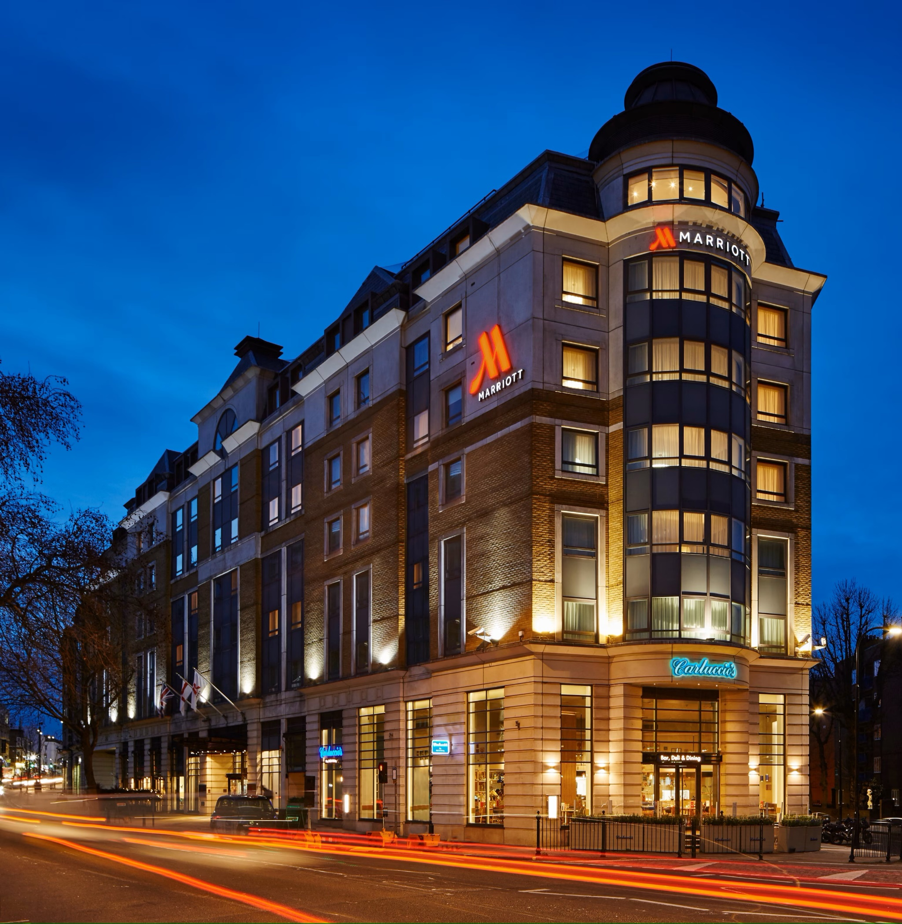 | Name: Rocio Garcia (2022578)  Module Title: Managing Hotel Administration  Module code: BMIH6004  Lecturer: Lisa Bassler  Submission date: 13/11/23

Content Table
- Navigating the Depths of Hospitality Excellence: A Student's Insight at Hotel Marriott Maida Vale
- Navigating Hotel Management: A Reflective Approach with Era Cycle
- Kick-off Chaos: A Rugby Day Lesson at Marriott Maida Vale
- Operational Insights: Managing Hotel Administrations
- Adapting Dynamically: An Agile Action Plan
- Conclusion
- Reference List

- Navigating the Depths of Hospitality Excellence: A Student's Insight at Hotel Marriott Maida Vale
Introduction
Marriott Maida Vale emerged as a sanctuary of refined hospitality, beckoning me into an immersive exploration of guest interaction within the reception and concierge departments. These critical spheres transformed into my daily classroom, where the art of creating enduring first impressions became a skill honed amidst the dynamic energy of the lobby. Here, I discovered the pivotal role played by initial encounters in shaping the overall guest experience.

What etched itself most vividly during my time at the front desk was the extraordinary camaraderie among the staff. Beyond the polished professionalism, there was an authentic warmth that infused every interaction, where routine tasks evolved into opportunities for meaningful connections. Navigating through the ebb and flow of daily challenges alongside seasoned professionals, I unearthed the delicate balance required to uphold the exceptional service standards synonymous with Marriott Maida Vale.

The individuals behind the front desk, from seasoned receptionists to attentive concierge staff, played a pivotal role in fostering a culture of authentic hospitality. They exemplified that true guest service extends beyond transactions; it is about creating an environment where every guest not only feels welcomed but genuinely valued.

Standing on the precipice of transitioning into the professional realm, the immersive experiences at Marriott Maida Vale have indelibly shaped my understanding of hospitality. The front desk, with its blend of professionalism and genuine care, stands as the focal point of my journey, illustrating that excellence is not merely about efficient operations but also about forging authentic connections in the relentless pursuit of providing an unparalleled haven for our discerning guests.
- Navigating Hotel Management: A Reflective Approach with ERA Cycle
My journey in hotel management at Hotel Marriott Maida Vale has been a vibrant exploration. To enrich this experience, I've applied the Jasper Reflective Practice Model (Jasper, 2013) with a focus on Experience, Reflection, and Action.

The Jasper Model has shifted my learning paradigm. It's not merely about skill acquisition but understanding the impact of my actions and contributing positively to the organization. This reflective journey propels my growth in the hospitality industry.

Recently, I observed communication challenges within the front office team. In response, I'm proposing a daily briefing session to enhance team cohesion. Applying the Jasper Model, I foresee this initiative fostering better communication and contributing to the hotel's overall efficiency.

In conclusion, the Jasper Reflective Practice Model is a practical tool empowering individuals in their professional journeys (Jasper, 2013). I'm excited about applying this model, envisioning its role in making me a more effective contributor to the world of hotel management.

- Kick-off Chaos: A Rugby Day Lesson at Marriott Maida Vale
On my second day of placement in the Front Desk and Concierge departments at Marriott Maida Vale, a notable event unfolded that significantly impacted my learning experience. It was a day marked by the anticipation of a crucial rugby match for the American public at Wembley Stadium, just minutes away from the hotel. The magnitude of the event was evident as the hotel expected approximately 80 rooms to be occupied, reaching full capacity with a total of 239 rooms. The day began with the promise of being both challenging and exhilarating, especially given the significance of the front desk as the first and last point of contact for hotel guests.

Three hours into my shift, the first wave of guests arrived from the airport, signifying the commencement of a hectic period. It was during this time that the inefficiencies in handling a large group became glaringly apparent. As a student of International Hotel Management, I was eager to understand the intricacies of managing such situations efficiently. To my surprise, the lounge area designated for the group's check-in was not adequately prepared, lacking refreshments and sufficient space to accommodate over 100 people. As I engaged the waiting guests in conversation and offered them complimentary water, I observed a disconnect between the front desk, the manager, and the agency organizing the trip.

As the number of waiting guests increased, and their frustration grew, the lack of communication and coordination became evident. Despite the rooms being ready from early morning due to the hotel's previous night occupancy of 70%, the check-in process was delayed until 3 pm, as contracted with the organizing agency. This inflexibility and lack of proactive communication left both guests and staff in a challenging situation. The disconnect between the receptionists and the manager, coupled with the absence of a sense of urgency, reflected poorly on the hotel's customer service and first impressions.

Despite my efforts to maintain a positive atmosphere, the receptionists felt exhausted and isolated under these challenging circumstances. The manager's response, dismissive and uninvolved, contributed to a sense of frustration among the team. This experience exposed the consequences of bad communication, poor management, and a lack of customer-centric leadership—a valuable lesson in the importance of proactive problem-solving and effective teamwork in the realm of hotel management.

- Operational Insights: Managing Hotel Administrations
Amidst the morning chaos powered by the rugby match event, a wave of emotions swept over me. The stress of the morning prompted a realization about my expectations for effective leadership. As someone aspiring to be a leader, dedicated to fostering team support and guest happiness, this situation made me keenly aware of how even the smallest signs of managerial disinterest can reverberate across various aspects.

Witnessing the frustration among the staff was poignant. It felt like I could sense it wasn't the first time they had faced such challenges. As a student trainee, I found myself without the authority to enact change in the unfolding events. Instead, my role became about attending to guests' immediate needs, attempting to bring a moment of joy by striking up conversations about their favourite rugby teams.

This experience left me wishing to be in the office, working side by side with the manager to navigate and swiftly resolve last-minute challenges. The impact lingered, making me ponder the reality that even in prominent hotel chains, there are instances where staff dynamics hinder rather than facilitate professional development, leaving employees mentally strained and their superiors seemingly indifferent.

Reflecting on my response, I recognized a desire to contribute ideas to improve the situation, a sentiment constrained by the limitations of my role. This prompted an introspective look, acknowledging the need to enhance my communication skills and cultivate a proactive approach in presenting ideas to the manager, especially in challenging circumstances.

The overarching lesson gleaned from this situation emphasized the critical importance of communication, team support, and meticulous organization, particularly when dealing with the convergence of a large group in the hotel lobby. The juxtaposition of frustrated rugby enthusiasts and couples seeking tranquillity underscored the potential ripple effect on the overall guest experience.

Examining the reasons behind the challenges, it became evident that neglecting such issues hampers the seamless functioning of the front desk, concierge, and security. The lack of proactive problem-solving and managerial engagement significantly contributed to the disruption. It underscored the necessity for addressing issues promptly to facilitate the work of receptionists, concierges, and security, preventing disturbances that could impact the overall guest experience.

- Adapting Dynamically: An Agile Action Plan
In a scenario mirroring the vibrant morning of the rugby match event, I would proactively leverage the learnings acquired. First and foremost, I would swiftly communicate with the manager, emphasizing the importance of timely decision-making and organization to avoid unnecessary stress on both the team and guests. The missing moment, one I would have eagerly witnessed, was the culmination of the orchestrated vibrancy — the full check-in at 3 pm.
Drawing from the insights gained, I would propose creative solutions to ensure a smooth check-in process for large groups. Recognizing the pivotal role of effective communication, I would engage with the team to ensure everyone is on the same page regarding the specific needs and expectations during such events.

This involves fostering an environment where ideas and feedback are welcomed, creating a more collaborative and agile response to challenges.
The learnings from this experience will be applied proactively, especially when anticipating events that could lead to a surge in guest arrivals. Prior to such occasions, I would engage with the management team to discuss potential challenges and establish contingency plans. This proactive approach would involve not only communication and collaboration with the team but also a meticulous review of the event details to ensure the necessary preparations are in place.

- Conclusion
This experience has been a crucible for personal and professional growth. Moving forward, I am fuelled by a renewed commitment to enhance communication, streamline processes, and nurture a guest-centric culture. This learning log not only encapsulates the nuances of my journey but propels me toward a future where every interaction at the front desk is a seamless blend of efficiency, warmth, and unparalleled hospitality.

- Reference List
(2023) 11 ways to improve employee development | . Available at: https://www.indeed.com/career-advice/career-development/employee-developement (Accessed: 13 November 2023).
Alemar, S. (2022) 10 common hotel problems and solutions, RSS. Available at: https://www.canarytechnologies.com/post/common-hotel-problems-and-solutions (Accessed: 10 November 2023).
Dignon, A. (2023) Five biggest challenges facing the hospitality industry in 2023, Trail. Available at: https://trailapp.com/blog/five-biggest-challenges-facing-the-hospitality-industry-in-2023 (Accessed: 06 November 2023).
Goals, objectives and reflective habits (1970) The University of Edinburgh. Available at: https://www.ed.ac.uk/reflection/reflectors-toolkit/goals-objectives-habits (Accessed: 04 November 2023).
Greenwood, K. and krol, natasha (2020) 8 ways managers can support employees’ mental health, Harvard Business . Available at: https://hbr.org/2020/08/8-ways-managers-can-support-employees-mental-health (Accessed: 04 November 2023).
Karina (2023) Top 8 hospitality challenges 2023 - impact, issues & solutions, Complete Hospitality Management. Available at: https://completehospitalitymanagement.com/hospitality-challenges/ (Accessed: 10 November 2023).
L, L. (2023) The role of managers in supporting employee wellbeing, Loving Life. Available at: https://lovinglifeco.com/hr/the-role-of-managers-in-supporting-employee-wellbeing/ (Accessed: 04 November 2023).
Miles , M. (2022) Supporting employees: 6 ways to unlock their full potential, BetterUp. Available at: https://www.betterup.com/blog/supporting-employees#:~:text=Better%20employee%20engagement.&text=They%20are%20purpose%2C%20development%2C%20a,positive%20benefits%20for%20your%20organization. (Accessed: 05 November 2023).
Mistry, S. (2022) How to deal with common challenges in hotel industry in 2023?, eZee Absolute. Available at: https://www.ezeeabsolute.com/blog/how-to-deal-with-challenges-in-hotel-industry/ (Accessed: 06 November 2023).
Newsome, P. (2023) Supporting employees in the workplace: Benefits & Tips, 4 Corner Resources. Available at: https://www.4cornerresources.com/blog/supporting-employees-in-the-workplace/ (Accessed: 04 November 2023).
Reflective writing (no date) Reflective writing - The University of Nottingham. Available at: https://www.nottingham.ac.uk/studyingeffectively/writing/writingtasks/reflective.aspx (Accessed: 01 November 2023).
Robinson, J. (2023) In-depth explanation of era cycle of reflection writing, Crowjack. Available at: https://crowjack.com/blog/strategy/reflection-models/era-cycle (Accessed: 10 November 2023).
School, E.B. (2021) 9 tips for dealing with the upcoming challenges in hotel management, Blog | EU Business School. Available at: https://www.euruni.edu/blog/tips-dealing-challenges-hotel-management/ (Accessed: 06 November 2023).
Wood, R.C. (2013) Key concepts in hospitality management. Los Angeles: SAGE.

