DIGITAL MARKETING ASSESSMENT

ZARA

Name - Ashok Gorana
Student Number - 2130640
Module - LCMB7010
Lecturer – Amitave Banik
Course - Master’s in Business Administration

Table of Contents
Part One 3
INTRODUCTION 3
ZARA: A BRIEF HISTORY OF THE COMPANY 4
ANALYSIS OF THE GLOBAL MARKET AND RETAIL SECTOR IN TERMS OF ZARA 6
DIGITAL MARKETING PLAN 8
WHAT IS ZARA’S MARKETING STRATEGY? 8
ANALYSIS OF DIGITAL ASSETS OF ZARA 10
ZARA ONLINE 10
ZARA’S APP 11
ZARA’S AUGMENTED REALITY DISPLAYS 13
ZARA IN THE METAVERSE 14
INTERNAL AND EXTERNAL COMMUNICATION STRUCTURE FLOW OF ZARA 16
ZARA AND ITS FLOW OF COMMUNICATION 16
DIGITAL MARKETING STRATEGIES AND MARKETING MIX 17
THE MARKETING STRATEGIES OF ZARA 18
THE MARKETING MIX OF ZARA 20
CONCLUSION 21
PART-2 22
INTRODUCTION 22
MACHINE LEARNING IN DIGITAL MARKETING 23
WHY USE MACHINE LEARNING FOR DIGITAL MARKETING? 24
HOW TO USE MACHINE LEARNING FOR DIGITAL MARKETING? 25
CONCLUSION 28
REFERENCES 29

Part One

INTRODUCTION

There are a number of companies which have benefited from the introduction of a well-managed digital management plan. As explained by Visser (2019), digital marketing refers to a form of marketing that takes account of electronic and computer devices to convey promotional and marketing messages to the target customers. With the overall increase in the adoption of digital tools and techniques, companies have swiftly transformed to digital marketing tools over the traditional ways of advertising. This is because traditional marketing tools and methods have become costlier and less impactful as compared with digital marketing. Furthermore, Charlesworth (2022) underlines that increased reach, lower cost, easy to learn, effective targeting and the ability to introduce multiple targets within the same campaign are a few advantages of digital marketing over the traditional ones.

This assessment takes account of Zara, one of the most popular names in the fast fashion industry and its digital marketing tools and mechanisms. Zara is one of the most innovative companies when it comes to digital marketing and processes (Roll, 2022). As underlined by Ravi (2019), the company has been able to make use of social media better than other fast fashion brands and its ability to engage a large number of customers through multiple social media websites has ensured that it receives a significant return on little investments it makes on direct marketing. Rai (2022) underlines a special point about the digital marketing processes of Zara. As per the author, the company spends around 0.3% of its total revenue on promotions and marketing as compared with the industrial average of around 4%. This also means that the profit margins of the company can go up to 85% as compared with the industrial averages of around 65-70%. This kind of ability to outclass the industrial standards has been possible due to the zero-investment digital marketing strategies introduced by the company (Ravi, 2022).

However, it would be rather exaggerating to mention that the marketing processes of Zara do not include any costs or expenses. This assessment takes a comprehensive analysis of the digital marketing tools and innovations that the company has been able to introduce in the past few years which have contributed to the long-term success of the enterprise. One of the most important aspects of the digital marketing strategies of the company is the ability to innovate (in terms of usage of tools). For instance, the company recently came up with a plan to introduce digital marketing campaigns through video games, thereby outsmarting the competitors within the sector (Joseph, 2021). This kind of innovation has made the company a definitive market leader.

ZARA: A BRIEF HISTORY OF THE COMPANY
It all started with Ortega establishing a clothing factory in 1963, “Inditex”, which today is the biggest fashion group having over 7,000 stores worldwide. A decade after establishing Inditex, Ortega ventured into the retail sector of the clothing industry with a small store called Zorba, which was later renamed to be called Zara.

Today Zara is the flagship store of Inditex, with stores in more than 85 countries. The annual sales of Zara never saw a downfall since its establishment and constitutes around 70% of the total sales of Inditex. the brand only expands annually by venturing into new countries and markets. Zara asserts certain dominance in the clothing industry and always pursuit excellence.

Technological advancement is the secret ingredient to the success of Zara. Ortega had a vision, and he materialised it quite virtually. Since 2010, when the brand was launched online for the first time, Zara has heavily relied on its digital presence to attract and retain customers. Zara understood that when a customer is using any of its digital platforms, they communicate with the brand, and therefore it endeavoured to make the experience nimble.

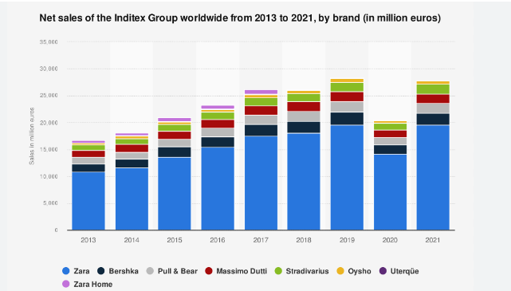
Fig-1: Net global sales of Inditex; Source-Statista

ANALYSIS OF THE GLOBAL MARKET AND RETAIL SECTOR IN TERMS OF ZARA

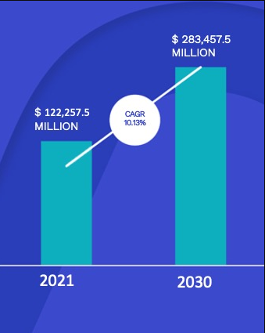
Fig-2: Estimated growth of Global Fast Fashion Market; Source-Verified Market Research

The Fast-fashion industry was valued to be around US$ 122,257.5 Million in 2021 and is estimated to reach around US$ 283,457.5 Million by 2030. Fast fashion means delivering the latest trend from the catwalk to the store at minimum prices. The clothes are meant to be worn for a single season, therefore, the brands providing fast fashion work as retailers to ensure the fast delivery of the latest trends. In the retail sector of the fast fashion industry, there are more than 40 brands present globally like Zara, ASOS, H&M, Mango, Uniqlo, etc., among others, and the competition is only growing.

But Zara has still been the leading force behind the fast fashion industry’s growth as a retailer globally, and today, it is leading the clothing industry’s retail sector. Even with such tough competition, Zara holds 11% of the total global market of the retail fast fashion industry. Zara was able to outshine all its competitors even with a reduced revenue of €11.94 billion, which was still €4 billion more than the top competitor H&M overall. What makes its success even more monumental is that the brand has a strict “No Ad Policy” and spends as little of its revenue on marketing.

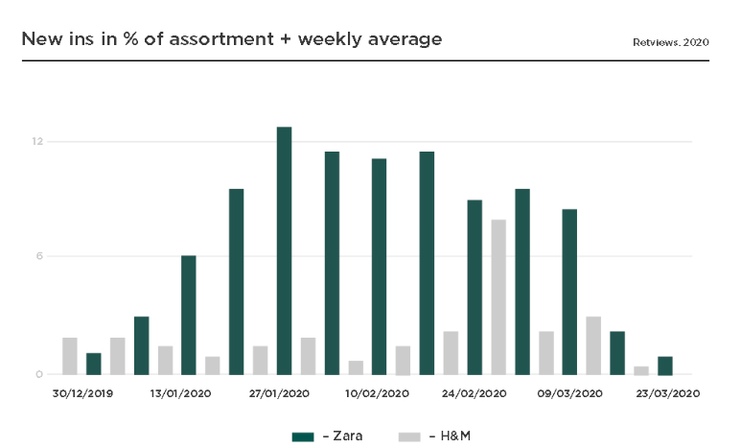
Fig-3: Zara’s rate of launching a new line in the market as compared to its competitor; Source-Retviews

When Zara came up with the concept of fast fashion, that too on a global scale, it was predicted that Zara’s strategy of introducing fast fashion would backfire, causing serious losses to the brand. The reason being they will lose millions in unsold stocks as they will launch a new collection every two weeks.

DIGITAL MARKETING PLAN

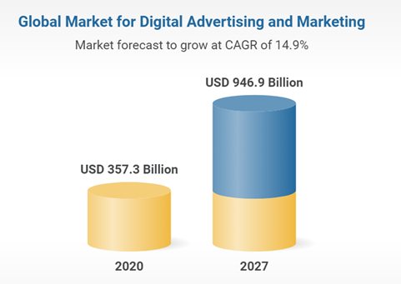
Fig-4: Global Digital Market current position and expected growth; Source-Research and Marketers

With traditional marketing still holding its ground, digital marketing is taking the game by storm. With its accessibility and affordability, digital marketing has revolutionised the communications between buyers and sellers (Sullivan, 2017). Today, organisations know where their customers are coming from, their hankerings, and the methodology to dish the same out (Chaffey, Ellis-Chadwick, 2019).

WHAT IS ZARA’S MARKETING STRATEGY?

Marketing strategy of an organisation needs to undergo rapid changes in order for it to be successful in the long-term (Belz et al., 2007). The strategies and marketing tools which were relevant a couple of decades ago might not be able to attain similar results as compared with the contemporary digital marketing tools. One of the most significant advantages that Zara enjoys is the fact that its marketing strategy is unconventional in nature. There would be hardly any TV commercial or a billboard or an advertisement in print media by the company.

The potential buyers of a brand like Zara have a massive online presence. What they are looking for, what they may resonate with, what will make them substantialise into actual buyers, and other relevant information is readily available online. Zara collects such data from platforms like e-commerce sales, PDA devices, RFID tags, customer reviews and surveys, etc.

Zara is always online, collecting data from its social media and other platforms, while its analysts are working 24 hours on the data. The data collected by Zara comes in all form, structured, semi-structured and unstructured.

What makes its success even more monumental is that the brand has a strict “No Ad Policy” and spends as little as 0.3% of its revenue on marketing. With its “No Ad Policy,” Zara created a sense of exclusivity for itself and its customers. While digital marketing plans were a success as the majority of its target audience has a massive digital presence. They could do so as they developed a digital marketing plan to reach the audience before anyone else could.

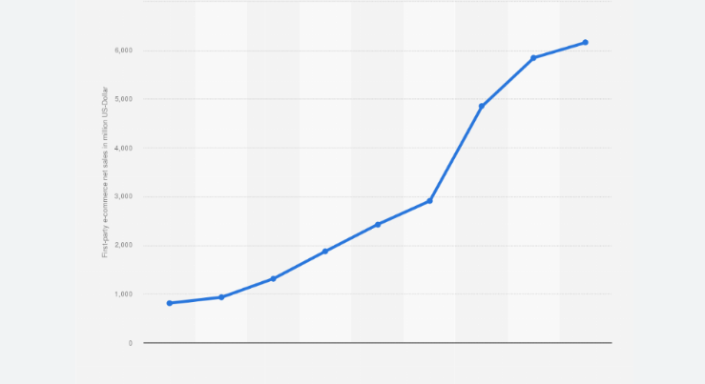
Fig-5: Digital sales of Zara from 2014-2022; Source-Statista

ANALYSIS OF DIGITAL ASSETS OF ZARA

Being digital means being in a state of positive and non-positive electronic technology to generate, store and process data (Kim, Mauborgne, 2017). That data which is stored electronically in strings of 0’s and 1’s, is digital. An asset is a resource with some current, future or potential economic value. Simply put, an asset can be anything that is either owned by you or to you. Therefore, by bringing the two together, it can be understood that digital assets are assets stored in digital form.

Zara aspires to create responsible passion for fashion amongst a broad spectrum of consumers, spread across different cultures and age groups (Roll, 2022). The company was born after keeping a close view on the customers and it continues doing so after years of progress within the sector. The company’s biggest strength lies in always listening to the customers and hence digital assets of the company are largely focussed on the existing and potential customers only. For instance, in order to infuse gaming in the marketing, the company came up with a video game platform which was quite well-received by the customers (Stevens, 2021).

ZARA ONLINE

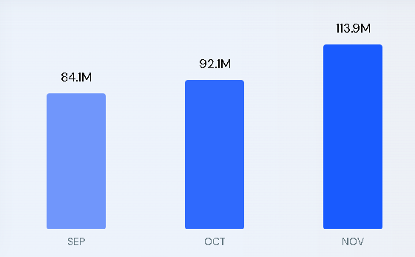
Fig-6: No of visitors on zara.com from Sept-2022 to Nov-2022; Source-Similarweb

Zara’s website is one of the most efficient e-commerce websites on the internet, may it be in comparison to its competitors or otherwise. On Zara’s website, the customers have a real-time experience as the website is continuously updated with new and relevant information and is always in tune with their physical store’s collection. That makes it visible to potential customers.

One thing that Zara ensured while developing and maintaining its website was that it understood that as a Fast Fashion Brand, the website would be flooded with images and videos of its new collection regularly; therefore, it was crucial to come up with an interface that would not look crowded even with tones of options floating around the website. As a result, the brand’s website is consistent and standard with similar aesthetics throughout but is sectioned into quite a few pages to vitrine all the options while still maintaining a link between various pages.

Another quality of the website is the control and freedom the website allows its users. A user can easily navigate throughout the website and in an instance of a mistake or error, can as easily return to the previous page. What this ensures is that the users are at ease while using the website, which keeps them engaged even if things go wrong. And if things do go wrong, then they can easily communicate it with the support team via the help desk provided on the website itself.

This is not all to it; the website has other amazing features like customisation options for the users. So now the customers can easily change the background to something they prefer or relate to, give voice commands while using the website, adjust the contrast of the website as they please, making the whole experience even more personal and intimate.

ZARA’S APP
And all the similar qualities are also available in the brand’s mobile app. The app and all of its functions load quickly. This is crucial for the success of any app as this warrants that the precious time of the users is respected, leaving them with a good user experience, as users won’t stick to an app that takes more than reasonable time to load. The app, just like the website, is sectioned into various categories, and each category hosts all the options available. Users can easily navigate within the categories or from one category to another without any issues. At the same time, they will also get the “match with” options where other products that match the selected category are vitrine.

ZARA’S AUGMENTED REALITY DISPLAYS

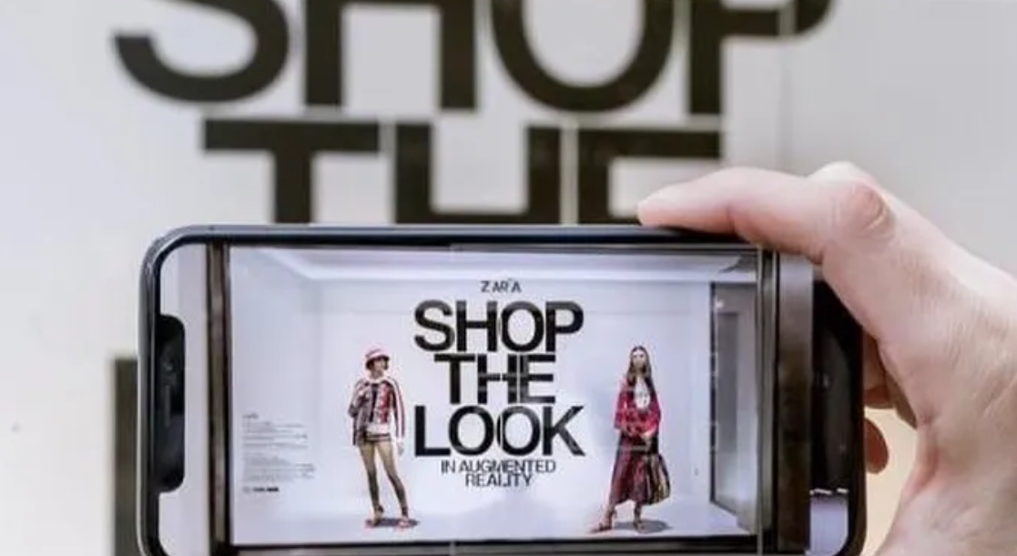
Fig-7: Zara’s Augmented Reality Shopping

Augmented Reality integrates digital information into the real world. It is a concept where the best of both worlds is mixed together to give you a digital experience in the physical world (Pulizzi, 2014). In augmented reality, instead of creating an artificial environment, the digital information or the perceptual data is overlaid upon the real-world environment.

But how is such advanced technology relevant to a brand which retails fast fashion? Well, this is exactly what the world was asking when Zara first announced its first augmented reality campaign in 2018. As it has already been established, that Zara is not only fast with fashion but also with technology; it was a no-brainer that if anybody could pull something like this off, it was Zara.

So in 2018, Zara announced its first augmented reality campaign, which would be hosted by around 120 stores for two weeks around the globe, and it was completely different from any previous application of augmented reality in the real world. The concept was unique yet simple; they applied the concept of augmented reality to their stores instead of their application or website.

But the digital endeavour didn’t stop there, Zara made sure that the customers could easily download and install the AR App; they provided on-store Wi-Fi Networks and QR Codes to download the app. In the app, there were options to follow the look they liked and purchase it, either through the app or in the store.

ZARA IN THE METAVERSE

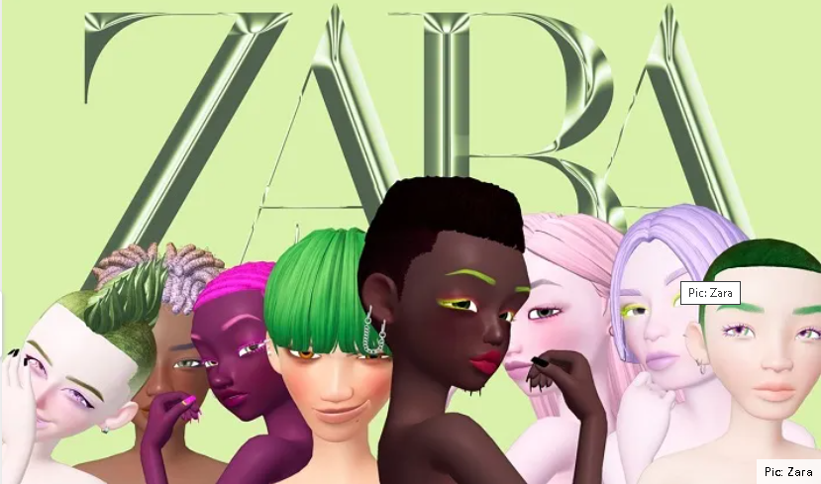
Fig-8: Lime Glam Spring-Summer 2022, Zara’s first solo meta collection.

Zara is the prime example of how digitalisation can impact and uplift any sector and create unlimited possibilities. It moves the fashion fast, and so does the digital platforms of the brand.

The latest of it all is the brand’s collaboration with a South Korean brand, “Ader Error,” to create a collection for the Metaverse of South Korea, “Zepeto,” which is in tune with its real-world collection. The brand will stay true to its motto; the collection will be of fast fashion, right off the runway, straight to the metaverse.

Luxury brands like House of Gucci have already made their avenue into the metaverse, but the game will change significantly with the entry of Zara. This is because Zara is a retailer of fast fashion garments, which means the collection will be in tune with the fashion trends of the physical world. Now the avatars will have real-time access to the ongoing trends, thinning the line between real and virtual even further.

INTERNAL AND EXTERNAL COMMUNICATION STRUCTURE FLOW OF ZARA

“Communication is the key to human success, whether it be personal or professional.
It is the art of hearing and being heard.”

As managerial personnel, it is crucial to understand that the aim of communication is not only to attract customers but also to engage them actively, understand them, resolve their issues and materialise them into actual sales. Generally, managers focus on external communication, i.e., marketing ignoring the internal flow of the communication, but this is a recipe for disaster (Sullivan, 2017).

ZARA AND ITS FLOW OF COMMUNICATION

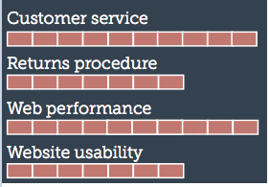
Fig-9: Various External Communication flows of Zara; Source-Internet Retailing

The communication channels in Zara are seamless and fluid. They have well-defined paths for communication and set schedules for conducting them. The best example is the scheduled ordering of new stock by store managers every two weeks and the delivery of it on the same timeline, i.e., every two weeks. And similarly, the digital platforms are also updated with the new collection in alignment with the physical store.

The brand has leaned heavily upon digitalisation to capture the market and ensure smooth internal working as well and has excelled at it. How the brand operates and communicates is exemplary and should be learned from (Lowndes, 2014).

DIGITAL MARKETING STRATEGIES AND MARKETING MIX

Digital marketing means moving the traditional marketing strategies of an organisation to a digital platform. So, any marketing strategy engaging a digital platform, using electronic means like computers, tablets, phones, etc., is digital marketing. They can simply be compared to offline marketing or traditional marketing like ads in magazines or billboards; instead, now they are just digitalised.

Now that we understand that any marketing campaign which is communicated to the audience digitally is digital marketing, the next big question is, what are the correct digital channels to do it and how many channels are to be engaged for an effective digital marketing? Well, the answer is simple, it all depends on the size of the marketing, who is the targeted audience and where can you find them easily. For example, for a fast fashion brand, the targeted audience is the millennials, and they can be easily interacted with through a social media site like Instagram or YouTube (Popović-Šević et al., 2021).

Zara, the fashion icon, even though embarked on the journey of digitalisation later than its competitors, has still mastered the art of digital marketing by ensuring that the customers click the buy button (González-Padilla & Zori, 2021).

THE MARKETING STRATEGIES OF ZARA
It is not arduous to prosper with the right tools and effective strategies. And Zara did exactly that. It created a brand presence that resonated with its targeted audience. Zara focused on millennials who wanted fast fashion at an affordable price but took it a notch further by introducing technology (Popović-Šević et al., 2021).

- THE ZARA POP-UP

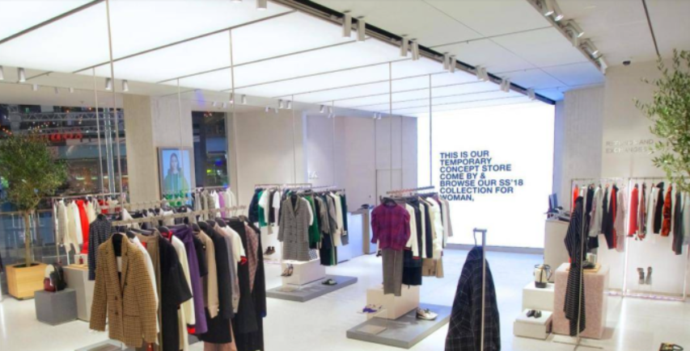
Fig-10: Zara’s Pop-Up Store; Source-Fashion United

In 2018, the brand set up a pop-up dedicated to its digital sales. The concept was to integrate digital marketing with traditional marketing. The brand provided a place for its customers to try garments prior to ordering them online. The Pop-Up only provided the facility to try the clothes the customers were interested in buying but had no backup to physically sell the same.
The Pop-up was very much in touch with the brand’s online strategy as it highly focuses on visuals and aesthetics to attract customers digitally (Popović-Šević et al., 2021).

- ENSURING NO BACKLOG

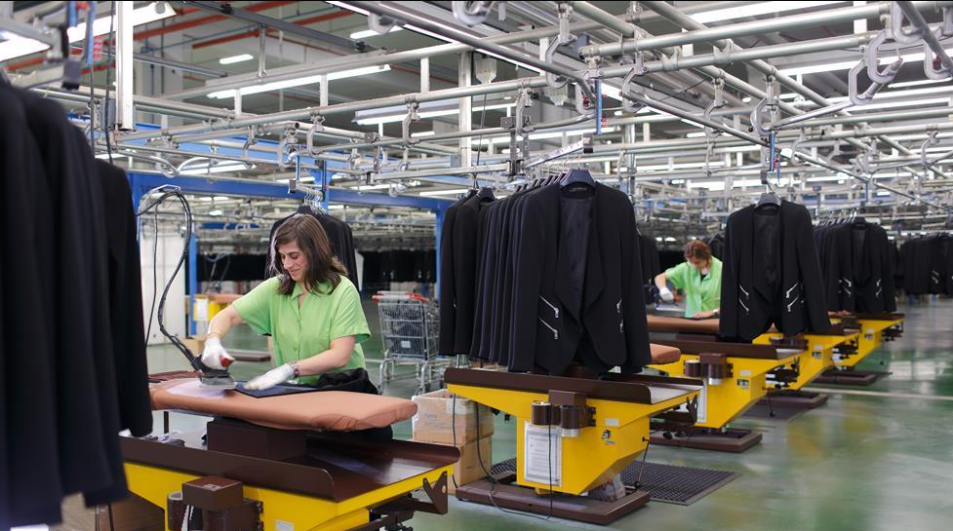
Fig-11: Factory at Inditex Headquarters’; Source-RetailWeek

In its digital marketing strategies, Zara also highly focuses on ensuring that there is no backlog in delivering digital purchases. The mantra is to deliver what is promised. Zara, through its digital marketing, postulates fast fashion, and to deliver on it, they have established several warehouses which are solely dedicated to its digital sales (Saraheide, 2016). And to further the campaign, they are also planning to introduce same-day pick-up of the online packages. And that is yet another KPI of the brand.

- ACCEPTANCE OF THE REALITY
Zara’s acceptance of the fact that it is not the first one to come up with a design, but it is definitely the fastest to get it to customers, is a major marketing strategy. Zara restocks its stores every two weeks, and the online platforms are updated simultaneously, and for that, it has heavily depended on technology.

THE MARKETING MIX OF ZARA
The marketing mix is the combination of the four “P’s” that an organisation targets to differentiate itself from its competitors and create a positive brand image in the mind of its targeted customer base. The marketing mix of Zara is very effective and interesting:
PRICE IN MIX
As a fast-fashion brand, Zara has to ensure that the prices of its products are reasonable. This is important because they need to ensure that the customers do not repeat the collection and buy new garments every season.
PRODUCT IN MIX
Zara is a retailer of ready-to-use garments. It focuses on providing ready-to-wear fast-fashion garments. As a fast-fashion brand, the products provided by Zara, even though of good quality, are only meant to be worn for a single season, as they introduce new collections every two weeks.

PLACE IN MIX
Zara was founded in Spain in 1975 and later expanded throughout the country. In 1988 the company entered Portugal and in America in 1989. And since then, the brand did not look back. Today the brand is a global success.
PROMOTION IN MIX
Even though Zara is a fast-fashion brand, it has maintained the element of luxury & exclusivity. As a part of its marketing strategy, Zara follows a strict “No Ad Policy” to establish itself as a luxury brand. Though it is very active in marketing and has several indirect advertisement strategies.
THE MARKETING MIX OF ZARA

CONCLUSION

The company made its online debut in 2010 on its online boutique, i.e., its official website in a few selected markets, but the same was extended globally in a short span of time. Though, as compared to its competitors, the debut was delayed, with its strong response to the industry dynamics and effective marketing plans, it created a dominating position without monopolising the market.

As a retailer of garments in the fast fashion sector, Zara has excelled in applying and utilising digital means and marketing strategies to reach out to its potential customers, engage with them, gain customer loyalty and consequentially maximise its return on investments. May it be regularly updating its website and app with the new collection in alignment with its real-time collection or them introducing complex concepts like augmented reality and metaverse in the already complicated and fast-phased fashion industry with ease, Zara has outshined its competitors and even other non-competing organisations in the field of digital marketing.

PART-2

INTRODUCTION

With technological advancements, organisations are adopting digital marketing, as that is where the world is. To have impactful digital marketing campaigns, they rely on Artificial Intelligence and its various streams like Machine learning. Artificial Intelligence is a computer’s ability to imitate the intelligence of the living. It is what makes a digital computer or a computer-operated robot do tasks that are generally associated with humans. In the most basic sense, Artificial intelligence works by imbibing bevvies of data, delving into the data for correlation or patterns, which are finally used in making future predictions.

MACHINE LEARNING IN DIGITAL MARKETING

Machine Learning is a subunit of Artificial intelligence that trains a system to apply solutions to various situations, which may or may not be pre-identified or sorted. It is the most significant trend in digital marketing and is reforming the entire industrial scenario around how organisations engage in digital marketing (Trappenberg, 2019). And with tools like personalisation, instant customer support, and big data, digital marketing gives organisations an edge over the competition.

The preeminent consumer base for most organisations is Gen Z and Millenials, the generations with the highest technology exposure. Their technological exposure means the marketplace is rapidly digitalising, further pushing organisations to have an online presence. The benefit of their online presence is that it is easy to gather information about what works and what does not, i.e., there is an ample amount of data for organisations to work with.

Marketing managers use such data to predict the future and accordingly plan their actions (Larsen and Becker, 2021). For instance, the global retailer of fast fashion, ZARA, highly engages in machine learning and artificial intelligence at every step of their supply chain, may it be, designing or displaying or the final shipping, to collect data on customer behaviour and use it to make future decisions.

WHY USE MACHINE LEARNING FOR DIGITAL MARKETING?

Marketers, time and again, have struggled with the high volume of data present on consumers, market and market trends. Even with the abundance of data at their fingertips, they at times are not able to make sense of it. As machine learning is about learning from past mistakes and experiences to come up with better and refined solutions, the more data, the better the algorithm gets, making it the most viable digital marketing tool (Kargutkar and Mandge, 2022).

The benefits of Machine learning are many in the field of digital marketing. Despite the fact that what machine learning does can be done by humans, too, it is not feasible to involve human resources in such activities (Sterne, 2017). The digital market is way more volatile than the physical one. The trends change overnight, and so do the consumer’s behaviour and preferences. Organisations need to be proactive and highly agile to survive these changes. Humans, irrespective of their high intelligence level, cannot compete with the accuracy level and speed of machine learning.

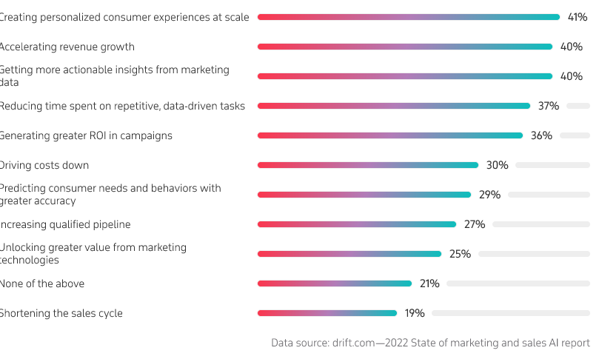
Fig: 2 - Artificial intelligence and Digital Marketing; Source: Itransition

HOW TO USE MACHINE LEARNING FOR DIGITAL MARKETING?
The importance of machine learning and artificial intelligence in the field of digital marketing is self-defining. But, as crucial as it is to have machine learning as a part of an organisation’s digital solution it is also crucial to have a machine learning tool that is in tune with the organisation, its products, and its vision and mission statement.

- ANALYSE YOUR DATA
No matter the type of machine language an organisation engages with, the key to it all is data. What creates and develops a machine learning algorithm is big data collected over a period of time. The importance of data in digital marketing is two-fold; it helps an organisation recognise its customer base and what they want. With that information, marketers develop plans and strategies to engage with and retain their potential customers. Machine learning also aids marketers in segmenting the customer base and creating logical groups for them (Ellickson et al., 2022). And if any of these were to be done manually, the task would take ten times the time, with half the efficiency.

- INCREASE PERSONALISATION
With the various options present in the market, consumers are getting picky. Now they do not want just anything; they want a service that has been developed keeping them in mind. Personalisation is highly popular and can be a deal breaker for more than 90% of customers, who, in an instance of lack of personalisation, would switch to a competitor with a better-personalised experience (Kargutkar & Mandge, 2022).

Therefore, marketers are now turning to machine learning to create a digital environment around their brands that ensure a personalised experience for their customers. They deploy an algorithm that collects data based on consumer behaviour and patterns at various stages and then use the same to make recommendations and offers for each consumer.

- CREATE AND OPTIMISE CONTENT
Content is the king, even if not entirely, yet to a great extent. Unlike in the recent past, paid advertising is not adequate, and organic growth with indirect publicity is the most relied-upon method to attract customers. Search engine optimisation has taken the market by storm, but it may not be as simple as it appears. However, with machine learning, the keywords and anchor texts can be identified, which will help the organisation’s content rank high in the google search result organically.

- IMPROVE MARKETING AUTOMATION

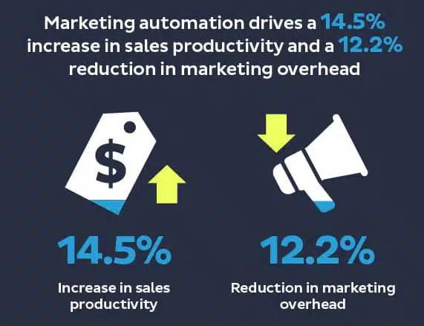
Fig:2 - Benefits of Marketing Automation, Source: Invesp

Marketing automation can help an organisation increase its sale by up to 14.5% while additionally reducing the marketing overheads by up to 12.2%. Though automation can be done manually, it is nowhere near as effective as digital automation. With machine learning, an organisation can basket all aims of automation, may it be saving time or reducing scope of errors to deliver the best results. For instance, when a customer leaves Zara online without making a purchase, Zara will email them offers based on their previous shopping and browsing history.

- UTILISE CHATBOTS
Eight out of ten consumers who have conversed with a chatbot replied positively to it. A chatbot is a type of artificial intelligence that implies machine learning to converse with humans. It makes a powerful customer service tool, especially for an online business. With a chatbot, an organisation won’t need an on-hand human resource to reply to customers or solve their queries. In fact, with time and enough data, a chatbot will be able to not only accurately solve consumer queries but even upsell them. Though, in its initial stage, it may need human assistance before reaching a high accuracy level.

CONCLUSION

Unlike popular belief, machine learning and Artificial Intelligence are not the same; therefore, the terms should not be used interchangeably. Artificial intelligence is the broader term that defines a machine’s ability to imitate the intelligence of humans. In contrast, Machine learning is a part of Artificial Intelligence, which helps a machine learn from older data and previous experiences without being specifically programmed to do that. Irrespective of the differences, the terms are prevalent even beyond the world of computer science due to their ability to assist organisations in having a competent digital marketing solution, which guarantees a maximised return on investment for them.

REFERENCES
Belz, C., Schögel, M. and Tomczak, T. (2007) Innovation Driven Marketing, pp. 3–20. Available at: https://doi.org/10.1007/978-3-8349-9186-7_1.
Charlesworth, A. (2022) “Marketing goes digital,” Digital Marketing, pp. 30–60. Available at: https://doi.org/10.4324/9781003147411-3.
Chaffey, D. and Ellis-Chadwick, F. (2019) Digital Marketing: Strategy, implementation and practice. Harlow, England: Pearson.
Digital Advertising and Marketing - Global Market Trajectory & Analytics (no date) Research and Markets - Market Research Reports - Welcome. Available at: https://www.researchandmarkets.com/reports/347974/digital_advertising_and_marketing_global_market (Accessed: January 2, 2023).
Ellickson, P.B., Kar, W. and Reeder, J.C. (2022) “Estimating marketing component effects: Double machine learning from targeted digital promotions,” Marketing Science [Preprint]. Available at: https://doi.org/10.1287/mksc.2022.1401.
Fast fashion market size, share, trends, Opportunities & Forecast (2022) Verified Market Research. Available at: https://www.verifiedmarketresearch.com/product/fast-fashion-market/ (Accessed: January 2, 2023).
González-Padilla, P. and Zori, C.G. (2021) “Big Data Optimization in Zara,” Advances in Marketing, Customer Relationship Management, and E-Services, pp. 145–157. Available at: https://doi.org/10.4018/978-1-7998-8003-5.ch008.
Joseph, S.A. (2021) Fashion major Zara's new marketing strategy; sells clothes using video games, GCC Business News. Available at: https://www.gccbusinessnews.com/fashion-major-zaras-new-marketing-strategy-sells-clothes-using-video-games/ (Accessed: January 2, 2023).
Kargutkar, S.M. and Mandge, O.L. (2022) “Enhanced Machine Learning Evaluation in Digital Marketing,” Research & Review: Machine Learning and Cloud Computing, 1(2), pp. 19–24. Available at: https://doi.org/10.46610/rrmlcc.2022.v01i02.004.
Kim, W.C. and Mauborgne Renée (2017) Blue Ocean Shift: Beyond competing: Proven steps to inspire confidence and seize new growth. London: Macmillan.
Larsen, K.R. and Becker, D.S. (2021) “Why use automated machine learning?,” Automated Machine Learning for Business, pp. 1–22. Available at: https://doi.org/10.1093/oso/9780190941659.003.0001.
Lowndes, L. (2014) How To Talk To Anyone : 92 Little Tricks. London: HarperCollins.
Popović-Šević, N. et al. (2021) “Marketing focused on the online brand community: The example of Zara,” Marketing, 52(1), pp. 32–42. Available at: https://doi.org/10.5937/markt2101032p.
Pulizzi, J. (2014) Epic content marketing: How to tell a different story, break through the clutter, and win more customers by marketing less.
Rai, P.K. (2022) Pawan Kumar Rai on linkedin: Zara has a unique "zero investment in advertising" rule - they spend a...: 24 comments, Pawan Kumar Rai on LinkedIn: Zara has a unique "zero investment in advertising" rule - they spend a... | 24 comments. Available at: https://www.linkedin.com/posts/pawan-kumar-rai-2a437a61_zara-has-a-unique-zero-investment-in-advertising-activity-6980127929439588352-HWsf/?originalSubdomain=my (Accessed: January 2, 2023).
Ravi, K. (2019) Zara's social media strategy - how they delight their customers, Unmetric Social Media Analytics Blog. Available at: https://blog.unmetric.com/social-media-strategy-zara (Accessed: January 2, 2023).
Roll, M. (2022) The secret of zara's success: A culture of customer co-creation, Martin Roll. Available at: https://martinroll.com/resources/articles/strategy/the-secret-of-zaras-success-a-culture-of-customer-co-creation/ (Accessed: January 2, 2023).
Saraheide, E. (2016) “Zara and fast fashion ,” Ethics in Marketing, pp. 132–137. Available at: https://doi.org/10.4324/9781315626642-26.
Smith, P. (2022) Inditex: Net sales worldwide by Brand 2021, Statista. Available at: https://www.statista.com/statistics/456505/sales-inditex-group-worldwide-by-format/ (Accessed: January 2, 2023).
Sterne, J. (2017) Artificial Intelligence for marketing: Practical applications. Hoboken, NJ: John Wiley & Sons, Inc.
Stevens, B. (2021) Zara owner Inditex becomes latest to launch its own video game - latest retail technology news from across the Globe, Zara owner Inditex becomes latest to launch its own video game. Available at: https://www.chargedretail.co.uk/2021/05/18/zara-owner-inditex-becomes-latest-to-launch-its-own-video-game/ (Accessed: January 2, 2023).
Sullivan, J. (2017) Simply said: Communicating Better at work and beyond. Hoboken: Wiley.
Trappenberg, T.P. (2019) “Machine learning with sklearn,” Fundamentals of Machine Learning, pp. 38–65. Available at: https://doi.org/10.1093/oso/9780198828044.003.0003.
Visser, M. (2019) “Digital Marketing,” Digital Marketing Fundamentals, pp. 10–23. Available at: https://doi.org/10.4324/9781003021674-1.

