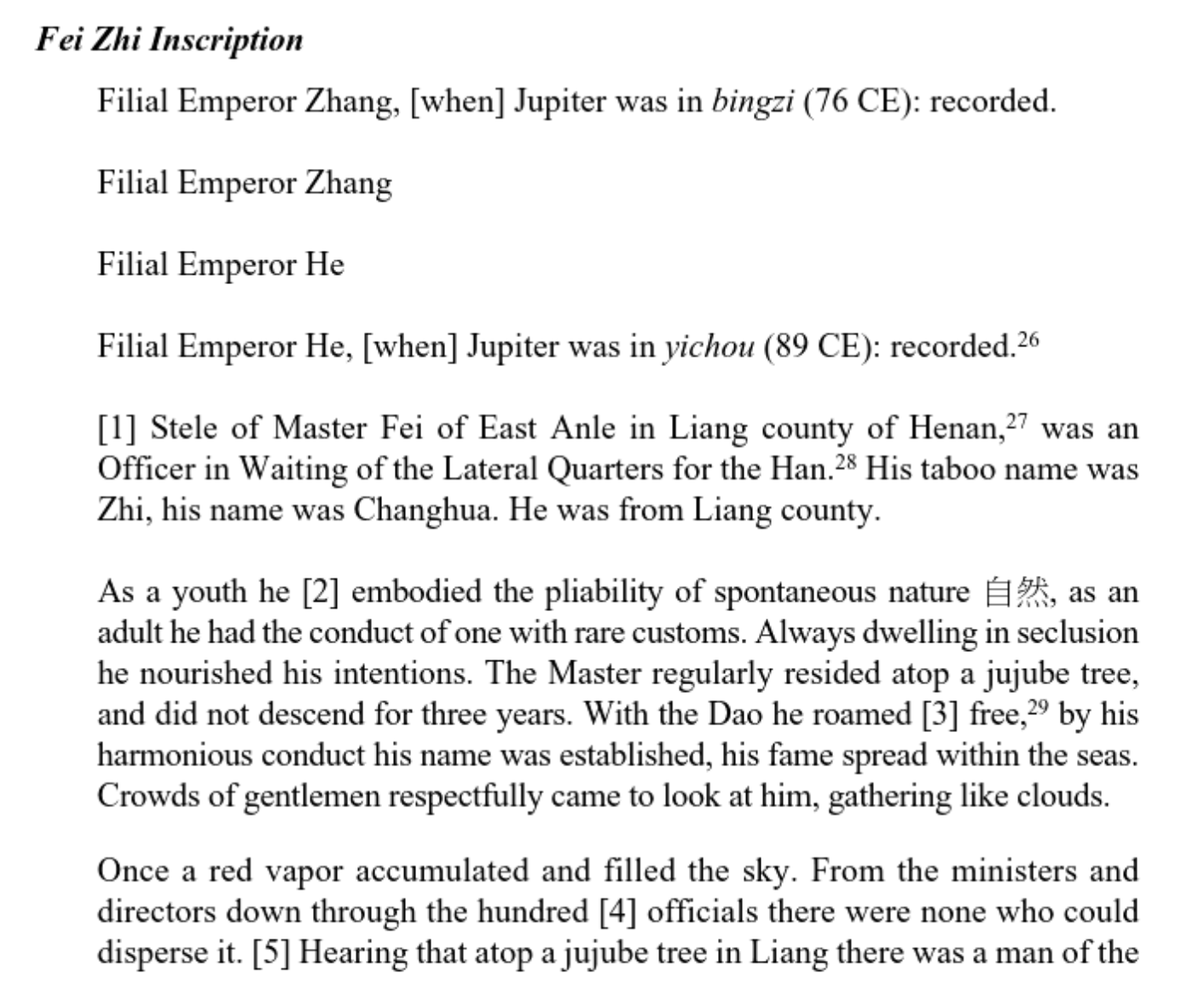
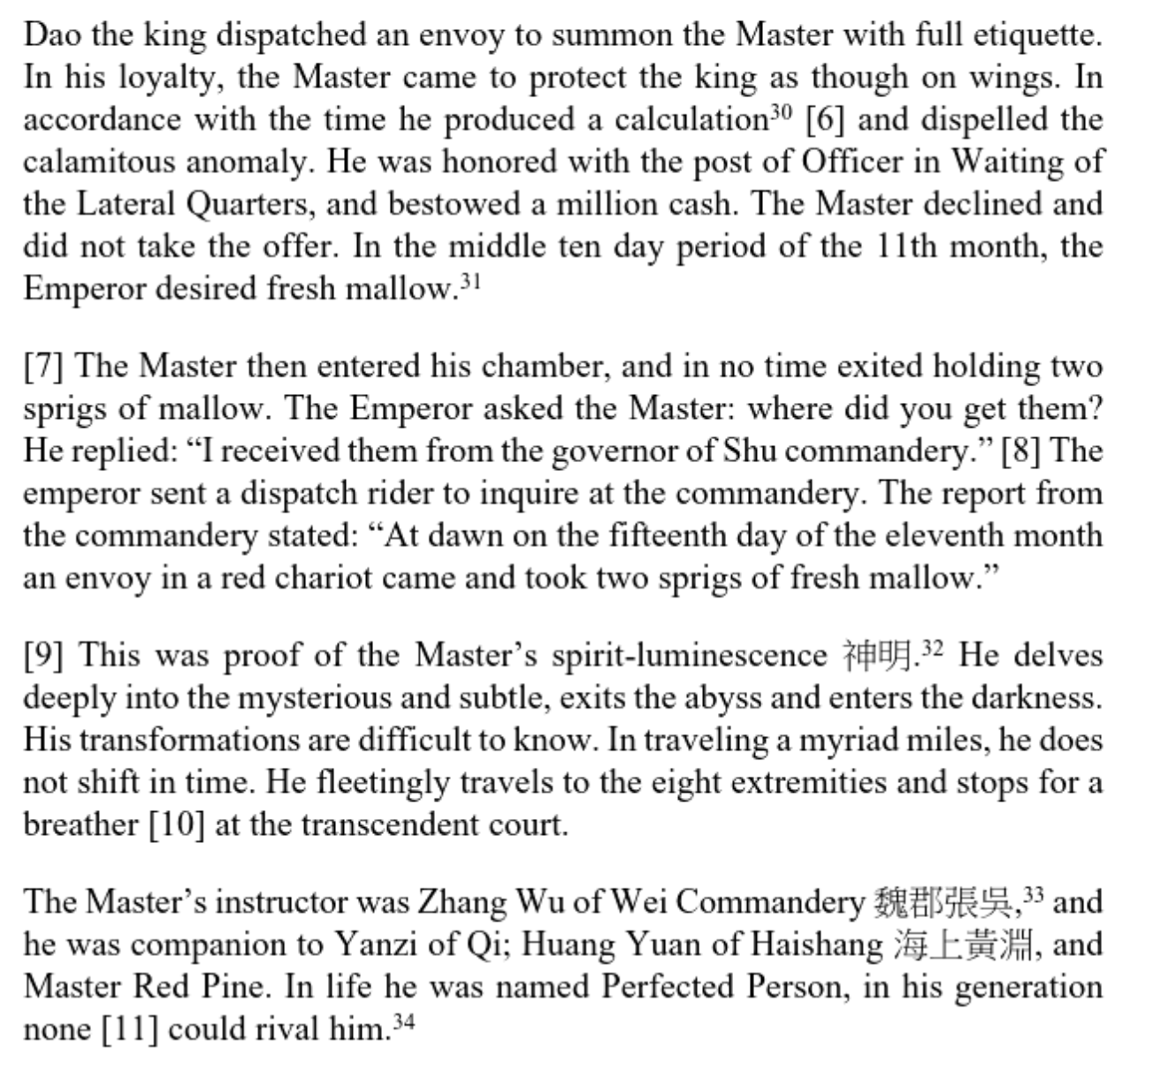
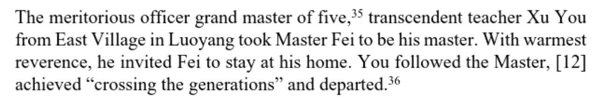
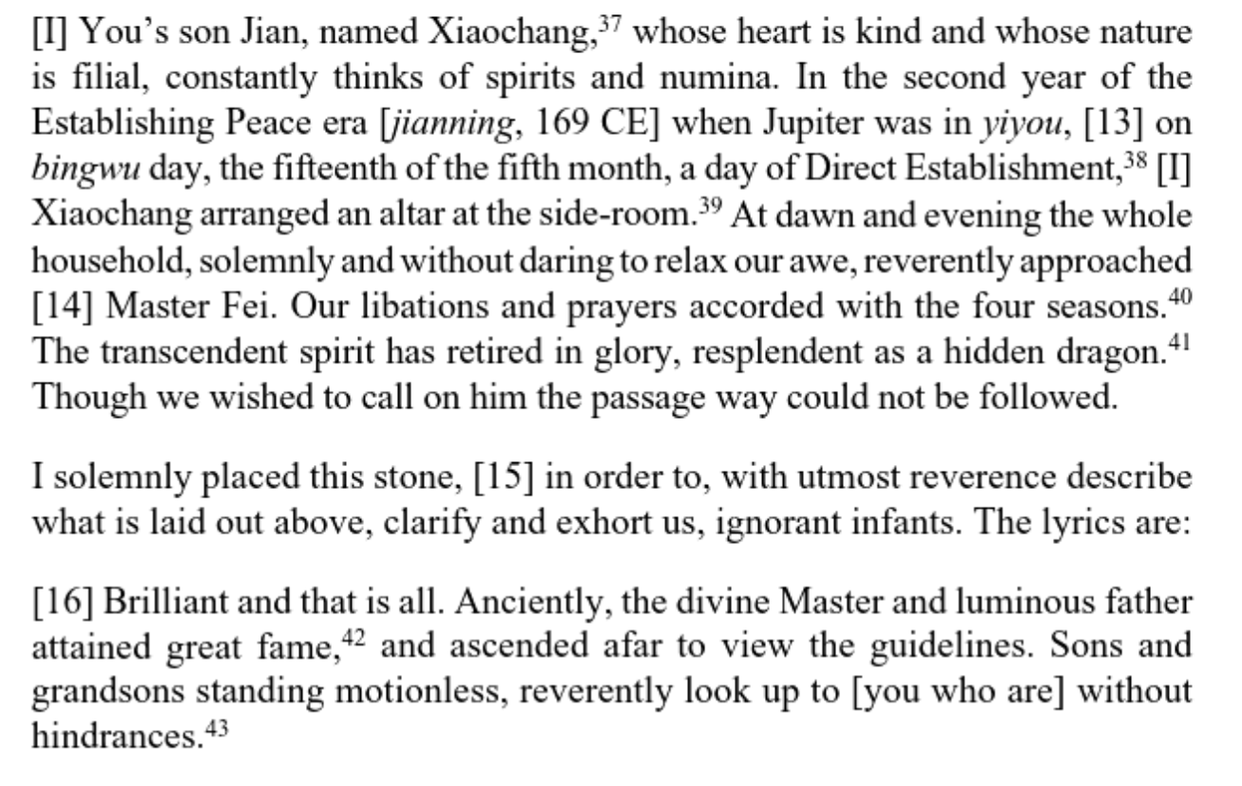
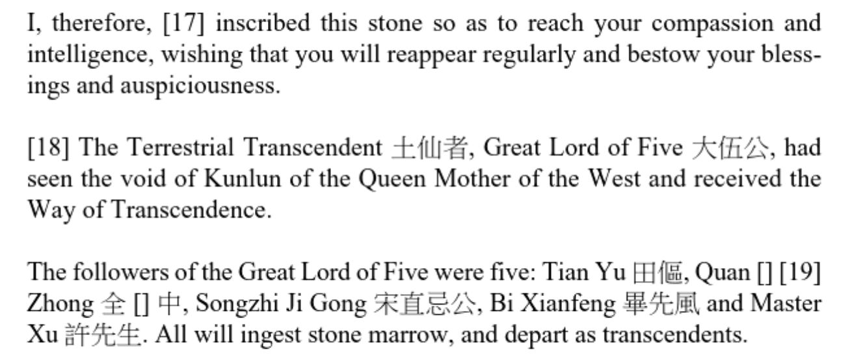

The exhortatory tract Yangping Parish 陽平治
The Teaching says: I instruct the Five Pneumas, Central Pneumas, Supervisors of Deities, Circulating Pneumas of the Four Sectors, Left and Right Overseers of Deities, and Parish-Heading Libationers of the twenty-four parishes, the leaders of the alternate parishes, and the unassigned parish citizens both male and female, young and old. I received the Dao on the first day of the fifth month of the inaugural year of the Han Peace reign period [142] from the royal divine pneuma of the First Emperor of the Han. Taking five bushels of rice as a pledge offering, I wanted to cause all those worthy individuals who could attain transcendence to rise up and be saved. You people are all so difficult to teach. I cannot talk to you. You turn right into wrong and consider bent to be straight. At this confluence of a thousand years, what should I do about you? I have followed the Supreme Lord Lao as he travelled to the end of the earth in all eight directions, traveling amongst the citizens in order to select the seed citizen, but in the end we could find none at all. Neither among the commoners nor all of you was there anyone who qualified to be a seed. You only lust after glory, wealth, money and possessions, grain, silk brocade, and filmy cottons. You think your only concern is to care for your wives and children. You extort the taxes of other [masters’] citizens, collect their cash and goods. You steal the services of the commoners solely to create citizen households. You cultivate agriculture and forge plowshares4 in order to care for your wives and slaves. You consider yourselves correct and others wrong, hoping to obtain fame for your accomplishments. You adorn your person and make yourself wealthy, lust unrestrainedly for cash and possessions. Your households are not harmonious; jealousy rules them. Men and women, young and old, talk about each other, taking turns to slander and defame. Your loose talk fills the roads, and you say something different when the person’s back is turned. If others say something different from you, you turn on them and say they are jealous. You are not prudent in dealing with the spirits, nor do you worry about the Heavenly Dao. You cause the pneumas to be confused and disordered. Who should be accused of these crimes? Each of you claims to have received a secret Teaching, speculating about how to act on the basis of precedents. I cannot stand you people any longer! I want to seize you and make you face a bill of indictment. Do you have any idea what that would mean? You libationers and leaders, men and women, young and old, you are all so benighted! You are no different from the profane! You say one thing but think another. You have a human’s head but the heart of an animal. You show no moderation in the bedchamber, giving free rein to your lascivious emotions. Men and women, young and old do not correct each other. You are so benighted. As a group your conduct is filthy and defiled, and you have abandoned the path of the master. Lord Lao, the Most High, having projected on the basis of previous events, has established guiding principles and raised high the net [of justice]. Previous actions will be used to assess for punishment those leaders who have been entrusted with responsibilities and libationers who were assigned parishes, executing three or four of every ten, so that they can return to the Heavenly Bureaus to be interrogated and tortured as punishment for their crimes. You people, be wary of this! The pneumas will move quickly. At most a year or two. Within the next three years, you people will hear about it. He is going to make you people see it with your own eyes. Could you fail to be wary of this? Are there still a few old-timers or not among the various libationers and leaders? Since the Jian’an period or the first year of Huangchu [220 ce], all the various leaders and libationers have cited a Teaching to create their own parishes. They no longer obtain them according to the former rules of the Dao. They do not make you people perform [the promotion ritual] according to the Teachings of my Yangping, Lutang, and Heming parishes. These actions you take, are they in accord with former precedents or not? If they are auspicious, why am I so anxious? I am anxious to turn my attention to getting in touch with the people of the parish. The Determiner of Pneumas has sent down teachings, telling you all what Lord Lao, the Most High, has passed on, that he wants to make all of you take care, to earnestly exert yourselves and further to exhort yourselves for the sake of the Dao to maintain all of the principles and to encourage the commoners to convert.

教：謝二十四治、五氣、中氣、領神、四部行氣、左右監神、治 頭祭酒、別治主者、男女老壯散治民：吾以漢安元年五月一日，從 漢始皇帝王神氣受道，以五斗米為信，欲令可仙之士，皆得升 度。汝曹輩乃至爾難教。叵與共語。反是為非，以曲為直。千載 之會，當奈汝曹何？吾從太上老君周行八極，按行民間，選索種民，了不可得。百姓汝曹，無有應人種者也。但貪榮富錢財、穀 帛錦綺絲綿，以養妻子為務；掠取他民戶賦，歛索其錢物；掠使 百姓，專作民戶；修農鍜私，以養妻奴；自是非他，欲得功名；榮 身富己，苟貪錢財；室家不和，姤𡜍為先；男女老壯更相說道，轉 相誹謗，溢口盈路，背向異辭，言語不同，轉相說𡜍，不恤鬼 神，以憂天道，令氣錯亂罪，坐在阿誰？各言祕教，推論舊事。吾 不能復忍汝輩也！欲持汝輩應文書，頗知與不？祭酒主者，男 女老壯，各爾憒憒，與俗無別。口是心非，人頭蟲心。房室不 節，縱恣淫情。男女老壯，不相呵整。為爾憒憒，群行混濁，委 託師道。老君太上推論舊事，攝綱舉網。前欲推治諸受任主者、職 治祭酒，十人之中，誅其三四，名還天曹，考掠治罪。汝輩慎 之！氣將欲急，遠不過一年二年，三年之中，當令汝曹聞知，當 令汝輩眼見，可不慎之！諸祭酒主者中頗有舊人以不？從建安、黃 初元年以來，諸主者祭酒，人人稱教，各作一治。不復按舊道法 為得爾。不令汝輩按吾陽平、鹿堂、鶴鳴教行之。汝輩所行，舉 舊事相應與不。吉，吾有何急？急轉著治民，決氣下教，語汝曹 輩，老君、太上轉相督，欲令汝曹人人用意，勤心努力，復自一 勸，為道盡節，勸化百姓。

The Celestial Master said: “Examining the men and women of the realm, [I find that] in everyday life they are disloyal, and, when a good deed is done, they do not seek to repay it, so that the devastation of disasters arises daily. The interrogations of Heaven, the raids of demons, and the circulation of the Five Poisons all arise from a lack of faith; they give no thought to keeping the One and doing good, and so each person summons his or her own calamity. I am concerned that you will not attain to longevity and immortality. I have received a Teaching of the utmost urgency from the Most High and have been ordered to show it to the Heavenly citizens so that they might know the prohibitions and taboos and would not offend against the divine writing of the spirits, the Demon Statutes of Lady Blue’s Mystic Capital. I allow all of you to hear of it so that the refractory may return to obedience and the evil return to good, reforming their past actions and cultivating those to come, all in accordance with the demonic statutes and commands.”
天師曰：視天下男女，日用不忠，行善不報，災害日興。天考、 鬼賊、五毒流行，皆生於不信，不念守一行善，身招其禍。念子 不得久世長生。吾受太上教勑嚴切，令以示天民，令知禁忌，不 犯鬼神靈書《女青玄都鬼律》。令使汝曹皆悉知聞，逆者還順， 惡者還善，改往修來，當依鬼律令。

