Assignment feedback

Student Name: Kenny Owen
Student University Email: 1300552@student.uwtsd.ac.uk
Module code: AHAC5013  Module title: Bio-Archaeology and Forensics | Student ID number:  1300552 |  | Educational support needs:  Dyslexic
Assignment title: Pollen – Whitland By-pass Pollen Site
Assignment due date: 10th May 2018
Assignment Number: 4
(i.e. 1,2,3)
WORD COUNT FOR THIS ASSIGNMENT IS 1488 WORDS – EXCLUDING REFERENCES.
Marker’s signature: |  | Date:
Provisional.
NB. All marks are provisional until confirmed by the final examination board.

Part One
Whitland By-pass Pollen Assessment Report
Due to the construction of a new bypass at Whitland, Carmarthenshire an archaeological excavation of a Roman road was undertaken allowing archaeologists to investigate a one hundred metre stretch of the road. This produced radio-carbon dates of 370BC-75AD & 200BC-135AD (Coflein, 2003) however, this investigation delved deeper into the early Bronze Age. A pollen sample taken at a ninety centimetre depth from the by-pass construction site was examined under a binocular stereoscopic microscope. At an eighty to one hundred centimetre depth the context analysed consisted of greyish brown very silty peaty clay with monocolyledonous remnants. This included wood, bark and evidence of leaves, suggesting an old lake or river bed changing over time to a peat bog, fen and then open woodland. Just above the ninety centimetre layer sample, existence of stone at eighty-eight centimetres suggested a possible anthropological existence. Analysis detail from laboratory observation at ninety centimetres is as follows:

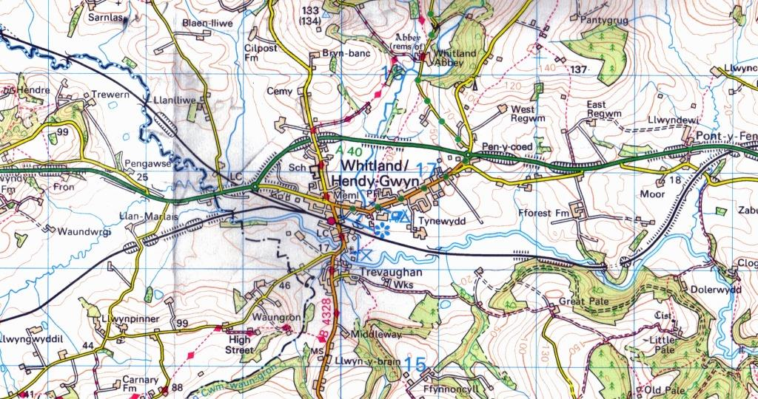

Grid Reference: SN158/20171726

In abundance was the Black Alder pollen (Alnus glutinosa, c.Zonoporate), with thirty five particles counted suggesting it was the dominant species during the woodland period. Next, in quantity during this chronological sequence was the Hazel shrub (Corylus avellana, c.Zonoporate), with twenty five pollen grains and the English Oak (Quercus robus, c.Zonocorpate) with twenty two pollen grains and In lesser quantity were Birch trees (Betula pubescens, c.Zonoporate), with a significant eleven pollen grain count.The remainder of the pollen consisted of Lime (Tilia cordata, c.Trizonoporate) with one grain and suggesting a warm climate, Willow (Salix genus, c.Zonocolpate) with two, Ivy (Hedera helix, c.Trizonocolporate) with one, and herb pollen with grass (Gramineae, c.Monoporate) recording two pollen grains, and Sedge grass (Cyperaceaeor or Carex, c.Monoporate) with one grain. Also in evidence were spores from ferns (Filicales, c.Polyads) with three pollen grains. The pollen analysis at ninety centimetres suggested an open wooded area with some open grassland. Included in the sample were aquatic specimens of moss (Lycopodium, c.Polyads) with eight pollen grains and fern (Polypodium, c. Polyads) with three pollen grains confirming evidence of a past wetland peat bog contained in the layer through bioturbation: worm and insect dynamics, floralturbation: plant root displacement and faunalturbation: animal burrowing. Through the stratigraphy between eighty to one hundred centimetres, other pollen grains and spores were found including, Buttercup (Ranunculus, c.Pantocolpate), Violets (Viola,c.Zonocolporate), Chickweed (Cerastium, c. Caryophyllaceae) and Rush (Junctus, c.Tetrads) (Andrew, R., 1984; Beattie, A. J., 1969; Bower, F. O., 1928; Encycolpedia.com, 2005; Fiore, C., 2018; Goldberg, P. and Macphail, R.I., 2006; Jiang, 2016; Microbehunter, 2018; Miller, D., 2003; Moore, P. D., et al, 1991; Pollenlibrary.com, 2018; Popweb, 2001; Sporomex, 2017; University of Worcester, 2017; Wiltshire, P. E. J. et al, 2015; Wronska, D. et al, 2010). See graph, table and pie charts below for detailed analysis with the original pollen count chart and drawing.

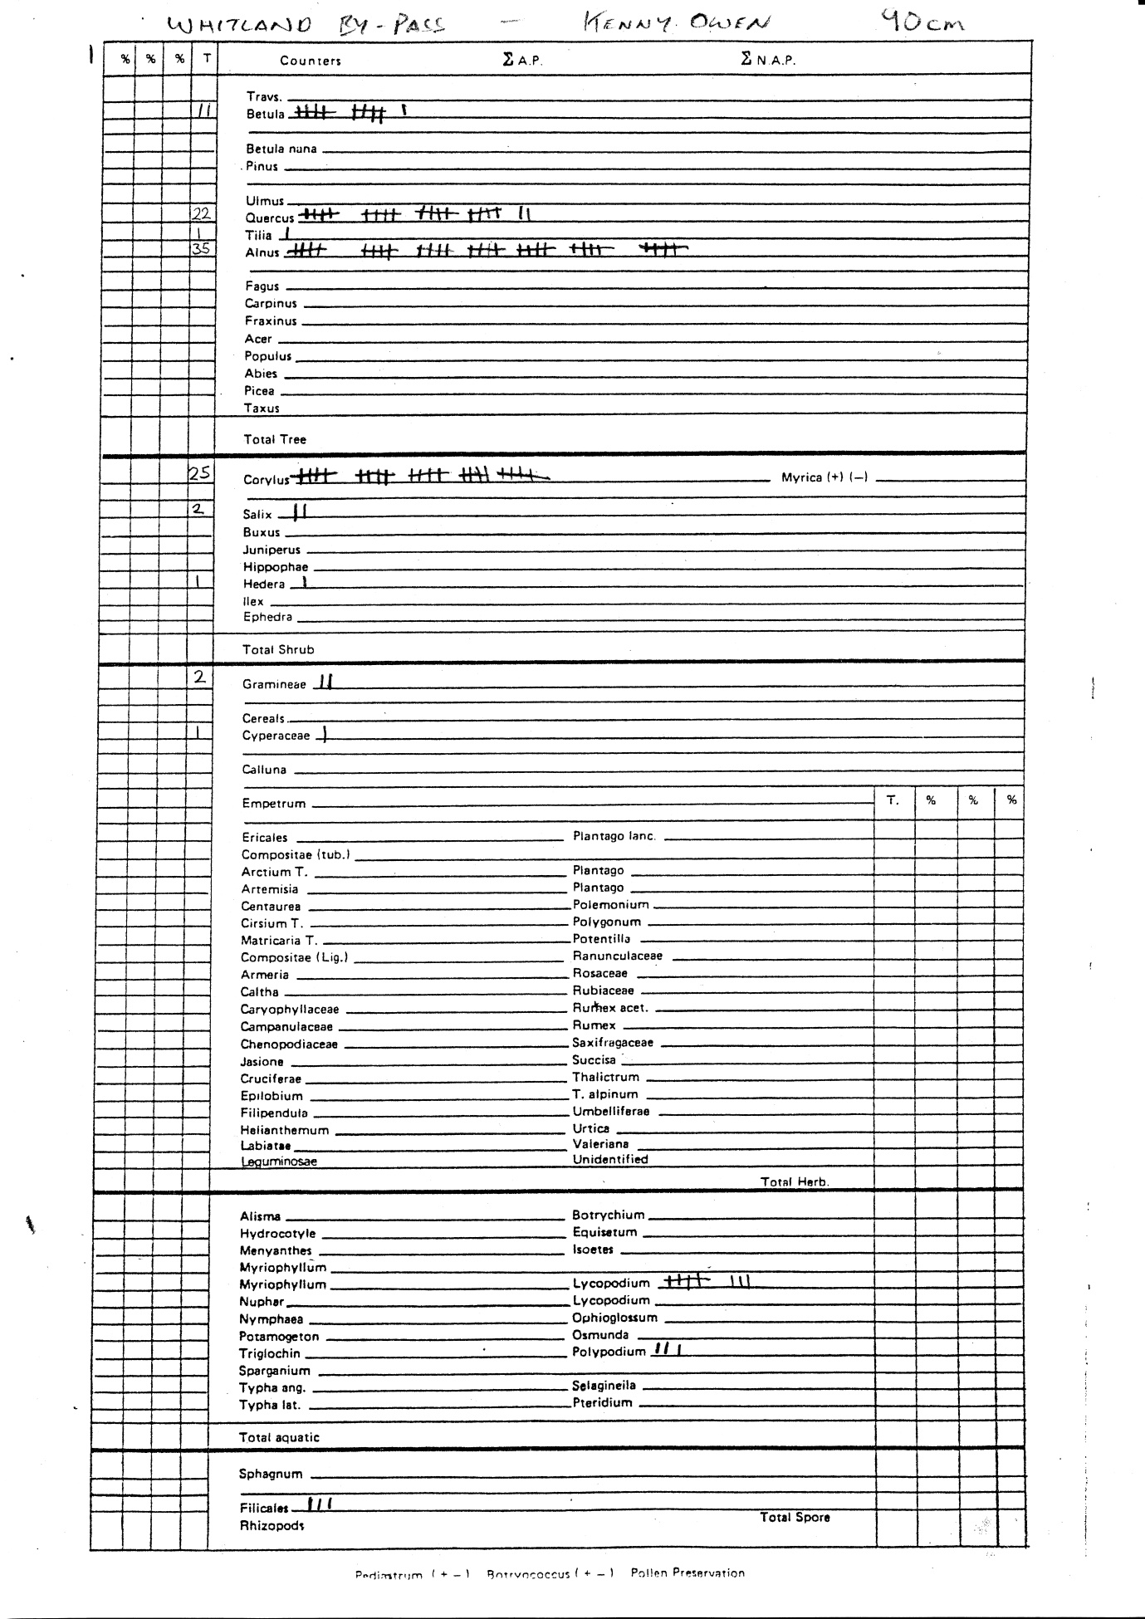

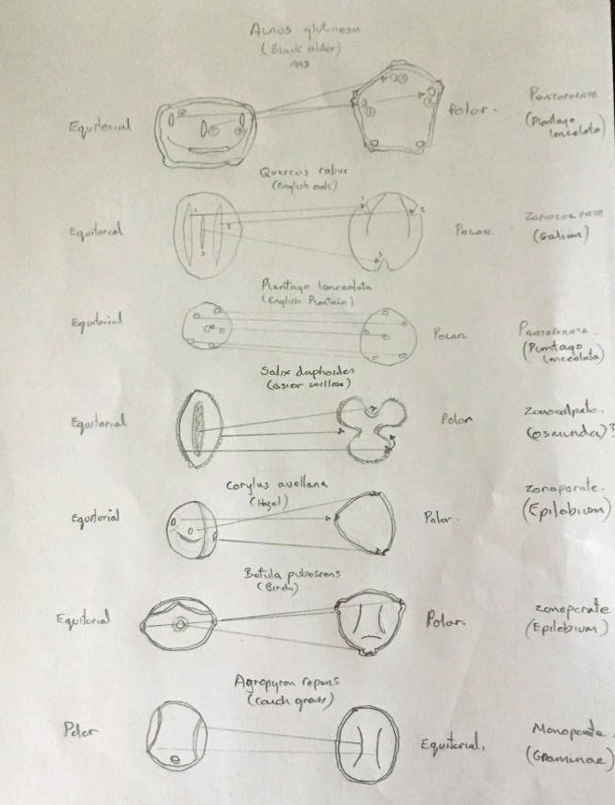
10
5
15
20
25
30
35
40
Betula
Quercus
Tilia
Alnus
Corylus
Salix
Hedera
Percentage of pollen grains and spores
Pollen and spore species
Gramineae
Cyperaceae
Lycopodium
Polypodium
Filicales

Fig.1: Graph showing percentage of each pollen/spore species as recorded in the laboratory analysis.
11/9.65%
22/19.29%
1/0.87%
35/30.70%
25/21.92%
1/0.87%
1/0.87%
3/2.63%
8/7.01%
3/2.63%
2/1.75%
2/1.75%

Fig.2: Pie chart showing amount/percentage of each pollen/spore species as recorded in the laboratory analysis.

Fig.3: Pie chart showing percentage of each tree pollen species as recorded in the laboratory analysis.
7
4
51
1
32
16
Fig.4: Pie chart showing percentage of each shrub pollen species as recorded in the laboratory analysis.
89

33

67

Fig.5: Pie chart showing percentage of each herb pollen species as recorded in the laboratory analysis.

21

58
21

Fig.6: Pie chart showing percentage of each aquatic pollen/spores species as recorded in the laboratory analysis.

In conclusion, the resulting evidence and the radio carbon dates suggest a period of around 2556BC, Bronze Age, there was not sufficient evidence to form a complete picture of the environment during this period apart from there being an open woodland area with probable anthropological intervention.

Part Two
Pollen Hystogram showing zones 1 to 5
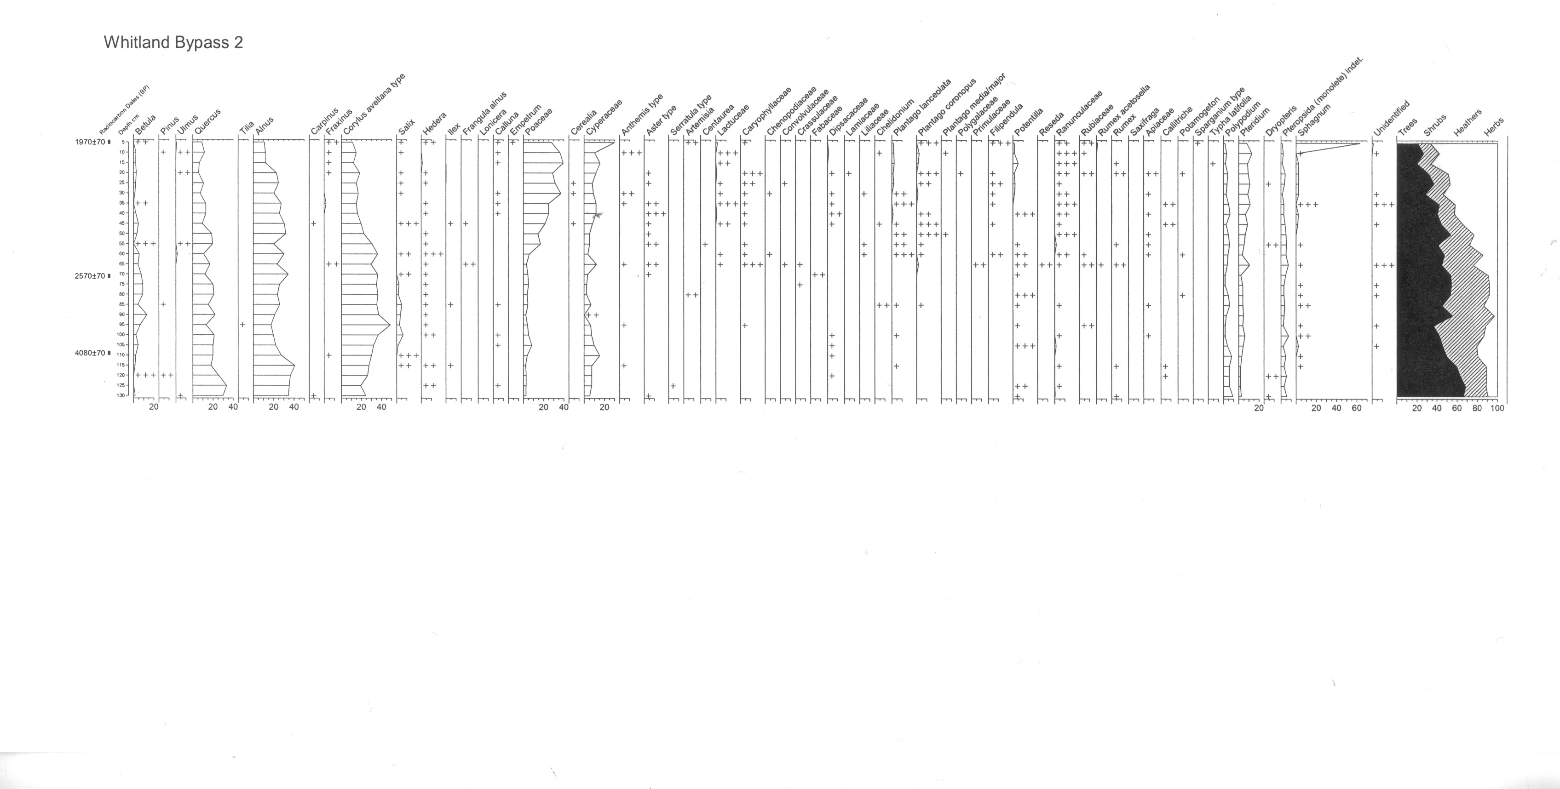
Zone 3
Zone 4
Zone 5
Zone 1
Zone 2

Zone 1 = 2735BC –2722BC – Bronze Age
Zone 2 = 2722BC - 2698BC – Bronze Age
Zone 3 = 2698BC – 2597BC – Bronze Age
Zone 4 = 2597BC to 637BC – Late Bronze Age to Early Iron Age
Zone 5 = 637BC – 21AD – Iron Age and Roman Conquest

After interpretation of the pollen count, not spores, five zones shown on the diagram above reflect the greatest impact to the environment through anthropological and, or, climate change.

Zone one (130cm – 125cm): Tree species are the most prevalent in this layer showing a steady increase with sixty seven percent of the total population of all vegetation. The main trees in this sequence were dominated by Quercus with thirty four percent, Alnus with thirty five percent. Also showing a slow decline were shrubs at twenty five percent of the total population. Corylus was the dominant species declining from twenty five to twenty percent of the pollen count throughout the sequence. Heathers and herbs were under represented with only eight percent of the total population. Poaceae at three percent and Cyperaceae at seven percent of all similar species.

Approx 2735BC –2722BC: The early Bronze Age with forestation still in abundance after colonisation of flora since the Devensian stadial shows no evidence of anthropological clearance. Light grey clay suggesting a water logged area drying to damp peaty marsh land?

Zone two (125cm – 115cm): Tree species make up sixty percent of the overall population, a significant fall of seven percent. Quercus shows a sharp decline of sixteen percent making up only eighteen percent of the tree species while Alnus rises by five percent to forty percent of trees. Shrubs show an increase with Corylus making up twenty nine percent of the total population, an increase of eight percent. Poaceae with four percent and Cyperaceae with seven percent of heathers and herbs stay constant at eight percent overall.

Approx 2722BC - 2698BC: Deforestation taking place through anthropological intervention during the Bronze Age, which allowed shrubs to flourish, cultivation of land and areas cleared for dwellings and animals rearing.

Zone three (115cm to 95cm): Betula makes an impact with six percent of all tree species, Quercus shows a negligible rise but falls off rapidly to fifteen percent while Alnus depreciates to twenty percent comprising a total population of all species at thirty eight percent, a significant reduction. Corylus, the most dominant shrub continues to increase by twenty percent to fifty percent of its species and a total population of fifty percent. Poaceae and Cyperaceae stagnate through the sequence but decline gradually at ninety five centimetres.

Approx 2698BC – 2597BC: Deforestation especially of Alder is rapidly taking place Hazel is now in abundance and grasses cover the land where once trees stood. Vegetation during this period suggests numerous flowering plants from monocotyledon remains. Charcoal represents human activity.
Zone four (95cm to 50cm): A similar pattern emerges throughout the zone for both tree and shrub species showing sharp increases and steady declines with trees showing a fifty percent average of total population, and shrubs tailing off towards the end of the zone. Betula shows an increase in species population to fifteen percent but becomes almost extinct at the fifty five centimetre level before recovery at five percent. Quercus is in fluctuation throughout the sequence constantly rising and falling from fifteen to twenty percent of its species, while Alnus growth is stead to seventy centimetres and like Quercus, fluctuates from twenty five to thirty five percent in the latter sequence. Poaceae and Cyperaceae continue to dominate their species with small numbers showing a slight increase before decline at the end of the zone.

Approx 2597BC to 637BC: Cultivation and forest management is evident from the fluctuations in tree growth and clearance to support population growth. Towards the end of the zone the demand for wood outstrips the requirement to control as population increases. Grasses, heathers and herbs begin to take hold due to deforestation while shrubs still thrive although, due to woodland increasing at the end of the zone, shrubs begin to decline. Here, the chronology moves from the Late Bronze Age to the Early Iron Age when charcoal is used to smelt iron ore. Moss present suggesting a damp, peaty environment with flowering plants and charcoal from anthropological actions.

Zone five (50cm to 5cm): Here, a rapid decline in both tree and shrub populations but heathers and herbs increase exponentially. Betula continues to decline throughout the sequence to almost extinction, Quercus still in decline holds steady and continues to fluctuate at between ten to fifteen percent of its population while, Alnus thrives at thirty percent at the start of the zone but sharply declines to ten percent at the end of the sequence corresponding to Quercus numbers. Shrubs, for the first time show a sharp decline in numbers from twenty two percent to just eight percent of the species population. As a result of the decline in trees and shrubs, heathers and herbs now dominate with Poaceae peaking at forty percent and Cyperaceae at thirty percent of species population.

Approx 637BC – 21AD: Here we see a rapid decline in tree species from fifty five percent reduced to twenty percent resulting in more open-grassland and for the Iron Age to thrive before Britain was invaded, twice by Julius Caesar in 55BC and 54BC and, for the third time by Claudius of the Roman Empire in 43AD (de la Bédoyère, 2013). Trees were once again used for building, walkways, roads and gullies, barricades and charcoal for smelting.

Conclusion
The chronology shows how anthropological change affected the land after the last stadial from a land covered with trees in 3000BC to largely open-grassland in Roman times (Wilkinson and Stevens, 2011, p.92-96; O’Connor and Evans, 2005, p.162-163; Study.com, 2018) .
References
Andrew, R., 1984. A Practical Pollen Guide to the British Flora. Cambridge: Quaternary Research Association.
Beattie, A. J., 1969. The Floral Biology of Three Species of Viola. New Phytol. Vol.68, p.1187-1201. [online] Available at: https://nph.onlinelibrary.wiley.com/doi/pdf/10.1111/j.1469-8137.1969.tb06517.x [Accessed 23 March 2018].
Bower, F. O., 1928. The Ferns (Fisicale). Vol 3. [online] Available at: https://archive.org/details/fernsfilicalestr03bowe [Accessed: 22 March 2018].
Coflein, 2003. ROMAN ROAD WEST OF CARMARTHEN;VIA JULIA, SECTION NORTH-EAST OF WHITLAND. [online] Available at: http://www.coflein.gov.uk/en/site/268119/details/roman-road-west-of-carmarthenvia-julia-section-north-east-of-whitland#images [Accessed: 21 March 2018].
De la Bédoyère, 2013. Roman Britain A New History. London: Thames and Hudson.
Encyclopedia.com, 2005. Lycopodium. [online] Available at: https://www.encyclopedia.com/medicine/drugs/pharmacology/lycopodium. {Accessed: 23 March 2018].
Goldberg,P. and Macphail, R. I., 2006. Practical and Theoretical Geoarchaeology. Oxford: Blackwell Publishing.
Fiore, C., 2018. Characteristics of Vascular Plants. [online] Available at: https://sciencing.com/characteristics-vascular-plants-5488490.html [Accessed: 23 March 2018].
Jiang, D. et al, 2016. Petrolipalynology. Beijing: Springer.
Microbehunter, 2018. Ranunculus (Buttercup) pollen. [online] Available at: http://www.microbehunter.com/ranunculus-buttercup-pollen/ [Accessed 23 March 2018].
Miller, D., 2003. Cerastium Tomentosum. Royal Horticultural Society. [online] Available at: https://www.rhs.org.uk/plants/details?plantid=368 [Accessed: 23 March 2018].
Moore, P. D. et al, 1991. Pollen Analysis. 2nd Edition. Oxford: Blackwell Scientific Publications.
O’Connor,T. and Evans, J. G., 2005. Environmental Archaeology Principals and Methods. 2nd ed. Stroud: Sutton Publishing.
Pollenlibrary.com, 2018. Thread Rush (Juncus filiformis). [online] Available at: http://www.pollenlibrary.com/Specie/Juncus+filiformis/ [Accessed: 23 March 2018].
Popweb, 2001. Tilia cordata (Small Leafed Lime). [online] Available at: http://www.geog.qmul.ac.uk/popweb/tilia/palaeo.htm [Accessed: 23 March 2018].
Sporomex, 2017. Spores and Pollens. [online] Available at: http://www.sporomex.co.uk/technology/51-pollenspores [Accessed: 24 March 2018].
Study.com, 2018. Monocotyledon Plants: Examples, Definitions and Pictures. [online] Available at: https://study.com/academy/lesson/monocotyledon-plants-examples-definition-pictures.html [Accessed: 4 April 2018].
University of Worcester, 2017. National Pollen and Aerobiology Research Unit. [online] Available at: http://www.worcester.ac.uk/discover/national-pollen-and-aerobiology-research-unit.html [Accessed: 23 March 2018].
Wilkinson, K. and Stevens, C., 2011. Environmental Archaeology, Approaches, Techniques and Applications. Stroud: The History Press.
Wiltshire, P. E. J. et al, 2015. Two sources and two kinds of trace evidence: Enhancing the links
between clothing, footwear and crime scene. [online] Available at: https://ac-els-cdn-com.ezproxy.uwtsd.ac.uk/S0379073815002352/1-s2.0-S0379073815002352-main.pdf?_tid=7de25c4d-f5cd-4e62-b1fb-8a81c4d0c6d8&acdnat=1522697546_d850ed23aa60473561f431fa4713279f {Accessed: 2 April 2018].
Wronska-Pilarek, D. et al, 2010. Pollen morphology of selected Central European species from subgenera Vignea and Carex (Carex, Cyperaceae) and its relation to taxonomy. [online] Available at: https://onlinelibrary.wiley.com/doi/abs/10.1111/j.1095-8339.2010.01093.x [Accessed: 23 March 2018].

SELF-REFLECTION SHEET.

PLEASE COMPLETE BEFORE SUBMISSION AND ATTACH TO YOUR WORK

Date:10th May 2018 Module: Bio-Archaeology and Forensics Name: Kenny Owen

Guidance: You might consider the following elements:

- Argument: does it have one/ is it backed by sufficient evidence/ how lucid is it?
- Structure: how clear is it /is my essay easy to follow/ does it help my argument?
- Analysis: is more/less analytical than narrative/ does it address the question?
- Reading: was this sufficiently broad/ have I referenced properly?
- How might I improve my performance in future?

Strengths

Enthusiasm

Weaknesses:

General Comments:

Please give a mark for your work: 69-60

(for eg: 1st = 70+: 2/1 = 69-60: 2/2 = 59-50: 3rd = 45-49: pass = 40-44: fail = 39- )

