A Critical Analysis of Royal Bank of Scotland and Danske Bank Group’s Financial Accounts.
Syed Moksudul Islam
MBA Banking and Finance - MBA LCMB7012

Programme - MBA Banking and Finance - MBA LCMB7012
Banking Financial Management & Financial Markets
Student – Syed Moksudul Islam 170937
Submission Deadline – 17/04/2022 3pm
5000 Words
Lecturer – Dr David Jenkins
d.jenkins1@uwtsd.ac.uk

Executive Summary
Part 1 of the report will assess the financial activities of two prominent retail banks, Royal Bank of Scotland, a UK bank and Danske Bank, a European bank. The report will examine the five-year annual account of both banks to understand the similarities and the differences in the operations. The study will utilize financial banking ratios to examine the bank's performance and activities. The report will use income profit ratios to understand the profitability of the bank. Return ratios will be used to understand the income generated from assets. Efficiency ratio will be used to understand how banks productivity and capital generate revenues. The financial risk ratio will measure the level of debt and understand the bank’s financial soundness. The purpose of the examination is to understand the pricing of financial instruments and assets, financing theory, and the function of markets. Part 2 will examine the Nationwide Building Society; the study intends to understand the difference between mutual and traditional banks. The study will seek to understand the different products and services offered by a mutual and it benefits to the members. Furthermore, the study will discuss how IT technology shapes the world of banking and its effect on consumers.

Contents
Introduction 5
Income Profit Ratios 6
Royal Bank of Scotland and Danske Bank’s Interest receivable, Interest payable, and Net Interest Income 6
Interest Expense Margin 6
Interest Income Margin 7
Royal Bank of Scotland and Danske Bank’s Fees and Commissions Receivable 7
Net Fee Income for RBS 8
Net Fee Income for Danske Bank 8
Royal Bank of Scotland and Danske Bank’s Profit and Loss for the Year 8
Net Interest Margin (NIM) For Royal Bank of Scotland 9
Net Interest Margin (NIM) for Danske Bank 9
Return Ratios 10
Royal bank of Scotland and Danske Bank’s Total Assets 10
Return on Assets (ROA) for Royal Bank of Scotland 10
Return on Assets (ROA) for Danske Bank 11
Royal Bank of Scotland and Danske Bank’s Total Liabilities 11
Royal Bank of Scotland’s Return on Equity (ROE) 11
Danske Bank’s Return on Equity (ROE) 11
Efficiency and Provision Ratios 12
Royal Bank of Scotland’s Efficiency Ratio 12
Risk Ratios 12
Royal Bank of Scotland’s Interbank Ratio 13
Danske Bank’s Interbank Ratio 13
Royal Bank of Scotland’s Loan-to-Deposit Ratio 13
Royal Bank of Scotland’s Tier 1 Capital 14
Danske Bank’s Tier 1 Capital 14
Final Evaluation of Royal Bank of Scotland and Danske Bank 14
Introduction 15
Overview of Nationwide Building Society 15
The Difference Between a Mutual and Banks 16
Primary Earnings of Building Society 16
Other Source of Earnings by Nationwide Building Society 17
A comparison of Products and Services 17
Compering Product and Services Between Nationwide Building Society and Barclays Banks 18
Performance of Building Societies Versus Banks 18
Using Ratios to Measure Performance and Financial Strength 19
Digital Banking System 19
Conclusion 20
Reference Page 21

List of Figures
Figure 1, Royal Bank of Scotland and Danske Bank’s Interest receivable, Interest payable, and Net Interest Income 2016 to 2020. 6
Figure 2, Royal Bank of Scotland and Danske Bank’s Fees and Commissions Receivable 2016 to 2020 7
Figure 3, Royal Bank of Scotland and Danske Bank’s Profit and Loss for the Year 2016 to 2020. 8
Figure 4, Royal Bank of Scotland and Danske Bank’s Total Liabilities 2016 to 2020. 11
Figure 5, Royal Bank of Scotland’s Interbank Ratio 2016 to 2020. 13
Figure 6, Danske Bank’s Interbank Ratio 2016 to 2020. 13

List of Tables
Table 1, Interest Expense Margin for RBS 2016 to 2020. 6
Table 2, Interest Income Margin for RBS 2016 to 2020. 7
Table 3, Net Fee Income for RBS 2016 to 2020. 8
Table 4, Net Fee Income for Danske Bank 2016 to 2020. 8
Table 5, Net Interest Margin (NIM) for Royal Bank of Scotland 2016 to 2020. 9
Table 6,Net Interest Margin (NIM) for Danske Bank 2016 to 2020. 9
Table 7, Royal bank of Scotland and Danske Bank’s Total Assets 2016 to 2020. 10
Table 8, Return on Assets (ROA) for Royal Bank of Scotland 2016 to 2020. 10
Table 9, Return on Assets (ROA) for Danske Bank 2016 to 2020. 11
Table 10, Royal Bank of Scotland’s Return on Equity (ROE) 2016 to 2020. 11
Table 11, Danske Bank’s Return on Equity (ROE) 2016 to 2020. 11
Table 12, Royal Bank of Scotland’s Efficiency Ratio 2016 to 2020. 12
Table 13, Royal Bank of Scotland’s Loan-to-Deposit Ratio 2016 to 2018. 13
Table 14, Royal Bank of Scotland’s Tier 1 Capital Ratio 2016 to 2020. 14
Table 15, Danske Bank’s Tier 1 Capital 2016 to 2020. 14
Table 16, Income Statement (Nationwide Building Society, 2022). 16
Table 17, Interest receivable and similar income (Nationwide Building Society, 2021). 17
Table 18, Source, Nationwide Building Society’s Annual Accounts (2021); Barclays Bank's Annual Accounts (2021). 19

Part 1. A Critical Analysis of Royal Bank of Scotland and Danske Bank Group's Financial Accounts.

Introduction
Banks are unique institutions that buy and sell money; banks purchase money from the central bank at a set rate; banks are financial intermediaries with the average person interacting on a regular interval. The money is then loaned out to the public through personal loans, mortgages, overdrafts, and credits cards (Gerken, Eakins and Mishkin, 2012). A bank's primary income is the interest charged on the loans that have been sold to the customers. Bank’s largest source of their money derives from the customer’s deposits; cash is then used to loan to other customers (CFI, 2022). Financial systems are complex and made-up banks, insurance companies, mutual funds, finance companies, and investment banks. The debt markets to consider, banks and many large businesses use the debt markets like security, dentures, government and corporate bonds. Part 1 of the report will critically analyze the financial accounts of the Royal Bank of Scotland against the European Danske Bank. Financial ratios will be used to determine the level of income generated, risks will be analyzed, and overall health of the banks. Part 2 of the study will focus on a mutual bank, understand how building societies function against traditional banks, and the key benefits to the members.
How Banks Generate Income
- Overdraft facility with monthly charges.
- Special paid monthly accounts give customers additional facilities like phones insurance, breakdown cover, and travel insurance.
- Premier/Business accounts with a monthly charge.
- Selling insurance products like life and car insurance and earning fees.
- International money transfer charges customers for the service.
- Selling corporate bonds allows the bank to earn yearly interest income.
This part of the report will examine the financial performance of the Royal Bank of Scotland against the European Danske Bank. Graphs, ratios and 5-year annual accounts will analyze both banks' performance.

Income Profit Ratios

Royal Bank of Scotland and Danske Bank’s Interest receivable, Interest payable, and Net Interest Income
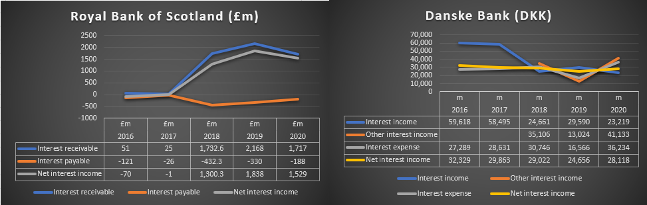
Figure 1, Royal Bank of Scotland and Danske Bank’s Interest receivable, Interest payable, and Net Interest Income 2016 to 2020.
RBS had made substantial gains in 2018; interest receivable was at £1,732.6m, 6,830 % from the previous year. The net interest income for 2018 was £1,300.3m, a change of 130,130.0% from 2017. The main reason for the significant gain is the income received from the loans and advances to banks £2,344.0m, and loans and advances to customers of £60,521.1m. The loans had accumulated interest from products service given to the customers. Loans and advances were given to other banks that accumulated additional income. There was an increase in customers deposit from £64m in 2017 to £75,023.6m in 2018, a change of 117,124.4 %. This allowed the RBS to lend more loans to customers and gains interest income.

Interest Expense Margin
Table 1, Interest Expense Margin for RBS 2016 to 2020.
The interest expense ratio is used to understand the expenditure and liabilities for each year. These interests are paid to account holders and interest expenses on debt securities RBS holds. 2020 the interest expense is at 0.22%, which has lowered the payment over the previous years. However, comparing two banks from different countries with the ratio is not a good indicator as interests are set according to their countries.

Interest Income Margin
Table 2, Interest Income Margin for RBS 2016 to 2020.
Interest income margin aids banks to understand the level of income received from loans, receivables, bonds, and other forms of income. The ratio indicates that the income received from loans is declining compared to the previous year.
Danske Bank has seen its interest income reduced from 29,590m DKK in 2019 to 23,219m DKK in 2020, a reduction of 25.5%. The other interest income was higher at 41,133m DKK in 2020, a positive change of 215.8 % from 2019; its interest expense was 36,234m DKK for 2020. The net interest income for 2020 stood at 28,118m, an improvement of 14.0% against the previous year.

Royal Bank of Scotland and Danske Bank’s Fees and Commissions Receivable
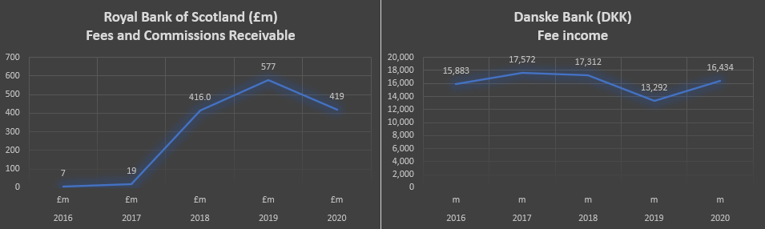
Figure 2, Royal Bank of Scotland and Danske Bank’s Fees and Commissions Receivable 2016 to 2020
RBS recorded fees and commissions receivable of £577m in 2019, a change of 38.7% from 2018, dipping to £419m in 2020, a drop of 27.4%. The earnings for both years are derived from payment services, credit and debit card fees, lending, financing, and other commission related services; the costs are related to retail and commercial banking (see RBS annual account 2020, notes to the financial statement). However, many banks were impacted by the Covid-19, affecting the bank revenues in 2019 – 2020, reflecting lower fees and commissions (KPMG, 2020).
Danske Bank recorded a fee income of 16,434m DKK in 2020, increasing 23.6% from 2019. The lower fee income in 2019 was due to Covid-19 and customers unable to use their credit cards, resulting in lower fee income. However, the net fee income from re-mortgaging was high as customers took advantage of low interests.

Net Fee Income for RBS
Table 3, Net Fee Income for RBS 2016 to 2020.
Having a high net fee income is the second most important earning for a bank. This income derives from bank’s charges, cheques bouncing, commission, money transfers, and late fees. In 2020 the net fee income was at 110.11%; the high percentage was due to low net profits.

Net Fee Income for Danske Bank
Table 4, Net Fee Income for Danske Bank 2016 to 2020.
The high percentage reflects that Danske Bank has seen its net profit decline in 2020, giving a high ratio. Both banks have suffered due to covid-19 affecting normal revenues.

Royal Bank of Scotland and Danske Bank’s Profit and Loss for the Year
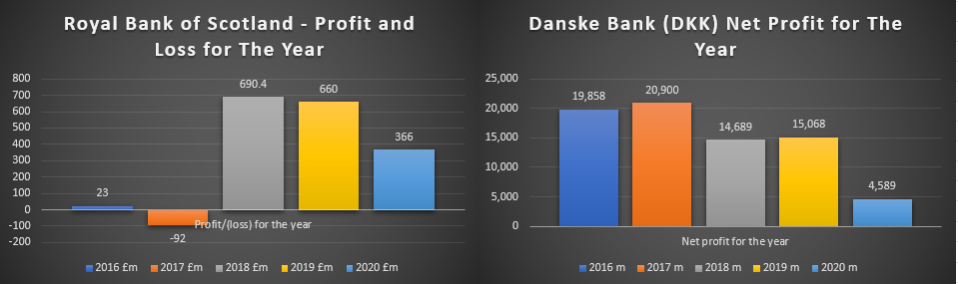
Figure 3, Royal Bank of Scotland and Danske Bank’s Profit and Loss for the Year 2016 to 2020.
RBS will go from a loss-making to a profitable bank by 2020; however, it has seen a decline in profits. Covid-19 has affected the banking sector, putting a dent in the net profits. According to (Makortoff, 2020), RBS revealed that pre-tax profits had fallen to £519m in the first three months of 2020, compared to £1bn in the previous year. The bank has considerable exposure to the leisure industry, property, retail and shipping. The closer of these industries reduced bank's revenues streams like business loans, debit and credit card fees, and earnings from business banking.
The pandemic impacted Danske Bank’s profits, resulting in lower yields. The low profits were due to 4500 mortgage holidays and 0% interest on overdrafts for three months (Danske Bank Group, 2020).

Net Interest Margin (NIM) For Royal Bank of Scotland
Table 5, Net Interest Margin (NIM) for Royal Bank of Scotland 2016 to 2020.
Net interest margin is the net profit that a bank makes; the formula for the ratio is as follows. Interest earned minus interest expense paid to the account holder, then divided by average earning assets. The assets are the products that make revenues for the bank, like bonds, income from rental property, dividends, and short-term loans to other banks. 2016 the RBS paid more in interest payments than receiving earnings from assets employed. This could mean the asset is not generating enough revenues; in 2016, the total asset generating income was £8,330m, and the ratio was at -0.84 a loss. In 2020 the total asset had grown to £99,242m improving the ratio by 1.54%, increasing income from the asset. This is due to higher loans to customers, increased loans to other banks, and cash balance in the central bank, all producing income.

Net Interest Margin (NIM) for Danske Bank
Table 6,Net Interest Margin (NIM) for Danske Bank 2016 to 2020.
Between 2016 to 2020, Danske bank has seen its net interest margin ratio decline from 0.93 to 0.68%. Danske Bank’s asset has generated less interest income (Kumar, 2018). However, interest fluctuates and affects profit; with high-interest rates, banks pay more on savings. Likewise, customers borrow loans and mortgages as money is cheap if interest is low (Bank of England, 2020).

Return Ratios

Royal bank of Scotland and Danske Bank’s Total Assets
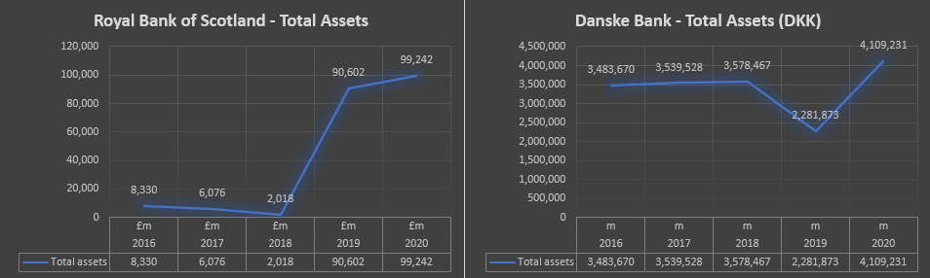
Table 7, Royal bank of Scotland and Danske Bank’s Total Assets 2016 to 2020.
Since 2018 RBS has accumulated substantial assets; previously, the bank had made losses and has now regained its ground. 2020 the bank’s assets had grown further by 9.5%; these were largely due to more cash balance at the central bank and loans and advances to banks.
Danske Bank has seen a surge in its asset growing from 2,281,873 DKK in 2019 to 4,109,231 DKK in 2020, a change of 80.1%. The significant change has derived mainly from cash in hand and deposits with the central bank, a 313.6% change from 2019. The other significant change was that loans stood at 1,023,323 DKK, a change of 220.3% from the previous year, 2020.

Return on Assets (ROA) for Royal Bank of Scotland
Table 8, Return on Assets (ROA) for Royal Bank of Scotland 2016 to 2020.
The return on assets (ROA) ratio shows the return on total assets against net profit after tax, showing its profitability against its assets. 2020 the ROA had declined from 0.73% to 0.37%, the profit was significantly low, and it had dropped to £366m from £660m, a change of 44.6%. This was due to a higher interest payable of £188m, a 43% increase, 2.8% rise in staff cost, and impairment release loss of £690m, a 233% increase.

Return on Assets (ROA) for Danske Bank
Table 9, Return on Assets (ROA) for Danske Bank 2016 to 2020.
2020 Danske Bank saw its Return on Asset drop from 0.66% in 2019 to 0.11% in 2020. This was due to loan impairment charges that decreased the profit for 2020.

Royal Bank of Scotland and Danske Bank’s Total Liabilities
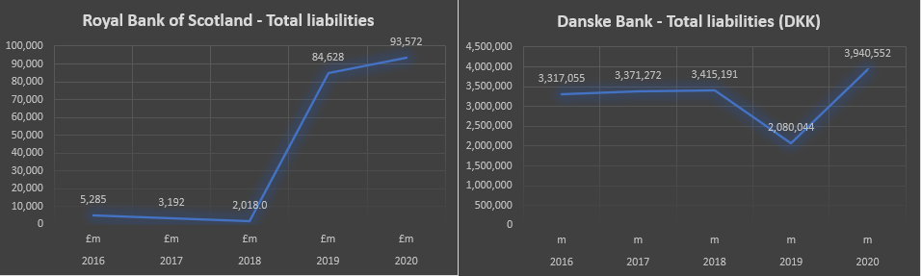
Figure 4, Royal Bank of Scotland and Danske Bank’s Total Liabilities 2016 to 2020.
Equity represents the stake held in the company by shareholders after assets minus total liabilities. Part of the capital has risen from cost cuts and asset sales, and RBS has been holding onto its capital with the hope to buy back shares from the British government (Cruise and Withers, 2019).

Royal Bank of Scotland’s Return on Equity (ROE)
Table 10, Royal Bank of Scotland’s Return on Equity (ROE) 2016 to 2020.
The above ROE ratio shows in 2020, 6.45% lower than the previous year of 11.05, largely due to lower profits.

Danske Bank’s Return on Equity (ROE)
Table 11, Danske Bank’s Return on Equity (ROE) 2016 to 2020.
Danske Bank has seen it return on equity drop from 8.83% in 2019 to 2.72 in 2020. This was due to the net profit dropping from 15,068m DKK in 2019 to 4,589m DKK, causing the ROE to fall significantly.

Efficiency and Provision Ratios
Efficiency ratios are used to examine banks or businesses to understand how efficiently they employ their resources and capital assets to generate revenues. Generally, it shows how much cash is generated against the expenditure. It is also considered better if the ratios are lower; banks commonly aim to achieve 50/60% efficiency (Padberg, 2017).

Royal Bank of Scotland’s Efficiency Ratio
Table 12, Royal Bank of Scotland’s Efficiency Ratio 2016 to 2020.
Cost to income ratio is a crucial ratio for banks to measure the bank's earnings. It takes into operating costs like staff costs, premises and equipment, depreciation and amortization; however it does not include impairment losses. The impairment is the bad debts from an investment that has very little or no value has been written off; excluding this cost will give you a clearer ratio. The lower the ratio the more profitable, this in effect telling the investor how much is being earned per pound. RBS in 2016 had an efficiency ratio of 39.76%, with an operating expense of £33m operating profit before the impairment charge of £83m. In contrast 2020, the ratio was 82.61%, much higher; however, while the operating expense was much higher at £874m likewise, the profit was high at £1,058m, making the ratio much higher. Though much lower in profit and cost in 2016, the ratio indicates the bank earned more money for every pound employed (MoneyWeek, 2021).

Risk Ratios
An Interbank is a short-term or overnight borrowing of money between banks. This is done to manage liquidity and reserve to stop the shortfall of liquid cash. Banks may lend money to other banks as they may hold extra cash surplus and earn interest payments. Likewise, banks may need to borrow when there is a shortfall and pay interest (FREIXAS and JORGE, 2008). The interbank ratio helps banks to measure the liquidity risk; having an interbank ratio of above 100% is considered low risk.

Royal Bank of Scotland’s Interbank Ratio
Figure 5, Royal Bank of Scotland’s Interbank Ratio 2016 to 2020.
RBS interbank ratio in 2016 was at 228.21%, which is exceptionally high; however, this had improved by 2019 to 102.78% lowering liquidity risk. This was due to lower loans to other banks and higher deposits by other banks, narrowing the ratio. The lower ratio reduces liquidity risk in an event depositors may withdraw large sums of money. However, relying on another bank's funds can put the bank in a risky position, a shortfall of funds.

Danske Bank’s Interbank Ratio
Figure 6, Danske Bank’s Interbank Ratio 2016 to 2020.
Danske Bank has a very high interbank ratio, and this is due to high loans to other banks and low deposits by other banks. Danske Bank also uses its cash by lending to other banks and receiving interest earnings. 2020 the income from other interest was 41,133m DKK; this was higher than the interest income at 23,219m DKK. It shows a bank's ability to create an income stream from several sources like short-term lending to other banks.

Royal Bank of Scotland’s Loan-to-Deposit Ratio
Table 13, Royal Bank of Scotland’s Loan-to-Deposit Ratio 2016 to 2018.
Loans to deposit ratio evaluates the bank's liquidity can be exposed if customers decide to withdraw their savings. The sudden withdrawal can cause a shortfall or a bank closure if customers feel the bank may go bust. To avoid low liquidity and stay within a safe range, it is recommended to have a low ratio, nothing more than 80%. RBS has maintained its ratio of 57.64% in the 2020 show. RBS achieved lower loans and higher deposits by efficiently managing liquidity (Ahern, 2021).

Royal Bank of Scotland’s Tier 1 Capital
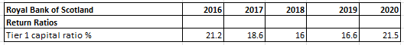
Table 14, Royal Bank of Scotland’s Tier 1 Capital Ratio 2016 to 2020.
Basel III Accord regulation that banks are required to maintain a minimum of 6% Tier 1 capital. The Tier capital assesses the banks credit risk by measuring its core capital against the total risk-weighted asset. For example, RBS Tier 1 is at £5,400m divided by Total Risk-Weighted Asset (RWAs) by £25,133m, and the ratio is 21.5%, which is better than the previous year of 16.6%. The reason the ratio is lower in 2019 is due to the higher (RWAs) £28,920m. The ratio indicates the RBS financial strength of the bank that should be able to withstand any volatility in the banking industry (Padberg, 2017).

Danske Bank’s Tier 1 Capital

Table 15, Danske Bank’s Tier 1 Capital 2016 to 2020.
Danske Bank has maintained its Tier capital Ratio above 20% from 2017 to 2020, higher the ratio the better. The bank in a good position to withstand any volatility.

Final Evaluation of Royal Bank of Scotland and Danske Bank
Royal Bank of Scotland had a turbulent history as it was bailed out by the government using taxpayer money. Considering the bank had a terrible history, it was able to restore its previous glory and bring it back to profitability. RBS has paid its first dividend of £45.5bn since its bailout ten years ago (Davies, 2018). Figure 1, the performance had been staggering from 51m interest income in 2016 to £1,717m in 2020. Historically interest rates have been low since 2008, making money very cheap for borrowing (Haqqi, 2022). Consumers are influenced by the low rate and borrow more money in mortgages and loans; consumers generally spend more with credit and debit cards creating revenues for the banks like RBS, who benefited from the low rates. Danske has performed well throughout the trading year from 2016 to 2018. However, Danske Bank saw a reduction of interest income drop to 23,219m DKK in 2020, a 25.5% change.
Comparing both banks using Net Fee Income, RBS has a ratio of 110.11% in 2020, while Danske bank's Net Fee Income ratio was at 358.12% in 2020. This was due to Danske bank's decline in net operating income, causing the ratio to be higher than normal; this ratio can be deceptive at times (see tables 3 & 4). Net Interest Margin (NIM) was used to understand how much the asset generated income. RBS (NIM) in 2020 was at 1.54%; this had improved from the 2016 ratio of -0.84%. Danske bank’s (NIM) was at 0.68% in 2020, much lower than RBS; it shows Danske was paying more interest on its savings than generating interests from its assets that have been employed (see tables 5 & 6). Return on Assets (ROA) = NPAT/Total Assets for RBS stood at 0.37% in 2020, Danske Bank (ROA) was at 0.11% in 2020. Though both banks showed a drop in (ROA), Danske has seen a more significant drop due to loan impairment charges that decreased the Profits.
RBS Interbank Ratio in 2020 at 102.78% has lowered its liquidity risk; in contrast, Danske Bank has a very high of 485.18% in 2020 and a higher risk of liquidity. Danske Bank has lower liquidity, putting the bank at a higher risk of cash shortage if large groups withdraw cash from the bank. RBS Tier 1 Capital in 2020 was 21.5%. Danske Bank’s ratio for 2020 was 20.5%. Both banks have maintained a reasonable ratio; however, the ratio for Danske Bank has been more consistent for the last five years.

Part 2. A Study of Nationwide Building Society

Introduction
Nationwide Building Society's story started back in the early 19th century. When every day was a challenge for job seekers, people flocked to the cities from the countryside seeking jobs. Housing was an issue for migrants; many could not afford to buy homes and renting were other options. To mitigate this housing crisis, individuals pooled their savings in aid to help each other buy homes. This was the start of the Co-operative Permanent Building Society, which opened it doors in 1884; by 1970 it had changed its name to Nationwide. The assignment is an examination of the Nationwide Building Society and how its functions and how differs from the high street banks. It will also analyze products and services offered by building society and compare them against a bank. The assignment will observe the products and services developed for the consumers and how it has changed with the environment.

Overview of Nationwide Building Society
Nationwide Building Society is a British mutual financial institution, currently number 7th largest in the world with 15 million members. Initially founded in Swindon, England and current headquarters is situated there. The mutual employees 18,644 personnel as of 2021 and is listed in the stock market with a market capitalization of 1.85B GBP (Google Finance, 2022).

The Difference Between a Mutual and Banks
Building societies consider themselves to be a mutual bank; the customers are considered a member of the society and the bank is owned by them. Mutual banks were originally organized to aid lower-income individuals to have a safe place to put their savings and earn interests; this tradition still continues. Building society operates solely for the benefit of customers and the communities. Profits are returned to the customer through better saving rates, and lesser fees are charged and working closely with local charities. According to Rasmusen (1988), banks are different; some refer to them as stock banks, and the key difference in both institutions is who controls them. A bank is owned by its shareholders and vote in a manager to run the bank on their behalf, the profit earned is shared amongst the shareholders, so the managers are constantly working hard to make their shareholders happy. The shareholders are also free to sell their shares. The depositors in the banks are just customers; however, a mutual bank is owned by customers but not controlled by them.

Primary Earnings of Building Society
Table 16, Income Statement (Nationwide Building Society, 2022).
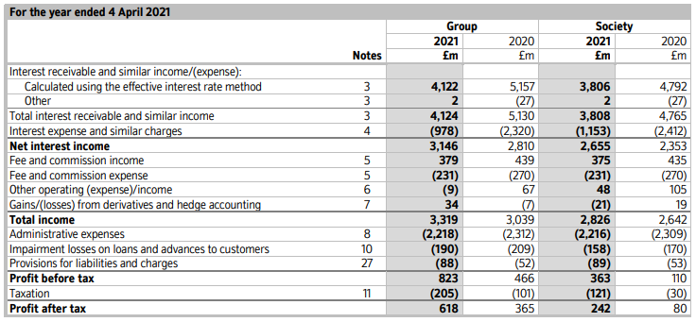
The primary function of the Nationwide Building Society is to offer its members mortgages and savings facilities. Like most banks building societies, primary earnings derive from the interest earnings from the mortgage. Customers will pay higher interest rates on the mortgage and receive lower interest rates on their savings, and the difference is the profits. This interest income minus the interest expense and the amount remaining is interest income. For example, currently, Nationwide is offering a mortgage interest rate of 2.39% monthly fixed for 2 years on a 180-thousand-pound loan. Calculating the annual percentage rate (APR) 2.39%^12= 32.76%. Having a 2-year fixed rate bond a saver will be paid 1.4% an annual equivalent rate (AER) paid annually on the fixed savings.

Other Source of Earnings by Nationwide Building Society
Table 17, Interest receivable and similar income (Nationwide Building Society, 2021).
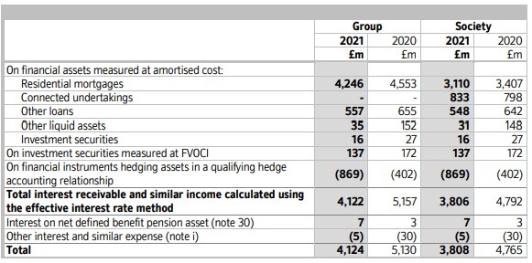
Similar to a bank, mutual’s have a variety of investments and assets that they receive in the form of interest income. The bank loans and advances to other banks and similar institutions earn short-term earnings like interbank lending and long-term interests. The banks also buy investment securities like income bonds, shares, mutual funds, and properties to earn income. These assets are the second most important earnings for Nationwide and make up the total asset in the accounts. Though mortgages are important long-term earnings for mutual, additional earnings derive from the sales. Fees are charged for processing the mortgage, life insurance and mortgage protection insurance are sold with a mortgage. Building insurance is necessary for the mortgage's lifetime; contents insurance is sold too. Buyers may also purchase critical illness and income protection insurance to protect them against sickness and unemployment.

A comparison of Products and Services
Both banks and building societies have evolved and now offer similar products and services. Since the introduction of The Building Societies Act of 1986 mutuals were able to expand their service and products (BSA Org, 2013). Nationwide has added products like credit cards, insurance cover, internet banking, business banking, and current accounts.
High street banks have evolved too; banks are now offering mortgages to their clients. Previously, many mortgage companies were listed on stock exchange, underperforming mortgage companies became victims of takeovers or mergers, and banks now had more access to mortgage products. Banks also offer additional facilities like share trading accounts and commercial loans. Nevertheless, both banks and building society offer similar products and services, competing for the very same customers.

Compering Product and Services Between Nationwide Building Society and Barclays Banks
Nationwide Building Society | Barclays Bank
Mortgage  Personal loans  Overdrafts  Internet/telephone, branch banking  Insurance  Business banking  Business loans  Current/premier/saving accounts  Stock market services (not available) only ISA.  Credit, and debit Card | Mortgage  Personal loans  Overdrafts  Internet/telephone, branch banking  Insurance  Business Banking  Business loans  Current/premier/savings accounts  Stock market service full service  Credit, and debit card

Comparing products and services between Nationwide Building Society against Barclays Bank. Both banks have very similar products and services and operate in a similar manner.

Performance of Building Societies Versus Banks
In the journal of Banking and Finance Valnek (1999) wrote from 1989 to 1993, building society financed 71.2% of the mortgages. However, the paper report went on to highlight the key issues of ownership of mutual; this owner system is considered an old structure. The argument here is that managers cannot be held accountable for their mishandling as the members have no say. This isn’t the case for stock banks, where shareholders can vote and choose their managers to serve them. This brings up the issue that managers of mutual banks may serve their interest, while stock banks will serve the interest of shareholders. The banks have a structured mechanism to motivate managers, rewards and bonuses. Mutual organizations have other benefits; since there is a fewer incentives, managers also don’t enter high-risk projects; this was highlighted by Rasmusen (1988). Members can feel safe as managers will not take unnecessary risk. Managers in mutual also feel safe since there is little control from outside the organization. Mutual organizations have other benefits, especially when making decisions; this is done with a few individuals, so decisions are very efficient. The study also found that mutual bans constantly outperformed the retail banks. The study also found that retail banks are more affected by negative outcomes. Furthermore, the paper suggests both banks and mutual have similar risks; however, banks get less compensated for their risks.

Using Ratios to Measure Performance and Financial Strength
Nationwide Building Society | Barclays Bank
Total Tier 1 Capital Ratio 40.5% | Total Tier 1 Capital Ratio 19.2%
Common Equity Tier 1 Ratio (CET1) 36.4% | Common Equity Tier 1 Ratio (CET1) 15%
Leverage Ratio 5.4% | Leverage Ratio 4.9%
Net Interest Margin (NIM) 1.12% | Net Interest Margin (NIM) 2.93%
Table 18, Source, Nationwide Building Society’s Annual Accounts (2021); Barclays Bank's Annual Accounts (2021).
Nationwide’s total tier 1 capital ratio is at 40.5%, having better capital adequacy ranking than Barclays 19.2%. In an event failure, Nationwide will absorb losses better than Barclays. Nationwide’s common equity tier 1 ratio (CET1) is at 36.4%, Barclays is at 15%, the banks use their core capital like ordinary shares retained earnings like dividends and issue of instruments. Nationwide has better positioned to withstand any losses as its (CET1) is much higher than Barclays. According to Nationwide’s leverage ratio is 5.4%; the building society has a larger debt capital than Barclays bank, but only buy a small margin. The net interest margin for Nationwide is at 1.12%, and Barclays is at 2.93%; Barclays has more interest earnings and lower interest expense. However, mutuals pay more interest on their members accounts and charge lower interest in their mortgages; this results in a lower (NIM) ratio. Using the above ratio, Nationwide scores very high, having strong assets and a low-risk business model keeping members safe.

Digital Banking System
The financial institution has gone through immense change since the introduction of IT technologies. Since the growth of the internet, personal computers and handheld gadgets like mobile phones have changed the way, consumers do their banking activities. This was tested in the pandemic when banks and most shops had to close their business due to the risk of infection. However, many customers could do online banking through their apps or PC, paying bills, setting up direct debits taking and out insurances. Banks and Building society are taking advantage of this new trend reducing operational costs. While many customers can do their finances on the internet, there is very little need for high street banks. Self-serving Kiosk have been introducing in high street banks and building society to reduce the workforce and save on salary, making banks more profitable. New technologies are constantly added to enhance user experience to aid the development of digital banking. Consumers also see very little need to carry cash as most buying activities can be processed using credit and debit cards, in the near distant future, the world is going cashless, reducing more costs of printing money (Vaidya, 2021). Credits will be on the decline as most people can make payments through their phones and apps. Online banks are currently growing; many popular banks have appeared online, like Starling bank, Revolut, and Atom Bank.

Conclusion
Part of the report analyzed the financial activities of Royal Bank of Scotland and Danske Bank and made comparisons between both banks. The study first analyzed both banks using income profit ratios using interest expense margin, net fee income, net interest margin to understand the profitability of both banks. Return ratio like return on assets, and return on equity was used to understand measure how effectively an investment is being managed, the ratio compared the gain or loss from an investment relative to its cost. The efficiency ratio was utilized to examine how effectively the bank uses its resources and capital to generate revenues against expenditure. Risk ratios were used to examine the risk associated with low liquidity and how it can be managed by having a contingency plan. Part 2 of the study focused on the Nationwide Building Society. The study was to understand how mutual bank operate and understand the difference products and services. The study found that mutual banks generally operate very similar to traditional bank. However, the study found the key difference is mutual consider account and mortgage holders as members. The sole purpose is to serve the members with better saving rates and cheaper mortgages, and all profits are returned to the members in the form of better interest rates. Banks see the account holders as customers, creating wealth and working to enhance stockholders.

Reference Page
Ahern, D. (2021). How to Calculate the Loan to Deposit Ratio, with Average LDR of the Big Banks. [online] Investing for Beginners 101. Available at: https://einvestingforbeginners.com/loan-to-deposit-ratio-daah/ [Accessed 14 Apr. 2022].
Bank of England (2020). Interest Rates and Bank Rate. [online] Bank of England. Available at: https://www.bankofengland.co.uk/monetary-policy/the-interest-rate-bank-rate [Accessed 14 Apr. 2022].
Barclays Bank PLC (2021). Barclays PLC Annual Report 2021. [online] Available at: https://home.barclays/investor-relations/reports-and-events/annual-reports/ [Accessed 17 Apr. 2022].
BSA .org (2013). The Building Societies Act 1986 - a BSA Summary Sixth Edition. [online] Building Society Association. Available at: https://www.bsa.org.uk/information/consumer-factsheets/general/the-building-societies-act-1986-a-bsa-summary-fift [Accessed 16 Apr. 2022].
CFI (2022a). Efficiency Ratios - Overview, Uses in Financial Analysis, Examples. [online] Corporate Finance Institute. Available at: https://corporatefinanceinstitute.com/resources/knowledge/finance/efficiency-ratios/.
CFI (2022b). How Do Banks Make Money? - Overview, Forms, Examples. [online] Corporate Finance Institute. Available at: https://corporatefinanceinstitute.com/resources/knowledge/finance/how-do-banks-make-money/ [Accessed 10 Apr. 2022].
Cruise, S. and Withers, I. (2019). Investor Frustrations Build as RBS Grapples with Excess Capital Conundrum. [online] Reuters. Available at: https://www.reuters.com/article/rbs-capital-idINKCN1TY1VY [Accessed 12 Apr. 2022].
Danske Bank Group (2020). Financial Results Three Months to End March 2020 | News and Insights | about Us | Danske Bank. [online] danskebank.co.uk. Available at: https://danskebank.co.uk/about-us/news-and-insights/financial-results-three-months-to-end-march-2020 [Accessed 12 Apr. 2022].
Davies, R. (2018). RBS Pays Its First Dividend since £45.5bn Bailout 10 Years Ago. The Guardian. [online] 12 Oct. Available at: https://www.theguardian.com/business/2018/oct/12/rbs-pays-its-first-dividend-since-bailout-10-years-ago [Accessed 15 Apr. 2022].
FREIXAS, X. and JORGE, J. (2008). The Role of Interbank Markets in Monetary Policy: a Model with Rationing. Journal of Money, Credit and Banking, 40(6), pp.1151–1176.
Gerken, W., Eakins, S.G. and Mishkin, F.S. (2012). Study Guide for Financial Markets & institutions, Frederic S. Mishkin, Stanley G. Eakins, Seventh Edition. Boston: Pearson Prentice Hall.
Google Finance (2022). Nationwide Building Society (NBS) Stock Price & News - Google Finance. [online] www.google.com. Available at: https://www.google.com/finance/quote/NBS:LON?sa=X&ved=2ahUKEwjF64Sn-pj3AhWEQEEAHfssCwMQ3ecFegQIERAg [Accessed 16 Apr. 2022].
Haqqi, S. (2022). Bank of England Base Rate | money.co.uk. [online] www.money.co.uk. Available at: https://www.money.co.uk/mortgages/bank-of-england-base-rate [Accessed 15 Apr. 2022].
KPMG (2020). COVID-19: Impact on the Banking Sector - KPMG Global. [online] KPMG. Available at: https://home.kpmg/xx/en/home/insights/2020/07/covid-19-impact-on-banking-m-and-a-2020.html [Accessed 10 Apr. 2022].
Kumar, R. (2018). Interest Margin: [online] id.elsevier.com. Available at: https://www.sciencedirect.com/topics/economics-econometrics-and-finance/interest-margin/pdf [Accessed 14 Apr. 2022].
Makortoff, K. (2020). RBS Profits Halve as Bank Takes £800m Coronavirus Hit. [online] The Guardian. Available at: https://www.theguardian.com/business/2020/may/01/rbs-royal-bank-scotland-profits-bank-coronavirus [Accessed 11 Apr. 2022].
MoneyWeek. (2021). Cost/income Ratio. [online] Available at: https://moneyweek.com/glossary/cost-to-income-ratio [Accessed 15 Apr. 2022].
Nationwide Building Society (2021). Annual Report and Accounts 2021. [online] Nationwide Building Society. Available at: https://www.nationwide.co.uk/about/corporate-information/results-and-accounts [Accessed 16 Apr. 2022].
Nationwide Building Society. (2022). Compare Savings Accounts & ISAs | Nationwide. [online] Available at: https://www.nationwide.co.uk/savings/compare-savings-accounts-and-isas/ [Accessed 16 Apr. 2022].
Padberg, T. (2017). How to Analyse Bank Financial Statements : a Concise Practical Guide for Analysts and Investors. Petersfield: Harriman House.
Rasmusen, E. (1988). Mutual Banks and Stock Banks. The Journal of Law and Economics, 31(2), pp.395–421.
Sammut-Bonnici, T. and Galea, D. (2015). SWOT Analysis. Wiley Encyclopedia of Management, [online] 12(1), pp.1–8. Available at: http://onlinelibrary.wiley.com/doi/10.1002/9781118785317.weom120103/abstract.
Vaidya, N. (2021). Capgemini BrandVoice: Why Is Automated One-Stop-Shop Online Banking the Future of Business Banking? [online] Forbes. Available at: https://www.forbes.com/sites/capgemini/2021/11/01/why-is-automated-one-stop-shop-online-banking-the-future-of-business-banking/?sh=4959272047f4 [Accessed 17 Apr. 2022].
Valnek, T. (1999). The Comparative Performance of Mutual Building Societies and Stock Retail Banks. Journal of Banking & Finance, 23(6), pp.925–938.
Yuksel, I. (2012). Developing a Multi-Criteria Decision Making Model for PESTEL Analysis. International Journal of Business and Management, [online] 7(24), pp.52–66. Available at: https://www.researchgate.net/profile/Ihsan-Yueksel/publication/274863692_Developing_a_Multi-Criteria_Decision_Making_Model_for_PESTEL_Analysis/links/569aaf1708ae6169e55dad01/Developing-a-Multi-Criteria-Decision-Making-Model-for-PESTEL-Analysis.pdf [Accessed 13 Apr. 2022].

