BMIH6005
Organisational Consultancy

Name of the Report: Strategic Operations Transformation at Marina Bay Sands - Operations Department: A Comprehensive Consultancy Report by Lions Advisory
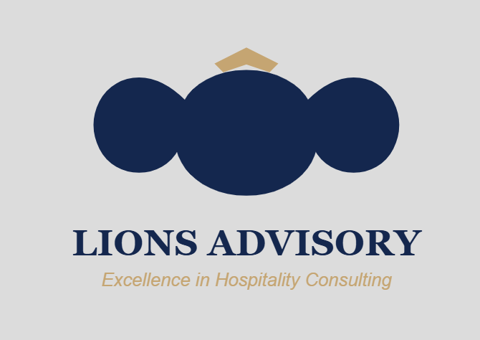

Student Name: Gheorghe Plescan
Student Number: 2234901
Name of the Company: Marina Bay Sands in Singapore

Executive Summary
Lions Advisory, a hospitality consulting firm, has identified key issues that affect Marina Bay Sands (MBS) and provided a strategic recommendation on how to improve on its performance and position in the luxury hospitality industry. Having opened in 2010 as Singapore’s first integrated resort with over 2,500 rooms now, annual revenues for MBS exceed USD 3.88 billion with the Q3 2023 net revenue of USD 1.01 billion, which makes up 35% of Sands Corporation's total revenue. Nonetheless, there are several threats that have a close relationship with the Caribbean; they include heavy reliance on casino business giving the company 65% of its revenues, increasing operation costs, and changing customer profiles, which necessitate radical changes to operations.
There are several findings that were identified through the market research and the later data analysis in the strategic analysis process. Singapore still has strong tourism statistics for the present year, 2023, where international arrivals recorded 13.6 million, and the annual tourism receipts were expected to surpass (Singapore dollar) SGD 25 billion in the year 2024. Nonetheless, MBS has operational risks such as high electricity tariffs charged at an average of SGD 0.30 per kilowatt-hour and a high job vacancy rate of about 6.6% in mid-2023. Current trends in travel reveal that 88% of the international travellers seek sustainable lodges, and the middle-class consumers of the SEA region are projected to be 350 million in 2030. The hotel achieves an average occupancy of 92% annually and greatly benefits from it, though the emerging integrated resorts in the Southeast Asian region put pressure on the company to differentiate services and optimise operations.
By utilising STEEPLED, SOAR, and TOWS, there is a clear sign of the huge room for improvement. Others include the fact that operationally executing intelligent services saves up to 20% and that sustainability practices will cut utility expenses by up to 15%. In their perspectives on market diversification and revenue generation, the increased middle class and the demand for sustainable luxury stays are apparent. Businesses using environmental focalisation strategies find these have positive impacts on operating costs, and customer-targeted campaigns have an effect on increasing the number of loyal guests.
Based upon the analysis, Lions Advisory is advised to pursue six strategic recommendations that shall cost £18.5 million to implement. First, new and additional income streams should be looked at by looking into wellness tourism, family entertainment, and culture earnings (£4.5 million) as a means of increasing the earnings of the county. Second, use artificial intelligence in maintaining and enhancing client services (£3 million). Third, apply smart systems and sustainable operation of processes by improving energy efficiency (£5.5 million). Fourth, training (£2.2 million—includes the development of employees through formal training programs and by reward and incentives based on performance). Fifth, increase marketing areas for targeting middle-income people (£1.8 million). Sixth, subsequently, digital marketing should increase its outreach by launching special (£1.5 million). The duration of implementation varies between 6 to 12 months with quantifiable targets set for each of the planned initiatives.
The company strives to maintain and strengthen its market position of market leadership after implementing the strategic framework for MBS. By putting into practice these measures, the resort shall be able to experience improved revenue status for growth, increase operational efficiency, and tap the populace. Such measures are centred on bettering non-gaming revenues, customer satisfaction through the use of Net Promoter Score, diminishing utility costs through sustainability, and employee satisfaction with higher retention. It also gives specific timeframes for the implementation of each action and results that are easy to assess to measure success.
The following strategic change will improve MBS’s competitive advantage and favourable financial characteristics, as well as guarantee all guests’ high satisfaction. From the analysis, the proposed projects are in tandem with the market trends as well as the customer needs, wants, and demands across its operations and growth. With the help of these recommendations, MBS will be able to hold the leadership position, satisfy the guests, optimise the processes, and guarantee the financial stability in the competitive environment of the luxurious hotel business.

Table of Contents
Executive Summary 2
1.0 Introduction 5
1.1 Overview of the Company 5
1.2 Background of the Consultancy Firm 6
1.3 Objectives of the Report 7
2.0 Comprehensive Analysis of Marina Bay Sands 8
2.1 STEEPLED Analysis 8
2.2 SOAR Analysis 12
2.3 TOWS Analysis 14
2.4 TOWS Strategies 16
3.0 Strategic Recommendations and Change Management 18
3.1 Strategic Recommendations 18
3.2 Measuring Impacts and Success 20
3.3 Potential Benefits of Implementing Recommendations 21
3.4 Cost Analysis 23
4.0 Action Plan 24
4.0 Conclusion 26
References 27

1.0 Introduction

1.1 Overview of the Company
The global economic growth largely depends on the tourism industry, which in turn depends on luxury hotels focusing on customised services and high-quality service delivery (Burnes, 2014). A good example of this success is the Marina Bay Sands (MBS), which opened in 2010 as one of the world’s leading luxury hotels and integrated resorts. Located in the Marina Bay district of Singapore today, Marina Bay Sands boasts over 2,500 rooms and suites and a number of other facilities such as a casino, luxury shopping mall, restaurants, and its famous rooftop pool (Marina Bay Sands, 2024).
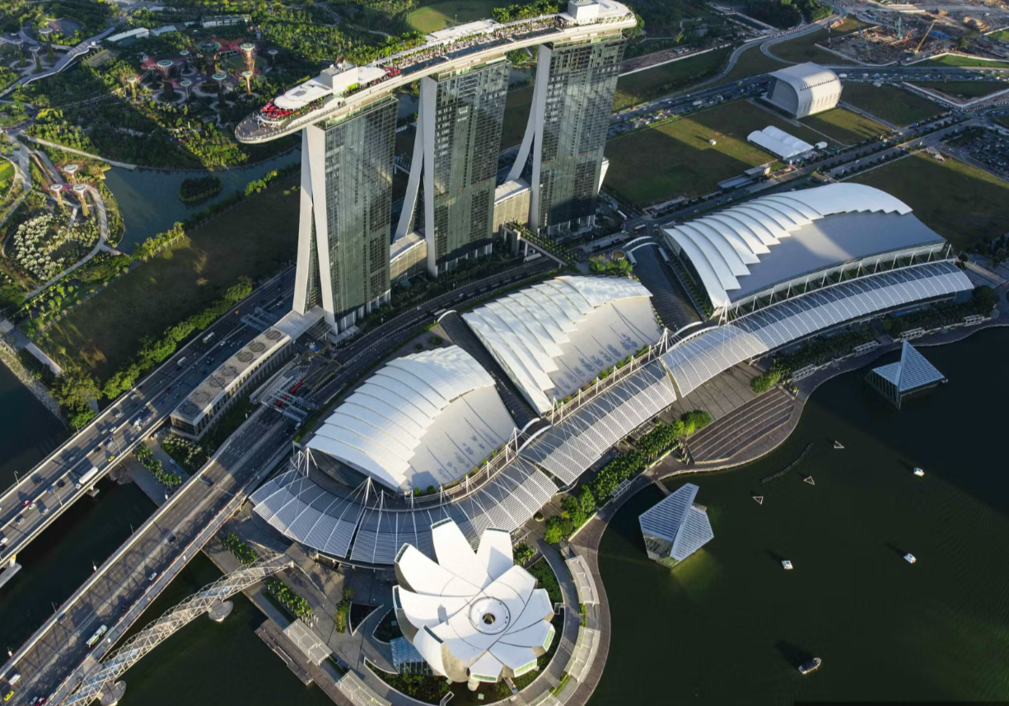
Figure 1: Marina Bay Sands (Singapore), Source: (Mariana Bay Sands, 2024).
As a company with more than 10,000 employees and an annual revenue of more than USD 3.88 billion, MBS has an important role in Singapore’s tourism and economy. Sands Corporation’s total net revenue was $1.79 billion in Q3 2023, which is so much higher than the $258 million it received in Q3 2022 (Marina Bay Sands, 2024). However, MBS faces operational threats such as instability of customer satisfaction, cost increase, and issues of sustenance. This is important in order to continue being a key player in the market as competitors come up with new strategies to overcome its barriers.
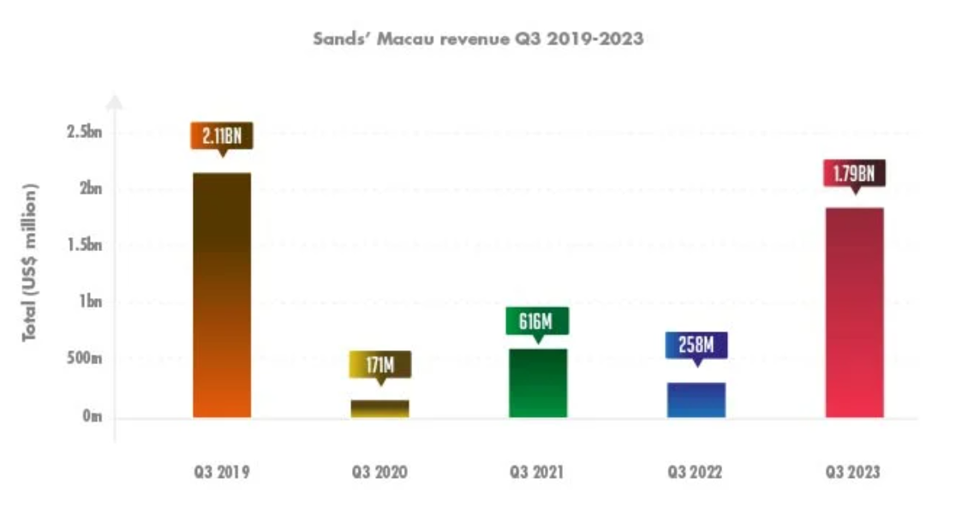
Figure 2: MBS’s 3rd Quarter Revenue, Source: ((Marina Bay Sands, 2024).

1.2 Background of the Consultancy Firm
Lions Advisory, which was hired for solving the challenges of the company is the specialist consultancy firm that provides strategic solutions. Lions Advisory operates as a leading consulting company that delivers strategic operations and market positioning services for luxury hotels and integrated resorts throughout Asia-Pacific territories. Lions Advisory exists as a hospitality consulting firm that was established in 2015 to unite consultant experience with analytical insights for transformational results. The organisation achieves status as an operational efficiency leader alongside strength in revenue optimisation and sustainability integration and digital transformation approach success. Through effective partnerships, Lions Advisory proves its expertise by delivering positive results to luxury hospitality brands that achieve market success while preserving upscale standards along with financial growth.

1.3 Objectives of the Report
Several strategic frameworks were used in the report to capture all the concerns that face MBS and the available possibilities for investment. First, in the STEEPLED analysis of the hotel environment, there is an examination of the social, technological, environmental, and economic surroundings affecting the hotel operations. For example, the adoption of sustainable travel by all customers and environmental regulations in Singapore exerts pressure on organisations, hence requiring green operation changes (Cheong and Lee, 2021). High costs of energy and growing concern for the environment justified the need for MBS to embrace sustainable management of resources in order to cut down on costs and to meet guest expectations. Subsequently, the SOAR analysis shall reveal where MBS stands and the possible area of growth. This aspect of the hotel also offers a wide and desirable opportunity for a boost in customer satisfaction and the enhancement of various business processes (Shin and Jeong, 2022). For instance, applying technology can improve the guest experience or, at the same time, improve efficiency in other areas.
After this, the TOWS matrix will convert the threats and weaknesses into a meta-strategy. This will ensure the strategic alignment as it is faced with challenges, including a shortage of labour and operational inconvenience. On similar lines, workforce training programs combined with automation can reduce risks arising from workforce disruption and enhance sustained productivity (Pang, 2020). Last but not least, this report, which is prepared by Lions Advisory, will give an evaluation of MBS’s threats and opportunities with the help of the STEEPLED, SOAR, and TOWS tools. Using some of these strategic models, the consultancy will provide well-substantiated recommendations that respond to the operation and strategic direction of the hotel. However, based on the MBS’s sound structure and measures, it has the potential to overcome its threats and create memorable experiences for its visitors, tailoring sustainable growth in the stiff hospitality industry.

2.0 Comprehensive Analysis of Marina Bay Sands

2.1 STEEPLED Analysis
It is essential to explore the STEEPLED factors prevailing in the working environment of Marina Bay Sands to have a clear perception of the external forces affecting its functioning in Singapore’s cut-throat luxury hospitality industry.
Social Factors: Singapore has a rich cultural and ethnic population, which contributes to the millions of annual tourists, so such a market impacts MBS’s services. According to the STB (2024), Singapore received 13.6 million international tourists in 2023, and Indonesia is one of the leading countries with 2.3 million tourists. This multicultural diversity implies that the services have to be personalised to suit the needs and desires of the guests (Shin and Jeong, 2022). MBS hence needs to offer products that are unique to the guests, such as foreign languages and specific dish cuisines, to further strengthen its competitive advantage.
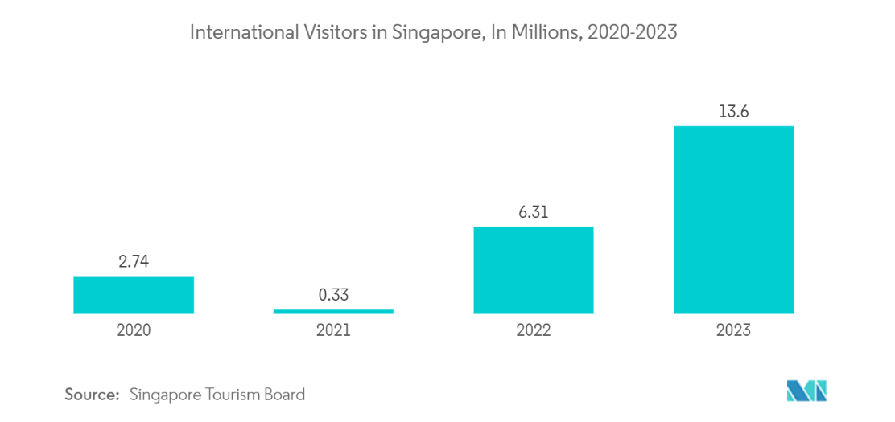
Figure 4: International Visitors in Singapore, Source: (STB, 2024).
Technological Factors: Today, there is robust technological advancement that has shifted the hospitality industry, including MBS, to apply the changes with increased adoption of technology in various operations and customer service delivery. It also has check-in machines and a smart energy system for operations in the hotel whereby resource utilisation is optimised in order to reduce costs (Marina Bay Sands, 2024). They include artificial intelligence that can be used to enhance services and other resources such as virtual and predictive maintenance solutions (Liu and Yang, 2021). Nevertheless, technological dependence has the disadvantage of requiring constant system updates and staff education.
Economic Factors: Singapore's general tourism and its tourism industry in particular, and the current economic revival after the pandemic’s impact shape MBS revenues or profitability. The country’s tourism receipts shall reach a figure of $4.62 to $5.69 billion in 2030 with a CAGR of 4.26%, outlining a stable sector growth (Mordor Intelligence, 2025). However, there are always threats such as inflation and an increase in labour costs within the region that make it hard to sustain the profit margin (Cheong and Lee, 2021). To mitigate these forces, labour cost controls, an efficient supply chain, and other cost-cutting measures will be inevitable.
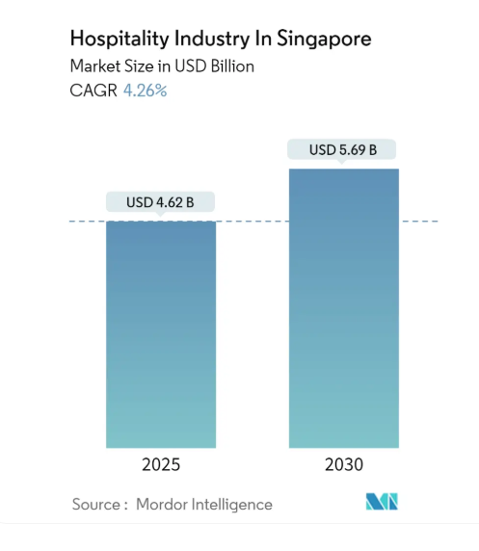
Figure 5: Hospitality Industry in Singapore, Source: (Mordor Intelligence, 2025).
Environmental Factors: The operational conduct of luxurious hotels has been affected by environmental sustainability since clients are savvy about thrifty accommodations. They have also adopted certain environmental policies, such as an energy-efficient lighting system, water management, and waste disposal (Marina Bay Sands, 2024). Singapore has set high standards that have placed many regulatory bodies as far as environmental compliance is concerned, and therefore MBS is under pressure to come up with the latest measures to implement compliance measures in order to suit both the regulatory requirements and the customers who are economically conscious of the environment (Cheong and Lee, 2021). Inability to achieve such expectations may harm the hotel’s reputation and its patronage of repeated customers.
Political Factors: The political stability of Singapore offers conducive grounds for business and foreign investment opportunities reaching out, especially because of the government’s plans to increase the operations of the hospitality industry, which provides a favourable outlook (Köseoglu et al., 2020). For example, the steady political conditions of Singapore play an important role in establishing its beneficial business terrain. The Political Stability and Absence of Violence/Terrorism index score for Singapore in 2023 reached 1.42, exceeding the worldwide benchmark of -0.06 (The Global Economy, 2024). However, the internal and external factors that may impact international travel include geopolitical risk, sales, and citizenship policies within the collaborating countries (Le and Phi, 2021). MBS must stay alert on changes in the political environment in case there are negative impacts on its operations because of the cancellation of international travel in some markets.
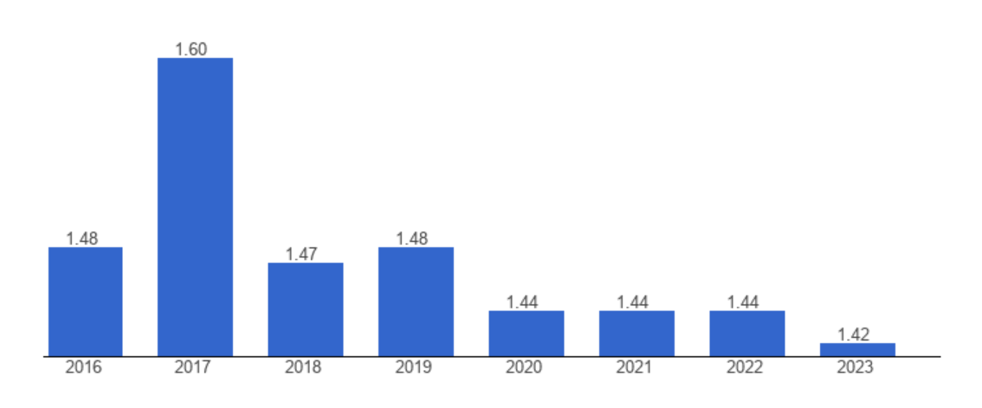
Figure 6: Singapore Political Stability Index Scores, Source: (The Global Economy, 2024).
Legal Factors: On the employment practices, safety measures, and data, the hotel has to submit to the Singapore rules and regulations. For instance, the country’s Personal Data Protection Act (PDPA) has invariant measures in ensuring the security of such information (Szende et al., 2021). Legal compliance reduces the amount of risks contributing to combined legal costs resulting from fines and loss of reputation.
Ethical Factors: As a result, keeping up with the ethical culture is critical to ensure that MBS’s reputation and shareholders’ confidence are retained. The hotel has CSR activities that seek to support community needs and promote responsible gambling (Chen McCain et al., 2019). Finally, the protection of labour rights with equal employee treatment is encouraged to enhance the company’s sustainability (Tanveer et al., 2024).
Demographic Factors: Global factors include shifting the demographic structure where middle-class tourism consumers and elderly travellers are on the increase (Yeng et al., 2018). Thus, MBS can benefit from these changes, for instance, through new services related to recreational activities for guests of the older age and special offers targeting the average middle-class families (Awan et al., 2021). These groups are considered able to enlarge the potential customer base of the hotel and thus increase the range of revenues.
Thus, the STEEPLED view shows the external environment that affects MBS as complex. If these factors are provided a strategic approach, they should open up growth avenues for the hotel and also reduce risks and sustain the market leader status of luxury hospitality for the hotel.

2.2 SOAR Analysis
This model analyses the strength, opportunities, aspirations, and relevant results of MBS, which shows how internal strength and external opportunity map for the sustainable advancement of the organisation.
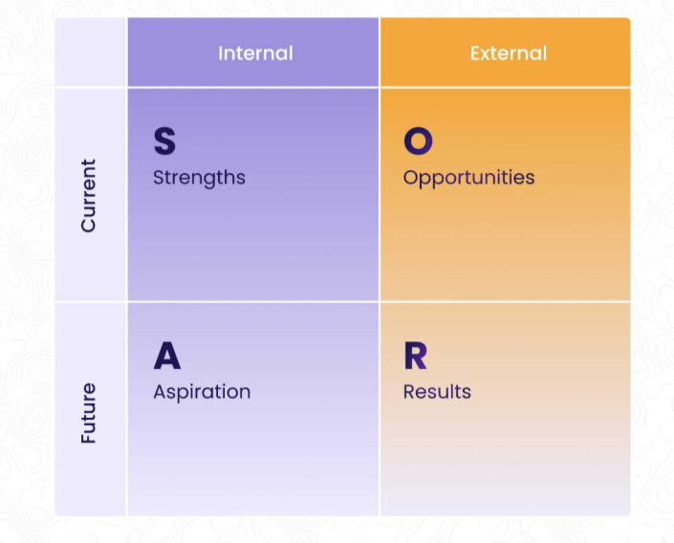
Figure 7: SOAR Matrix, Source: (Konovalova et al., 2018).
Strengths: MBS relies on Singapore's lack of political risk and the pro-tourism policies of the country, for instance, the Marina Bay redevelopment that the company believes will sustain long-term growth (Reuters, 2024). Through optimised customer experience with AI devices, check-in kiosks, and smart applications, the operational costs are also low, thus saving 15% of energy across the globe when combined with smart energy management (Konovalova et al., 2018). Also, MBS’s sustainable measures in line with the Singapore Hotel Sustainability Roadmap 2030 have helped the company to market itself to environmentally sensitive visitors (GSTC, 2024). The high-spending individuals are significant in boosting the company’s revenue, hence maintaining the competitive edge (Mordor Intelligence, 2025).
Opportunities: The Southeast Asian middle class is likely to be made up of more than 350 million households in the next 10 years, and this presents a Southern opportunity for MBS whereby it can come up with special family-orientated and middle-end packages (Njoroge et al., 2019). For example, India has always been a significant source market for Singapore, where about one million travellers visited Singapore in 2023 (Statista, 2024). The number of visitors increased fairly as the world is gradually coming out of the COVID-19 pandemic and the associated restrictions on travelling. With global attitudes to sustainable travel increasing, international sustainable tourism increasing (88% of travellers are interested in sustainable accommodations), MBS also increases its carbon-neutral initiatives and eco-certified rooms (Ben Youssef and Zeqiri, 2022). AI-based customer service e-services and solutions have great forces to address and create new chances to enhance customer goodwill, where the customer retention rate has been enhanced by 20% (Lam et al., 2022). Expanding to high AHC (actual individual high-consumption expenditure) individuals will yield even more revenue (Mordor Intelligence, 2025).
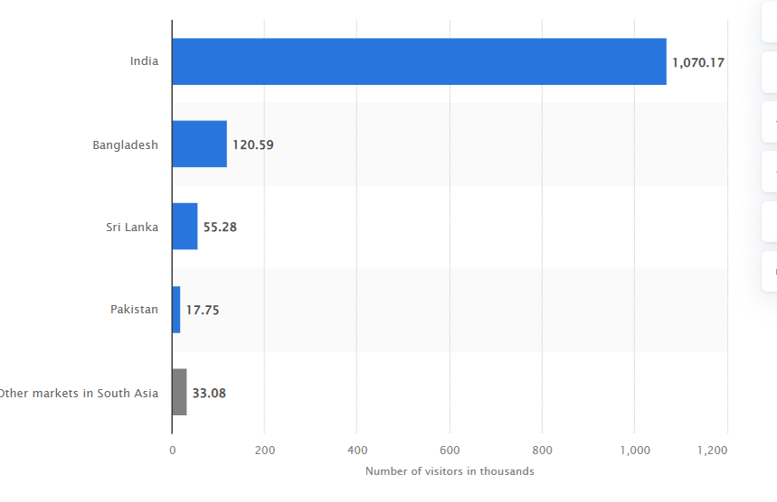
Figure 8: Visitors form South Asian Countries to Singapore, Source; (Statista, 2024).
Aspirations: MBS looks forward to sharing the ambition of assuming the role of a model luxury hospitality firm to adopt operational practices complementing the sustainable waste management and renewable energy utilisation as per the standards set by the country (Tanveer et al., 2024). Their goal is to provide guests with more customised services and for the maintenance of various facilities and equipment (Liu et al., 2020). Non-gaming activities and centres, including wellness centres and cultural experiences, are attempts to increase the revenue besides the luxury operation of hotels and target middle-class families with high expenditure and high-yielding tourists (Awan et al., 2021).
Results: MBS’s strategic goal of increasing non-gaming revenues and keeping the company’s profitability will be closing the gap in labour costs and improving resource management (CNA, 2024). It intends to achieve or even surpass the government tourism strategic goal of having at least 60% of its room stock experience an eco-certification by the year 2025 (GSTC, 2024). Moreover, the company wants achievable cost reduction objectives, most importantly through such efficiency technologies to reduce energy usage by 15%, hence increasing the margins (Lam et al., 2022). Based on the information provided in the theoretical part, operational efficiency and market diversification will enable MBS to maintain its dominant market position despite the regional geopolitical threats (Le and Khoi, 2021).

2.3 TOWS Analysis
This analysis will assist MBS in coming up with sustainable strategies that transfer the threats and complement the weaknesses by relating them to external threats to create a lasting competitive edge.
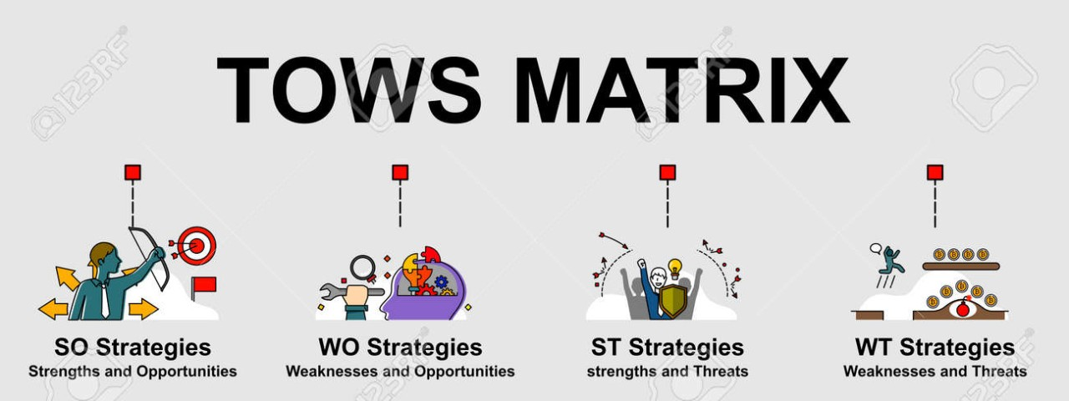
Figure 9: TOWS Matrix, Source: (Rossidis et al., 2021).
Threats: MBS encounters rising competition from integrated resort companies throughout Southeast Asia since Genting Highlands in Malaysia and Hoiana Integrated Resort in Vietnam have seen increasing popularity (Köseoglu et al., 2020). The continuous increase in operating expenses, particularly affecting workforce salaries and utility bills, creates financial challenges for MBS and related businesses. The average power rate in Singapore for 2023 reached SGD 0.30 per kilowatt-hour, which resulted in substantial utility bills for facilities such as MBS (CNA, 2024). Geopolitical instability that includes travel bans and currency volatility acts as a factor to decrease international arrival numbers (Le and Phi, 2021).
Opportunities: Presently, the luxury tourism sector in the Southeast Asian region is steadily expanding with the rising middle-class population. Since 2018, the luxury hospitality sector in Asia-Pacific has seen a 9% yearly growth and it will reach 42.8 billion by 2030 (Stellar Market Research, 2024). According to the Singapore Tourism Board (2024), it is projected that tourist receipts will be even higher at SGD 25+ billion, the international tourists being known to spend heavily. Also, hospitality is an indication that technology innovation in the industry is viable. The utilisation of AI solutions has also been shown to enhance overall hotel productivity, averaging at 20% (Tan et al., 2022). Since 88% of global travellers claim to choose to go for goods that are eco-friendly, green tourism is another potential that MBS can tap (Ben Youssef and Zeqiri, 2022). Another strategy that could be used by MBS to adjust its offer to the long-haul passengers could be entering into partnerships with international airlines (Vo and Chovancová, 2019).
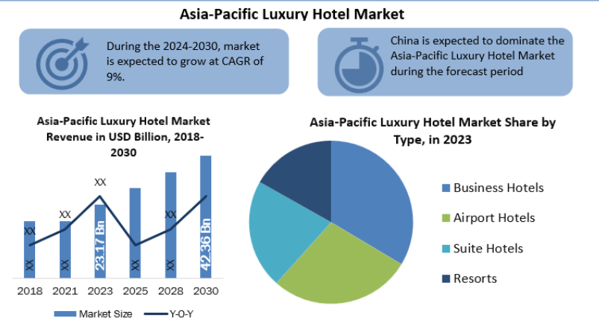
Figure 10: Asia-Pacific Luxury Hotel Market, Source: (Stellar Market Research, 2024).
Weaknesses: Due to its complete concentration on the rich and higher category of vacationers, more so with its casino business unit, MBS appears constrained in expanding its pool of budget consumers (Lia and Caesar, 2029). The gambling industry as a whole comprises about 65% of MBS’s total revenues by 2023, which puts the toll of the property under vulnerability to changes to gambling laws. Moreover, large-scale facilities come with the disadvantage of high maintenance costs in order to ensure that they are in good condition. For instance, according to Ampountolas et al. (2021), luxury hotels that are located across the globe use about $1,200 per room to maintain their facilities. There are also issues with labour supply and demand since the unemployment standing of Singapore condemned the hospitality industries with a job empty rate of 6.6% in the middle of 2023 (CNA, 2024).
Strengths: The Company has a significant competitive advantage mapped by its famous brand name and integration of hotel space, shopping centres, thematic entertainment, and convention floors (Jain et al., 2023). Singapore is connected to many countries; hence, business travellers and leisure travellers are always guaranteed (Tajeddini et al., 2020). MBS enjoys a high level of occupancy, which stands at 92% annually due to the improving tourism industry of the region (Tan et al., 2022). The seamless integration of technology in the operations of the resort, such as AI in delivering individualised services, has also added to customer satisfaction and effectiveness (Liu and Yang, 2021).

2.4 TOWS Strategies
Strengths-Threats (ST) Strategies:
- Leverage MBS’s brand image and the high occupancy levels to counter this threat by promoting its brands in response to this threat, as seen in Tajeddini et al. (2020).
- Introduce efficient technologies and solar panels to cut down on energy costs and respond to the tendencies of growing prices on electricity (CNA, 2024).
Strengths-Opportunities (SO) Strategies:
- Build relationships with international airlines and travel agencies to target new middle-class customers (Vo and Chovancová, 2019).
- Ensure that sustainability policies, like carbon-neutral events and sustainable food sourcing, are expanded to appeal to the increasing green tourism market (Ben and Zeqiri, 2022).
Weaknesses-Threats (WT) Strategies:
- Develop new sources of income based on the augmentation of non-gambling facilities such as family clubs and health resorts (Chen et al., 2024).
- Mitigate labour gaps by improving employee turnover, reducing policies through offering scarce benefits, and enhancing their staff development (Rossidis et al., 2021).
Weaknesses-Opportunities (WO) Strategies:
- Offer more mid-range accommodation services and flexible pricing strategies for it to be affordable for the price-sensitive customers (Mun et al., 2021).
- Introduce the concept of intelligent maintenance solutions to combine predictive maintenance and decrease the annual room maintenance expenses by up to 15% (Ampountolas et al., 2021).
- These will help MBS to turn threats into strengths so as to considerably reduce risks and achieve viable business advancements and development through analytics.

3.0 Strategic Recommendations and Change Management

3.1 Strategic Recommendations
Diversify Revenue Streams Beyond Casino Operations:
Association with high regulatory risks and volatility of the casino market affects MBS (Ali et al., 2019). Venturing into wellness tourism and other forms of entertainment for families, as well as cultural tours, will enthral different and unique customer bases (Toma and Grădinaru, 2018). For instance, wellness activities such as yoga and spa therapy would attract tourists who are willing to spend more, while a destination’s engaging events to appeal to all the family promote inclusiveness (Gursoy, 2018). Marketing contacts and disputes with international travel agencies and local partners will be a major factor in the long-term growth of MBS. It means that it is cross-departmental training that should be carried out to achieve staff support in the change management (Beattie and Wyer, 2019).
Strengthen Digital Infrastructure for Personalised Guest Services:
The use of artificial intelligence systems and data mining is vital in achieving individualised guest services such as room preferences, reward programs, or activity suggestions (Fauzi, 2023). Digital marketing technologies, which include mobile applications and virtual concierge services, have the potential of improving their operational performance (Martín-Rios and Ciobanu, 2019). Marketing promotions that are specific to the guest’s actions improve guest loyalty in luxury hotels, according to Nusair et al. (2019). Therefore, Lewin’s change model will be crucial to a change in technological adoption by levelling off resistance, changing, and consolidating the phase (Kotter, 2012). Staff training and technical support remain a crucial component for the integration process to be effective.
Adopt Advanced Energy Efficiency Practices:
MBS should promote the use of smart energy management systems, LED lighting, and installation of solar panels for better energy intake with less emission (Christine et al., 2023). There is also a necessity in the introduction of water-saving technologies and ecological features of rooms, as well as biodegradable and smart toiletries and climate-control systems into MBS to address tourists’ environmental concerns (Handani et al., 2022). They can also help to promote the image of the brand since sustainability is now a priority for tourists (Charlton et al., 2021). This will be supplemented with the help of external sustainability consultants, in cooperation with whom sustainability audits and evaluations will be carried out to determine the effectiveness of the project’s performance (Mirzaalian and Halpenny, 2019).
Enhance Employee Engagement Through Structured Development Programs:
High levels of job satisfaction amongst employees are important for retaining clients and low turnover rates (Baron and Armstrong, 2007). The idea is that increased company training, coaching, management, and staff workshops and development, such as mentors and leadership and stimulating practice, will increase motivation and keep valuable employees (Belias et al., 2023). Partnership with educational institutions for the development of skills will provide long-term employment training and skill upgrade prospects, as stated by Whittington and Molloy (2005). That is why performance-based rewards and career map charts may help to increase the level of employees’ loyalty (Brierley, 2006). In addressing the change management strategy, there should be feedback meetings, organisational identity programs, and, more importantly, communications that are consistent in the organisation (Subramaniam et al., 2011).
Target Emerging Middle-Class Markets:
MBS should develop packages targeting these populations as there are projected to be more than 350 million middle-class households in Southeast Asia in 2030 (Wang et al., 2022). Sale promotions offer packages with reduced days of stay and attractive prices for family-type vacations that will attract cost-sensitive customers (Seyitoğlu and Costa, 2024). Thus, partnering with social media influencers and travel agencies will help MBS obtain the visibility it needs among regional tourists (Handani et al., 2022). The marketing strategies that should be employed should emphasise the affordable luxury and present the opportunity for short breaks and long weekends and highlight what special things there are to do in each location (Fisman and Sullivan 2014). Such opportunities will involve market research to fine-tune the effectiveness of the campaigns through pilot programs.

Strengthen Social Media and Digital Marketing Presence:
To address today’s travellers, a strong online profile is required. It is therefore recommended that MBS create promotional campaigns on the internet through social media platforms, blogging, and other strategies like involving influencers (Mirzaalian and Halpenny, 2019). Thus, combined with the promotion of user-generated content and personal special offers, it is possible to increase direct sales and customer loyalty (Nusair et al., 2019). The following marketing approaches have to be presented according to the target audience, geographic location, affluence, and choice (Fauzi, 2023). It was seen that digital marketing should be monitored for its effectiveness in real time, besides having regular performance audits, with a specific focus on the returns on investment (Martín-Rios and Ciobanu, 2019).

3.2 Measuring Impacts and Success
Revenue Diversification: The performance of MBS in revenue diversification will therefore be gauged based on the annual increase of non-gaming revenues such as wellness tourism, family programs, and cultural events, among others (Toma and Grădinaru, 2018). This means that customer satisfaction surveys will be used to evaluate the extent to which the new offerings are effective in attracting various tourists, and post-event feedback will be used to analyse the results to make appropriate kinds of adjustments (Ali et al., 2019).
Digital Infrastructure Improvements: In order to measure the changes caused by digital transformation on guest satisfaction, MBS will regularly track factors such as the Net Promoter Scores (NPS) and online guest reviews (Handani et al., 2022). Increased usage of guest loyalty and more often multiple bookings will demonstrate the success of the personalisation approach. Also, the analysis of utilising rates of virtual concierge services and AI recommendations will also assist in determining system efficiency (Fisman and Sullivan, 2014).
Sustainability Initiatives: In this MBS sustainability strategy, the outcome indicators to be used to reflect on success will include energy usage, water usage, and utilities cost reduction in the company, which will be monitored monthly through smart monitoring systems, as indicated by Charlton et al. (2021). Business compliance with the national environmental standards and sustainability certifications will also act as an index of success (Arisandi et al., 2023). Finally, information on guests’ experience with various sustainability elements in the rooms will also be obtained (Mirzaalian and Halpenny, 2019).
Employee Retention and Engagement: Ensuring workforce optimisation will also be measured based on the yearly human resources data that depict the turnover level and internal satisfaction rates (Belias et al., 2023). Secondary measures include membership in training courses, mentorship schemes, and leadership development training (Brierley, 2006). The opinion of the employee during the routine performance appraisals as well as the exit interviews will reveal the areas of performance that require additions (Subramaniam et al., 2011).
Marketing Expansion Effectiveness: Monitoring the marketing actions of MBS in attracting middle-income travellers will observe the enhanced regional sales and enhance the likelihood of conversion (Nusair et al., 2019). It will also determine the level of interactions many people will be engaging with the page, click-through rates, and the number of new followers (Martín-Rios and Ciobanu, 2019). Thus, the increase in the revenues achieved through the targeted packages will indicate the extent of its efficiency (Seyitoğlu and Costa, 2024).
Digital Marketing Success: Evaluation will be outlined through indexes that focus on digital marketing by identifying the effectiveness of social media platforms (Wang et al., 2022). Such measures as conversion rates, shares in the social networks, and direct booking as an upsurge will help in understanding the extent to which different campaigns It will also help track information from the users’ posts that may assist in the evaluation of the brand loyalty and the satisfaction of the guests (Charlton et al., 2019).

3.3 Potential Benefits of Implementing Recommendations
Stabilised Revenue through Diversification: The development of MBS’s non-gaming revenues will guarantee the company’s financial solidity, which, in turn, will eliminate the highly relevant problem of fluctuations in casino operations (Johnson, 2005). Wellness tourism and cultural programs as well as children and family entertainment-related programs can attract more visitors, which will lead to better average revenues. Venturing into new markets means that it is in line with market trends and thus minimises the risk of low casino revenue for MBS by diversification (Whittington et al., 2020). This enhances the firm’s financial position or better places it to cope with shocks in the outside environment (Buttrick, 2009).
Enhanced Customer Satisfaction and Retention: The overall values of guests are considered to be maximised since a good, personalised experience makes them revisit, making it easier to retain them for longer times (Newton, 2010). Hiring AI specialists and integrating personalisation tools help MBS choose the convenient layouts of rooms, the types of dinner services, and recommend which activities should be arranged, which ones the client may be interested in (Mavridopoulou and O’Mahoney, 2020). This approach has been helpful in luxury hospitality organisations because service differentiation is essential, especially in today’s competition (Köseoglu et al., 2020). As guests’ satisfaction increases by receiving personalised services, they will provide word of mouth and positive online reviews that will bring other customers into the business; hence, a self-employment cycle (O’Mahoney, 2021).
Cost Savings through Sustainable Practices: Efficiency measures like efficient lighting systems, smart energy management, waste management, etc., bear good returns on operational costs (Noordzife, 2014). Indeed, through the application of effective green technologies, MBS can reduce the utility costs to irrelevant levels as well as enable it to meet the global standards of sustainability (Buttrick, 2009). These savings might then be invested in some other areas that are considered more important, such as the expansion of marketing and upgrades in the use of technology in operations, thus increasing profitability. Besides, the engagement of sustainable elements enhances the image of the brand, attracting the environmentally aware consumers, thereby increasing the potential for extra incomes (Tajeddini et al., 2019).
Improved Employee Morale and Productivity: For instance, skill development training, relationships between an employee and their mentors, and incentives and recognition based on employee performance all decrease turnover and enhance service delivery (Mavridopoulou and O’Mahoney, 2020). Those bits of work environment that allow the employee to grow within the organisation ultimately make them loyal, hence promoting more stability in operations (Johnson, 2005). The promotion of an experienced staff can benefit MBS through cutting costs on recruitment and training of employees; an efficient employee gives satisfactory results and excellent customer service (Whittington et al., 2020). Staff satisfaction also enhances collaboration and productivity as well as fosters innovation for future business development (O’Mahoney, 2021).
Broadened Market Reach through Targeted Marketing Strategies: Marketing strategies aimed at the middle-class group in the SEA is a great opportunity for MBS to tap into a large and growing market (Tajeddini et al., 2019). Thus, MBS can utilise dynamic pricing, promote new and flexible travel packages, and create relevant alternatives to achieve the desired motivation of price-sensitive travellers (Köseoglu et al., 2020). Working with the social media personalities and with the OTA will create customer awareness of the company (Newton, 2010). Also, it will enable MBS to improve the marketing strategies over and over again to achieve higher occupancy rates in the future consistently (O’Mahoney, 2021).

3.4 Cost Analysis
To achieve these recommendations, MBS has to factor in the corresponding costs in areas of infrastructure, people, marketing, and technology. This document provides details of the costs for each program that have been broken down to show the budget estimate for each program in the overall strategy to support MBS efforts toward strategic growth and sustainability.
Recommendation | Estimated Cost (GBP) | Details
Diversify Revenue Streams | £4,500,000 | Infrastructure upgrades for wellness facilities, development of family attractions, and marketing programs.
Strengthen Digital Infrastructure | £3,000,000 | Integration of AI-driven platforms, staff training, and system maintenance for personalized guest services.
Advanced Energy Efficiency Practices | £5,500,000 | Installation of solar panels, smart energy systems, and water-saving technologies across key operational areas.
Employee Development Programs | £2,200,000 | Training workshops, leadership courses, mentorship initiatives, and performance-based incentives.
Marketing Expansion to New Markets | £1,800,000 | Social media campaigns, influencer collaborations, and dynamic pricing implementation for targeted outreach.
Strengthen Digital Marketing | £1,500,000 | Digital content creation, analytics tools, and continuous social media engagement strategies.
Table 1: Cost of the Recommendations, Source: (Self-Made).
These investments are necessary as they aim at enhancing MBS’s growth and operations and breaking into more markets. The costs are to be incurred in the short-term point of operations with long-term strategic gains from acquiring a wider range of services and expenses on sustainability programs. This way, MBS is able to avoid exposing itself to lots of risks while at the same time producing the best results.

4.0 Action Plan
The MBS approach of executing the presented recommendations involves the proposals being tactically applied systematically as a way of proactively responding to various emerging challenges, capturing and harnessing the identified growth opportunities to attain MBS sustainable and strategic objectives. Here’s the summary of the problem, the solution, the expected outcomes from this strategy, the timeframe it is expected to take, and cost estimates.
No. | Problem | Solution | Desired Outcome | Time Scale | Completion Date | Planned Budget (GBP)
1 | Over-reliance on casino revenue | Diversify revenue streams through wellness, family-friendly programs, and cultural events. | Increased non-gaming revenue, reduced vulnerability to market fluctuations. | 12 months | February 2026 | £4,500,000
2 | Limited digital infrastructure for personalization | Strengthen AI-powered systems and virtual concierge services. | Enhanced customer satisfaction, improved loyalty, and repeat visits. | 8 months | October 2025 | £3,000,000
3 | Rising operational and energy costs | Implement energy-saving technologies, solar panels, and eco-friendly room features. | Reduced utility expenses, improved environmental compliance, and positive brand perception. | 10 months | December 2025 | £5,500,000
4 | High employee turnover | Launch training programs, leadership development workshops, and performance-based incentives. | Improved retention rates, enhanced staff morale, and higher service quality. | 6 months | August 2025 | £2,200,000
5 | Untapped middle-class market | Target marketing campaigns and dynamic pricing to attract middle-income tourists. | Increased market reach, higher occupancy rates, and revenue growth from new demographics. | 8 months | October 2025 | £1,800,000
6 | Weak digital marketing and social media presence | Strengthen digital presence through targeted campaigns, influencer collaborations, and real-time performance monitoring. | Increased engagement, improved brand awareness, and higher direct bookings through digital channels. | 6 months | August 2025 | £1,500,000
Table 2: Action Plan For Implementation, Source: (Self-Made).
This is well detailed in the action plan, which makes sure that expenditures are likely to be proportional to the returns that are expected from the investment. Each solution is intended to be sustainable, and the method for its assessment is described based on key performance indicators introduced for different levels of implementation. Possible problems like misunderstanding and opposition from staff members or delays in delivering the project should be expected to be taken care of appropriately. The strategic advantage of this approach is that MBS can keep being at the top of the market and achieve sustainable growth by saving money in the long term while investing in only strategic initiatives currently.

4.0 Conclusion
The consultancy report conducted in this context has led to the identification of the current market position of Marina Bay Sands and its possible future prospects in the luxury hotel industry. The STEEPLED environment analysis, the SOAR and TOWS tools also help the understanding of the opportunities for strategic growth and the recognition of MBS’s activities and position in the market strengths. When making the assessment, the researcher found out that MBS, although a strong and widely recognised player in the market, has many operational issues that should be addressed. The utilisation of results discovered that client diversification beyond the dependence on casino business, improvement of technology structures, and the application of sustainable practices are vital components. These conclusions have led to the identification of six strategic recommendations that include the following implementation procedures and costs. The following strategic plan offered in this report outlines both short-term and long-term goals for the organisation’s operations. The suggested strategies include the development of wellness tourism and family entertainment as additional sources of income, improvement of digital services for targeted clients, implementation of energy-saving measures in services, improvement of employee training programs, extension of services for the middle-income population, and effective digital advertising.
Overall, the provided action plan is quite organised, as it offers specific steps that are attached to definite deadlines and objectives. This systematic approach would enable MBS to monitor the progress that it requires from time to time for any alterations during the implementation process. The proposed strategies are put forward to be interrelated and interdependent, which forms the basis of this plan for development and operational improvement. Each of those strategic initiatives outlined by Lions Advisory shows that MBS is set to enhance its current market leadership status. The execution of these recommendations will lead to contemporary issues facing MBS being solved while at the same time laying down an ability for growth in the elite hotelier market segment of the better future. The consultancy team has appreciated the experience of joining the strategic endeavour and is open to further projects.

References
Ali, F., Park, E., Kwon, J., and Chae, B. (2019). 30 Years of contemporary hospitality management: uncovering the bibliometrics and topical trends. International Journal of Contemporary Hospitality Management, 31(7), 2641-2665.
Ampountolas, A., Shaw, G., and James, S. (2021). Examining the relationships between market indicators and hotel pricing approaches. Tourism Economics, 27(8), 1591-1614.
Arisandi, D., Gao, F. P., and Loh, C. M. (2023). What Kind of “Green” do the Guests Want? An Exploration of Adoption of Luxury Hotel Green Room Attributes. Sustainability, 14(15), 9382.
Awan, M. I., Shamim, A., and Saleem, M. S. (2021, November). Re-interpreting ‘luxury hospitality’ through experienscape, customer satisfaction, and customer well-being. In International Conference on Business and Technology (pp. 783-804). Cham: Springer International Publishing.
Baron, A., and Armstrong, M. (2007). Human Capital Management. London: Kogan Page.
Beattie, M., and Wyer, S. L. (2019). Change management and leadership in the fourth industrial revolution. In Tourism, Hospitality and Digital Transformation (pp. 25-46). Routledge.
Belias, D., Trihas, N., Dimou, I., and Kourgiantakis, M. (2023). The effect of goal motivation on the integration and the success of an organizational change in the hospitality sector. International Conference on Tourism Research, 6(1), 34-42.
Ben Youssef, A., and Zeqiri, A. (2022). Hospitality industry 4.0 and climate change. Circular Economy and Sustainability, 2(3), 1043-1063.
Brierley, E. (2006). Talent on Tap: Getting the Best from Freelancers, Interims and Consultants. London: Chartered Institute of Personnel and Development.
Burnes, B. (2014). Managing Change (4th ed.). Great Britain: Prentice Hall.
Buttrick, R. (2009). The Project Workout. London: Prentice Hall.
Charlton, P., Doucet, S., Azar, R., Nagel, D. A., Boulos, L., Luke, A., and Montelpare, W. J. (2019). The use of the environmental scan in health services delivery research: A scoping review protocol. BMJ Open, 9(9), e029805.
Chen McCain, S. L., Lolli, J. C., Liu, E., and Jen, E. (2019). The relationship between casino corporate social responsibility and casino customer loyalty. Tourism Economics, 25(4), 569-592.
Chen, J. Z., Ahrens, K., and Tay, D. (2024). ‘Luxurious’ metaphors in luxury hotel websites in Singapore and Hong Kong: A mixed-methods study. Applied Corpus Linguistics, 4(2), 100090.
Cheong, F., and Lee, Y. H. (2021). Developing an environmental management system for evaluating green casino hotels. Sustainability, 13(14), 7825.
CNA. (2024). Lower household electricity and gas tariffs from January to March. Available at: https://www.channelnewsasia.com/singapore/lower-electricity-gas-tariffs-prices-january-march-2025-sp-group-4831091
Fauzi, M. A. (2023). A bibliometric review on knowledge management in tourism and hospitality: Past, present and future trends. International Journal of Contemporary Hospitality Management, 35(6), 2178-2201.
Fisman, R., and Sullivan, T. (2014). The Org: How the Office Really Works. Murray, London.
GSTC. (2024). Singapore’s Hotel Sustainability Roadmap. Available at: https://www.gstcouncil.org/singapore-hotel-sustainability-roadmap-progress/
Gursoy, D. (2018). Future of hospitality marketing and management research. Tourism Management Perspectives, 25, 185-188.
Handani, N. D., Williady, A., and Kim, H. S. (2022). An analysis of customer textual reviews and satisfaction at luxury hotels in Singapore’s Marina Bay area (SG-Clean-Certified Hotels). Sustainability, 14(15), 9382.
Handani, N. D., Williady, A., and Kim, H. S. (2022). An analysis of customer textual reviews and satisfaction at luxury hotels in Singapore’s Marina Bay area (SG-Clean-Certified Hotels). Sustainability, 14(15), 9382.
Jain, V., Wirtz, J., Salunke, P., Nunkoo, R., and Sharma, A. (2023). Luxury hospitality: A systematic literature review and research agenda. International Journal of Hospitality Management, 115, 103597.
Johnson, M. (2005). The Independent Consultant’s Survival Guide. London: Chartered Institute of Personnel and Development.
Kalyar, M. N., Ali, F., and Shafique, I. (2021). Green mindfulness and green creativity nexus in hospitality industry: Examining the effects of green process engagement and CSR. International Journal of Contemporary Hospitality Management, 33(8), 2653-2675.
Kipping, M., and Clark, T. (2012). The Oxford Handbook of Management Consulting. Oxford University Press.
Konovalova, E. E., Yudina, E. V., Bushueva, I. V., Uhina, T. V., and Lebedev, K. A. E. (2018). Forming approaches to strategic management and development of tourism and hospitality industry in the regions. Journal of Environmental Management and Tourism, 9(2), 241-247.
Köseoglu, M. A., Altin, M., Chan, E., and Aladag, O. F. (2020). What are the key success factors for strategy formulation and implementation? Perspectives of managers in the hotel industry. International Journal of Hospitality Management, 89, 102574.
Kotter, J. (2012). Leading Change. Harvard Business Review Press.
Lam, F. K. C., Bte Raimy, Z., Teo, Y. L., Tan, V., Ng, Y. K., and Tan, J. (2022). Sustaining a hotel business during a crisis: A Singapore luxury hotel’s journey during COVID-19. Journal of Tourism and Hospitality, 20(2), 100-116.
Le, D., and Phi, G. (2021). Strategic responses of the hotel sector to COVID-19: Toward a refined pandemic crisis management framework. International Journal of Hospitality Management, 94, 102808.
Liu, C. H., and Jiang, J. F. (2020). Assessing the moderating roles of brand equity, intellectual capital, and social capital in Chinese luxury hotels. Journal of Hospitality and Tourism Management, 43, 139-148.
Liu, C., and Yang, J. (2021). How hotels adjust technology-based strategies to respond to COVID-19 and gain competitive productivity: Strategic management process and dynamic capabilities. International Journal of Contemporary Hospitality Management, 33(9), 2907-2931.
Marina Bay Sands. (2024). Annual Report 2023. Available at: https://id.marinabaysands.com
Martín-Rios, C., and Ciobanu, T. (2019). Hospitality innovation strategies: An analysis of success factors and challenges. Tourism Management, 70, 218-229.
Mavridopoulou, E., and O'Mahoney, J. (2020). Elitism in strategy consulting: How institutional prestige influences recruitment. Management Consulting Journal, 3(1), 12–22.
Mirzaalian, F., and Halpenny, E. (2019). Social media analytics in hospitality and tourism: A systematic literature review and future trends. Journal of Hospitality and Tourism Technology, 10(4), 764-790.
Mordor Intelligence. (2025). Singapore hospitality market forecast 2024–2030. Available at: https://www.mordorintelligence.com/industry-reports/hospitality-industry-in-singapore
Newton, R. (2010). The Management Consultant: Mastering the Art of Consultancy. Financial Times.
Njoroge, M., Anderson, W., and Mbura, O. (2019). Innovation strategy and economic sustainability in the hospitality industry. The Bottom Line, 32(4), 253-268.
Noordzife, G. (2014). Project Management of Hotel Opening Processes: Exploring Better Ways to Manage New Hotel Openings. CreateSpace.
Nusair, K., Butt, I., and Nikhashemi, S. R. (2019). A bibliometric analysis of social media in hospitality and tourism research. International Journal of Contemporary Hospitality Management, 31(7), 2691-2719.
O’Mahoney, J. (2021). How small consultancies grow: Challenging problem-based theorising. Management Consulting Journal, 4(1), 5-20.
Pang, J. M. (2020). A conceptual framework for measuring innovative human resources practices in luxury and upscale hotels in Singapore. Asia Pacific Journal of Advanced Business and Social Studies, 6(2), 44-53.
Reuters. (2024). Singapore expects full tourism recovery by 2024. Available at: https://www.reuters.com/world/asia-pacific/singapore-expects-full-tourism-recovery-by-2024-2023-01-17/
Rossidis, I., Belias, D., and Vasiliadis, L. (2021). Strategic human resource management in the international hospitality industry. In Culture and Tourism in a Smart, Globalized, and Sustainable World (pp. 337-346). Cham: Springer International Publishing.
Seyitoğlu, F., and Costa, C. (2024). A systematic review of scenario planning studies in tourism and hospitality research. Journal of Policy Research in Tourism, Leisure and Events, 16(4), 731-748.
Statista. (2024). Number of visitors in Singapore from South Asia in 2023, by country of origin. Available at: https://www.statista.com/statistics/876045/number-of-visitors-from-asia-singapore/
STB (Singapore Tourism Board). (2024). Singapore Achieves Historical High in Tourism Receipts in 2024. Available at: https://www.stb.gov.sg/content/stb/en/media-centre/media-releases/Singapore-Achieves-Historical-High-in-Tourism-Receipts-in-2024.html.html
Steallar Market Research. (2024). Asia-Pacific Luxury Hotel Market: Industry Analysis and Forecast (2024-2030). Available at: https://www.stellarmr.com/report/Asia-Pacific-Luxury-Hotel-Market/1250
Subramaniam, Collier, P., Phang, M., and Burke, G. (2011). The effects of perceived business uncertainty, external consultants and risk management on organisational outcomes. Journal of Accounting and Organizational Change, 7(2), 132-157.
Szende, P., Dalton, A. N., and Yoo, M. (Eds.). (2021). Operations management in the hospitality industry. Emerald Publishing Limited.
Tajeddini, K., Ratten, V., and Merkle, T. (Eds.). (2019). Tourism, Hospitality and Digital Transformation: Strategic Management Aspects. Routledge.
Talaja, A., Podrug, D., and Brešković, L. (2023). The role of organizational culture and employee satisfaction in managing change: The case from the hotel industry. Tourism in Southern and Eastern Europe, 7, 409-423.
Tan, K. P. S., Li, X., and Lee, S. (2022). Exploring the determinants of hotel operating performance stabilization in emerging markets. Journal of Hospitality and Tourism Research, 46(4), 742-770.
Tanveer, M. I., Yusliza, M. Y., and Fawehinmi, O. (2024). Green HRM and hospitality industry: Challenges and barriers in adopting environmentally friendly practices. Journal of Hospitality and Tourism Insights, 7(1), 121-141.
The Global Economy. (2024). Singapore: Political stability. Available at: https://www.theglobaleconomy.com/Singapore/wb_political_stability/?utm_source=chatgpt.com
Toma, S. G., and Grădinaru, C. (2018). The marketing mix in a luxury hotel chain. The Journal Contemporary Economy, 3(2), 105-111.
Vo, N. T., and Chovancová, M. (2019). Customer satisfaction and engagement behaviors toward the room rate strategy of luxury hotels. Tourism and Hospitality Management, 25(2), 403-420.
Wang, Y. C., Tsai, Y. L., and Fu, R. J. (2022). Pipeline speed of chain-branded hotels in the US: A competitive dynamics perspective. International Journal of Hospitality Management, 104, 103226.
Whittington, R. et al (2020) Exploring Strategy. Harlow: Pearson Education Limited.
Whittington, R., and Molloy, E. (2005). HR’s Role in Organisation: Shaping Change. Research Report. London: Chartered Institute of Personnel and Development.
Yeng, S. K., Jusoh, M. S., and Ishak, N. A. (2018). The impact of total quality management (TQM) on competitive advantage: A conceptual mixed-method study in the Malaysian luxury hotel industries. Academy of Strategic Management Journal, 17(2), 1-9.

