

Program: Master of Business Administration
Module: Strategic Management
Module code: LCMB7003
Word count: 4954
Lecturer: Dr Zulfiqar Khan
Student Name : Samit Chanda
Student ID: 2504511
Submission Date- 1st April 2026

Table Of Contents
Section 1: Strategic Analysis of Samsung Electronics
1.0 Organizational History and Background ......................................3-4
2.0 External and Internal Environment Analysis .................................4-9
3.0 CSR and Sustainability Objectives ..............................................9-10
4.0 Balanced Scorecard: Comprehensive and Holistic View ............10-12
5.0 Strategic Decisions and Actions ................................................12-13
6.0 Strategic Evaluation and Recommendations .............................14-17
Section 2: Reflective Account
Reflective Account (Gibbs Reflective Cycle) ..................................17-19
Reference List ............................................................................ 20-24

Section 1
1.0 Organisational History and Background.
Samsung Electronics Co., Ltd. is one of the largest and most diversified technology conglomerates in the world that started as a small South Korean trading company in 1969, as a subsidiary of Samsung Group, founded by Lee Byung-chul in 1938 (Chang, 2008). Its mission statement is to be committed to its talent and technology in order to produce the best products and services that build upon the creation of a better global society (Samsung, 2023a). It is focused on influencing the world and shaping the future with the help of innovative technologies, products, and design that make the lives of people richer (Samsung, 2023a).
In the past, Samsung Electronics has developed with strategic turns. It started as a company manufacturing cheap consumer electronics, but in 1993, under the so-called New Management program, which proclaimed that Samsung had to change everything, but wife and children, it began to transition to a shift towards high quality and innovation (Michell, 2010). This was a strategic change that allowed Samsung to lead in several fields of the technology industry, such as semiconductors (memory chips), smartphones, display panels, and consumer electronics (Song, 2017).
The business approach of Samsung is defined as vertical integration and diversified income streams. It functions under the three main divisions, which are Device Solutions (semiconductors), Device eXperience (mobile communications and consumer electronics) and Harman (connected technologies) (Samsung, 2024a). This gives Samsung the ability to provide components to its competitors and at the same time compete with them in the end-consumer markets- a strategy that has been termed as coopetition (Brandenburger and Nalebuff, 1996).
Samsung is a company that is in the challenging global technology business. It has Apple, Xiaomi, and Oppo as its main competitors in the smartphone industry, Intel, TSMC, and SK Hynix in semiconductors, and LG, Sony, and new brands in China in consumer electronics (Statista, 2024). In 2023, Samsung controlled the largest market share with 20.1 percent in the global smartphone market and the top sector in the DRAM and NAND flash memory (Counterpoint Research, 2024; IDC, 2024; TrendForce, 2024).
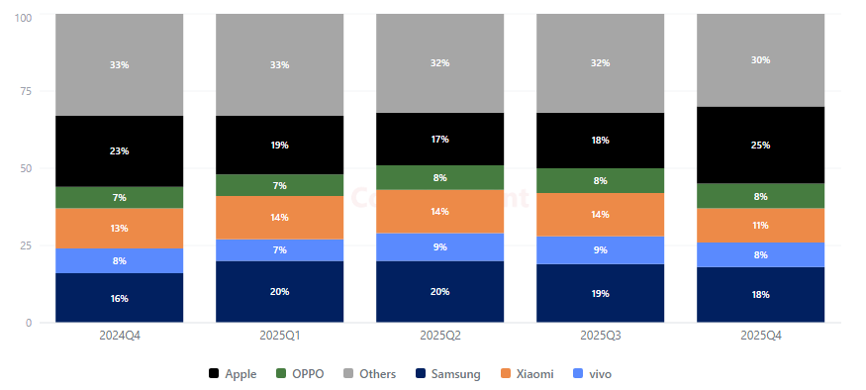
Figure 1: Global smartphone market share
Samsung is experiencing a growing threat of competition with Chinese manufacturers of consumer electronics and TSMC of advanced semiconductor fabrication, as well as more general issues, such as geopolitical tensions and cyclical declines in chip demand (Financial Times, 2024). To be able to know where Samsung stands strategically, it is important to conduct a strict analysis of the environment surrounding the company as well as its internal environment.
2.0 External and Internal Environment Analysis.
2.1 External Environment: PESTEL Analysis.
PESTEL framework allows analyzing macro-environmental forces that influence the strategic environment of an organisation in a systematic way (Johnson, Whittington and Scholes, 2017).
Samsung has an impact on political factors significantly. The presence of US-China tensions in geopolitics has transformed the worldwide semiconductor supply chains, and the US CHIPS and Science Act (2022) encourage the production of chips in the US, which will positively affect the planned chip production plant of Samsung at $17 billion in Texas (White House, 2022). Nevertheless, the strategic uncertainty of Samsung is caused by a fragile diplomatic stand of South Korea between the US and China, its largest trading partner, where Samsung has major manufacturing facilities (Kim and Lee, 2023). Also, the fact that Samsung has a strong connection with the South Korean government, as seen in the scandalous presidential pardon of Vice Chairman Lee Jae-yong in 2022, is a governance issue (BBC, 2022).
Economical reasons are that the overall semiconductor market in the globe is going through severe cyclical declines in 2023 and this led Samsung to experience a 85 percent annual decrease in operating profit (Samsung, 2024a). Exchange rates, especially the Korean won/US dollar, have a great effect on the competitiveness of exports and the reported profits (Bank of Korea, 2023). Consumer spending on high-end electronics has been limited by increasing global inflation and interest rates, as well (IMF, 2023).
The socio-cultural drivers comprise the changing consumer behavior of high-quality and feature-packed smartphones and foldable phones, where Samsung has been dominating the market with Galaxy Z Fold and Z Flip (IDC, 2023). The increasing need of smart home systems and IoT allows the company to grow. Nevertheless, brand loyalty trends differ widely by market high-end markets in North America and Western Europe are dominated by Apple, and in Asia, Latin America, and Africa, by Samsung (Counterpoint Research, 2024).
The central point in the strategy of Samsung is the technological factors. The adoption of superior semiconductor nodes (3nm and smaller), the emergence of artificial intelligence application demands on a high-performance chip, and the advent of generative AI are all transformational opportunities (McKinsey, 2023). This strategic direction can be observed in the Galaxy AI initiative, developed by Samsung in 2024, which implies the on-phone AI functionality (Samsung, 2024b). Nonetheless, TSMC has a technological advantage in terms of advanced foundry processes, which is a major threat to the company in terms of competition (Nikkei Asia, 2024; Reuters, 2024).
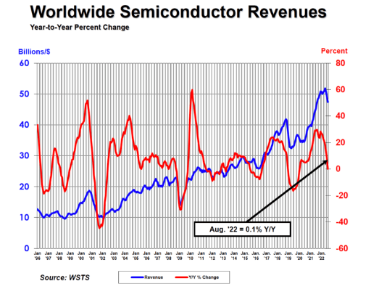
Figure 2: Global semiconductor sales trend
Strategic decisions are more influenced by environmental factors. The increasingly problematic e-waste, stricter environmental policies (e.g. the proposed Right to Repair directive by the EU), and the increasing demand of consumers toward eco-friendly products are forcing Samsung to deal with its environmental impact (European Commission, 2023). Samsung has made a promise to reach net-zero carbon emission levels by 2050 and use more recycled materials in its products (Samsung, 2023b).
Laws include copyright issues which are rife in the technology sector with the protracted patent tussle between Samsung and Apple being the most notable (Pisano and Teece, 2007). The laws of data privacy, such as GDPR and the Personal Information Protection Act of South Korea, obligate Samsung to comply with the laws of data privacy in the range of its services that require large amounts of data (Park, 2021). Regulatory risk is also presented in regulatory challenges in antitrust scrutiny of Samsung dominance in memory semiconductors (KFTC, 2023).
2.2 Strategy and strategic challenges and critical success factors.
The external analysis shows that the company has a few critical success factors: its technological leadership in semiconductor production; its success in incorporating AI into a variety of products; its ability to overcome supply chain disruptions caused by geopolitical issues; and its brand competitiveness in the market where smartphones have become quite commoditised (Song, 2017). The strategic issues that require attention most are the closing of the foundry technology gap with TSMC, the challenge of keeping up with the unpredictability of semiconductor cycles, and maintaining market share against aggressive competitors in China such as Xiaomi and Huawei (whose rebound under US sanctions poses a new threat) (Financial Times, 2024; Nikkei Asia, 2024; Canalys, 2024).
2.3 Internal Environment Analysis: This analysis examines the internal operations of the firm to establish the internal capabilities of the firm.
The internal environment of Samsung is described as having formidable resources and capabilities that have been developed over a 5-decade period (Chang, 2008).
The main material assets involve large-scale manufacturing facilities in the world: Semiconductor fabrication factories in Pyeongtaek (South Korea), Austin (Texas), and Xi an (China); smartphone assemblies in Vietnam and India; and display assembly plants in South Korea and China (Samsung, 2024a). In 2023, Samsung had a capital expenditure amounting to approximately 43.4 billion, which demonstrates its focus on staying at the manufacturing scale (Samsung, 2024a).
Samsung brand is among the intangible resources as at 2023, it is the fifth most valuable global brand with its value standing at 91.4 billion (Interbrand, 2023). Its large patent portfolio Samsung, as one of the three largest patent filers in the world, has competitive protection as well as source of licensing income (WIPO, 2023). Moreover, the organisational culture of Samsung (ppalli-ppalli (quickly-quickly)) allows the company to react fast to market demands and develop new products, but it has also been criticisedto put a lot of pressure on the staff (Michell, 2010).
Its core strengths are world-class semiconductor design and fabrication, end-to-end supply chain management of components to finished products, speed in innovation cycle in consumer electronics and a global distribution channel serving more than 200 countries (Song, 2017).

2.4 VRIO Framework Analysis
Applying Barney and Hesterly's (2015) VRIO framework:
Resource/Capability | Value | Rarity | Imitability | Organisation | Competitive Implication
Memory semiconductor leadership (DRAM/NAND) | Yes | Yes | Very difficult (massive capital requirements) | Yes | Sustained competitive advantage
Vertical integration (components to devices) | Yes | Yes | Difficult to replicate fully | Yes | Sustained competitive advantage
Foldable display technology | Yes | Yes (decreasing) | Moderately difficult | Yes | Temporary to sustained advantage
Global brand recognition | Yes | Moderate | Difficult to build rapidly | Yes | Sustained advantage
Advanced foundry capabilities | Yes | No (TSMC leads) | N/A | Partially | Competitive parity/disadvantage
Galaxy ecosystem and services | Yes | Moderate | Increasingly imitable | Partially | Temporary advantage

The competitive advantage of Samsung is memory semiconductor dominance which has been the most sustained. The DRAM and NAND flash industries demand such immense amounts of capital to operate a fabrication plant (numbering to the millions of dollars) that it poses an insurmountable entry barrier (Benchmark Mineral Intelligence, 2023). The 40 percent share of Samsung in the DRAM market 40 percent is a result of decades of compounded investments and learning curve benefits that other firms can hardly duplicate (TrendForce, 2024).
Vertical integration is a unique strategic ability. The fact that Samsung produces its own processors (Exynos), displays (AMOLED), memory chips and camera sensors and incorporates them into its smartphones gives the company cost advantages, security in supply and design optimisation possibilities that the least vertically integrated competitors do not have (Teece, 2018). This type of resource is useful, uncommon and expensive to replicate, which meets the criteria of maintaining advantage in VRIO (Barney, 1991).
Nonetheless, there is also one significant weakness in the VRIO analysis: Samsung has a lower high level of process technology in comparison with TSMC, its yields are lower at the 3nm node, and the company can also lose major clients like Apple, Qualcomm, and Nvidia (Nikkei Asia, 2024). This is a major strategic weakness in a region that Samsung has chosen as one of its growth priorities.
2.5 Internal Competitiveness and Strengths.
In the perspective of resource-based view (Barney, 1991; Grant, 2016), the competitive advantage of Samsung can be explained through the synergistic integration of its component manufacturing units with the product-facing consumer-focused units. With this vertical integration, Prahalad and Hamel (1990) say it develops the set of key competencies, which is the learning that is experienced in a variety of production skills and technology streams. The competence of Samsung to grow and formulate semiconductors, displays, and batteries internally and produce finished devices is a capability that not many competitors can match in scope and only Apple can match the similar integration in a few aspects (Teece, 2018).
More importantly, Samsung will have to keep investing in the renewal of these competencies. The dynamic capabilities point of view (Teece, Pisano and Shuen, 1997) points out that long-term benefit necessitates the capacity to observe the opportunities, capture them, and reorganise resources to respond to them. Rapid adaptation to AI and foldables is an indication of dynamic capability in Samsung but the gap in foundry technology shows what happens when the capability of the company is superseded by others.

3.0 CSR and Sustainability Objectives.
The CSR policy of Samsung includes environmental sustainability, social responsibility, and governance engagements as developed by the company in its statement as Together for Tomorrow! REA vision (Samsung, 2023b). The approach complies with the shared value framework by Porter and Kramer (2011) because the sustainability efforts are becoming more connected to the commercial needs: the energy-efficient production saves money, the recycled materials usage mitigates supply chain risks, and the sustainability credentials affect buying choices of the environmentally-aware consumer (Deloitte, 2023).
On the environmental front, Samsung has strived to ensure that it emits no carbon in all its operations (Scope 1 and 2) by 2050, and that it uses renewable energy sources in all its global operations by 2027 (Samsung, 2023b). The idea of the Galaxy Upcycling programme that involves the reuse of old smartphones as IoT devices is an example of the principles of the circular economy (Ellen MacArthur Foundation, 2021). Samsung also made more of its products more recyclable and its Galaxy devices used ocean-bound plastics (Samsung, 2023b).
Nevertheless, when using the triple bottom line framework by Elkington (1997) tensions can be observed. The labour conditions at its supply chain have also been subject to criticism towardsSamsung especially its component suppliers in Southeast Asia (Amnesty International, 2020). The governance model of the company, which includes the involvement of the controlling Lee family, cross-shareholding among affiliates of Samsung Group, and the criminal record of its executives, is a legitimate stakeholder issue (BBC, 2022; Chang, 2008). Although Samsung has enforced more powerful compliance programmes and an independent sustainability Committee, critics assert that governance reforms are still poor compared to world best practices (Corporate Governance Watch, 2023).
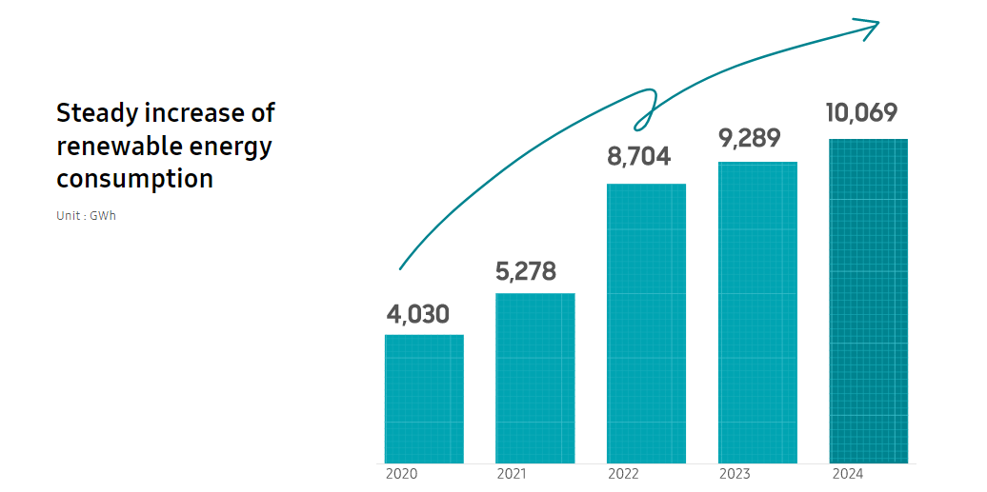
Figure 3: Samsung sustainability strategy
Therefore, it is evident that Samsung environmental CSR is truly strategic, although it still has to improve social and governance aspects to attain full legitimacy of stakeholders (Carroll, 1991).
4.0 Balanced Scorecard: Comprehensive and Holistic View.
The Balanced Scorecard (Kaplan and Norton, 1992) facilitates multi-dimensional performance evaluation based on four perspectives that are interrelated giving a more holistic evaluation of the strategic implementation of Samsung as compared to the financial metrics only.
4.1 Financial Perspective
The financial vision of Samsung is to regain profitability after the 2023 semiconductor crisis and maintain long-term investment in its strategic areas of growth. The KPIs are consolidated revenue (2023 of 200.7 billion), operating profit margin (which dropped to 1.6 in 2023 vs. 13.9 in 2022 due to the memory chip downturn), return on equity, and the free cash flow generation (Samsung, 2024a). Targets are advised to focus on recovers the margin since the semiconductor demand will be back to its feet due to the AI-related chip demand. The most notable efforts are producing high-bandwidth memory (HBM) at high volumes to satisfy the needs of AI applications and enhancing the quality of foundry production to go after customer orders (Morgan Stanley, 2024).
4.2 Customer Perspective
The customer-based KPIs are the smart phone market share worldwide, position rankings, score on customer satisfaction, premium segment share. In 2023, Samsung continued to lead in the smartphone industry at 20.1% share across the globe, although it experienced a decline in high-end markets where Apple took over (Counterpoint Research, 2024; Counterpoint Research, 2024b; IDC, 2024).The targets should focus on growing the share of premium smartphones with Galaxy AI differentiation and develop the foldable category. Some of these efforts include better integration of the Galaxy ecosystem, extending the life of software updates (seven years of OS updates now), and supporting the after-sales service networks (Samsung, 2024b).
4.3 Internal Business Processes Perspective.
Some of the process-related KPIs are the yield rates of semiconductor, time to market with new products, manufacturing defect rate and supply chain efficiency. Samsung has been facing challenges in yield at the 3nm node level that has been a vital operational drawback in its capacities to compete with TSMC on receiving large orders with clients (Nikkei Asia, 2024). Target Goals should focus on attaining competitive yield rates in the advanced nodes and shortening the product development times. Among them, there is the $230 billion investment plan of semiconductor capacity growth to 2042 and the adoption of EUV lithography on fabrication lines (Samsung, 2023c).
The Learning and Growth Perspective is the fourth perspective related to learning and growth.
KPIs of learning and growth are R&D spending (2023 is 20.1 billion, about 10 percent of revenue), the number of patents registered, the rate of employee retention, and recruitment in AI and semiconductor design (Samsung, 2024a; WIPO, 2023). The capacity to hire the best minds in engineering will also play the key role of bridging the foundry gap and be on the forefront of AI innovation at Samsung. Among them, the growth of AI research centres worldwide and the development of the expertise in the generative AI applications can be mentioned. The efforts encompass the Samsung AI Centre network in Cambridge, Toronto, Moscow, and New York, as well as collaborating with major universities in terms of developing semiconductor research talents (Samsung, 2023a).
5.0 Strategic Decisions and Actions.
5.1 Business-Level Strategy
Using the generic strategies framework developed by Porter (1985), Samsung has traditionally been engaged in a broad differentiation strategy in consumer electronics, making its products premium and innovation-driven offerings competing with the Apple at the high end but also providing mid-range products to reach greater market segments (Song, 2017). Samsung is able to integrate cost leadership based on massive economies of scale with differentiation based on technological innovation in its semiconductors, what Hill (1988) calls an integrated strategy.
This two-sided model is advisable as the best business-level strategy since only through vertical integration can Samsung achieve cost and differentiation benefits simultaneously across its business segments (Bowman and Faulkner, 1997). The advice in the consumer electronics sector is to improve differentiation by enhancing AI-based software experiences and curved form factors, which have yet to be commercialised by competitors (IDC, 2023). The cost leadership through further scale investment in the memory semiconductors to keep up with the market dominance and pricing power is guaranteed in times of cyclical downturns (Johnson, Whittington and Scholes, 2017).
5.2 Corporate-Level Strategy
On the corporate level, Samsung is engaged in related diversification into semiconductors, smartphones, displays, consumer electronics and connected technology (Harman) (Ansoff, 1965). This diversification has great synergies: semiconductor innovations feed into device services, display technology breakthroughs support differentiation of smartphones, and provision of components to third parties generates money as manufacturing scale is created (Rumelt, 1974).
The Corporate Strategy suggested is to further diversify along the related lines and more specifically in two regions. To begin with, intensifying the business to grow the foundry business to decrease the reliance on volatile memory markets and harness the expanding custom AI chip demand (Morgan Stanley, 2024). Second, expanding into the area of AI and connected ecosystem, using the comprehensive hardware range (smartphones, TVs, appliances, wearables) to establish an integrated smart living platform (McKinsey, 2023).
It is also advisable to expand internationally to regions that have been underpenetrated especially Africa and Latin America whose penetration of smartphones is on the increase. The current good distribution channels in these areas would offer a platform to leverage the growth of Samsung as the number of middle-range devices increases (Statista, 2024).
5.3 Change management and strategic implementation: This section will provide information regarding change management and implementation.
The strategy of Samsung with regard to strategic change has been both transformative and discontinuous in the past. The biggest strategic shift was the 1993 declaration by Lee Kun-hee called the New Management that radically transformed the company into more of a quality-centered manufacturing company, showing what Kotter (1996) defines as creating urgency and selling compelling vision (Michell, 2010).
Samsung has in recent years been able to cope with the shifting to AI rather nimbly. The introduction of AI capabilities into its 2024 smartphone line-up within only a few months of the mainstream adoption of generative AI is indicative of organisational responsiveness (Samsung, 2024b). Nonetheless, using the Lewin model (1951) of change, the obstacles in change faced by Samsung foundry indicate that the need to unfreeze the old ways of producing semiconductors and organisational culture by embracing new models has not been adequate, as manifested by the challenges of low yield that have plagued its 3nm production (Nikkei Asia, 2024).
It is recommended that the foundry transformation move toward a fuller change management process, with the understanding of Kotter (2012) that it is important to create guiding coalitions and mobilize the masses of action. This can include external recruitment of talent within TSMC and formation of independent organisation units of the organisation that have the freedom to introduce radical process innovations without being bound by the current operational cultures.

6. Strategic Evaluation and Recommendations
6.1 SWOT Analysis
Strengths | Weaknesses
Market leadership in memory semiconductors | Foundry technology gap vs. TSMC
Vertical integration across components and devices | Governance concerns (family control, legal history)
Global brand recognition and distribution | Weaker software ecosystem vs. Apple
Diversified revenue streams | Dependence on volatile semiconductor cycles
Rapid innovation capability | Lower brand loyalty in premium segments vs. Apple

Opportunities | Threats
AI-driven semiconductor demand boom | Intensifying Chinese competition (Xiaomi, Huawei)
Foldable device market growth | TSMC extending foundry technology lead
Smart home and IoT ecosystem expansion | Geopolitical disruption to supply chains
Emerging market smartphone growth | Commodity pricing pressure in memory markets
Foundry market expansion | Global economic slowdown reducing consumer spending

6.2 Ansoff's Matrix Application
Based on the frameworks of growth developed by Ansoff (1965):
- Market penetration: Galaxy AI extension to mid-range devices to achieve more smartphone share in the current markets.
- Market development: Growing faster in Africa, Latin America and India with low-end device products.
- Product development: The introduction of next-generation foldable devices, production of HBM chips in large quantities aimed at supporting AI applications, as well as the development of AI capabilities on the device.
- Diversification: Adopting automotive semiconductor and increasing services on smart home platforms.
The most important strategic step is the product development with the HBM and sophisticated AI chips integration because it is the most crucial growth impetus in the nearest term due to the entire infrastructure of AI development worldwide (Goldman Sachs, 2023).
6.3 BCG Matrix Application
Using the BCG Matrix (Henderson, 1970):
- Stars HBM chips, AI (high growth, growing share); Galaxy S/Z series smartphones (high growth in the premium/foldable segments) (TrendForce, 2024b; Counterpoint Research, 2024b)
- Cash Cows: DRAM and NAND memory (dominating and mature market, bringing in a lot of cash)
- Question Marks: Foundry business (high-growth market, Samsung has low relative share compared to TSMC); SmartThings IoT platform
- Dogs: Other old consumer electronics product lines (TVs in older markets with crashing margins)
The given analysis suggests that Samsung must reinvest the profits on the memory in Focus of Cash Cow and selectively in Question Marks, especially the foundry business, which is the largest strategic growth opportunity assuming that technological challenges can be addressed (TrendForce, 2024).
6.4 Recommendations
The analysis gives three strategic recommendations:
To begin with, Samsung must be willing to bridge the technology divide between themselves and TSMC by focusing on development of better process node yields, possibly through joint ventures or mapping of specific skills. This is essential since it is the largest diversification opportunity Samsung can possibly have by a long margin, as the foundry market is expected to hit 200 billion dollars by 2030 (Goldman Sachs, 2023), and would ameliorate earnings volatility associated with memory semiconductor cycles. This is consistent with the dynamic capabilities framework of Teece, Pisano and Shuen (1997) which underlines that the competitive advantage is reliant on the dynamism of competencies in light of a fast changing environment.
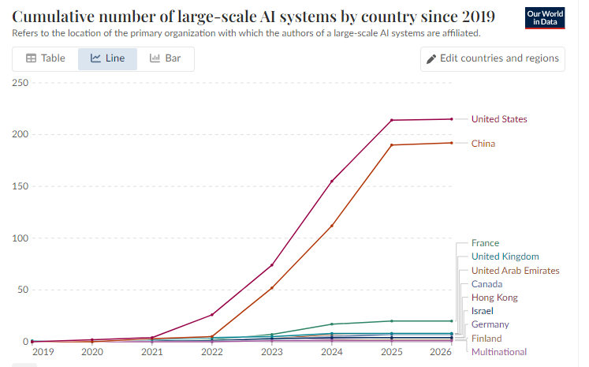
Figure 4: Growth of artificial intelligence technologies
Second, Samsung ought to make its smartphone ecosystem stand out with even stronger integration of AI and longer software life. The strategic capability of Apple is becoming more based on the integrated software-hardware platform and services revenue (Cusumano, 2010). The collaboration between Samsung and Google as well as its own Galaxy AI services offer a framework to develop similar ecosystem stickiness, but that will need years of investments in software engineering and services where Samsung has traditionally underinvested compared to hardware (Song, 2017).
Third, Samsung ought to enhance corporate governance through minimizing the role of family-based dynasty, enhancing independent boarding, and promoting transparency in accordance with the global best practice. Empirical studies have always shown that good governance is also positively related with the long-term shareholder value and trustworthiness (Aguilera and Jackson, 2010). Since Samsung has had a history of governance scandals, the implementation of meaningful reform would have a positive effect on the institutional investor confidence and the ongoing Koreasia discount of Samsung stock (Chang, 2008).
All these recommendations put Samsung in a position to continue to experience its competitive advantages in terms of technology renewal, ecosystem differentiation, and modernisation of governance to enable it to remain resilient in the cyclical and competitive challenges to come.

Section 2: Reflective Account
Reflecting Gibbs Reflective Cycle.
Description
This reflective report discusses the researching, analysing, and preparing the strategic analysis of Samsung Electronics given in Section 1. The task included the choice of an organisation, the implementation of various strategic frameworks, critical assessment of its competitive position and evidence-based recommendations. It entailed a lot of academic literature, industry reports, financial reports, and modern business journalism that took several weeks.
Feelings
Firstly, I was excited and a bit frightened. The decision to pick Samsung was driven by its interesting complexity in that it is both a supplier of components and consumer brand, competing and at the same time with the same companies. But this complexity was what complicated the analysis because Samsung is represented across several industries (semiconductors, smartphones, displays, consumer electronics) with its own competitive interactions. I was not sure whether I was able to attain enough richness in all the fields within the word limit.
As the study proceeded, I felt an increasing intellectual stimulation, especially when the VRIO analysis uncovered what I found to be the strategic paradox of the semiconductor business of Samsung: leading in memory and yet lagging in foundry despite apparent similarities in the underlying technological bases. This is a subtle observation that supported the fact that strategic analysis is a rewarded pursuit as compared to shallow description. On the other hand, I was at times frustrated by the lack of primary data concerning the inner workings of Samsung since the company does not report in English, and its organisational culture is fairly closed to outsiders.
Evaluation
The process was successful in a number of ways. This analytical process of the systematic development of external (PESTEL) to internal (VRIO) analysis, then to performance analysis (BSC), strategic decision-making (Porter, Ansoff), and lastly strategic analysis (SWOT, BCG) developed a logically coherent analytical narrative (Johnson, Whittington and Scholes, 2017). I also liked the combination of the CSR analysis with the overall strategic themes, which show the way the weaknesses in governance are related to the issue of the Korea discount on Samsung valuation-a fact that was revealed through the integration of financial, governance and strategic lenses.
Nevertheless, obstacles were also apparent. My original PESTEL analysis was too descriptive and included factors without a sufficient assessment of their relative strategic importance. The reworking of this part to focus on factors with the most significant strategic outcome, especially the geopolitical processes that influence semiconductor supply chains and demand revolution of AI, significantly enhanced the quality of analytical work. The part on the balanced scorecard was also a challenge because I needed to interpret the financial reports and industry standards closely in order to translate the strategy of Samsung into the specifics of KPIs, which could not be achieved by only adhering to theoretical frameworks.
Analysis
Using the insights of these experiences in academic terms, I understand that the shift between the descriptive and critical analysis is characteristic of the changes of developmental stages as suggested by Moon (2004). Initial tendency of using extensive description was what can be termed as surface-level learning, and progressive revision allowed the progress of reaching deeper engagement as is applicable to the idea of deep learning introduced by Biggs and Tang (2011). The difficulty of being analytically comprehensive amid the business diversity of Samsung also underscored the fact that the strategy is a synthetic art that demands holistic integration as opposed to the application of sequential models of analysis.
The epistemological shortcomings of strategic analysis that involves the secondary sources were reinforced by the challenge of acquiring information on Samsung internal matters. According to Nonaka and Takeuchi (1995), strategic knowledge is often tacit and is instilled within the routine of an organisation and is not available in the form of documents. This weakness is a reminder of the need of methodological humility in strategy research and the usefulness of triangulating various types of data to construct valid analytical inferences.
Conclusion
My strategic analysis skills have been developed significantly because of this assignment. I have also realised that truly critical analysis involves more than simply applying theoretical frameworks, it involves questioning the assumptions they have, acknowledging their limitations, and integrating conclusions of more than one point of view. The Samsung case helped to emphasize that industry-specific dynamics are very essential- semiconductor economics are fundamentally different and very different than consumer electronics markets, and successful strategy analysis should take into consideration such heterogeneity. Another insight I have had is the interdependence of the strategic aspects: the lack of governance has an impact on investor confidence, which limits access to capital, which influences the ability to invest in technology, which shapes the competitive positioning, proving that strategic variables are unlikely to work in isolation (Grant, 2016).
Action Plan
To expand on this learning, I will engage in a number of steps. To begin with, my financial analysis skills, especially ratio analysis and valuation methods will be developed stronger because this would have enhanced the balance scorecard and financial perspective of my analysis (Kaplan and Norton, 1996). Second, I will use primary sources such as earnings call transcripts and patent databases in a more systematic way to create more original, evidence-based knowledge. Third, I will engage in comparative application of the frameworks, i.e., examine Samsung with a direct rival like TSMC or Apple, so as to hone my competitive positioning relative to competitors. Lastly, the literature on strategy process (Whittington, 2001) and content-oriented approaches will also be discussed because the assignment has brought to light the fact that analysis of strategy formation and implementation is no less analytically significant than choice of strategies.

Reference List
Aguilera, R.V. and Jackson, G. (2010) ‘Comparative and international corporate governance’, Academy of Management Annals, 4(1), pp. 485–556.
Amnesty International (2020) Time to recharge: corporate action and inaction to tackle abuses in the cobalt supply chain. London: Amnesty International.
Ansoff, H.I. (1965) Corporate strategy: an analytic approach to business policy for growth and expansion. New York: McGraw-Hill.
Bank of Korea (2023) Annual report 2023. Seoul: Bank of Korea.
Barney, J.B. (1991) ‘Firm resources and sustained competitive advantage’, Journal of Management, 17(1), pp. 99–120.
Barney, J.B. and Hesterly, W.S. (2015) Strategic management and competitive advantage: concepts and cases. 5th edn. Harlow: Pearson.
BBC (2022) ‘Samsung heir Lee Jae-yong pardoned by South Korean president’, BBC News, 12 August.
Benchmark Mineral Intelligence (2023) Semiconductor supply chain outlook. London: Benchmark Mineral Intelligence.
Biggs, J. and Tang, C. (2011) Teaching for quality learning at university. 4th edn. Maidenhead: Open University Press.
Bowman, C. and Faulkner, D. (1997) Competitive and corporate strategy. London: Irwin.
Brandenburger, A.M. and Nalebuff, B.J. (1996) Co-opetition. New York: Doubleday.
Canalys (2024) Global smartphone market analysis. Available at: https://www.canalys.com (Accessed: 31 March 2026).
Carroll, A.B. (1991) ‘The pyramid of corporate social responsibility’, Business Horizons, 34(4), pp. 39–48.
Chang, S.J. (2008) Sony vs Samsung: the inside story of the electronics giants’ battle for global supremacy. Singapore: Wiley.
Corporate Governance Watch (2023) CG Watch 2023: hard decisions. Hong Kong: ACGA and CLSA.
Counterpoint Research (2024) Global smartphone market share Q4 2023. Hong Kong: Counterpoint Research.
Counterpoint Research (2024) Global smartphone market share Q4 2023. Available at: https://www.counterpointresearch.com/global-smartphone-share/ (Accessed: 31 March 2026).
Counterpoint Research (2024b) Global smartphone market trends. Hong Kong: Counterpoint Research.
Cusumano, M.A. (2010) Staying power: six enduring principles for managing strategy and innovation. Oxford: Oxford University Press.
Deloitte (2023) 2023 global technology, media and telecommunications predictions. London: Deloitte.
Elkington, J. (1997) Cannibals with forks: the triple bottom line of 21st century business. Oxford: Capstone.
Ellen MacArthur Foundation (2021) The circular economy in detail. Cowes: Ellen MacArthur Foundation.
European Commission (2023) Right to repair: Commission introduces new consumer rights. Brussels: European Commission.
Financial Times (2024) ‘Samsung faces dual challenge from TSMC and Chinese rivals’, Financial Times, 22 January.
Goldman Sachs (2023) The semiconductor cycle and AI opportunity. New York: Goldman Sachs Research.
Grant, R.M. (2016) Contemporary strategy analysis. 9th edn. Chichester: Wiley.
Henderson, B. (1970) The product portfolio. Boston: Boston Consulting Group.
Hill, C.W.L. (1988) ‘Differentiation versus low cost or differentiation and low cost: a contingency framework’, Academy of Management Review, 13(3), pp. 401–412.
IDC (2023) Worldwide quarterly mobile phone tracker. Needham: International Data Corporation.
IDC (2024) Worldwide smartphone market analysis. Needham: International Data Corporation.
IMF (2023) World economic outlook: a rocky recovery. Washington, DC: International Monetary Fund.
Interbrand (2023) Best global brands 2023. New York: Interbrand.
Johnson, G., Whittington, R. and Scholes, K. (2017) Exploring strategy: text and cases. 11th edn. Harlow: Pearson.
Kaplan, R.S. and Norton, D.P. (1992) ‘The balanced scorecard—measures that drive performance’, Harvard Business Review, 70(1), pp. 71–79.
Kaplan, R.S. and Norton, D.P. (1996) The balanced scorecard: translating strategy into action. Boston: Harvard Business School Press.
KFTC (2023) Annual report on competition policy. Sejong: Korea Fair Trade Commission.
Kim, S. and Lee, J. (2023) ‘South Korea’s semiconductor strategy amid US-China technology competition’, Asian Survey, 63(4), pp. 612–638.
Kotter, J.P. (1996) Leading change. Boston: Harvard Business School Press.
Kotter, J.P. (2012) Leading change. 2nd edn. Boston: Harvard Business Review Press.
Lewin, K. (1951) Field theory in social science. New York: Harper & Row.
McKinsey & Company (2023) The semiconductor decade: a trillion-dollar industry. New York: McKinsey & Company.
Michell, T. (2010) Samsung Electronics and the struggle for leadership of the electronics industry. Singapore: Wiley.
Moon, J.A. (2004) A handbook of reflective and experiential learning. London: RoutledgeFalmer.
Morgan Stanley (2024) Samsung Electronics: AI memory demand and foundry outlook. New York: Morgan Stanley Research.
Nikkei Asia (2024) ‘Samsung’s foundry woes deepen as TSMC extends lead’, Nikkei Asia, 5 February.
Nonaka, I. and Takeuchi, H. (1995) The knowledge-creating company. New York: Oxford University Press.
Our World in Data (2024) Artificial intelligence. Available at: https://ourworldindata.org/artificial-intelligence (Accessed: 31 March 2026).
Park, S. (2021) ‘Data privacy regulation in South Korea: implications for technology firms’, Computer Law & Security Review, 41, p. 105572.
Pisano, G.P. and Teece, D.J. (2007) ‘How to capture value from innovation’, California Management Review, 50(1), pp. 278–296.
Porter, M.E. (1985) Competitive advantage: creating and sustaining superior performance. New York: Free Press.
Porter, M.E. and Kramer, M.R. (2011) ‘Creating shared value’, Harvard Business Review, 89(1/2), pp. 62–77.
Prahalad, C.K. and Hamel, G. (1990) ‘The core competence of the corporation’, Harvard Business Review, 68(3), pp. 79–91.
Reuters (2024) ‘TSMC extends lead in advanced chipmaking’, Reuters. Available at: https://www.reuters.com (Accessed: 31 March 2026).
Rumelt, R.P. (1974) Strategy, structure, and economic performance. Boston: Harvard Business School Press.
Samsung (2023) Sustainability report. Available at: https://www.samsung.com/global/sustainability/ (Accessed: 31 March 2026).
Samsung (2023a) About Samsung. Available at: https://www.samsung.com/global/about-us/ (Accessed: 18 March 2024).
Samsung (2023b) Samsung Electronics sustainability report 2023. Suwon: Samsung Electronics.
Samsung (2023c) Samsung announces $230 billion investment in semiconductor capacity. Press release. Suwon: Samsung Electronics.
Samsung (2024a) Samsung Electronics annual report 2023. Suwon: Samsung Electronics.
Samsung (2024b) Galaxy AI: a new era of mobile intelligence. Press release. Suwon: Samsung Electronics.
Semiconductor Industry Association (2024) Global semiconductor sales. Available at: https://www.semiconductors.org (Accessed: 31 March 2026).
Song, J. (2017) The Samsung way: transformational management strategies from the world leader in innovation and design. New York: McGraw-Hill.
Statista (2024) Consumer electronics worldwide. Hamburg: Statista.
Teece, D.J. (2018) ‘Business models and dynamic capabilities’, Long Range Planning, 51(1), pp. 40–49.
Teece, D.J., Pisano, G. and Shuen, A. (1997) ‘Dynamic capabilities and strategic management’, Strategic Management Journal, 18(7), pp. 509–533.
TrendForce (2024) DRAM and NAND flash market share Q4 2023. Taipei: TrendForce.
TrendForce (2024b) Semiconductor market trends. Taipei: TrendForce.
White House (2022) CHIPS and Science Act fact sheet. Washington, DC: The White House.
Whittington, R. (2001) What is strategy—and does it matter? 2nd edn. London: Thomson Learning.
WIPO (2023) World intellectual property indicators 2023. Geneva: World Intellectual Property Organization.

