Problem solving and Decision Making BMSW4004

Student :Vianelis Fermin-Pena
Student NO:2129429
Lecturer: Chijioke Uba

No table of contents entries found.
Table of Context
Introduction.............................................................................2
Nature and Impact of the problem................................................................2&3
Pestle/Fishbone Analysis of Causative Factors..................................................................4
Identification Using Pestle and Fishbone.........................................................................4&5
Plan to implement the decision to Solve the Complex Problem.....................................................................................5Conclusion.........................................................................5&6
References......................................................................................................... 6

Introduction
“The act of finding ways of dealing with problems” (Oxford,2022) The retail sector in the United Kingdom has faced numerous challenges this year. “It has proven difficult to fill all of these vacancies” (Feltham, 2022) Due to the severity of the challenges, they faced, some retail companies were forced to go into administration. Most of the challenges stem from external factors such as Brexit, the Covid 19 pandemic, and the cost-of-living crisis.
Many of these businesses were unable to operate due to lockdown restrictions and supply chain issues. One of the companies affected was a formal workwear retailer TM Lewin. The company is experiencing significant profit decline. TM Lewin is a British online menswear retailer. Following on from my presentation I have conducted further research. The main causes TM Lewin are having is inflation, covid, supply chain issues and pandemic. At TM Lewin 1400 firms were Closed down, so this indicated that many employees would have lost their jobs and had less disposable income, and stores would have shut down so this impacted in the extreme financial profit decline. On the other hand, the company to be successful, the arising problem from the cause and factors must be resolved. To do so I must use the correct Model to identify the problem. Models used to analyse the problem were Pestle and Fishbone.

Nature and Impact of the Problem
“The art of identifying problems and implementing the best possible solutions is known as problem solving. Revisiting your problem-solving abilities could be the missing link in leveraging your business's performance, achieving Lean success, or unlocking your professional potential” (Simplilearn,2022)
- Firstly, the profit is declining external and internal factors. It is affecting all TM Lewin Stores. The impact of profit decline on TM Lewin is losing money due to Inflation, administrative costs, pandemic stress, and a lack of sales. The inflation rate for the Uk has been “The Consumer Prices Index (CPI) rose by 11.1% in the 12 months to October 2022, up from 10.1% in September 2022. In October 2022, the CPI annual inflation rate was the highest.” ((King, 2022) When the inflation is high this means less spending power for businesses and consumers and reducing good and demands for TM Lewin and other stores. On the other hand, this article shows what the inflation should be on a good rating. The UK target inflation of 2% +/-1. (Pettinger et al., 2021)
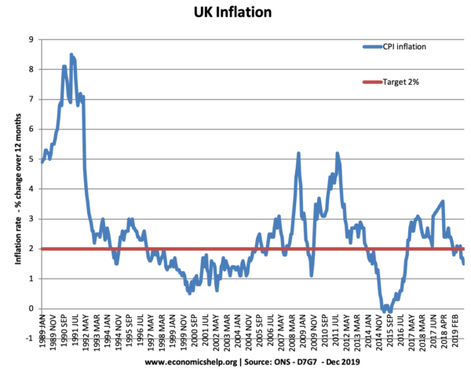
The nature and impact of the problem is that Tm Lewin has gone into huge profit decline. Sales are not being made as formal shirt purchases are not being produced. This is because the company consumer worked from home and restrictions on large events were not permitted.
PESTLE /Fishbone Analysis of Causative Factors
“The PESTLE analysis tool is one of many used to help managers identify their market positioning and strengths” (Dictionary, 1995)
Political Factors:
The political factor that could have affected the store was Brexit because they have left the EU. Whatever goods or products they were receiving may have gone up. As prices had gone up.
Corona virus 19 is a political factor because the store has generated online so they were losing out on physical sales. costumers may not like to use online and on the other hand the elderly generation may not know how to use technology well. “LONDON (Reuters) - British shirt shop T.M. Lewin will close all its stores and go online only, its restructurer said on Tuesday, resulting in around 600 redundancies as the COVID-19 pandemic continues to hammer the high street.” (Staff, 2020) TM Lewin

The main causes Identified of TM Lewin are:
- Inflation
- Covid pandemic
- Pressure of supply chain issues. No sales are being made due to the fact of the

Identification using Pestle and fishbone Diagram2

Ishikawa diagram,” is a visual causal diagram for performing a root cause analysis (Kaoru Ishikawa, 1976) (Franklin, 2019). The fishbone-shaped diagram, also known as the Ishikawa or cause and effect diagram, is used to improve team performance in determining potential root causes of quality problems. As an illustration of how this diagram can be used in practise, within TM Lewin.

Political | Government COVID lockdown | Closing shops prevented customers from Purchase reducing sales
Economic | Cost of living crisis and inflation  Supply Chain issue
Social factor | Staying at home  Ban of public events | No Sales  No staff  No Profits
Technology factors | Remote working

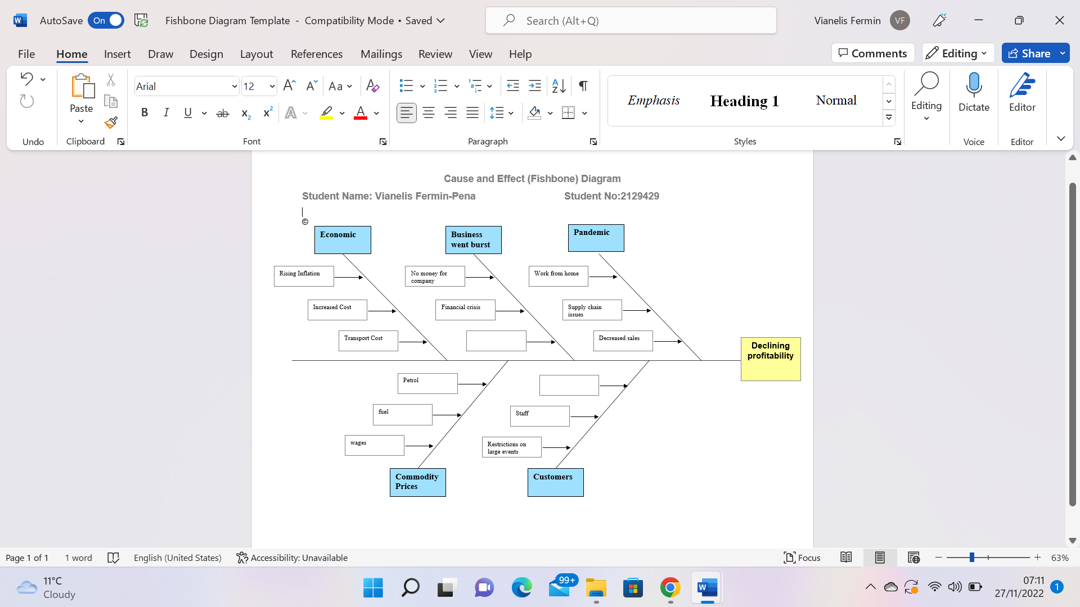(Fermin-Pena,2022)

Plan to implement the decision to solve Complex Problem
To reduce these problems, I have produced some solutions such as
- Reduce Price items
- Deploy Staff
- Online networking
Reducing price list will give an opportunity for the business to keep a stable gain of income.TM Lewin could also do some Car boot sales to reduce the stock of products. It is affecting Commodity prices such as TM Lewins employees' wages, Fuel prices and petrol. As they had work from home measures T-shirts were not being made and the business experienced profit Decline. Furthermore, setting up an online networking process to gain ideas from the public can be a great call for the business and an effective learning curve. On the other hand, deploying staff until they are back in business because TM Lewin may not have enough money to pay staff wages.They can go into joint venture with another company to have a different opportunity. “A joint venture is a commercial arrangement in which two or more participants agree to work together to achieve a specific goal. Joint ventures are a broad category of collaborative business arrangements that involve varying degrees of integration and can last for a fixed or indefinite period.” (Burges, Salmon) (n.d.) I would also give half redundancy and a full month's wage. “Redundancy is when you dismiss an employee because you no longer need anyone to do their job. This might be because your business is:
- changing what it does
- doing things in a unique way, for example using new machinery
- changing location or closing” (Service, 2014) I would go to Redundancy to reduce the work force so that the employees that remain would be able to stay on their current salary. As a result the Business should be able to cover the downfall in the business

Conclusion
To conduct this report Coronavirus has also been identified as the primary cause of increased mortality during the recent global pandemic. Due to the fact of all the TM Lewin stores going Bankrupt. I have done further research on this case. Primary causes include macroeconomic factors such as political, economic, and social issues. However, the study identified significant appropriate measures that have been established to address the problem at hand at TM Lewin. Following my presentation, I conducted a Pestle analysis to evaluate the Causes and Effects of the problem. Political, economic, and social issues are also important macroeconomic factors.

References
Dictionaries, O.L. (no date) Problem-solving, problem-solving noun - Definition, pictures, pronunciation, and usage notes | Oxford Advanced Learner's Dictionary at OxfordLearnersDictionaries.com. Available at: https://www.oxfordlearnersdictionaries.com/definition/english/problem-solving?q=problem%2Bsolving (Accessed: November 21, 2022).
Simplilearn (2022) What is problem solving? steps, techniques, and best practices explained, Simplilearn.com. Simplilearn. Available at: https://www.simplilearn.com/what-is-problem-solving-article (Accessed: November 21, 2022).
Franklin, B. (2019) Kaoru Ishikawa, the fishbone cause-and-effect diagram, and benefits to healthcare, Healthcare Market Review. Available at: https://healthcaremarketreview.com/kaoru-ishikawa-the-fishbone-cause-and-effect-diagram-and-benefits-to-healthcare/#:~:text=The%20fishbone%20cause-and-effect%20diagram%2C%20which%20is%20colloquially%20known,unwanted%20conditions%20occur%E2%80%9D%20%28Wilson%2C%20Dell%2C%20%26%20Anderson%2C%201993%29. (Accessed: November 21, 2022).
Dictionary, C. (1995) Pestle analysis, Cambridge Dictionary. Available at: https://dictionary.cambridge.org/dictionary/english/pestle-analysis?q=PESTLE%2Banalysis (Accessed: November 22, 2022).
King, A. (2022) Consumer price inflation, UK: October 2022, Consumer price inflation, UK - Office for National Statistics. Office for National Statistics. Available at: https://www.ons.gov.uk/economy/inflationandpriceindices/bulletins/consumerpriceinflation/october2022#:~:text=a%20year%20earlier.-,The%20Consumer%20Prices%20Index%20(CPI)%20rose%20by%2011.1%25%20in,which%20began%20in%20January%201997. (Accessed: November 24, 2022).
Staff, R. (2020) Menswear shop T.M. Lewin to close all UK stores, go online only, Reuters. Thomson Reuters. Available at: https://www.reuters.com/article/us-health-coronavirus-britain-tmlewin-idUSKBN2412X4 (Accessed: November 25, 2022).

Salmon, B. (no .date) A guide to joint ventures and joint venture structuresb, Burges Salmon. Available at: https://www.burges-salmon.com/news-and-insight/publications/guide-to-joint-ventures#:~:text=A%20joint%20venture%20is%20a,a%20fixed%20or%20indefinite%20duration. (Accessed: November 26, 2022).
Feltham, W. (2022) Top challenges facing the retail industry, and how to overcome them, Elucidat. Available at: https://www.elucidat.com/blog/top-challenges-facing-the-retail-industry/ (Accessed: November 27, 2022).
Pettinger, T. and Mason, A. (2021) What is the optimal inflation rate?, Economics Help. Available at: https://www.economicshelp.org/blog/2114/inflation/optimal-inflation-rate/ (Accessed: November 27, 2022).
Service, G.D. (2014) Making staff redundant, GOV.UK. GOV.UK. Available at: https://www.gov.uk/staff-redundant#:~:text=Redundancy%20is%20when%20you%20dismiss,for%20example%20using%20new%20machinery (Accessed: November 27, 2022).
(Fermin-Pena,2022)

