Learning in the digital era – ACCA4025_BIRM



Student name: Diana Driu
Module code: ACCA4025
Assignment title: Component 1. E-Portfolio
Lecturer name: Martin Svejda

Contents
TASK 1 - Academic and Employment Skills, IEEE Referencing and Use of AI 3
a) Essential academic and employment skills for an administrative/receptionist career 3
b) Current AI assistants and their application to administration 4
Task 2 - Collaborative Teamwork and Professional Academic poster (A3 Poster) 9
Team Activity 9
b) Professional academic poster 10
TASK 3 Automatic Referencing tool 10

TASK 1 - Academic and Employment Skills, IEEE Referencing and Use of AI

a) Essential academic and employment skills for an administrative/receptionist career
An administrative receptionist is often the first point of contact for an organisation and may be responsible for welcoming visitors, answering enquiries, managing appointments, handling correspondence and supporting general administration. The UK National Careers Service identifies customer service, teamwork, attention to detail, administration, remaining calm under pressure, verbal communication and competent use of computers and software as important receptionist skills [1]. Therefore, developing these abilities during higher education can prepare a graduate for the demands of an administrative/receptionist position.

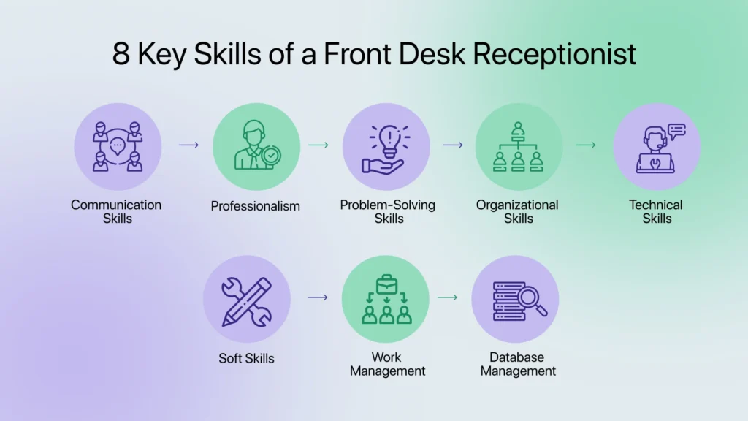
Figure 1: Essential skills for an administrative/receptionist role

Communication is particularly important because receptionists communicate with visitors, customers, managers and colleagues through face-to-face conversations, telephone calls and written messages. Research into administrative professionals identifies communication, information and communication technology, organisational and time-management skills, interpersonal skills and problem-solving as important areas for future professional effectiveness [2]. Similarly, research concerning receptionists highlights the importance of communication in customer-facing interactions [3].
Organisation and time management are also essential because a receptionist may have to manage several activities at the same time. The development of these skills through university deadlines, presentations, group work and work experience can help a graduate become more reliable and confident in the workplace. A recognised administrative handbook also emphasises time management, communication, relationship management and professional confidence as important areas for administrative professionals [4].
Digital literacy is increasingly important because administrative work relies heavily on computers and software. Developing confidence with word-processing, spreadsheets, email, calendars and online communication systems can therefore improve workplace performance. Microsoft 365 Copilot, for example, can assist with drafting and summarising documents in Word, analysing data in Excel and composing or summarising emails in Outlook [5].
Responsible use of AI can provide an additional employability skill. ChatGPT can support activities such as drafting, rewriting, summarising, problem-solving and data analysis [6]. However, AI-generated information requires human checking because the user remains responsible for the accuracy and appropriateness of the final work. Consequently, developing communication, organisation, digital literacy, customer-service and responsible AI skills during study can provide a strong foundation for a successful administrative/receptionist career.

b) Current AI assistants and their application to administration

Several AI assistants are currently popular and have different strengths. ChatGPT is particularly useful for drafting, rewriting, summarising, brainstorming and analysing files or data, making it suitable for drafting professional emails, creating meeting agendas and organising information [6]. Microsoft 365 Copilot is particularly appropriate for administrative work because it is integrated with Word, Excel, Outlook, PowerPoint and Teams; it can help draft documents, analyse spreadsheets, summarise emails and identify meeting actions [5]. Google Gemini is useful for research, writing, planning and productivity, with integration across Google's ecosystem [7]. Google reported that the Gemini app passed one billion monthly users in August 2026 [7]. Claude can be useful for summarising information, collaborative writing, question answering and analysing documents [8]. Perplexity is particularly useful for research because its answer engine provides cited answers and is designed around web-based research [9].

AI assistant | Best use | Example for administration
ChatGPT | Writing, brainstorming and data analysis | Drafting an email or analysing a spreadsheet
Microsoft 365 Copilot | Office productivity | Summarising Outlook emails or assisting with Excel
Google Gemini | Research, planning and Google productivity | Organising information and planning meetings
Claude | Long-form writing and document analysis | Summarising policies or improving correspondence
Perplexity | Web research with citations | Finding and comparing information about suppliers
Table 1: Comparison of AI assistants

ChatGPT
The selected tool for practical demonstration is ChatGPT because it can support realistic administrative activities. The student should use a fictional or non-confidential dataset rather than uploading real customer, employee or company information.

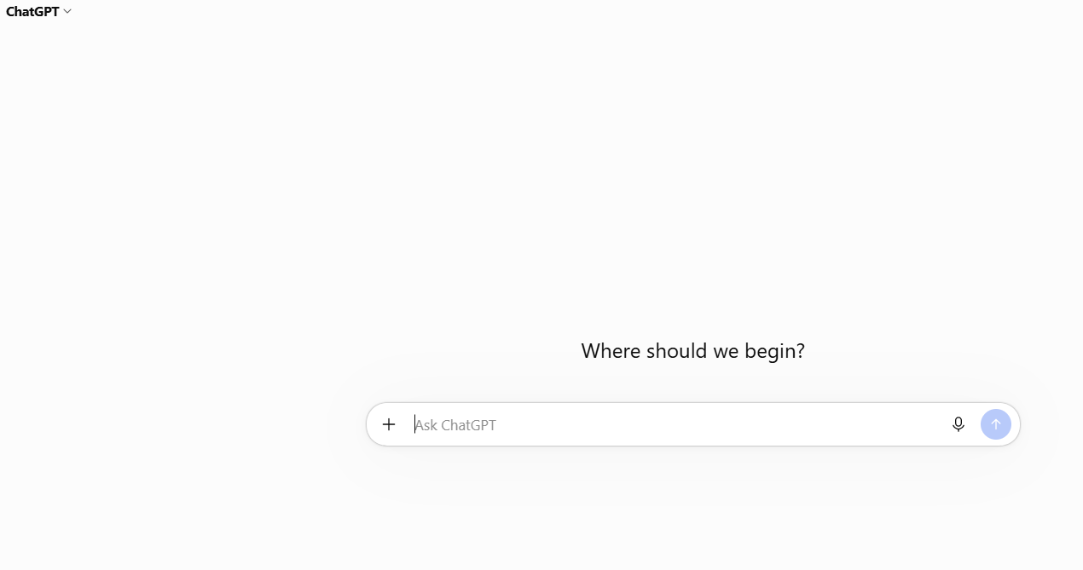
Figure 2 Initial prompt

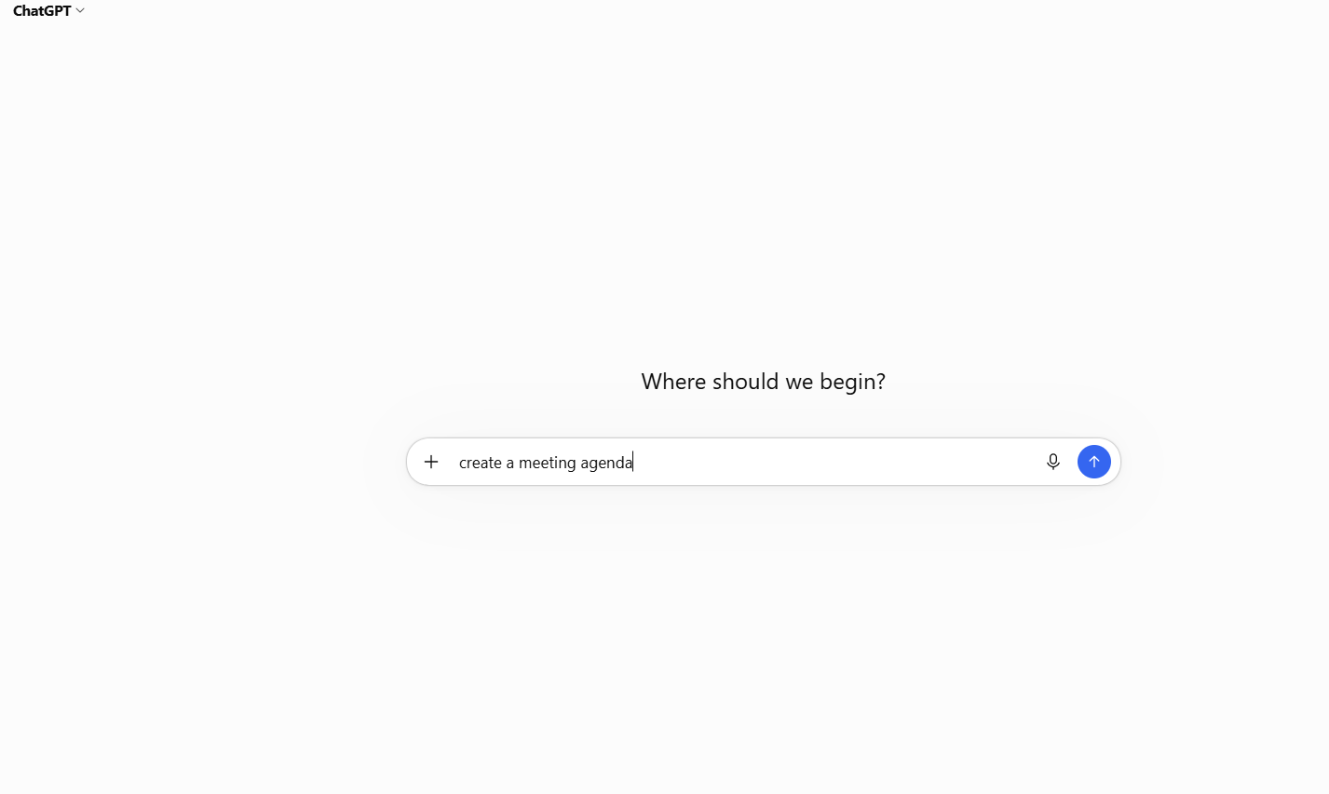
Figure 3 Improved prompt
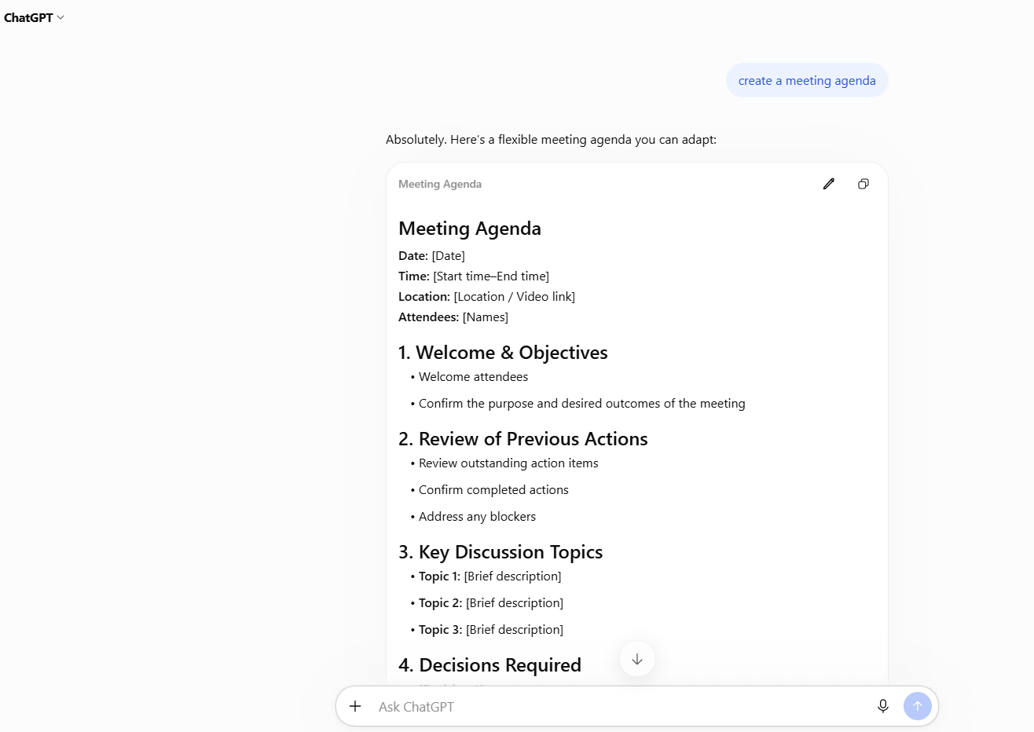
Figure 4 AI-generated result
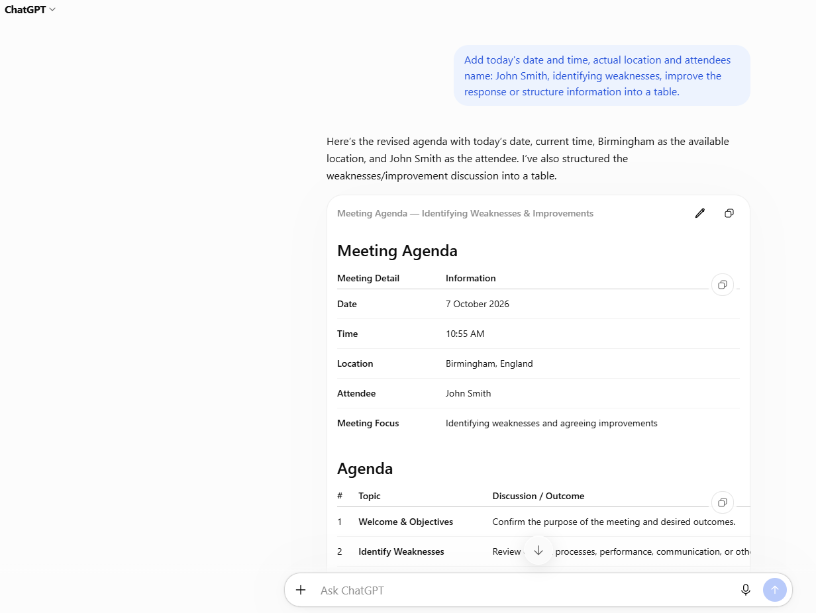
Figure 5 Evaluation

The activity demonstrates contextualised generative AI because the tool is given a specific administrative scenario and instructions. It demonstrates problem-solving and professional communication rather than simply asking a general question. The output should still be checked by the student because AI can produce inaccurate or inappropriate information. OpenAI itself recommends reviewing outputs, while the UWTSD guidance stresses responsible acknowledgement of AI-generated material.

LinkedIn Learning AI course
A particularly suitable current course is “Generative AI: From Prompts to Partnership” by Jeremy Utley. LinkedIn Learning lists it as a beginner-level, 54-minute course released on September 30, 2026. It covers generative AI, prompting, collaboration with AI, limitations such as hallucinations and safe workplace use.

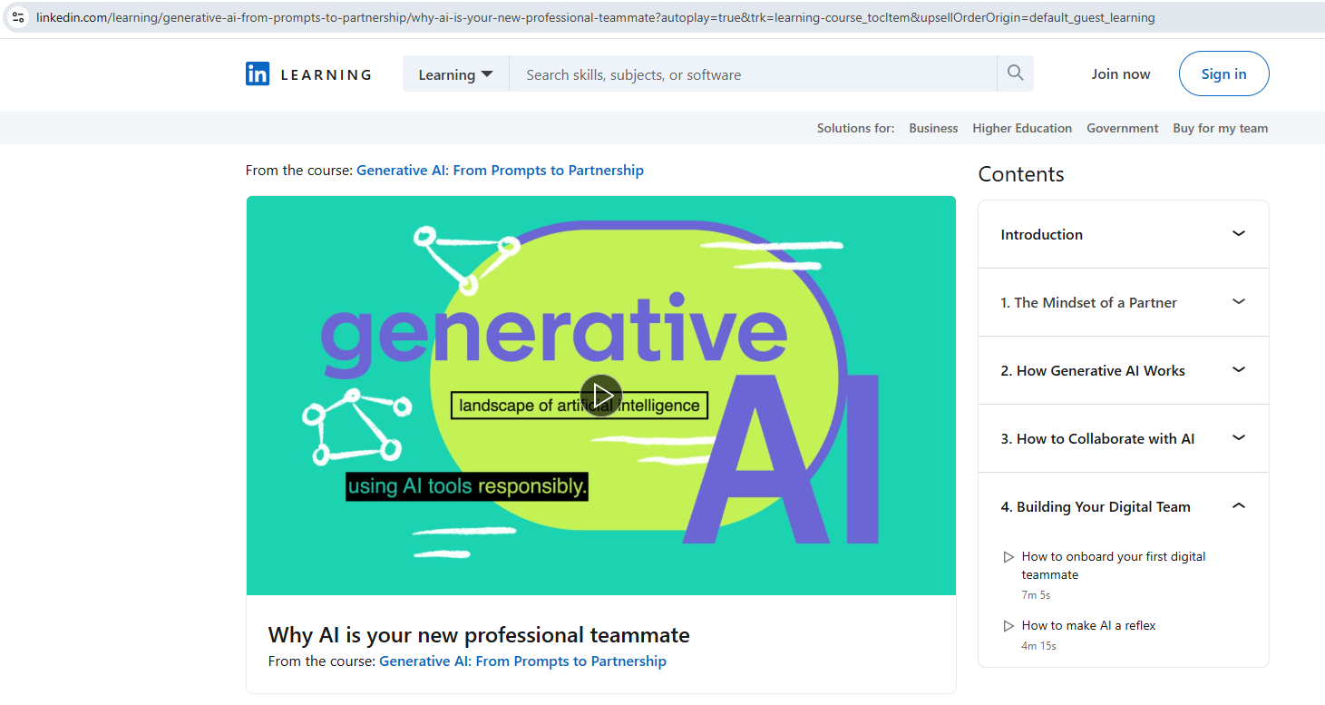
Figure 6 Screenshot of the LinkedIn AI course

The course helped develop an understanding of how effective prompting can improve AI-generated responses. It also highlighted the importance of checking AI outputs and recognising limitations. These skills are relevant to an administrative/receptionist career because AI could support routine communication, information organisation and productivity while professional judgement remains the responsibility of the employee.

References
[1] National Careers Service, “Receptionist,” GOV.UK. [Online]. Available: National Careers Service – Receptionist. [Accessed: Oct. 7, 2026].
[2] A. A. J. Venter, T. H. H. Herbst, and C. G. Iwu, “What will it take to make a successful administrative professional in the fourth industrial revolution?,” SA Journal of Human Resource Management, vol. 17, a1224, 2019, Doi: 10.4102/sajhrm.v17i0.1224.
[3] K. Ardana and I. W. Swandana, “Improving receptionists’ communication skills: A study of speaking types at Desa Potato Head Bali,” Quantum Journal of Social Sciences and Humanities, vol. 5, no. 5, 2024. [Online]. Available: Journal article. [Accessed: Oct. 7, 2026].
[4] S. France, The Definitive Personal Assistant and Secretarial Handbook: A Best Practice Guide for All Secretaries, PAs, Office Managers and Executive Assistants, Kogan Page, 2021. The publisher identifies communication, confidence, time management and relationship management among the areas covered by the book.
[5] Microsoft, “Microsoft 365 Copilot,” Microsoft. [Online]. Available: Microsoft 365 Copilot. [Accessed: Oct. 7, 2026].
[6] OpenAI, “ChatGPT capabilities overview,” OpenAI Help Centre. [Online]. Available: ChatGPT capabilities overview. [Accessed: Oct. 7, 2026].
[7] Anthropic, “Introducing Claude,” Anthropic. [Online]. Available: https://www.anthropic.com/news/introducing-claude. [Accessed: Oct. 7, 2026].
[8] Perplexity, “Perplexity,” Perplexity. [Online]. Available: https://www.perplexity.ai/. [Accessed: Oct. 7, 2026].
[9] J. Utley, “Generative AI: From Prompts to Partnership,” LinkedIn Learning, Sep. 30, 2026. [Online]. Available: https://www.linkedin.com/learning/generative-ai-from-prompts-to-partnership. [Accessed: Oct. 7, 2026].

Task 2 - Collaborative Teamwork and Professional Academic poster (A3 Poster)

Team Activity

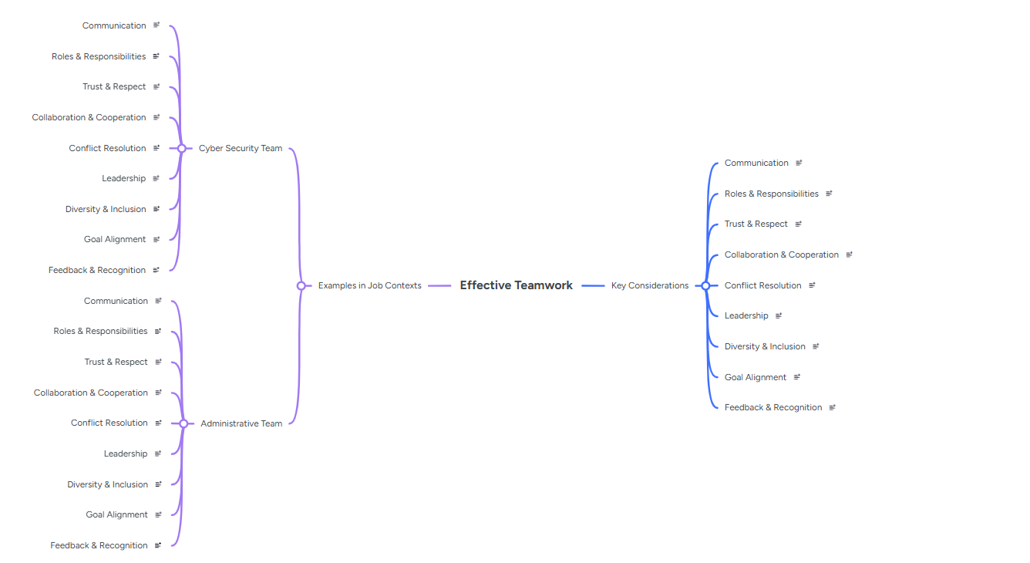
Figure 7 Creation of the mind-map in Mindmeister

b) Professional academic poster

TASK 3 Automatic Referencing tool

References
[1] E. Salas, D. E. Sims, and C. S. Burke, “Is there a ‘Big Five’ in teamwork”, Small Group Research, vol. 36, no. 5, pp. 555–599, 2005, Doi: 10.1177/1046496405277134.
[2] J. Jarvis, S. Clark, and M. Wildy, “Staff–student collaboration: Student learning from working together to enhance educational practice in higher education,” Teaching in Higher Education, vol. 21, no. 3, 2016, Doi: 10.1080/13562517.2015.1136279.
[3] A. A. J. Venter, T. H. H. Herbst, and C. G. Iwu, “What will it take to make a successful administrative professional in the fourth industrial revolution?,” SA Journal of Human Resource Management, vol. 17, a1224, 2019, Doi: 10.4102/sajhrm.v17i0.1224.
[4] “Untangling graduate employability and work readiness to inform evidence-based practice in higher education,” Higher Education Research & Development, 2026, Doi: 10.1080/07294360.2026.2615303.

