


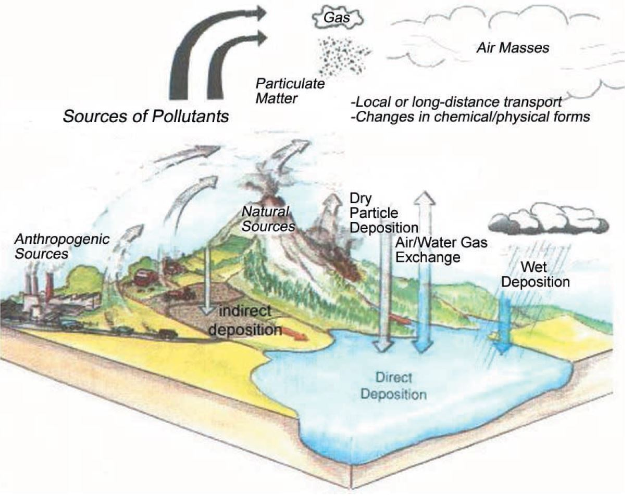
particulate emissions management strategies: Open-cast coal mining
Author: Sion Evans (P150600)
Environmental Pollution Controls: M6X01198
Lecturer: Dr Andrew Thorn
School of Engineering
22/05/2020

Executive Summary
Coal is a cheap fossil fuel that despite having significantly damaging effects on the environment is continued to be mined, processed, and used for combustion. As a result, a new surface coal mining operation is being constructed in Wales. Particulate emissions associated with surface mining and coal processing have shown be impact human health breeding a range of cardiovascular and respiratory diseases as well as damaging the surrounding environment. As a part of the negotiation to build this new mine, a clear plan to reduce and manage particulate emissions must be submitted to the local environmental agency. This paper found that by deploying management strategies such as suppression, isolation and removal, heavy particulate emitting processes such as drilling, transporting, dumping and crushing can experience a reduction of between 50-80% of emissions the effective deployment of monitoring and management technology.
List of Tables
Table 1. Typical mining equipment (Mitra, 2012). 7
Table 2. Material and physical process properties that influence the magnitude of particulate emission (Petavratzi, 2005) 9
Table 3. Association between rock type and health implications (Petavratzi, 2005) 12

List of Figures
Figure 1. Labelled structure of an open-cast mining pit (National Research Council, 2012) 7
Figure 2. Classification of particulate matter (Gautman, 2016) 8
Figure 3. classification of respirable emissions with relation to particle size (Gautman, 2016) 9
Figure 4. Table illustrating the mass fraction % of PM emitted from haul roads (Patra, 2016) 10
Figure 5.Health implications associated with coal mining (Gautman, 2016) 11
Figure 6. Predictive equations used for various mining operations (Chakraborty, 2002) 13
Figure 7. Validation of predictive equations with field measurements (Chakraborty, 2002) 13
Figure 8. Dry dust collector system diagram (Deparment of Health and Human Services, 2010) 14
Figure 9. (Deparment of Health and Human Services, 2010) 16
Figure 10. Diagram of a standard hopper enclosure configuration (Deparment of Health and Human Services, 2010) 16
Figure 11. diagram of a tyre stop water spray and shield system (Deparment of Health and Human Services, 2010) 17
Nomenclature
M = Moisture content (%) PM = Particulate matter
s = Silt content (%) PE = Particulate emissions
u = Wind speed (${ms}^{-1})$ TSD = Total suspended dust
h = Drop height (m) GD = Generated dust
l = Size of loader ($m^{3})$ RD = Respirable dust
x = Frequency of loading ($no.h^{-1}$)
v = Average vehicle speed ($ms^{-1})$
c = capacity of dumpers (t)
y = frequency of unloading ($no.h^{-1}$)
a = Area ($km^{2}$)
E = Emission rate ($gs^{-1}$)
Table of Prefixes
Factor | Prefix | Symbol
$${10}^{3}$$ | Kilo- | $$k$$
$${10}^{0}$$ | Base unit | G, L, mol etc
$${10}^{-2}$$ | Centi- | $$c$$
$${10}^{-3}$$ | Milli- | $$m$$
$${10}^{-6}$$ | Micro- | μ

Contents
1. Introduction 4
1.1 Surface Mining Principles 5
2. Pollution Due to Coal Mining 5
2.1. Particulate Matter 6
2.2. Surface Mining Operations - Sources of PM Emission. 8
2.3. Beneficiation Plant Operations – Sources of PM emission 9
2.2. Associated Impacts. 9
2.2.1. Human Health Implications 9
2.2.2. Environmental Implications 10
3. Identifying Particulate Emissions 10
4. Strategies for Managing Particulate Emissions 12
4.1. Drill Particulate Emissions 12
4.2. Controlling Haulage Dust Emissions 13
4.3. Managing Primary Dump Emissions 14
4.4. Crusher Emission Control Technique 16
4.5. Belt Emission management techniques 16
5. Clear Plan for PM management 17
6. References 17

1. Introduction
Coal is a black sedimentary rock containing high concentrations of carbon and hydrocarbons. It is a cheap fossil fuel that was heavily used during the industrial revolution and fuels the development of the world during this time. Electricity generation through burning coal has become less popular due to it being valued as the highest emitter of destructive greenhouse gases and associated atmospheric pollution. Despite this, coal is still used worldwide and mining operations still continue, a report submitted by the BP reported an annual consumption of 3772.1 MTOE in 2018 (Dudley, 2019). In the same report energy consumption is shown to have increased by 2.9% between 2017-2018. As a result, plans to construct surface coal mining and processing facility has been accepted in Llanbacol, Wales.
Surface mining is the most used method throughout the world for extracting minerals (Arenas-Lago, 2017). Surface mining can be sub-categorised into strip, contour and mountaintop removal mining because of slight differences in their techniques in response to geographical terrain differences. It has been deemed the single largest source of toxic waste of all industries in the United States (Velan, 2018). One of the primary pollutants generated from surface mining operations is particulate matter (PM), which is described by (BSI, 1994) as the largest occupational health killer through the ages the cause of a number of detrimental human health and environmental impacts such as emphysema, silicosis, respiratory diseases, acid rain and destruction of ecology and. PM is emitted because vast amounts of overburden and coal ore mechanically broken down and transporting through processes such as drilling, blasting, transporting, dumping and processing.
Consequently, the local community and environment agency are opposing the construction of proposed site which has resulted in the requirement of a clear plan for reducing and managing particulate emissions generated from surface mining operations. This paper will:
- Identify the primary sources and classification of particulate emissions and analyse what measures can be taken to control emission from the mining site.
- followed by an evaluation of strategies that can be deployed to manage the dust on site, containing recommendations of the best practise.

1.1 Surface Mining Principles
Surface mines are vast open pits that are dug down on an angle in benches which are approximately 4-60m in length. A typical mine labelled with terminology can be seen in [Figure. 1] along with the typical equipment used in [table. 1].
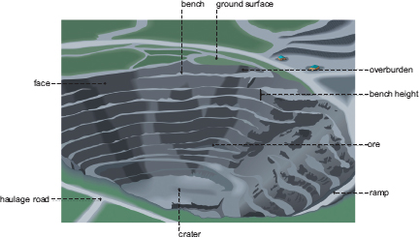

Figure 1. Labelled structure of an open-cast mining pit (National Research Council, 2012)

Table 1. Typical mining equipment (Mitra, 2012).
Equipment
Draglines
Trucks
Bucket Wheel Excavators
Crushers and Conveyers
Dozers
Slushers and dragline hoppers
Scrapers
Surface continuous miners
Shovels

2. Pollution Due to Coal Mining
Th potential contamination due to coal mine pollution has been described as the single largest source of toxic waste of all industries in the United States. The excavation completely changes the landscape and water courses and unbalances the concentration of minerals, which leads to environmental and human health impacts (Velan, 2018). The primary cause of this contamination is the emission of particulate matter (PM).

2.1. Particulate Matter
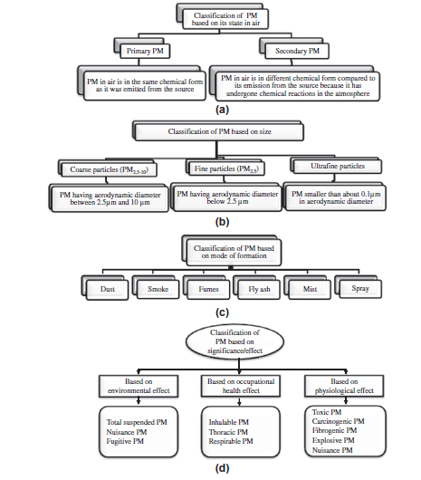
Particulate matter (PM) is a key indicator of air pollution caused by natural and human activities and is one of the primary pollutants produced from surface mining operations. Multiple studies have identified increased levels of PM in and around the surface mines due to mining and processing of mine minerals operations (Trivedi, 2010; Ghose, 2007; Singh, 2009). PM is primarily classified by its aerodynamic diameter (AD), which categorises its ability to travel suspended in the air and transport deep through the respiratory tract as stated by the British Standard Institute (BSI, 1994) where the total suspended particulate matter associated with surface mining ranges from 1 - 50μm falls within the ‘dust’ classification. Where ‘generated dust’ (GD) is the dust that occurs due to the operations and the particulate matter entrained into the air is referred to as the ‘total suspended dust’ (TSD). Dust is classified in terms of environmental, occupational health and physiological effects in relation to their size and chemical composition, as shown in [Figure. 2]. Definitions of these classifications can be in the definitions sub section at the beginning.
Figure 2. Classification of particulate matter (Gautman, 2016)

The size of the particulate matter influences the severity of the impacts, as the smaller particles PM1-15μm are most dangerous as reported throughout the works of (Kim, 2015; Patra, 2016). This is because their size allows them to travel further along the air pathway and penetrate the respiratory tract of the receiver to greater depths, which is directly related to the occupational health and physiological impacts discussed in section x. Among these finer particles carcinogenic and fibrogenic dust classification occurs with explosive PM typically methane. PM15-50μm are considered less harmful as these heavier particles have shown to settle much faster which dramatically reduces their transport along the pathway and limits their penetration capabilities at the receiver. However, they have still shown to have adverse effects on the environment as they can cause a reduction of environmental amenity. Additionally, these nuisance particulate emissions diminish visibility, damage machinery and can become irritants suspended in the atmosphere.
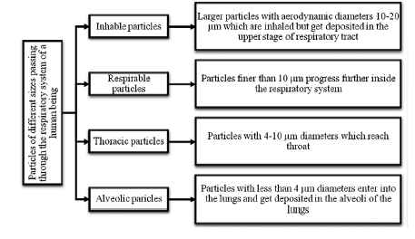

Figure 3. classification of respirable emissions with relation to particle size (Gautman, 2016)
The primary pathway for particulate matter is through the air surrounding the surface of the mine, once suspended into the air PM can become entrained into other pathways including watercourses and rain cycles. Consequently, weather conditions influence the rate of emissions. Whereby rainfall decreases emissions and drying wind increases the rate at which PM is lifted and entrained into the air and carried over greater distances (Arup Environmental, 1995). Additionally, material properties and physical processes shown in [Table. 2] influences the magnitude of PM emission.
Material Properties | Physical process parameter
Hardness | Mechanical breakdown process
Particle size distribution | Energy spent on the process
Particle density | Drop from height
Moisture content | Solids mass flow rate and extent of handling

Table 2. Material and physical process properties that influence the magnitude of particulate emission (Petavratzi, 2005)

2.2. Surface Mining Operations - Sources of PM Emission.
There have been a number of research papers on the emission on PM during surface mining operations, two of which include the works of (Ghose, 2007; Silvester, 2009). Whilst the cumulative effect of all operations was shown to give a summarized picture of the particulate emissions, through identifying the emissions from each individual operation, more effective PM management strategies can be deployed in relation to the process in question. The identification of such processes is determined using estimating equations shown in and sampling strategies mentioned in section 3. The remainder of this section will describe the mining processes and the associated particulate emissions.
The first operation of surface mining is the excavation of the overburden materials that are covering the coal deposit. During the breakdown and transport of these materials, vast amounts of PM are emitted, where as much as 600Kg of dust is generated every day during surface mining in India (Ghose, 2007). The high PM emitting processes that take place during this operation are as follows:
Drilling which is estimated to generate 20-25$mg m^{-3}$and 15-30$mg m^{-3}$ for drilling overburden and coal benches respectively (Ghose, 2007).
This is followed by blasting to break-up the mineral which causes short term high concentrations of PM and greater quantities of harder materials within the PM due to the energy released from blasting (Azarmi, 2014).
Following the blasting process, material is load onto a conveyor or dumber and transferred from the mining site to the processing plant. During which particulates become airborne at a rate influenced by those mentioned in [Table. 2]. A study undertaken by (Chaulya, 2006) reported emission rate of 0.6$g{ s}^{-1}$ for dumper loading coal and 0.8-1.4$g s^{-1}$ for unloading, where the rise of TSD in the coal mine was 450$μg m^{-3}$.
The haul road of the mine becomes a major source of particulate emissions due to road to tyre interactions during the transportation of materials. Haul roads are one of the key contributors to the total generated dust, for example it accounts for as much as 80.2% of Indian open cast mines as reported in an investigation undertaken by (Mandal, 2012). Typical particle size distribution from haul roads can be seen in [Figure. 4].
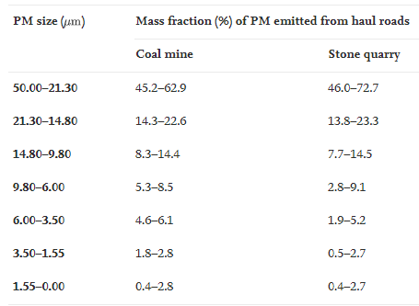

Figure 4. Table illustrating the mass fraction % of PM emitted from haul roads (Patra, 2016)

The stockyard and over burden dump are also identified as major sources of PM. Huge piles of material are left exposed to the prevailing wind so the largest the exposed area and stronger the wind, the greater the particulate emissions.

2.3. Beneficiation Plant Operations – Sources of PM emission
Additionally, a beneficiation plant is typically located in close proximity to the mine where the ore is crushed into finely ground tailings and chemically treated to separate unwanted minerals from the coal (Brusseau, 2004). This is especially important as the Anthracite deposits of coal have become scarce, the extraction of lower grade Sub-Bituminous and Lignite coal has become more popular. This lower grade fuel comes at a cost of more intensive and effective processing operations as a consequence of more abundant ash impurities containing sulphur, arsenic, cobalt and mercury, which demands treatment before it is allowed for combustion (Afework, 2018). The removal of inorganic ash components contributed to the generation and emission of PM through processes such as dumper unloading minerals at the receiving hopper, crushers reducing the size of the minerals, density separation using screens, hydrophobic and hydrophilic separation using froth floatation, drying of wet coal followed by stacking and loading the beneficiated material for dispatch to another site (Groppi, 2017; Ghose, 2007). Impacts, abrasion and dropping from heights

2.2. Associated Impacts.

2.2.1. Human Health Implications
One of the largest occupational health hazards and persons killer through the years in dust (BSI, 1994) There has shown to be an increased rate of diseases found in people who work on or live in close proximity to surface mining operations. Most typical diseases associated with coal miners are Pneumoconiosis and silicosis, which are irreversible lung diseases (Deparment of Health and Human Services, 2010). Other coal mining health implications include those in [Figure. 5]
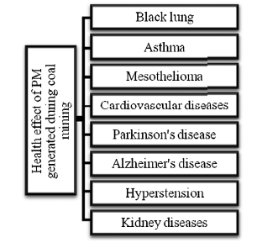
Figure 5.Health implications associated with coal mining (Gautman, 2016)

Additionally, occupational health implications occur within communities near mining operations where increased recordings of numerous health such as asthma, decreased lung function, cardiovascular diseases, hospital admission and premature mortality (Kim, 2015). Other health implications associated with various rock types are shown in [Table. 3].

Table 3. Association between rock type and health implications (Petavratzi, 2005)
Rock type | Health Implications
Chrysotile, crocidolite, anthophyllite | Asbestosis; Lung Cancer; Mesothelioma
Bentonites, talc | Pneumoconiosis; Talcosis; silicosis
Silica, quartz, flint and mica group materials | Silico-tuberculosis; silicosis; Pulmonary Fibrosis; Enlarged lymph gland
Limestone, marble, dolomite | Bronchitis; Emphysema;  Caustic burns; Dermatitis
Bauxite ore; corundum | Aluminosis; Ling Scarring; Pneumoconiosis; Emphysema
Iron ore: hematite,  magnetite, taconite | Siderosis; Increased lung cancer
Lead ore: galena,  cerussite, anglesite | Pneumoconiosis; Nephritis Anaemia

2.2.2. Environmental Implications
The atmospheric particulate emissions from coal mines can influence the ecology and agriculture of a region by depositing high concentration od matter containing heavy metals and soil acidification due to sulphur and nitrates. Impacts can include global climate change, modification of cloud property, stratospheric ozone depletion, reduction in visibility and acid rain.

3. Identifying Particulate Emissions
A crucial component in overall particulate emission (PE) management is the ability to identify, monitor and predict the particulate emission associated with each individual mining process so that more pragmatic objectives for dust control and management strategies can be deployed where necessary.
Typical obtained samples as reported by (Hinds, 1999) are as follows:
- Occupational health related samples of respirable, thoracic and inhalable dust.
- Process samples to evaluate the airborne dust concentration from the emission source.
- Background samples to measure the contribution of fugitive dust levels.
- Real-time dust measurements to determine the dust characteristics over set periods of time.
Most common sampling and monitoring strategies as reported by (UK Environment Agency, 2000; Hinds, 1999) are:
- Mass concentration methods.
- Sampling from still air.
- Isokinetic sampling extractive method.
- Continuous real-time monitoring.

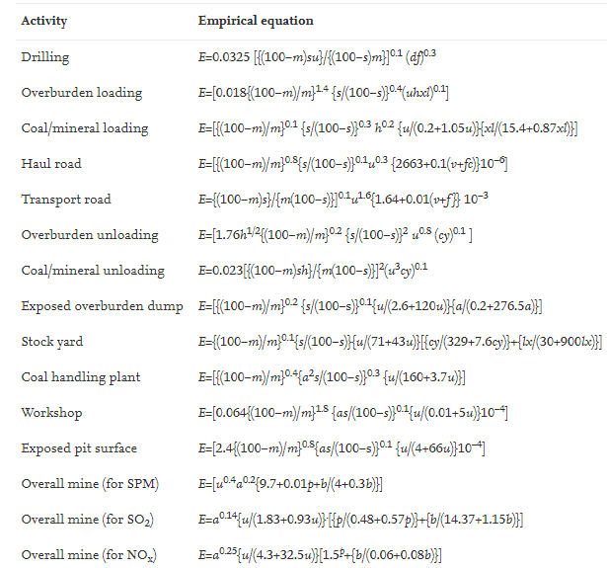
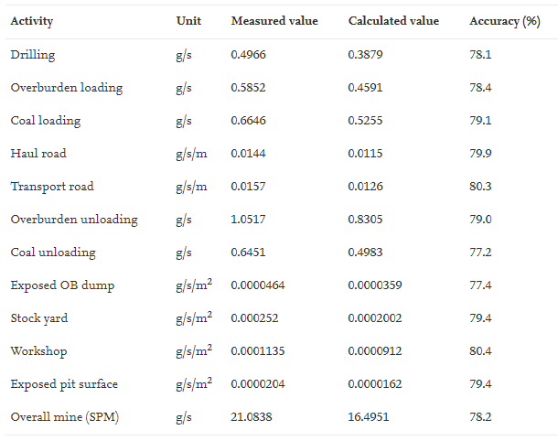
In the work performed by (Chakraborty, 2002), predictive equations for each PM generating process were developed and displayed in [Figure. 6]. Moreover, Chakraborty validated these equations with field measurements. These results can be seen in [Figure. 7].
Figure 6. Predictive equations used for various mining operations (Chakraborty, 2002)

Figure 7. Validation of predictive equations with field measurements (Chakraborty, 2002)

4. Strategies for Managing Particulate Emissions
Throughout surface mining many operations take place that emit various quantities and sizes or particulate matter. Consequently, there are various techniques used to reduce emissions from surface mining operations, which can be generalized into three main strategies. Namely:
Removal – This strategy concentrates efforts on removing the PM from the atmosphere as early as possible before it is emitted, typically done using dust collector systems
Suppression – One the of most widely used and effective strategy. This strategy is used across a range of processes and can be completed using atomised water sprays, electrostatically charged fogs, wet cutting, high pressure sprays, foam and descent chemicals (Petavratzi, 2005). By increasing the moisture content PE is significantly reduced, as shown in the equations displayed in [Figure. X].
Isolation – By isolating the PM during disruptive processes not only a reduction to the atmosphere is adhered, the exposure of respirable dust to mobile equipment operators can also be achieved through methods such as enclosed cabs and dust generation through screening.
The effectiveness of each strategy depends on the process it is being applied to. The complicated nature of dust emission rate and influential factors make it difficult to completely control the problem. Through using a combination of the previously mentioned strategies, the effectiveness of the dust management operations is significantly greater. This reminder of this section describes the technology, method and process application of such strategies along with recommendations on effectively implementing them.

4.1. Drill Particulate Emissions
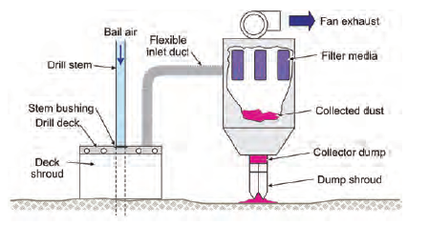
Drilling operations emit vast quantities of fine and coarse PM as discussed in section 3. Wet and dry dust collector systems are used as to manage dust from drilling following a removal strategy. As can be seen in [Figure. 8] it consists of a filtering compressed air dust collector that sucks the air from the shrouded drill deck located around the hole. The integrated suppression water-based technology is more effective for disabling emissions, however dry collection systems are the preferred technology due to their lower operational costs, longer drill bit life-cycle, ability to operate in freezing temperatures and without a water supply (Deparment of Health and Human Services, 2010).

Figure 8. Dry dust collector system diagram (Deparment of Health and Human Services, 2010)

Recommendations include:
- Maintain a collector dump discharge shrouded near the ground – After installing an extended shroud nearer to the ground [Figure. 8], a reduction of 61% of airborne respirable dust was measured.
- Maintaining a tight ground and drill deck shroud enclosure – By maintaining a ground to shroud height below 8 inches a significant reduction of dust leakage occurs. This is shown in a study undertaken by (Organiscak, 1999) where a reduction from $21.4mg m^{-3}$to $2.5mg m^{-3}$ was recorded. Additionally, an adjustable height shroud provides a better seal with un-even ground found to keep emissions near the shroud to 0.5 mg m^-3. This would prove beneficial in a Wales where the terrain is un-even with many hills and troughs.

- An airflow ratio of >= 3:1 between the collector and bailing – Loaded filters and material within the ductwork cause restrictions that result in dust leakages. With an airflow ratio >= 3:1 dust emissions are significantly decreased (Deparment of Health and Human Services, 2010).

- Effective drill stem seal with the drill table – By using a nonmechanical compressed air ring seal manifold under the drill deck, the restriction and leakage issues associated with rubber drill stem bushing can be overcome reducing emissions through the drill deck by 41-70% (Deparment of Health and Human Services, 2010).

- Maintain frequent inspections and maintenance – Particulate emission reduction as high as 51% was measured following a broken collector fan replacement (Organiscak, 1999)

4.2. Controlling Haulage Dust Emissions
The haulage roads contribute the most dust emissions to a surface mining site, where up to 20% of emitted particles are within the respirable size range as shown in [Figure. 4] (Patra, 2016). Resulting from tyre and road interactions, trucks have the potential to expose downwind miners and truck drivers to potentially health implicating respirable dust.
Suppression of dust particles using water. – The most effective and used technique of haul road dust control is suppression by wetting the road surface (Deparment of Health and Human Services, 2010). Despite being effective, this method requires continual maintenance due to dry climate, degradation from traffic and material spillage. The effect road wetting is clearly illustrated in [Figure. 9] where the unpaved road was sprayed in the morning and allowed to dry.
Treating unpaved roads. – In addition to suppression using water, treating roads with soil cement, hygroscopic salts, bitumen’s, surfactants and polymers have shown to have similar success and can decrease the maintenance intensity by increasing the time of effectiveness from hours to weeks (Olson and Veith 1987)

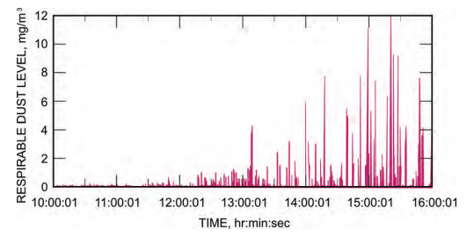

Figure 9. (Deparment of Health and Human Services, 2010)

Traffic Controlling. – By increasing the distance between truck drivers and isolating them, the un-settled dust has been shown to dissipate much faster. Applying this method, (Organiscak, 2004) measured a 40% reduction of respirable dust exposure to downwind miners and following trucks. Additionally, the research performed by Organiscak shown the dust concentrations generated by haul road processes significantly decrease around 100ft from the road. Additionally, vehicle movement and support activities should be limited during mining shifts.

4.3. Managing Primary Dump Emissions
The primary dump is a huge source of particulate emissions, isolation and suppression strategies are deployed to minimize this phenomenon. They are as follows:
Enclosure of the primary hopper – the primary strategy deployed is isolating the PM generated trough dumping material into the primary hopper. Custom-designed wall configured of stationary rigid and removable walls are constructed to complete this task. Contained in this configuration are staging curtains which are used to restrict the natural tendency for dust to emit out of the hopper. Full configuration can be seen in [Figure. 10]. Additionally, flexible plastic strips located on the dump side of the enclosure provides an overlapping feature creating a more effective seal and provides resistance to damage caused by bucket contact that could result in a leakage.
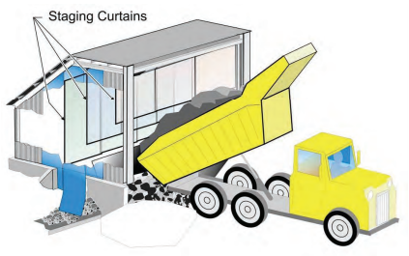
Figure 10. Diagram of a standard hopper enclosure configuration (Deparment of Health and Human Services, 2010)

Ventilation system – In some cases it is beneficial to include a ventilation system to filter the entrained dust from the air. This is typically only applicable in smaller hoppers as vast amounts of compressed air are required to create negative gradient in a large space.
Supress enclosure dust with water – A more effective method than ventilation is to supress the dust using water. A general rule of thumb is to start by adding 1% moisture as a function of weight, followed by a comparative analysis of improvements gained and consequences and applicable adjustments.
Recommendations include:
- Use of a mechanical or automated switching device along with a delay timer would ensure water sprays are only active during dumping operations and a short while after to prevent over hydrating the material.
- Inclusion of a tyre-stop water spray system at the most forward point to reduce the emissions caused by rollback under the hopper mechanism.
- Place a shield over water spray manifold to prevent any damage caused from falling material as shown in [Figure. 11]
- Installing a needle valve and waterflow meter can provide adjustable control of suppressive water systems.
- Good practise of adding small amounts of water into the air until visible dust has significantly declines would save vast amounts of water across the site.

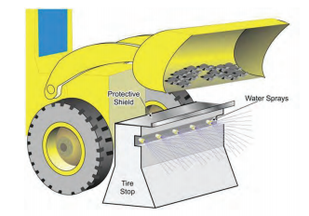

Figure 11. diagram of a tyre stop water spray and shield system (Deparment of Health and Human Services, 2010)

4.4. Crusher Emission Control Technique
The crusher is responsible for the highest generation % of small respirable PM caused by the mechanical abrasion of large material into small fine components for treatment (Petavratzi, 2005). The following best practise management strategies should be deployed:
Fully enclosed crusher – Isolation is the most effective strategy for managing emissions from the crushing process. Unlike the enclosure constructed for the primary hopper station, the crushers are contained by a combination of steel plates, brattice, conveyor belt and foam sealant (Deparment of Health and Human Services, 2010). Regular maintenance is crucial due to the quantity of coal being transported through the crusher.
Increasing the moisture content – wet suppression strategy should be deployed to reduce the airborne respirable emissions. This is done with a built-in spray systems bar that spans the entire width of the conveyor, located above the crusher hammers to ensure a uniform distribution of spray. The (Deparment of Health and Human Services, 2010) recommend water pressure operating below 60psi.
Scrubber technology – fan-powered or high-pressure water-powered scrubber should be used to prevent fugitive dust from escaping the crusher area . Recommended flow rates are typically 6,500cfm and 1,000psi for fan-powered and water-powered scrubbers, respectively. The inlets should be ducted from the crusher to belt transfer and the crusher discharge outlet. Field test showed a reduction of more than 50% dust emission through using scrubbers (Deparment of Health and Human Services, 2010).

4.5. Belt Emission management techniques
The belt operations include transporting finely crushed material containing a higher percentage of PM within the respirable size category illustrated in [Figure. x]. Management techniques should include:
Supressing dust particles – flat-fan sprays and cone nozzles are examples of the spraying technologies to increase the moisture percentage of the dust contained within the conveyor belt. Typical operating values include 1-4g/m at a pressure of 50psi (Deparment of Health and Human Services, 2010)
Regular maintenance regime – Belt slippage, missing roller and worn belts cause misalignment and consequent particulate leakage (Organiscak, 1999). Regular maintenance and cleaning by scraping and washing should be performed to prevent fugitive dust becoming entrained in the airstream. Additionally, the use of a rotary brush to clean the conveying side located near the dump point will contribute to reducing dust levels.

5. Clear Plan for PM management
In conclusion, Due to the varying mechanics of the operations that take place across the mining site and the unpredictable nature of the factors influencing dust emission, the management objective can become difficult. In order to deploy and effective management strategy across the whole plant, a combination of all the management strategies previously evaluated should be deployed and operated to satisfy the recommendations. In all processes where strategies were deployed, a reduction of 50% or more PM was measured. Additionally, site installation os sampling technologies and strategies should be deployed to create more pragmatic objectives for maintaining reduced emission levels. Therefore, through effectively deploying and maintaining effective strategies the restrictions set by the local community and environmental agency can be adhered.

6. References
Afework, B. H. J., 2018. Bituminous Coal. [Online]
Available at: https://energyeducation.ca/encyclopedia/Bituminous_coal
[Accessed 20 05 2020].
Arenas-Lago, D. R.-S. A., 2017. Chapter 2 - A Multianalytical Approach for the Assessment of Toxic Element Distribution in Soils From Mine and Quarry Areas. In: J. B. C. &. M. A. P. Bech, ed. Assessment, Restoration and Reclamation of Mining Influenced Soils. s.l.:Elsevier, pp. 33-62.
Arup Environmental, 1995. The Environmental Effects of Dust From Surface Mineral Workings, London: HMSO.
Azarmi, F. K. P., 2014. The exposure to coarse, fine and ultrafine particle emissions from concrete mixing, drilling and cutting activities. Journal of Hazardous Materials, Volume 279, pp. 268-279.
Brusseau, M. F. G. A. J., 2004. Chemical Contaminants. In: J. a. B. M. Artiola, ed. Environmental Monitoring and Characterization. Arizona: Academic Press, pp. 299-312.
BSI, 1994. Characterisation of Air Quality - part 2: Glossary, British Standard Institute, Great Britain. BS 6069-2:1994/ISO 4225:, pp. 1-18.
Chakraborty, M. A. M. S. R., 2002. Determination of the emission rate from various opencast mining operations. Environmental Modelling & Software, 17(5), pp. 467-480.
Chaulya, S., 2006. Emission rate formulae for surface iron ore mining activities. Environmental Modelling & Assessment, 11(4), pp. 361-370.
Deparment of Health and Human Services, 2010. Best Practices for Dust Control in Coal Mining. IC 9517 INFORMATION CIRCULAR, pp. 1-69.
Gautman, S., 2016. Particulate matter pollution in opencast coal mining areas: a threat to human health and environment. International Journal of Mining, Reclamation and Environment, 32(2), pp. 75-92.
Ghose, M. M. S., 2007. Characteristics of hazardous airborne dust around an Indian surface coal mining area. Environmental Monitoring and Assessment, 130(1-3), pp. 17-25.
Groppi, J., 2017. An introduction to the nature of coal. In: T. O. A. J. R. Robl, ed. Coal Combustion Products (CCP's) Characteristics, Utilization and Beneficiation. s.l.:Woodhead Publishing, pp. 3-20.
Haldar, S. K., 2018. Mineral Exploration: Principles and Applications. 2nd ed. s.l.:Elsevier.
Hinds, W., 1999. Aerosol Technology: Properties, Behavior, and Meaurement of Airborne Particles. 2nd ed. New York: John Wiley & Sons.
Jones, T. B. P., 2002. CHARACTERISATION OF AIRBORNE PARTICLES COLLECTED WITHIN AND PROXIMAL TO AN OPENCAST COALMINE: SOUTHWALES, U.K.. Environmental Monitoring and Assessment, Volume 75, pp. 293-312.
Kim, K.-H., 2015. A review on the human health impact of airborne particulate matter. Environment International, Volume 74, pp. 136-143.
Mandal, K. K. A., 2012. Characterization of different road dusts in opencast coal mining areas of India. Environmental Monitoring & Assessment , 184(6), pp. 3427-3441.
Mitra, R., 2012. Surface Coal Mining Methods in Australia. In: T. Onargan, ed. Mining Methods. Sydney: InTech, pp. 1-29.
National Research Council, 2012. Chapter: 4 Uranium Mining, Processing, and Reclamation. In: Uranium Mining in Virginia: Scientific, Technical, Environmental, Human Health and safety. Washington DC: National Academy of Sciences, pp. 96-122.
Organiscak, J., 2004. Characteristics of fugitive dust generated from unpaved mine haulage roads. International Surface Mining, Reclamation and Environment, 18(4), pp. 236-252.
Organiscak, J. P. S., 1999. Field assessment of control techniques and long-term dust variability for surface coal mine rock drills and bulldozers. International Journal of Surface Mining, Reclamation and Environment, 13(4), pp. 165-172.
Patra, A. G. S., 2016. Emissions and human health impact of particulate matter from surface mining operation—A review. Environmental Technology & Innovation, Volume 5, pp. 233-249.
Petavratzi, E. K. S., 2005. Particulates from mining operations: A review of sources, effect and regulations. Minerals Engineering, Volume 18, pp. 1183-1199.
Silvester, S. L. I., 2009. A computational study of particulate emissions from an open pit quarry under neutral atmospheric conditions. Atmospheric Environment, 43(40), pp. 6415-6424.
Singh, G. p. A., 2009. Impact of mining on human health in and around Jhansi, Bhundelkhand region of Uttar Pradesh, India. Journal of Ecophysiology and Health, 9(1-2), pp. 47-54.
Trivedi, R. M. A., 2010. A Statistical analysis of ambient air quality around opencast coal projects in Warda valley coalfields, Western Coalfields Limited, India. Indian J. Environmnetal Protection, 30(12), pp. 968-977.
UK Environment Agency, 2000. Monitoring methods for ambient air., Bristol: Environment Agency.
Velan, M. P. M. N. V., 2018. Neyveli Lignite Mine Waste Rehabilitation for Sustainable Development. In: Bio-Geotechnologies for Mine Site Rehabilitation. s.l.:Elsevier, pp. 347-370.
Zhao, B. W. S., 2013. Environmental effects of the recent emission changes in China: implications for particulate matter pollution and soil acidification. Environmental Research Letters, 29 May.8(2).

