Name : Shikder Sujan
Student No : 2115669
Programme : Skills for the Workplace
Module : Effective Team Working & Communication
Module Code : BMSW4002
Word Count : 2195
Submission : 15/03/2022
Institute : University of Wales Trinity Saint David

EXECUTIVE SUMMARY

Effective communication means listening to the ideas and concepts of a competant team leader and working accordingly to achieve the ultimate goals of the organization. An organization will be able to improve only when it has a coherent and effective communication system at all levels of the organization and works accordingly.
Effective communication plays a very important role for any organization. Effective communication is essential for organisational development including eliminating unnecessary problems of the organization, increasing performance, increasing productivity, building a strong team.
The main purpose of this report is to review the issues mentioned in the case study and to report on the communication within the workplace by applying relevant theories. There are a number of findings included in the report such as Teamwork theories, Effective communication, Active listening, Preventing communication, Communication theories/models, etc.

TABLE OF CONTENTS

EXECUTIVE SUMMARY 2
TERMS OF REFERENCES 4
PROCEDURES 5
INTRODUCTION 6
MAIN BODY 6
Area-1 6
Application of teamwork theories 6
Area-2 9
Analysing the importance of two-way communication at the organization in the context of the given case study 9
Determining the importance of effective communication for the consistent success of the organization 12
CONCLUSION 13

TERMS OF REFERENCES

My honourable lecturer Melaine Squire asked to make this report. This report is a part of my assessment. I learned from this report:
How to build Effective Communication in the Workplace by using relevant theories, and also how to do development through effective communication in an organisation.
The lecturer asked to prepare this report when all the lectures have finished. The last date to submit the report is March 18, 2022 (by 3pm).

PROCEDURES

To prepare this report I have taken the help of various media, such as: academic books, academic journals, online search engines, websites etc.
I have prepared the report through communicational development in line with relevant theories.

INTRODUCTION

Communication at work place create a business opportunity it drives positive energy which increase the productivity in every aspect (Tripathy, 2018). Following report covers the case study which states that owner of lady’s fashion store in Swansea city wants to hire two new staff, also there is no formal team within the workplace, thus for running the business smoothly store wants to have responsible team and effective communication at work place. Report covers the application of teamwork and importance of two-way communication. It will illustrate the issue that is found in case study as company is moving forward for expansion, thus they required work force, also identified that there is less communication and coordination found in team.

MAIN BODY

Area-1

Application of teamwork theories
Teamwork refer as the ability of the team mates who lay out the work in efficient manner, usually team works together, they communicate with each other to find solution for any complex problem.

Tuckman’s teamwork theory:
This teamwork theory concentrates on the team to manage any task from beginning to ending of task. It involves the factors which are as follows:

Forming: It is initial stage where the team mates are not familiar with each other, in the team tasks are allocated to each members and they behave independent. In this time spent more on planning and bonding because no unconditional trust is found between team mates (Tisocco and Fernández Liporac, 2021). Thus for the fashion store, in this initial stage team always desire for the better team leadership, to provide better leadership will help in developing team spirit.

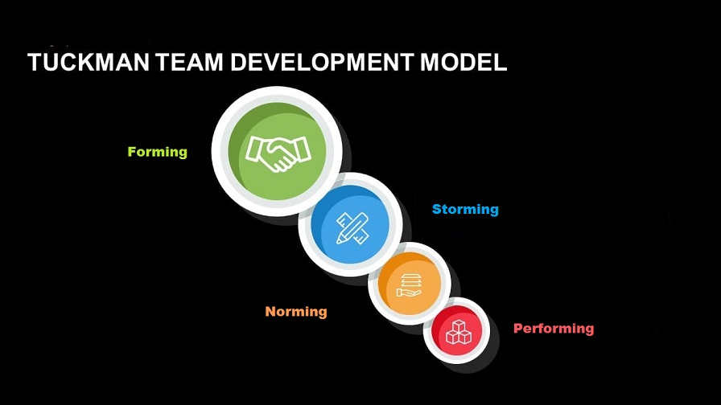
Figure 1: Tuckman’s Team Development (Tuckman, 1965)

Storming: After formation of team, team members started communicating with each other, moreover they also challenge each other, thus competition among the team members cause the problems in team work (Giannakas and et.al 2021). In such it is the responsibility of the team leader to solve the conflict among the team.
Norming: In this stage team member develop the spirit to grow together and they interact with each other to increase task productivity. As for the fashion store they can begin to implement such environment which enables the employees to feel dedicated towards their work.
Performing: A final stage where the team communication and task productivity increases simultaneously. Effectual performance is delivered when team works together. Thus after all changes in team fashion store will be able to deliver better services in market, which allows them to expand their business.

Thus with the help of this theory they can easily develop the team coordination, it is their responsibility to clears the goals which helps in creating the groups of individuals, and to follow cohesive work to develop task oriented teams.

Belbin team role theory:
Belbin theory describe the nine roles which are important for every team, these are-
Resource investigator: They are innovative and explores the chances for developing interactions and negotiate the resources on team’s behalf. Therefore, fashion store also need to analyse the team member who can fulfil this responsibility, so that it keep maintains the workplace environment.
Teamwork: For fashion store, team worker are those employee who help each other and lay out work together to complete their operational task efficiently. Those employees will fulfil the role of negotiators (Specht and et.al 2018).
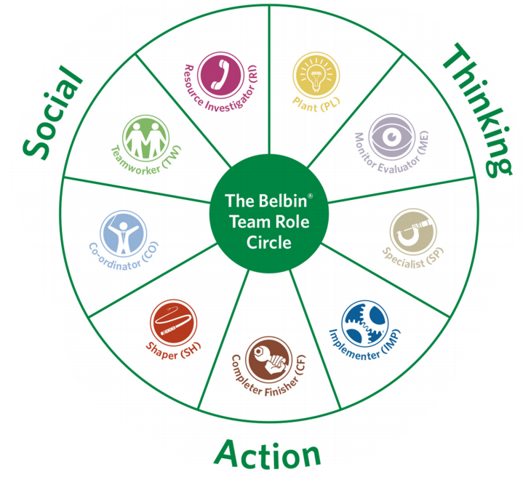
Plant: These are the team members who have novelty in their ideas and often develop innovative ideas for the firm. Thus with this fashion store can able to drive good revenues.

Figure 2 : Belbin’s Team Roles (Belbin, 2014)
Coordinator: Coordinators are traditional team leaders; they lead the team to perceive desired objectives. Firm need to give responsibility to those who have good leadership quality (Lynch, Lynch and Clemens, 2018).
Specialist: People who have specialised knowledge in particular things, they tend to be expert within team, thus with those employee fashion store will able to acquire better market position.
Monitor evaluator: They are the people who explore all the factors of task means evaluate all pros and cons to make any decision. In such firm is able to move forwardly without any prior mistake.
Shaper: Those team members who takes the challenges to improve the team, they are extroverted people and always carry out dynamic work. Such employees will help fashion firm to reduce workload.
Implementer: These people always responsible to convert team ideas into practical, they maintain discipline at work place. Therefore, with this fashion firm can be able to convert their effective research into practical (Andrejczuk and et.al 2019).
Complete finisher: Those are the employee who works on every small details to avoid any mistake or error.

Thus having such team will enable fashion store to accomplish their goals and objectives. Thus with the implement of Belbin theory fashion store can easily enable their staff members to understand their strength which lead them to implement effective communication within team.

Area-2

Analysing the importance of two-way communication at the organization in the context of the given case study

Two-way communication refers to the concept of exchanging the ideas and opinions among the people. This way of communication determines the proper platform to the people in order to share their ideas and thoughts. Also, it ensures the effective communication among the member of the organization. As it has been known in the case study that, the rapid expansion of the fashion store needs to employ more people in the organization.
The communication model of Shannon and Weaver states that the communication in the organization has to be part in the steps of sender, encoder, channel, noise, the decoder, and finally the receiver. This helps in the understanding of the message in effective manner. The fashion store must adopt this model of communication as it ensures the effective flow of communication.
In similar manner, The Berlo's communication model states the communication in the organization has to be take place within understanding the message in effective manner. It involves the encoder, message transmission and decoder.
The Schramm communication model has been considered as the two way-process that involves the sender and receiver. The exchange of opinion has been done under this model. This has been considered as one of the best model as it ensures the feedback of the receiver as well (John, Brooks and Schriever, 2019). In includes the process of interaction among the sender and receiver. This model enables the fashion store to exchanging the opinion among the different members. As a result, the effective interaction among the members will be created. Thus, it is highly important for the company to adopt the concept of two-way communication (Mao, Chen and Zhou, 2020).
The Interactive Model of two-way communication describes the communication as the process of exchanging the ideas, opinions, messages and thoughts with the physical and the psychological context. Thus, for the fashion store it is highly important to adopt the interactive model of communication as it assures the effective interaction among the members in the organization. In case, if there is no two-way communication exist in the organization then, it leads to create the environment for the fashion store in which all the members perform their activities by their own without consulting it with the other members and the supervisors. The first demand of the business in terms of getting expansion is to create the effective interaction among the members. So, the internal environment of the company can be maintained (Haman, and Pylaieva, 2018). It has been found from various studies that, the internal environment decides the success rate of the business. In similar manner, In the fashion store the interactive model has to be adopted as it helps in overcoming the numerous challenges. The major elements of this model are:

Encoder, Source and decoder- In this step the encoding and decoding of the message has been done. The person decodes the message for the person whom the message has to be sent. At this stage firstly, the person encode the message in the mind and then, decode it to the another person (Sylla, 2019). This ensures the better delivering of the ideas. In similar manner, this step leads to enable the staff of fashion store to make clear ideas in their mind and then, the ideas has to be share with the other members. This assures the clarity in delivering the ideas.
Message- The information that has been passed with decoding has been considered as the message (Marnewick and Joseph, 2019). Thus, the delivering of message among the different members of the department has been done.
Feedback- This is one of the vital aspect of the interactive communication as it involves the feedback after getting the message. This enables the employer in order to know whether the message that has been delivered has been understand by the subordinates or not. In the Fashion store, this element assures the effective understanding of the information to the employees as when there are large number of employees in the organization it is hard to know the understanding rate of the employees (ALAN, 2020). Thus, this element assures the effective understanding of the information.
Field of experience- It refers to the knowledge and experience that has been possessed by the particular person after getting the information. For example; In Fashion store, the employer delivers the information regarding the new project afterwards, the employees provides their opinions on the basis of their existing creativity and skills (HAGIU and BORTOȘ, 2020). The employees get the platform in terms of sharing their experience. This leads to remove the communication barrier and assures the moral of the employees in the fashion store.
The above point proves the importance of the interactive model of two-way communication. This concept leads to add the glory in the working procedure of the fashion store as this provides the platform to the employees in terms of understanding the information in effective manner (Nădrag and Buzarna-Tihenea, 2018). Also, it provides the opportunities to the employees for showing their creativity. As a result, the employees becomes more effective.

Determining the importance of effective communication for the consistent success of the organization
The effective communication is highly important for adding the higher success rate in the organization as it ensures the effective exchange of thoughts among the different members in the organization. The effective communication in mainly parted in two parts and that is Verbal & Non-verbal communication. Both the form of communication plays the vital role for adding the success and creating effective working procedure in the fashion store. The verbal form of communication refers to using the words in order to convey the message to the employees. Whereas, the non-verbal form of communication includes using effective facial expression, body language, eye contact, appearance and so on. For the expansion of the fashion store it is highly mandatory that, the employees feels motivated and have the sense of belongingness in the organization. Therefore, using the effective ways of communication creates the sense of belongingness in the mind of the employees, and they contribute in their task with complete dedication (Abrashi, 2018). Using effective facial expression while delivering the message to the employees increases the morale and value of the employees in the organization.

Therefore, the employers of the fashion store must use the effective ways of communication that involves the verbal and non-verbal communication as well. The employees feel motivated. Also, the employees gets the sense as they are the part of the organization. Thus, the effective communication can boost up the morale and confidence of the employees and improves their working procedure (Al-Fedaghi, 2020). As a result, the working procedure in the organization becomes collaborative and all the members interacts with each other. Furthermore, this leads to assure the success and growth to the organization (Ali Almamari and Kolluru, 2020).

CONCLUSION
From the above report is has been concluded that, group work and effective communication plays the vital role in adding the higher success rate in the organisation. Furthermore, the report has shown that, effective team working can solves the number of barriers and efficient strategies of communication improves the flow of communication among the members in the organisation.

REFERENCES
Books and Journals
Abrashi, G., 2018. Organizational Communication-the Importance of Communication Strategy in Times of Crisis for the Organization. European Journal of Social Sciences. 1(2). pp.21-25.

ALAN, G.A.E., 2020. The importance of marketing public relations for “new” consumers. New Communication Approaches in the Digitalized World. p.157.

Al-Fedaghi, S., 2020. Underpinning Theories of Software Engineering: Dynamism in Physical Sources of the Shannon Weaver Communication Model. arXiv preprint arXiv:2010.08538.
Ali Almamari, L.T.H. and Kolluru, M., 2020. A qualitative study on the relationship between management and communication within organization. Ali Almamari, Lamees Talib Hilal and Kolluru, Mythili, Journal of Student Research. Qualitative Study on the Relationship between Management and Communication within Organization (July 11, 2020).
Andrejczuk, E. and et.al 2019. Synergistic team composition: A computational approach to foster diversity in teams. Knowledge-Based Systems. 182. p.104799.

Belbin, M., 2014. Belbin team roles. Book Belbin Team Roles.
Giannakas, F. and et.al 2021. A deep learning classification framework for early prediction of team-based academic performance. Applied Soft Computing. 106. p.107355.

HAGIU, A. and BORTOȘ, S., 2020 TOWARDS AN APPLIED ETHICS IN DIGITAL COMMUNICATION: A TRANSDISCIPLINARY PERSPECTIVE ON RESPONSIBILITY. F ilosofie, p.110.
Haman, K. and Pylaieva, T.V., 2018. Importance of good communication skills.

John, P., Brooks, B. and Schriever, U., 2019. Speech acts in professional maritime discourse: A pragmatic risk analysis of bridge team communication directives and commissives in full-mission simulation. Journal of Pragmatics. 140. pp.12-21.

Lynch, D.S., Lynch, M.J. and Clemens, C.M., 2018. Belbin Team Roles. The Handbook of Communication Training: A Best Practices Framework for Assessing and Developing Competence.

Mao, Z., Chen, Y. and Zhou, L., 2020, October. A Multidimensional Interactive Techniques for Satellite Communication Simulation Application. In Proceedings of the 4th International Conference on Computer Science and Application Engineering (pp. 1-5).
Marnewick, A.L. and Joseph, N., 2019. The Importance of Planning for Communication in a Project During the Requirements Process. IEEE Engineering Management Review. 48(1). pp.104-112.
Nădrag, L. and Buzarna-Tihenea, A., 2018. The Importance of Business Communication in an Organization. International Journal of Innovation in the Digital Economy (IJIDE). 9(2). pp.40-56.
Specht, A. and et.al 2018. A story of data won, data lost and data re-found: the realities of ecological data preservation. Biodiversity Data Journal. (6).
Sylla, M., 2019. Between Organization and Performance: When the Firm Meets Information and Communication Technologies. International Journal of Human Resource Studies. 9(3). pp.37-54.

Tisocco, F. and Fernández Liporace, M., 2021. The Tuckman Procrastination Scale: Psychometric Features among Buenos Aires Undergraduates. Psychological Thought. 14(2).

Tripathy, M., 2018. Building quality teamwork to achieve excellence in business organizations. International research journal of management, IT and social sciences. 5(3). pp.1-7.

Tuckman, B.W., 1965. Developmental sequence in small groups. Psychological Bulletin, 63, 384-399.

