11/18/2025
University of Wales Trinity Saint David
London Campus
IWD: Database Design and Development
Assignment 01
Module Name: Introduction to Web and Database Concepts
Module Code: ACCA4023

Student Name: Maksim Zanev
Student ID:2436811
Group: 2

Lecturer’s Name: Suneth Fernando

Contents
Introduction to the case study 3
Entity Relationship Diagram (ERD): 3
Entities interact within the database 5
Logical Design 6
Table Creation in MS – Access 6
Bike Table 6
Rent Table 6
Rider Table 6
Track Table 7
Key Table 7
Relationships between tables 7
Testing and Validation 8
Normalization Process 9
The First Normal Form (1NF) 9
Second Normal Form (2NF) 10
Third Normal Form (3NF) 10
MS- Access 11
Forms Creation 12
Bike Form 12
Rent Form 12
Rider Form 13
Track Form 13
Forms Creation – Summary 13
Queries Creation 14
Bikes Out On Rental Query 14
Bikes Due To Service Query 15
15
Most Used Bikes Query 16
16
Queries Creation – Summary 16
Report Creation 17
Bikes Out On Rental Report 17
Bikes Due To Service Report 18
Most Used Bikes Report 19
Calculations 20
Dashboard Creation 20
Dashboard Creation – Summary 20

Introduction to the case study

This case study explains how I designed and built a database system for the Eco_Ride Electric Bike Rental service. The goal is to replace the manual paperwork and basic spreadsheets with a structured database that is easier to manage. In this assignment, I go through each step of the development process, starting with identifying the main entities like Riders, Bikes, Rentals, and Staff.
I created an ER diagram to show how these entities are connected, and then I used it to build the tables in MS Access. I show the logical design, the table structures, and how the relationships were created using primary and foreign keys. I also carried out the normalisation process up to 3rd Normal Form to make the data organised and efficient.
To make the system easier to use, I created forms, queries, and reports, all shown with screenshots in both Design View and Datasheet/Report View. I also built a simple dashboard that allows easy navigation between the main menu and the forms. Overall, this case study shows the full process of creating a working database solution for Eco_Ride.

Entity Relationship Diagram (ERD):

This ER diagram shows the design of the Eco_Ride Electric Bike Rental system. I identified all the entities, listed their key attributes, and connected them with the correct relationship types. The diagram explains how riders rent bikes and how staff members track and manage them.
• Rider ↔ Rental (One-to-One):
This is a one-to-one relationship because a rider can only have one active rental at a time, and each rental belongs to only one rider.
• Bike ↔ Rental (One-to-One):
This relationship is also one-to-one as one bike can only be rented once at a time, and each rental is linked to only one bike.
• Bike ↔ Staff (Many-to-Many):
This is a many-to-many relationship because one bike can be tracked by several staff members, and each staff member can track more than one bike.
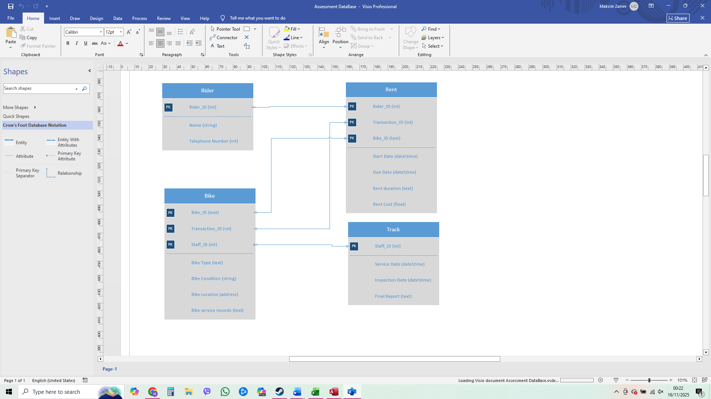

Type of Relationship between Entities (please explain each relationship with appropriate examples from the case study.)
One – to – One
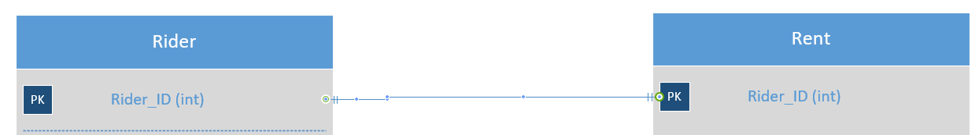
This is a one-to-one relationship because a rider can have only one active rental at a time, and each rental belongs to only one rider.

One – to – Many
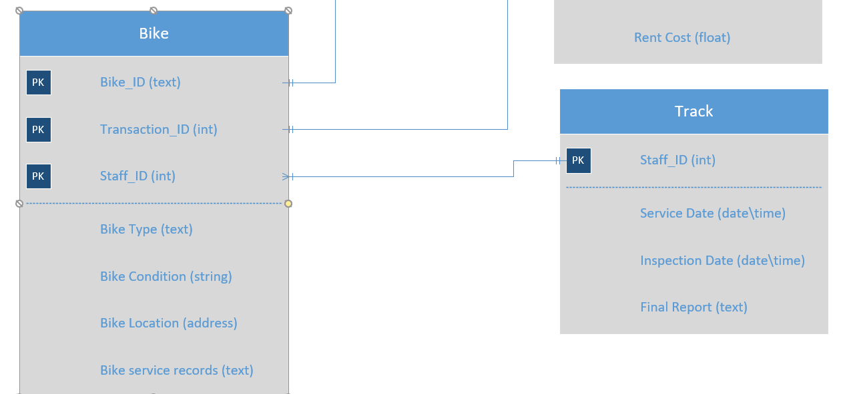
This is one-to-many relationship because one bike is tracked from many staff, and many staff can track one bike.

Many – to – Many

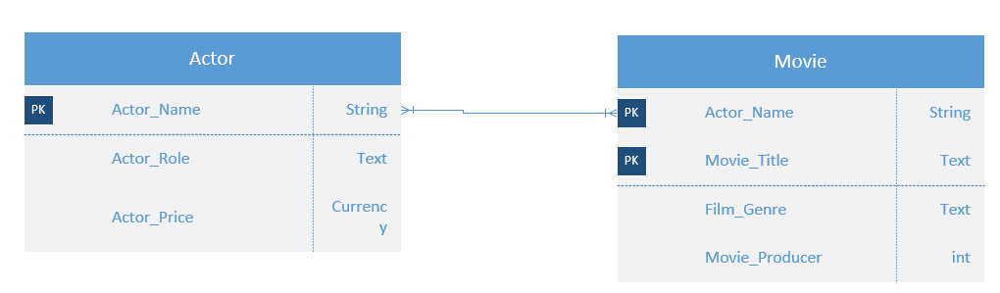
This is a many-to-many relationship because an actor can perform in many movies, and each movie can include many actors.

Entities interact within the database
ER modelling helps me because it gives a clear picture of the system before I build the database. It shows the main entities, their attributes, and how they connect to each other. This makes it easier to understand the data, avoid mistakes, and choose the correct relationship types. By having the diagram first, I can plan the tables, primary keys, and foreign keys properly. Overall, ER modelling works like a blueprint that guides me when creating the final database

Logical Design
Table Creation in MS – Access

Bike Table
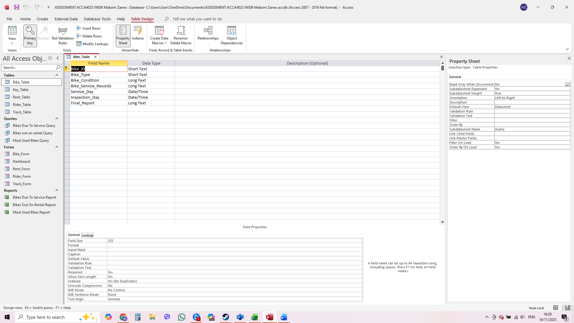
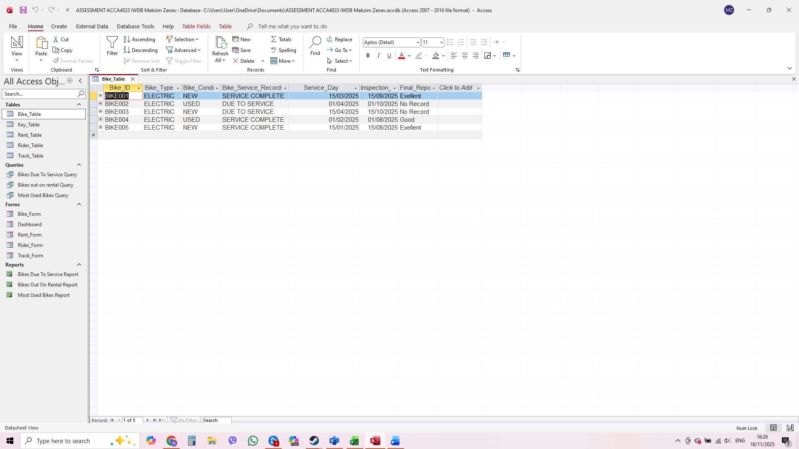

Rent Table
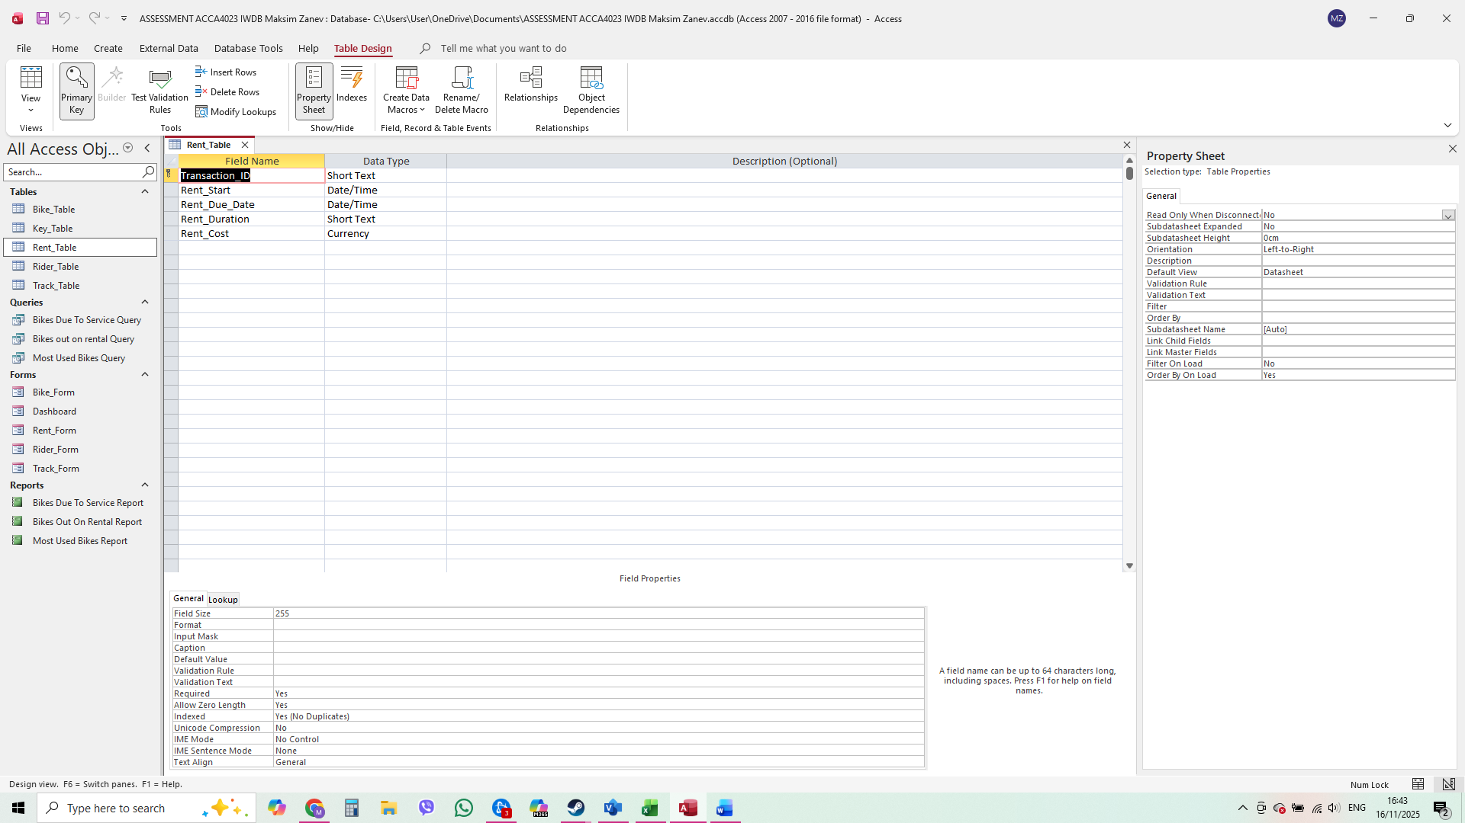
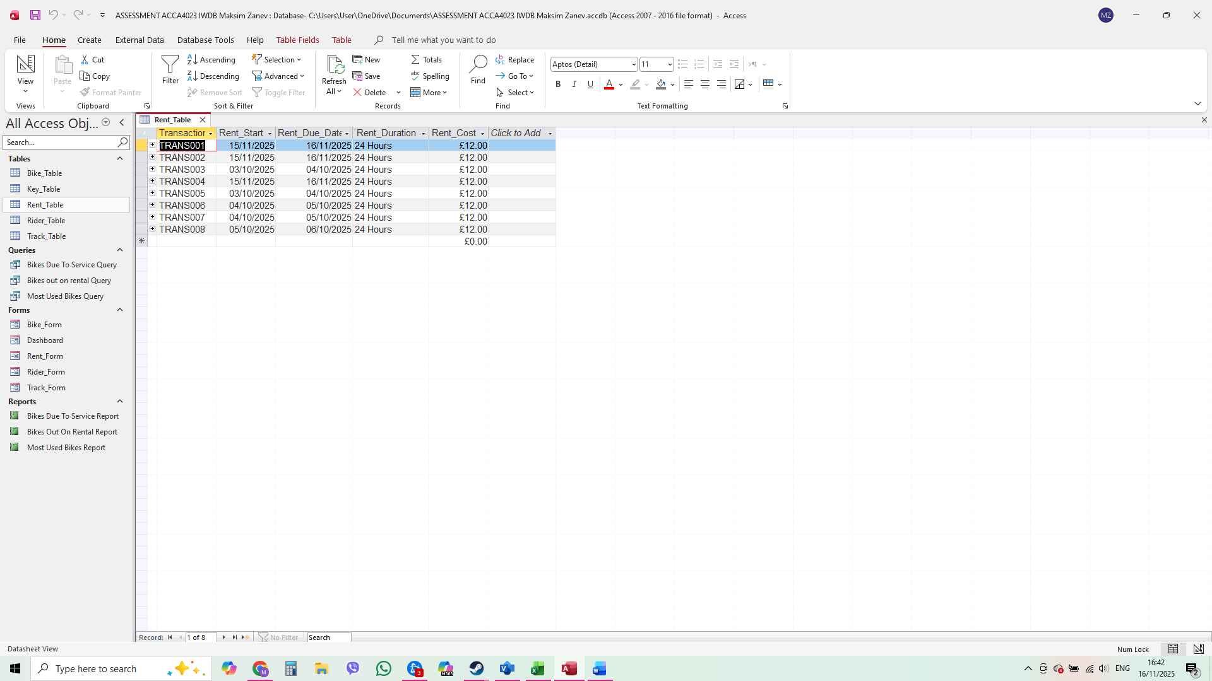

Rider Table
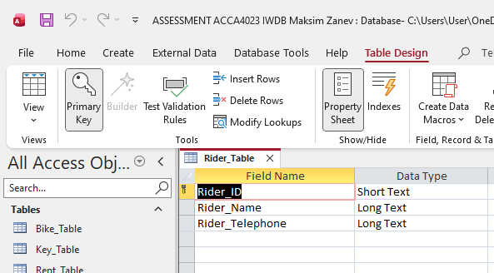
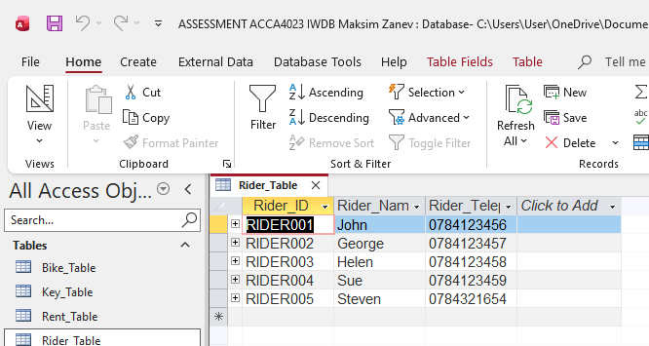

Track Table
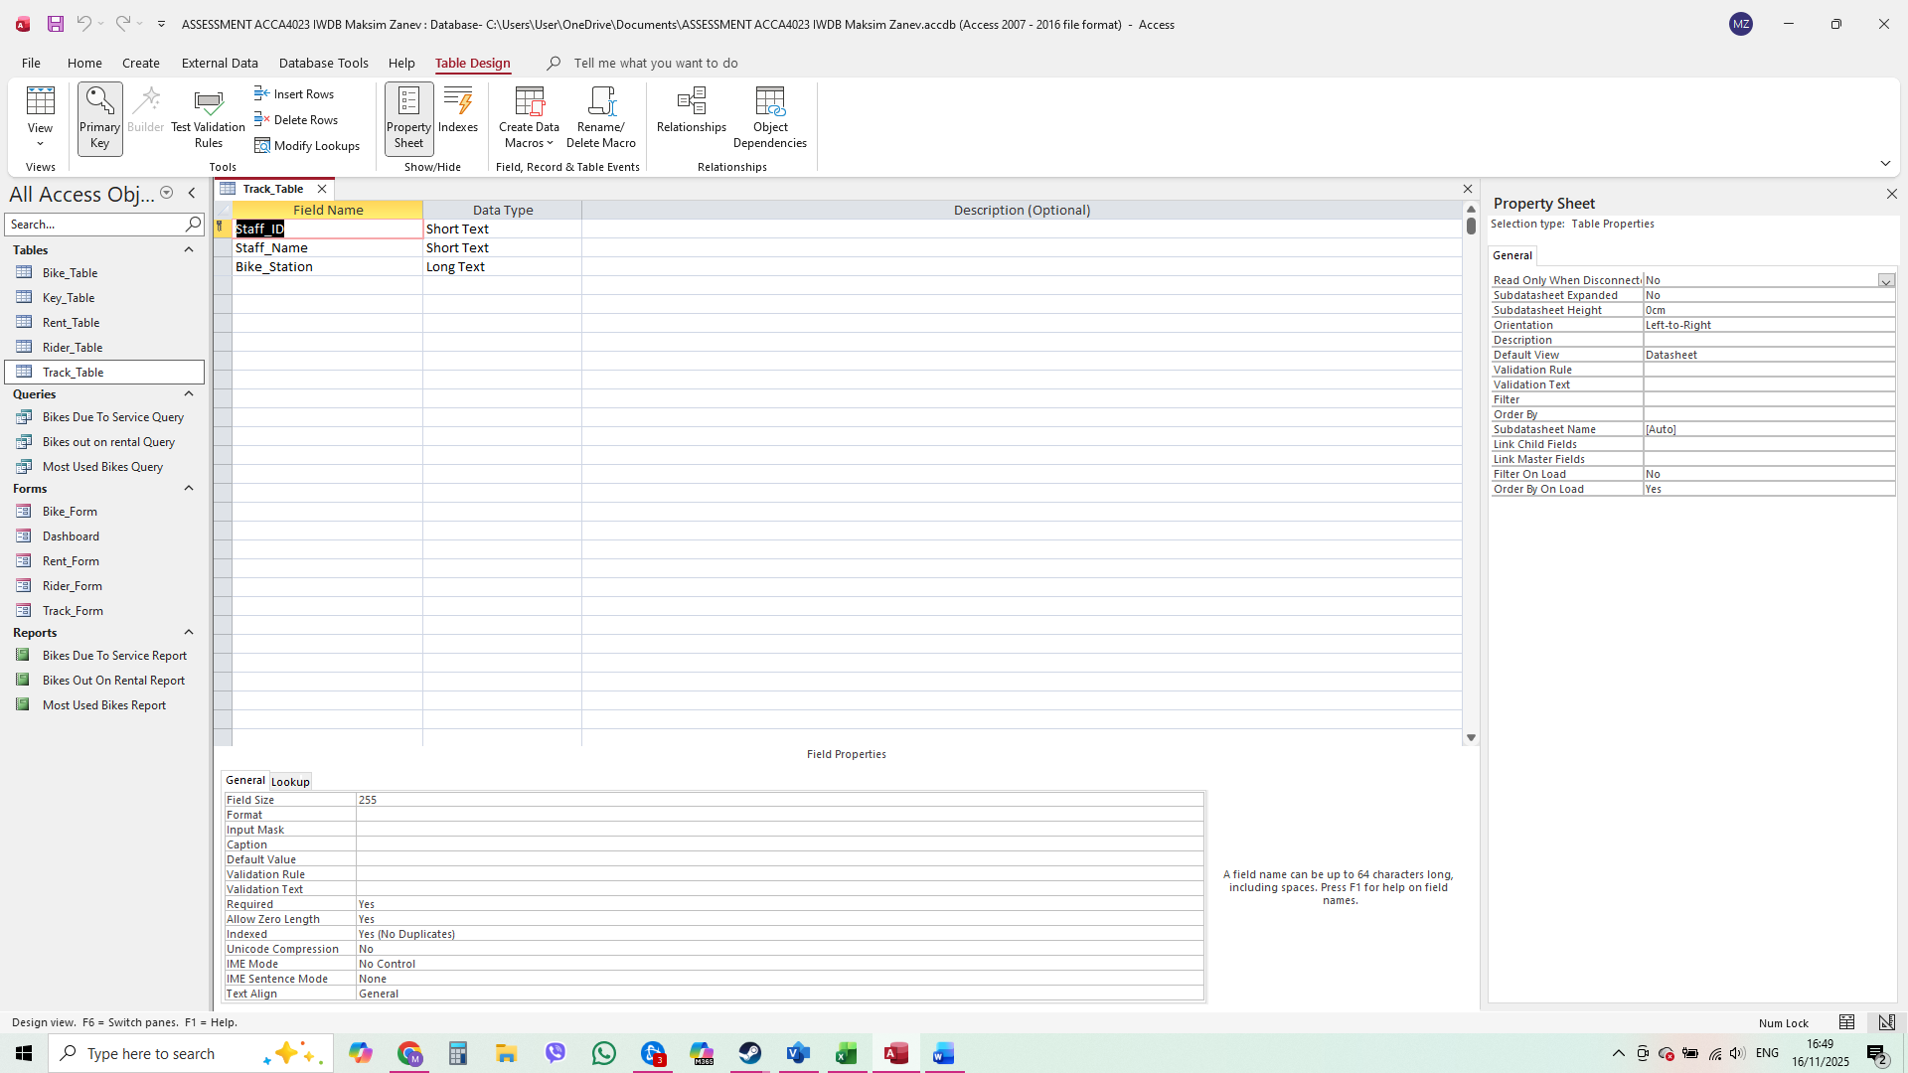
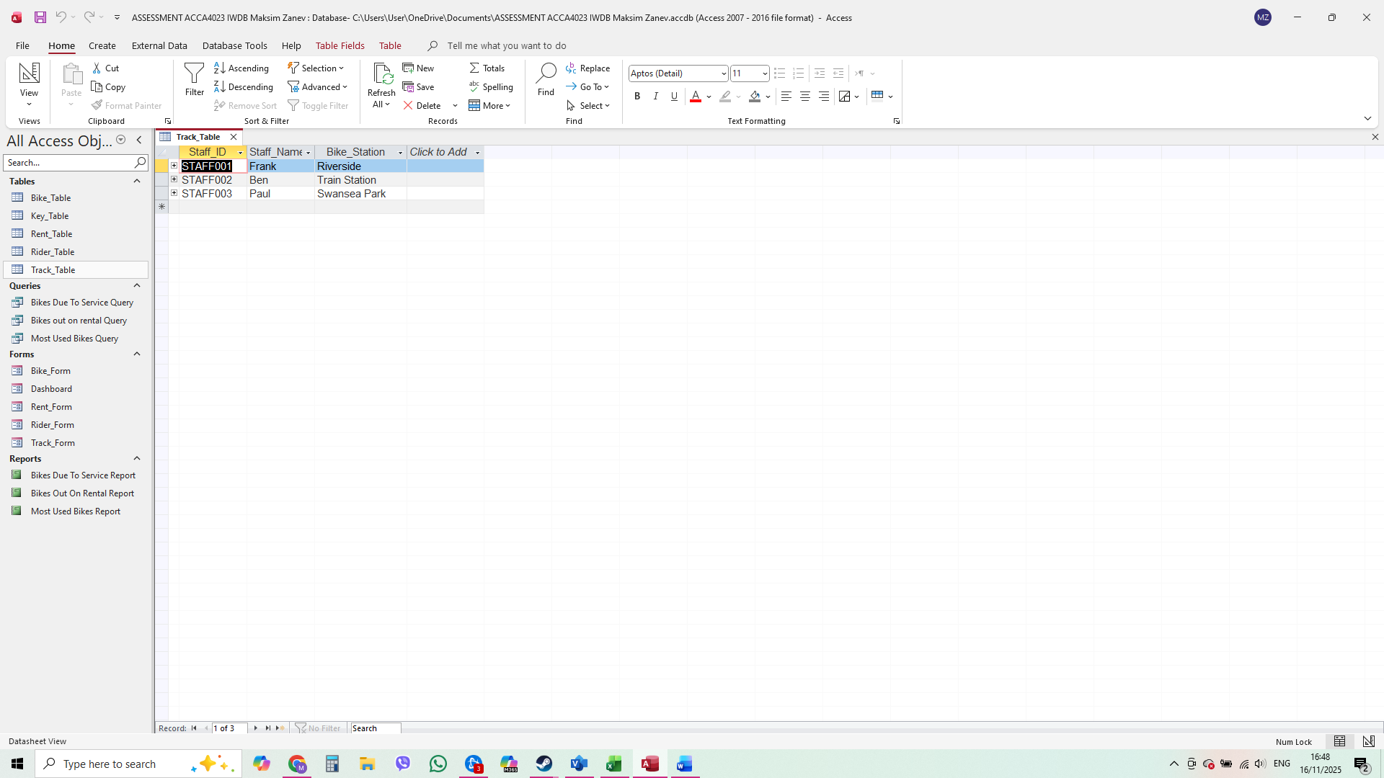

Key Table
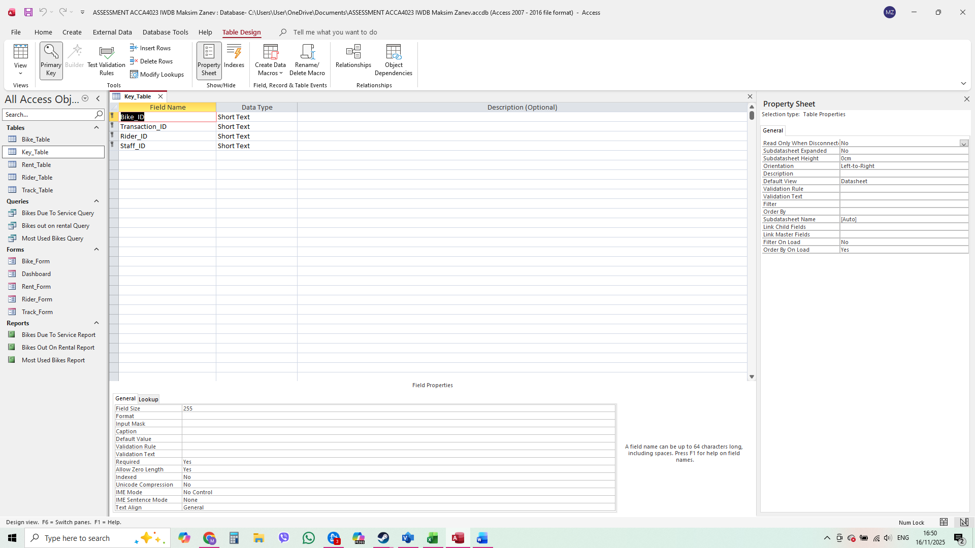
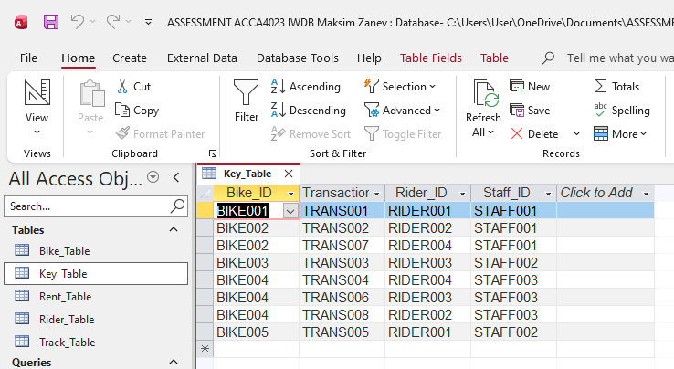

Relationships between tables

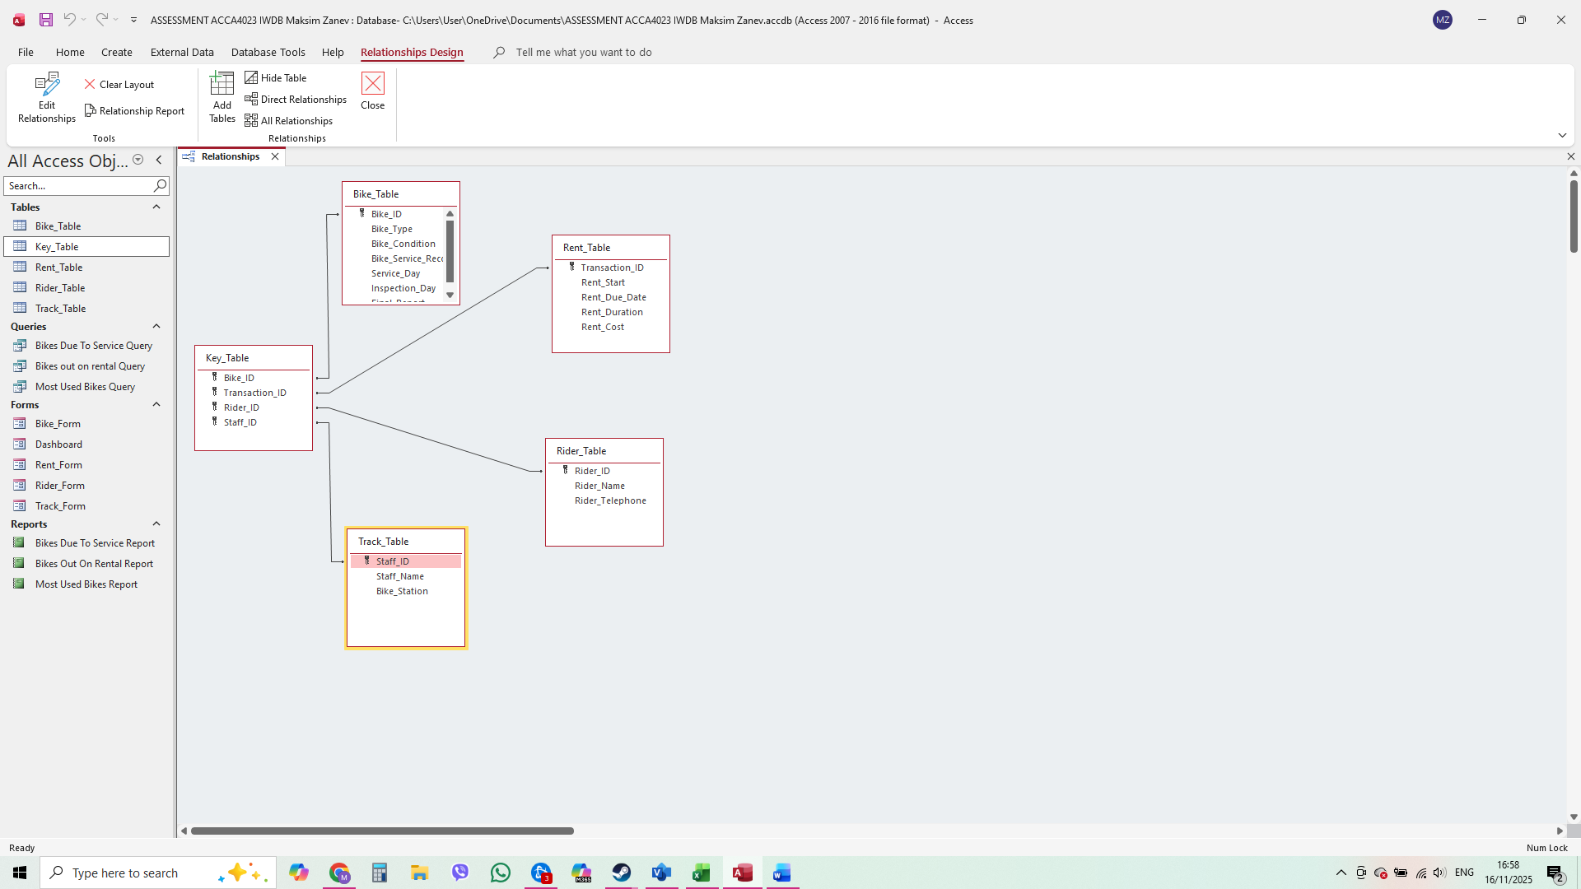
Each table in my database uses a primary key to uniquely identify its records and foreign keys to create the relationships between tables. The Bike_Table uses Bike_ID as its primary key, and this key is used in other tables to link information to each bike. The Rider_Table uses Rider_ID as its primary key, which connects each rental to the correct rider. The Rent_Table has Transaction_ID as its primary key and includes Rider_ID and Bike_ID as foreign keys to link each rental back to the rider and the bike involved. The Track_Table uses Staff_ID as its primary key to identify each staff member. Finally, the Key_Table contains Bike_ID, Transaction_ID, and Staff_ID as foreign keys, which allow it to link bikes, rentals, and staff members together and support the one-to-many relationship between staff and bikes.

Testing and Validation
Test Cases | Expected Results | Actual Results | Any Discrepancies
Bikes currently out On rental | It is expected to identify all bikes that are currently out on rental on a specific day. | Specific query is created to filter data on this query. | No
Bikes due to service | It is expected to find all bikes that are Due to service status | Specific query is created to filter data on this query. | No
Most used bikes | It is expected to show which bikes are used the most and have the highest number of rentals over a specific period. | Specific query is created to filter data on this query. | No

Normalization Process
Take screenshots of 3rd Normal form from MS-Excel and Paste here and annotate each table.
Unnormalized Table
The first picture shows the Unnormalised Table, which represents the initial stage of the normalisation process. This table contains all the raw data and information collected for the system before any structure or organisation is applied. At this stage, the data is not separated into entities, and there are repeating groups, duplicated values, and mixed attributes. The purpose of showing the unnormalised table is to demonstrate how the information originally existed and to provide a starting point for breaking it down into cleaner, more efficient tables in later normalisation stages.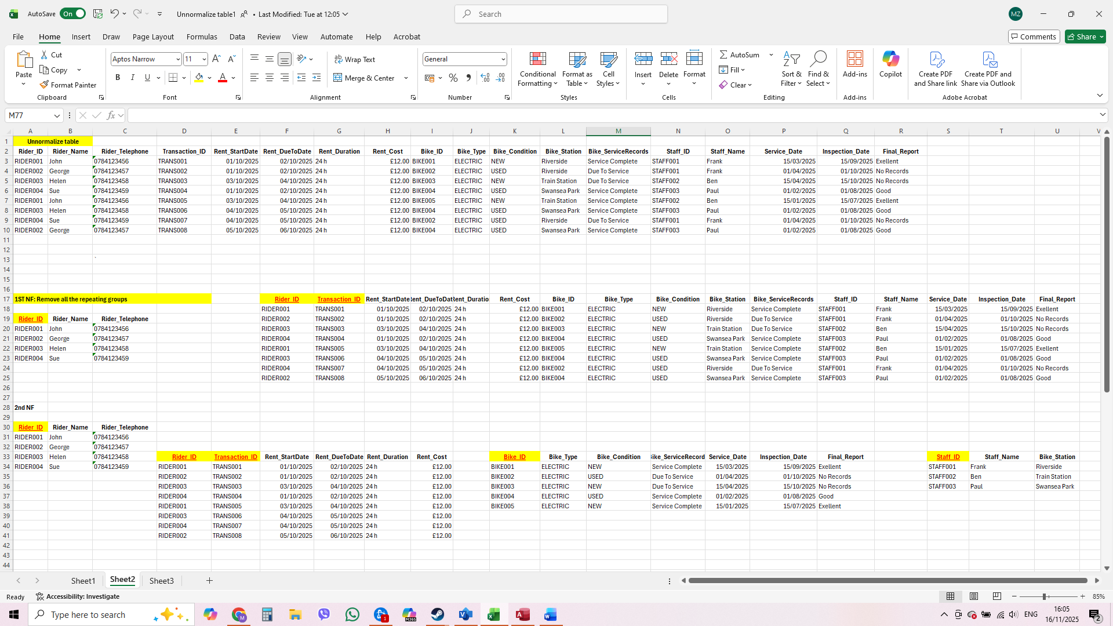

The First Normal Form (1NF)
The First Normal Form (1NF) stage removes repeating groups and ensures that all data is stored in individual, single-value fields. In this step, I reorganised the unnormalised table by separating any multi-valued attributes into their own rows and making sure each column contains only one type of information. This creates a more structured layout where every record is unique and every field holds atomic (indivisible) data. The purpose of 1NF is to clean the data and prepare it for further normalisation, reducing duplication and making the table easier to work with.
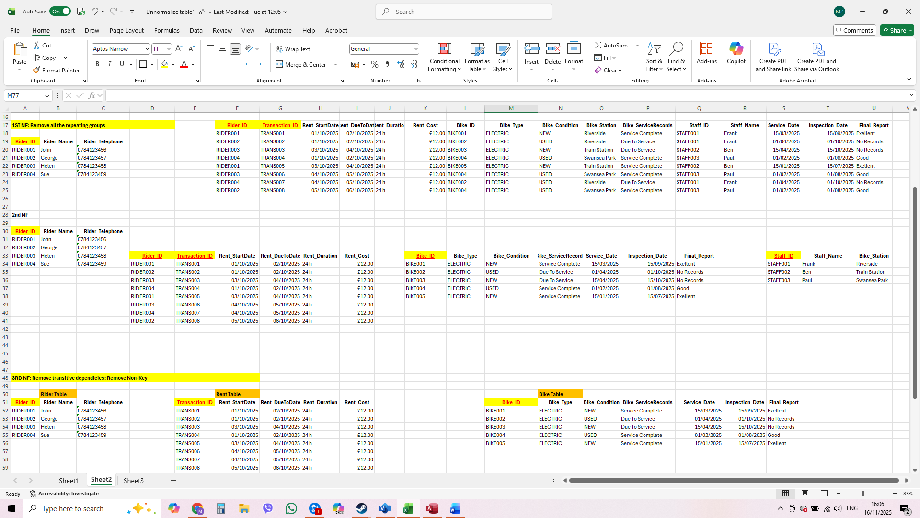

Second Normal Form (2NF)
In the Second Normal Form stage, I removed partial dependencies by separating data that does not fully depend on the whole primary key. This means that any attributes linked only to part of a composite key were moved into their own tables. By doing this, each table now contains information that is directly related to its full primary key. This helps reduce duplication further and ensures that each table has a clear purpose. The aim of 2NF is to improve the structure from 1NF and prepare the database for the final stage of normalisation.
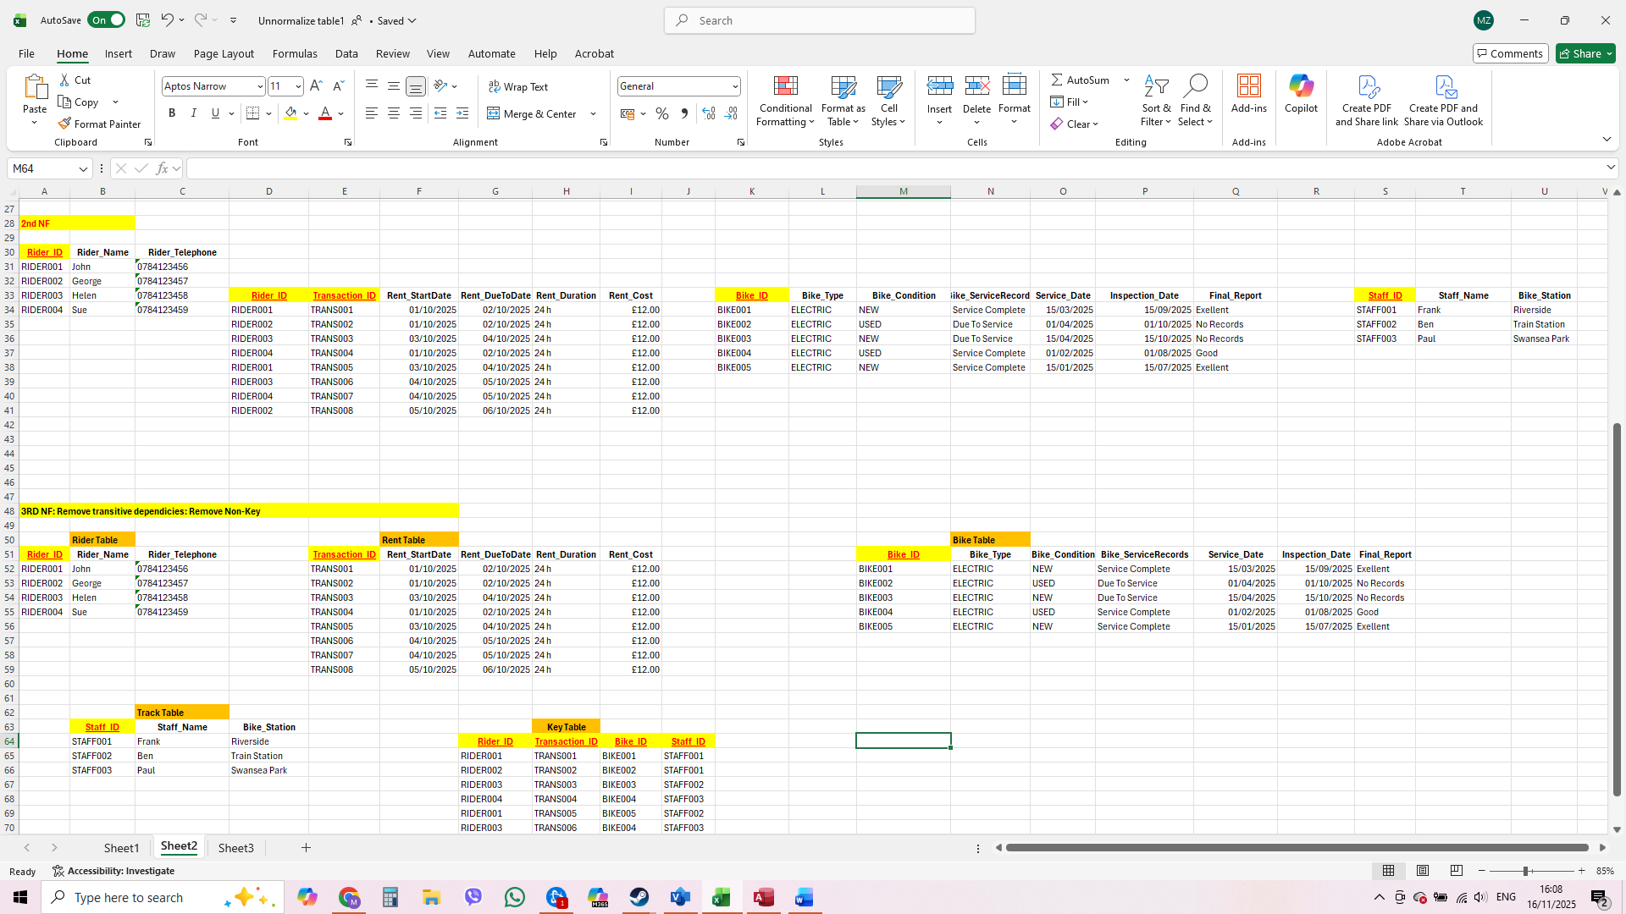

Third Normal Form (3NF)
The Third Normal Form stage removes transitive dependencies, which means separating any attributes that depend on other non-key attributes instead of the primary key. In this step, I created new tables where needed to make sure every field depends only on the main key of that table. As a result, the database becomes more efficient, avoids unnecessary repetition, and reduces the risk of update anomalies. The purpose of 3NF is to create a clean and fully organised set of tables that support accurate queries and reliable data management.

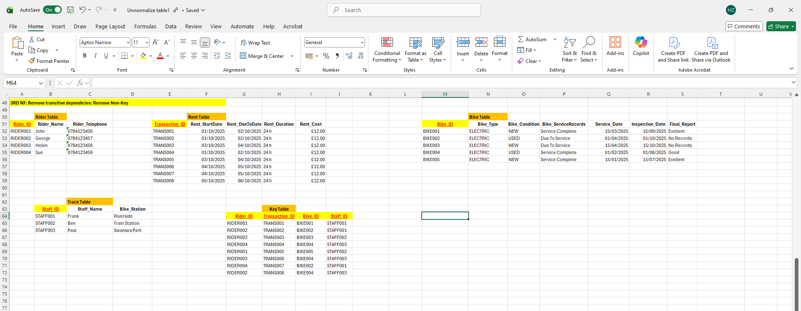

MS- Access

Forms Creation

Bike Form
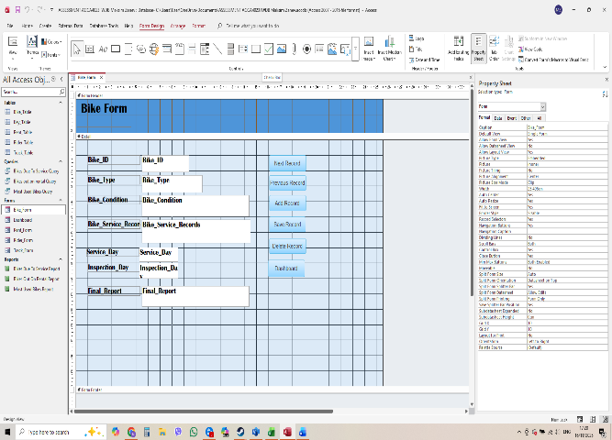
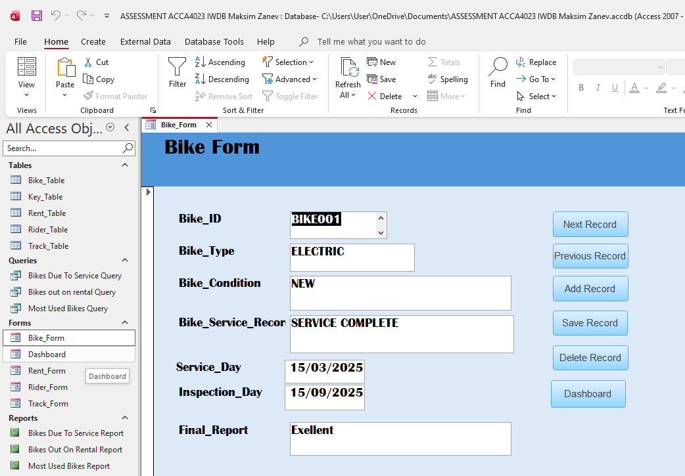

Rent Form
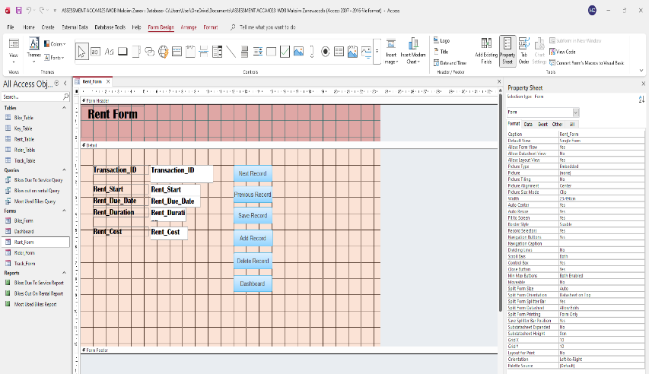
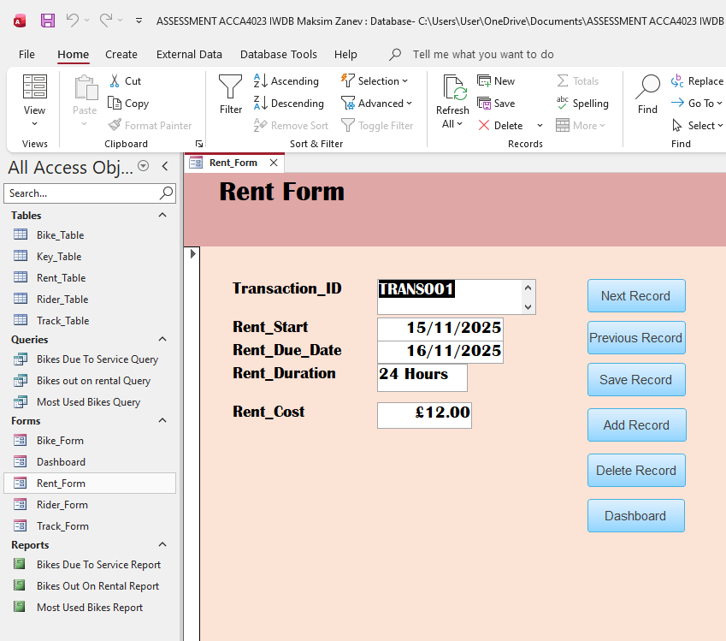

Rider Form
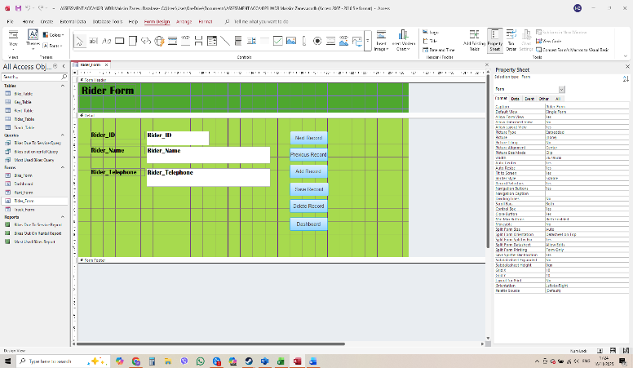
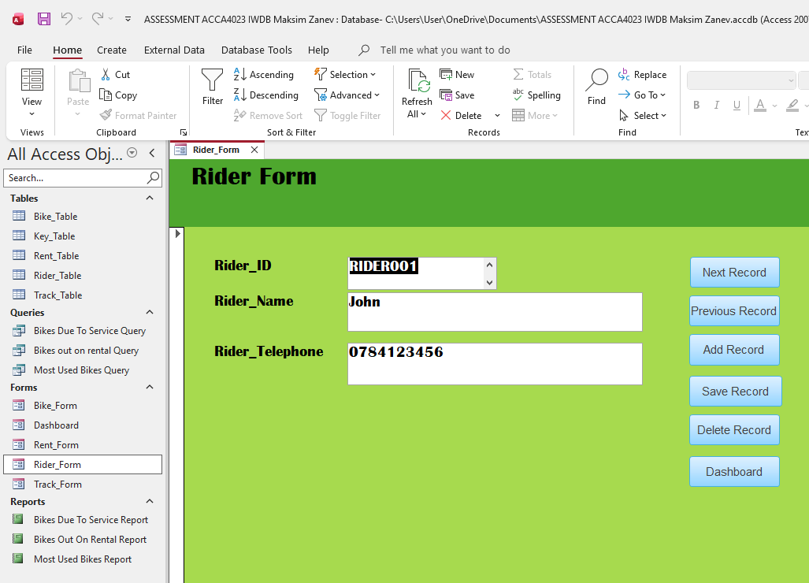

Track Form
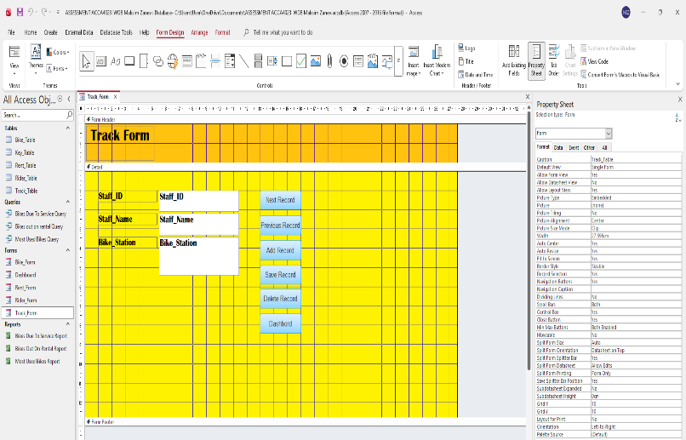
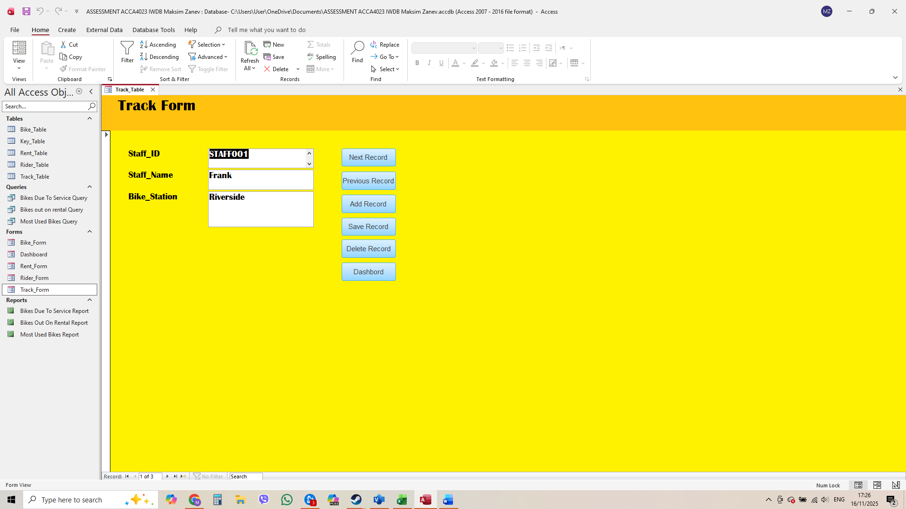

Forms Creation – Summary
For this project, I created several forms to make data entry and updates easier in the Eco_Ride database. Each form is shown in both Form View and Design View. In Design View, I adjusted the layout of the forms by moving fields, resizing boxes, and organising the labels so everything looks clear. This helped me improve the design and make the forms look neat and easy to use in Form View. Using Design View allowed me to create forms that are simple to understand and comfortable for users to work with.

Queries Creation

Bikes Out On Rental Query
SELECT
Bike_Table.Bike_ID,
Rent_Table.Rent_Start,
Rent_Table.Rent_Due_Date
FROM
Rent_Table
INNER JOIN (
Bike_Table
INNER JOIN Key_Table ON Bike_Table.Bike_ID = Key_Table.Bike_ID
) ON Rent_Table.Transaction_ID = Key_Table.Transaction_ID
WHERE
(((Rent_Table.Rent_Start) = #11 / 15 / 2025 #));

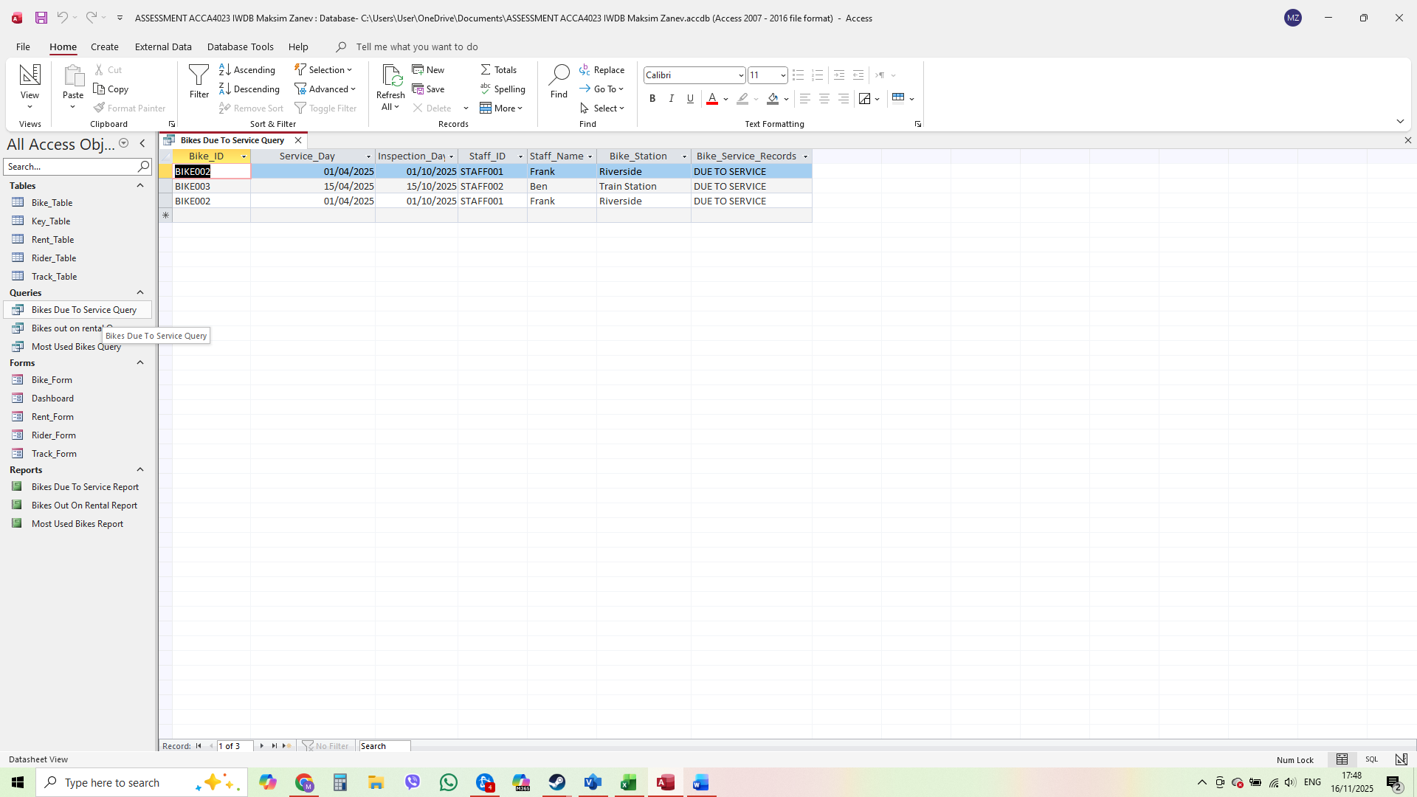

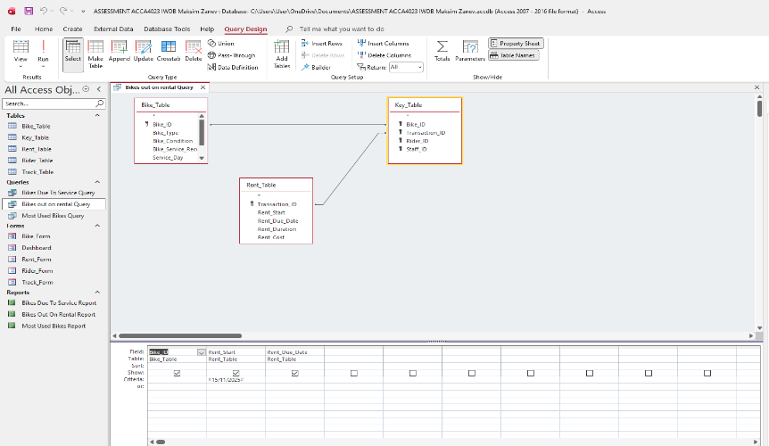

Bikes Due To Service Query
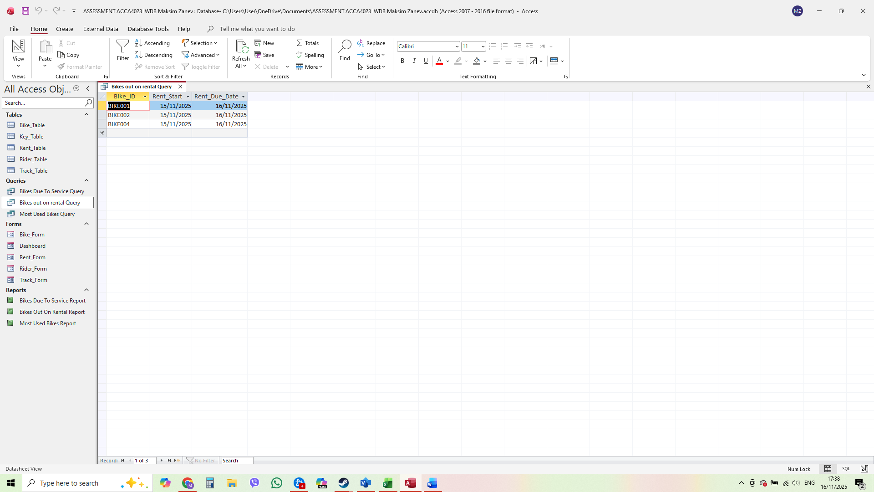
SELECT
Bike_Table.Bike_ID,
Bike_Table.Service_Day,
Bike_Table.Inspection_Day,
Track_Table.Staff_ID,
Track_Table.Staff_Name,
Track_Table.Bike_Station,
Bike_Table.Bike_Service_Records
FROM
Track_Table
INNER JOIN (
Bike_Table
INNER JOIN Key_Table ON Bike_Table.Bike_ID = Key_Table.Bike_ID
) ON Track_Table.Staff_ID = Key_Table.Staff_ID
WHERE
(
(
(Bike_Table.Bike_Service_Records) = "DUE TO SERVICE"
)
);

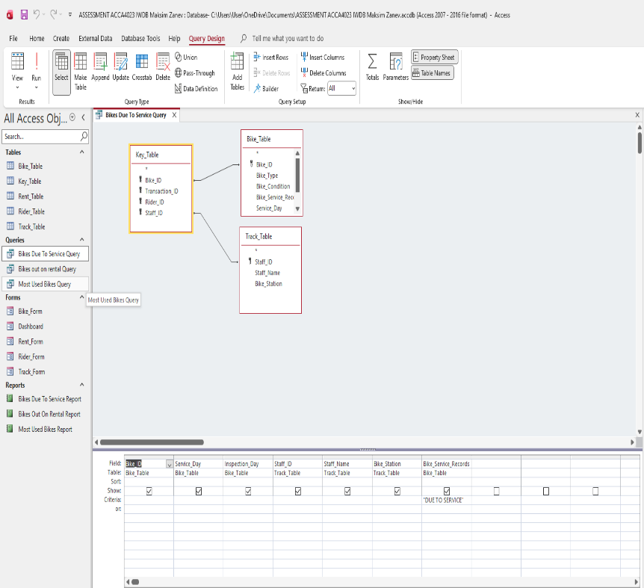

Most Used Bikes Query
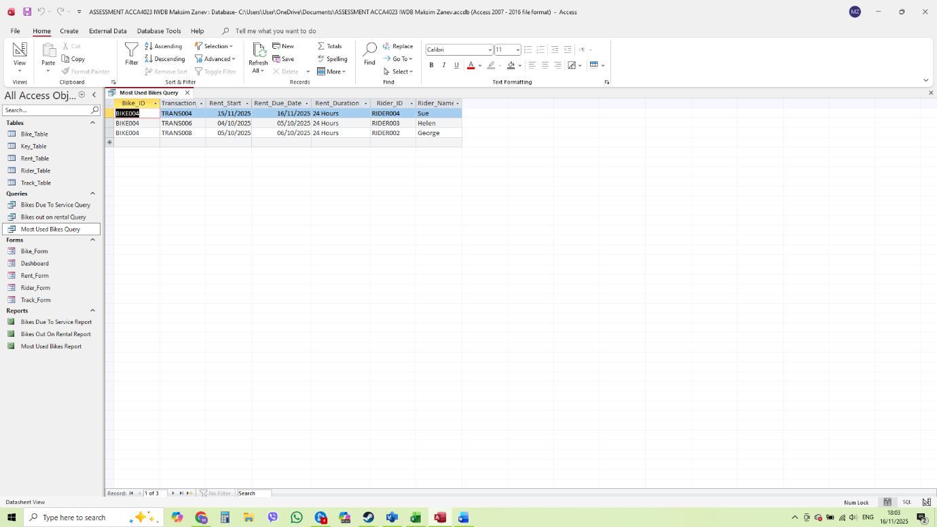
SELECT
Bike_Table.Bike_ID,
Rent_Table.Transaction_ID,
Rent_Table.Rent_Start,
Rent_Table.Rent_Due_Date,
Rent_Table.Rent_Duration,
Rider_Table.Rider_ID,
Rider_Table.Rider_Name
FROM
Rider_Table
INNER JOIN (
Rent_Table
INNER JOIN (
Bike_Table
INNER JOIN Key_Table ON Bike_Table.Bike_ID = Key_Table.Bike_ID
) ON Rent_Table.Transaction_ID = Key_Table.Transaction_ID
) ON Rider_Table.Rider_ID = Key_Table.Rider_ID
WHERE
(((Bike_Table.Bike_ID) = "BIKE004"));

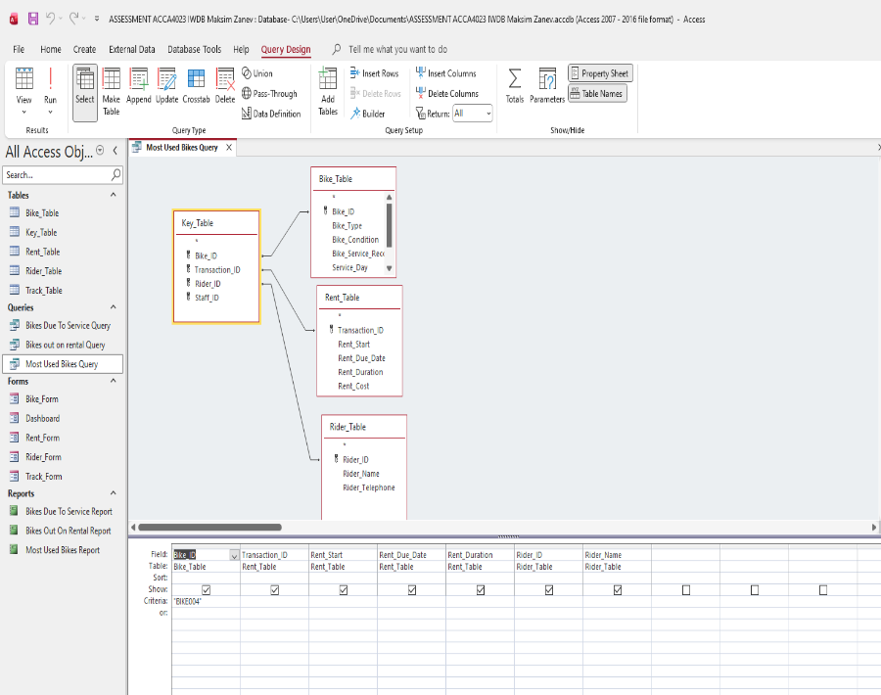

Queries Creation – Summary
I created three queries to retrieve and analyse important information from the Eco_Ride database. These queries help filter data, search for specific records, and combine information from multiple tables, such as checking which bikes are currently rented or which bike is due to service date. For each query, I provided screenshots of the Datasheet View, Design View, and the SQL code to clearly show how the queries were built and how they work. This demonstrates the full process of creating the queries and ensures the results are easy to understand and use

Report Creation

Bikes Out On Rental Report
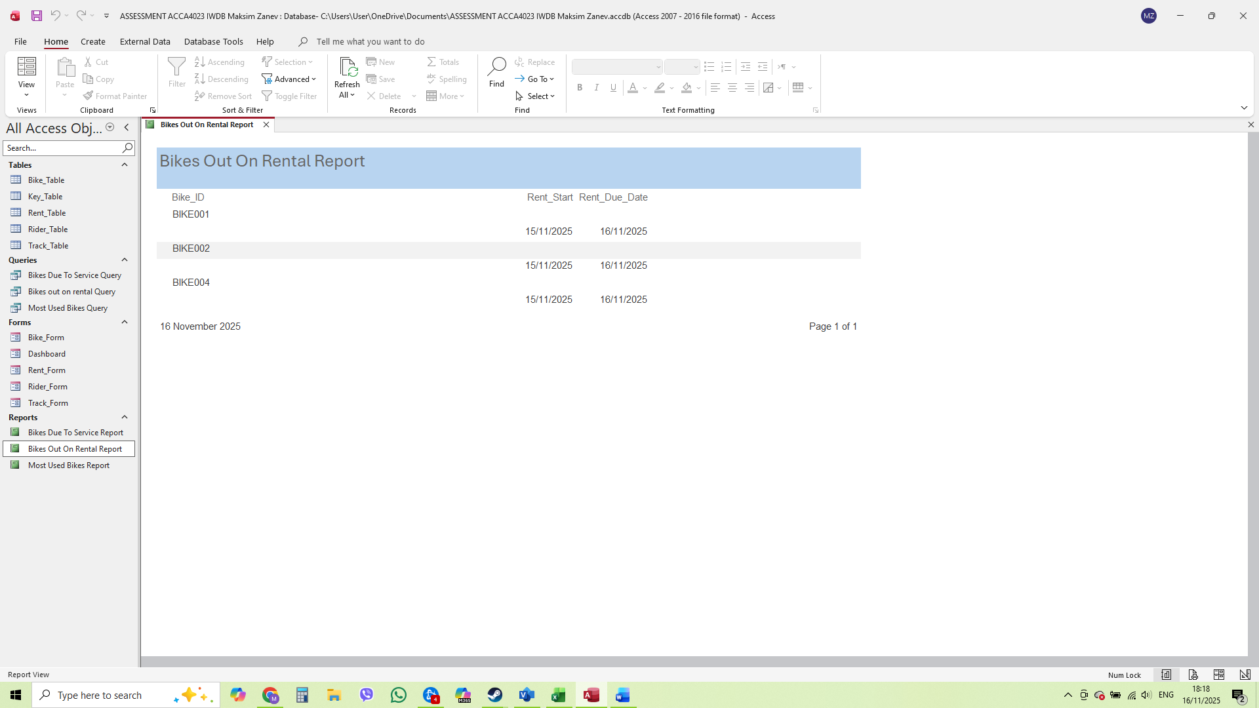

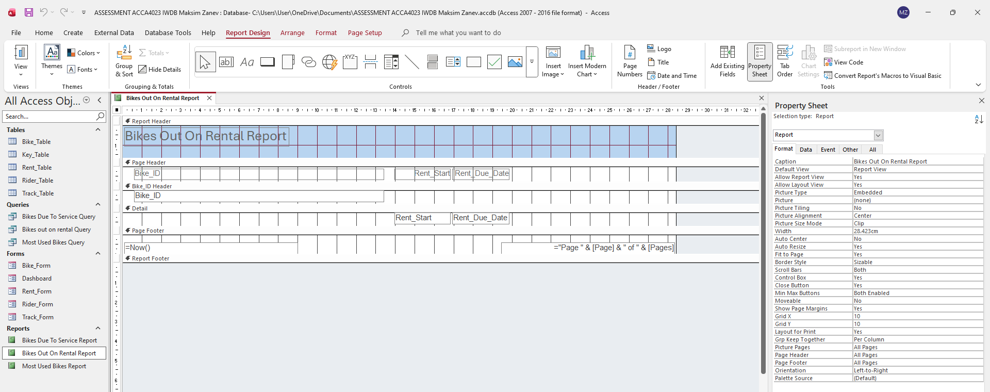
I created a report based on the query that shows all bikes currently out on rental. The report displays useful details such as the bike ID, and the rental date. I designed the report to be clear and easy to read, with a clean layout that helps staff quickly see which bikes are not available at the moment. I also provided screenshots of the report in Report View and Design View, showing how the report was structured and formatted. The annotations explain each part of the report and how it presents the information from the query.

Bikes Due To Service Report

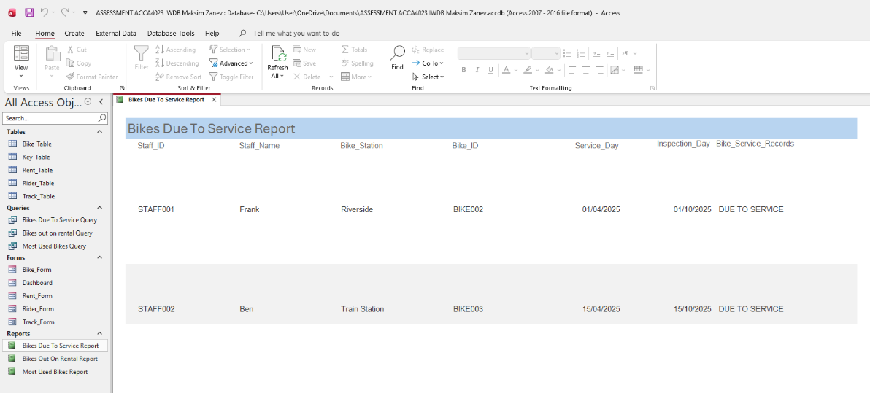

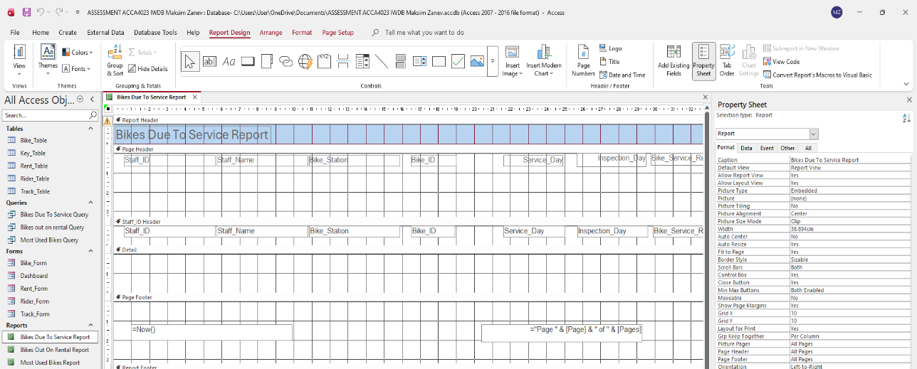

I created a report based on the query that identifies all bikes that are due for service. The report includes important details such as the bike ID, staff ID, the last service date, and any notes related to maintenance. It is designed to help staff quickly see which bikes need attention, making it easier to plan repairs and keep the fleet in good condition. I also provided screenshots of the report in Report View and Design View, showing how the layout was arranged and formatted. The annotations explain the different sections of the report and how the information from the query is presented clearly for staff use.

Most Used Bikes Report

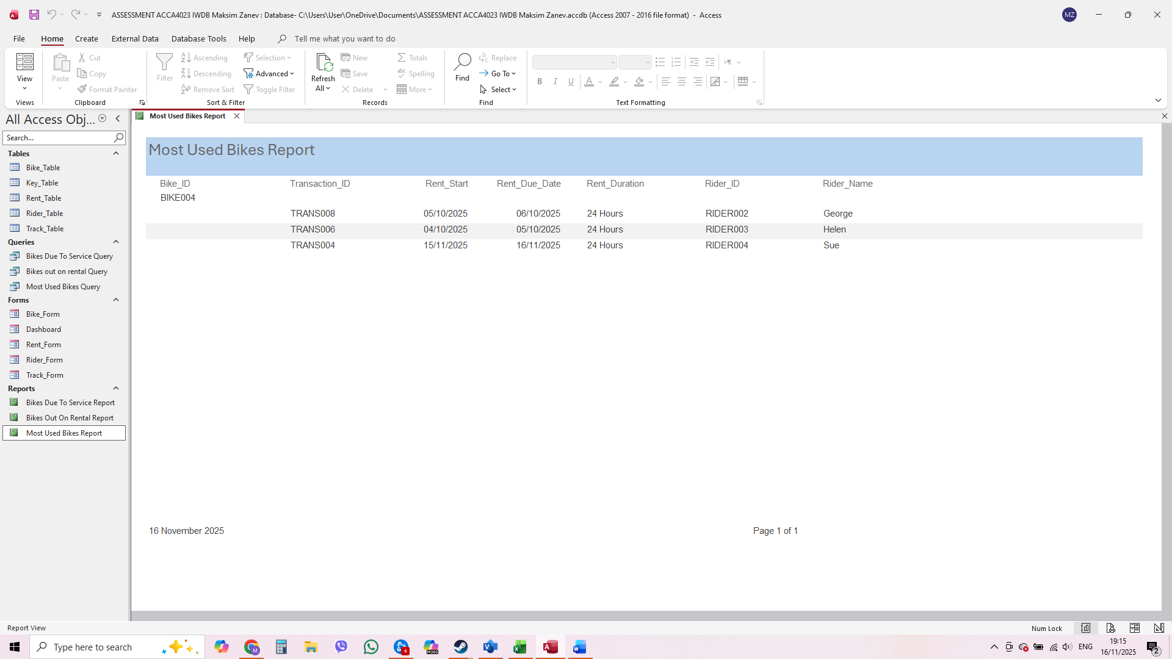

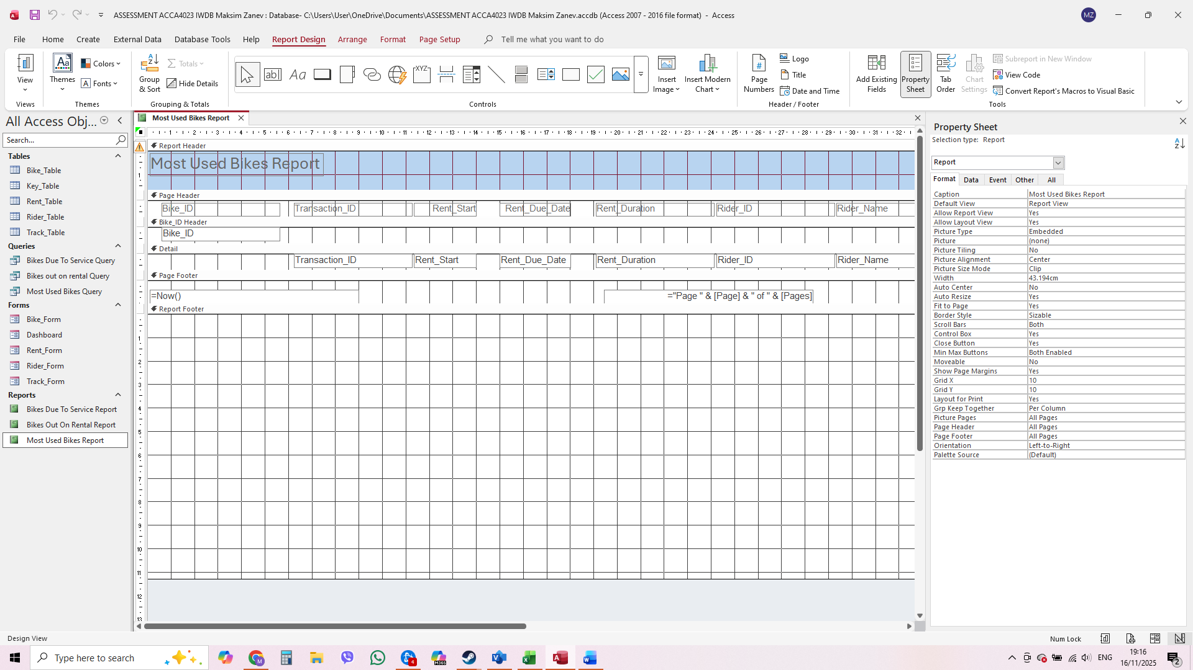
I created a report based on the query that shows which bikes are used the most within a selected period. The report includes details such as the bike ID and the number of rentals duration for each bike. This helps staff quickly identify the most popular bikes and understand usage patterns. I also provided screenshots in Report View and Design View to show how the report was structured and formatted. The annotations explain how the data is displayed and how the layout makes the information easy to read and analyse.

Calculations
I have no calculations used in this mini project.

Dashboard Creation

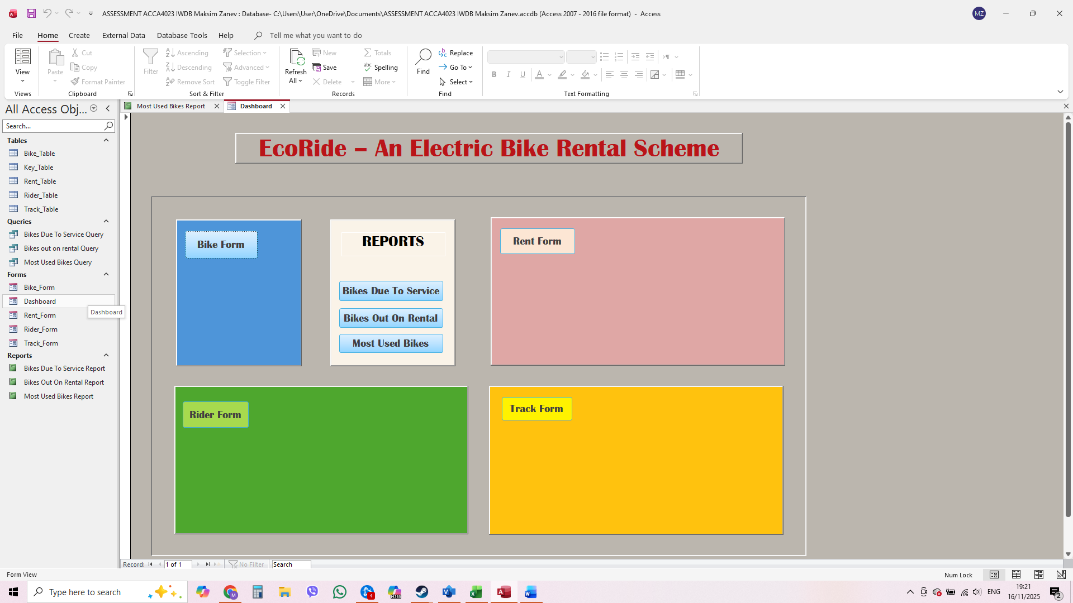

Dashboard Creation – Summary
I created a dashboard to make navigation in the Eco_Ride database easy and user-friendly. The dashboard includes buttons that allow users to open different forms, such as Rider Form, Bike Form, Rental Form, and Staff Tracking Form and Report section. Each button is clearly labelled so users can quickly access the area they need. I also added navigation buttons inside the forms that link back to the main dashboard, allowing users to move around the database without confusion. This setup helps improve usability and makes the system easy to operate for anyone using it. Screenshots are provided to show how the dashboard works and how the navigation flows between the dashboard and the forms.

