Problem
Analysis and Solution
Development

Module Name: Analysing and Solving Problems
Module Code: ACCA 4019
Student Name: Sinan Kyazim
Student ID: 2513882
Group:4
Lecturer’s Name: Dr Redhwan Al-amri

Table of Contents
Table of Contents 1
1. Introduction 2
2. Deconstruct the Problem 2
2.1 MoSCoW Technique Requirement 3
2.2 Variables Identification 4
3. Proposed Solution 4
3.1 Flowchart 6
3.2 Flowchart Explanation 9
4. Reflection and Justification 11
4.1 Abstract thinking 11
4.2 Sub-dividing 11
4.3 Justification of solution 11
4.4 Limitation 12
4.5 Assumption 12
5. Conclusion 12
Refferences 13

Introduction
One important skill developed through education is the ability to work effectively as part of a team. For this reason, students are often assigned group projects and divided into teams. However, this can be a significant challenge, as students have personal and professional commitments outside university. Difficulties in organising group meetings to work on projects can lead to delays in completing tasks, an uneven distribution of workload and missed deadlines.
This report proposes a solution designed to address these challenges. The main concept is that, rather than requiring all group members to attend every meeting, meetings are structured according to their purpose and participation requirements. The approach uses a shared weekly availability calendar to identify suitable meeting times while considering project tasks, required attendance and upcoming deadlines. Following each meeting, all members receive a detailed summary to maintain shared awareness of project progress, decisions and responsibilities.

Deconstruct the Problem
The case study identifies a key student problem: the inability to effectively organise group project meetings. The results are delayed tasks, an uneven distribution of workload and missed deadlines. Figure 1 illustrates the decomposition of the initial problem into five interconnected components. Each component is addressed through specific requirements and constraints.
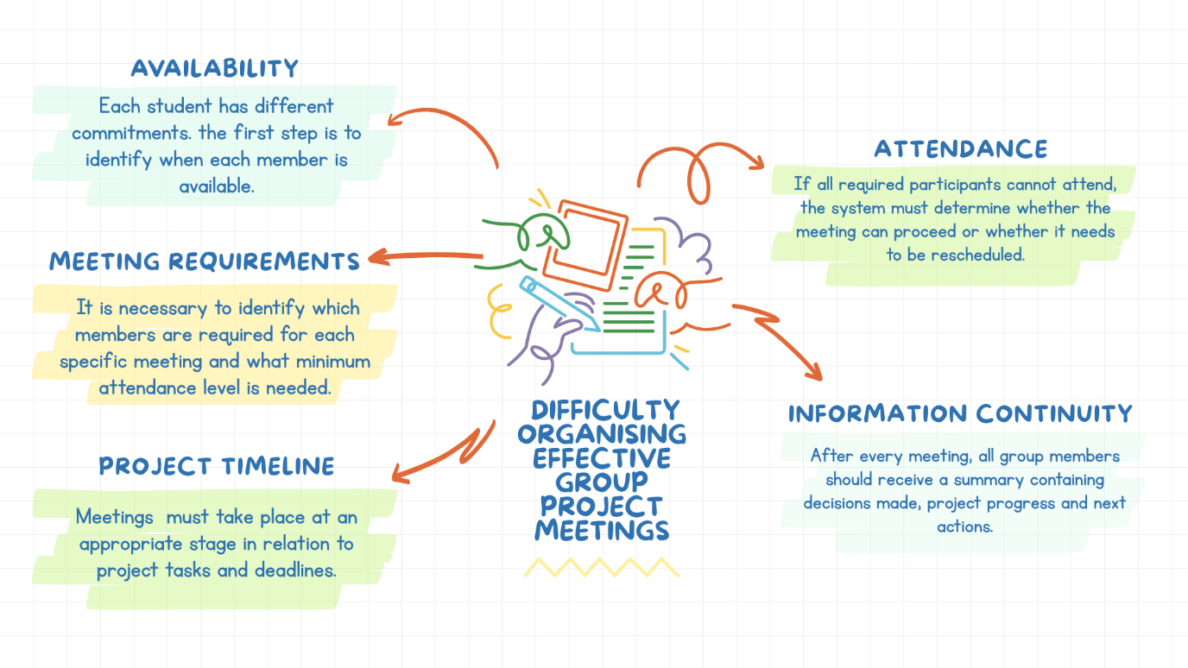
Figure 1. Problem deconstruction diagram (selfmade in Canva)
To address this problem, a weekly availability calendar can be introduced to identify the required participants for each meeting based on the specific task that needs to be completed. Different attendance thresholds will be applied depending on the purpose and requirements of each meeting. Following every meeting, all group members will receive information about the decisions made, progress achieved and next steps. This approach aims to ensure sufficient time for completing all tasks before the final submission deadline.
The proposed solution must consider several constraints. Not all students are available at the same time, availability is dynamic and may change. Some meetings will require full attendance from all group members, while the available time before the final deadline is limited. The solution therefore needs to balance flexibility with project control.

MoSCoW Technique Requirement
The MoSCoW technique is applied to prioritise the identified requirements. This approach categorises the requirements into the following groups:
- M (MUST) – crucial requirements, without them the group project results in a high risk of failure.
- S (SHOULD) – they are less important than M, but they should be included if it is possible.
- C (COULD) – they can be left out but still are significant.
- W (WON’T) – not a priority for the project time. [1]
MUST HAVE | Must collect weekly availability information from all group members.
MUST HAVE | Meetings must be scheduled according to project tasks, required participants and deadlines.
MUST HAVE | Different attendance thresholds must be applied depending on the purpose of each meeting.
MUST HAVE | All group members must receive a summary after each meeting.
MUST HAVE | The final review meeting must take place before the submission deadline to allow time for corrections.
SHOULD HAVE | Meetings should be organised only when required by project progress to avoid unnecessary sessions.
SHOULD HAVE | The system should allow students to update their availability when needed.
SHOULD HAVE | The system should support rescheduling when attendance requirements cannot be achieved.
COULD HAVE | The system could provide reminders and notifications for upcoming meetings and deadlines.
COULD HAVE | The system could integrate with existing digital calendars.
WON’T HAVE | The system will not automatically assign project tasks or evaluate individual student performance.
WON’T HAVE | The system will not manage students complete academic schedules outside the project.
Table 1. MoSCoW technique requirements of the case study

Variables Identification
These variables represent the factors that influence meeting organisation and the decision-making process:
Variables | Description
Student availability | The days and time periods when each group member is available for meetings.
Meeting type | The purpose of the meeting – general (initial; final review) or task-specific.
Required participants | The group members whose attendance is necessary for a specific meeting.
Attendance threshold | The minimum level of attendance required for a meeting.
Meeting duration | The amount of time required to complete a specific meeting.
Project tasks | The activities and stages of the project that require coordination.
Task completion time | The estimated time needed to complete a task or project stage.
Project deadline | The final submission date that determines the available timeframe for meetings.
Meeting schedule | The selected date and time assigned for each meeting.
Buffer period | The time reserved between the final review and submission for potential corrections.
Table 2. Variables identification

Proposed Solution
My proposed solution to the case study is a flexible and modular group meeting scheduling system based on students’ pre-entered weekly availability data. The innovative aspect of this approach is that, unlike the traditional method of searching for a time when all group members are available, the system identifies the required participants according to the purpose and specific task of each meeting. This results in two key principles: 1. a balanced and proportional distribution of the project workload among group members and 2. organisation of meetings based on the availability of the members required for each task.
My idea is that, at the beginning of each week, students enter their available and unavailable periods into a shared integrated calendar. Based on this information, the system schedules meetings according to the current stage of the project and the remaining time until the final deadline. Each meeting will have a defined type, required participants and minimum attendance requirement.
For example, Meeting 1 will involve presenting the project and its requirements, brainstorming and distributing the tasks. This meeting will require 100% attendance from all group members. This approach will allow meetings to be modular, as intermediate project tasks will be distributed among group members and specific members will be responsible for completing them. Task-specific meetings can proceed with a minimum attendance of 80% of the required participants.
After each meeting, all group members will receive detailed information about the topics discussed, decisions made and progress achieved. This will minimise information loss and prevent interruptions to the workflow, even when some members are unable to attend a particular meeting.
The system will schedule meetings according to the overall project timeline. Another key principle is that the final review will be scheduled several days before the submission deadline. This will provide a buffer period for making any necessary corrections and organising an additional meeting if required.

Flowchart
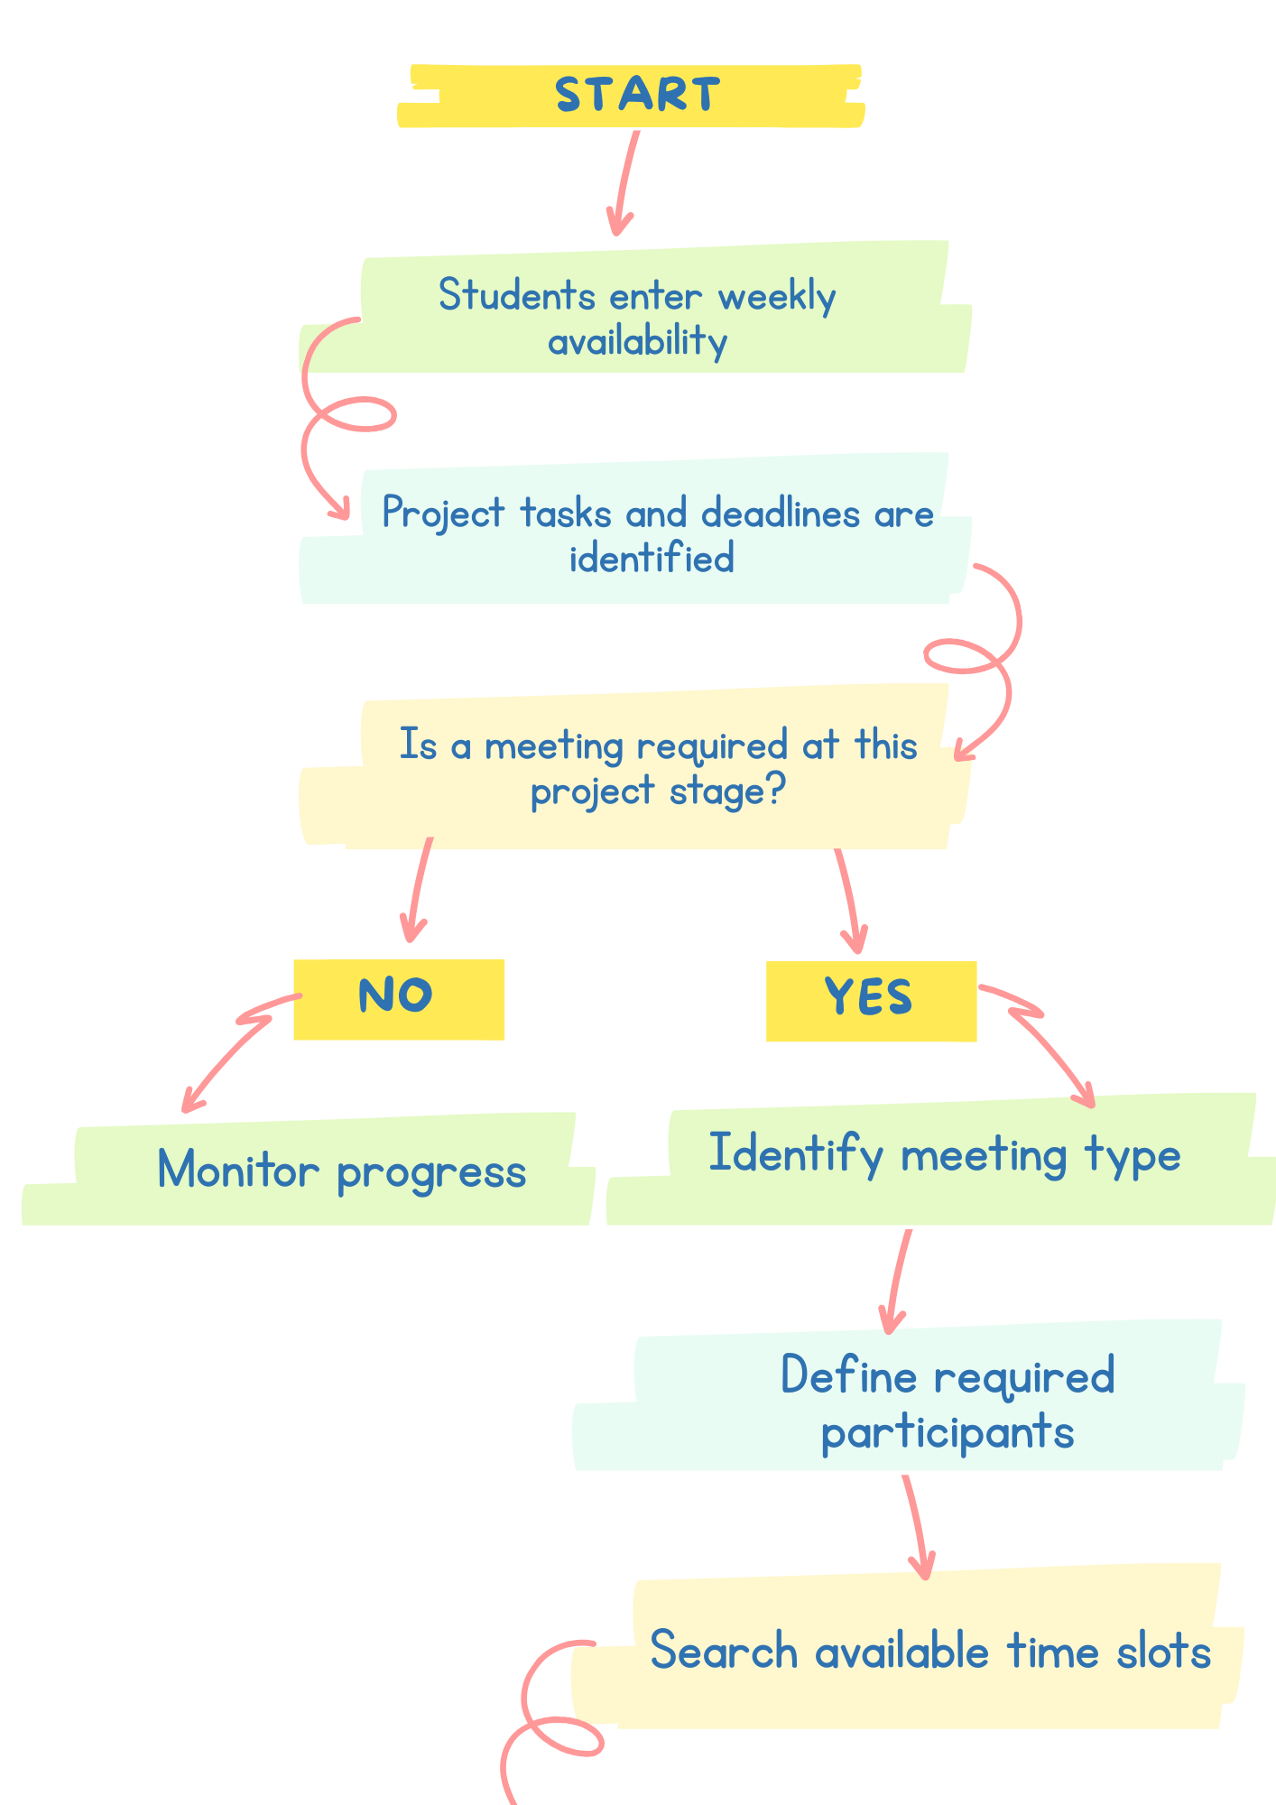

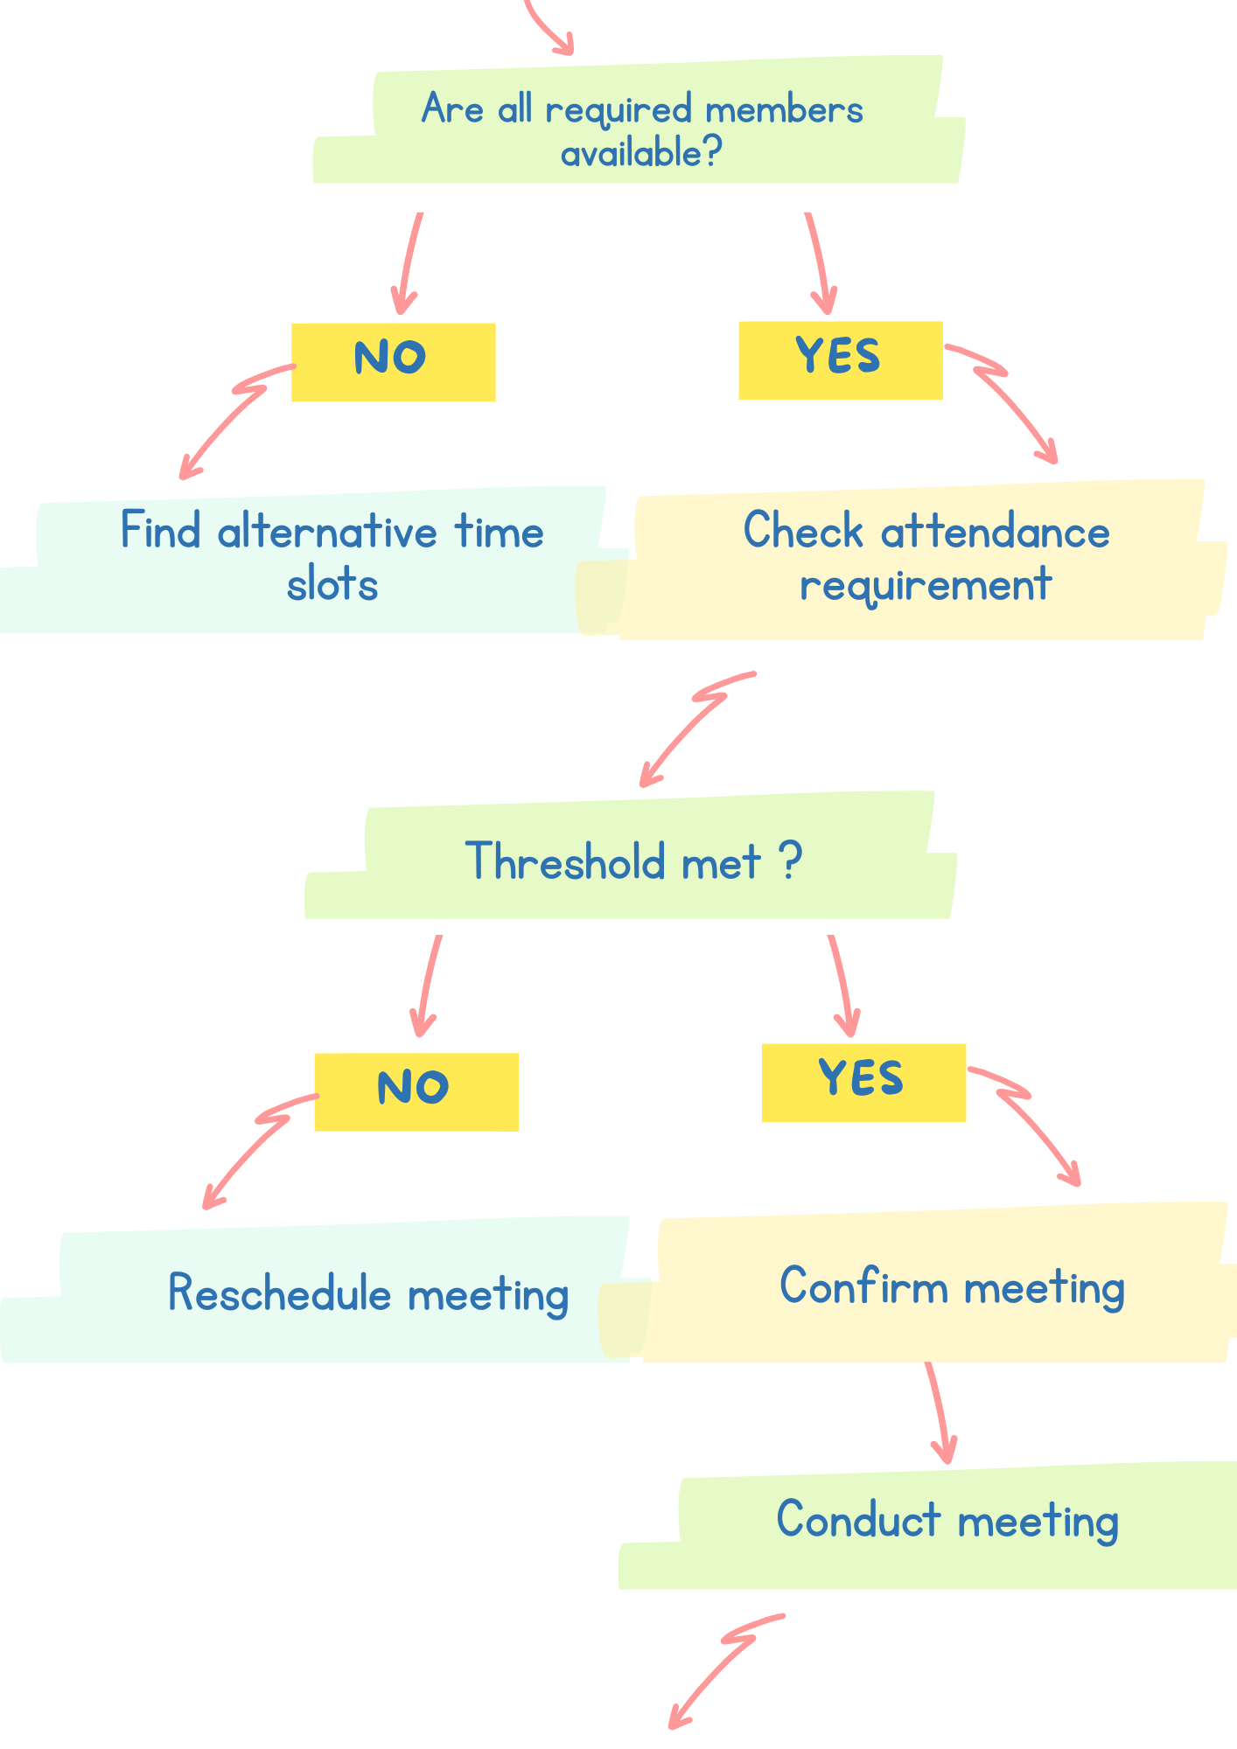

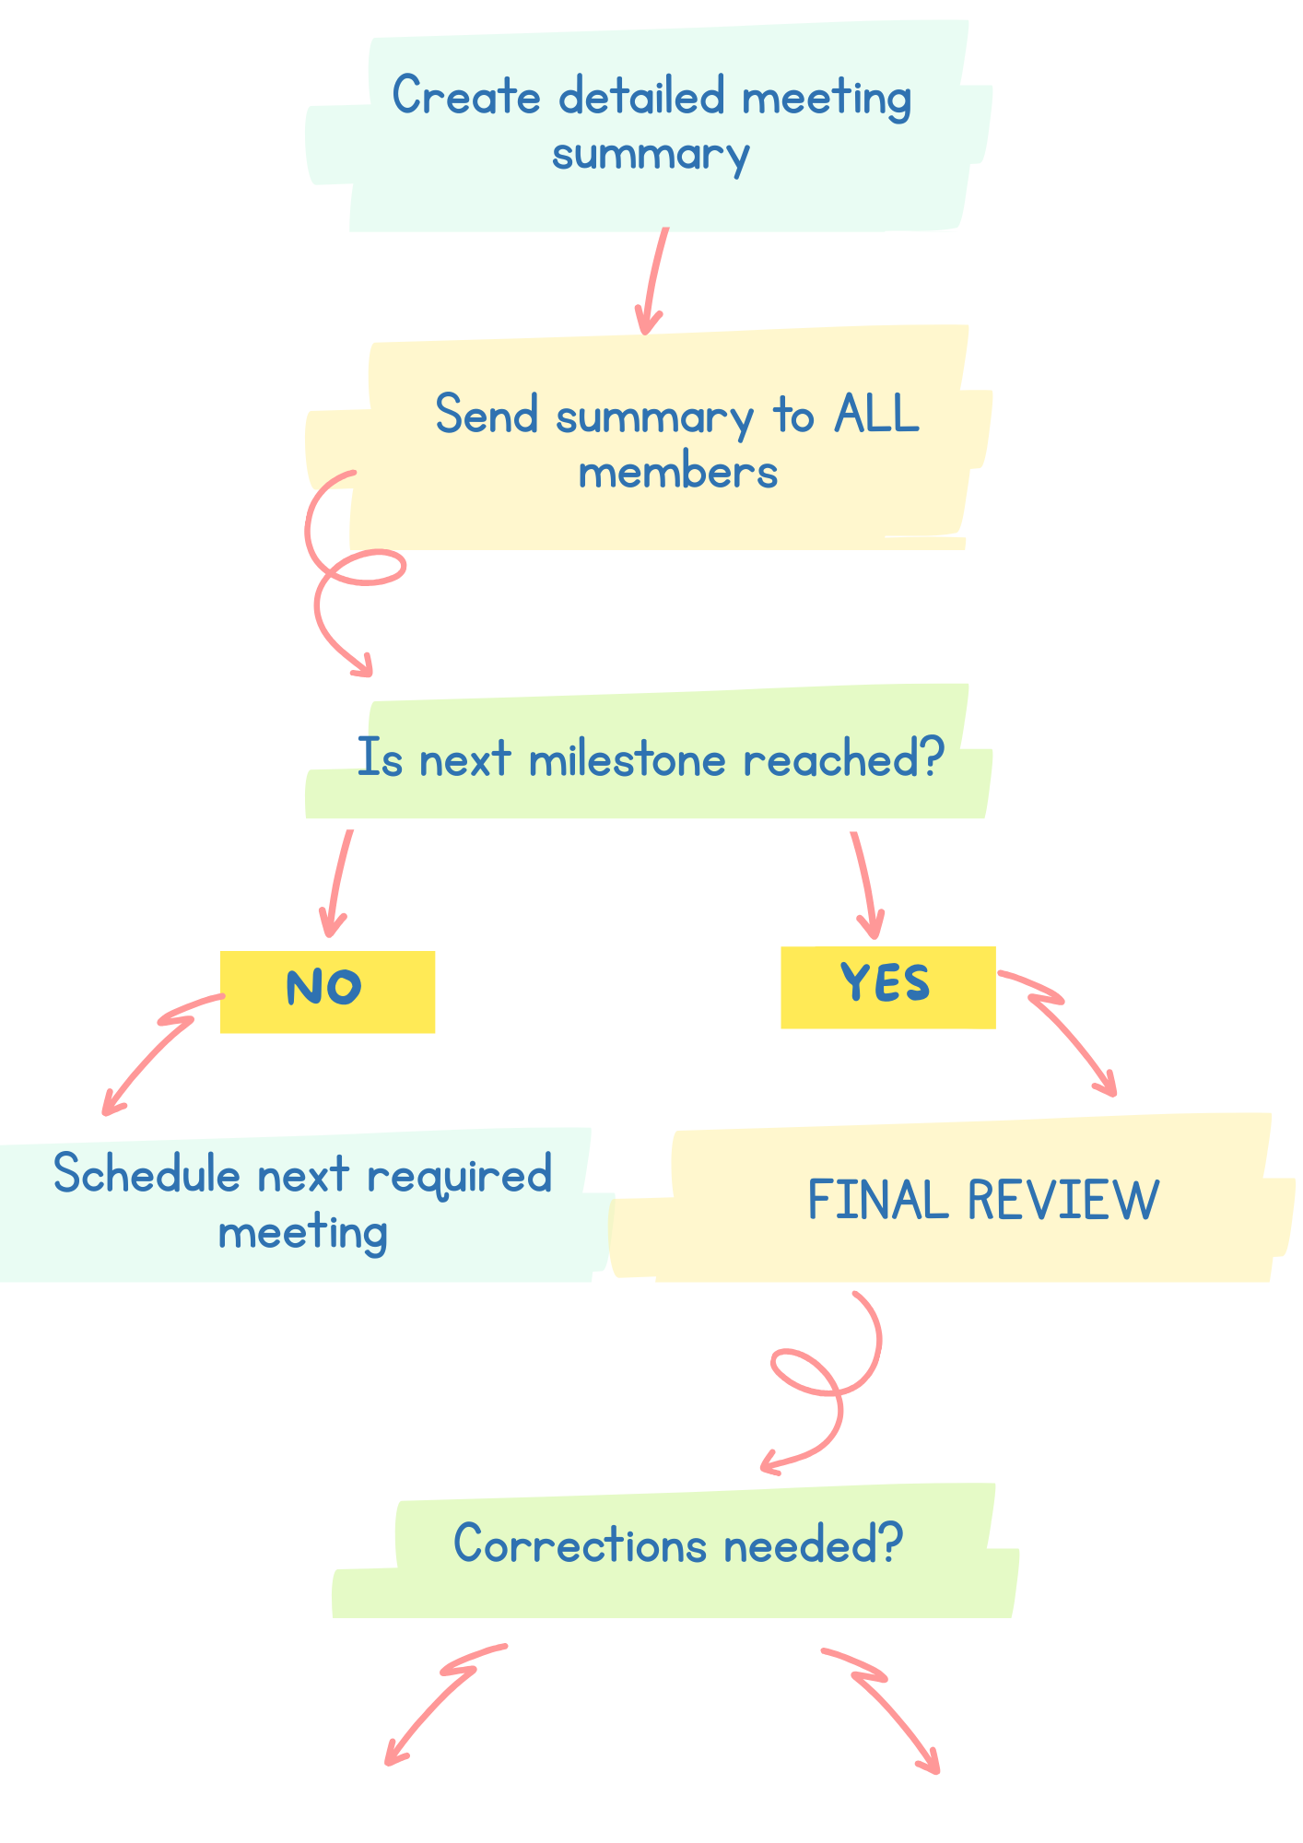

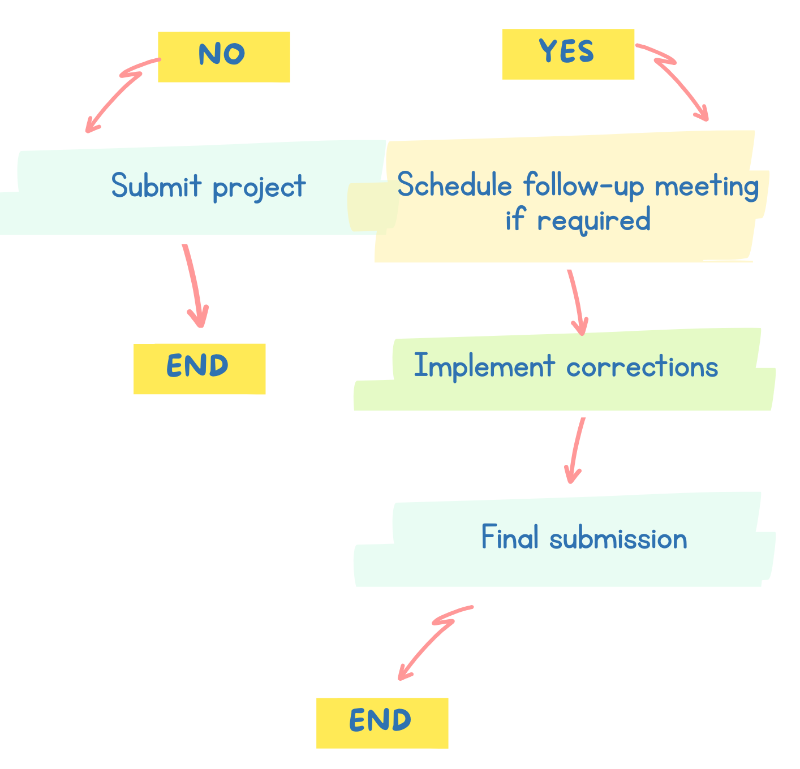
Figure 2. Flowchart of the proposed flexible and modular meeting scheduling process (selfmade in Canva)

Flowchart Explanation
Weekly availability and project status
Each student will enter their commitments and available hours for the upcoming week into a shared calendar. This information will be updated weekly, allowing the system to be flexible.
The system will then match the available time slots and availability with the current project status and final deadline. Based on this information, a suitable date and time for the meeting will be determined. The system will not simply search for the first available time when all members are free. Instead, it will consider the purpose of the meeting, the required participants and the remaining time until the deadline. In this way, scheduling becomes part of the overall project workflow.

Meeting type and required participants
The main element of my proposal for modular approach is that the type and purpose of each meeting are identified before it is scheduled. For example, the first meeting will involve the whole group and will include a presentation of the project and its requirements, brainstorming and distribution of tasks among members, with the aim of balancing each student’s workload throughout the project. This meeting will require 100% attendance, as all members need to understand the project and participate in the initial planning.
Task-specific meetings will involve only the members directly responsible for the relevant tasks. This will reduce the time commitment required from students.
Finding suitable meeting times
For each meeting, the required participants will be identified according to the relevant project milestone or task. Their availability will then be checked in the shared calendar and suitable time slots will be identified. The most appropriate meeting time will be one that is compatible with the schedules of all required participants while also taking place at an appropriate stage of the project in relation to its progress and final deadline. If there is no suitable time, the system will search for an alternative, such as another hour slot or day. In this way, the scheduling process will minimise timetable conflicts without compromising the project deadlines.
This approach is particularly useful for task-specific meetings because it eliminates the need to find a common available period for the entire group when only certain members are required.
Attendance thresholds and rescheduling
The system will check whether the minimum attendance requirement has been met depending on the type of the meeting. For meetings requiring full participation, such as the initial planning meeting and Final Review, 100% attendance will be required. For task-specific meetings, a minimum attendance of 80% of the required participants will be accepted. If the required threshold is met, the meeting will proceed. If it is not met, the meeting will be rescheduled to the earliest suitable time available. This provides flexibility while ensuring that the required participants are sufficiently represented.
Information sharing after every meeting
Following every meeting, whether general or task-specific, a detailed summary will be provided to all group members. It will include the main topics discussed, decisions made and progress achieved. This will ensure that students who were unable to attend can understand what has been completed so far and identify the point from which they should continue their work on the project.
Deadline management and final review
The final important element of the system is managing the remaining time before the project deadline. Meetings should be distributed according to the time required to complete the tasks and the remaining period until the submission deadline. The initial planning meeting should take place sufficiently early, for example approximately two weeks before the deadline, so that all members have sufficient time to complete their allocated workload. The Final Review should be scheduled approximately three to four days before the deadline to provide a buffer period in case corrections are required. If problems are identified and corrections are necessary, an additional meeting can be organised. If no corrections are required, the project can be finalised and submitted within the deadline.

Reflection and Justification

Abstract thinking
Timetabling is a big problem and the amount of computation required to find solutions increases with the size of the problem. [2] My proposed solution to the problem presented in the case study is based on abstract thinking. The focus of my approach is to identify universal factors, such as availability, required participants, project tasks, milestones and deadlines. By applying relevant constraints while allowing for a high degree of adaptability and changes to the scheduling model, meetings can be organised in a more flexible and efficient way. [3]

Sub-dividing
“Divide and Conquer” is a crucial scheme for handling larger problems. [4] The second approach I used was to divide the general problem into smaller components, including availability, meeting requirements, participant selection, scheduling, attendance, information continuity and deadline management. This allowed me to analyse each component separately and establish relationships between them. For example, availability determines which time slots are possible, while meeting requirements determine which students need to be included in a specific slot. The components of the proposed system work together, providing flexibility while allowing information to be processed simultaneously.

Justification of solution
I consider my proposal appropriate because it addresses the three main objectives of the case study. The weekly availability calendar allows suitable meeting times to be identified based on the availability of the students required for each meeting. The modular meeting model reduces the risk of conflicts because full group attendance is not required for every meeting. The scheduling process, the division of the project into milestones and the final deadline provides greater control over the time available for completing the project, increasing the submission success on time.
I considered the scheduling optimisation problem as a system of hard and soft constraints. For example, the requirement for 100% attendance at the initial planning and task distribution meeting and the Final Review can be considered a hard constraint, while personal preferences for a particular meeting time can be considered as a soft constraint. Such approaches are commonly used in academic timetabling, where multiple constraints need to be satisfied simultaneously while minimising conflicts. [3]
In my opinion, one of the strongest aspects of my idea is its flexibility. Missing a meeting does not automatically result in a failure of the scheduling process. Different attendance thresholds are applied according to the purpose of each meeting, allowing a balance to be maintained between efficiency and the participation of group members.

Limitation
The main limitation of the system is its strong dependence on the accuracy of the information provided by students about their weekly availability. If incorrect information is entered, the system may suggest an unsuitable meeting time. In addition, although an 80% attendance requirement is applied to task-specific meetings, this does not guarantee that the intended objectives of the meeting will be achieved. If an absent student has specific skills or knowledge relevant to the task, the meeting may be less effective.
Also I think, the system will be more suitable for smaller teams, as scheduling complexity may increase when there are many group members, limited availability and an approaching deadline. In such circumstances, finding a suitable meeting time that satisfies all relevant requirements may become increasingly difficult.

Assumption
It is assumed that students will provide correct information about their availability, participate fairly in the distribution of the workload and complete their assigned tasks. It is also assumed that the project tasks, required participants, milestones and deadlines will be determined during the initial meeting.

Conclusion
By combining adaptive attendance requirements, shared information and deadline-aware scheduling, the proposed flexible and modular scheduling system provides a structured approach to managing group project meetings. The proposal aims to reduce conflicts and supports more balanced group work.

Refferences

[1] | MSc. Ton Nguyen Trong Hien, "MOSCOW TECHNIQUE IN PROJECT MANAGEMENT: RESEARCH ON REQUIREMENT PRIORITIZATION RATIO IN SOFTWARE PROJECT TO INCREASE CUSTOMER SATISFACTION BASED ON MOSCOW-INTEGRATED KANO MODEL," FINANCE PUBLISHING HOUSE, 2022.
[2] | W. P. P. Y. C. H. P. Pongcharoen, "Stochastic Optimisation Timetabling Tool for university course scheduling," International Journal of Production Economics, vol. 112, no. 2.
[3] | T. V. A. Dr. Nikhil R. Joshi, "Optimizing University Course Timetabling Using Constraint Satisfaction Models," International Academic Journal of Science and Engineering, vol. 10, no. 4, pp. 5-8, 2023.
[4] | T. D. Chuong, C. Liu and X. Yu, "Decomposition for Large-Scale Optimization Problems: An Overview," Artificial Intelligence Science and Engineering, vol. 1, no. 3, 2025.

