Introduction
Setting out is the process of surveying were the positions and levels of buildings, roads,
drainages, sewers, and all other engineering projects are already marked on a plan are transferred
to the ground by a variety of methods and by specifically manufactured instruments or is the
process by which information is taken from construction design drawings and then pegs, profiles
or other marks are set to control the construction work and to ensure that each element is
constructed in the right position and to the correct level.
Setting out is simply the physical transfer of plan into the ground. Setting out can be
complex yet simple. For more accurate transfer some engineers uses the service of land surveyors
to get their setting out right especially in large projects. Setting out is the process of transferring
the plan on paper to the actual ground or site of construction. A building is set out in order to
clearly define the outline of the excavation and the line of the walls, so that construction can be
carried exactly according to the plan. The centre line method of setting out is generally preferred
and adopted.
Introduction
Setting out is the process of surveying were the positions and levels of buildings, roads,
drainages, sewers, and all other engineering projects are already marked on a plan are transferred
to the ground by a variety of methods and by specifically manufactured instruments or is the
process by which information is taken from construction design drawings and then pegs, profiles
or other marks are set to control the construction work and to ensure that each element is
constructed in the right position and to the correct level.
Setting out is simply the physical transfer of plan into the ground. Setting out can be
complex yet simple. For more accurate transfer some engineers uses the service of land surveyors
to get their setting out right especially in large projects. Setting out is the process of transferring
the plan on paper to the actual ground or site of construction. A building is set out in order to
clearly define the outline of the excavation and the line of the walls, so that construction can be
carried exactly according to the plan. The centre line method of setting out is generally preferred
and adopted.



Student name: Antonio Joseph
Student ID number: 2113837
Module: Digital Surveying
Module code: ACBA4002
Assignment Title: Essay
Lecturer: Dr Jamiu A. Dauda

Table of Contents

Introduction……………………………………………………………………………………………………………………………….1
Brief History……………………………………………………………………………………………………………………………….1
Classification of Surveying………………………………………………………………………………………………………2-4
Listed Building Surveying………………………………………………………………………………………………………..5-6
References…………………………………………………………………………………………………………………………………7

Introduction
Setting out is the process of surveying were the positions and levels of buildings, roads, drainages, sewers, and all other engineering projects are already marked on a plan are transferred to the ground by a variety of methods and by specifically manufactured instruments or is the process by which information is taken from construction design drawings and then pegs, profiles or other marks are set to control the construction work and to ensure that each element is constructed in the right position and to the correct level.
Setting out is simply the physical transfer of plan into the ground. Setting out can be complex yet simple. For more accurate transfer some engineers use the service of land surveyors to get their setting out right especially in large projects. Setting out is the process of transferring the plan on paper to the actual ground or site of construction. A building is set out in order to clearly define the outline of the excavation and the line of the walls, so that construction can be carried exactly according to the plan. The centre line method of setting out is generally preferred and adopted.

Brief history of Surveying
Land surveying is an ancient practice that dates back at least to 1,400 B.C., when the ancient Egyptians used land surveying for the taxation of land plots. Four thousand years ago, Egyptians used measuring ropes, plumb bobs, and other instruments to gauge the dimensions of plots of land. The name for Egyptian surveyors was “harpedonaptae,” which means “rope stretchers” (as shown in figure 2) through translation. Egyptions used these surveying techniques during the construction of the Great Pyramids(as shown in figure 1). 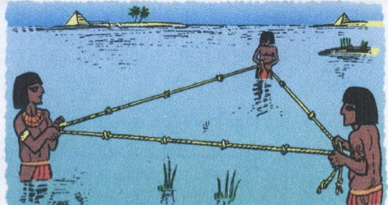
figure 1 figure 2
Since then, it has evolved as both an art-form and a mathematical science. Land surveying now encompases many sub-categories such as: boundary surveying, topographic mapping, engineering surveying, photogrammetry, and geodetic surveying.

Classification of surveying
Surveying can be classified based on different factors:
- Classification based on nature of field
- Classification based on the object of survey
- Classification based on the instruments
Classification based on nature of field
On this basis survey may be classified as land survey, marine or hydraulic survey and astronomical survey. Land Survey. It involves measurement of various objects on land. This type of survey may be further classified as given below:
- Topographic Survey: It is meant for plotting natural features like rivers, lakes, forests and hills as well as man-made features like roads, railways, towns, villages and canals.
- Cadastral Survey: It is for marking the boundaries of municipalities, villages, talukas, districts, states etc. The survey made to mark properties of individuals also comes under this category.
- City Survey: The survey made in connection with the construction of streets, water supply and sewage lines fall under this category. Marine or Hydrographic Survey. Survey conducted to find depth of water at various points in bodies of water like sea, river and lakes fall under this category. Finding depth of water at specified points is known as sounding. Astronomical Survey. Observations made to heavenly bodies like sun, stars etc., to locate absolute positions of points on the earth and for the purpose of calculating local time is known as astronomical survey.
Classification based on the object of survey
On the basis of object of survey the classification can be as engineering survey, military survey, mines survey, geological survey and archeological survey. This type of survey may be further classified as given below:
- Engineering Survey: The objective of this type of survey is to collect data for designing civil engineering projects like roads, railways, irrigation, water supply and sewage disposals. These surveys are further sub-divided Reconnaissance Survey which determining feasibility and estimation of the scheme and Preliminary Survey for collecting more information to estimate the cost of the project, and Location Survey to set the work on the ground.
- Military Survey: This survey is meant for working out plans of strategic importance.
- Geological Survey: This survey is for finding different strata in the earth’s crust.
- Archeological Survey: This survey is for unearthing relics of antiquity.

Classification based on the instruments
A various classifications may be based upon the instruments or methods employed, the chief types being:
- Chain surveying is the simplest form of surveying. The principle of chain surveying is triangulation. In this surveying method, we only measure linear measurements. Also, it is suitable for small areas. The areas are divided into triangles and the sides of the triangles are measured.
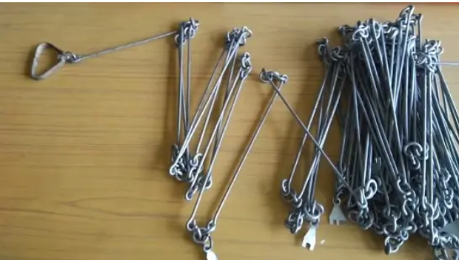

Plane table survey is one of the fastest methods of surveying. In plane table surveying, the fieldwork and plotting are done using a graphical method. It is mostly adapted for small and medium scale mapping where great accuracy is required Mostly preferable in magnetic areas where compass surveying is not possible. Also, we can check errors and mistakes using check lines.

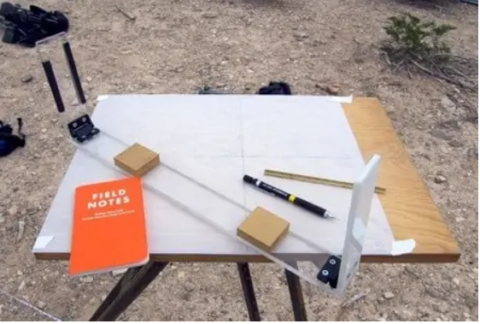

Compass surveying in this type of surveying, a compass is used to determing the direction of survey line, and the length of survey lines are measured by a chain or tape, or laser range finder. The compass is generally used to run a traverse line.

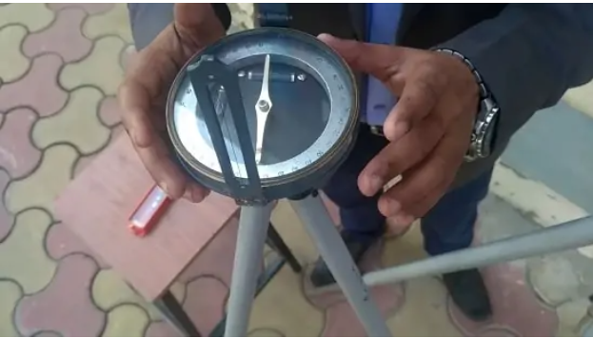

Tacheometric surveying is angular surveying in which horizontal and vertical distance are calculated from the angular measurements. It is a convenient surveying method. Tacheometric surveying uses transit theodolite with a stadia diaphragm for taking measurements. This method is preferable when a direct method of surveying is not possible.

Theodolite is a surveying instrument that measures horizontal and vertical angles. It is one of the precise methods of surveying. This type of surveying helps to find the level difference, setting out, prolonging survey lines of the area.

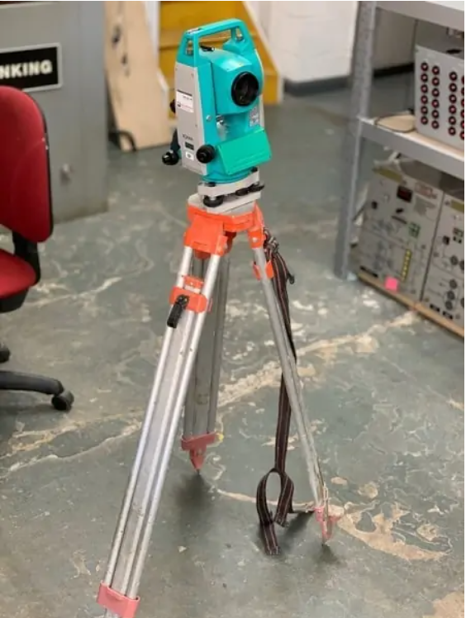

Photographic and Ariel surveying these types of surveying are done by taking photographs from elevated ground stations. It deals with the production of maps such as topographic or planimetric maps by compiling number of photographs taken in that area.

Listed Building Survey

What Is a Listed Building Survey?

Historic Building Surveys are bespoke and vary according to your requirements and the type and age of the building. This type of inspection is based on a RICS Level 3 survey (a thorough inspection of the property and a detailed report based on the inspection), sometimes referred to as a Structural Survey.. The report is supplemented with additional, legal, historical, and technical information relevant to the property. Great care is taken to identify and record historical or architecturally significant fabric. This helps explain the cause and implications of any defects that may be present. The purpose of surveying has remained somewhat the same over time: establishing boundaries, creating maps for navigation, and developing land. While the purposes of surveying remain constant, the tools used to accomplish them have evolved dramatically with human advancement.

Why do we survey the listed building?

Every old building is unique, and the type of defect is often age, material or location specific. Some defects may be visible others; hidden with only subtle clues as to the type and extent of the problem. A full survey may carry a cost, but it provides you with all the information required to make an informed decision about the purchase and management of a property.

Key stages of surveying the listed building

Inspection/Observation

Physical inspection for the vast majority of surveys would be deemed physical with the aid of binoculars and/ magnifying glass for all visible surfaces, investigation by non-destructive probing or opening of construction, materials and condition. Investigation of normally not visible parts as far as possible uses a 3m ladder, lifting covers, entering voids for better visibility.

Recording

Recording of the physical inspection is usually supported by detailed note-taking and photographic recording. The purpose of the records is to enable the surveyor to reconstruct post-survey the extent of the physical information available to a person conducting physical inspection at the time of survey. Subjective assessments are required to tailor the amount of detail collected to the instructions.

Further Investigation

Specialist physical appraisals are particularly useful for historic and unique buildings and artefacts, such as X-Rays, magnetic resonance, infra-red, thermal and other specialist imaging techniques that surveyor would use to obtain a working knowledge of the uses and application of such specialist techniques in order to advise the client of specialist survey techniques which are beyond the limit of their expertise but reasonably required for the proper fulfilment of the brief. The surveyor would be expected to advise the client in the procurement of specialist physical appraisals and interpret the results for the client’s proper understanding of the outcomes.

Reporting

In reporting the findings, the surveyor should include a reiteration of the brief and any agreed variations from it and the limitations that transpired through the desk studies and inspection processes. The effect of any limitations on the client’s objectives should be noted and the findings of each point of enquiry set out logically, to lead the reader. The surveyor should distinguish facts from opinion, and refer to the sources relied on in forming opinions and recommendation arising from each point, including whether further investigation or monitoring is recommended and advice on the procurement of additional investigation.

Data collection and storage

There is no statutory minimum period for the storage of data. The surveyor’s professional indemnity insurance usually specifies the period for which records should be retained, which is typically based on the contractual liability of the surveyor and surveying firm. This is in conflict with best practice in conservation, as documentary evidence collected during surveys and projects continues to be useful long after the contractual obligations of the parties have been fulfilled. It is therefore advisable to ensure that records which could add to the understanding of sites and artefacts are not arbitrarily destroyed. Conversely, placing documents into long term (and possibly publicly-accessed) archives may contravene the surveyor’s contractual obligations for confidentiality. In all cases, the clients and insurers consent should be sought for publication, archiving or destruction of records.

Observation equipment on listed building survey

When at the observation stage of listed building survey a digital camera would be used for photography in building recording. Where a permanent archived record is being created however, concerns remain over the long-term access to digital images. The recommended first step when creating a photographic record of a building is therefore to contact the archive where the record will be deposited and confirm their policy. As a supplement to any archive guidelines the following section provides a minimum standard for digital image capture. Minimum standards for film photography are also provided below, for anyone seeking to deposit a record with an archive that still requires this.

REFERENCES
https://historicengland.org.uk/images-books/publications/understanding-historic-buildings/heag099-understanding-historic-buildings/
https://www.rics.org/globalassets/rics-website/media/upholding-professional-standards/sector-standards/building-surveying/historic-building-conservation-1st-edition-rics.pdf
https://www.npaheritage.com/listed-building-surveys/
https://dailycivil.com/types-of-surveying/#A_Classification_based_on_the_nature_of_the_field
https://www.brainkart.com/article/Classification-of-Surveying_4598/

