


Project
Report

Student name: Cristina Limbau
Student number: 2410885
Module: Managing Projects in the Organisation (BMSW5009)
Lecturer name: Lan Zhang
Date: 8th July 2026

Executive Summary

This report critically evaluates the project management approaches adopted during the planning and delivery of the Students Business Pop-Up Market, a one-day entrepreneurial event designed to provide students with practical business experience while enhancing their entrepreneurial skills. The report examines how project management tools and techniques contributed to achieving the project's objectives and evaluates their effectiveness throughout the project lifecycle.
The evaluation demonstrates that establishing a clearly defined project scope provided realistic boundaries for delivery within the available time and resources. The Work Breakdown Structure (WBS) and Gantt Chart created a structured planning framework that improved tsk organisation, scheduling and project coordination, while task allocation strengthened accountability by assigning responsibilities according to individual roles. Risk analysis supported proactive decision-making by identifying potential threats and implementing mitigation strategies before they affected project delivery.
The report further evaluates the role of stakeholder management and communication in supporting project success. Stakeholders were identified and prioritised according to their level of power and interest, enabling communication methods and frequency to be tailored to stakeholder influence and information requirements. This approach improved coordination, facilitated timely decision-making and strengthened engagement throughout the project.
Overall, the findings indicate that successful project delivery depended not on the individual use of project management tools, but on their integration throughout the planning and implementation process. While the project achieved its intended objectives, the evaluation identified opportunities to enhance future projects through earlier stakeholder engagement, greater use of digital project management software and more frequent project reviews. Collectively, these improvements would strengthen project coordination, improve stakeholder relationships and increase the effectiveness of future Students Business Pop-Up Market events.

Table of Contents

Contents
Table of Contents 3
1. Introduction 4
2. Findings 5
2.1 Project Management Tools 5
2.2 Application of Project Management Tools 6
2.2.1 Scope Management and Iron Triangle 6
2.2.2 Work Breakdown Structure in the Project 7
2.2.3 Gantt Chart in the Project 8
2.2.4 Task Allocation in the Project 9
2.3 Communication and Stakeholders 10
2.3.1 Stakeholder Prioritisation 10
2.3.2 Communication Strategy 12
3. Conclusion 13
4. Future Improvements 14
5. Reference List 15

1. Introduction

The Students Business Pop-Up Market was developed as a project management initiative to provide university students with practical entrepreneurial experience through the organisation of a one-day business event in Cardiff city centre. The project aims to provide students with hands-on business experience that enhances managerial knowledge, confidence and employability by creating a realistic environment in which they could develop and showcase their business ideas.
To achieve this aim, the project established objectives to secure a suitable venue and obtain the required permissions within the agreed timeline, recruit a balanced range of student vendors across sectors including products and services, promote the event through social media, posters and partner networks, and deliver a safe and well organised event with effective set-up, trading and pack-down procedures.
This report critically evaluates the project management tools and techniques applied throughout the project lifecycle, assessing their effectiveness, limitations and contribution to the successful planning and implementation of the Students Business Pop-Up Market.

2. Findings

2.1 Project Management Tools
Project management relies on several tools and techniques to support decision making throughout the project lifecycle, from initiation to completion. Their purpose extends beyond organising activities, as they provide a structured framework for defining objectives, allocating resources, monitoring progress and responding to uncertainty. Heagney (2022) argues that effective planning increases the likelihood of project success by providing clear direction and improving coordination. However, project management tools should not be viewed as independent solutions, as their effectiveness depends on how they are integrated and adapted to meet the specific requirements of a project.
Project initiation establishes the foundation for successful delivery through the definition of project scope, objectives and constraints. A clearly defined scope helps maintain focus on agreed outcomes while preventing unnecessary changes during implementation. The Iron Triangle highlights the relationship between scope, time and cost, demonstrating that changes to one constraint influence the others (Kerzner, 2025). The model has been criticised for concentrating on operational performance while giving less attention to broader measured of project success, such as stakeholder value.
Stakeholder identification and communication planning also contribute to effective project management by promoting collaboration and supporting informed decision-making. Early stakeholder engagement enables project managers to understand stakeholder expectations and influence, while communication strategies must remain flexible as project priorities evolve (Freeman, 2023).
Planning and scheduling techniques translate project objectives into manageable activities. The Work Breakdown Structure decomposes projects into smaller stages, improving clarity and supporting responsibility allocation (Norman, Brotherton and Fried, 2008). However, because the WBS does not determine task timing, it is commonly integrated with Gantt Chart, which provide a visual schedule of activities and milestones, enabling project progress to be monitored effectively (Bianconi, 2024).
Risk Analysis complements these techniques by identifying and prioritising potential threats before they affect project objectives. Rather than eliminating uncertainty, risk management supports proactive decision-making through continuous monitoring and mitigation strategies (Edwards, Serra and Edwards, 2025). Effective project management relies on integrating planning, scheduling, stakeholder and risk management rather than applying them independently.

2.2 Application of Project Management Tools

2.2.1 Scope Management and Iron Triangle

Establishing a realistic project scope was essential to ensuring that the Pop-Up Market could be delivered within the available time and resources. Rather than developing a large public event, the project was intentionally limited to a one-day market with approximately 15-25 student vendors. This decision reduced project complexity while maintain the aim of providing students with practical entrepreneurial experience. Edkins et al. (2013) argue that decision made during project initiation influence project outcomes, making realistic scope definition fundamental to successful delivery.
The Iron Triangle further supported planning by balancing scope, time and cost throughout the project. Restricting the project scope enable available resources to be managed more effectively and reduced pressure on the project schedule. However, this approach also limited the number of participants and the potential community impact. Despite this limitation, the planning decisions reflected a realistic balance between ambition and feasibility, demonstrating that successful project management depends on delivering agreed objectives within existing constraints rather than expanding project scope unnecessarily (Meredith, Shafer and Mantel, 2021).

2.2.2 Work Breakdown Structure in the Project

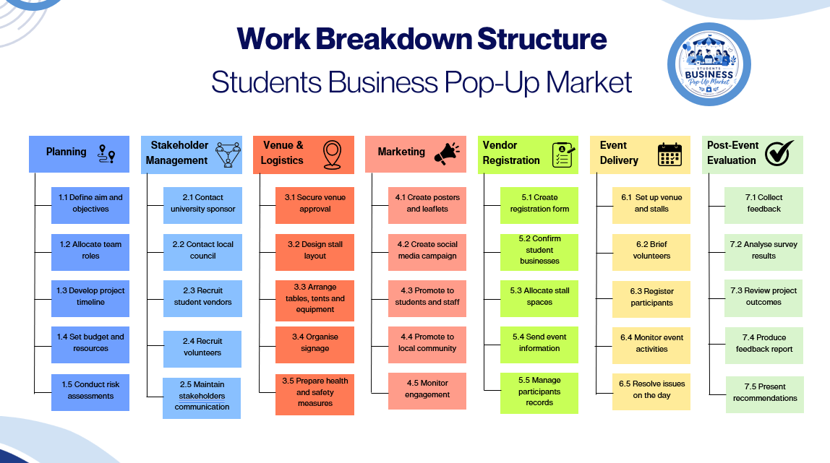
Figure 1

Organising the project through a WBS (Figure 1) enabled the aim to be translated into a logical sequence of manageable stages before implementation began. Rather than allocating activities randomly, the project was structured according to the project lifecycle, beginning with planning and concluding with post-event evaluation. This sequencing ensured that early decisions, including objective setting and preliminary planning, informed later activities such as venue preparation, marketing and event delivery. Su (2022) suggest that a structured WBS enhances project coordination by establishing clear relationships between activities, allowing work to progress in a logical and controlled manner.
This structure of WBS also strengthened project planning by recognising dependencies between phases instead of treating activities as isolated tasks. For example, vendor registration depended upon earlier promotional activities, while successful event delivery relied on the completion of venue preparation, logistics and resource planning. Identifying these relationships before scheduling reduced the likelihood of unrealistic sequencing and provided a stronger foundation for the project timeline. However, the effectiveness of the WBS remained dependent on the quality of the initial planning decisions. Any omitted activity would have affected subsequent planning, particularly the development of the Gantt Chart. This supports Molinari's (2023) argument that effective project plans rely on a coherent structure that enables later management tools to be applied successfully rather than functioning as independent tools.

2.2.3 Gantt Chart in the Project
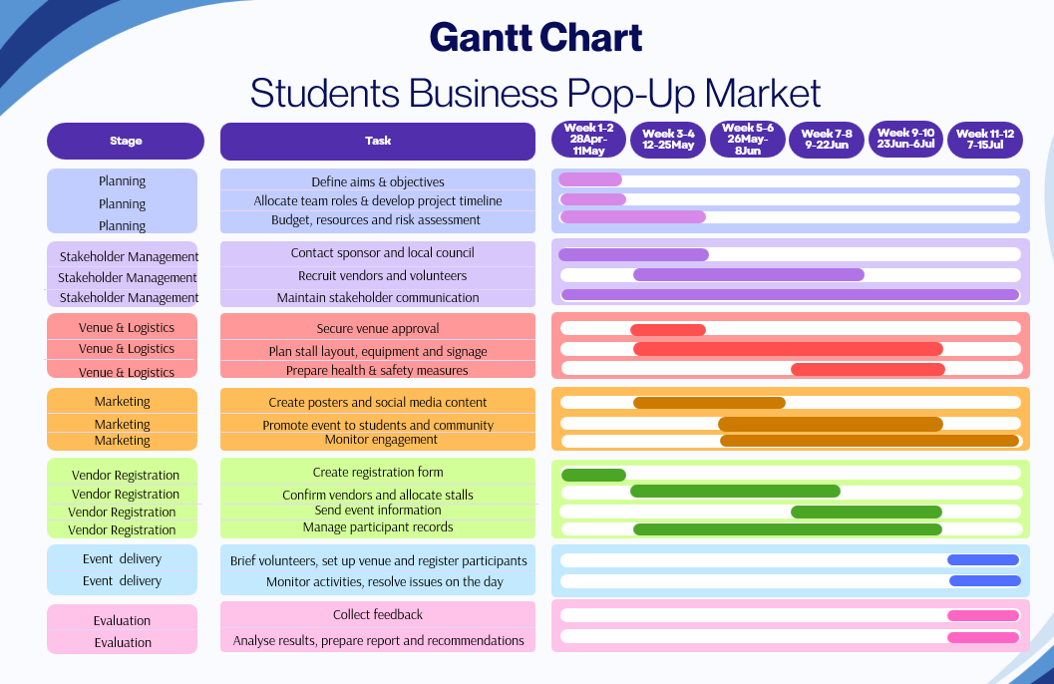
Figure 2

The Gantt Chart (Figure 2) converted the WBS into a realistic project schedule, allowing activities to be organised across the twelve-week period. Rather than assigning dates to individual tasks, it helped the team identify the order in which activities needed to be completed, ensuring that key tasks, such as venue approval were completed before vendor registration and event delivery. This reduced the risk of delays caused by starting activities before earlier tasks had been completed. Kidston and Holmes (2015) argue that effective scheduling should support project control by showing how activities are connected, enabling better planning and decision-making throughout the project.
As shown in Figure 2, several activities were planned to run at the same time, including stakeholder engagement, venue preparation and marketing. This made better use of the limited project timeframe by allowing progress to continue across different work areas instead of waiting for one stage to finish before another began. However, this approach also meant that delays in important activities, such as securing the venue, could affect later tasks and require the project schedule to be updated. Therefore, the Gantt Chart was valuable not only because it organised the project timeline, but because it provided a flexible planning tool that could support ongoing monitoring and informed decision making throughout the project delivery (Bianconi, 2024).

2.2.4 Task Allocation in the Project
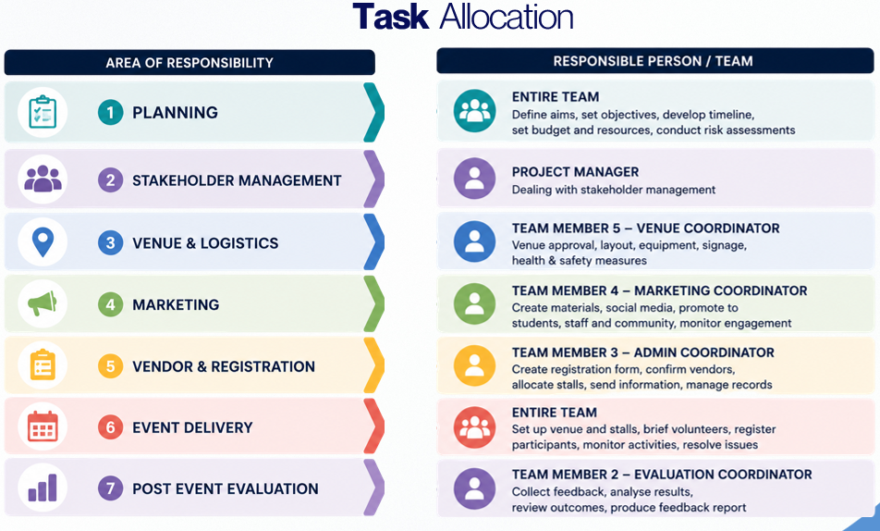
Figure 3

Following the development of the project schedule, responsibilities were allocated to individual team members to ensure that each stage had clear ownership (Figure 3). Rather than distributing tasks equally, responsibilities were assigned according to each member’s role within the project, allowing specialised areas such as venue, marketing, vendor registration and post-event evaluation to be managed by designated coordinators. This approach improved accountability by providing clear responsibility for key deliverables while allowing planning and event delivery to remain collaborative activities involving the entire team.
Belbin and Brown (2022) argue that allocating responsibilities according to individual strengths can improve team performance by encouraging ownership and reducing uncertainty over decision-making. This was reflected in the project, where clearly defined roles reduced duplication of work and enabled team members to concentrate on their allocated responsibilities. However, this approach also relied on effective collaboration, as delays within one area had the potential to influence the progress of other project activities. Regular coordination remained essential to ensure that individual contributions supported the successful delivery of the overall project.

2.3 Communication and Stakeholders

2.3.1 Stakeholder Prioritisation
Effective stakeholder management began by identifying the individuals and organisations that could influence or be influenced by the Students Business Pop-Up Market. Rather than attempting to engage every stakeholder equally, the project first identified those with the greatest potential to influence planning, resource allocation and project delivery, including the project team, sponsors, the local council and students. This early assessment provided a clear understanding of stakeholder expectations and enabled project efforts to be directed towards the groups that would have the greatest impact on project success. Freeman (2023) states that stakeholder identification is a fundamental stage of project management because it enables project managers to recognise whose interests should be considered before decisions are made.
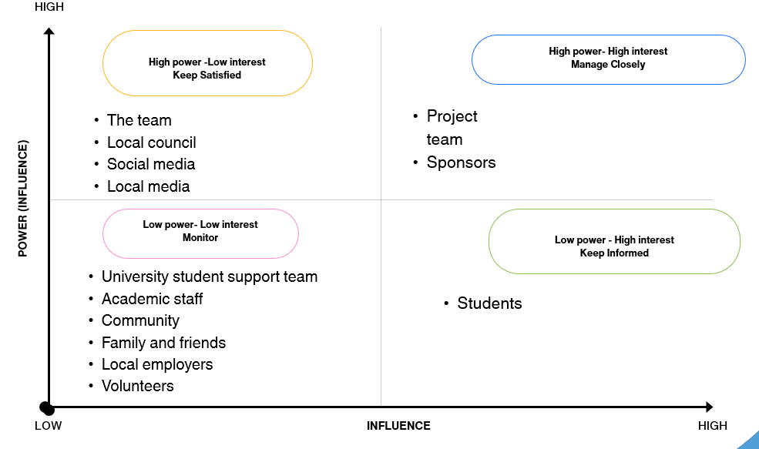
Figure 4
Following identification, stakeholders were prioritised using the Power-Interest Grid (Figure 4), recognising that different stakeholder groups required different levels of engagement. The project team and sponsors were categorised as high-power and high-interest because they were directly involved in decision making, resource provision and overall project delivery. The local council required close management due to its authority over venue approval, meaning that delays in communication could have affected the project timeline. Kujala et al. (2022) suggest that prioritising stakeholders enables project managers to allocate communication and management efforts more effectively by focusing on those with the greatest influence over project outcomes.
Students were place withing high-interest but low-power category. Although they represented the primary beneficiaries of the project, they had limited influence over operational decisions. Keeping students informed rather than involving them in management decisions allowed the project resources to remain focused on higher priority stakeholders while still maintaining participant engagement. However, stakeholder influence can change throughout the project, meaning that stakeholder analysis should be reviewed continuously rather than treated as a one-off planning exercise (Crane and Livesey, 2003).

2.3.2 Communication Strategy
The stakeholder prioritisation process directly influenced the project’s communication strategy by recognising that communication should reflect each stakeholder’s level of influence, interest and involvement throughout the project. Rather than applying the same communication approach to every stakeholder, the project varied both the communication method and frequency according to stakeholder requirements. High-priority stakeholders, including the project team, sponsors and the local council, required more frequent communication through meetings and email updates to support timely decision-making, monitor project progress and respond quickly to any issues that could affect delivery. In contrast, students primarily required periodic updates through social media and promotional channels, as their involvement focused on participation rather project management. Benvenuto, Cherubini and Tomasin (2021) suggest that selecting communication methods according to stakeholders needs improves both the efficiency and effectiveness of project communication.
Tailoring communication in this way reduced unnecessary information sharing while ensuring that stakeholders received relevant updates at appropriate stage of the project. This supported more effective coordination and minimised the risk of delays caused by poor communication or slow decision making. However, the communication strategy depended on maintaining consistent and timely engagement throughout the project. Failure to communicate regularly with key stakeholders could have delayed approvals or reduced stakeholder confidence, while insufficient communication with participants may have affected vendor recruitment and event attendance.

3. Conclusion

This report demonstrated that the effectiveness of project management depends less on the individual tools selected and more on how they are integrated throughout the project lifecycle. While the Students Business Pop-Up Market was successfully supported by structured planning, scheduling, stakeholder management and risk analysis, the evaluation also highlighted that these tools were not without limitations. Their effectiveness relied on realistic planning assumptions, continuous monitoring and effective communication between key stakeholders. Consequently, project success was influenced not simply by the existence of project management tools, but by the quality of the decisions made throughout the planning and delivery process.
Overall, the project achieved its objectives while demonstrating that project management is a dynamic process requiring flexibility, collaboration and ongoing evaluation to respond efficiently to changing project requirements.

4. Future Improvements

Although the project achieved its intended aim, the evaluation identified several opportunities that could strengthen future delivery.
One improvement would be to begin stakeholder engagement earlier, particularly with sponsors and external organisations. Earlier engagement would provide additional time to secure financial support, confirm partnerships and resolve potential issues before they influence later project stages. This proactive approach could also increase opportunities for vendor recruitment and event promotion, reducing the pressure placed on the final weeks of the project.
A further improvement would be to adopt dedicated project management software, such as Microsoft Project or Trello, to complement the existing planning tools. While the WBS and Gantt Chart provided a clear framework for planning, digital project management platforms would enable real-time progress tracking, task updates and improved collaboration between team members. This would allow emerging issues to be identified earlier, supporting quicker decision making and reducing the likelihood of delays affecting dependent activities.
Finally, stakeholder management should remain a continuous process throughout the project lifecycle rather than being concentrated during the planning phase. Regular reviews of stakeholder priorities and communication requirements would allow the project team to respond more efficiently to changing expectations and maintain stronger stakeholder relationships. As Heagney, (2022) suggests, project management is an ongoing process of monitoring and adapting rather than simply following an initial plan. These improvements would strengthen project coordination, increase flexibility and enhance the overall effectiveness of future Students Business Pop-Up Market events.

5. Reference List

- Belbin, M.R. and Brown, V. (2022) Team Roles at Work. 3rd edn. London: Routledge.
- Benvenuto, N., Cherubini, G. and Tomasin, S. (2021) Algorithms for Communications Systems and their Applications. John Wiley & Sons.
- Bianconi, F. (2024) ‘Gantt Charts’, in F. Bianconi (ed.) Data and Process Visualisation for Graphic Communication: A Hands-on Approach with Python. Cham: Springer Nature Switzerland, pp. 175–181. Available at: https://doi.org/10.1007/978-3-031-57051-3_13.
- Crane, A. and Livesey, S. (2003) ‘Are You Talking to Me?: Stakeholder communication and the risks and rewards of dialogue’, Unfolding Stakeholder Thinking 2. Routledge.
- Edkins, A. et al. (2013) ‘Exploring the front-end of project management’, Producation Planning & Control, 24(8–9), pp. 743–755. Available at: https://doi.org/https://doi.org/10.1080/21573727.2013.775942.
- Edwards, P.J., Serra, P.V. and Edwards, M. (2025) Managing Project Risks. 2nd edn. West Sussex: John Wiley & Sons.
- Freeman, R.E. (2023) ‘Stakeholder Management: Framework and Philosophy’, in S.D. Dmytriyev and R.E. Freeman (eds) R. Edward Freeman’s Selected Works on Stakeholder Theory and Business Ethics. Cham: Springer International Publishing, pp. 61–88. Available at: https://doi.org/10.1007/978-3-031-04564-6_3.
- Heagney, J. (2022) Fundamentals of Project Management, Sixth Edition. Nashville, UNITED STATES: HarperCollins Leadership. Available at: http://ebookcentral.proquest.com/lib/trinity/detail.action?docID=29731108 (Accessed: 3 June 2026).
- Kerzner, H. (2025) Project Management: A Systems Approach to Planning, Scheduling, and Controlling. John Wiley & Sons.
- Kidston, P. and Holmes, G. (2015) Planning, Scheduling, Monitoring and Control: The Practical Project Management of Time, Cost and Risk. Princes Risborough, Buckinghamshire: Association for Project Management. Available at: http://ebookcentral.proquest.com/lib/trinity/detail.action?docID=6425572 (Accessed: 3 June 2026).
- Kujala, J. et al. (2022) ‘Stakeholder Engagement: Past, Present, and Future’, Business & Society, 61(5), pp. 1136–1196. Available at: https://doi.org/10.1177/00076503211066595.
- Meredith, J.R., Shafer, S.M. and Mantel, S.J.Jr. (2021) Project Management : a strategic managerial approach. 11th edn. New York: Wiley & Sons.
- Molinari, A. (2023) ‘Project Plan Structure’, IEEE Technology and Engineering Management Society Body of Knowledge (TEMSBOK). John Wiley & Sons, Ltd, pp. 189–203. Available at: https://doi.org/10.1002/9781119987635.ch12.
- Norman, E.S., Brotherton, S.A. and Fried, R.T. (2008) Work Breakdown Structures: The Foundation for Project Management Excellence. New Jersey: John Wiley & Sons.
- Su, Y. (2022) ‘WBS-Based Method in Teaching Management Information Project’, Journal of Computer Networks and Communications, 2022(1), p. 9623385. Available at: https://doi.org/10.1155/2022/9623385.

