

Master of Business Administration
International Business pathway

Toyota Circular Battery+: A Sustainable EV Battery Refurbishment, Second-Life Energy Storage and Closed-Loop Recycling Ecosystem
Assessment 2: Individual report

Module name: Marketing Management
Module code: LCMB7024

Student name: Chahil Maheshbhai Italiya
Student ID: 2535771

Word count: Approx.2500
Submission date: 13th Aug 2026

Table of Contents
Element 2 2
2.1 Geographic Segmentation 2
2.2 Demographic Segmentation 3
2.3 Psychographic Segmentation 4
2.4 Behavioural Segmentation 5
2.5 Target Audience 5
2.6 Differentiation 6
2.7 Positioning 6
Element 3 7
3.1 Product 7
3.2 Price 7
3.3 Place 8
3.4 Promotion 9
3.5 People 9
3.6 Process 10
3.7 Physical Evidence 10
Element 4 11
4.1 Description 11
4.2 Feelings 11
4.3 Evaluation 11
4.4 Analysis 12
4.5 Conclusion 12
4.6 Action Plan 12
References 13

Element 2
The analytical basis for transforming Toyota Circular Battery+ from a sustainability idea into a profitable brand extension is provided by segmentation, targeting, differentiation, and positioning (Kotler and Keller, 2016). The addressable market is divided using geographic, demographic, psychographic, and behavioural factors below, building on Smith's (1956) fundamental difference between market segmentation and product differentiation.

2.1 Geographic Segmentation
With over 10.8 million automobiles sold worldwide in 2024, Toyota has a production and retail presence in over 170 countries (Toyota Motor Corporation, 2025a). Geographic segmentation should provide priority to markets like Japan, Western Europe, and North America that have a large density of electric vehicles (EVs), established dealership infrastructure, and supporting end-of-life battery regulations, as opposed to a simultaneous global launch.
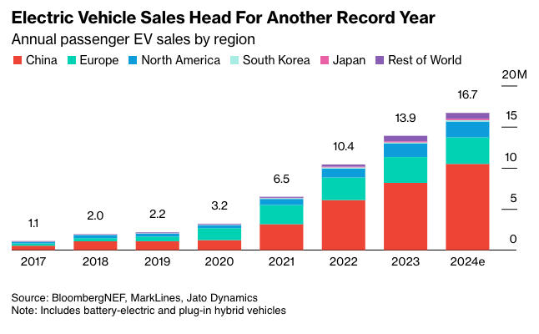
Source: https://evboosters.com/ev-charging-news/global-ev-sales-on-track-for-new-highs-despite-slowing-momentum/
Global EV sales exceeded 17 million units in 2024, accounting for over 20% of new car sales, according to the International Energy Agency (2024; 2025). Adoption was primarily concentrated in these areas, so segment prioritization should reflect the geographic concentration of EV parc growth to maximize near-term battery-return volumes.

2.2 Demographic Segmentation
The primary demographic comprises Toyota and Lexus hybrid or battery-electric vehicle (BEV) owners aged approximately 30–55, with above-average disposable income and urban or suburban homeownership (relevant to residential energy storage adoption).
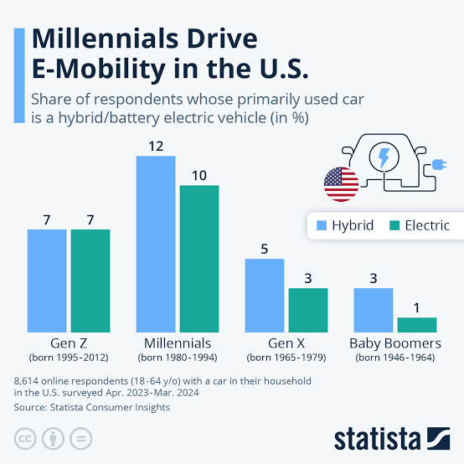
Source: https://tinyurl.com/pkun3v9h
This cohort intersects with vehicles reaching 8–15 years of age, the point at which batteries typically retain 70–80% of original capacity and become suitable for second-life applications (International Energy Agency, 2024; Harper et al., 2019). A secondary demographic comprises B2B procurement managers within utilities, renewable energy developers and commercial property firms.

2.3 Psychographic Segmentation
According to Solomon's (2020) examination of self-concept and green buying motives, consumers are divided based on sustainability principles and environmental self-identity rather than just income.
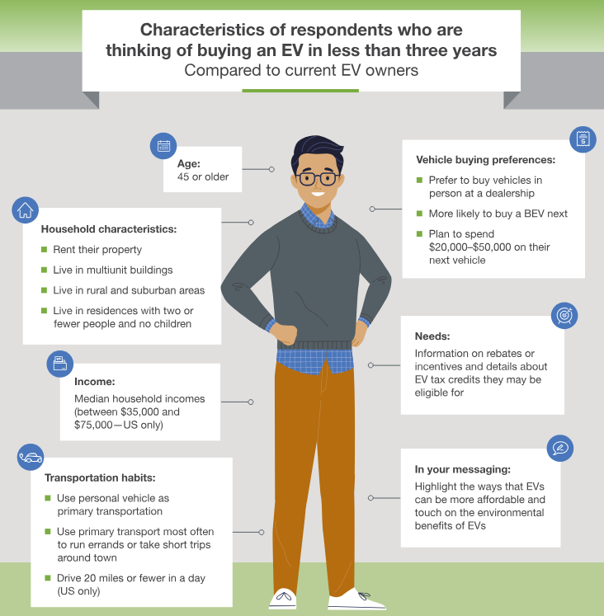
Source: https://www.esource.com/report/1352404ob7/which-customers-are-likely-buy-ev-within-next-five-years
However, Peattie and Crane (2005) warn that in order to prevent greenwashing scepticism, environmentally framed segments must be truly values-driven rather than just eco-labelled. This risk is particularly pertinent given Toyota's dual identity as a mass-market manufacturer entering a sustainability-branded space.

2.4 Behavioural Segmentation
Three distinct behavioural subgroups can be identified: early technology adopters driven by novelty and innovation; brand loyalists with high repurchase intent who will engage through trust in the Toyota name; and functionally driven customers responding primarily to the financial trade-in incentive rather than environmental motivation. Kotler and Keller's (2016) usage- and attitude-based behavioural segmentation reasoning is reflected in this tripartite framework.

2.5 Target Audience
The main focus is current owners of BEVs and Toyota/Lexus hybrids in developed EV markets whose batteries are getting close to the 8–15-year automotive-life threshold, especially those who have already used Toyota's repair network. This is a "captive base" that significantly reduces the cost of acquiring new clients in comparison to bringing in new ones.
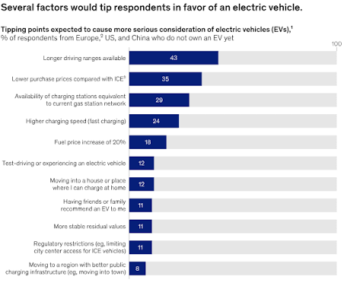
Source: https://tinyurl.com/cch8vzyf
B2B purchasers of stationary storage, such as utilities, renewable energy developers, and commercial operators, are the secondary target because they are in a position to profit from the global EV battery recycling and second-life market, which is expected to increase from USD 28.1 billion in 2025 to over USD 95 billion by 2034 (Precedence Research, 2025).

2.6 Differentiation
Because Toyota alone controls the entire lifecycle from original manufacture through dealership take-back to certified refurbishment, it sets itself apart from competing manufacturer schemes like Nissan's 4R Energy and independent recyclers like Redwood Materials and Li-Cycle through OEM-certified provenance and closed-loop traceability.
According to Aaker and Keller (1990) and Volckner and Sattler (2006), brand-extension success relies on perceived fit and quality transfer from the parent brand; Toyota's manufacturing history and current warranty infrastructure directly lend credibility to the refurbished-battery offer in a manner that pure-play recyclers cannot match.
Therefore, differentiation is based on three pillars: (1) warranty assurance and certification; (2) seamless integration with current dealership infrastructure; and (3) a genuine, full-lifecycle circularity story that addresses Peattie and Crane's (2005) concerns about trustworthiness.

2.7 Positioning
In contrast to non-circular OEM competitors (high brand equity, low visible circularity) and low-trust independent recyclers (high sustainability claim, low brand equity), Toyota Circular Battery+ is situated in the "high sustainability credibility × high brand trust" quadrant.
Toyota Circular Battery+ is the only manufacturer-certified circular battery ecosystem that converts end-of-life EV batteries into trusted second-life value for environmentally conscious Toyota owners and sustainability-focused organizations. Unlike third-party recyclers, Toyota's global manufacturing heritage and 10.8 million vehicles installed annually (Toyota Motor Corporation, 2025a) guarantee certified quality and full traceability.
In addition to advancing SDGs 7, 9, 12, and 13, this posture directly supports Toyota's declared objective to becoming carbon neutral by 2050 (Toyota Motor Corporation, 2025b) and integrates sustainability credentials within a competitive market that can be defended commercially.

Element 3
The extended services marketing mix of 7Ps (Booms and Bitner, 1981) is more appropriate than McCarthy's original four-element framework first conceived by Borden (1964) because Toyota Circular Battery+ combines a physical product (refurbished batteries, second-life storage units) with an intangible service layer (collection, certification, monitoring).
Zeithaml, Bitner, and Gremler (2018) suggested that in addition to the conventional Product, Price, Place, and Promotion, servitized or hybrid offerings necessitate the explicit management of People, Process, and Physical Evidence. This reasoning directly applies to a circular ecosystem where trust and traceability are just as crucial as the actual battery.

3.1 Product
The primary product is a certified circular ecosystem bundle that includes second-life stationary storage systems, reconditioned batteries for vehicle reuse, and a warranty and monitoring service.
Using Kotler and Keller's (2016) three-level product model, the certified refurbished battery itself is the actual product; traceability data, digital health monitoring, and warranty assurance are the augmented product; and sustainable, reasonably priced energy storage and mobility is the core benefit.
Since certified provenance serves as an intangible quality that boosts green brand confidence, this enhanced layer is the main difference (Chen, 2010).

3.2 Price
Value-based pricing is used instead of cost-plus pricing. As a loyalty-reinforcing incentive rather than a stand-alone price point, the trade-in credit model lowers the effective cost of a new Toyota EV or of servicing for customers. By utilizing the reduced input cost of used cells, second-life systems are priced competitively versus new lithium-ion storage for B2B storage clients.
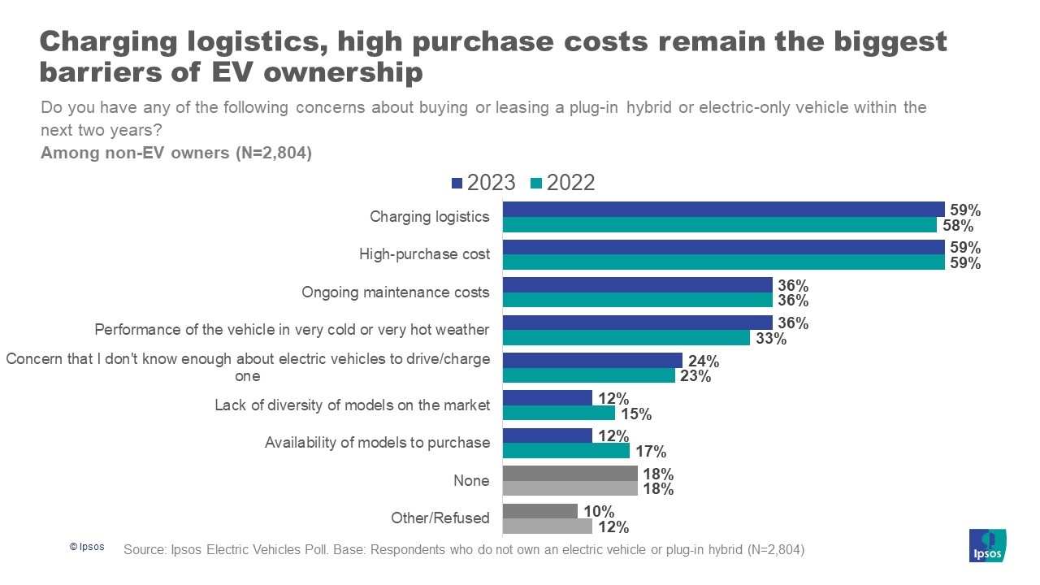
Source: https://www.ipsos.com/en-us/high-purchase-cost-and-convenience-charging-logistics-remains-barriers-owning-ev-americans
This supports a penetration strategy into a market predicted to grow from USD 28.1 billion to USD 95 billion by 2034 (Precedence Research, 2025). In comparison to uncertified used batteries on the open market, a small certification premium is applied, which reflects the brand-equity value determined by Aaker and Keller (1990).

3.3 Place
By utilizing Toyota's current dealership network in more than 170 countries, distribution avoids the significant fixed costs associated with constructing new physical infrastructure (Toyota Motor Corporation, 2025a). An omni-channel strategy includes a direct B2B channel for the distribution of second-life storage through collaborations with utilities and renewable energy installers, in-person dealership drop-off, and app-based scheduling of battery collection.
This efficiency in reverse logistics is crucial: According to Geissdoerfer et al. (2016), return volumes and refurbishment economics would not be feasible without effective reverse supply chains, which are a key component of circular economy business models.

3.4 Promotion
To overcome the greenwashing scepticism noted by Peattie and Crane (2005), communications must strike a balance between authenticity and sustainability storytelling. Verifiable facts, such as the 70–80% capacity retention reported by Harper et al. (2019) and alignment with SDGs 7, 9, 12, and 13, should be prioritized over general environmental claims in promotion.
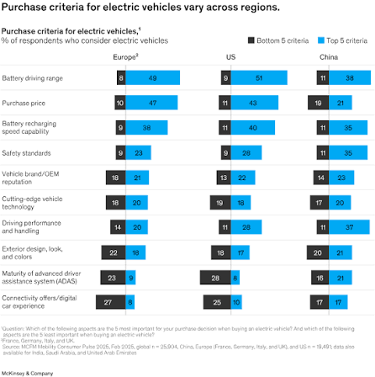
Source: https://tinyurl.com/cch8vzyf
Dealership point-of-sale materials, in-app trade-in reminders for the primary consumer category, and ESG-focused thought-leadership content targeted at the B2B investor and procurement market found in the STDP research are examples of channels.

3.5 People
In order to reduce the brand-extension fit risk identified by Volckner and Sattler (2006), certified, specially qualified personnel are crucial; subpar refurbishment would immediately harm parent-brand equity. Due to their role as brand ambassadors in customer interactions, dealership personnel also need to be trained in the circularity narrative itself (Zeithaml, Bitner, and Gremler, 2018).

3.6 Process
The "Process" component of the mix is operationalized by the four-stage closed-loop process shown in the Element 1 poster: Return, Incentive, Refurbish, and Second-Life. Customer friction at the point of return, a crucial barrier in circular business models, is decreased by a standardized, digitally recorded procedure (via app-based scheduling and QR-coded battery tracking) (Geissdoerfer et al., 2016).

3.7 Physical Evidence
The "certified and trustworthy" positioning established in Element 2 is reinforced by tangible cues, such as dealership take-back centres, certification labelling, QR traceability codes, and an app dashboard showing battery health and carbon savings, which lower the inherent intangibility risk of a service-based green offering (Zeithaml, Bitner, and Gremler, 2018).
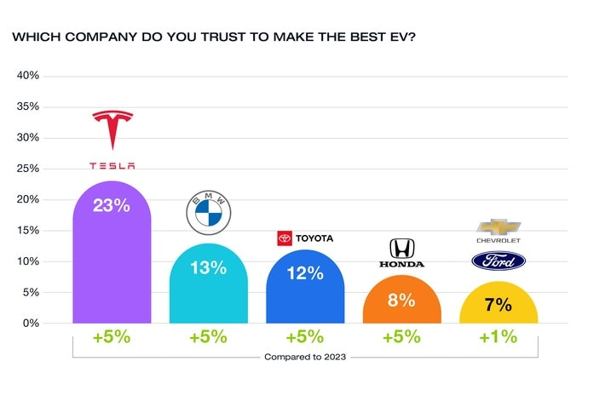
Source: https://www.edmunds.com/car-news/consumer-expectations-of-evs-clash-with-market-realities.html
When taken as a whole, the seven components support a single, cohesive strategy: utilizing Toyota's current scale and trust infrastructure to make circularity low-friction for consumers while establishing a sustainability position that can be defended and supported by data ahead of the 2050 carbon-neutrality target (Toyota Motor Corporation, 2025b).

Element 4
This reflection examines my experience creating the Toyota Circular Battery+ approach and creating the accompanying poster presentation using Gibbs' (1988) six-stage reflective cycle: description, feelings, evaluation, analysis, conclusion and action plan.

4.1 Description
Through this project, I created a sustainable brand extension concept, carried out an STP analysis, used the 7Ps marketing mix, and translated the resulting strategy into an A0 poster synthesizing data like Toyota's 10.8 million vehicle sales in 2024 (Toyota Motor Corporation, 2025a), the 70–80% battery capacity retention window (Harper et al., 2019), and the estimated USD 28.1 billion–95 billion battery recycling market (Precedence Research, 2025).

4.2 Feelings
Since any error in the "People" or "Process" components of the mix could undermine parent-brand trust, I was initially unsure of how to translate a broad sustainability ambition into a commercially credible strategy. The size of Toyota's current brand equity felt as much a constraint as an asset (Volckner and Sattler, 2006). But as the segmentation study went on, my confidence increased when I realized that the "captive base" of current Toyota owners was a low-acquisition-cost primary target.

4.3 Evaluation
In response to Peattie and Crane's (2005) caution about greenwashing scepticism, it was effective to base each strategic assertion on verified evidence rather than generic sustainability rhetoric. It was also successful to organize the marketing mix around Booms and Bitner's (1981) 7Ps instead of the conventional 4Ps since it made trust-building components (People, Process, Physical Evidence) clear.
It is something that a framework that was only product-focused would have missed. The process-flow portion overflowed onto the footer band in the first iteration of the poster due to a three-column structure, which made it necessary to repeatedly adjust the card heights and vertical spacing until the design reached visual balance.

4.4 Analysis
The poster's overflow problem serves as an example of a more general lesson on the connection between strategic content and communication format: even a technically sound strategy may fall short if it is presented in an imbalanced or cluttered manner.
This is similar to the "Physical Evidence" approach used in Element 3, which states that audiences evaluate credibility based on tangible, skilfully produced artifacts rather than only content quality (Zeithaml, Bitner, and Gremler, 2018).
Geographical prioritization (IEA, 2024; 2025) had to be cross-checked against demographic and behavioural segments to prevent targeting a market with no feasible acquisition channel. The STP and 7Ps exercises also demonstrated analytically that segmentation variables cannot be treated in isolation.

4.5 Conclusion
Overall, I could have engaged earlier with the visual design constraints of the poster rather than treating it as a final-stage translation exercise; doing so would have saved revision time. I could also have triangulated the STDP segments against a wider range of academic positioning literature earlier in the process, rather than retrofitting theory after the segmentation structure was largely fixed.

4.6 Action Plan
In future projects, I plan to develop a shared reference framework (segmentation variables, positioning theory, mix framework) at the beginning of the project rather than incrementally, and to prototype visual deliverables (posters, dashboards) alongside written strategy development rather than sequentially. My ability to combine quantitative market data with qualitative brand strategy has improved as a result of this project, which will help me in future roles involving brand management, consulting, or marketing analytics.

References
Aaker, D.A. and Keller, K.L. (1990) 'Consumer evaluations of brand extensions,' Journal of Marketing, 54(1), p. 27. https://doi.org/10.2307/1252171.
Booms, B.H. and Bitner, M.J. (1981) Marketing Strategies and Organization Structures for Service Firms. In: Marketing of Services, American Marketing Association, Chicago, 47-51.
Borden, N.H. (1964) The Concept of the Marketing Mix. Journal of Advertising Research, 4, 2-7.
http://www.jar.warc.com
Chen, Y.-S. (2009) 'The drivers of green brand equity: green brand image, green satisfaction, and green trust,' Journal of Business Ethics, 93(2), pp. 307–319. https://doi.org/10.1007/s10551-009-0223-9.
Geissdoerfer, M. et al. (2016) 'The Circular Economy – A new sustainability paradigm?' Journal of Cleaner Production, 143, pp. 757–768. https://doi.org/10.1016/j.jclepro.2016.12.048.
Gibbs, G. (1988) Learning by Doing: A Guide to Teaching and Learning Methods. Oxford: Further Education Unit, Oxford Polytechnic.
Harper, G. et al. (2019) 'Recycling lithium-ion batteries from electric vehicles,' Nature, 575(7781), pp. 75–86. https://doi.org/10.1038/s41586-019-1682-5.
IEA (2024) Global Critical Minerals Outlook 2024. https://www.iea.org/reports/global-critical-minerals-outlook-2024 (Accessed: August 2, 2026).
IEA (2025) Global EV Outlook 2025. https://www.iea.org/reports/global-ev-outlook-2025 (Accessed: August 2, 2026).
Kotler, P. and Keller, K.L. (2016) Marketing Management. 15th edn. Harlow: Pearson Education.
Peattie, K. and Crane, A. (2005) 'Green marketing: legend, myth, farce or prophesy?' Qualitative Market Research an International Journal, 8(4), pp. 357–370. https://doi.org/10.1108/13522750510619733.
Precedence Research (2026) Electric vehicle battery Recycling market Size, report by 2035. https://www.precedenceresearch.com/electric-vehicle-battery-recycling-market (Accessed: August 2, 2026).
Smith, W.R. (1956) 'Product differentiation and market segmentation as alternative marketing strategies,' Journal of Marketing, 21(1), p. 3. https://doi.org/10.2307/1247695.
Solomon, M.R. (2020) Consumer Behaviour: Buying, Having, and Being. 13th edn. Harlow: Pearson Education.
Toyota Motor Corporation (2025a) Global Sales Results. Tokyo: Toyota Motor Corporation. https://global.toyota/en/company/profile/production-sales-figures/202512.html (Accessed: 2 August 2026).
Toyota Motor Corporation (2025a) Toyota Integrated Report 2025. Toyota Motor Corporation.
Toyota Motor Corporation (2025b) Toyota Environmental Challenge 2050. Tokyo: Toyota Motor Corporation. https://www.toyotaeffect.com/stories-of-impact/toyota-environmental-challenge-2050/ (Accessed: 2 August 2026).
Völckner, F. and Sattler, H. (2006) 'Drivers of brand extension success,' Journal of Marketing, 70(2), pp. 18–34. https://doi.org/10.1509/jmkg.70.2.18.
Zeithaml, V.A., Bitner, M.J. and Gremler, D.D. (2018) 'Services Marketing Integrating Customer Focus Across the Firm 7th Edition,' EBOOK [Preprint]. https://opaclib.inaba.ac.id/index.php?p=show_detail&id=1416.

