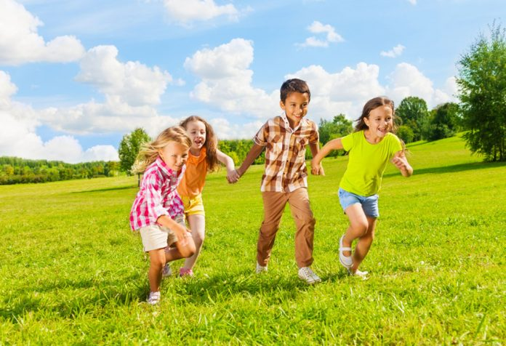
What is Physical Development in Children?
https://parenting.firstcry.com/articles/physical-development-in-early-childhood/

This blog will contain information about different aspects of physical development that happens in children in school or at home. Children have many growth spurts compared to adults. The writer will also bring their own personal views and experience in physical development into this blog to show a psychologist point of views as this is a professional view to make it more accurate.

What is it and what are the signs?
Physical development is the growth of the muscles, bones and body parts in a human, they grow faster in children. Children develop motor skills gross motor skills, this is movements that is used by the big muscles in the body some examples are:
- Riding a bike
- Climbing frames
- Running, Skipping
- Obstacle courses
They also develop fine motor skills and this is used by the smaller muscles in the body and some examples are:
- Using pens, pencils and crayons
- Play dough
- Threading with beads onto thin rope / String
- Fingers painting

All of these help a child physically develop and grow because they will gain more skills, especially with the gross motor skills. Children muscles and limbs will grow fast you will see this by children will seem thinner than they were as an infant because they grow taller, also that their legs and arms grow faster than their fingers and toes, this is why you need to provide the nutrients to help your child’s develop and help the growth (C, 2020).

Physical Development in School Compared to Home
Children develop most of their skills when they are in school because the school encourages the children to start new skills and help them develop their motor skills in school. Children learn and understand. School will introduce new activities that the children may not do at home, such as different sport activities – tennis, football, throwing balls etc. The helps a child build their muscles and make then stronger it also improves their health and fitness which is very good for their development, throwing balls helps with their hand-eye coordination and arms muscles. Obstacle courses is another that help a child develop because it’s a creative fun way for the children to exercise and helps them develop in many different ways, such as balance, strength, endurance and many more. (EYER Team, 2018). There are a range of activities that the school can help a child physically develop compared to home, school helps more gross motor than fine motor skills.

Whilst at home development for the children may be harder because some families don’t have big enough gardens for their children to do gross motor skills, however taking your child to the park will help develop their gross motor skills as the park has various actives such as monkey bars, climbing frames and you can kick a ball around these will help a child develop majorly because they all use a lot of strength to use and it will help them build their strength. Another way to help your child’s physical development is let them help you make food, this can help their fine motor skills because they are using hand movements and this also helps them for when they are older.

My Own Experience
At the age of 5 a doctor had thought I suffered from a condition called dyspraxia. According to (Dyspraxia Foundation, 2020) “Dyspraxia, a form of developmental coordination disorder (DCD) is a common disorder affecting fine and/or gross motor coordination in children and adults”. With this I struggled with many different types of activities, such as riding a bike this was a major difficulty for me and I could not hold my balance correctly, another is catching a ball, I struggled to catch it properly because of the poor hand eye coordination I had. The doctor recommended that I had to go to health care professionals, paediatric physiotherapist to help me use cutlery and to write. I used to go on trampolines sessions to help me with my co-ordination one a week, this was to try and help me get my balance correctly. As I got older, I started to get better at balance and I am able to keep balance much better now, however I still struggle with my balance now, also I am still struggling with hand eye coordination.

Conclusion
This blog should have shown how important it is for a child’s development. There is a lot of reliable information about the physical development of a child and ways to help to develop it. The writer has also put their own experience in this blog to put into perspective for others to see how they developed.

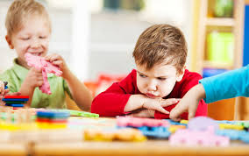
The Emotional Development in Children

https://www.mom365.com/preschool/development/emotional-development-issues-in-children

This blog will contain information about the emotional development of a child. How they develop and what it can do for them. Children have many different emotional spurts and have their own characteristics and way to deal with emotions. The writer will also talk about a theorist view on a child emotional development.

What is it?
Emotional development is the ways and learning process to express a feeling or feelings to a certain aspect or situation. Children will learn each emotion to each situation as they grow older and understand what emotion to use in that situation. Some Children deal with their emotions longer or shorter than others. There many different emotion types:
- Sad
- Happy
- Angry
- Shy
- Scared, etc.

Toddlers have high emotions and they will cry over many different things because they are slightly unaware how to control their emotions correctly. They also get frustrated easily and they are prone to get temper tantrums a lot. According to (Morrisey, 2019) “terrible twos and terrible threes”. Usually these tantrums come from frustration which can happen when the toddler is especially hungry or tired. To avoid these, you could have set time meals and snacks so that the child doesn’t get too hungry, also set times for sleep and naps (if they need them) so that the child doesn’t get overtired. To cope with these, ignoring the child is one way because sometimes children will do this to get attention from the parents. Also distracting the child is good technique because if you distract them with one item at a time with could distract them and may want to play with it and this may stop the tantrum.

Attachment and the John Bowlby Theory
The pre-attachment stages are, birth to 6 weeks is when the baby starts to show small attachment issues to their mother and the mother will stay close to the baby because the baby may cry when the mother leaves the baby. Then 6 weeks to 6-8 months will start to have trust that the mother will answer to the baby when they start to cry, they will start to respond to familiar faces. Also, 6-8 months to 18-24 months will start to get separation anxiety from their mother or parents the baby will not stop crying when the mother or parent’s leave them thinking that they will not come back. Finally, 18 months to 2 years start to understand their emotion and language more, they also start to understand that their parents will come back to them (Heike Griffiths, 2020).

John Bowlby is a theorist and he thinks that attachment is known as an intense emotional relationship between 2 people that goes on over time. It is an emotional tie to specific person that is a need to seek closeness during stressful times or in general times. A lot of young children suffer from attachments to their mothers as a new-born, this is because the mother is caretaking for the needs of the child because of this the child gets attached, when they feel any emotion, they will want attention and protection from their mothers (Heike Griffiths, 2020).

Activities to Help with Emotions
Children need to learn about their emotions and how to use correct emotions for certain situations. Schools can bring in emotional learning techniques to make it fun for them, it also helps with their development and skills because it is important for them to learn as this shows them to seek help when they need it. Some activities are:

Polystyrene egg faces paint the eggs with different faces and emotions. Teach the children about the different emotions on the eggs and get them involved on how they are feeling, you could get them to pain an egg and show how they are feeling or say an emotion and get them to choose the egg showing the emotion you said to see if they know the emotion.

Singing songs, you can sing “if you are happy and you know it” but bring different emotions in (sad, upset, angry etc) this is a fun and involvement way to help children with their emotions. For example, singing “if your sad and you know it” make a sad face, if you excited smile and jump about, the children will find this very fun. All of these with help the emotional development of the child and there are many other activities you can do.

Conclusion
This blog has the information about emotional development that happen in child, also plenty of information about attachment in children and the ways that you can help children learn about their emotions and how a professional theorist opinion is on this topic. This blog should show how important it is for a child’s development.

What is Social Development?
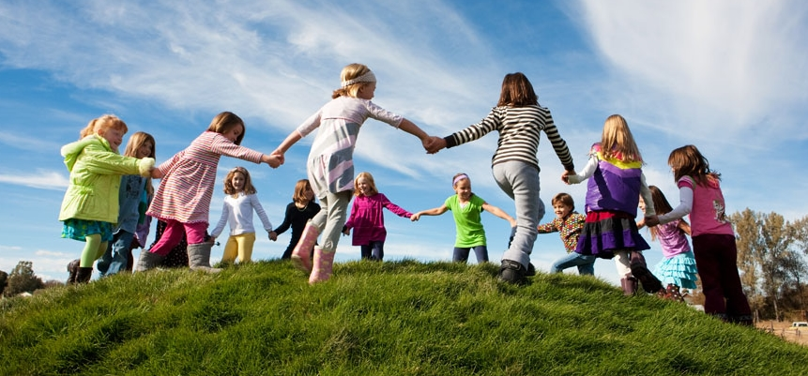

https://pages.shanti.virginia.edu/Social_Development_Lab_3/

In this blog the writer will talk about the social development in children. Social development is very important because it is how you interact with others and it helps with confidence, school, learning and making new friends. The blog will also show a professional psychologist theory on this.

What is it and why is it important?
Social development is how people develop their social skills over time, it mainly happens in childhood because that is where they learn to socialise. They gain communication skills as children and this helps them for when they get older, communication is key in many things. Good Communication helps with many of things such as maintain good friendships and relationships. For example, if a person needs help with something, they need to communicate to get the help.

It is important because having a good social life help you make new friends, and this can make you feel better about yourself because you have lots of friends and that you are able to communicate well. It also helps boost your confidence which is good for development because as the child grows older, they will have more confidence in talking to other children and going into public to socialise with other people well. Being social as a kid is an important way to help overcome their shyness. Also if a child works well in a team this a good way of social development because children working with other children is a way for them to learn new skills such as respect and co-operation which is important for later in life.

Good and Bad
There are many good and bad forms of social development in children. Children should be taught good form however be informed about the bad forms so that they know right from wrong.

A good form of social development is when a child’s parents take their kids out to parks or indoor play areas and this can help them socialise because they are playing and interacting with other children, this is boosting their social and confidence skills up it. This can help them when they are older because they won’t be scared to go and talk to other people or children and have no problem with socialising. It is very important for parents to encourage social activities for the children to help them develop.

A bad form of social development is having a sheltered childhood, for example some parents have social issues themselves and they will over shelter their children because they may not have had the chance to socialise as much as their children do and they are unaware of how important is for a child’s development. This can affect them when they grow older because they can then have social issues and possible have social anxiety because they didn’t get the chance to socialise as much as a kid.

Lev Vygotsky Theory
Lev Vygotsky is a Russian psychologist who developed a theory for Sociocultural and Cognitive development in the early twentieth century. He believes that children that are more advanced with social interaction with other people and children are particular more skilled than those who are not. According to (Psychology Notes HQ, 2020) “Vygotsky believed that social learning comes before cognitive development, and that children construct knowledge actively”. Vygotsky believes that children learn through social interaction that include dialogue from collaborative and cooperative, he called these people with the high skills More Knowledge Other and these are known as teachers, parents, tutors and peers, also that social interaction is a critical role in the way children learn and the process of learning.

Conclusion
In this blog, it has the information about the social development in depth and how it is important for a child’s development, also there has been the good and bad issues that can happen for the development. There is also the professional Lev Vygotsky theory to make you more aware of the development. This blog should show how important it is for a child’s development.

Language and Communication Development
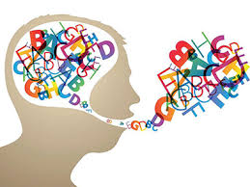

http://llwyn-yr-eos.ceredigion.sch.uk/cms/services-view/alc1/

In this blog the writer will be explaining how the development of speech and language in children. There will also be a personal experience that happened to the writer explained within this blog. Language development is a major part of a child’s development and speech difficulty happen in a lot of children at the start of their childhood and possible carry on until adulthood.

What is it?
Communication and language development is more than just talking it is also the way the child understands another person as well as speaking a sentence or pouncing words. Speech is also included in this as this is Speech is making the sounds that become words, this is physical way of talking and language is or way of using words to communicate, it is using words and gestures to say what we mean and also understanding what others say.

What are the Needs? How can you help?
Children have many needs in communication and language because they can struggle with this for a long time and they need the help to make it better for them. They can occur without the child having developmental needs, it can be a part of the child having general learning difficulties, autism or attention deficit hyperactivity disorder.
The children will need to get help such as going to a speech and language therapist to help them with their speech. A Speech and Language Therapist will help manage disorders of speech, language and communication. They will help with putting sentences together so you can ask for something or hold a conversation, also making the correct sounds needed for what they will say so it can be understood and said correctly. Going to a Speech and Language Therapist can help a child’s language and communication development a lot because if not taught correctly they will struggle when they are older and helped them talk to their best ability.

My Own Experience
As a child I struggled with my own speech and language. I was in primary school when this happened, and this is when the teachers picked up that I wasn't able to pronounce certain sounds or getting them mixed up such as (“CH”, “SH”, TH”), these are common phonics problems in children language, I also had a slight stutter and occasionally talked through my nose. I used to go to a speech and language therapist as my parents were worried and we were recommended to go to receive the help that I need. I also still struggle with some speech issues as an adult as sometimes still stutter when I am nervous or anxious also sometimes still talk through nose. However, as an adult I do not go to a speech and language therapist as it is not as severe as I was as a child and I do not struggle to communicate with other people, they also understand me when I am speaking.

Why is it Important for Development?
Communication is important for development because communication is a key skill to have because it helps us get what we want, it helps us learn and helps us meet new people. It is important for children to have a good communication because the better we at it the better out quality of life will be. Babies will learn to communicate by watching and listening to their parents and then they will start to copy their parents, the more a parent talk to their baby the faster they will develop their language and communication skills. The use of language is how we form friendships and this is very important for children because if communication is poor then children will find it hard to talk to other children because they physically are unable to and this will affect them in later life because they will find it hard to communicate in later life if it is not helped with, also if communication is poor children will notice that they don’t have as many friends as the other children and this can affect their confidence and this can make them not want to communicate more. This is why it is important for children to develop language and communication.

Conclusion
This blog has contained information about the language and development of a child. This has information on ways to help children and what it is about and also there is a personal experience of my own and the importance of it. I hope this blog should show how important it is for your child’s development.

Reference List
(Tian C, 2020) Physical Development in Early Childhood. First Cry Parenting. Available From: https://parenting.firstcry.com/articles/physical-development-in-early-childhood/

(EYR Team, 2018) Top 10 Physical Activities for Children. Early Years Resources. Available From: http://www.earlyyearsresources.co.uk/blog/2018/05/top-10-physical-activities/

(Dyspraxia Foundation, 2020) What is Dyspraxia. Dyspraxia Foundation. Available From: https://dyspraxiafoundation.org.uk/about-dyspraxia/

(mom 365, 2017) Emotional Development Issues in Children. Mom 365. Available From: https://www.mom365.com/preschool/development/emotional-development-issues-in-children

(Heike Griffiths, 2020) Individual Development. ESES4004 Session 3 Power point. Moodle. Available From: https://moodle.uwtsd.ac.uk/course/view.php?id=2969

(Amrisha Vaish, 2017) Welcome to the Early Social Development Lab. Early Social Development Lab. Available From: https://pages.shanti.virginia.edu/Social_Development_Lab_3/

(Psychology Notes HQ, 2020) Vygotsky’s Sociocultural Theory of Cognitive Development. Psychology Notes HQ. Available From: https://www.psychologynoteshq.com/vygotsky-theory/

(Ysgol Llwyn-Yr-Eos, 2020) ALC1 / Dolphins. Ysgol Llwyn-Yr-Eos. Available From: http://llwyn-yr-eos.ceredigion.sch.uk/cms/services-view/alc1/

