A critical analysis and evaluation of the observation research tool, ‘Leuven Scale’.
Targed/Target 1 | Use what you read more effectively to support the points you make
Targed/Target 2 | Try not to write short paragraphs
Targed/Target 3
Targed/Target 4
Targed/Target 5

Introduction
Within my research visit, I was observing to see ‘How focus groups impact pupil engagement’. I observation three pupils in a year two classroom. By having a three children to observe may be more effective because it could give better results due to being able to concentrate on less children.
In Foundation Phase, there are different learning experiences for pupils. Play is very important, it gets pupils motivated and excited which encourages them to want to learn (Unicef, 2018). Learning through play is a way of children to learn without realising it and provides pupils with a variety of skills and opportunities needed to develop.
In addition, outdoor learning is significant for children to learn through nature and using resources that they may not being able to use inside a classroom. For example, forest schooling gives children opportunities to explore the world around them. Forest school, aids pupils to develop different skills such as confidence, social skills and gain new perspectives (Knight, 2013), whereas some pupils may struggle to develop within a classroom setting. Foundation phase helps pupils to build on their imagination through exploring new environments and the use of resources (Twinkl, No Date).
Literature review
The purpose of foundation phase is to learn new skills and widen children’s abilities to prepare them for their future. It allows children to have a positive and exciting approach to their learning. Children get the chance to participate in practical activities, in which will advance their skills (Welsh Government , 2018). Children are challenged and encouraged to be more independent and to be responsible for their learning.
The Foundation Phase has different learning environments that can strongly impact children’s development and progression. Having briefly mentioned in the introduction, play contributes significantly to children’s development. According to Professor Jeremy Smith, play is a way to see how well a child’s social and intellectual skills develop (Jenny Eppard, 2020). However, some people may argue that play can be less effective and could lead to problems if not done correctly (Walsh , et al., 2017). Play can be used in all areas of learning. Role play areas are very popular in Foundation phase classes. They can be very beneficial, because they aid children to develop their communication, imagination, and social skills (Early Start, 2023). Furthermore, outdoor learning is also embedded into children’s learning, especially with the new curriculum. Forest schooling is used in schools, it allows children to be able to explore the environment around them, build on their social skills and give them chance to express their feelings. They can shout and let all their emotions out (Forest Research , 2023).
It could be said, another important impact to children’s learning is the use of resources. Some people believe that the shape of the tables used in classrooms can potentially contribute to the way children learn (Kaplan , 2023). For example, horseshoe shaped tables could be argued that it is more beneficial because the teacher be in the centre of the table. However, on the other hand rectangle tables could fit more children around.
Teachers use a variety of pedagogies that impact a child’s learning. The Montessori method is commonly used, this method ensures that children take more responsibility for their own learning. The responsibility of the teacher is to guide children through their learning. This method ensures that all children are given the correct resources need for them. A Montessori classroom environment is set up to motivate children to want to learn (SupplyDesk, No Date ). Furthermore, another method used within foundation phase is a child centred approach which is more of a constructivist approach to teaching. A constructivist named Bruner would say, that teachers should not be teaching by reputation and instead should aid the process of learning (SimplyPsychology, 2019). Teaching methods could potentially cause the level of child engagement to fluctuate depending on what method is being used.
Additionally, In September 2022 Wales was introduced to a new educational curriculum. The purpose of the new curriculum aids to allow children to access a wide range of support which will enable them to succeed and gain opportunities in life (Welsh Government , 2021). The new curriculum now refers to progression steps. This means that learning continues right through rather than having key stages. Graham Donaldson believes it will.
‘Increase potential for higher attainment by minimising transitions and shifts in purpose and approach at intervals’ (Michael Dauncey, 2021).

Methodology
Moreover, planning needed to take place before conducting research to be effective. The observation tool used to carry out the research was a Leuven scale. The Leuven scale was used to measure pupils’ engagement. After creating my own Leuven scale (appendix 3), I produce an observation schedule (Appendix 1) where I wrote my findings and kept score of each child. In my opinion, my observation schedule work to some extent. However, someone children it did not work for. Before starting my observation, I spoke to the teacher to find out whether any of the children had any vulnerabilities in which may impact the observation (Department for Children, Education, 2008).
According to Learning Journals, they suggest the Leuven scale does not consider children with (ALN) (Learning Journals , 2023). By studying the Leuven scale children with Additional learning needs are likely to score lower than other children because some learn in different ways and environment because of this it may look like they are not engaged based off the Leuven scale. Most children with ALN get easily distracted and need the support to stay on track and concentrate. Furthermore, the Leuven scale does not seem to consider aspects that may have happened prior to the observation. For example, a child hurt themselves or just had play it. Which I think it all these facts can impact the level of engagement in a child. In which may cause the results to not be as reliable.
On the other hand, the Leuven scale is that it is very basic and easy to follow. It makes it more efficient to use when you are observing. It can at times be quite clear, however in certain situation it can be quite difficult to know what score to allocate to a pupil especially when it comes to children with additional learning needs. According to Learning Journals, they believe that the Leuven scale is a good way in putting ‘a child at the centre of their own learning’ (Learning Journals , 2023) rather than teachers basing their assessments of the whole class. It may be beneficial because it could aid children to develop and succeed more as they are getting the support need. From my perspective, having a child centred approach is more significant than observing the class holistically because every individual is different and learns in a variety of ways. It is said, the Leuven scale is a good tool to help teaching when it comes to assessing and planning their lessons (Structual Learning, No Date ). This could potentially help teacher to understand what resources work best for certain individual rather than holistically.
Discussion and findings
Ethics plays an important role in educational research because it ensures that we treat all participants fairly and they are not discriminated against in anyway. This can include gender, diversity and ethnic backgrounds and additional learning needs. It helps participants to understand the nature of the research and how it will be conducted. The research outcome in ethics will not be prejudice or influenced by researchers or another external bias. Following on from this. The guideline contained in British Educational Research Association (BERA) have five principles for educational researchers to follow. These are.
‘Responsibilities to participants, responsibilities to sponsors clients and stakeholders in research, Responsibilities to the community of educational researchers. All educational researchers should aim to protect the integrity and reputation of research by ensure that they conduct it to the highest standards. Responsibilities for publication and dissemination. Researchers should communicate their findings in their clear start forward fashion and in language judged appropriate to the intended audience. Responsibilities for researchers wellbeing and development. This means safeguarding the physical and psychological wellbeing of researchers.’ (The British Educational Research Association, 2018).
In my observation, I was observing the children in 10-minute intervals, for three times. Overall, I observed the children for 30 minutes. The lesson I observed was split into two sections. The first part of the lesson the group of children take part in a phonics session. Within the phonics session, the teacher had flash cards containing words. The children had to shout the word out as followed. The second half, the children had a guided reading session. They read a line each from the story. Then answered a quiz to show how well they had listened.
Child one was in the process of being diagnosed with Autism. In which the teacher explained that they struggled to concentrate and stay still. Due to them potentially having autism, this may affect the results in the observation. In the first 10 minutes of observing child one, I scored them a one (appendix 2). This implied the child had extremely low engagement with the phonic task based off my Leuven scale. They did not seem to be involved within the lesson, they were not listening and taking part. In the next 10 minutes, the lesson moved on to the guide reading session. Child one got asked to read, and point and a word to describe one of the characters. Therefore, I scored them a two. They had low engagement with the guided reading session, they were involved in the task, but they were not focused. They only got involved when spoken to. They were easily distracted, by background noise. The last 10 minutes, they had to answer questions on the comprehension task. When it came to child one answering the questions, they knew all the correct answers. I was very surprised and found it quite hard to what to score them within my Leuven scale.
Child two had health and wellbeing issues. They worried a lot about certain things. This may also affect my observation results. In the first 10 minutes of the lesson, I scored them a three based off my Leuven scale. Child two seemed to take some time to settle into the lesson. They didn’t seem to make much effort with recalling the words on the flash cards. They were not very involved. Additionally, the last 20 minutes child two, showed more interest and seemed to be enjoying. I scored them a four. They showed high level of engagement with the lesson, this could be because they felt more confident and less worried as there was only a small group of children.
To my knowledge child three had no background issues that my impact the results of my observation. Throughout the first 20 minute, I scored the child a five. Their engagement within the focus group was extremely high. They showed a constant level of high of involvement with the lesson. They were not easily disrupted and showed they were focussed throughout. However, within the last 10 minutes of the lesson their engagement level seemed to of dropped. This could imply that they got bored or that the lesson was too long.
By looking at my results there was very mixed engagement within the focus groups. From this I do not think I am confidentially able to answer my question. From the outcome of my research, A key factor in the level of engagement was linked to the educational ability of the participants. In this case, the highest level of engagement was with the highest educational ability. This was contrasted with the lowest scoring on my Leuven scale was with the pupil with the lowest educational ability. Whilst conducting my research, I followed BERA guidelines to ensure that my observation was done correctly and not biases. When I selected the participates in the focus group, I made sure I select a fair representation of the class. My research was not influenced by any participants. From my observation, I have been able to collect quantitative data. This could show the level of engagement between children with Additional learning needs and more than capable children (Department for Education and Skills, 2015).
Conclusion and recommendations
Overall, I am still underdiceded on a conclusion on the impact that focussed groups has on engagment due to all the various factors. I believe that the Leuven scale may not have been the best tool to measure engagment becausee it does not seem to take into account children with Additional learning needs and they learn in different ways. By carrying out my observation, I now understand that every individual learns and concentrates in a various way. When I go out on placement, I will take this in to consideration and understand that some children may not be able to sit still, they may have to fidget with an item, they may need to stand. I believe that children should be able to feel relaxed and comfy to learn to their full potential. I have also understood that some children may find it hard to concentrate for example some children with additional learning needs.

References
Department for Children, Education. (2008) Observing Children, Cardiff: Welsh Assembley Government .
Department for Education and Skills. (2015) Effective use of data and Research Evidence, Cardiff: Welsh Government .
Early Start. (2023) Importance of Role Playing.
Available at: https://www.earlystartgroup.com/nursery/importance-of-role-playing/
(Accessed: 20th February 2023).
Forest Research. (2023) Forest Schools: impact on young children in England and Wales.
Available at: https://www.forestresearch.gov.uk/research/forest-schools-impact-on-young-children-in-england-and-wales/
(Accessed: 20th February 2023).
Jenny Eppard. (2020) 'The Importance of Play in Early Childhood Education'. [Video].
Available at: https://www.youtube.com/watch?v=xkSRPR8u9Ac
(Accessed: 26th February 2023).
Kaplan. (2023) Choosing the Best Table Style for Your Students.
Available at: https://blog.kaplanco.com/ii/choosing-table-style
(Accessed: 20th February 2023).
Knight, S., 2013. Forest Schooland Outdoor Learning in the Early Years.. 2nd Edition ed. London : Sage.
Learning Journals. (2023) What Is the Leuven Scale and How to Use It.
Available at: https://learningjournals.co.uk/what-is-the-leuven-scale-and-how-to-use-it/#:~:text=One%20of%20the%20major%20advantages,of%20early%20years%20development%20teaching
(Accessed: 26th February 2023).
Michael Dauncey. (2021) 'Donaldson Review: An end to Key Stages and a change to the way we structure pupils' progression?', Senedd Research, 27th May.
Available at: https://research.senedd.wales/2015/03/18/donaldson-review-an-end-to-key-stages-and-a-change-to-the-way-we-structure-pupils-progression/
(Accessed: 26th February 2023).
SimplyPsychology. (2019) Bruner - Learning Theory in Education.
Available at: https://www.simplypsychology.org/bruner.html#:~:text=Bruner%20(1961)%20proposes%20that%20learners,being%20told%20by%20the%20teacher
(Accessed: 26th February 2023).
Structual Learning. (No Date) Leuven Scale: A Teacher's Guide.
Available at: https://www.structural-learning.com/post/leuven-scale-a-teachers-guide#:~:text=The%20main%20advantage%20of%20the,effective%20early%20years%20teaching%20resources
(Accessed: 20th February 2023).
SupplyDesk. (No Date) Pedagogy Profile: the Montessori Method.
Available at: https://www.supplydesk.co.uk/resource/pedagogy-profile-montessori-method/#:~:text=Amongst%20British%20parents%2C%20the%20Montessori,childhood%20and%20primary%20school%20education
(Accessed: 26th February 2023).
The British Educational Research Association. (2018) Ethical Guidelines for Educational Research, London: The British Educational Research Association.
Twinkl. (No Date) What is The Foundation Phase in Wales?.
Available at: https://www.twinkl.co.uk/teaching-wiki/the-foundation-phase-in-wales
(Accessed: 20th february 2023).
Unicef. (2018) Learning through Play.
Available at: https://www.unicef.org/sites/default/files/2018-12/UNICEF-Lego-Foundation-Learning-through-Play.pdf
(Accessed: 20th February 2023).
Walsh , G., McMillan, D. & McGuinness, C., (2019) Playful Teaching and Learning. 1st ed. London : SAGE.
Welsh Government (2018) How is my child doing in the Foundation Phase.
Available at: https://www.gov.wales/sites/default/files/publications/2018-06/how-is-my-child-doing-in-the-foundation-phase-a-guide-for-parents-and-carers.pdf
(Accessed: 20th February 2023).
Welsh Government. (2021) 5 things you may not know about Wales’s new curriculum.
Available at: https://www.gov.wales/5-things-you-may-not-know-about-waless-new-curriculum#:~:text=The%20new%20curriculum%20has%20been,for%20the%20future%20of%20Wales
(Accessed: 26th February 2023).

Appendices
Appendix 1

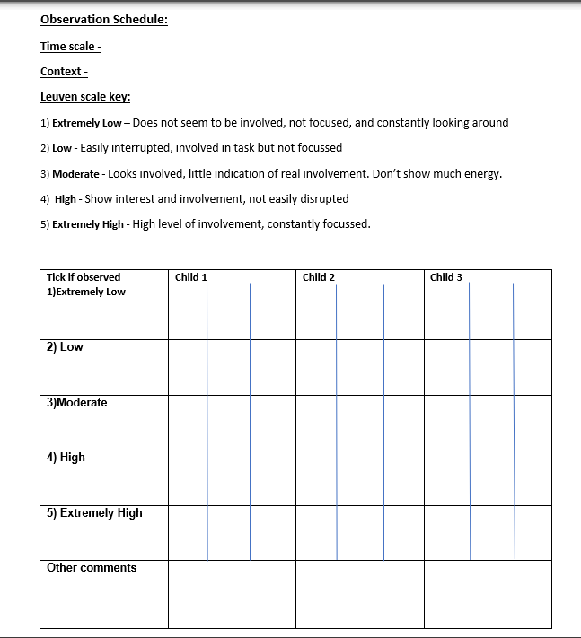

Appendix 2
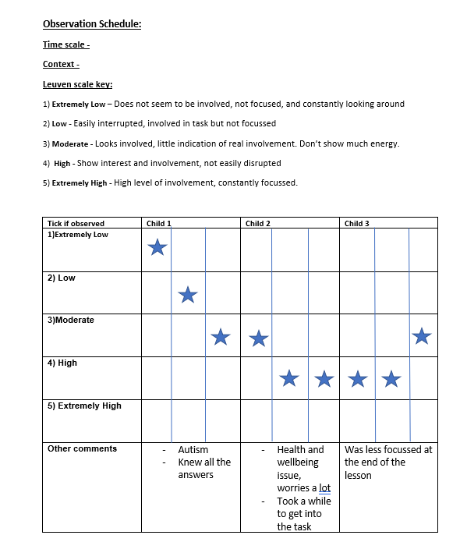

Appendix 3
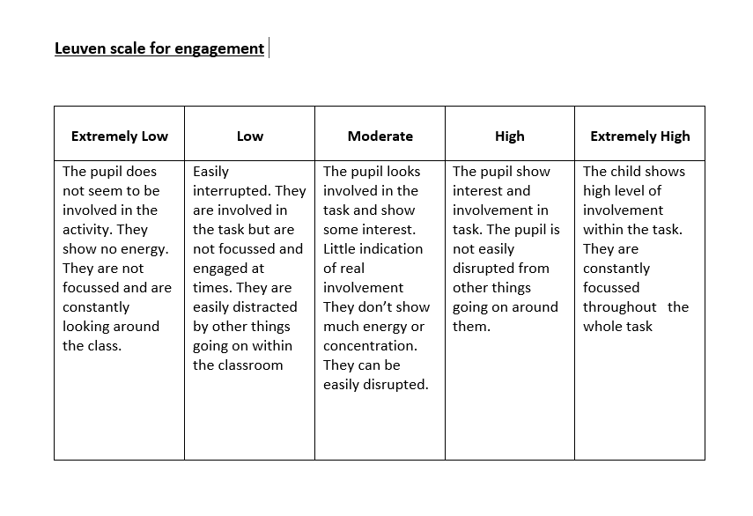

Adfyfyrio Proffesiynol - Professional Reflection

Roedd y Dyddiau Ymchwil yn caniatáu i ti ddechrau wneud cysylltiadau rhwng damcaniaeth ac arfer. Defnyddia’r templed hwn i fyfyrio ar dy brofiad fel ymchwilydd.
The Research Days allowed you to start making connections between theory and practice. Use this template to reflect on your experience as a researcher.

- Disgrifia UN o'r arsylwadau a gyflawnwyd gennyt. Beth wnest ti ei ddysgu ohono?
Describe ONE of the observations you carried out. What did you learn from it?

One observation I carried out was ‘How does outdoor learning impact child engagment‘. By conducting this observation I found out that outdoor learning helps keep children movitated and enthusatic towards learning. It also gives children the opportunity to use resources that they may not be able to you on daily bases. It also aids children to explore different apparticis and devlop their cognitive development.

- Beth oedd yr heriau a'r cyfleoedd o fod yn sylwedydd nad oedd yn cymryd rhan (non-participant observer) yn yr ystafell ddosbarth?
What were the challenges and opportunities of being a non-participant observer in the classroom?

A challenge I came across whilst being a non participant observer in the classroom was that I felt like i was restrictited and islated from the children. As I was more concentrating on the observation. I did not get the chance to form connection and get to know the children. However, I did get the opportunity to see how different children learn and understand how all the different environment impact a childs egagement and ability to learn

- Yn dy brofiad di, beth oedd manteision a chyfyngiadau'r Raddfa Leuven fel offeryn ymchwil?
In your experience, what were the benefits and limitations of the Leuven Scale as a research tool?

The leuven scale was very easy to follow, however I think it was very broad and did not take certain factors into consideration. For eaxmple, children with Additional Learning Needs(ALN), whether something had taken place prior to the observation or maybe a child was not themselves that day.

- Beth oedd prif bwyntiau dysgu i ti o ran bod yn ymchwilydd yn yr ystafell ddosbarth?
What were the main points of learning for you in terms of being a researcher in the classroom?

By being a research I believe you should follow Bera 2018 with their five priniciples. I think you should ensure that you are being fair and that your research is not influenced by anyone else. You should also not discrimminate towards any individual involved within the observation. You should also that your research is kept confidentially throughout the whole procces.

- Beth fyddet ti'n ei wneud yn wahanol pe bae ti'n cynnal yr ymchwil hon eto? Pam?
What would you do differently if you were to conduct this research again? Why?

If I was to conduct this research again, I think I would use an alternitve solution rather than use the leuven scale. I do think it was the best tool to use to collect reliable data.

- Trafoda unrhyw ddulliau eraill o ymchwil y gallet eu defnyddio yn yr ystafell ddosbarth i wella dy ymarfer. Beth yw'r pethau positif a negyddol?
Discuss any other methods of research you could use in the classroom to improve your practice. What are the positives and negatives?

There are a variety of other methods I could of ponteially used as a research to conduct my observation. A method I could of used could of been a one to one interviewing. However, due to it being based in a year two class, I could maybe to a one to one session with a child to see how engaged they are. Following on from that, I could of used questionnaires about what lessons they like and what they dislike and see the difference in the level of engagment.

