Data Handling & Business Intelligence (LCBB5000)
Cristian Sirota
Business and Management
Lecturer Name: Khaza Ahmed

Table of Contents
Section 1 (2000 words) 2
a) Descriptive Statistics 2
1. Mean: 2
2. Median: 2
3. Mode: 2
4. Standard Deviation: 2
5. Comparison of Variance: 2
6. Comparison of Standard Deviation: 3
7. Interpretation of the last three outcomes: 3
b) Presentation of data using MS Excel 4
c) Using SPSS 7
1. Correlation between coffee consumption and the health index score 7
2. Scatterplot of coffee consumption (on the horizontal axis) and effects on the human body - health index score (on the vertical axis) 12
Section 2 (1000 words) 15
a) Discuss the advantages and disadvantages of using SPSS, Excel, or Tableau using relevant practical examples. 15
b) Explain the meaning and importance of the Data Mining Cycle with examples 16
References 18

Section 1 (2000 words)
Understanding Coffee Consumption and Health Index Scores: An Analysis
The data showed that there was indeed a connection between coffee intake and an index of health among 40 people. In this work, an effort was made to analyze the variability and trends in data to find out whether coffee drinks can have any impact on health.

a) Descriptive Statistics

1. Mean:
The average coffee intake in this group is 3.625 cups a day, implying that the level of consumption is still moderate. This value serves as the central tendency of the data while outliers can affect it.

2. Median:
The number 3.5, representing the number of cups consumed per day on average, can be viewed as a typical consumption level, which is shown as a midpoint when the data is arranged in ascending order.

3. Mode:
A bar of 2 cups per day indicates that this amount was observed the most, with this level having the most counts in the dataset. This shows that this diversity of levels was the most frequent.

4. Standard Deviation:
The standard deviation from health index scores is computed to be 13.41, which speaks about the higher variability in health statuses within in the sample. This tool specifically depicts the dispersion of scores around the mean and portrays important differences in health outcomes among people.

5. Comparison of Variance:
The variance is a numerical quantity that is used to measure the dispersion of values under consideration relative to their mean value. It shows the divergence between data values and the mean and hence displays the ambiguity. Given such data, the change in coffee consumption per day is about 4.34 as the mean and standard deviation are calculated. This implies that the participants in the surveys hold a more moderate level of their daily intake of coffee and are subject to changes. The coffee lovers who go through periods of increased or decreased daily coffee consumption will result in the distribution of consumption, centered at the mean.
Secondly, it is surprising that the dispersion of health index scores is almost 179.89. This suggests the existence of a relatively high degree of deviance between the values of the health index among these individuals. The wide coverage of health index scores tells us about the in-depth heterogeneity of the health status of the individuals represented in the survey, with the upper score meaning the better health state of our respondents and the lower score pointing to worse health represented in our respondents. It can be inferred from the higher coefficient of variation in health index scores than daily coffee intake that more data have a spread out distribution and these findings demonstrate that there are lots of disease variations in the population studied.

6. Comparison of Standard Deviation:
The standard variation is a measure of the dispersion of the data matters about a mean within a dataset. Furthermore, the standard deviation concerning the number of cups of coffee consumed every day can be observed to be about 2.08, implying that the difference in the volume of coffee consumed daily between individuals might be relatively high. The mean health index score is 13.41, which as a standard deviation of health index scores was considerably higher than those of the surveyed participants. Analyzing one index and another, the standard deviation as the health index score is larger than the mean health index score, is larger, indicating a wider range of variation in health status compared to coffee consumption. Therefore, the standard deviation of the variable of "Health Index Scores" is greater than the standard deviation of the variable of regular and decaf coffee consumed in 12 hours.

7. Interpretation of the last three outcomes:
In particular, the data's standard deviation of well-health index score (HIS) at almost 13.41 expresses that the mean value has dispersions of the people score on health index scores. Greater variation around the mean will usually be represented in this way by a higher standard deviation, which implies more diverse health statuses indicated by higher health indexes among the surveyed persons. The variability may be related to many parameters like age, habits of life, life and socio-economic status, and ongoing health conditions.
Moreover, the standard deviation of the health index score (which was about 179.89) complemented the already acquired insight by quantifying the average dispersion of individual health indices scores. The variability is the measure of the distance that each observation point is from its mean, while the mean itself demonstrates the average squared deviation of the data set. High variance means that health index scores are distributed widely among the interviewees, which implies that there is a large variety of this index or a big dispersion of its scores. The Standard Deviation vs. Variance is an important principle in statistics when the Square Root of the Variance is the Standard Deviation. For this case, the result of the standard deviation of HIS (13.41) is true where the variations among health index scores were proved with the square root of its variance.
A common practice in the literature on epidemiologic statistics or health assessment is using standard deviation and variance in order to study the variability of the health results among populations. Simply put, the analysis of data where the health-related quality of life or health index scores have been evaluated over various sociocultural groups can draw broader knowledge using the challenging method, i.e., measures of dispersion. Such a method is applied to determine the range and distribution of health status. The model that explains the Sixty-Four item health survey (SF-36), an instrument often used to measure health status, according to the studies conducted by Ware and Sherbourne (1992) highlights that the variability in the health outcomes not only promotes the understanding of the interventions applied in the health sector but is also the phase that policy decisions are informed.
Although the fact that coffee consumption has an impact on health is proven by divergent scores on the health index, it is not the only predictor. Other factors including diet, exercise, heredity, and lifestyle decisions probably account for the wide clinical range of conditions viewed. Hence, employing a dynamic approach to health management by addressing various lifestyle factors is essential for attaining an optimally healthy lifestyle. These insights showcase the nuances of individual determinants of health and emphasize the significance of personalized interventions designed to address the unique needs and circumstances of individuals.

b) Presentation of data using MS Excel
MS Excel was used to plot charts including pivot tables that offers an easy way of representing the data for the specified question. Pivot tables constitute powerful instruments for data summarizing and analysis which is shown by its feature which is the possibility to customize the table according to the specific criteria used for data aggregation. In addition to the tables on the pie charts, the pivot chart gives the readers a picture of the summary of the work, the tool facilitates in interpretation of the trends and patterns. The main benefits of data presentation with pivot tables and charts include effective data summarization at higher hierarchical levels, which helps users quickly identify critical trends, as well as a dynamic representation of data visualization through chart and graph interactivity, which facilitates easy perception of complex data. Maximizing these factors grants the resultant reports and presentations a high sense of clarity. This enables a full comprehension of the original data; therefore, the user can have a straightforward understanding of the information expressed in the documents. The steps of how to make a pivot table or pivot chart are shown below:
Select Your Data Range:
Highlight the entire range of data you want to include in your pivot table or chart. This can be done by clicking and dragging over the cells containing your data.
Insert Pivot Table or Pivot Chart:
- Go to the "Insert" tab on the Excel ribbon.
- For a pivot table: Click on "PivotTable" and select the type of pivot table you want (e.g., New Worksheet or Existing Worksheet).
- For a pivot chart: Click on "PivotChart" and choose the type of chart you want to create (e.g., Bar Chart, Line Chart, Pie Chart, etc.).
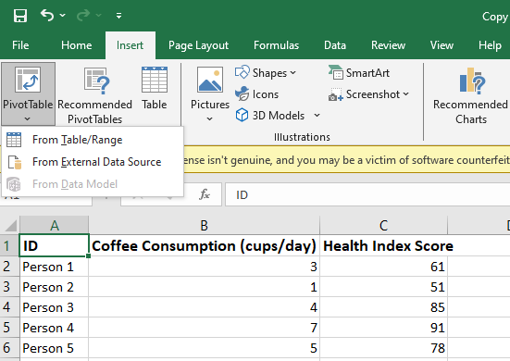

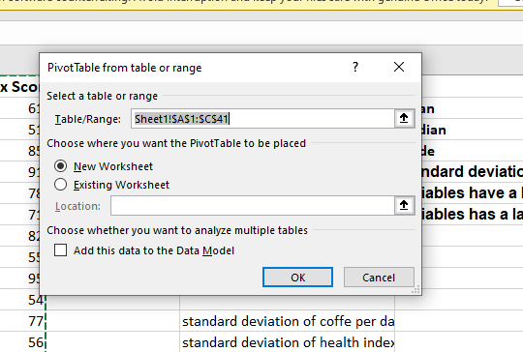

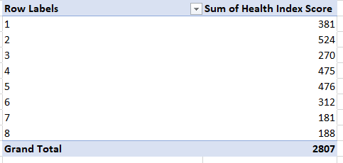

c) Using SPSS

1. Correlation between coffee consumption and the health index score
Step # 1
Open SPSS and import your dataset containing the variables for coffee consumption and health index scores.
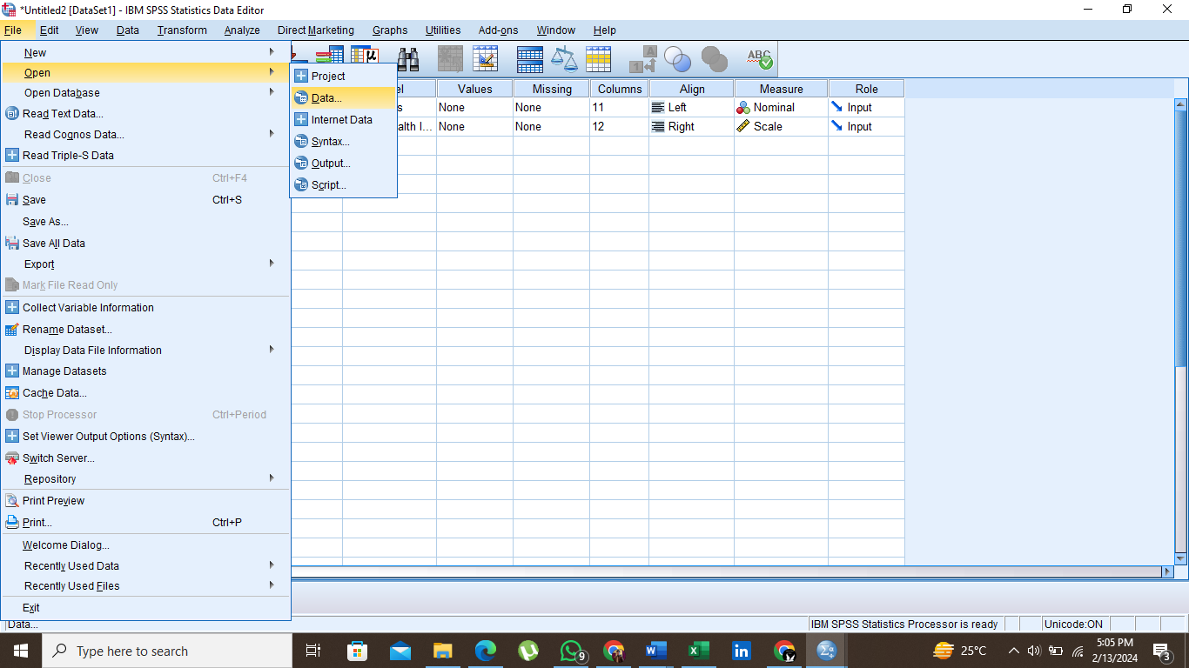

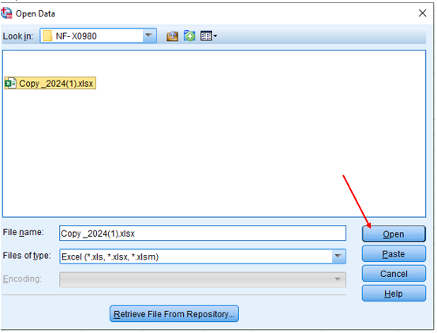
Step # 2
Go to the "Analyze" menu, then select "Correlate," and choose "Bivariate" from the submenu.
In the "Bivariate Correlations" dialog box, select the variables for coffee consumption and health index scores and move them to the "Variables" box.
Click "OK" to run the analysis. SPSS will compute the correlation coefficient (Pearson's r) between coffee consumption and the health index score.

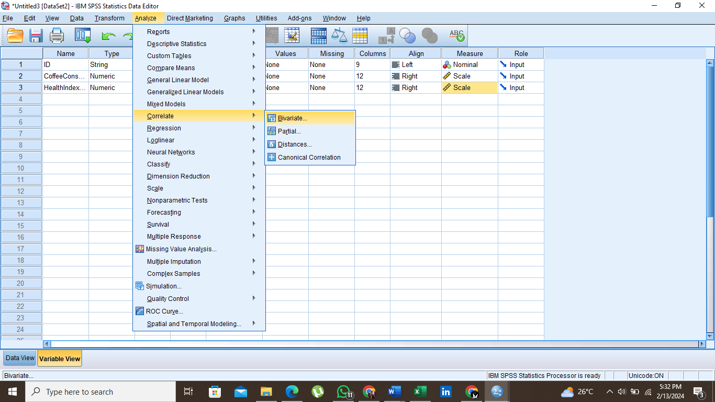
Step # 3
Once the analysis is complete, SPSS will generate output containing the correlation coefficient along with its significance level.
Interpret the correlation coefficient and its significance level to determine the strength and direction of the relationship between coffee consumption and the health index score.
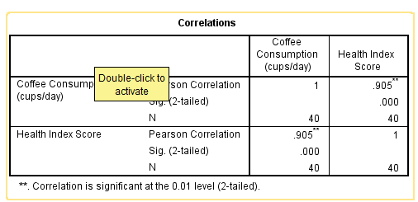
The Pearson correlation coefficient helps to determine the strength and direction of the linear relationship between the two variables. In this case, both correlations (Coffee Consumption vs. Score of Health Index and Score of Health Index vs. (Coffee Consumption) have the strongest positive correlation with a value of 0.905. moreover, the p-value (or significance level) determines the probability of getting a correlation coefficient at this value, even if there are no actual correlations in the population. Here, the p-value is <0.001 (Sig.). (2-tailed) = .000), which indicates that the correlation is statistically significant at the 0.01 level (2-tailed). It means that the observed correlation coefficients could not have been due to chance alone.
Having a correlation coefficient of 0.905 and a significant p-value, it can thus be said that there is a strong positive linear relationship between coffee consumption and health index score. In other words, the health index score tends to increase when coffee consumption increases, and it decreases when coffee consumption decreases. This result is strong and not likely to be due to randomness. Although the correlation is significant, it is important to note that correlation does not imply causation. Although there is a strong relationship between coffee consumption and health index score, there could be other variables or factors not accounted for in this analysis that are influencing both variables independently.

2. Scatterplot of coffee consumption (on the horizontal axis) and effects on the human body - health index score (on the vertical axis)
Step # 1
Go to the "Graphs" menu and select "Chart Builder."
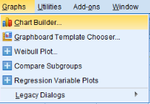
Step # 2
In the Chart Builder dialog box, choose "Scatter/Dot" under the "Gallery" tab.
Drag the "Simple Scatter" icon to the chart preview area.
Click on the "Variables" tab and select the variable for coffee consumption as the X-axis variable and the variable for health index scores as the Y-axis variable.
Customize the scatterplot as needed by adjusting options such as titles, axis labels, and markers.
Step #3
Click "OK" to generate the scatterplot.

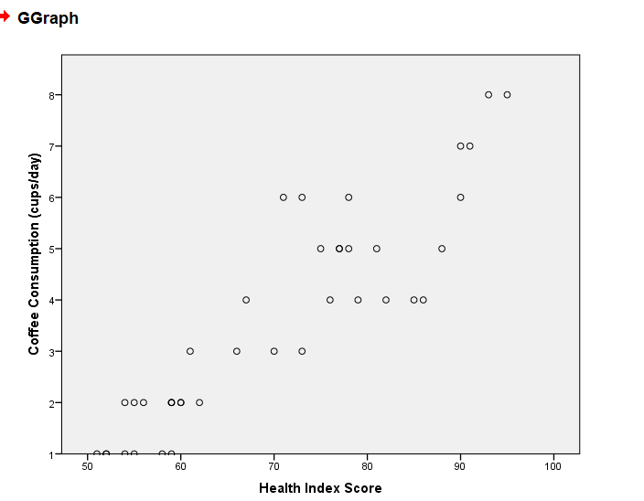

Comments
There seems to be a slight positive correlation between coffee consumption and health index scores. As coffee consumption increases, there appears to be a tendency for health index scores to increase as well, although the relationship is not perfectly linear. However, there are a few outliers where individuals have relatively high health index scores despite consuming fewer cups of coffee per day, and vice versa. These outliers could be due to other factors such as diet, exercise, genetics, or other lifestyle choices not captured in the dataset. Besides, there is a cluster of data points around the mid-range of both coffee consumption and health index scores, indicating a concentration of individuals with moderate coffee consumption and average health index scores.
There is noticeable variability in health index scores for individuals with similar coffee consumption levels. If this is indeed the case then it can be concluded that the health index scores are indicative to other factors than coffee consumption and consumption itself may not be a determinant of the health index scores. Although the graph tells facts on the relation between coffee consumption and health index scores of this particular dataset, it is still worth mentioning some potential drawbacks. If the result only shows the correlation, it does not mean that one variable causes the change in the other variable. The other factors that are not accounted for in the current dataset may be the reason of observed pattern. Beyond that, the actual sample size is small, so the patterns observed might not generalize to the other people.

Section 2 (1000 words)

a) Advantages and disadvantages of using SPSS, Excel, or Tableau
Statistical process is one of the major aspects in the decision making process across and over various industries, and these software programs like SPSS, excel, and Tableau do the task efficiently, as they are powerful tools. SPSS is the firm with a host of statistical procedures that match all the requirements of complex analysis, for example, regression analysis, factor analysis, and ANOVA. For instance, an individual doing research on the reason behind customer satisfaction in the retail environment may deploy SPSS to run multiple regression analysis and discover relationship between variables like quality of product, the level of competitiveness and customer services and overall satisfaction. In contrast, the advanced options of the SPSS are complex which requires the program to have in-depth statistical knowledge (Milovanović and Perišić, 2020). Furthermore, SPSS is expensive software, and authorization of a license may be expensive particularly for self-users or organizations that do not have enough finances.
Nevertheless, the amazing popularity and adaptability of Excel among many people make it an essential tool – for business people and anybody else conducting analytical work. Its simple structure, familiarization to different levels of technical expertise, and usability characteristic makes it easy-to-use upon using it. The fact that Excel has plethora of functions and formulas, which include data entry, manipulation, and basic statistical analysis, is one of the factors that makes it so easy to do different tasks with this work program. For example, a financial analyst may use excel to generate budgets, financial models and reports with a snap of a finger by mere use of sum, average and if functions to conduct all calculation and analysis of data (Incerti et al., 2019). However, SPSS statistical software has some functions such as categorical data analysis which lack in Excel. The software may not be able to cope with complicated analysis, to deal with huge volumes of data, or solve multi-factorial problems. Furthermore, Excel is susceptible to errors including typos and complicated calculations when it comes to large data sets or complicated.
Whereas, Tableau is a leader in making it easy to nest data visualization types that can either created dashboard or charts with zero effort. The ease of use, drag-and-drop interface, and simple design of this site mean that even the technically challenged users can quickly find their way around the site (Vasundhara, 2021). Tableau visualizations are powerfully effective for the interactive exploration of data, with insights surfacing dynamically that can be deeply understood swiftly and succinctly. For example, a sales manager about product performance for different regions, time, and products, can build interactive dashboards to visualize sales trends for different geographic areas and see the performance of various products over time (Ko and Chang, 2017). It incorporates the feature of handling large data sets in an aggressive manner, which allows the user to see data that came from various sources in one panel, for instance, from databases, spreadsheets, and cloud services. Also, as compared to other programs, Tableau is often expensive and unaffordable for startups or a single person. Licensing fees or subscription costs might be a barrier to some organization's budgets, especially for those organizations that may not cover the actual cost of it.

b) Explain the meaning and importance of the Data Mining Cycle with examples
The Data Mining Cycle, also known as the Knowledge Discovery in Databases (KDD) process, is a systematic approach used to extract useful information or patterns from large datasets. It consists of several interrelated stages, each essential for transforming raw data into actionable insights (Rotondo and Quilligan, 2020). Understanding the Data Mining Cycle is crucial for organizations seeking to leverage their data effectively to make informed decisions and gain a competitive edge.
The Data Mining Cycle typically comprises the following stages:
Understanding the Business Objectives:
The first stage is the identification of the business issue that data mining intends to focus on. There is all likelihood that the goals of the data mining project and how the derived insights would contribute to organizational objectives will be clearly articulated (Schneider et al., 2023). One example is how a retail company may target customer retention by uncovering the causes of customer churn.
Data Preparation:
In this stage, raw data is pulled from various sources and prepared for subsequent data analysis. Sometimes there is a need to clean the data from different errors, inconsistencies, and missing values, while in other cases, one has to integrate the data from different sources. An example of this would be a healthcare provider gathering patient data from EHRs, billing systems, and demographic databases. Then, the data will be cleaned and combined to be analysis-ready.
Exploratory Data Analysis (EDA):
EDA implies 'data exploration' to discover the dataset’s structure, relationships, and patterns (Peng et al., 2021). Descriptive statistics, data visualization methods, and data mining algorithms can be applied to find connections and to determine the trends within the data. An example would be a marketing team analyzing transaction data and using EDA to discover purchase patterns and group customers based on their buying behavior.
Model Building:
At this moment, predictive or descriptive models are built with machine learning algorithms and statistical methods. Though the models themselves are distinctive, their purpose is the same: to make predictions of events in the future and to reveal the structure of the underlying data (Schneider et al., 2023). For instance, a credit card company had to develop a predictive model to assess the chances of a new credit card applicant's default, and they did that using data like credit history, income, and others.
Evaluation:
When models have been formed, they must then be tested to measure performance and precision. In modeling performance determination, validation should be carried out by testing models with new data or using the cross-validation technique to confirm the models’ generalizability. Such as, a predictive model established by a healthcare provider with an objective to determine the readmission risk of patients based on the historical data would validate its predictions with actual outcomes.
Deployment:
The last stage of the cycle of Data Mining is about putting the result of the model or recommendation based on the findings into the system of the corporation or decision-making processes among its leaders (Li et al., 2022). Such illustration can comprise of different models into each application, dashboard, or process in your company. An instance is the person working for a retail Company uses recommendation engine based on collaborative filtering technique to personalize the product recommendation for online shoppers. The Data Mining Cycle involves processes that are iterative and therefore, the output of one cycle becomes the input of the another. For appication, EDA could entail a fusion of diminutive info to major information or boost of model evaluation may occur on the stage of model-building process. Additionally the cycle does not as often take a linear pattern and materialization loops may happen as new data comes in or business objectives take different form as well. The Data Mining Cycle is of a paramount importance for organizations aiming at gleaning the power of their data assets and making use of it to reach operative strategic decisions (Plotnikova et al., 2023). Through a strategic application of data mining, organizations can derive useful information, bring to light hitherto implicit trends, and utilize data informed decisions that enhance their operations, touch client needs, and engender business growth.

References
Incerti, D., Thom, H., Baio, G. and Jansen, J.P., 2019. R you still using excel? The advantages of modern software tools for health technology assessment. Value in Health, 22(5), pp.575-579.
Ko, I. and Chang, H., 2017. Interactive visualization of healthcare data using tableau. Healthcare informatics research, 23(4), pp.349-354.
Li, C., Chen, Y. and Shang, Y., 2022. A review of industrial big data for decision making in intelligent manufacturing. Engineering Science and Technology, an International Journal, 29, p.101021.
Milovanović, M. and Perišić, J., 2020. Advantages and limitations of using SPSS in teaching statistics. MEFkon 2020 INNOVATION AS AN INITIATOR OF THE DEVELOPMENT “INNOVATIONS IN THE FUNCTION OF DEVELOPMENT”, p.274.
Peng, J., Wu, W., Lockhart, B., Bian, S., Yan, J.N., Xu, L., Chi, Z., Rzeszotarski, J.M. and Wang, J., 2021, June. Dataprep. eda: Task-centric exploratory data analysis for statistical modeling in python. In Proceedings of the 2021 International Conference on Management of Data (pp. 2271-2280).
Plotnikova, V., Dumas, M., Nolte, A. and Milani, F., 2023. Designing a data mining process for the financial services domain. Journal of Business Analytics, 6(2), pp.140-166.
Rotondo, A. and Quilligan, F., 2020. Evolution paths for knowledge discovery and data mining process models. SN Computer Science, 1(2), p.109.
Schneider, J., Seidel, S., Basalla, M. and vom Brocke, J., 2023. Reuse, Reduce, Support: Design Principles for Green Data Mining. Business & Information Systems Engineering, 65(1), pp.65-83.
Vasundhara, S., 2021. Data Visualization View with Tableau. Stochastic Modeling and Applications, 25(1), pp.178-187.

