The Process Of Creating An Accurate And Visually Effective Map
Contents
Introduction 1
Data capture and layer selection 1
Google Maps 2
Ordnance Survey (OS) Data 2
Drone Data 3
Light Detection and Ranging (LIDAR) Data 3
Data Limitations 4
Time and Capture 4
Scaling and Resolution 4
Distortion 5
Conclusion 5
Table of Tables 6
Table of Figures 6
References 6

Introduction
Using the Geographical Information System (GIS) software QGIS, students were tasked to determine the suitability of an area of land next to UWTSD Swansea Campus to become an explosive trials site. The task utilised a wide variety of resources available on open source mapping software Digimaps, as well as manually collecting data using a Mavik 2 drone. A Boston Dynamics SPOT robot also assisted the surveying, however was unable to retain any of the visual data it collected.
The report outlines how a variety of methods were used to capture quantitative and visual data on the trials site. It then details the process of map layer selection to enhance the visual effects of the poster. Additionally, it explores the issues surrounding creating completely accurate map data.

Data capture and layer selection
To create a comprehensive and impactful case study, the poster contains multiple map layers. Each layer displays data from a different GIS study, to provide information on a specific category, such as roads and buildings.

Google Maps
The initial layer utilised Google Maps satellite data from 2022, providing the most accurate map information available. The layer allowed the viewer to understand the local area around the site.
A polygon feature was then added over this data, as shown in figure 1. This provided a dual purpose of distinguishing the trials site from its surroundings whilst offering the audience an understanding of its scale from using a measurement tool to determine its area.
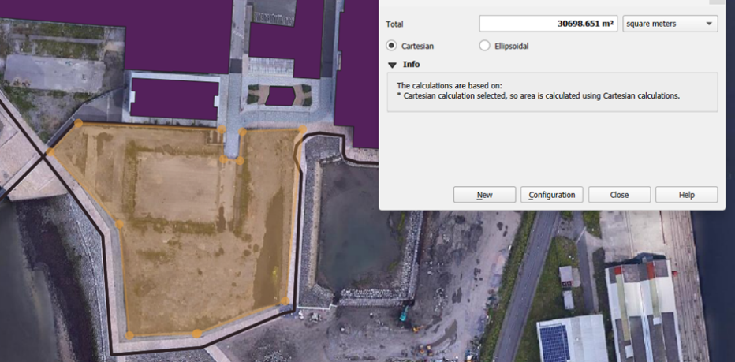
Figure 1- A polygon layer being added to the Google Maps data to determine the area of the trials site
University buildings were then singled out in a distinctive colour to emphasise how close the proposed trials site was to the campus.

Ordnance Survey (OS) Data
Using Digimaps, OS data was used to incorporate roads, paths and bodies of water to the scene. These eluded the proximity of civilians to the site, re-emphasising the safety and environmental concerns of this location.
To establish safety parameters, a buffer tool was used to create a radius around both the path, road and university buildings, displaying areas where explosives were deemed unsafe. To make it clearer for the audience, the opacity was altered to highlight the small amount of space within the trials site, as shown in figure 2.
The scalebar was added to highlight how small the left-over land was in comparison to the initial site shown in map 1.
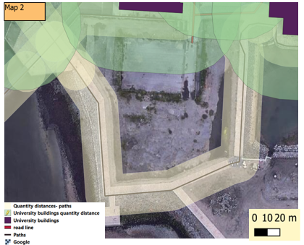
Figure 2- A map displaying where explosives were unsafe to use

Drone Data
The Mavik 2 drone was selected to provide a comprehensive survey of the site, utilising both a conventional and thermal imaging camera. The drone collected photographic data at varying altitudes of different sections of the site.
Using its higher resolution data, the drone was able to highlight different aspects of the site significantly better than the lower resolution Google Maps data. The drone survey revealed a waterlogged segment of the site not evident from Google Maps, as shown in figure 3. The additional detail offered by this photograph visually demonstrated the issues with flooding in the area.
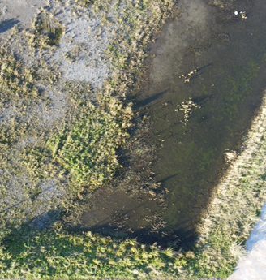
Figure 3- An image of the waterlogged section of the proposed trials site, captured by the drone
Each image contained Global Positioning Service (GPS) coordinates, allowing them to be placed accurately onto the map as a separate layer. This provided a realistic on-the-ground view of the trials site, providing visual context to the poster.

Light Detection and Ranging (LIDAR) Data
LIDAR data was added to determine the site topography, specifically how flat the site was. It also supported the drone imagery data by displaying the waterlogged segment as a few metres below the rest of the site.
As demonstrated by figure 4, this data was presented using a rainbow colour ramp. This provides the audience with both visual and numerical data on how prone to flooding the area is- especially due to the absence of data points above 11.2m sea level.
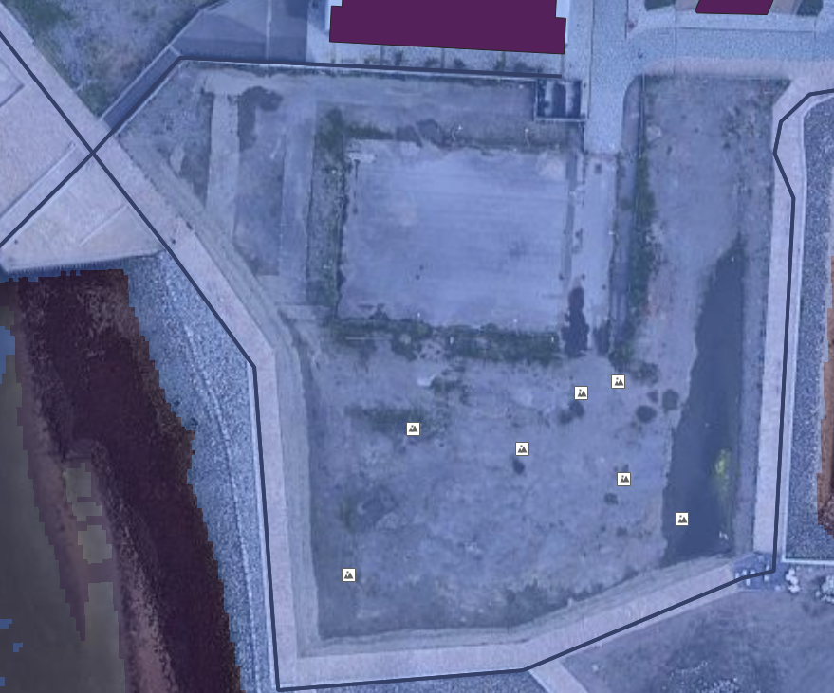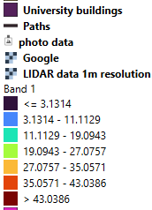
Figure 4- The map displaying the topography data for the site

Data Limitations

Time and Capture
In table 1, most layers of data are shown to be taken recently, providing the most up-to-date representation of the area studied.
Layer | Year of Release
Google Maps | 2022
LIDAR data | 2020-22
OS data (roads, water areas, paths) | March 2023
Drone data | November 2023
Table 1-The dates each layer was originally captured [1] [2]
The data is also taken from trusted and recognised sources, ensuring data credibility.
However, the data was collected from different years, creating inconsistencies in the data sets. For example, drone photography in figure 5 implies that there is car parking directly next to the trials site, however this is not indicated by any of the other map layers. This undermines the validity of the other layers, reducing confidence in the other map datasets.
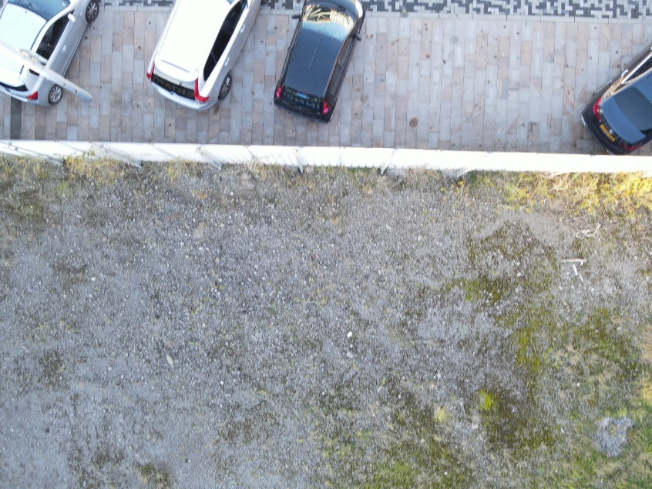
Figure 5- An image of the trials site bordering on a car park

Scaling and Resolution
A data input error of just 0.5mm will produce an error of 625mm on a 1:1250 scale map, due to the effects of scaling [3]. Whilst initially small measurements, these can be extrapolated into larger scaling errors dependent upon the resolution of the equipment used. The LIDAR data within the map has a 1m resolution, which could potentially introduce a worst-case error of up to 1250m at the same scale. Therefore, data resolution and accuracy can have dramatic repercussions on the positioning of key site locations, altering the true nature of the site altogether

Distortion
When features on a curved surface are represented on a flat surface, their shape and size will be subject to a degree of distortion. Each mapping company has a different way to deal with such distortions to provide their data in the best way for their customers.
Google Maps uses a variant of the Mercator projection to enable viewers to visualise typical street views (e.g. roads at right angles) like they do in reality. However, this projection can result in exaggerated proportions, and the shapes and angles of buildings being altered.
In comparison, the OS data uses a Transverse Mercator Projection. Whilst it often maintains the angles and shapes of buildings, it can distort the direction of the map from North [4] [5].
The map was created through pulling together data from different projections. This requires the coordinates from each map to be converted into a universal format used across multiple maps. However, when coordinates are transformed to fit this universal projection, distortions that existed in the original maps may be exaggerated or modified, thus affecting overall accuracy.

Conclusion
To conclude, data from Digimaps, OS and a drone were incorporated into QGIS to provide a visually appealing poster. Despite selecting current data from recognised sources, external factors such as distortion will always prevent maps achieving complete accuracy.

Table of Tables
Table 1-The dates each layer was originally captured [1] [2] 5

Table of Figures
Figure 1- A polygon layer being added to the Google Maps data to determine the area of the trials site 2
Figure 2- A map displaying where explosives were unsafe to use 3
Figure 3- An image of the waterlogged section of the proposed trials site, captured by the drone 4
Figure 4- The map displaying the topography data for the site 4
Figure 5- An image of the trials site bordering on a car park 5

References

[1] | The University of Edinburgh , “DigiMaps,” EDINA, [Online]. Available: https://digimap.edina.ac.uk/. [Accessed 5 1 2024].
[2] | Data Maps Wales , “LiDAR 1m resolution 2020-22 DTM (16bit),” The Welsh Government , [Online]. Available: https://datamap.gov.wales/layers/geonode:LiDAR_1m_2020_22_DTM_16bit_COG. [Accessed 6 1 2024].
[3] | Boundary Problems , “Using Ordnance Survey maps,” Jon Maynard Boundaries Ltd, [Online]. Available: https://www.boundary-problems.co.uk/boundary-problems/osmaps.html. [Accessed 6 1 2024].
[4] | Barcelona Field Studies Centre , “Google Maps Projection,” Barcelona Field Studies Centre , [Online]. Available: https://setcompass.com/GoogleMapsProjection.htm. [Accessed 3 1 2024].
[5] | Arc Map , “Transverse Mercator,” ArcMap, [Online]. Available: https://desktop.arcgis.com/en/arcmap/latest/map/projections/transverse-mercator.htm. [Accessed 7 1 2024].

