

Programmed: Master of Business Administration

Module: Marketing Management

Module code: LCMB7024

Title: Marketing Portfolio : Brand Development

Lecturer: Dian Mayasari

Student Name: Muskan Kapadia

Student ID: 2511297

Submission Date- 19th November 2025

Table of content
1 | Introduction | 03
2 | STDP  Segmentation  Targeting  Differentiation  Positioning | 04
3 | 7Ps Marketing Mix | 08
4 | Brand Poster | 15
5 | Reflection | 17
6 | References | 18

Introduction

Unilever Blossom created the fictitious personal care brand PureKind, which fits into the expanding "clean beauty" and "gentle care" market. The idea combines the consumer's desire for gentle, hypoallergenic, and ethically made personal care products with Unilever Blossom's sustainability pledges. PureKind can strategically compete, connect with customers, and develop long-term brand equity by using the STDP framework, which stands for segmentation, targeting, differentiation, and positioning.

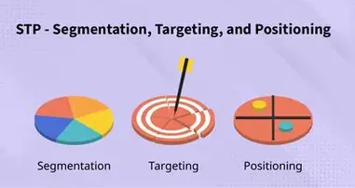

Element 1 STDP Analysis for Unilever Blossom PureKind Personal Care Brand

1. Segmentation
Markets are usually divided into segments by Unilever Blossom based on behavioral, psychographic, geographic, and demographic factors. Health-conscious and environmentally conscious customers looking for gentle and open personal care are the target market for PureKind.
a) Demographic Segmentation
• Age: Mostly adults between the ages of 18 and 45, including young professionals, recent parents, and environmentally conscious adults. • Gender: All genders, but slightly more appealing to mothers who make decisions for the home and female buyers.
• Income: Middle to upper-middle income segments who are willing to pay a small premium for clean and safe products.
• Family Status: Families with young children or individuals with sensitive skin.

b) Psychographic Segmentation
• Lifestyle: Consumers living wellness-oriented lifestyles, prioritizing natural ingredients, sustainability, and minimalism.
• Values: Transparency, ethical sourcing, cruelty-free products, and environmental responsibility.
• Personality: Conscious consumers who prefer brands aligned with social and environmental values.

c) Behavioral Segmentation
• Usage Rate: Regular users of personal care (shampoo, body wash, deodorants, lotions).
• Benefits Sought:
• Hypoallergenic and non-irritating formulas
• Natural and plant-derived ingredients
• Sustainable packaging
• Ethical and eco-conscious manufacturing
• Loyalty : the brand continuously lives up to gentle-care standards, there is a high chance of customer loyalty.
d) Geographic Segmentation
• Primary markets: Urban and suburban areas in developed or emerging markets.
• Climate: High relevance in humid and polluted environments where gentle cleansing is valued.
• Distribution access: Countries where Unilever Blossom already has strong retail and e-commerce penetration.

2. Targeting
PureKind should implement a focused targeting strategy that centers on the "conscious care" consumer segment, as indicated by the above segmentation.
- Primary Target Segment
Adults between the ages of 20 and 45 who are concerned about their health and the environment, have sensitive skin, and respect ingredient sustainability and safety.
They favor companies that communicate openly and employ gentle, plant-based formulas.
- Consumer Profile (Persona): “The Gentle Minimalist”
• A 28-year-old urban professional who supports sustainable brands, avoids harsh chemicals, shops online, and reads ingredient lists.
• Favors goods that are safe for the environment and one's own health, yet gentle enough for everyday use.

- Secondary Target Segment
Parents of infants and young children who need hypoallergenic products for the family.
This segment values trust, safety, fragrance-free options, and dermatologist-tested formulas.

- Why These Segments?
• They show fastest growth within the clean beauty market.
• They have higher willingness to pay for quality and sustainability.
• They align with Unilever Blossom corporate sustainability goals.
• They are digitally engaged, supporting strong e-commerce opportunities.

3. Differentiation
PureKind differentiates itself through a combination of functional, emotional, and ethical value propositions.

a) Functional Differentiation
1. Ultra-gentle formulations:
• Free from sulfates, parabens, phthalates, dyes, and harsh fragrances.
• and safe for sensitive skin.
2. Plant-derived active ingredients:
• Aloe, oat, chamomile, and coconut-based cleansers.
• Safe yet effective hydration and cleansing.
3. High-quality packaging:
• 100% recyclable bottles
• Optional refill pouches or refill stations for reduced waste

b) Emotional Differentiation
PureKind stands for kindness to skin, health, community, and the environment.
It establishes emotional connection through:
• Transparency in ingredients
• Ethical and cruelty-free sourcing
• A simple, calming aesthetic that reinforces trust and purity

c) Social and Ethical Differentiation
• Low-waste supply chain using recyclable materials.
• Partnering with NGOs for access to clean water and hygiene education.
• Carbon-conscious production, aligned with Unilever Blossom climate commitments.
• No animal testing, aligned with cruelty-free standards where legally allowed.

d) Competitive Differentiation
PureKind competes with brands like Aveeno, Cetaphil, The Honest Company, and Native.
Its advantage lies in combining Unilever Blossom scale and R&D capabilities with boutique-style “clean brand” appeal, offering a credible alternative at a slightly more accessible price.

4. Positioning

- Positioning Strategy
PureKind should adopt a value-based positioning focused on simplicity, safety, and sustainability.

- Positioning Statement
“For individuals and families seeking safe, gentle, and eco-conscious personal care, PureKind delivers plant-powered, dermatologist-approved products that care for your skin and the planet. Unlike conventional personal care brands, PureKind combines purity, transparency, and sustainability without compromising on quality or affordability.

Element 2 Marketing Mix (7Ps) for Unilever’s PureKind Personal Care Brand

1. Product
PureKind’s product strategy centers on delivering gentle, transparent, and sustainable personal care to individuals and families. Unilever Blossom R&D capabilities allow PureKind to differentiate on formulation quality, safety, and environmental responsibility.

- Product Line
The core product line includes:
• Shampoos and Conditioners (sulfate-free, silicone-free, fragrance-free options)
• Body Washes and Bar Soaps (plant-derived cleansers, hypoallergenic)
• Face Cleansers and Moisturizers (dermatologist-tested, non-comedogenic)
• Deodorants (aluminum-free, sensitive-skin variants)
• Baby Care Range (tear-free wash, mild lotion, diaper cream)
• Refill Pouches for select products to support sustainability goals

Product Features
1. Ultra-Gentle Formulations
• Free from parabens, sulfates, dyes, phthalates, and harsh fragrances.
• Mild ingredients like chamomile, oat extract, and aloe.
2. Clean Beauty Transparency
• Ingredient lists that clearly define function and safety.
• QR code with sourcing information and environmental footprint details.
3. Eco-Friendly Packaging
• 100% recyclable bottles made with at least 70% post-consumer resin.
• Refill pouches that reduce plastic by up to 80%.
• Packaging designed for efficient recycling streams.
4. Brand Identity and Design
• Minimalist aesthetic with soft, natural tones.
• Clear labeling for sensitive skin and eco certifications.
• Inclusive messaging suitable for all ages and genders.

Through these features, PureKind’s product philosophy delivers reassurance, gentleness, and environmental stewardship.
2. Price
PureKind uses a value-based pricing strategy, balancing affordability with premium positioning. Unilever Blossom aims to make clean, gentle products accessible without compromising quality.

- Pricing Strategy Components
1. Competitive Pricing
PureKind’s pricing falls slightly above mainstream personal care brands like Dove or Nivea, but below premium natural brands such as Aveda or Honest Company.
This positions PureKind as an accessible premium choice.
2. Tiered Pricing Structure
• Core products (shampoo, body wash): mid-range pricing.
• Specialty items (baby care, sensitive skin lines): slightly higher due to specialized formulations.
• Refill systems: lower per-use cost to encourage sustainable behavior.
3. Psychological Pricing
• Price points such as $5.99 or $12.49 create an approachable perception.
• Bundle pricing for e-commerce encourages trial across categories.
4. Promotional Price Adjustments
• Introductory discounts during launch.
• Membership and loyalty program discounts through e-commerce partners.

Pricing reinforces PureKind’s brand promise: premium purity without premium exclusivity.

3. Place (Distribution)
Unilever Blossom robust global distribution network allows PureKind to reach mass-market and niche segments simultaneously.

- Distribution Channels
1. Retail Presence
• Supermarkets (Tesco, Walmart, Carrefour)
• Pharmacies and drugstores (CVS, Boots, Watsons)
• Specialty health stores (Whole Foods, Holland & Barrett)
2. E-Commerce
• PureKind’s own website with subscription options
• Major platforms (Amazon, Lazada, Shopee, Flipkart)
• Unilever’s “Beauty & Wellbeing” digital marketplace
3. Refill and Zero-Waste Partnerships
• Select retailers equipped with refill stations
• Partnerships with eco-stores and zero-waste shops
4. Global Footprint
• Launch in key markets: US, UK, India, Southeast Asia, and Australia
• Adaptations for humidity, pollution levels, and local ingredient tolerances

Logistics Considerations
• Use of Unilever Blossom green logistics initiatives to reduce carbon footprint.
• Ensuring consistent stock availability through automated supply chain planning.

PureKind’s distribution strategy emphasizes accessibility, convenience, and eco-friendly partnerships.
4. Promotion
PureKind’s promotional strategy blends emotional storytelling, ingredient transparency, and sustainability messaging.

Communications Objectives
• Build brand trust by emphasizing purity and safety.
• Educate customers about ingredients and environmental impact.
• Position PureKind as a responsible, family-friendly brand.

Promotional Channels
1. Digital Marketing
• Social media campaigns on Instagram, TikTok, and YouTube
• Influencer partnerships with dermatologists, eco-activists, and mommy bloggers
• Ingredient spotlight videos and “behind the formula” content
2. Brand Storytelling
• Emphasizes kindness to skin, families, and the planet
• Testimonials from consumers with sensitive skin
• Documentaries on sustainable sourcing and Unilever’s green commitments
3. Traditional Advertising
• Print ads in health and lifestyle magazines
• Retail displays featuring soft, calming visuals
• Posters in pharmacies
4. Cause Marketing
• Partnerships with water and sanitation NGOs
• “Buy One, Give One” campaigns for underserved communities
• Environmental awareness programs in schools
5. Sales Promotions
• Launch discounts, bundle deals, and loyalty rewards
• Free samples distributed via pharmacies and e-commerce orders

Promotion focuses on building credibility, emotional connection, and sustainability awareness.

5. People
The “People” element extends to all individuals involved in delivering the PureKind brand experience from employees to partners to consumers.

Internal Staff and Training
• Store merchandisers and beauty consultants trained on product benefits, ingredient safety, and environmental claims.
• Customer support equipped with skin sensitivity knowledge.
• Employees encouraged to participate in sustainability initiatives.
External Partners
• Dermatologists and skincare experts consulted during R&D.
• Ethical suppliers for natural ingredients.
• NGO partnerships supporting hygiene education.

Customer Engagement
• PureKind’s online community encourages discussion of sensitive skin care, eco-living, and product feedback.
• Social listening tools gather consumer insights for continuous improvement.

People deliver the human authenticity behind PureKind’s brand promise.

6. Process
PureKind’s processes ensure product safety, trust, and sustainability while offering a smooth consumer experience.

Operational Processes
1. Quality Control
• Strict dermatological testing
• Review of ingredient safety and ethical sourcing
• Batch testing for hypoallergenic claims
2. Sustainability Processes
• Closed-loop packaging initiatives
• Reduced water usage in manufacturing
• Transparent reporting on environmental impact
3. Customer Service Processes
• Efficient return/refund systems
• Chatbot and live support on digital channels
• Easy access to ingredient lists and FAQs
4. E-Commerce Experience
• User-friendly interface with filters for sensitivities and preferences
• Subscription models for essentials
• Low-barrier trial kits delivered to homes
Process excellence enhances consumer trust in PureKind’s purity and consistency.

7. Physical Evidence
As a personal care brand, PureKind depends on visual, sensory, and experiential cues that signal safety and gentleness.

Key Elements of Physical Evidence
1. Packaging
• Clean, minimalist designs using soft pastels
• Clear labeling of sensitive skin suitability
• Visible eco-certifications
• Tactile packaging textures that feel natural and premium
2. Retail Display
• Organized shelving with gentle lighting
• “Plant-derived ingredients” and “Kind to Skin” signage
• Tester stations in select stores for lotion and cleansers
3. Digital Presence
• A calm, wellness-inspired website aesthetic
• Ingredient transparency icons and sustainability dashboards
• Customer reviews and before/after testimonials
4. Brand Collateral
• Informational brochures
• Eco-friendly paper bags
• Sustainable gift sets and limited-edition packaging

Physical evidence reinforces the brand’s commitment to purity and environmental integrity.
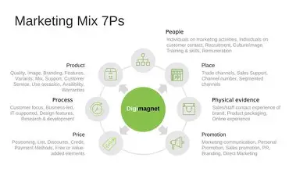

Element 3 Promotion Poster of Unilever Blossom Purekind’s
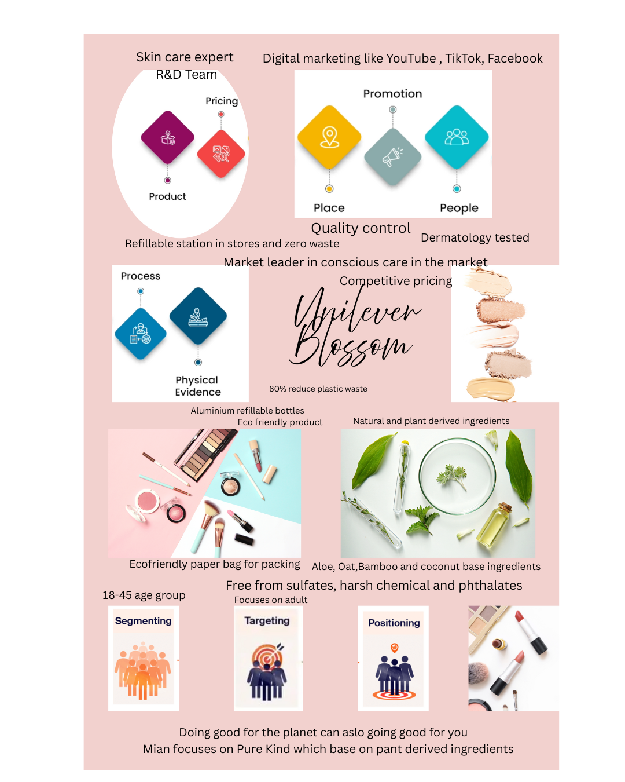

PureKind is powered by plant-based science and circular packaging. Each product is formulated with 95% naturally derived ingredients, dermatologically tested, and delivered in refillable aluminium bottles, cutting plastic waste by 80%. Our value lies in making sustainable living effortless and affordable aligning with Unilever Blossom vision of "making sustainable living commonplace."
Our marketing strategy combines digital storytelling, influencer advocacy, and community partnerships. We'll connect with Gen Z and millennial audiences through transparent ingredient education, social media challenges, and partnerships with eco-conscious creators. Distribution will begin via online direct-to-consumer platforms, expanding to key retail partners with refill station stores.
By blending sustainability, science, and simplicity, PureKind positions Unilever as the leader in the next wave of conscious beauty - proving that doing good for the planet can also feel good for you.





Element 4 Reflection
Developing the PureKind personal care brand concept for Unilever Blossom was a valuable experience that strengthened my understanding of marketing strategy, brand development, and professional communication. Working through the full process—from shaping the brand idea to building the STDP framework and 7Ps marketing mix—helped me apply theoretical concepts in a practical and creative way while thinking critically about consumer needs, sustainability trends, and the competitive personal care market.

Creating a brand concept that aligned with Unilever Blossom values yet offered a unique strategic direction was particularly insightful. PureKind had to feel authentic within Unilever Blossom portfolio while addressing real consumer gaps such as clean beauty, ingredient transparency, and sensitive-skin solutions. This showed me that strong branding relies not just on creativity, but on grounding ideas in genuine market opportunities.

Completing the STDP analysis improved my ability to segment the market and identify realistic, high-potential target groups. These insights were essential when developing the 7Ps, which required balancing innovative ideas with feasibility and consistency with industry norms.

Preparing the marketing pitch further strengthened my communication skills. I learned how to present a complex strategy in a persuasive, coherent way by focusing on key insights and maintaining a clear narrative flow. Feedback and iterative refinement also helped me improve the clarity and strength of the concept.

Overall, this project improved my strategic thinking, creativity, and confidence in applying marketing principles to real-world situations.

Refrences :
- Paluchová, J. (2017) ‘11. Consumer segments in an international context’, pp. 173–197. Available at: https://doi.org/10.3920/978-90-8686-852-0_11.

- Xia, M. (2025) ‘Aesthetic camping - urban lifestyles in China’, Continuum, 39(4), pp. 583–602. Available at: https://doi.org/10.1080/10304312.2025.2499968.

- Sajinčič, N. et al. (2021) ‘An Exploratory Study of Consumers’ Knowledge and Attitudes about Lignin-Based Sunscreens and Bio-Based Skincare Products’, Cosmetics, 8(3), p. 78. Available at: https://doi.org/10.3390/cosmetics8030078.

- Kaushik, M. et al. (2023) ‘Safety Concern and Regulatory Status of Chemicals Used in Cosmetics and Personal Care Products’, Dermato, 3(2), pp. 131–157. Available at: https://doi.org/10.3390/dermato3020011.

- Boonchanachai, C. et al. (2025) ‘A scoping review of sustainable orthodontic supply chains: innovations and waste management in clear aligner therapy’, European Journal of Orthodontics, 47(6). Available at: https://doi.org/10.1093/ejo/cjaf080.

- Anderson, C. (1997) ‘Values-based management’, Academy of Management Perspectives, 11(4), pp. 25–46. Available at: https://doi.org/10.5465/ame.1997.9712024837.

- ‌ United Nations (2022) The Sustainable Development Goals Report 2022. United Nations. Available at: https://unstats.un.org/sdgs/report/2022/The-Sustainable-Development-Goals-Report-2022.pdf.
‌
- Reinhardt, F.L. (1998) ‘Environmental Product Differentiation: Implications for Corporate Strategy’, California Management Review, 40(4), pp. 43–73. Available at: https://doi.org/10.2307/41165964.

- Chen, W. et al. (2024) ‘Artificial Intelligence in Logistics Optimization with Sustainable Criteria: a Review’, Sustainability, 16(21), p. 9145. Available at: https://doi.org/10.3390/su16219145.

- Petrick, G. (2011) ‘“Purity as life”: H.J. Heinz, religious sentiment, and the beginning of the industrial diet’, History and Technology [Preprint]. Available at: https://doi.org/10.1080/07341512.2011.548972.

- Nohynek, G.J. et al. (2010) ‘Safety assessment of personal care products/cosmetics and their ingredients’, Toxicology and Applied Pharmacology, 243(2), pp. 239–259. Available at: https://doi.org/10.1016/j.taap.2009.12.001.

- ‌ Lampe, M. and Gazda, G.M. (1995) ‘Green marketing in Europe and the United States: An evolving business and society interface’, International Business Review, 4(3), pp. 295–312. Available at: https://doi.org/10.1016/0969-5931(95)00011-n.

- Gao, Y. et al. (2024) ‘Safety‐in‐use test of facial cosmetic products on normal and self‐assessed sensitive skin subjects’, International Journal of Cosmetic Science, 46(3), pp. 391–402. Available at: https://doi.org/10.1111/ics.12938.

- Baron, R.A. and Markman, G.D. (2000) ‘Beyond social capital: How social skills can enhance entrepreneurs’ success’, Academy of Management Perspectives, 14(1), pp. 106–116. Available at: https://doi.org/10.5465/ame.2000.2909843.

- ‌ Chong, W.K. and Patwa, N. (2023) ‘The Value of Integrity: Empowering SMEs with Ethical Marketing Communication’, Sustainability, 15(15), p. 11673. Available at: https://doi.org/10.3390/su151511673.
‌
- Vinzenz, F. et al. (2019) ‘Marketing sustainable tourism: the role of value orientation, well-being and credibility’, Journal of Sustainable Tourism, 27(11), pp. 1663–1685. Available at: https://doi.org/10.1080/09669582.2019.1650750.

- ‌ Cagliano, A.C. et al. (2017) ‘Analyzing the diffusion of eco-friendly vans for urban freight distribution’, The International Journal of Logistics Management, 28(4), pp. 1218–1242. Available at: https://doi.org/10.1108/ijlm-05-2016-0123.

- ‌ Papista, E. and Dimitriadis, S. (2019) ‘Consumer – green brand relationships: Revisiting benefits, relationship quality and outcomes’, Journal of Product & Brand Management, 28(2). Available at: https://doi.org/10.1108/jpbm-09-2016-1316.

- ‌ Yao, H. et al. (2019) ‘Highly Efficient Clean Water Production from Contaminated Air with a Wide Humidity Range’, Advanced Materials, 32(6), p. 1905875. Available at: https://doi.org/10.1002/adma.201905875.

- Morita, S., Jindo, K. and Maliotis, P. (2023) ‘Exploring the Influence of Work Integration Social Enterprises on Consumers through Differentiated Customer Value Proposition’, Sustainability, 15(7), p. 5630. Available at: https://doi.org/10.3390/su15075630.
‌

