Research and written report for Independant
by
Lowri Hart
2205236

Supervisor: Phil Organ

Project submitted as part of the requirements for the award of
BA HONS (Animation & Visual effects)

April 2025

Contents

Introduction........................................................................................................................................2-3

Planning and research.........................................................................................................................3-5
Storyboarding and sketching.............................................................................................................5-10
Creating 3d models..........................................................................................................................10-11
Adding audio and sound effects......................................................................................................11-12
Issues and overcoming problems....................................................................................................12-13
Reflection and conclusion...................................................................................................................13.
Bibliography.........................................................................................................................................14

Introduction
What defines animation? To me, animation is when You must acquire and learn a wide variety of styles, media, and techniques when looking to be accepted in an industry. These are the things i thought when first brainstorming what I would do for my animation. When planning my ideas for my independent project, I wanted to create something that would not only push me out of my comfort zone. But also show my range and ability to take on unique styles. It gives me more opportunities and options when it comes to seeking animation jobs for those looking for a specific style.
I knew it was going to be difficult and time consuming. I could've created animation in a style that I had previously done. However, I knew if I was going to apply for future jobs with this project in my portfolio. I wanted it to reflect what sort of jobs I was passionate about and what I would excel at. If were to add a piece I was not passionate about, it would not help me in the long run.

For a previous project, I had created a simple 2D comedic animation of a Roman soldier being trampled by his own army. I had taken inspiration from classic shows such as 'Looney Tunes' and 'Tom and Jerry'. I found it to be quirky and enjoyable to create. It also helped that I did not have to fear things such as anatomy or realism, which do not exist in the world of cartoons. The limits are your imagination; there is no need for research or accuracy. To test my boundaries and range. I decided that my independent project would be to create a short animation of the same topic- a gladiator army- and compose it in a completely opposite style. Making it more realistic and serious. Yes, it would challenge me and the abilities I possessed at the time. However, if planned and coordinated correctly, I could create a high-quality animation with good marks and be a star piece in my portfolio.
My Independent project would be a Gladiator fight scene set in Rome.
After solidifying my idea and discussing it with my tutors, I decided first to plan out my progress after presenting my idea at the beginning of January. I would take a few days to gather any research I would need to use as references to make my animation more historically and anatomically accurate. I researched a few YouTube videos on ancient Roman armour and weaponry. Learning as well how my characters would hold and swing their swords or spears around, depending on the weight and power of the weapon. Their emotional state in the battle also would play a significant role in the scenes. So, I researched a few movies about Ancient Greek/ Roman battles. To see how the other characters reacted to their role in the war. And how differently they would fight each other. Some characters are energetic and willing to fight. In comparison, others were shaky and unable to even hold a sword.

For my target audience, I aim for a much older demographic: adults and teens. Due to the graphic scenes of blood and gore that will be occurring throughout the animation. When I start looking for job opportunities in animation. I would be satisfied taking a job as a child's animator or illustrator. However, my dream demographic would be older and more mature generations. I believe there is a sense of more freedom in creating media for that demographic. Both jobs have their own doors that they open and lead to opportunities. Whichever one my employers request of me, I will happily oblige. But I will be pushing my more adult and serious animations to the front.

Plan & Research
To ensure accuracy in the costume, scene, and weapon design, I reviewed numerous movies to references and understand my animation's movement, mood, and design elements much better.
I used scenes from "Gladiator" [1]. I planned to have multiple one-on-one battle scenes throughout the animation. Watching how the main character, Maximus, moves around the arena. Focusing on his defence and how he dodges and escapes his enemy. Mainly when he uses his shield to roll smoothly and dive out of the way.
Another scene that was useful for my research was the final fight between Maximus and Commodus [2]. I studied the difference in Maximus' defence and how differently he fought now, than in his previous fights, now that he had a bleeding stab wound. Commodus' behaviour and wardrobe were also important. He wears white and gold to appear almost heavenly and God-like. Believing himself to be one. The flowing fabric of his tunic and Maximus's shirt not only illustrated the motion of my character's clothes. But also, how the colours that a character wear could hide true intentions or show you how a character truly sees themselves.

Another movie I also took inspiration from was 'Risen' [3]. The film featured a good amount of battle scenes that I researched extensively. In used one scene that I researched, I took notes on how the army formed a protective barrier around them using their shields, which was an historically accurate battle strategy. And even though it sounds mildly gruesome, both movies were quite helpful in understanding how the characters would act during a death scene. Learning how a character would fall depending on the power of the weapon and the direction of their body weight.

'Troy 2011' [4]. It is an example of a movie, not exactly known for its historical accuracy. However, it is a good example to use for close combat referencing. The majority of references I have used for my research have been long-distance combat, with characters using spears and shields meant to protect multiple people at once. Whilst they are useful for my design, I wanted to find a reference for a closer one on one battle, as I plan to execute in my own scenes.
In this scene, both opponents use spears but then change to short daggers and more rounded shields. A vast difference from the regular shields used by other soldiers. And just like with the final gladiator battle, you can see how Achilles' opponent still struggles to fight, even after being stabbed, yet still holding his sword up high and continuing to fight until his last breath.

The first battle scene in the movie '300' [5] is an incredible reference that helped me greatly when studying the movement of cloth and capes. In the first battle, the soldiers are adorned with long, flowing capes that perfectly dance around them when slicing their enemies. They also add a sequence of slow-motion scenes to create an intense and powerful mood. It was an ideal reference for both the cloth movement and creating atmosphere.

After putting my research together, I had a summary of the key points to help create my animated scene, inspired by what I had watched and read. There were many similarities between them all, which was good. I now had a clear style I wanted to achieve.
Most Roman battles or any type of ancient combat in media mostly came in the form of live action, so there were little to no good, animated references I could use as a visual example.
However, I recently began watching series that piqued my interest and looked exactly how I wanted my animation to play out, and it was set in ancient Greece and a good example of a 2D animated series that dabbles with dark and gruesome battle scenes is. It is the 'Blood of Zeus' [6]. I took a lot of inspiration from the series as it is very close to how I animate and a style I would like to see more often. It uses a wide range of smear frames and perfect lighting, and each character has a fighting style that defines what type of God they are and makes their personalities really pop out. It did have a lot of magical and mystical themes in it as well, which was enjoyable to watch and entrancing to see when they used their powers against each other. I didn't want magical elements in my animation sequence; however, I would like to attempt an animation like that in the future.

It was not just movies I used as a reference. There were a variety of history channels on YouTube [7] that explained the armour, weaponry, and battle strategies of a Roman army. Giving my animation more realism. I always had a slight irritation with historical series or animations. There was always something inaccurate in the animation that would completely throw me off what I was watching. So, when making my project, accuracy plays a vital role in telling and animating a story.

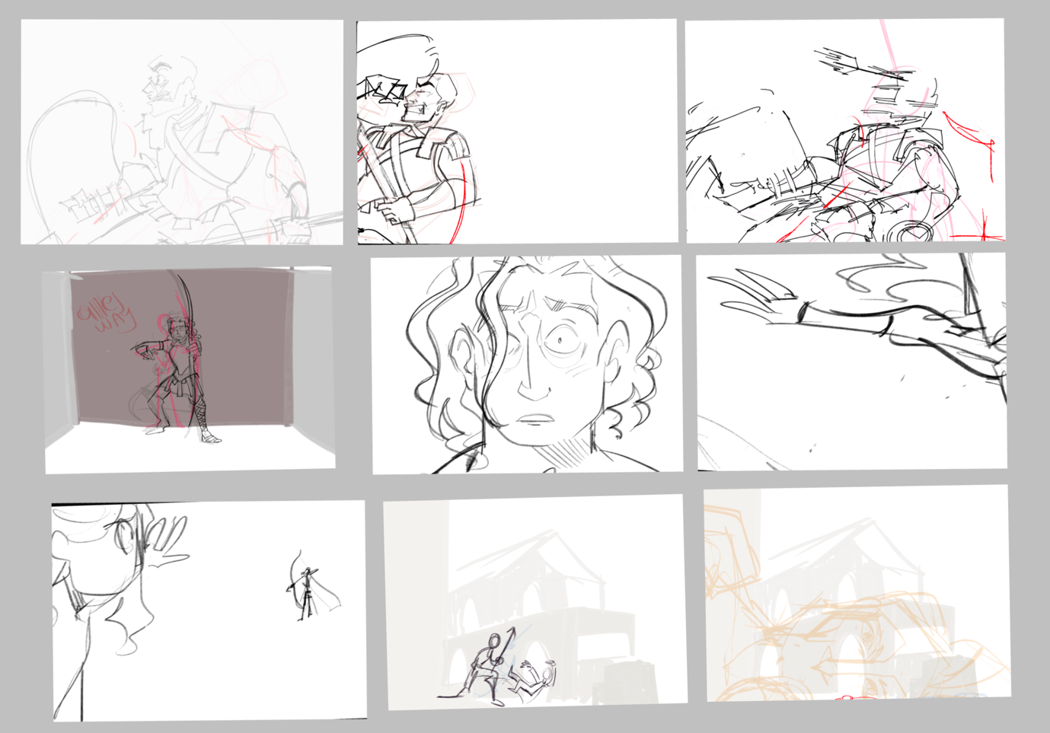

(Storyboard for animation p1)
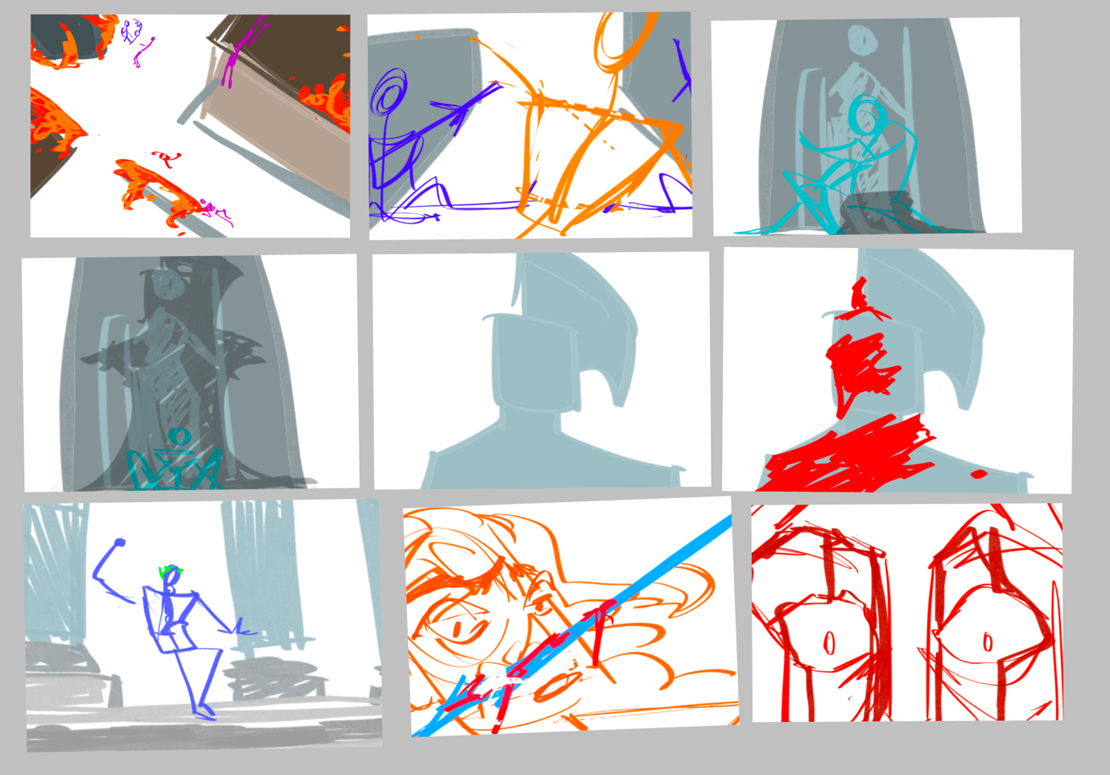
(Storyboard for animation put 2)
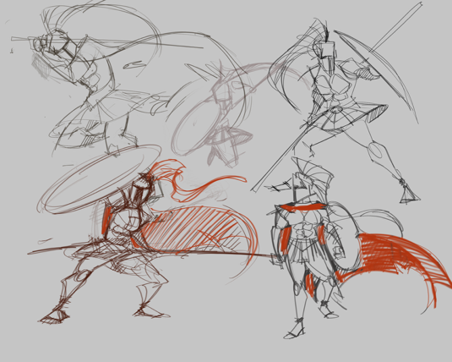
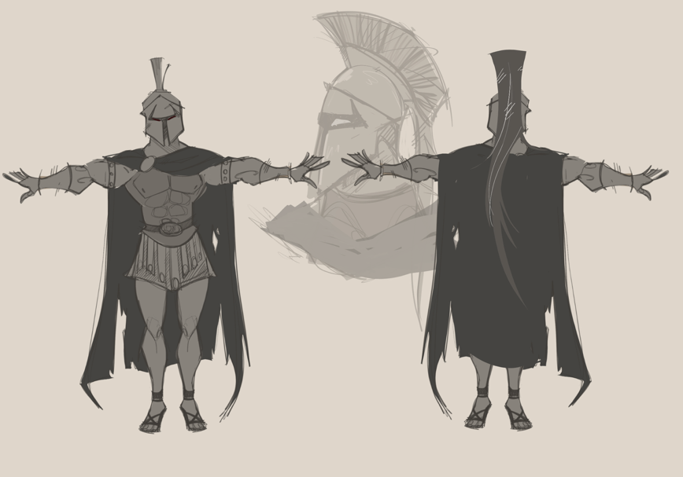
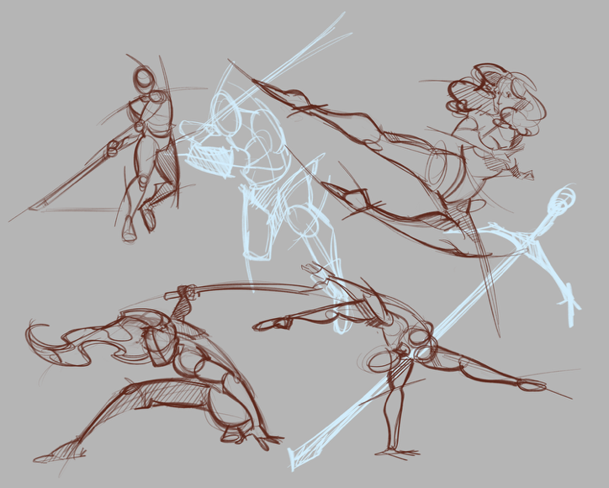
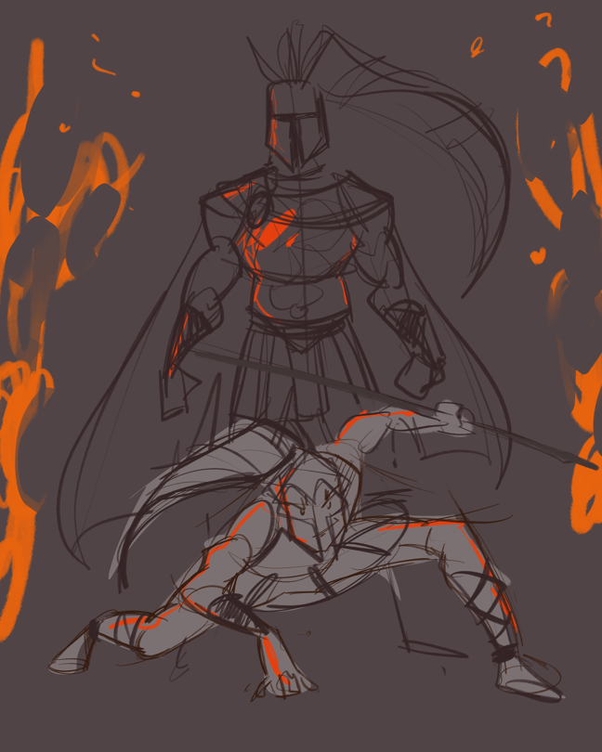
(Concept art of character designs.)

Storyboarding and sketching
Once the extensive amount of research had been completed, I then began sketching out my scenes for the animation. My plan was to create the animation around 1 minute long. However, if anything were to change or I would run out of time, I could see myself shortening it down to 30 seconds at least. But nothing less. For my animation I used Procreate Dreams, which was a system I had been using for a while and had come quite skilled in. It was useful, simple, and easy to navigate. I did several scene tests to see which ones flowed better in my sequence.

The plan was to create a short story where we, the viewers, follow the main character, a young Spartan warrior who is caught in a conflict. He tries to escape the opposing soldiers whilst dodging any attackers and watching the town burst into flames. the mood and innocent look of the main character make you believe he is the protagonist, caught in the gruesome war. However, at the end of the animation, we see him executing what looks like an emperor. And suddenly, the atmosphere of the scene changes. Once the boy was small and feeble, turns out to be the reason the town is burning and covered in flames in the first place. Showing the viewer the deception, and that the character they were internally cheering on to survive. Was the antagonist this whole time.

It would be a fun idea to practice characterisation and deception. Giving subtle hints to the viewer that you. may have been tricked and makes you rewind to see the small hints of foreshadowing. For example, the "villains" logo hung on a banner in town, burnt and destroyed. The fear of the townspeople as our main character runs past. Not scared of the situation, but of him specifically. Or draw him to look confused as he runs through the towns, no idea where he is or where to go. This makes you think, does he live here? He should know where he is. Subtly foreshadowing his true identity.

There is a popular game called 'A Way Out' [8] Which is similar to the plot of the animation i am creating. In the game, you play two men escaping a prison. Throughout the game, you are given small hints that one of you is not who they say they are. It is not until the end where you discover, that open of you is a secret cop and have been lying to your co-player the entire time. That is what I think of when creating my animation.

Whilst sketching several ideas for my storyboard, I also considered the angles I wanted. And where the cameras were to be placed process consisted of drawing several angles of the battlefield. Each angle depicting Several different emotions from where the view is pointing. For example, a higher camera angle gives the viewer a scene of the entire shot. Allowing your eyes to wander the scene and take in points of the scene. Whilst a close low shot from the ground, focus on the character and only them. A low camera shot can also make them seem more powerful, as if we were beneath them. giving the shot an intense feeling.

Once again, I took a lot of inspiration from the series Blood of Zeus. I tried to adapt the characters' style and movement into my own work. I worked on pacing and timing some of the characters' actions. So, you could see the delay in their reactions and how they responded to the attackers.

falling into issues became a daily occurrence at this point. The sketching was taking much longer than expected, whilst I did not let it worry me, it did make the process feel longer than it should have. And I tried my best to balance this project along with my other workloads as well. But for a while, I felt like I was not achieving anything new as the days went by. However, Once I solidified my scenes. Pace and timing. I was able to find a steady pace and continue my work.

Another style that came to mind when creating my animation, was a well-known 2D animated series. That being 'Avatar the last Airbender' [9]. An Asian inspired animation style, which is simple yet slightly cartoonish. It was a one that I wanted to hopefully create more art pieces with. With its flowy-like in-betweens, slice of humour, tension, powerful lore and characterr development. And most importantly, is its battle scenes. Whilst it was part of my research. I still favoured the blood of Zeus as my main inspiration.

When sketching the different layers, the animation and combing them. I focused a lot on the hair and clothing of the characters. Light or delicate pieces on a character will cause more movement and add weight to the characters, bringing them to life and adding to the realism that I was hoping to convey. Adding tatters, cuts and marks on their capes also adds a sense of history in the article of clothing. Giving hints to the viewer on how long the battle had been taking place and who had been amid the fight and those who ran away. I believe truly that little things, such as looks, small hand movements/ gestures can make a big difference to how the scene plays put and adds hidden meanings to senses. Small details that catch your eye and add depth into your world.

3D modelling
Trying to find a way to implicate 3D imagery in the animation was difficult. I wanted somehow to combine both 2d and 3D media into my work for extra range. It was then I realised I could create the background and buildings using 3D models created in Maya. This would help me immensely with bleeding multiple types of media together and showing my skill in the other areas I have learned over the years. I created a model of Roman temple and a few other insignificant things. My plan was to position the models at a certain angle during the fight scene so it would look like the scene was occurring at various places, without having to waste time creating to many models just to go unseen or to waste.
3D modelling is one of my weakest strengths. My results for most of my 3D models have been average, and it was challenging to overcome during this project. With help from my tutor, I was able to make another attempt to navigate the UV-unwrapping and make some progress, with improved results.

For inspiration for the buildings in my scene. I looked at games who also used roman buildings. The main game being the well-beloved classic 'Assassins creed brotherhood' [10] made back in 2010. In the game there is a wide range of detailed buildings that I was able to find and use as refences for my background. The buildings were close together and created windy paths that flowed through the streets. Seeing the layout this game used, really help me visualise the layout of my animation and how my characters would move through the street. Make sure to have little to no straight roads, only a few sharp Coners to ad distress and make the camera have a shake affect when our screen has a shake effect when our main character slams into a wall.

Rendering & audio
After finishing my line art and competing another part of the animation. I then moved onto the rendering process and adding additional sound effects. Firstly, I used a simple colour scheme for the characters and scenes. Nothing too vibrant so that it changed the mood of the animation, yet nothing too dull so that the different characters and backgrounds blend in with each other. Since the scene centred around the theme of death. I overlayed the animation, using adobe animate, with a dark filter. Creating an ominous and uneasy feeling. The exact type of emotions I intended for my audience.

For the sound effects. It was a combination of my own homemade effects and ones free to the public domain. For the more technical sounds, such as the burning of the fire and the clashing of weapons. I used 'Freesound.org' [11], which had a variety of sounds that I was able to synchronise with the animation. However. There were a few sounds throughout the animation that were created by me. I had dabbled with home sound effects before in many personal projects and ones submitted for university work. I created the sound of footsteps by moving my shoes around on different surfaces. Such as stone flooring, gravel or sand. For the scenes where my characters are running on the different floors. And the shuffling sounds are created with me in a soundproofed room with a pillow. Making your own sounds is exceptionally reliable. It allows you to time the scenes to your liking and help you visualise and plan the scene in your mind. How heavy do you want the footsteps? Do you want the character to trip and fall? Even the sound of your hands moving or breathing can make a scene so much more intense, detailed and alive.

Issues and overcoming problems
Throughout this animated journey, there had been many trials set before me on this path. My first issue was stepping outside of my comfort zone and creating something that would challenge me for the next few months. The amount of attention this needed was extremely overwhelming. However, I handled this task accordingly to the best of my ability, with minor issues along the way. Timekeeping was also a challenge. With the multiple deadlines stacked together, my self-confidence was slowly deteriorating. I did not believe I would be able to balance these deadlines all at once. However, I was soon able to overcome these issues with steady pacing achieving all that I could in the given time.

Another issue I faced was the issue of 3d modelling. As previously mentioned, my 3d modelling is in desperate need of improvement. Challenging me through the weeks. I knew from the start that I would not have to model too many items. Only those that were essential to the scene. When the time comes to begin searching for apprenticeships and jobs, I will be staying away from those areas. However, knowing the basics of Maya is vital knowledge to have and can become useful if it is ever needed. But for now, I can confidently say that I shall be sticking to 2d animation.

Looking back on the work I produced, there is room for improvement when it comes to the in-betweens of the animation. I tried my best to confidently produce a flowing and expressive animation with extensive research on in-betweens. My research stems from multiple videos online. To my personal copy of the book 'The Animators Survival Kit' by Richard Willimas [12]. If I were to attempt this animation again in the coming future. I would re-attempt the in-betweens and learn how to perfect the movements of the cape and other flowing fabrics more efficiently

And lastly, the final area I can say I needed improvement on was my own grand expectations. I am a person who will try to push myself further than necessary. The need to improve and challenge myself. Expecting important things and high-quality work, when sometimes, just doing what I can at the time is enough. Overthinking and over-examining things are two areas that I need to improve on, not just in my work, but as a personal hurdle as well. I am happy with the quality of work I produced for this project. And I am delighted I am able to express myself in multiple animation styles. But I do need to learn to keep a steady pace and not overthink my work or myself.

Conclusion
To conclude this report. This project has been an outstanding experience. It has helped me immensely in so many ways. it has helped me push past my limits and overcomes areas that I was extremely lacking self-assurance. Yet overall, I believe I have created an exceptional animation that I would be happy to present in my portfolio. I Also I believe I have completed an extraordinary amount of research for my project. Finding different media and resources that have helped me improve and structure the quality of my work. This experience has also enabled me utilise skills that will help me greatly and execute them into future projects for my job or clients. I have achieved all the goals I set myself back in January with confidence. Though I do recognise I have had to fix a few problems that found their way into my plan. Whilst yes, I am disappointed my animation is not as long as I hoped it to be when I first presented at the start of the year. However, understanding that not everything will go the way you expected and overcoming that is extremely important, especially in the arts.
I adore animation. with all my heart. It is a passion I have owned for as long as I can remember. For years, I knew that this would become my passion and career one day. And this project shown my ability to do so. My goal after university is to go into 2d animation and work for a studio. There are so many things I understand I must improve on, and they are my goals for the future. My passion for animation only strengthens with each project I do, and each idea I bring to life keeps fuelling my passion every day. And one day, many years from now, I will look back on this and see how far I have come and how much I have improved. We'll have to wait and see.

Bibliography
[1] Night Watch (2023). Gladiator Full Fight Maximus Vs Tigris of Gaul | Night Watch [1080p HD Blu-Ray]. [online] YouTube. Available at: https://www.youtube.com/watch?v=0ToyjG0Du2Y [Accessed 16 Apr. 2025].

[2] Universal Pictures (2024). Gladiator’s Last Battle: Maximus vs. Commodus | Gladiator. [online] YouTube. Available at: https://www.youtube.com/watch?v=NbGzu0Bb3pw [Accessed 24 Nov. 2024].

[3] Johnny's War Stories (2023). Risen - Testudo Scene. [online] YouTube. Available at: https://www.youtube.com/watch?v=Mqjppp_2pGM [Accessed 28 Apr. 2025].

[4] www.youtube.com. (n.d.). Troy (2004) Hector vs Achilles 4K. [online] Available at: https://www.youtube.com/watch?v=j-Ze3KEhKnM

[5] JoBlo Movie Clips (2024). First Battle Scene | 300 (2006) Gerard Butler, Movie CLIP HD. [online] YouTube. Available at: https://www.youtube.com/watch?v=AGrExbRqCX0 [Accessed 28 Apr. 2025].

[6] Blood of Zeus (2025). Blood of Zeus ｜ Ares vs Apollo and Hermes. [online] YouTube. Available at: https://www.youtube.com/watch?v=97idxKOadNg [Accessed 28 Apr. 2025].

[7] www.youtube.com. (2020). a Roman Legionary’s armour and equipment. [online] Available at: https://www.youtube.com/watch?v=zajRWl995ms
Naked Science (2016). Roman Military Technology and Tactics. YouTube. Available at:https://www.youtube.com/watch?v=kkgjiCKHvoY

[8] store.steampowered.com. (n.d.). A Way Out on Steam. [online] Available at: https://store.steampowered.com/app/1222700/A_Way_Out/.

[9] Insider (2021). How ‘Avatar: The Last Airbender’ Animated Its Realistic Fight Scenes | Movies Insider. YouTube. Available at: https://www.youtube.com/watch?v=DJ86QWzI2Wo [Accessed 27 Aug. 2025].

[10] WildGamerSK (2022). ASSASSIN’S CREED BROTHERHOOD FREE ROAM GAMEPLAY (8K 60FPS). [online] YouTube. Available at: https://www.youtube.com/watch?v=p7rDBPBJFQI [Accessed 28 Apr. 2025].

[11] Freesound (2012). Freesound. [online] Freesound.org. Available at: https://freesound.org/.

[12] Richard Williams (n.d.). The Animator’s Survival Kit Richard Williams. [online] Internet Archive. Available at: https://archive.org/details/TheAnimatorsSurvivalKitRichardWilliams.

.

.

.

