Social Media Needs Analysis
Introduction
This needs analysis will conclude current issues within areas of social media and the gaps that will have significant repercussions on certain ages. Focus groups have been put together within educational settings to find out what needs to be done and what is being done. The use of social media is a worrying factor for the next generation as it is becoming increasingly the norm for every child or young person in todays society. There are many gaps that need filling within the social media platform, as children and young people find ways of accessing social media sites without being the correct age. Social media is allowing children to be a part of their social media sites without considering the impacts that social media has on children and young people.
The Welsh mid year Figure of population is currently 3,113,200 people. In a NSPCC report they present the findings from a survey using 1,024 teenagers aged 11-16 in the UK. During this report they found that 23% of the younger age using social media sites had been upset through using these sites during the past year.
Figure 1.1 Sourced NSPCC Website (2013)
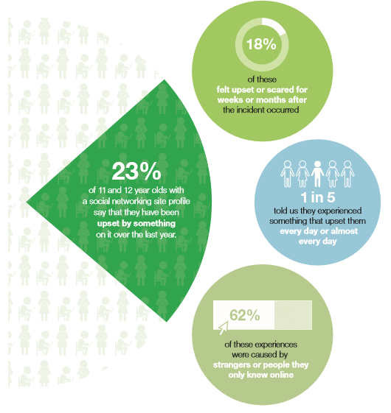
Many users know that the negative impacts through social media are mostly caused by strangers, or those that they do not know online. Social media is used as a mask to say or do what most people would not do face to face. Cameron, D (2013) “Now, of course, a free and open internet is vital. But in no other market and with no other industry do we have such an extraordinarily light touch when it comes to protecting our children. Children can’t go into the shops or the cinema and buy things meant for adults or have adult experiences; we rightly regulate to protect them. But when it comes to the internet, in the balance between freedom and responsibility we’ve neglected our responsibility to children… So we’ve got to be more active, more aware, more responsible about what happens online. And when I say we I mean we collectively: governments, parents, internet providers and platforms, educators and charities.” There are many other sources that agree with this statement as security and restrictions are not as safe as we assume they would be with such high profile social media sites. UKCCIS Evidence Group, (2016) “Many providers ban users under 13 and apply particular technical protection mechanisms and moderated services for minors under 18. However, age restrictions are only partially effective. Fewer younger than older children use social networking sites, but many ‘underage’ children are still using these services. It seems clear that measures to ensure that under-aged users are rejected or deleted from the service are not successful on the top social networking site services used by children in Europe.” This is issue that not just educational settings need to address, but also for parents of children to understand all age restrictions and have the knowledge of what their children are using and what is being said via these sites.
There has been an update on research through the NSPCC in their findings that through the upset experienced in previous findings, mentioned previously, the experiences range from being stalked by unknown users, and being sent sexual messages. We see these issues in the news regularly, around the area of inappropriate content that is sent to users who are too young, or do not wish to see- be part of this content. Most of the children affected can recover from these situations they have encountered; however, this is not something that they should need to recover from. This should not be an issue to start with. Many of the findings conclude that this is something that they have experience daily.

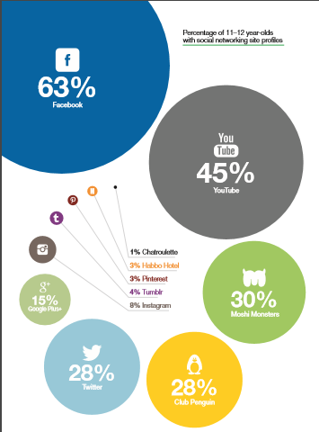
Source: NSPCC research. Base: All 11–12 year olds who had a social networking account: Facebook: 171; YouTube: 119; Twitter: 60; Moshi Monsters: 70; Club Penguin: 64.

Facebook, YouTube and Twitter are some of the most popular sites used by young people in this generation. These sites require an age of 13 to be able to use a profile. There has been a lot of research found that children under this age limit regularly use these sites, regardless of the age limit required. If half of the UK’s younger adults use these sites, there is an estimation of 666,000 children using these sites who are under age.
Many parents help their children set up their social media accounts. They are aware that they are active on these sites, yet some forget to monitor what is happening on these sites regarding their children.

Social media sites cannot take responsibility for children who choose to lie about their age so that they can be part of these networks. These sites are not able to look into every single profile to ensure that what is being filled out for the profiles are correct.
The NSPCC have the childrens best interest at heart. Although many children may feel like they are caged and unable to interact with their friends on these sites, they need to be protected. The NSPCC challenges social media sites to use a different approach in how they protect children on their sites. These sites can indirectly be appealing to younger children through advertising. They have challenged these sites to find the younger children who are illegally using these sites.
There are many websites that encourage young people and parents to know the advice that is out there for their children and to stay safe whilst using the internet. All children and parents should be up to date with all dangers of social media sites and the negative impact that it can have on all users. Users should be able to find the correct information needed to all issues that could arise from social media sites. Some sites advertise stories of previous issues, such as those we hear about in the news on a daily basis.
The internet should not be something that we are fearful of, but something we should be aware of. Parents and children need to communicate anything that these social media sites are causing upset. If issues arise, all involved should voice their concerns and be able to communicate with others.

Below, the NSPCC has included an ‘agreement’ draft that could be used between parents and children.
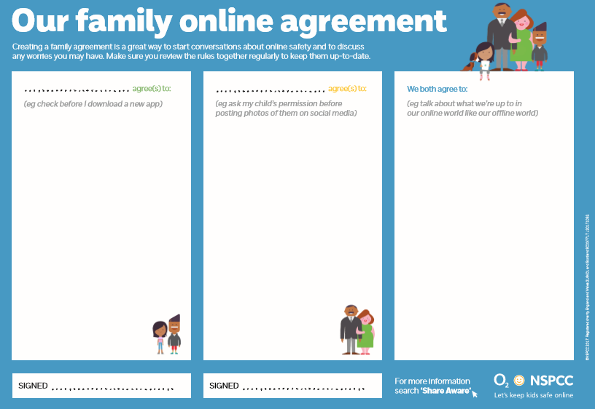
Figure 1.3 Sourced from NSPCC (2013)
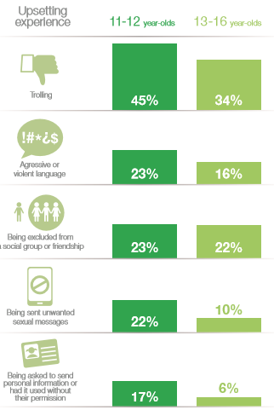
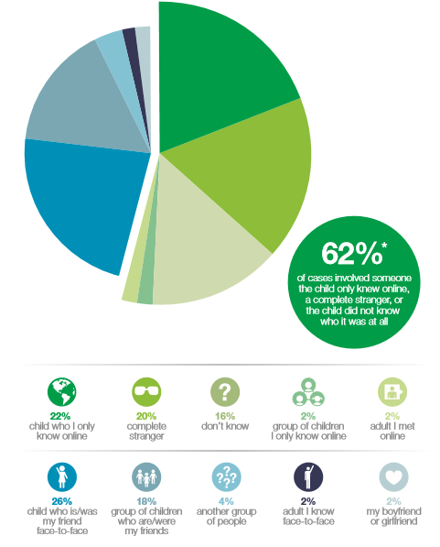
Figure 1.4 and 1.5 Sourced from NSPCC (2013)

During the last few years, ChildLine has received an increase in calls relating to social media sites and the issues that they are facing. They dealt with a worrying number of children who had mentioned specifically upset and inappropriate content shared with them. ChildLine are more than happy to deal with these issues, as they are there to help and listen, however, the increase of these statistics worries the company, as it seems social media sites are doing more harm than good.
In conclusion, from this needs analysis paper, we can agree that social media sites are becoming a worsening issue. Social media is powerful and can be addictive for those who are not aware of the advice and regulations that are in place for all users. Social media is becoming a growing issue for children and young people. These issues will continue to arise, and most likely increase as these sites become more popular. All users, need to be aware of how to deal with this issues that arise, so that they are able to stay safe online. Not only should social media be challenging those who are under age, but parents, schools etc need to be clamping down on helping young people understand all rules for social media sites, and how they can stay safe online.

References
Butin, D. W. and Seider, S. (2012) The Engaged Campus: Certificates, Minors, and Majors as the New Institutionalization (Community Engagement in Higher Education), London: Palgrave Macmillan.
Butin, D. W. (2010) Service-Learning in Theory and Practice: The Future of Community Engagement in Higher Education, London: Palgrave Macmillan.
Edwards, C. (2011) Communication and Community Engagement, Dubuque: Kendall Hunt.
Sterling, S. R. (2001) Sustainable Education: Revisioning Learning and Change, Totnes: Green Books.
Redding, S., Murphy, M. and Sheley, P. (2011) Handbook on Family and Community Engagement, USA: Information Age Publishing.
Schuetze, H. G. (2010) The community engagement and service mission of universities, Leicester: National Institute of Adult Community Education
Watson, D. (2007) Managing Civic and Community Engagement (Managing Universities and Colleges: Guides to Good Practice), Maidenhead: Open University Press.

