
Student Name: Madalina Nagy
Student Number: 2019619
Module: Sustainability and Tourism Management (BMIH5006)
LEVEL 5
Programmes: BA (Hons) International Hotel Management
School of International Hotel Management
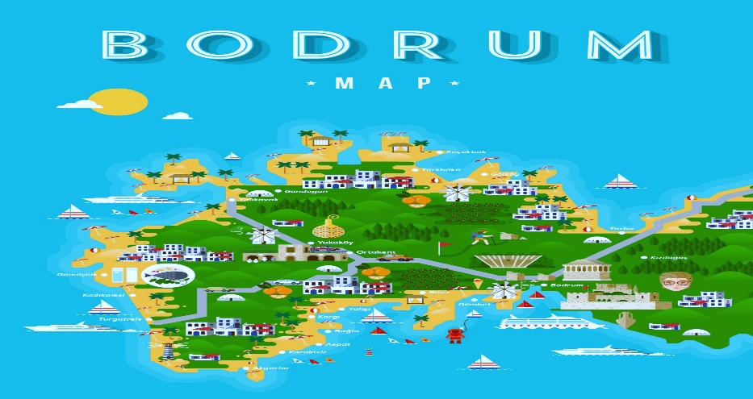
DESTINATION MANAGEMENT: BODRUM, TURKEY

Lecturer: Dr Huw Thomas

December 8, 2022
University of Wales Trinity Saint David
Executive Summary

In this report, the economic and social effects of Bodrum's tourism industry have been examined.

The report identifies three main areas where investment will be required: 1) Urban renewal; 2) Tourism; 3) Infrastructure Development. The first area includes redevelopment of existing public spaces such as squares and streets, new roads, pedestrian zones, and green areas. In addition, it includes upgrading existing infrastructure including water supply networks, sewerage systems and road network (including construction of new roads). The second area focuses on tourism related investments including hotels, restaurants, and other tourist facilities such as marinas. This also includes improvements to existing ferry terminals so that they can accommodate larger cruise ships from Europe or Asia. It also includes improved access routes for tourists coming into town by land or sea along with provision for parking facilities at these points so that visitors do not have to park their cars outside the city centre before visiting various attractions within it.
The overall objective of the report is to develop and promote tourism in Bodrum as a year round tourist destination with an emphasis on leisure travel and active recreation opportunities for visitors from around the world who wish to experience Turkey's rich cultural heritage, beautiful natural environment and diverse cuisine; provide employment opportunities for local people; encourage investment in new hotels, restaurants, shops and other facilities; create a favourable business climate conducive to attracting new investors; improve access by road, rail and air transport systems serving Bodrum from across Turkey as well as Europe, Asia Minor (Anatolia), Cyprus (North) and North Africa (Tunisia); provide improved access for tourists travelling between Istanbul/Izmir International Airport (IST) and Bodrum International Airport (BJV); establish an international airport terminal at Kekova district within the boundaries of Bodrum.

Table of Contents

Executive Summary……………………………………………………………………2
Introduction……………………………………………………………………………...3
Culture……….……………………………………….………………………………….3
Sustainability…………………………...……………………………………………….5
Socio-cultural impact…………………………………………………………………...6
Economic Impact..................................................................................................6
Butlers model of Bodrum Turkey destination management…………….………….…………………………………………. ….…...7
Destination management of Bodrum Turkey……………………………...…………8
Conclusion………………………………………………………………………………10
Recommendations…………………………………………………………….……….11
Bibliography…………………………………………………………………………....12

Introduction

Bodrum, also known as “The Land of The Eternal Blue” stated by Homeros is a popular coastal resort and a tourist destination located on the Sothwest Meditteranean cost of Turkey. Bodrum is located in the province Mugla of turkey. Intense nightlife, historical sites, beautiful beaches, holiday villages and quality hotels are the Turkey’s most popular, largest resorts and holiday towns located on the Aegan coast. Ortakent, Gumusluk, Akyarlar, Bitez, Yalikavak, Torba, Gundogan, Gumbet are the popular holiday towns and resorts in Bodrum as they offer quality accommodation and hotels.
Bodrum, which was formerly the ancient metropolis of Halicarnassus, had degenerated into a basic fishing village by the late Ottoman Empire, but everything changed when tourism entered the picture in the middle of the 20th century.
The village of Bodrum in Turkey is one of the greatest for sun-and-sea holidays in the summertime, when visitors from all over the world flock there to experience its allure.
Since the Law for Encouragement of Tourism was passed in 1982, there has been a discernible rise in tourism investments in Turkey. By supporting massive tourism complexes, investment incentives have also become more directed toward coastal regions, particularly the Mediterranean and Aegean shores, which already have adequate infrastructure and development potential (Ecemis & Adogan, 2009).

Culture
Bodrum is a city in the western part of Turkey, which has been an important port for thousands of years. It was one of the most important cities during the Byzantine Empire and Roman Empire periods. The city is famous for its beautiful beaches and turquoise waters. Bodrum Castle is also very well-known as it was used to be a fortress during the Ottoman period. It’s still standing today, but unfortunately, it’s not open to visitors anymore since it became a museum after being closed by the Turkish government in 1963 due to safety issues. However, there are some parts that you can visit like the castle walls or watchtowers on top of them.
Bodrum is an area that has always been on the forefront of culture. It has been known for its unique architecture, which is reflected in every corner of the city. The most important aspect of Bodrum’s culture is its historical legacy. This legacy can be seen in every part of the city, and it makes Bodrum one of the most beautiful cities to visit in Turkey.
Bodrum also has a rich history that can be traced back to 4,000 years ago when it was inhabited by Greeks who called it Halikarnassos (meaning “Sunny Cape”). Today, Bodrum attracts tourists from all over the world with its natural beauty and historical attractions. There are many hotels and restaurants in Bodrum where you can enjoy local food or international cuisine at reasonable prices.
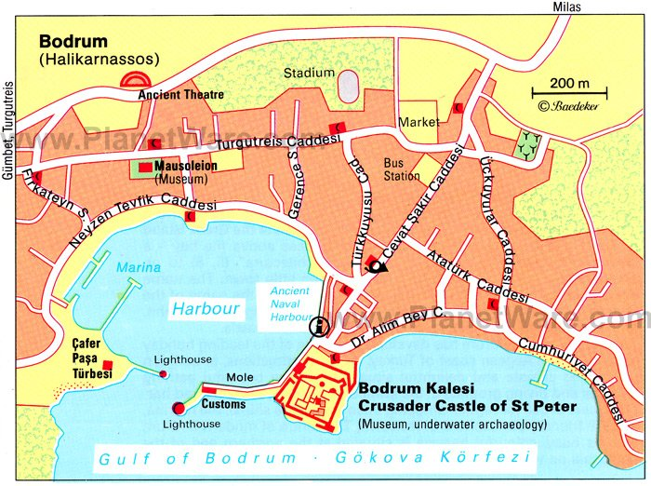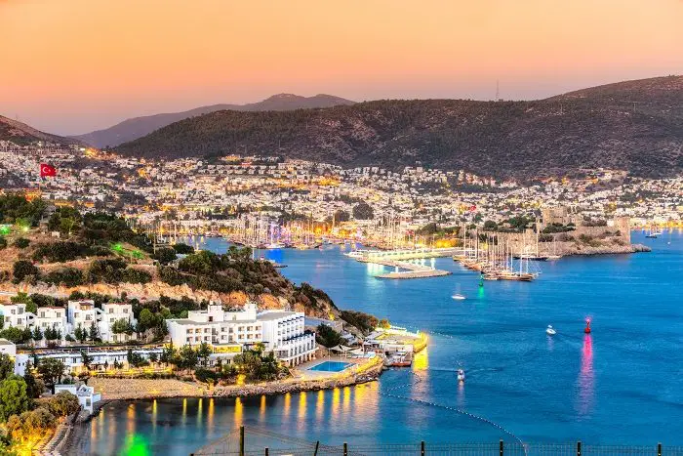
Sustainability
The report aims to create a new model for sustainable development (economic, social and environmental) in the Bodrum area based on a holistic approach that includes all stakeholders.
Stakeholders include local people, businesses, institutions, and organizations; state bodies (governments) as well as international organizations such as UNDP, UNESCO, and EU. Stakeholders include those involved in tourism activities such as hotels, restaurants, and shops; real estate developers; farmers who produce olive oil or vegetables for sale at markets; fishermen who catch fish for sale at markets; craftsmen who make handicrafts like pottery or wooden carvings etc.; also, tourists visiting Bodrum from abroad will be considered stakeholders.
Tourism is developed based on the original features of Bodrum. A correlation between the conservation of cultural and natural values and tourism development has been determined. Also, there is a correlation between changes in social structure and tourism development. Lastly, there is a correlation between changes in economic structure and the tourism development of Bodrum. Also, serious threats to the sustainability of tourism have been recognized in Bodrum.
All such components have a great impact on Bodrum's ability to make perfect tourism and to maintain it as viable for as long as possible.
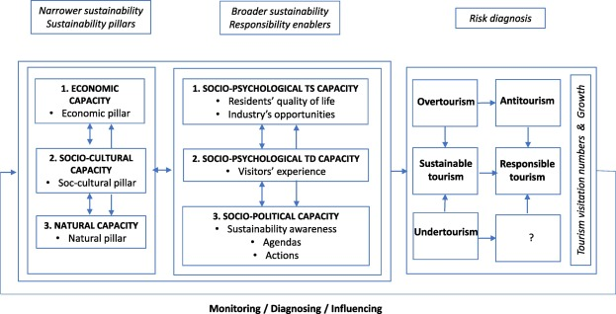

Socio-cultural impact
The socio-cultural aspect is also important when evaluating sustainable tourism practices within any given location; fortunately this area appears strong within Bodrum’s context too with cultural attractions such as museums being easily accessible throughout the region along with traditional Turkish markets offering visitors authentic experiences that can’t be found anywhere else-providing invaluable exposure for local communities who wish to share their culture more widely than ever before whilst simultaneously boosting visitor number even further. Finally, we must consider environmental factors; here again things look promising tanks largely due to efforts made by both private organisations and public bodies alike who have implemented strict regulations regarding waste management and energy consumption amongst other initiatives designed specifically at protecting fragile ecosystems surrounding coastal areas like those found near Bodrum’s shoreline.
Economic impact
Its economic impact is very high. It has a lot of hotels, restaurants, and shops. The number of visitors from abroad is also increasing every year. There are many tourists from Russia, China and Japan who come to Bodrum for the first time. They are not only interested in the historical sites, but they also want to go to places where they can enjoy themselves on holiday with their families.
In Bodrum are a lot of tourists who come as tourists and also are many people who work in the tourism industry. This means that they are employed, and they pay taxes, which helps to support the local economy. In addition, there are some small businesses that serve the needs of tourists and locals alike. There is a restaurant where you can eat seafood or fish dishes, there is a bar with drinks for sale and there are shops where you can buy souvenirs or clothing items made by local artisans. All these activities contribute to maintaining the economy as it has been done since antiquity.
The Bodrum government supports the economy by providing a stable environment for our citizens to work and live. The government will continue to provide services, such as electricity and water supply, in an efficient manner while maintaining the quality of these services. In addition, the government will continue to encourage tourism through its efforts to improve infrastructure and increase security at all entry points into Bodrum.
The Bodrum Government Infrastructure Support (BGS) is a public-private partnership established in 2006 with the objective of supporting the development, maintenance, and expansion of infrastructure projects in Bodrum. The BGS is managed by a Board composed of representatives from both public and private sectors. The BGS has two main areas: Infrastructure Development Projects: This area supports the implementation and execution of infrastructure projects that are either under construction or have been approved for implementation by the Ministry of Transport, Maritime Affairs & Communications (DGMMC). These projects include road networks, ports, airports, railways etc. Maintenance Projects: This area supports the implementation and execution of maintenance projects that are either under construction or have been approved for implementation by DGMMC. These include rehabilitation works on existing roads/bridges etc., which need to be carried out periodically as part of regular maintenance programs.
Butlers model of Bodrum Turkey destination management
Six stages of Butler’s model:
Following are the stages of Butler’s model:
- The exploration stages.
- The involvement stages.
- The development stages.
- The consolidation stages.
- The stagnation stages.
- The decline scenario.
Butler developed a model that represents the significance of how a resort may face a growth period due to the increased number of tourists visit (BBC, 2015). An observation of particular areas where there are chances of development to occur such as:
- Involvement, local residents offering facilities to tourists in which they reside while visiting
- Exploration, group of tourists who visit the tourist locations
- Development, promotion to address the location that makes able its expansion into a tourist destination
- Consolidation includes the significant of tourism growth at a slower rate which can lead to case conflicts with each other.
- Stagnation, facilities that are obtainable to tourists and are no practicable
- Rejuvenation, provide funding in order to make better the facilities and other locations.
- Decline, the continuous level of decline in case of no support and funding in order to rejuvenate the area.
All of these stages have a great impact on the ability of Bodrum to make the tourism perfect and remain feasible for all the tourists for a longer period of time.
Destination management of Bodrum Turkey
It is necessary to establish a strategy plan for the growth of tourism industry and measures of supply and demand in order to promote tourism. For this purpose, sustainable tourism is needed which contribute to provide effective results for the people living in the region (Brebbia & Pineda, 2006). Following are the important considerations that must be made and have a great impact on tourism industry (Brebbia & Pineda,2006).
- The number of available individuals housing units
- Number of tourist attractions that are obtainable to the visitors of Bodrum
- The number of available units for families and groups
- The most common type of allocation of land as given by the community
- Perspective of residents regarding tourists’ influx into Bodrum on daily basis
- The quantity of parcels of land that are present for the establishment within Bodrum.
- Economy growth and thrived resulted due to increase in tourism as compared to the previous decade
- Respond of Bodrum to call in order to make better its safety and visibility to keep the tourists interested in the city
- Opportunities available in order to improve the conditions within Bodrum so as to retain and attract tourists for a longer period of time
- Proximity of Turkey with its neighbouring regions like Iran, Syria, Iraq for the purpose to obtain success with the tourism industry.
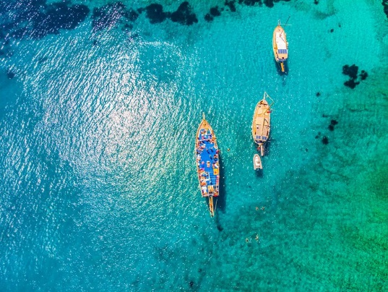
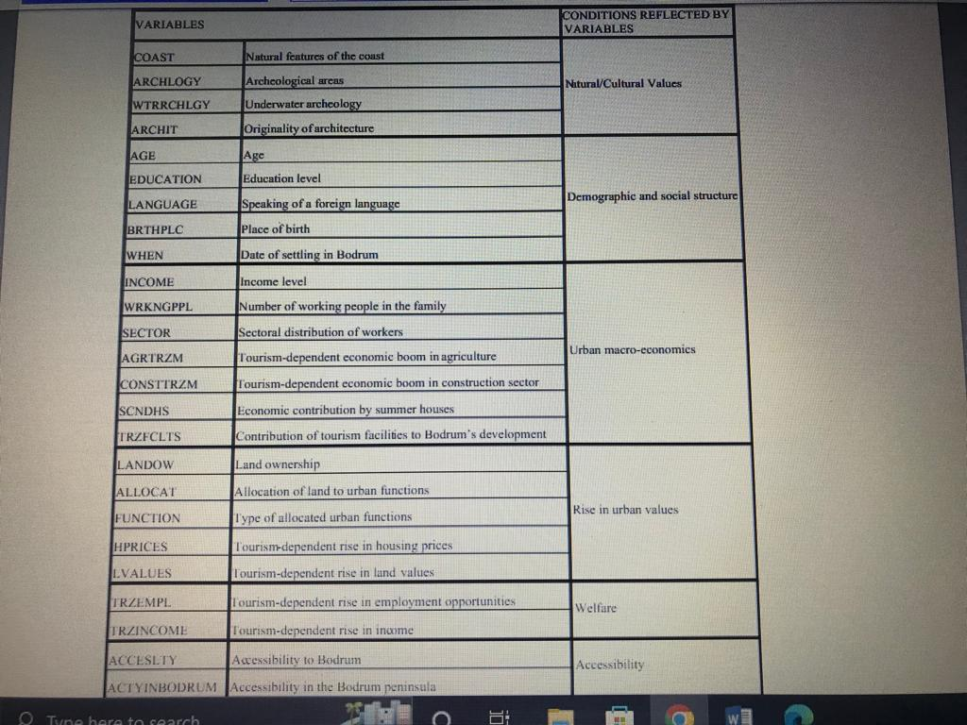
The variables in the analysis of the impact of tourism on socio-economic development in Bodrum:

The principal component analysis
Such analysis is done in the report to determine the impact of tourism on the development level of Bodrum. A model reflecting the significance of how a resort may go through a period of development as an outcome of the tourists who frequently visit it. A comprehensive observation is required in the areas where development is likely to take places such as involvement, exploration, development, consolidation, stagnation, and decline (Williams, 1979).
- Exploration: interest from a tourist group who visit the location
- Involvement: where residents offer tourists several facilities to reside in while their visiting period.
- Development: advertising to dominate an area for its expansion into a tourist destination
- Consolidation: growth of tourism in scope and significance at a lower rate to avoid conflicts between tourists.
- Stagnation: facilities available to tourists that are no longer feasible
- Decline: no support and funding to rejuvenate the region.
Conclusion

It can be concluded that the coastal tourism destination regions in Bodrum enhance tourism to research to analyse the potential threats of important locations and to discuss the effects of tourism based on such threats. Efforts have also been made related to developing strategies to alter the destiny of tourist destinations, like Bodrum which is one of the popular destinations for tourism but still got serious threats related to the sustainability of tourism.
All kinds of challenges observed in Bodrum must be addressed to make better the tourist attraction. The challenges of Bodrum as a tourist attraction must be addressed to fully understand the concepts related to the tourism industry and what has driven its growth to date. At the same time, any possible threats of terrorism within the country could ultimately impact how Turkey performs with its tourism focus on the coming years; as a result, these concepts must also be considered when addressing how to sustain growth within this industry over time that will have a lasting impact on the nation and the city.
Hence these hypothesis as mentioned above are proved that although blue, sea, and entertainment are considered to be the main focus and show similarities between tourism and the original identity of Bodrum, some evidences are present that shows the original identity of Bodrum is not included in its marketing or promotion as expected. It is also proved that Bodrum is one of the main tourism destination districts of Muğla province is located on the southern coast of the Aegean region. There is no such significant correlation for the second hypothesis. So, the cultural and natural values are not applied for the purpose to increase tourism development in Bodrum. A positive correlation between economic structure and tourism development have observed based on economic variables like tourism-dependent increases in income and economic contribution by summer houses.
Overall, it seems clear that despite some potential challenges ahead, Bodrum remains committed towards upholding principles associated with responsible travel and looks set remain one Europe’s premier destinations well into future.

Recommendations for the future development of the Bodrum, Turkey

According to the principal component analysis, land values are the main threats to the sustainability of tourism in Bodrum. It can cause serious hurdles in the attraction and beauty of Bodrum by the increased construction specifically in the coastal regions of Bodrum. Moreover, it makes the area more expensive as compared to the other ones. Strategies like focusing on misleading marketing and efforts to make better the land of Bodrum by giving concentration on its original identity, and cultural and natural values. The contribution should be made to improve the local economy of Bodrum. Planning efforts should be made along the coastal areas and certain steps should be taken to avoid any further construction that gives a negative impact on the beauty of Bodrum.
The main recommendation of this report is to develop new infrastructures in Bodrum and improve existing ones, such as roads, energy supply, water supply, sanitation system etc. This will also increase tourism potentials in Bodrum by providing better services to tourists visiting the city.

Word count: 2.197

Bibliography

- Bodrum.org (2015). Where is Bodrum? Retrieved from http://www.bodrum.org/listingview.php?listingID=2
- Brebbia, C.A., & Pineda, F.D. (2006). Sustainable Tourism II. WIT Press
- Deloitte (2013). Travel & Tourism. Retrieved from http://www.invest.gov.tr/pt-PT/infocenter/publications/Documents/TOURISM-INDUSTRY.pdf
- Deloitte (2013). Travel & Tourism. Retrieved from http://www.invest.gov.tr/pt-PT/infocenter/publications/Documents/TOURISM-INDUSTRY.pdf
- Ecemis, S., & Aydogan, M. (2009). Mass tourism effects on a coastal historical town: Bodrum case (Turkey). Ege Cografya Dergisi, 18(1-2), 85-103.
- Hunter, C. (1997), Sustainable Tourism as an Adaptive Paradigm. Annals of Tourism Research 24:857-867.
- Barke, M. and Towner, J. (2004) Learning from Experience? Progress Towards a Sustainable Future for Tourism in the Central and Eastern Andalucian Littoral, in Coastal Mass Tourism: Diversification and Sustainable Development in Southern Europe, Ed. B. Bramwell, Channel View Publication, Clevedon, 157-174
- Garcia, G. M, Pollard, J. and Dominguez Rodriguez, R. (2004), The Planning and Practice of Coastal Zone Management in Southern Spain, in Coastal Mass Tourism: Diversification and Sustainable Development in Southern Europe, Ed. B. Bramwell, Channel View Publication, Clevedon, 201-219.
- Vera Rebollo, J. F. and Baidal, J. A. I. (2004), Measuring Sustainability in a Mass Tourist Destination: Pressures, Perceptions and Policy Responses in Torrevieja, Spain, in Coastal Mass Tourism: Diversification and Sustainable Development in Southern Europe, Ed. B. Bramwell, Channel View Publication, Clevedon, 176-199.
- obledo, M. A. and J .Batle (2002) Re-planning for tourism in a Mature Destination: A Note on Mallorca, in Tourism in Western Europe, A Collection of case Histories., ed. By. R.Voase, Un. of Lincoln, CABI Pub
- Williams, T.A., 1979. Impact of domestic tourism on host population: The evolution of a model. Tourism Recreation Research, 4(2), pp.15-21.
- Magnarella, P.J., Turkdogan, O., Zahra, N.A., Eberhard, W., Erdentug, N., Guvenc, B. and Yasa, I., 1976. The Development of Turkish Social Anthropology [and Comments and Reply]. Current Anthropology, 17(2), pp.263-274.
- Sevencan, F., Yavuz, C.I. and Acar Vaizoğlu, S., 2017. Environmental consciousness of students from secondary and high schools in Bodrum, Turkey. Environmental Science and Pollution Research, 24(3), pp.3045-3053.
- Okumus, F. and Karamustafa, K., 2005. Impact of an economic crisis evidence from Turkey. Annals of tourism research, 32(4), pp.942-961.
- Alipour, H., 1996. Tourism development within planning paradigms: the case of Turkey. Tourism Management, 17(5), pp.367-377.
- Tanrıöver, S.H., 2011. Traditional architecture of Bodrum: the factors generating and affecting the architectural culture and identity. Intercultural understanding, 1, pp.79-87.
- Ayıran, N., 2011. Architectural continuity towards cultural sustainability in Bodrum. Open House International.
- Alipour, H., 1996. Tourism development within planning paradigms: the case of Turkey. Tourism Management, 17(5), pp.367-377.
- Gezici, F., Gül, A.Y. and Alkay, E., 2004. Potential, thresholds, and threats of tourism development in Bodrum Peninsula (Turkey). WIT Transactions on Ecology and the Environment, 76.
- Yuksel, A., 2001. Managing customer satisfaction and retention: A case of tourist destinations, Turkey. Journal of vacation marketing, 7(2), pp.153-168.

