
A critical evaluation of the role digital innovation in professional practice
Digital Innovation and professional practice
Andrew James_1700591_ECPT6006_A1_fINAL
PGCE-PCET

Contents
Introduction 1
Main Body 1
Literature Review 1
Selection and Justification 5
Application of Chosen Tool 8
Lesson plan 8
Picture of PowerPoint 13
Pictures of Mentimeter in use within the lessons 14
Evaluation and Reflection 16
Conclusion 18
References 19

Introduction
The purpose of this assignment is to recognise the advantages of using digital innovation within the education sector, to do this I will write a literature review that will critically evaluate available reading on a subject that represents digital innovation within the education sector. The next stage will look at the justification and the selection of a digital tool within one of my lessons that performed on my placement. The third phase will be the use of the digital tool, this will encompass my lesson plan and my evidence of the use of the digital tool within the lesson. The last section will be my evaluation and reflection on the use of a digital tool within the lesson I taught.
Digital innovation or transformation is described by Solution Path (2023) as a way of adapting a process to incorporate digital technology in an effort to create better results, the hope they say is to aid in the retention of students, enhance engagement or deliver an overall experience that is excellent not just for the student but also the educational institution. Nonetheless not everyone within the education sector are happy to integrate digital technology within their lessons, with the OECD (2016) say that the education sector could be classed as one of the most conservative sectors, it is also worth noting that the OECD (2016) are of the opinion that digital tools should be integrated into education to ease efficiency and productivity.

Main Body

Literature Review
This literature review will critically evaluate the use of digital tools for the purpose of creating quizzes on applications like Kahoot! and discussion tools through the use of applications like Mentimeter or Vevox. There will be an explanation of what are these tools and how they can be applied within a lesson and then what are the benefits but also what are negatives of using such tools.
When designing an activity there are learning outcome considerations that have to be made such as what is the overall purpose of the learning and if there is going to be assessment, what is the criteria and is it clear and relevant to the topic (Beetham, 2020). The considerations for using a digital tool according to Beetham (2020) are what resources will the learners need access to and what support will a leaner need, this could be IT support.

First what are the application tools Kahoot! and Mentimeter, Kahoot! is a digital tool that allows the creation of different games like quizzes that can be used as a way getting feedback for assessment but it can also be used in a way that allows reviewing of lesson content, reinforce learning and it could also help with increased focus and motivation (Kahoot!, 2023). Mentimeter (2023) say that their tool can also be used for assessing students like Kahoot!, Mentimeter (2023) further add that their tool allows for reflection, gauge student understanding, assess their knowledge but also evaluate and give feedback in real time instead of at a later date. They also say that the application can be used more than just answering questions, but a teacher can also gather their input so that the students feel that they are more involved in the learning process.
Punyanunt-Carter (2017) further adds that Kahoot! works in a way that allows students to create a unique nickname for themselves and answer questions that the teacher has provided with either a smartphone, laptop or tablet. She also adds that the students will receive points for both response accuracy and promptness, after each round a scoreboard is presented with the students who got the highest points earned.
Mentimeter is classed as presentation tool similar to either Microsoft’s PowerPoint or Google Slides however it allows the teacher to interact with students in real time through the use of polls, quizzes and through many other functions, it can also be used either in the classroom or in remote learning (Edwards, 2023).
Both Kahoot! (2023) and Mentimeter (2023) both stipulate that they are great to help with assessing a student's progress, in the view of Marshall (2020) assessment is integral in higher education learning because not does it guide students in their learning and secondly, she believes that any assessment should be accurate. This is because if it is not accurate then it could become unfair to students and could cause issues for an education faculty as unhappy students made lodge legal challenges. Both Kahoot! and Mentimeter have an option to create multiple choice questions,
A general view on the advantages of online learning is given by Race and Pickford (2007), is that it could excite learners this in turn can increase their motivation to learn, give learners instant feedback on choices and allow learners a chance to test their understanding of a subject. Although the advantages given by Race and Pickford (2007) are for general online use, the ones chosen could be compared with what are the presumed advantages of using Kahoot! and Mentimeter.
Another benefit of using digital based games for learning is given by Harding (2023) in that they can be used not only in a whole class setting with an interactive whiteboard, but it can also be used in a small group environment, in pairs or individually. She also refers back to assessing by saying that both teachers and the students can track information about where mistakes have been made in the learning environment or in an area of study that needs more content to help build knowledge.
Some of the advantages of the use of Kahoot! are provided by Mihoub (2021), he says that although it still maintains multiple choice quizzes with its gaming nature it removes the anxiety that traditional quizzes give, such as learning pressure test anxieties and delayed feedback. Recent research has found that students feel more engaged and learn without noticing while using the Kahoot! platform. Using a tool like Kahoot! has become so useful that some students from famous universities sit their exams on the platform (Mihoub, 2021). Citing research done by Rajabpour (2021) Sinnivasagam and Hua (2021) would agree with Mihoub (2021) and further add that the use of Kahoot! in the classroom brought a higher energy level in classrooms, this can be good because it will bring fun to the lessons as well as more motivation.
A journal article written by Kalleny (2020) found that students were fully engaged with the use of Kahoot! as a formative assessment and they gave an average score of 4.65 out of 5 in terms of the assessment being fun. Kalleny (2020) also discovered that the overall average of students who completed a questionnaire on the satisfaction of the platform was 24.25 giving a score of either agree or strongly agree.
As with all technology the use of Kahoot! has its disadvantages, one such disadvantage identified by Rajabpour (2021), who did a study on teacher’s perception of Kahoot!. The teachers in his study found that their students using other applications such as social media instead of playing the Kahoot! game. The other issue that he found during his research was that there were problems with access to the platform, he does state that the access issues were more due to connection with the internet rather than with gaining access on the platform and that there was bad design of the game.
Other disadvantages stated by Rajabpour (2021) was that teachers believed that Kahoot! was causing shorter attention spans for students, in contrast to these teachers views Rajabpour (2021) says that there is no evidence to support the teachers view but he does mention that if Kahoot! is used too often than it could cause shorter attention spans in students. This could also lead to the other issues teachers were finding, which was that students were forming undesired expectations, with one teacher saying that students were expecting lessons to be fun and games instead of being a place to learn (Rajabpour, 2021).
Other disadvantages of using a tool like Kahoot! are also provided by Mihoub (2021), he identifies that students will need their own electronic device and also an education institute will also need access to internet connection. Other disadvantages to think about when using the Kahoot! tool are that students may create inappropriate nicknames, this could make it harder for a teacher to supervise development of their students because they would not know who is who and the platform can also be a distraction for students who are lower achieving because they just see enjoyment of winning the game through random luck rather than analysing the questions, this would diminish the ability to share knowledge (Mihoub, 2021).
In a reflection done on the University of Bath (2023) website an educator said that they found the use of Mentimeter was good because students were more engaged and were keen to participate in the lesson, the students also found it less stressful and were more willing to answer questions through the use of Mentimeter rather than putting their hands up.
The benefits of Mentimeter in the view of Compton (2021) is that because Mentimeter is dependent on user devices such as smartphones or tablets, he says this is a benefit because students generally know how to use their own devices or at least have access to the internet. He further explains that these devices would have security and would be current in terms of software updates, it also has suggested by Compton (2021) turns what is usually an issue for teachers with devices like smartphones into a potential virtue.
Other positives cited by Compton (2021) are that there are numerous participation and interaction options that are also adaptable. He mentions that he tells his colleagues that instead of favouring the word cloud or open text formats how could they use other functions within their lessons, he further adds that it is more important to have a well-designed question that could be used for prompting either a discussion prior to the students voting or as a prompt for analysing or rationalising responses that have been offered. Edwards (2023) would agree with Compton (2021) on the adaptability of Mentimeter, he also adds that it is also possible to integrate Mentimeter with the likes of PowerPoint, this means that a teacher would not have to get use to a whole new software but can integrate a word cloud voting into their slides. Another benefit of this would be that a teacher would not have to take time out of their lesson to login to Mentimeter to initiate the voting but have in their slides ready to start.
Some of the criticism in regard to Mentimeter come from students, they said that it could take up more of lecture time and that it could be a poor substitute to being actually taught by a teacher, they also believe that it could be used as a of disruption by some students as they could see it has a way to mess around and using personal smartphones to connect to the internet could also be a distraction (Mohin et al., 2020). Other issues the students identified about Mentimeter were that a reliable internet connection was essential for the platform to work well and they would like to see the use of real names and have less anonymity as stated by Mohin et al. (2020), with to regard to the use of real names being used instead having anonymity Vallely and Gibson (2018) would agree with Mohin et al. (2020), they also had that there should be a way for students to be able to either edit or retrieve their answers once posted.
A potential issue of using digital items within the class could be that not every person has access to a digital device, with the Children’s Commissioner (2020) reporting that about 9% of families in the United Kingdom (UK) do not have access to digital device such as a laptop or tablet. This was a big issue during the Covid-19 pandemic when all of classes provided education institutes were moved online.

Selection and Justification
This section will analyse and evaluate the selection and justification of a digital tool or platform within a lesson that I have taught. To help me with my selection and justification I will choose and then use a digital educational framework. Has part of my justification I will outline how I plan to utilise a digital tool or platform and why I have chosen that specific tool or platform. I will also add how this tool or platform will help in my teaching but also what could be the challenges of using that tool, that could be with that specific tool or when incorporating it within my lesson.
The digital educational framework I have chosen to utilise is the TPACK framework, I have chosen this framework because I believe it is easy and simple to use compared to the other frameworks I have been taught. TPACK was created in 2006 by Mishra and Koehler and it focuses on 3 knowledge areas, these are: Technological Knowledge (TK) which is the relationship between digital tools and specific pedagogical practices, Pedagogical Knowledge (PK) which is the relationship between pedagogical practices and specific learning objectives and lastly Content Knowledge (CK) which it the relationship and intersections among digital tools and learning objectives (Kurt, 2019).
The Technological Knowledge of a digital tool has made me choose is Mentimeter, I have chosen to use the word cloud function on Mentimeter has a way to open discussion with the groups that I will be teaching. I choose Mentimeter over the Vevox platform, which as a similar function because I have used Vevox before and found it too complicated to use instead of Mentimeter which I found easy to use. I also based my choice based on the research I have done for literature review for this assignment, from my research the Mentimeter platform was rated highly for it use as an assessment tool.
The Content Knowledge for the two lessons that I will be teaching is a workshop on the Police and Criminal Evidence Act of 1984 more commonly known as PACE and the workshop will then focus on the Stop and Search powers which are laid out within the PACE act to level 5 police apprenticeship students who are currently in the police. My personal knowledge of the topic is based theoretical aspect of both PACE and Stop and Search whereas compared to the students who potentially should have the working knowledge of the subjects. The use of Mentimeter will allow me to gauge how much of the subject the students already known, and this would allow me to effectively know what areas I need to elaborate on.
For Pedagogical Knowledge, as this is two groups of new students to me, I do not know what is the best way that they learn. In my conversations with the normal teacher for these groups I was told that they do struggle with getting engagement from these students. This lack of possible engagement and that the lack of first-hand experience with these groups was the reason why I chose to incorporate Mentimeter into these lessons instead of another lesson as I think that the platform could be used as a way to start a discussion which would aid with engagement. I also plan to incorporate Mentimeter early on in the sessions so that it can be used as a way for me to get to know the students.
The way of how the word cloud function on Mentimeter works is described by Al-Ankar et al. (2021), the word cloud creates a visual representation of words in which they grow bigger witch indicates the frequency of that word being chosen. They say that this type of data can help to collect data from an audience, highlight the common answers and then present the data in a manner that students can understand. Using word clouds in academic settings allow participation from students but also provide a good starting point for discussion and interaction, the word cloud can be used in discussions, ice breakers and critical thinking (Al-Ankar et al., 2021), the ability to use this function in discussion and has ice breaker would support my use of the function in my lessons.
As previously mentioned within the literature review of Mentimeter, the University of Bath (2023) mentioned that one of the benefits to the platform were that students would not be required to put their hands up in class as this could be embarrassing for them, the advantage the word cloud tool of Mentimeter is that a word that has been posted by student’s numerous times becomes bigger. This is good because the students who have been reluctant to answer first would gain confidence knowing that there fellow students had the same answer. The other benefit that was mentioned by Compton (2021) was that these answers would be anonymous, so if there was an answer that may be incorrect then a student would not be embarrassed or be called out by other students due to having the wrong impression of the question.
On the other hand, the use of Mentimeter does have its flaws, these flaws were identified in the literature review. One of the issues that I found during my research was that for the teacher having the students being anonymous when answering was not beneficial because they were unaware of who was giving what answers, as reported by both Mohin et al. (2020) and Vallely and Gibson (2018). The main issue that could become a problem in the lesson would be poor internet connection or the students not having a digital device that could connect to the platform, to counterbalance this if the students do not have a device or there is poor internet than I will do this in analog function.

Application of Chosen Tool

Lesson plan
The image in this section shows one of my lesson plans where I have used Mentimeter, the use of Mentimeter can be find in the lesson detail under the title of What comes to mind when you think of PACE or Stop & Search?.
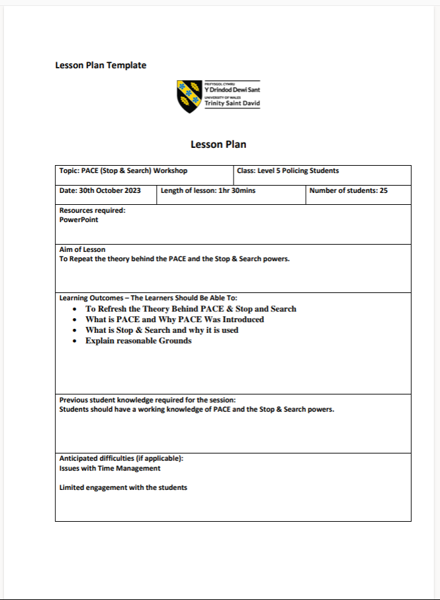
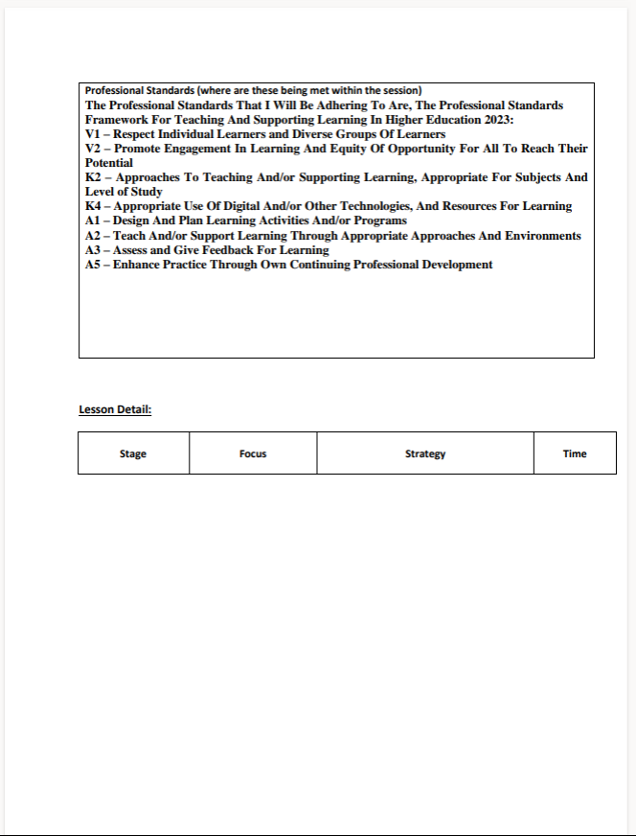
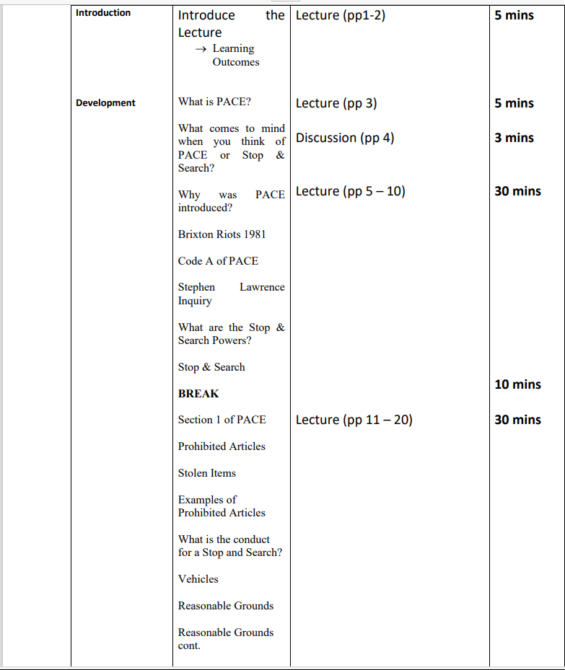
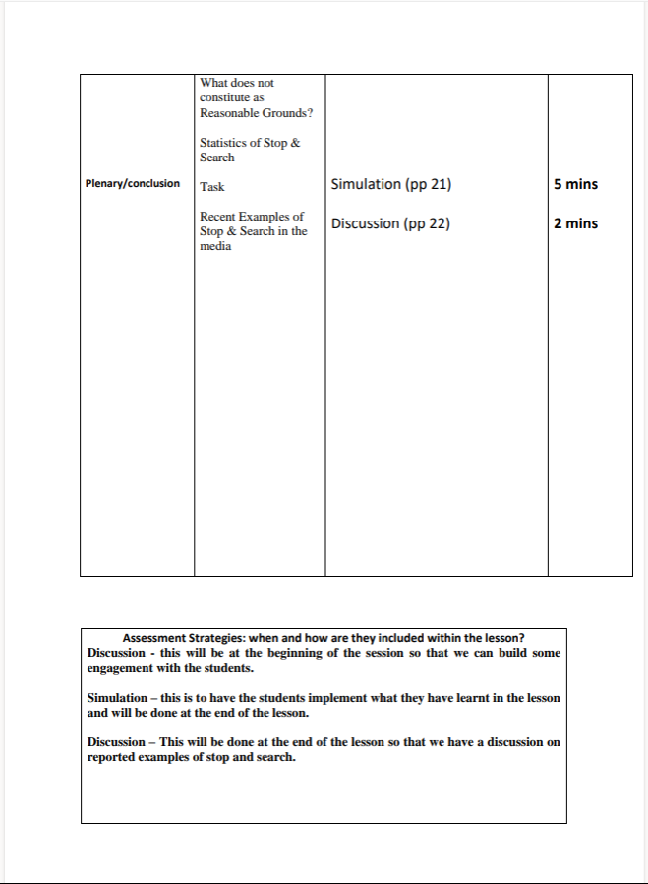
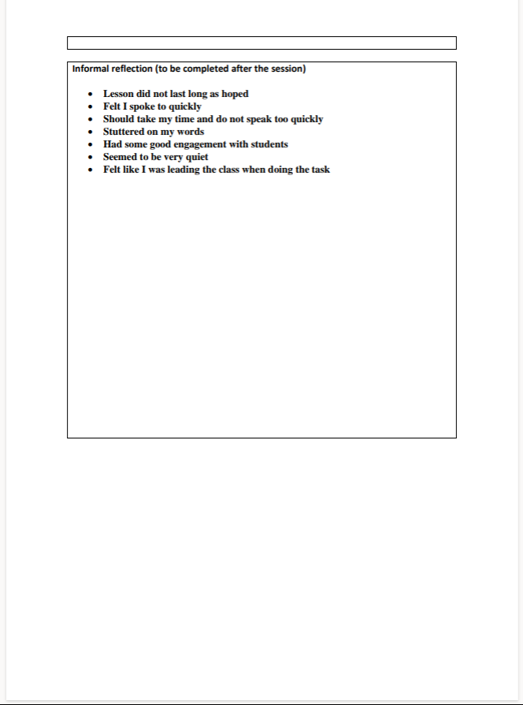

Picture of PowerPoint
The image shown in this section demonstrate what the slide looks like with the QR code and the web link, the image also shows what order this slide appears in.
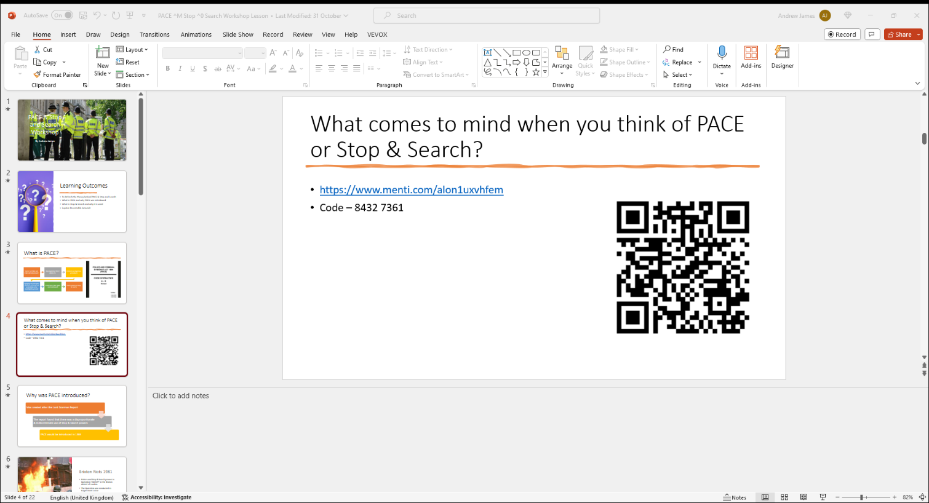

Pictures of Mentimeter in use within the lessons

Lesson 1
The first image shows the QR slide during the first lesson, this picture demonstrates what the students see when they saw the slide.

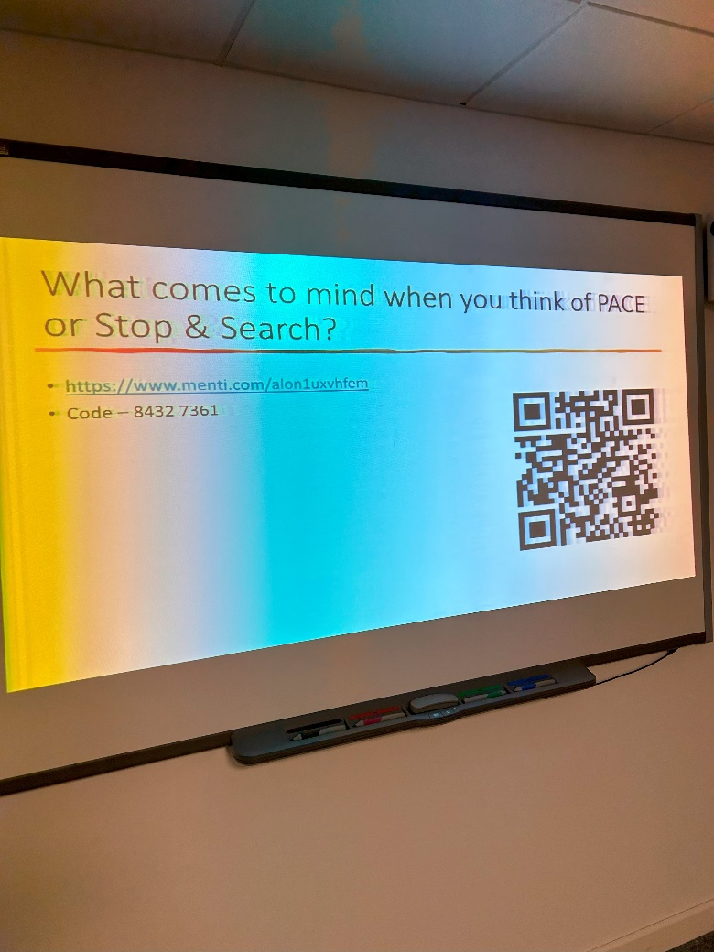

The second picture shows the responses from the first lesson.
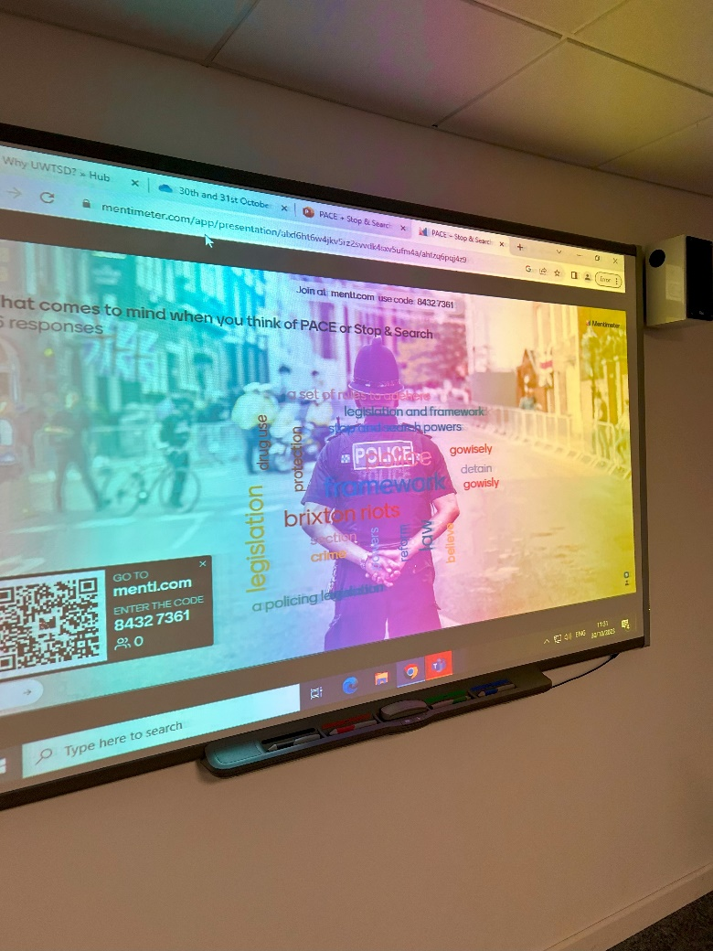

Lesson 2
The picture in this section shows the responses from the students in the second lesson.


Evaluation and Reflection
This chapter will look at my evaluate and then reflect on the two lessons that I taught where I used digital innovation through the use of Mentimeter as set out in the Selection and Justification chapter of this assignment. To aid me in my reflection I will use a reflection model, the model I have chosen is Kolb (1984) reflective model. The reasoning behind me choosing the Kolb (1984) reflective cycle is because it is a simple 4 stage reflective model, the 4 stages of the cycle are: Concrete experience this where you describe your experience, Reflective observations this where you reflect on that experience, Abstract conceptualisation is where you write about what you could have done better and the last stage is Active experimentation this is where I write about improvements I can make for my future teaching experience (Konak, et al., 2014).
The first session that I taught was on a Monday noon time, in this lesson I had about 20 students and in the second which was a Tuesday morning I only had 3 out of 20 students, I believe the students who did not attend were unsure about the timetable change. I used the same PowerPoint and I input a QR code on one of the slides which would automatically send the students to the Mentimeter word cloud that I created for those sessions, I also put in a weblink for the Mentimeter just in case the QR code did not work. From what I could see during the lesson I believe that all of the students were able to gain access through the QR code.
I found it easy to create the Mentimeter word cloud in contrast to when I have previously used the Vevox word cloud which found difficult to use and I also found it equally as simple to input the QR code on to the slide, I also found it easy to input the weblink onto the slide. In the two sessions I was able to sign in to Mentimeter prior to the start of the lessons so that it was ready to go instead having the students wait for me to log in, this could have caused a distraction and may have lost the interest of the students. As I mentioned from what I could see all of the students were able to get access to the word cloud.
What did not go well in the first lesson was the responses I got from the students in terms of their answers, I believe this happen because I was not clear in regard to what I wanted them to do. In the second session because of only having 3 students out of a class that should be close to 20 students, this meant that I was not able to get as many responses that had contrasting answers to the question. I also found in both classes that the discussion element of the word cloud that I hoped to achieve did not work as I had hoped, this was down to a lack of engagement especially with the first class. To the credit of 3 students in the second session they did try to get involved but the small number made it hard.
If I were to incorporate Mentimeter into one of my lessons again I would do it in a way that allows for the word cloud to appear on the slide rather than having to come out of the PowerPoint and go onto the internet to log in to Mentimeter and then go back to the PowerPoint slide, since the two lessons I have learnt how to do this and again I found it easier to do than I had initially thought it was when I created originally.
Also, in future I will make sure that I am very clear in what I want from the students in terms of answering the question, Race and Pickford (2007) say that a teacher should tell the students exactly what is excepted of them and make it so that it is clear and concise. To improve engagement with the students I should pick out students and ask them what they think instead of asking a question to the whole class and not receive an answer and then moving on. The use of questions are identified by Duckworth (2013), she also says that it is good to allow students to reinforce positive feedback and then redirect the students when they give negative feedback. She says that a teacher should encourage students share ideas and information when students share their ideas a teacher should then build on that idea so that they can validate their expertise.
The feedback I received from the students after the two sessions were mostly positive, one of the students said to me that feel that the use of Mentimeter would be good for students especially those are new to the subject. The students also found that it was easy to use and was really enjoyable. The feedback that made be happy the most to hear was from one student, they said that they found the use of Mentimeter was better than what they have previously done in other lessons where the teacher asked them to come to the front of the class to write on a whiteboard. They added that they did not like to use the whiteboard because they struggle with answers because another student had already given that answer. This anonymity of using Mentimeter is a positive as it removes the embarrassment for a student to raise a hand or in the case of this student to come to the front of the class (University of Bath, 2023), on the other hand this anonymity could also be an issue as pointed out by Compton (2021).
The last stage of Kolb (1984) is to do active experimentation, which is to put in practice what I have learnt from my reflection, since I have done those two lessons I have not had a lesson where the use of Mentimeter was useful. But I have learnt few techniques that I will put into practice next time I do such as incorporating Mentimeter into a PowerPoint.

Conclusion
To conclude from my research and through the use of a digital tool within a lesson, I believe that digital innovation tools such as Kahoot! and Mentimeter can be very useful however it should not be overused otherwise students can become numb too it. This would mean that the tolls would lose its purpose. From my sessions I would use Mentimeter again.
Word Count - 4214 (Not including words on lesson plan)

References
Al-Ankar, K., Macheta, A. and Le-Brun, L. (2021) Mentimeter Word Clouds!.
Available at: https://tel.yorksj.ac.uk/adding-a-Mentimeter-word-cloud-to-moodle/
(Accessed 3 December 2023).

Beetham, H. and Sharpe, R. (2019) Rethinking Pedagogy for a Digital Age. 3rd edn. New York: Routledge.

Compton, M. (2021) 5 reasons why Mentimeter works so well.
Available at: https://reflect.ucl.ac.uk/mcarena/2021/11/23/Mentimeter/
(Accessed 26 November 2023).

Duckworth, V. and Clarke, J. (2013) How to be a brilliant FE teacher: A practical guide to being effective and innovative. London: Taylor and Francis Group.

Edwards, L. (2023) What is Mentimeter and How Can It Be Used for Teaching? Tips & Tricks.
Available at: https://www.techlearning.com/how-to/what-is-Mentimeter-and-how-can-it-be-used-for-teaching-tips-and-tricks
(Accessed 26 November 2023).

Harding, E. (2023) The pros and cons of game-based learning. Available at: https://bedrocklearning.org/literacy-blogs/the-pros-and-cons-of-game-based-learning/
(Accessed 25 November 2023).

Kahoot! (2023) Transform your teaching with time-saving tools. Available at: https://Kahoot!.com/schools/
(Accessed 24 November 2023).

Kolb, D. (1984) Experiential learning: experience as the source of learning and development. New Jersey: Prentice Hill.

Konak, A., Clark, T. and Nasereddin, M. (2014) 'Using Kolb’s Experiential Learning Cycle to improve student learning in virtual computer laboratories', Computers and Education, Volume 72, pp. 11-22. Available at https://doi.org/10.1016/j.compedu.2013.10.013.
Kurt, S. (2019) TPACK: Technological Pedagogical Content Knowledge Framework. Available at: https://educationaltechnology.net/technological-pedagogical-content-knowledge-tpack-framework/
(Accessed 2 December 2023).

Marshall, S. (2020) A handbook for teaching and learning in higher education ; enhancing academic practice. 5th edn. New York: Routledge.

Mentimeter (2023) A unique way to assess students. Available at: https://www.Mentimeter.com/education/assessments
(Accessed 24 November 2023).

Mihoub, A. (2021) Kahoot! Advantages and disadvantages. Available at: https://tedxeuston.com/Kahoot!-advantages-disadvantages/
(Accessed 25 November 2023).

Mohin, M., Kunzwa, L. and Patel, S. (2020) Using Mentimeter to enhance, Hatfield: University of Hertfordshire.

OECD (2016) Educational Research and Innovation: Innovating Education and Educating for Innovation. Washington: OECD Publishing.

Punyanunt-Carter, N. (2017) eTools: Using Kahoot!! in the Classroom, Washington: National Communication Association.

Race, P. and Pickford, R. (2007) Making teaching work: Teaching Samrter in post-compulsory education. London: SAGE Publications.

Rajabpour, A. (2021) 'Teachers’ Perception of Advantages and Disadvantages of Kahoot!!', English Linguistics Research, 10(4), pp. 49-61. Available at https://doi.org/10.5430/elr.v10n4p49.

Sinnivasagam, P. and Hua, T. K. (2023) 'Gamification Functionality and Features of Kahoot!! in Learning-ESL Teachers and Students' Perceptions', Open Journal of Social Sciences, Volume 11, pp. 404-421. Available at 10.4236/jss.2023.112027.
Solution Path (2023) Digital Transformation in Higher Education: Things to Know. Available at: https://www.solutionpath.co.uk/resources/digital-transformation-in-higher-education/#:~:text=It%20is%20about%20adapting%20processes,both%20the%20student%20and%20the
(Accessed 24 November 2023).

University of Bath (2023) Using Mentimeter: Case studies from Staff at the University of Bath (Part 1). Available at: https://blogs.bath.ac.uk/clt/2023/06/27/using-Mentimeter-case-studies-from-staff-at-the-university-of-bath-part-1/
(Accessed 26 November 2023).

Vallely, K. and Gibson, P. (2018) 'Effectively Engaging Students on their Devices with the use Mentimeter', Compass: Journal of Learning and Teaching, 11(2), pp. 1-7. Available at https://doi.org/10.21100/compass.v11i2.843.

