
APPENDIX GA36d

LEVEL 7 ASSESSMENT SPECIFICATION

Student name: | Kwong Kin Hung | Student ID number: | 2235237
Programme: | DBA
Module: | Approaches to Research and Academic Communication
Module code: | HKBM7000 | Contribution to Overall Module Assessment (%): | 60%
Lecturer: | Dr Chammy Lau | Internal Verifier: | Prof Peter Fong
Assignment Title: | Assignment 1 –  Research Portfolio | Word count (or equivalent): | 5,000 words
Submission deadline: | 11 September 2023 | Return date of provisional marks & written feedback: | 10 October 2023
Submission method: | All written assessments, where practical and possible, must be submitted via Turnitin unless otherwise instructed by the Lecturer. (Please DO NOT put this assessment specification into Turnitin or it will match many similarities with other students’ submissions.)  Alternative submission method (if applicable):  Late submission of the assessment will result in a late penalty mark. Penalties for late submission: Up to one week late, maximum mark of 50%. Over one week late, 0%. Only the Extenuating Circumstances Panel may approve a change to submission dates.
Academic honesty / referencing: | Academic honesty is required. In the main body of your submission you must give credit to authors on whose research and ideas your work is based. Append to your submission a reference list that indicates the books, articles, etc. that you have used, cited or quoted in order to complete this assessment.
(4697 words)

Research Profolio

Title: How do the characteristics of Generation Z medical doctors affect the recruitment and retention strategies of private medical organisations in Hong Kong.
Kwong Kin Hung, Terence

Introduction
Aging population in Hong Kong
The population in Hong Kong is undergoing a significant demographic shift characterized by an aging population. According to projections by the Health Bureau of the Hong Kong Special Administrative Region (HKSAR) in 2023, the number of individuals aged 65 and over is expected to increase from 1.5 million, which accounts for 20% of the total population in 2021, to 2.52 million, representing 31% of the total population by 2039. This demographic transition brings numerous challenges, particularly in terms of healthcare and managing chronic diseases. (Health Bureau HKSAR, 2023)

The aging population in Hong Kong will substantially impact healthcare expenditure. With a larger proportion of the population requiring medical care, the projected costs associated with managing chronic diseases are expected to rise dramatically. (Figure 1) The Hong Kong government recognizes the importance of addressing this issue promptly and has developed a primary care blueprint to meet the evolving healthcare needs of the population.

In 2023, the government introduced a primary care blueprint that emphasizes community-based primary care. However, the existing community-based primary care system in Hong Kong is primarily reliant on the public sector, which is predominantly run by the hospital authority. This reliance on the public sector poses challenges in meeting the growing demand for healthcare services driven by the aging population.
To address this challenge, there is a growing emphasis on the development of primary care in the private sector. Successful programs have highlighted the need to expand primary care services beyond the public sector, encouraging the participation of private healthcare providers. As a result, there is an increasing demand for medical doctors to practice in the private sector in Hong Kong.

It is important to note that the practice of medicine is a human activity that cannot currently be replaced by artificial intelligence. The complexity and nuances of healthcare require the expertise and empathy of healthcare professionals. Therefore, the demand for medical doctors in the private sector is rising to cater to the healthcare needs of the aging population.

However, the scarcity of medical doctors in the private sector of Hong Kong, coupled with the challenge of maintaining their long-term stability, presents significant obstacles to the implementation of these projects.

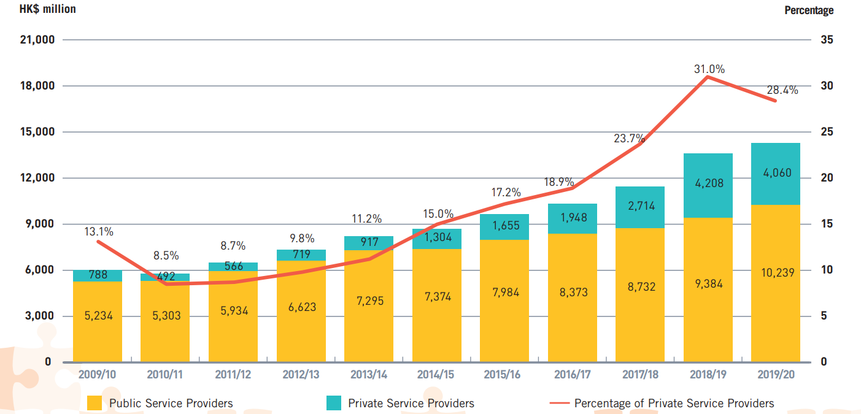
Figure 1: Public Expenditure on Primary Healthcare through public services Providers vs Private Service Providers (Excluded COVID-19 related expenditure)
Sources: Health Bureau HKSAR. (2023). The Healthcare Challenges in Hong Kong. Primary Healthcare Blueprint, 11–18.

Situation of medical doctors’ manpower in Hong Kong
The shortage of medical doctors in Hong Kong is a pressing issue, as the Department of Health of the Hong Kong Special Administrative Region (HKSAR) reported in 2022. (Department of Health HKSAR, 2022)Currently, there is a total of 15,546 doctors in Hong Kong, with approximately 6,458 practicing in the hospital authority and 457 in the Department of Health. The private sector is estimated to have around 7,000 doctors; however, the number of actively practicing doctors is around 4,000, with approximately 2,000 focusing on community primary care. Each year, an average of 500 medical graduates enter the workforce, with an estimated 90% of them being employed by the hospital authority for specialist training. The remaining 10% are expected to enter the private market to provide primary healthcare services. These statistics highlight the significant shortage of doctors, particularly in the private sector, and the need to address this issue to ensure sufficient access to primary healthcare for the population of Hong Kong. Efforts to attract and retain more doctors in the private sector and expand primary care services are crucial to meet the growing healthcare needs of the population.

Different Generations in Workforces
Like any other profession, the medical workforce in Hong Kong is composed of a mix of different generations. These generations, namely baby boomers, Generation X, millennials, and Generation Z, each have their own distinct definitions, but the dividing lines between them vary. (Sakdiyakorn et al., 2021)

Baby boomers are individuals born between the mid-1940s and mid-1960s following World War II. The term "baby boomers" refers to the significant increase in birth rates during this period. They have participated in social movements and witnessed advancements in technology. Baby boomers have notably influenced politics, the economy, and social norms. On the other hand, Generation X refers to individuals born between the early 1960s and early 1980s, following the baby boomer generation and preceding the millennials. They are characterized as independent and adaptable, having grown up during a time of significant social and economic changes.

The Pew Research Center (Dimock, 2019) has established the birth year cutoff for the Millennial generation as 1996, making anyone born between 1981 and 1996 a Millennial. The new generation that follows Millennials is commonly referred to as Generation Z. While there is no scientific process for determining generational names, the term "Gen Z" has gained popularity in popular culture and media. The generational boundaries are not arbitrary but are based on various factors such as political, economic, and social influences. Millennials experienced events like Hong Kong Protest during their formative years, contributing to their political views and polarization. They are also known for their racial and ethnic diversity. Generation Z is even more diverse than Millennials and has different experiences and characteristics. Millennials faced the impact of the economic recession when entering the workforce, which has influenced their life choices and future prospects. The long-term effects of these factors on Millennials will continue to shape worldwide societies for years to come.

Importance of stabilities of the workforce
The stability of doctors is of utmost importance in healthcare, as it directly impacts multiple aspects of the healthcare system. It plays a crucial role in establishing strong patient-doctor relationships essential for optimal patient management and outcomes. Having a stable and trusted doctor improves communication, continuity of care, and patient satisfaction, leading to better treatment adherence and overall well-being. Furthermore, doctor stability is vital for the financial sustainability of private medical organizations, ensuring a consistent patient base and reliable revenue stream. This enables organizations to provide high-quality care, invest in resources, and retain talented healthcare professionals. At the societal level, stability in primary care is particularly significant, as it promotes continuity of care, preventive medicine, and early interventions, resulting in better management of chronic conditions, improved health outcomes, and efficient allocation of healthcare resources. Doctor stability is crucial for fostering a robust healthcare system that delivers optimal care and benefits patients, healthcare organizations, and society as a whole.

Recruitment and retention strategies for health organizations
In the current workforce, the majority consists of Generation X and millennials, and organizations have already implemented recruitment and retention policies that cater to their needs and preferences. However, with the emergence of Generation Z, a new generation with distinct characteristics and values, the existing recruitment and retention strategies may not be suitable. The effectiveness of current strategies in attracting the new generations may be limited. Even if they do join health organizations, they are more likely to leave easily due to outdated retention policies. This can result in an unstable workforce, ultimately impacting the success of the primary care initiatives initiated by the Hong Kong Government. Therefore, health organizations need to adapt and implement new changes in their recruitment and retention practices to attract and retain top talent from this generation and ensure a diverse and thriving workforce.

Importance of research
With this in mind, this research study focuses on examining the characteristics of Generation Z doctors and how these characteristics will influence recruitment and retention policies within health organizations. By understanding the unique qualities of Generation Z doctors, healthcare organizations can develop strategies to attract and retain them effectively. This, in turn, will contribute to the successful execution of primary care blueprints and the delivery of quality healthcare services to communities. Based on the findings of this research, recommendations will be formulated for government bodies to aid in the implementation of primary care initiatives.

Apart from attracting and retaining Generation Z for long-term talent acquisition and retention strategies in health organizations that gain a competitive advantage in the industry, embracing the diversity and innovative thinking of Generation Z doctors that lead to improved patient care and organizational performance, this topic holds significant importance and urgency as it extends beyond business concerns and encompasses public interests. Recognizing that Generation Z represents the future major workforce, it becomes crucial to attract and retain this demographic within the private sector through appropriate recruitment and retention strategies. By ensuring an adequate supply of medical professionals aligned with the government's future plans, the implementation of primary care programs outlined in the primary care blueprint can yield substantial cost savings. A local study suggests that subsidizing screening and management services for diabetes and prediabetes among individuals aged 45 to 54 in the private sector could reduce direct healthcare expenses by approximately 28% over a 30-year period, resulting in savings of around 12.5 billion and preventing 47,138 deaths. Additionally, another local study demonstrates that the adoption of multi-disciplinary intervention programs for diabetes and hypertension could lead to significant healthcare cost reductions, with estimated savings of up to 38% and 33% per patient per year, respectively. The essence of incorporating technological advancements appeals to the preferences of Generation Z for effective implementation. (Health Bureau HKSAR, 2023)

Nature of topic area
This study aims to understand the unique characteristics and preferences of Generation Z doctors in order to develop effective recruitment and retention strategies for private medical organizations in Hong Kong. Generation Z doctors, born between the mid-1990s and early 2010s, have distinct values and expectations shaped by technological advancements and societal changes. The research will explore their work-life balance expectations, career development aspirations, technological preferences, and other relevant factors to inform tailored policies. Understanding these factors is crucial for attracting and retaining top talent in this generation, considering their digital fluency, desire for meaningful work, and emphasis on work-life integration. The study will also investigate how organizations can create supportive environments, provide growth opportunities, leverage technology, and consider workplace culture and diversity to effectively recruit and retain Generation Z doctors.

Literature Review
While numerous studies have been conducted on Generation Z and their unique characteristics, there is a noticeable gap in research specifically focused on Generation Z medical doctors. Despite the growing importance of this generation as the main working force in the future, limited attention has been given to understanding their distinct traits, motivations, and challenges within the medical profession. This lack of research hinders our understanding of Generation Z doctors' specific needs and preferences, which is crucial for developing effective recruitment and retention strategies in healthcare organizations. Given the importance of healthcare delivery and the critical role of doctors in society, it is vital to bridge this research gap and gain insights into the characteristics and experiences of Generation Z medical doctors.

Key Scholars for studying Generation Z and their findings
Several researchers have contributed valuable insights into Generation Z and their unique characteristics. Jean Twenge's work has focused on generational differences, particularly the impact of technology and social media on young people's mental health and well-being (Twenge, 2010). Corey Seemiller and Meghan Grace have examined Generation Z's values, beliefs, and behaviors, providing a deeper understanding of their distinct worldview (Seemiller & Grace, 2017). Danah Boyd's research has shed light on the implications of technology, social media, and online communication on young people's identity, relationships, and privacy(Boyd & Marwick, 2014). Neil Howe and William Strauss are well-known for their contributions to generation theory and the concept of generation cycles (Howe & Strauss, 2007).

Beyond the aforementioned researchers, scholars have identified distinct characteristics of Generation Z. They are often recognized as technologically savvy and digital natives, having grown up with technology seamlessly integrated into their lives (Prensky, 2001). Generation Z approaches life pragmatically, considering practicality as a guiding principle (McNeil, 2010). Moreover, they exhibit an inclusive mindset, actively embracing diversity and promoting inclusivity (Twenge et al., 2015). While Generation Z is collaborative and team-oriented, they also display individualistic tendencies. They seek meaningful work and demonstrate a lifelong learning mindset. Additionally, Generation Z possesses an entrepreneurial outlook and demonstrates adaptability and resilience. Notably, they prioritize work-life balance as a crucial aspect of their lives.

The working environment for doctors
The working environment for doctors is multifaceted and significantly impacts their professional lives (Hafferty & Light, 1995). Long and irregular working hours are a common feature of the medical profession. Doctors often work extended shifts, including nights, weekends, and holidays, which can disrupt their personal lives and pose challenges in maintaining a healthy work-life balance. This can lead to fatigue, burnout, and decreased job satisfaction. Finding ways to address these scheduling issues and promote a more balanced approach to work is crucial for the well-being of doctors.

The medical profession is renowned for its high-stress environment. Doctors frequently encounter intense situations, such as medical emergencies and life-or-death decisions. The pressure to provide optimal care under time constraints and high stakes can be overwhelming. This constant exposure to stress can impact their mental and physical health, necessitating the implementation of strategies to mitigate stress and support doctors' well-being. (Baer et al., 2017; Dyrbye et al., 2010; Shanafelt et al., 2009)

In addition to the inherent stress, doctors also face emotional demands in their daily work. They often interact with patients who are experiencing pain, suffering, and emotional distress. Doctors must navigate these emotions while maintaining professionalism and providing empathetic care. This emotional labor can be both rewarding and draining, highlighting the importance of emotional support and resources for doctors to cope effectively.

Multitasking and prioritization skills are essential in the medical profession. Doctors must manage multiple patients, medical cases, and administrative tasks simultaneously. The ability to make quick and accurate decisions, allocate resources effectively, and manage time efficiently is critical for providing quality care and maintaining patient safety.

Collaboration and teamwork are fundamental aspects of the medical field. Doctors work closely with nurses, technicians, specialists, and other healthcare professionals to deliver comprehensive care to patients. Effective communication, coordination, and interdisciplinary collaboration are essential for optimizing patient outcomes and ensuring a seamless healthcare experience. (Fay et al., 2015)

Continuous learning and professional development are vital for doctors to stay abreast of the latest medical advancements and evidence-based practices. The medical field is constantly evolving, and doctors must engage in ongoing education and training to provide the best possible care for their patients. Creating opportunities for doctors to pursue continuing education, research, and professional growth is crucial for maintaining their competence and ensuring the delivery of high-quality care.

Given the nature of their work, doctors shoulder a high level of responsibility. They are entrusted with the well-being and lives of their patients, and this responsibility weighs heavily on them. Their profession's ethical and moral dimensions require doctors to make complex decisions and act in the best interest of their patients, often under challenging circumstances.

Moreover, doctors work in diverse settings, ranging from hospitals and clinics to research institutions and public health organizations. Each setting presents distinct demands, challenges, and opportunities. Understanding these variations and tailoring support systems and resources to the specific needs of doctors in different practice settings is essential.

Research on Generation Z Medical Doctors
Recently (Narcisse Elenga & Guha Krishnaswamy, 2023) suggested several noteworthy characteristics that were identified in Generation Z medical doctors. Firstly, Generation Z doctors prioritize work-life balance and seek a fulfilling career that allows them to maintain a healthy equilibrium between their personal and professional lives. They value the importance of having a well-rounded lifestyle. Secondly, there is a recognized need for additional resources to enhance their work performance and improve overall efficiency. Generation Z doctors require adequate support and tools to excel in their roles. Thirdly, potential conflicts may arise with older colleagues due to differing outlooks and perspectives. These generational differences can lead to challenges in communication and collaboration. Fourthly, Generation Z doctors express a desire for more flexibility in their schedules and a seamless transition between their clinical duties and personal lives. They value a fluid work environment that accommodates their changing needs. Fifthly, they have the potential to disrupt previously established norms and favor diversifying their tasks. They seek varied experiences and opportunities within their medical careers. Sixthly, Generation Z doctors emphasize the importance of digital tools that integrate smoothly into their workflow without disrupting their productivity. They value technology that enhances their efficiency and effectiveness. Lastly, the feminization of the medical profession has an impact on Generation Z doctors, with a greater emphasis on prioritizing family obligations alongside their clinical work.
The findings from the available research offer valuable insights into the distinct qualities and requirements of Generation Z medical doctors. These insights provide guidance for healthcare organizations to adjust and meet their preferences and goals. It is important to note that there is currently no formal qualitative research specifically focused on Generation Z medical doctors, limiting our understanding of their unique traits and needs within the medical field. However, by considering broader research on Generation Z and their preferences in professional settings, healthcare organizations can still make informed adaptations to support this generation better. Future qualitative research specifically targeting Generation Z doctors would be beneficial in gaining a deeper understanding of their experiences and specific demands in the medical profession.

Matching vs conflict
Generation Z, characterized by traits such as being technologically savvy, adaptable, and having a desire for meaningful work, brings a set of unique characteristics that both align and conflict with the traditional expectations of the medical profession. On one hand, the long and irregular hours, high-stress environment, emotional demands, and conflicts in work-life balance within the medical field may clash with Generation Z's desire for work-life balance and individualism. However, their technologically savvy nature suits the multitasking and prioritization required in healthcare settings. Additionally, Generation Z's inclination towards lifelong learning and professional development aligns with the continuous learning and skill development necessary for doctors. Their inclusive and diverse mindset and entrepreneurial mindset can be beneficial in varied work settings and contribute to innovative approaches in healthcare. Other characteristics such as pragmatism, adaptability, and resilience also provide valuable assets in the medical profession, helping doctors navigate complex and evolving healthcare landscapes. By recognizing and harnessing these characteristics, healthcare organizations can create an environment that attracts and retains Generation Z doctors while capitalizing on their unique strengths and aspirations.

Recruitment and Retention Policy
Studies have examined the recruitment and retention strategies differences between Generation X and the baby boomer generation. (Cordeniz, 2002) Several strategies have been proposed for attracting and retaining Generation X faculty members in academic health centers. These include options like part-time practice, job sharing, increased access to technology, and providing unpaid leave for personal reasons. The research also highlights the importance of offering rewards beyond monetary compensation and career advancement. Professional development opportunities, access to new electronic equipment, generous time off, and increased flexibility are all factors that can contribute to the recruitment and retention of Generation X faculty members.

Furthermore, the studies suggest that establishing productive mentoring relationships between Generation X and older generations can be challenging. There is a tendency for each generation to attribute failures or difficulties to the other, indicating potential intergenerational conflicts. Recognizing and addressing these challenges is crucial for fostering positive working relationships and creating a supportive environment that promotes effective recruitment and retention strategies for Generation X faculty members.

Similarly, Generation Z doctors' recruitment and retention policy has also received considerable research attention in developed countries like the United States, Canada, and Australia. (Marchand & Peckham, 2017; Prensky, 2001; Viscomi et al., 2013) However, it is worth noting that no studies specifically focusing on Hong Kong, a unique and relatively small region, have been found. Therefore, the findings from research conducted in other developed countries may not directly apply to the context of Hong Kong.

Nevertheless, the author identifies several factors that are likely to be relevant to the recruitment and retention policy of medical doctors in Hong Kong. Working hours play a crucial role, as long and irregular hours can impact work-life balance and overall job satisfaction. Additionally, salaries and benefits packages are significant considerations for attracting and retaining medical professionals. The availability of resources and facilities, including state-of-the-art medical equipment and technology, can also influence the decision of doctors to join or remain in a particular healthcare institution.

Autonomy and decision-making authority are important factors that impact job satisfaction and professional fulfillment. Opportunities for professional growth and advancement, such as continuing education and career development programs, are also vital in attracting and retaining doctors. The diversity of patient populations and case complexity provide doctors with valuable learning opportunities and can influence their decision to stay in a particular setting.

Healthcare institutions' reputation and brand recognition can influence medical doctors' recruitment and retention. A positive reputation for high-quality care and strong academic affiliations can be attractive to doctors seeking to establish their careers or pursue academic pursuits.

Conceptual framework
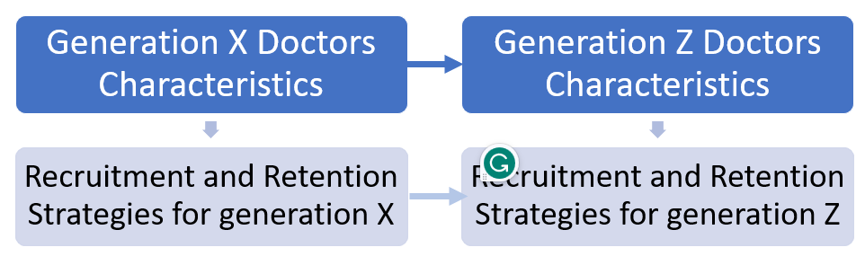
Fig 2 Conceptual Framework for Qualitative Studies
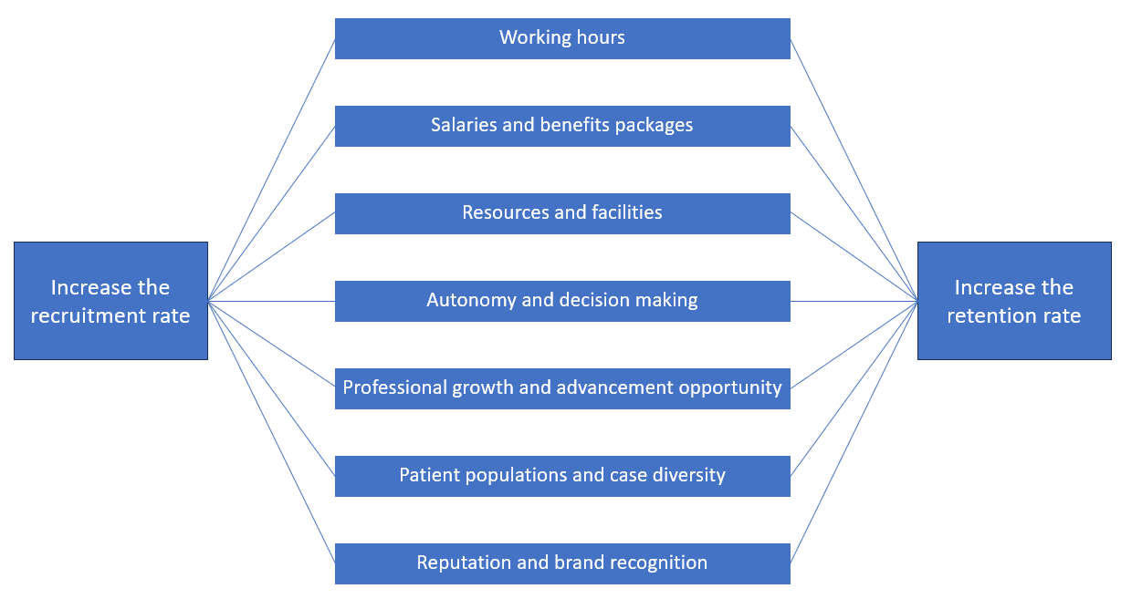
Fig 3 Conceptual Framework for Quantitative Studies

Research Questions and objectives
- To identify the characteristics of generation Z Medical Doctors which is different from that in pervious generation.
- To test the hypothesis that changes of these characteristics would increase the recruitment successful rate
- To test the hypothesis that change of these characteristics would increase the retention rate of doctors
- To suggest the change of recruitment and retention strategies that is suitable for the new generation of medical doctors.

Methodology
The first part would be qualitative research. Generation Z doctors, private health organization managers, and human resources professionals are engaged in in-depth interviews or focus group discussions. Their perspectives on the impact of Generation Z doctors' characteristics on recruitment and retention policies are explored using semi-structured interview guides. The qualitative data collected are analyzed using thematic analysis to identify common themes or patterns related to recruitment and retention policies.

To ensure a representative sample and enhance the generalizability of findings, the use of stratified random sampling is employed when selecting participants from different private health organizations in Hong Kong. This approach allows for the inclusion of various types and sizes of organizations, providing a more comprehensive understanding of the topic at hand. To ensure the sample accurately represents the target population, clear inclusion and exclusion criteria is defined when selecting Generation Z doctors, as well as private health organization managers and HR professionals. These criteria aid in selecting individuals who truly reflect the characteristics and roles relevant to the research, further enhancing the validity and applicability of the study's findings.

Content validity is established by ensuring that the survey questions and interview guides effectively encompass the essential aspects of Generation Z doctors' characteristics and their impact on recruitment and retention policies. Established scales or measures is employed that have been proven to be reliable and valid. A pilot study is conducted before implementing the research on a larger scale. This pilot study allows for testing the survey and interview protocols, enabling researchers to identify any potential issues related to question clarity, comprehensiveness, or appropriateness.

Concerning the reliability of the study, consistency in data collection is maintained by providing explicit instructions to both survey participants and interviewers regarding the research objectives, participant selection criteria, and data collection procedures. Clear guidance is provided to all parties involved who have a shared understanding and follow the same guidelines throughout the process. Interviewers are trained thoroughly to conduct interviews or focus groups consistently. Standardized protocol is followed to ensure that the same set of questions and prompts are utilized, enabling reliable comparisons across participants. It minimizes potential biases and variations in data collection techniques, enhancing the reliability of the study.
Moreover, inter-rater reliability is achieved by having other researchers independently analyze the qualitative data and compare their findings for consistency.

Several biases can be done as follows. To reduce selection bias, stratified random sampling techniques are employed, and clear inclusion and exclusion criteria is established when selecting participants. To mitigate response bias, participant anonymity and confidentiality are ensured to emphasize the importance of providing honest and accurate responses by participants. Clear instructions provided during data collection can further minimize the potential for bias in responses. Using standardized data collection and analysis protocols to address researcher bias can help ensure consistency and minimize the influence of personal biases.

The second part would be quantitative research. A survey is conducted to gather quantitative data on recruitment and retention policies and the characteristics of Generation Z doctors in private health organizations in Hong Kong. Independent variable is identified by reviewing the theme generated from the first part of the studies. A structured questionnaire incorporating validated scales to assess various aspects of Generation Z doctors' traits, such as work-life balance preferences, technological proficiency, and career expectations, is used. Hypothesis are generated and tested by statistical method. Stratified random sampling will be employed to ensure a representative sample from different types and sizes of private health organizations. Power calculations are employed to determine the appropriate number of participants, which consider factors such as the desired effect size, significance level, and statistical power to estimate the sample size needed for meaningful results. By conducting power calculations, an adequate number of participants can be ensured to detect significant effects or relationships in their data. This helps to enhance the reliability and validity of the study findings, providing stronger evidence to support the research conclusions. The collected survey data will be analyzed using statistical techniques like regression or correlation analysis to uncover relationships between Generation Z doctors' characteristics and recruitment/retention policies, providing valuable insights into the factors influencing the organization's strategies for attracting and retaining this specific demographic.

There are certain ethical considerations. Approval from research ethics committees should be collected before data collection. In addition, obtaining informed consent from participants and ensuring their anonymity and confidentiality is essential. Adhering to ethical guidelines throughout the process, including data storage, analysis, and reporting, is also important to maintain the integrity and trustworthiness of the research.

Summaries for new insights formation
New insights are generated into understanding Generation Z doctors through the synthesis of different perspectives and approaches. Diverse perspectives from various sources, including academic research, industry reports, surveys, expert interviews, and personal experiences is identified and gathered. These collected perspectives, seeking commonalities, differences, and patterns are carefully analyzed and compared. Key themes and concepts that emerge from this analysis is identified. Then, connections and overlaps between the different perspectives, noting areas of complementarity or contradiction, which can help identify gaps or areas requiring further exploration is identified. Engaging in critical thinking is crucial to question, challenge, and evaluate the perspectives, considering their strengths, weaknesses, validity, reliability, and potential biases or assumptions. By finding common ground and shared ideas among the perspectives, new insights can be generated by synthesizing concepts, proposing frameworks, or developing novel approaches to understanding Generation Z doctors.

Integration of knowledge to the studies topics through the doctoral journey
Theory refers to a set of principles or concepts that explain a phenomenon or guide research. In this case, generational differences, leadership, organizational behavior, and technology adoption theories can be utilized to understand Generation Z doctors. For example, theories on generational characteristics and preferences can provide insights into this generation of doctors' unique attributes and values.

Epistemology deals with how knowledge is obtained and what constitutes valid knowledge. In understanding Generation Z doctors, it is important to consider the sources of knowledge that influence their beliefs and behaviors. This includes academic research, data-driven insights, and firsthand experiences working with this generation.

Ontology is concerned with the nature of reality and what exists in the world. When understanding Generation Z doctors, it is useful to consider the contextual factors that shape their experiences and perspectives. This can include societal changes, technological advancements, cultural influences, and healthcare system dynamics.

Axiology deals with values and ethics. When understanding Generation Z doctors, it is important to consider their value systems and ethical considerations. This can include their commitment to patient-centered care, social justice, diversity and inclusion, and the ethical use of technology in healthcare.

Reference
Baer, T. E., Feraco, A. M., Sagalowsky, S. T., Williams, D., Litman, H. J., & Vinci, R. J. (2017). Pediatric resident burnout and attitudes toward patients. Pediatrics, 139(3). https://doi.org/10.1542/PEDS.2016-2163/53410
Boyd, danah, & Marwick, A. E. (2014). Networked privacy: How teenagers negotiate context in social media. New Media & Society, 16(7), 1051–1067. https://doi.org/10.1177/1461444814543995
Cordeniz, J. A. (2002). Recruitment, retention, and management of Generation X: A focus on nursing professionals. Journal of Healthcare Management, 47(4), 237–249. http://eproxy.lib.hku.hk/login?url=https://www.proquest.com/scholarly-journals/recruitment-retention-management-generation-x/docview/206725466/se-2?accountid=14548
Department of Health HKSAR. (2022). Health Facts of Hong Kong 2022 Edition Population and Vital Statistics for 2021. Department of Health.
Dimock, M. (2019). millennials-end-and-generation-z-begins/ Defining generations: Where Millennials end and Generation Z begins. Pew Research Center. http://www.pewresearch.org/fact-tank/2019/01/17/where
Dyrbye, L. N., Power, D. V., Stanford Massie, F., Eacker, A., Harper, W., Thomas, M. R., Szydlo, D. W., Sloan, J. A., & Shanafelt, T. D. (2010). Factors associated with resilience to and recovery from burnout: A prospective, multi-institutional study of US medical students. Medical Education, 44(10), 1016–1026. https://doi.org/10.1111/J.1365-2923.2010.03754.X
Fay, D., Shipton, H., West, M. A., & Patterson, M. (2015). Teamwork and Organizational Innovation: The Moderating Role of the HRM Context. Creativity and Innovation Management, 24(2), 261–277. https://doi.org/10.1111/CAIM.12100
Hafferty, F. W., & Light, D. W. (1995). Professional Dynamics and the Changing Nature of Medical Work. Journal of Health and Social Behavior, 132–153. https://doi.org/10.2307/2626961
Health Bureau HKSAR. (2023). The Healthcare Challenges in Hong Kong. Primary Healthcare Blueprint, 11–18.
Howe, N., & Strauss, W. (2007). The next 20 years: how customer and workforce attitudes will evolve. Harvard Business Review, 85(7–8), 41–52, 191. http://europepmc.org/abstract/MED/17642125
Marchand, C., & Peckham, S. (2017). Addressing the crisis of GP recruitment and retention: a systematic review. British Journal of General Practice, 67(657), e227. https://doi.org/10.3399/bjgp17X689929
McNeil, M. (2010). Post‐Millennial Feminist Theory: Encounters with Humanism, Materialism, Critique, Nature, Biology and Darwin. Journal for Cultural Research, 14(4), 427–437. https://doi.org/10.1080/14797581003765382
Narcisse Elenga, & Guha Krishnaswamy. (2023). A new generation of physicians—The Generation Z. Are you ready to deal with it? In Front. Public Health (Vol. 10, Issue 1015584, pp. 1–3). https://doi.org/10.1046/j.1525-1497.2000.05239.x
Prensky, M. (2001). Digital Natives, Digital Immigrants Part 2: Do They Really Think Differently? On the Horizon, 9(6), 1–6. https://doi.org/10.1108/10748120110424843
Sakdiyakorn, M., Golubovskaya, M., & Solnet, D. (2021). Understanding Generation Z through collective consciousness: Impacts for hospitality work and employment. International Journal of Hospitality Management, 94, 102822. https://doi.org/10.1016/J.IJHM.2020.102822
Seemiller, C., & Grace, M. (2017). Generation Z: Educating and Engaging the Next Generation of Students. About Campus, 22(3), 21–26. https://doi.org/10.1002/abc.21293
Shanafelt, T. D., Balch, C. M., Bechamps, G. J., Russell, T., Dyrbye, L., Satele, D., Collicott, P., Novotny, P. J., Sloan, J., & Freischlag, J. A. (2009). Burnout and Career Satisfaction Among American Surgeons. Annals of Surgery, 250(3). https://journals.lww.com/annalsofsurgery/fulltext/2009/09000/burnout_and_career_satisfaction_among_american.15.aspx
Twenge, J. M. (2010). A Review of the Empirical Evidence on Generational Differences in Work Attitudes. Journal of Business and Psychology, 25(2), 201–210. https://doi.org/10.1007/s10869-010-9165-6
Twenge, J. M., Exline, J. J., Grubbs, J. B., Sastry, R., & Campbell, W. K. (2015). Generational and Time Period Differences in American Adolescents’ Religious Orientation, 1966–2014. PLOS ONE, 10(5), e0121454-. https://doi.org/10.1371/journal.pone.0121454
Viscomi Hon BSc, M., Larkins MBBS BMedSci MPH&TM PhD FR, S., & Gupta MBBS FRACGP FACRRM PhD, T. Sen. (2013). Recruitment and retention of general practitioners in rural Canada and Australia: a review of the literature. Canadian Journal of Rural Medicine, 18(1), 13–23. http://eproxy.lib.hku.hk/login?url=https://www.proquest.com/scholarly-journals/recruitment-retention-general-practitioners-rural/docview/1284082572/se-2?accountid=14548

