DS 1 Template

My Screenshots/Photos JOSEFINA CARLOS GARCIA

Screenshot/Photo 1
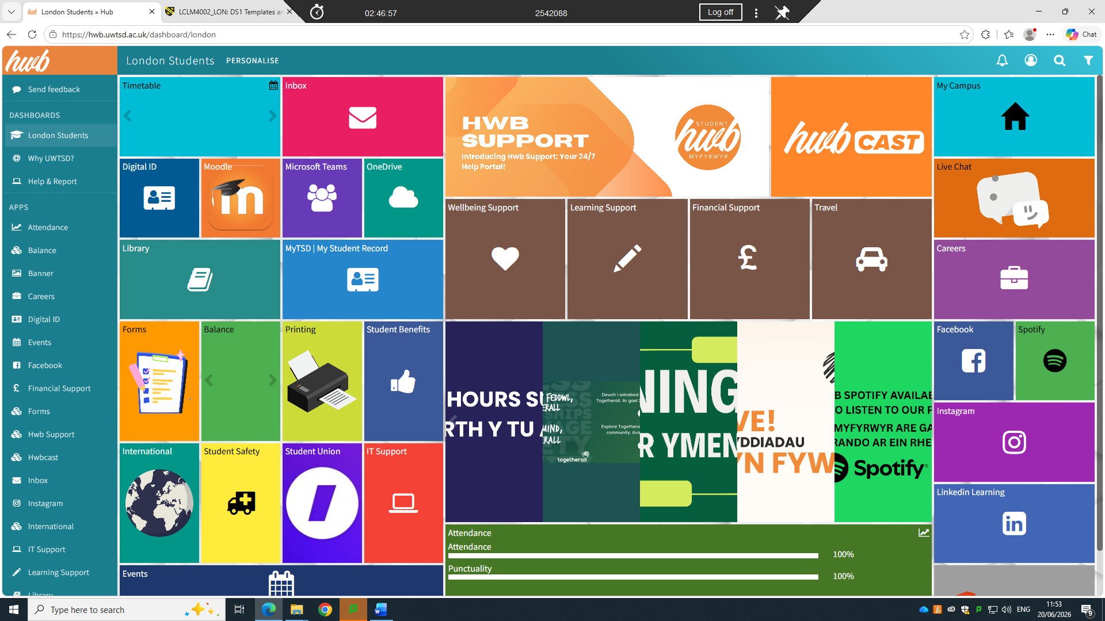
I use dashboard to know about all my tasks.

screenshot/Photo 2
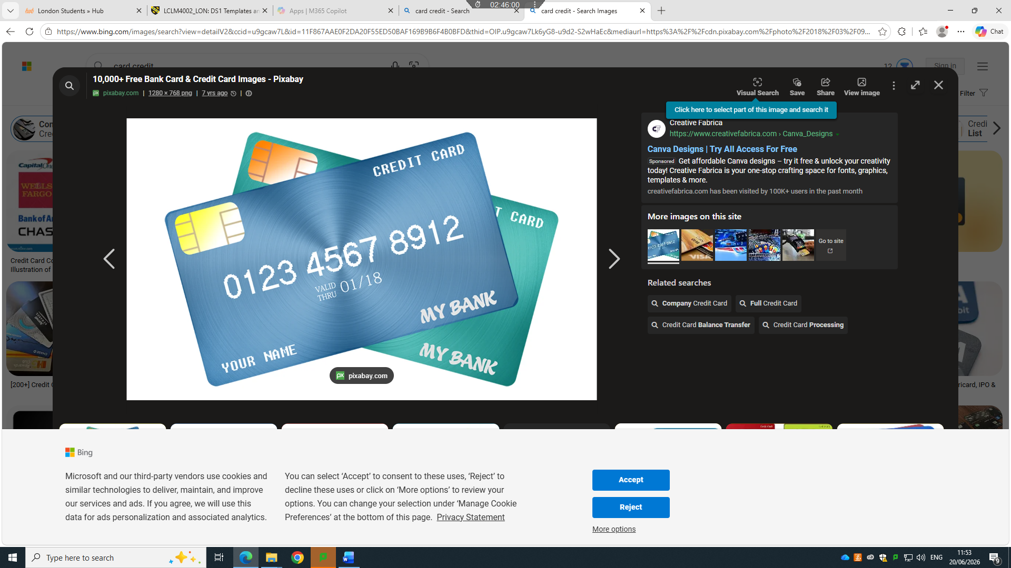
I use my credit card not to go in the bank to make easy for me to pay my bills.

Screenshot/Photo 3
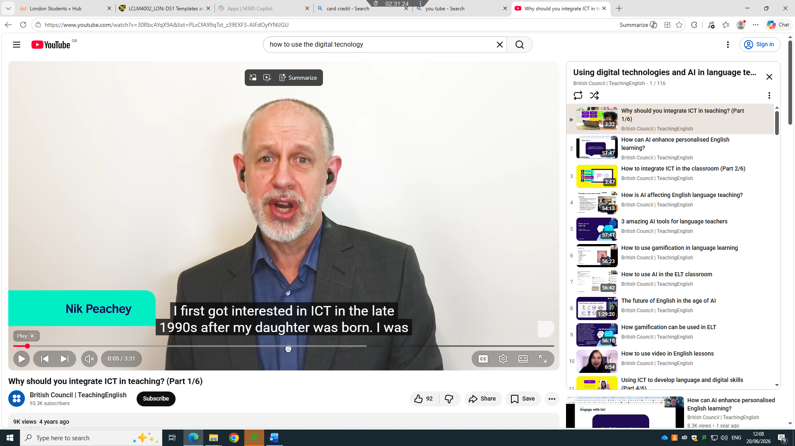
I use you tube to find how to have information about digital technology.

Screenshot/Photo 4

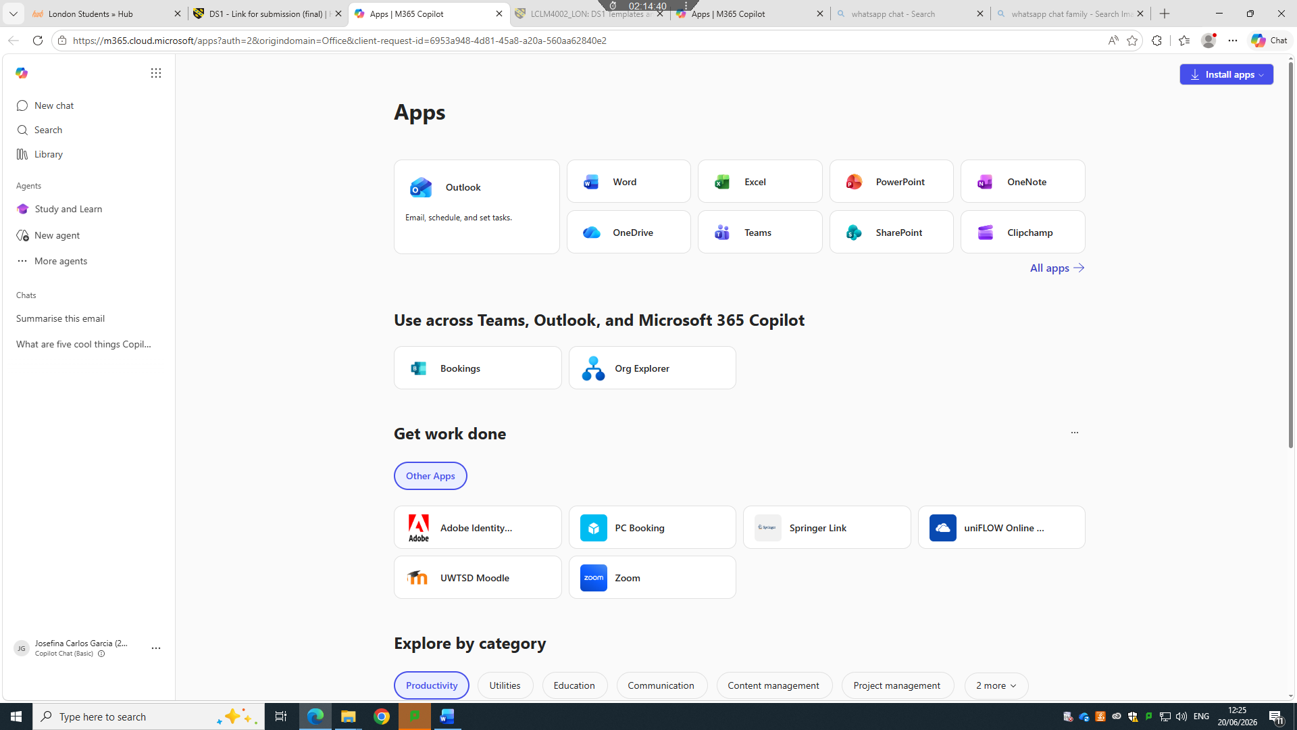
I’m using Microsoft to know about digital skill.

