Document of Intent
Supervisory roles
My supervisory roles for this project are Production Management and Animation Supervisor. I was a little apprehensive taking on both of these roles as I feel like they have the most responsibility and a lot of problems can arise if these roles are not performed effectively. My animation supervisor role has not come into much effect yet other than starting to plan out a schedule and seeing which characters are going to be ready to animate for each shot to plan out shot orders to animate. As we have not completed rigging the characters, it is difficult to give a definite start date to begin animating as most of the group have only a small amount of experience in rigging a character before and we are unsure how long this is going to take us. As one of the most prominently featured characters is the witch and I have had the most experience in rigging, I have taken on the role of rigging the witch so that she can be ready to animate as soon as possible. We will shortly be working as a group to decide what blend shapes will be needed for each character. I have taken on the Animation supervisor role as animation is my favourite task out of the whole animated short process and I have been eagerly awaiting that stage. I have accepted the role of Project Manager as I believe I have the best relationship with each member of the group and any issues that arise can be solved quickly and fairly and I am under the impression that all members of the group are comfortable voicing any problems to me and know that I will find a way to solve them. I believe I let people come up with their own ideas and like to integrate experiences from other members of the group to improve the overall outcome of the project where others may stick to a narrower route. However, I am already struggling to keep up with the amount of work this role entails due to other commitments. I think I will still be able to successfully take on this role as I am organised, I enjoy planning and I always get the task done to an acceptable standard within the time limit no matter what the circumstances. Although I do feel like the role is daunting, I am looking forward to seeing how I cope with the task as intense as this.
Primary Roles
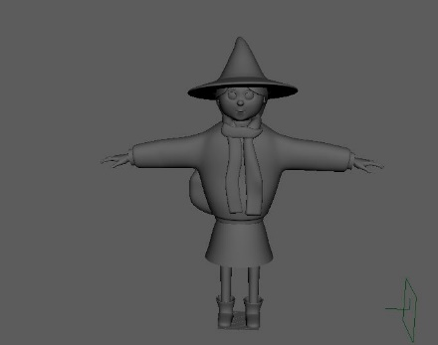
One of my primary roles is looking after all aspects of the witch character. Jiajun has modelled a basic structure for this character and passed it onto me. From this, I have corrected broken topology, added detail to the model, re-arranged parts to make it more suitable for rigging, UV’d the character as well as textured the character. I am currently at the stage where the group must decide whether the character is finished or not and there has been some disagreement over the texturing of the character which has slowed the process down at the moment.

This is a picture of the witch model that I was originally
given by Jiajun. It was great as a basic structure although there were
many holes in the model such as inside the sleeves and the skirt was very
thin so I added thickness and detail to the skirt. I also changed the scarf as
it was obvious on the model that the sections were not attached so I
re-modelled the scarf so that it will be possible to rig it so it can move
around if needs be. (Pan, J. 2018)
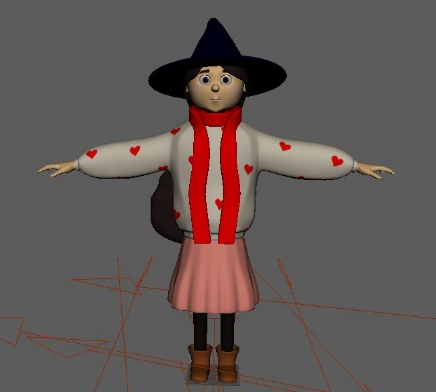
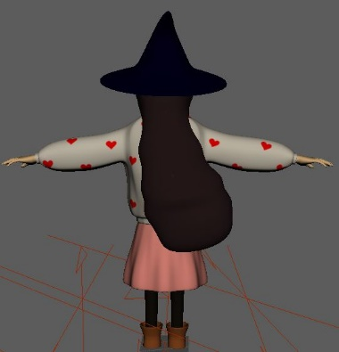
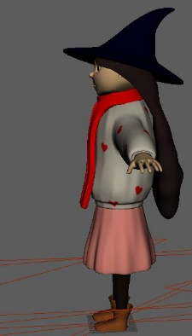
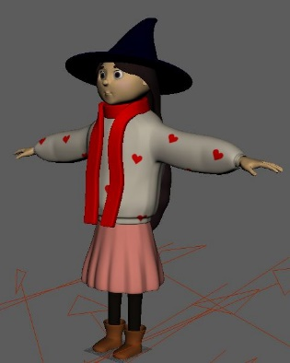

Screen shots of my witch model. I still need to add a little bit more detail to the textures but this character has almost been finished. (Own, 2018)

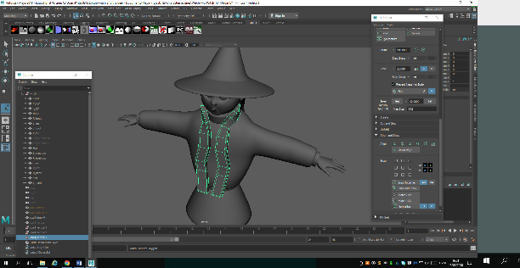
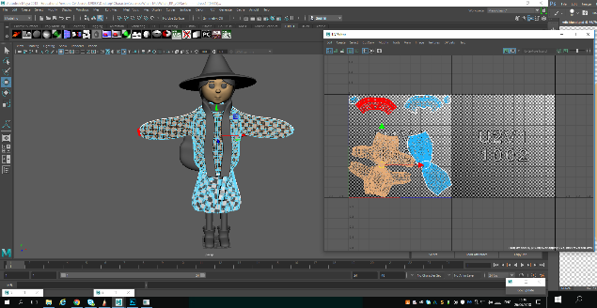

Some examples of the new topology I created and the UV snapshot of the characters torso and skirt. (Own, 2018.)
Originally, another one of my primary roles was to build all of the props for the interior of the supermarket. I began by modelling numerous fans, a till and shelving units before moving onto other tasks such as the witch. In the meantime, other members of the group expressed interest in modelling sections of the supermarket themselves. Because of this, we then separated the modelling tasks differently. Each member has been given a department to model, UV and texture however they like as long as it takes on features of the moodboard that all members of the group have cooperated to make. The only downside to this that has arisen so far is the styling of textures. Some textures are realistic but textures such as the ones featured on the witch are less realistic, which is why there is still an unresolved disagreement on how everything will be textured. Time will most likely decide this for us but we would like to get all aspects to the quality expected by all group members.
My department is the soft play and ball pit area which features heavily in the Deer scenes in the animation. I have enjoyed modelling the play areas as I have experimented with different techniques to get the best outcome such as using nurbs surfaces to create the slide. Another task I am experimenting with is creating a ‘net-like’ texture that features a plane with some transparent areas. I am having trouble UVing the plane that I have used for it to not stretch when the texture is on and also the transparent areas are appearing black when rendered so I need to research how this is done to get a better outcome. I have also been testing different ways to full the ball pit with balls and how they are going to react correctly with the Deer when he is in the ball pit. I have having issues with the particles and nmesh dynamics at the moment and can’t get the balls to fill the ball pit correctly. I will be attempting other ways to see if I can achieve a better outcome. This is one of the tasks that has been misjudged with how much time it is going to take and extra time will need to be added to the schedule for this aspect of the project.

Some rendered images of the softplay area. (Own, 2018)
We will all take on a primary role in rendering. We have currently done a number of rendering tests but as we have not finished a lot of the texturing yet, we are still unsure if we have an accurate time frame planned out for the rendering process. We are hoping to begin rendering by the beginning of August. At the moment, Stuart and I will be taking on the primary roles of compositing as we have both been working on the Pre-viz and have more of a grasp on the new order of shots. Stuart has been working on sorting out music for the piece and as I have been in charge of the sound effects for the pre-viz, I will take on the role of sound effects supervisor for the main project.
Secondary Roles
Next, I will be allocating shots for each member of the group to animate depending on what characters are rigged and ready to go. I am hoping to take on a large animating role as I feel like this is the area that I will best perform whereas other members have mentioned that they want to carry on with modelling at the moment which will be fine in the current overall forecast of the project. I would like to take a smaller role in the lighting as I feel like this is not a skill that I am capable of possessing and I think to get it to any great standard would need more practice time than this project allows therefore I am hoping to take more of a secondary role approach to lighting which corresponds well in the group as other members have expressed interest in taking lighting as their primary role.

