Unit Two homework sheet
- Practise writing the characters
tā
e
he
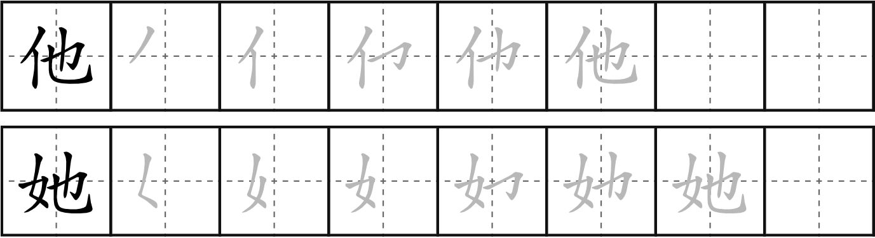
tā
hi
she

- Identify the radicals of the following characters. Write down the radicals and their English names in the brackets
- 河 (hé) - river（ ）
- 妻 (qī) - wife（ ）
- 喊 (hǎn) - shout（ ）
- 抖 (dǒu) - shake（ ）
- 烧 (shāo) – cook; burn （ ）
- 狸 (lí) – leopardcat （ ）
- 馊 (sõu) - food turning off（ ）
- 苦 (kǔ) – bitter （ ）
- 慌 (huāng) – panic （ ）
- 论 (lùn) – discuss （ ）

- Answer the following questions in pinyin or Chinese characters
e.g.: Ruth Jones shì nǎ guó rén?
Q: Ruth Jones是哪国人？
A: 她是威尔士人。/ tā shì Wēiěrshì rén。
Benjamin Cumberbatch shì nǎ guó rén?
1. Q: Benjamin Cumberbatch是哪国人？
他是英格兰人。
A: ______________。
Anthony Hopkins shì nǎ guó rén?
2. Q: Anthony Hopkins是哪国人？
他是威尔士人。
A: ______________。
Wú jīng shì nǎ guó rén?
3. Q: 吴京是哪国人？
他是中国人。
A: ______________。
Cillian Murphy shì nǎ guó rén?
4. Q: Cillian Murphy是哪国人？
他是爱尔兰人。
A: ______________。
Shani Rhys James shì nǎ guó rén?
5. Q: Shani Rhys James是哪国人？
她是威尔士人。
A: ______________。
David Tennant shì nǎ guó rén?
6. Q: David Tennant是哪国人？
他是苏格兰人。
A: ______________。
- Translate the following sentences into pinyin and record yourself reading them.
Hi, my name is xx. I’m (nationality). What’s your name? Where are you from?
你好我叫多米。我是威尔士人。你叫什么名字？你是哪国人？

- Cultural study
https://us02web.zoom.us/rec/share/Ce3-CN5u12lPP2TaoQ1T0W7Kj4kcj-vx1oA0q_XWAPZT-WAd-urBSCYvwC4Jez0a.IDLKyumKUwr5FCBM
Passcode: 659=NDFD
Research question:
1. What are the cultural symbols of Wales? Can you list a few?
Draig goch, cennin, cennin bedr, cestyll, mynyddoedd, yr iaith Gymraeg, eisteddfodau, canu, rygbi a pêl droed, picau ar y maen, y mari lwyd, telyn, tri pluen.
2. What do yellow daffodils mean in Wales?
Dydw i ddim yn siŵr beth yw ystyr cennin bedr. Rydym yn defnyddio'r symbol yma oherwydd mae’r cennin bedr yn tyfu yn y Gwanwyn. Mae ddiwrnod ein nawddsant, Dewi Sant, hefyd yn y gwanwyn ac felly mae yna gysylltiad amlwg fan yma. Y Prif Weinidog Cymraeg cyntaf, David Lloyd George (1916-1922), oedd un person i hybu defnydd o’r cennin bedr fel symbol Cymraeg.
Yn draddodiadol cenhinen, nid cennin bedr ydy symbol y Cymry. Yn hen hanes y Cymry, yn ystod brwydr yn erbyn y Sacsoniaid, penderfynodd y Cymry i wisgo cenhinen er mwyn adnabod ei gilydd ar faes y frwydr. Bu symbol o’r cennin aros am gannoedd o flynyddoedd. Rydym yn gweld cenhinen yn waith llenyddiaeth pan mae’r Cymry yn cael eu trafod, megis drama Shakespeare ‘Henry IV Part 1’. Felly, mae’r ddau yn symbol o Gymru, ond un yn cael hanes llawer fwy hen na’r llall.
3. Can you list five Chinese cultural symbols?
Temple of Heaven, The Great Wall, The Terracotta Warriors, Pandas, Food.
4. What does the Peach Blossom Spring imply for?
Utopia, the perfect place, a place that we should all wish to achieve, Nirvana.The Peach Blossom Spring story sounds like the new Marvel film, ‘Shang-Chi and the Legend of the Ten Rings’.
5. Do you know any literature form in the UK or Europe with the concept of the Peach Blossom Spring or idyllic land? Can you introduce it to us?
Utopia by Thomas Moore. Eden the lost garden. Islamic gardens try to re-create an Eden.
6. What do you think about the Chinese traditional painting? Can you summarise some features?
Beautiful, simple lines, movement, accuracy, perspective, use of ink, simple forms brought together to create a complex landscape.

