DOCUMENTATION
ON
PROGRAMMING IN C

5th April 2019

Faculty: School of Applied Computing
University of Wales Trinity Saint David
Student name: Gemma Dunlop
Module: Software Development
Lecturer: Mike Dacey/Tim Bashford
Programme: BSc (Hons) Computing Portfolio

Contents
Exercise 1 4
Before Coding 7
Problem Solving 8
Problems (easiest to hardest) 8
Evidence of Problems faced during coding 10
Duplicated Code 10
Testing 15
Testing Table 15
Test 3 17
Test 4 18
Test 6 19
Test 8 20
Test 9 21
Improvements 23
Exercise 2 24
Before Coding 26
Problem Solving 28
Problems (easiest to hardest) 28
Testing 29
Testing Table 29
Test 3 34
Test 4 35
Test 5 36
Test 7 37
Test 10 38
Test 11 39
Test 12 40
Test 13 41
Improvements 42
Exercise 3 43
Before coding 46
Problem Solving 49
Problem 1 50
Problem 2 53
Problem 3 55
Testing 56
Testing Table 56

Software Development assignment in C++

Exercise 1
I created a two-player game where player 1 enters 7 numbers within the range 1-10 and player 2 must guess whether the numbers player 1 has entered are higher or lower than the one before.
For exercise 1, I created 2 main functions: one function for when player 1 inputs their numbers, and another one for when player 2 enters their guesses.
In my first function, I created a for loop which allowed the program to output numbers consecutively within the range 1-7 starting with 1 and between each number outputted, the program read a number between 1-10 that player 1 has inputted. I added a while loop inside my for loop so player 1 can only type numbers between 1 and 10 or else a warning message shows up asking them to enter a number between 1 and 10. Player 1 also cannot any input any non-numbers, such as letters or non-alphanumeric characters.
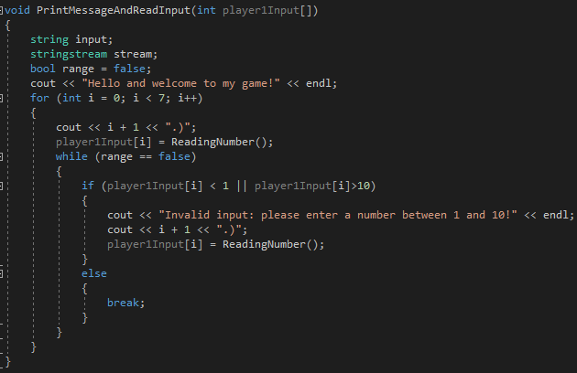
Output:
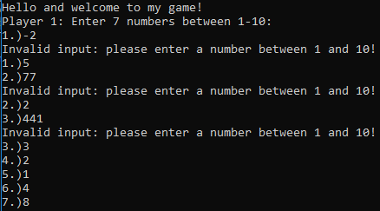
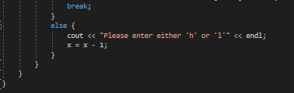
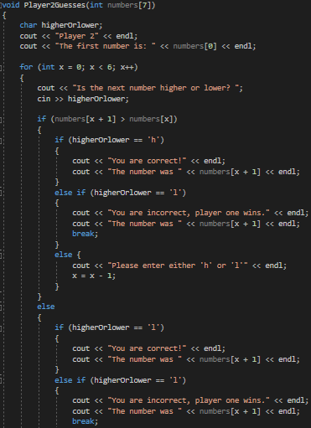
For my second function, I created another for loop for when player 2 makes their guesses. I made sure if player 2 entered any characters other than the letters ‘h’ or ‘l’, the program would not accept the input and will give player 2 a warning message asking them to enter their guess again. I did this by creating else statements after the if and if else statements.

Examples of outputs:
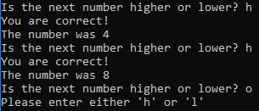
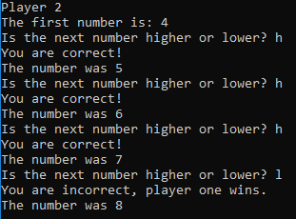
Next I called both my functions in the main body, along with a “system(“CLS”);” command between the two functions to hide player 1’s numbers from player 2.
This is what my main body looked like in the end:
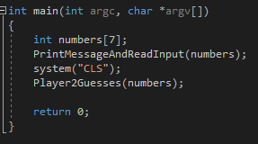
I also created a separate function for player 1’s numbers to minimise invalid input. This means the program will not accept a value inputted which is not a number.
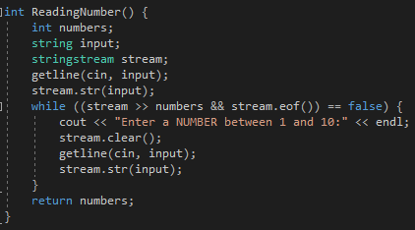

Before Coding
Before I started coding, I planned out my code on paper first. I decided to write down which elements of C++ I knew how to use which would possibly be useful for my game. As I was only just starting out with learning C++, I had not fully grasped how to use for loops hence why I put a question mark alongside it in my notes. Initially, I hadn’t used any for loops which meant my code was longer than it should have been.
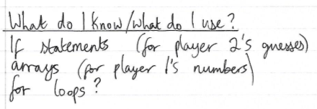
I then wrote any variables/arrays I needed to use to code my game.
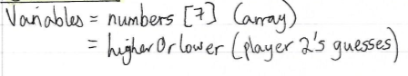
Next, I created a flow chart which I felt was the most effective way of planning my code ahead of coding as it gave me a feel for how the game works and what needed to be used where.
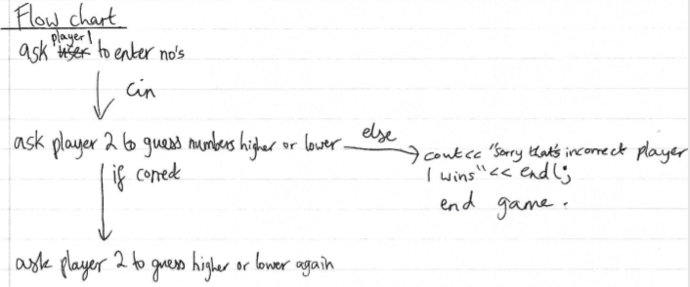

Problem Solving
After planning, I then began typing my code. However, I had with a few issues with it. I wrote each problem I had with my code on paper in a random order and alongside each problem, I wrote down possible solutions to each problem.
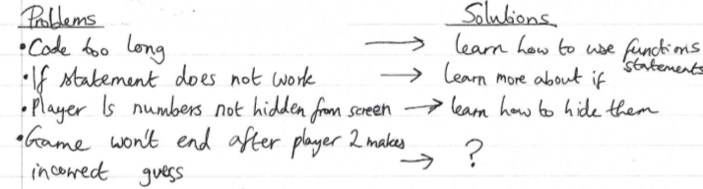
I then organised each problem from easiest to hardest and tried to solve each one in that order.

Problems (easiest to hardest)
- Player 1’s numbers are not hidden from the screen when player 2 makes their guesses.
- The ‘if’ statement does not work in the code where player 2 makes their guesses, which means the code does not work as it should.
- The game won’t end if player 2 makes incorrect guesses.
- The code is overall is too long and I have not created any functions, I have typed code in the main body.
I decided in order to solve these problems, I needed to learn how to use functions and I had to be more knowledgeable about using for loops. I tackled this issue by researching the areas I was weak at in C++. After doing this, I wrote down what I knew after researching.
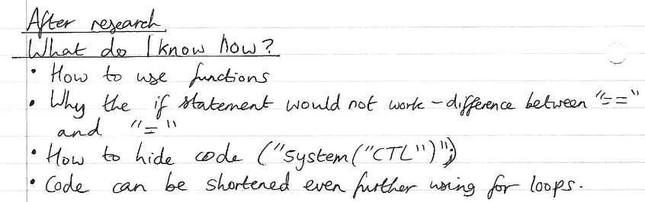

I then drew an improved flow diagram which identified how the code should look like now I understand a lot more about C++.
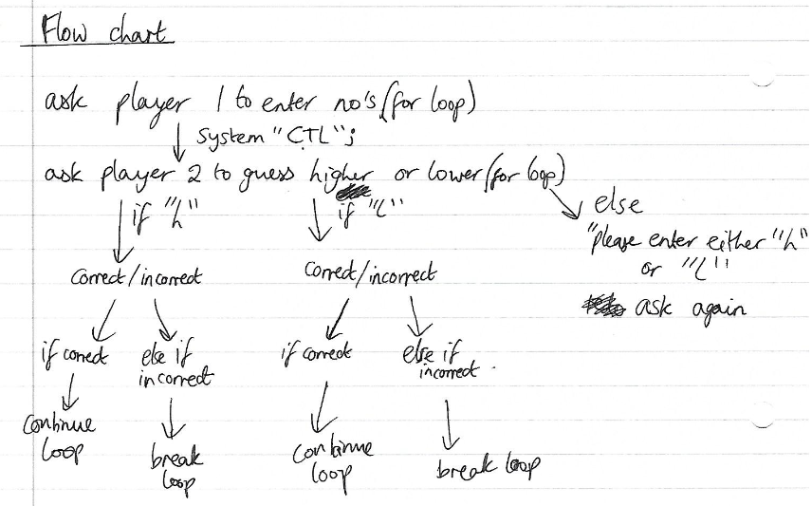
I solved problem 1 first. This was easy as I only needed to search online for the right command to use. I explained the solving of this problem, problem 2 and problem 3 during my testing. Evidence of problem 4 is explained below.

Evidence of Problems faced during coding

Duplicated Code
Initially, I wrote most of my code for the first exercise using duplicated code by coping and pasting code and changing it slightly to match each time the two players inputted values. I decided it would be beneficial to try and shorten the code as much as I could.
First I shortened the code for player 1’s input when they are asked to enter 7 random numbers between 1 and 10. This was my code at the start:
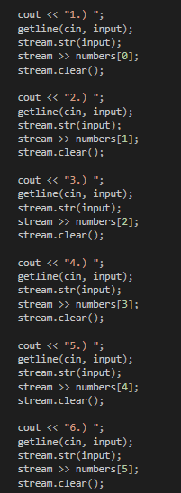
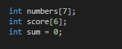

I created a function which allowed the program to read each number player 1 typed.
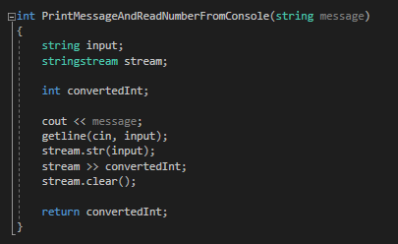
I then created a for loop in the main body to print 1-7 and between each number, I used the function I just created to record each of player 2’s numbers into an array called numbers[7].
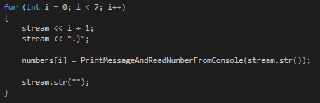
However, I realised I could simplify my code even further by putting the for loop into the function I created.
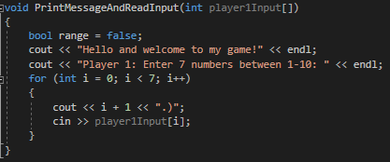
This made the main body even shorter as I just needed to call the function:
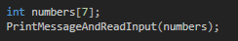

I also used duplicate code for each time player 2 entered their guesses by using the same if function 7 times.
This was the first time the user entered their guess:
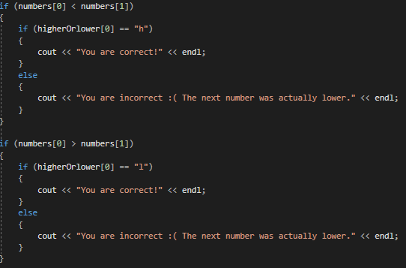
This was the second time, and the layout continued like this for every other time the user entered their guesses.
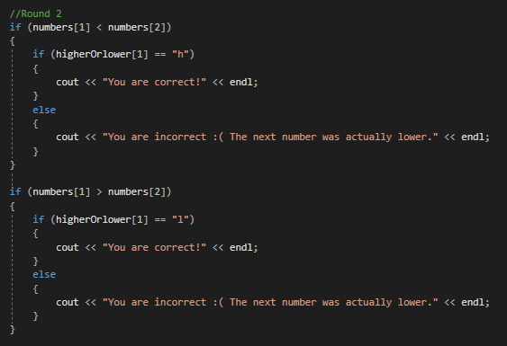

The code was incredibly long, so I resolved this issue by using a for loop instead:
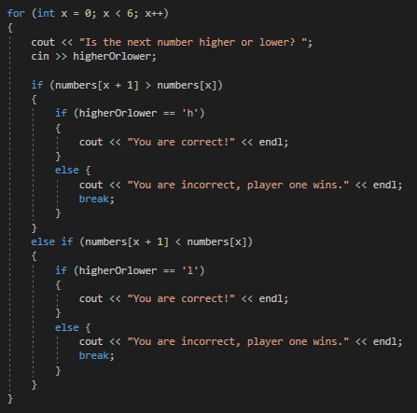

This meant only one if statement was needed for every time the user entered their guess which simplified the code and made it a lot shorter.
I also changed the “higherOrlower” variable type from a string to a char as only one character was to be entered when the user places their guesses. There was also no longer any need in using an array for this variable as my loop meant only one if statement and the value of the variable changed each time player 2 entered their guess.

Using for loops also allowed me to shorten the code for when the game asks the user to guess the next number.
So instead of using duplicate code like this for each guess:
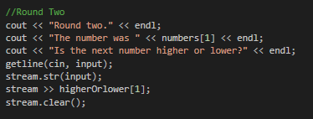
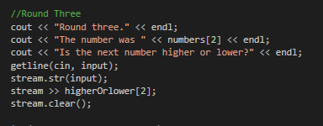
The code looked like this instead, and the if statements only needed to be used once:
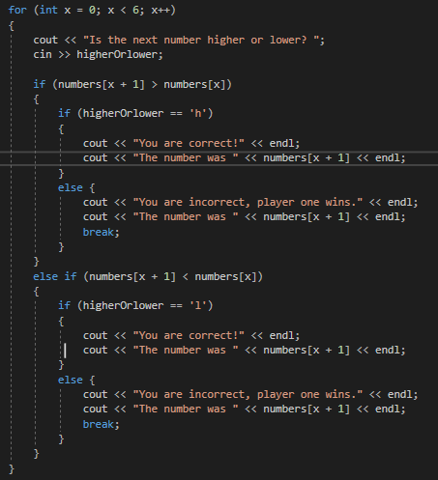

Testing

Testing Table
Test No | Aim of Test | Input(s) | Expected Output | Actual Output | Does it work as expected?
1 | Does the program ask player 1 for numbers between 1 and 10? |  | Displays ‘1.)’ and waits for a number to be inputted. | 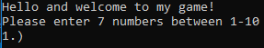 | Yes
2 | Can player 1 enter a number between 1 and 10? | 5 | Accepts the number and asks for the next one. | 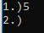 | Yes
3 | Can player 1 enter a number that is below the range 1-10? | 0 | Program does not accept value and asks to enter number again. | 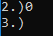 | No
3 | Can player 1 enter a number that is above the range 1-10? | 12 | Program does not accept value and asks to enter number again. | 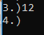 | No
4 | Does the program accept a letter being entered? | L | Program does not accept input and asks for input again. | 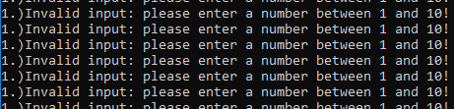 | No
4 | Does the program accept a non-alphanumeric character being entered? | * | Program does not accept input and asks for input again. | 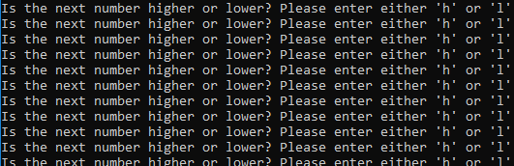 | No
5 | Does the program ask player 1 to enter 7 numbers? | 1, 5, 3, 2, 4, 2, 1 | Program asks user for a number 7 times. | 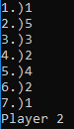 | Yes
6 | Are player 1’s numbers hidden from the screen when it’s player 2’s turn? |  | Player 1’s numbers cannot be seen by player 2. | 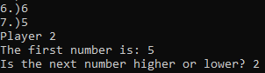 | No
7 | Does the program ask player 2 to enter either ‘h’ or ‘l’? |  | Displays what the first number is and asks to guess if next number is higher or lower. | 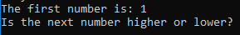 | Yes
8 | When player 2 guesses if it is higher or lower, does the program correctly state whether they are correct/incorrect? | L | The program will state that player 1 is correct if they guessed higher, and incorrect if they guessed lower. | 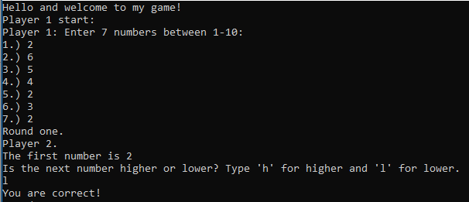 | No
9 | If player 2 enters a letter other than ‘h’ or ‘l’ does the program accept the number or decline it? | u | Program does not accept input and asks for input again. | 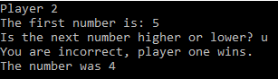 | No
9 | If player 2 enters a non-numerical character does the program accept the number or decline it? | * | Program does not accept input and asks for input again. | 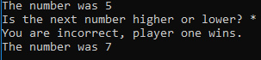 | No
10 | Does the game end if player 2 guesses wrong? | L | The program closes. | 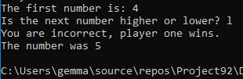 | Yes

Test 3
I had to change my code so the program would only allow numbers within the range 1-10 as the game’s rules require player 1 to type a value within this range.
I created a while loop inside the for loop I created so the game would only allow users to enter values between 1 and 10.
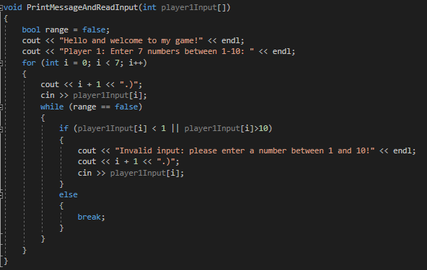

Output:
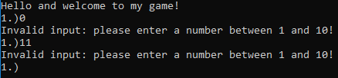

Test 4
I created a function which does not accept any value which isn’t a number to be inputted and outputs a message if the player inputs a letter instead of a number.
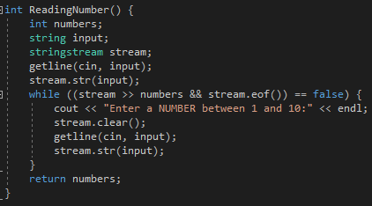
I called that function inside player 1’s function:
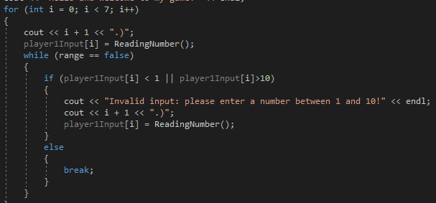

Output:
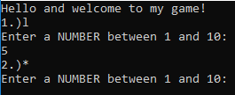

Test 6
I didn’t like how player 1s numbers were left on the screen. This defeats the point of the game as player 2 was able to see all of player 1s numbers.
I researched online and found out there is a way to clear the code once it’s finished outputting by using “system("CLS");” between functions [1].
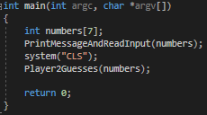

This is the output after player 1 enters their numbers. Player 1’s numbers are completely hidden from Player 2.
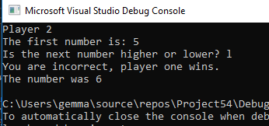

Test 8
When I tested my code to see if it worked, it seemed to have some faults as it told player 2 that they were correct in guessing the second number (6) is lower than the first (2).
This was my code:
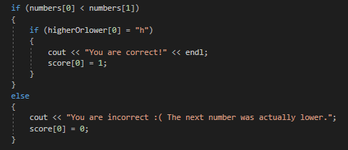
I realised this was happening as I only put one equals sign in my if statement where there should have been two. I learned the difference between one equal sign and two equals signs in C++ upon researching and I found out ‘=’ is used to assign values to variables and ‘==’ is to show something is equal to a value [2].
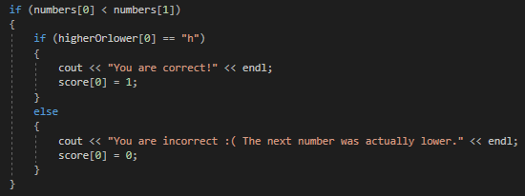

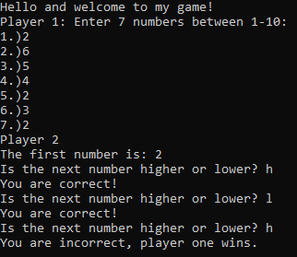
Output:

Test 9
If the user entered a value which isn’t either ‘h’ or ‘l’, the code told the user that they are incorrect, and the program closed. I needed to find a way to make the program give player 1 a warning message and re-ask them for a number if they entered a value which was not either ‘h’ or ‘l’.
Code before:
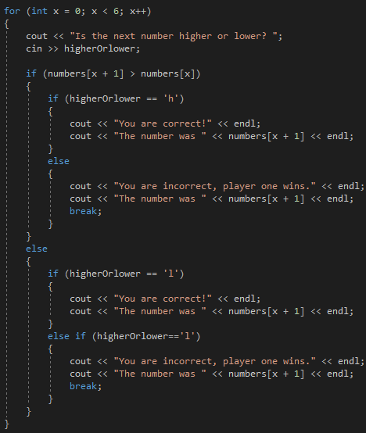

I changed the else statement to an ‘else if’ statement and added in an ‘else’ statement. This asked player 1 to enter only the letters ‘h’ and ‘l’ and by including the calculation x=x+1 into the else statement, it forced the loop to repeat when the user enters something not ‘h’ or ‘l’, whilst also not counting their value as a valid input.
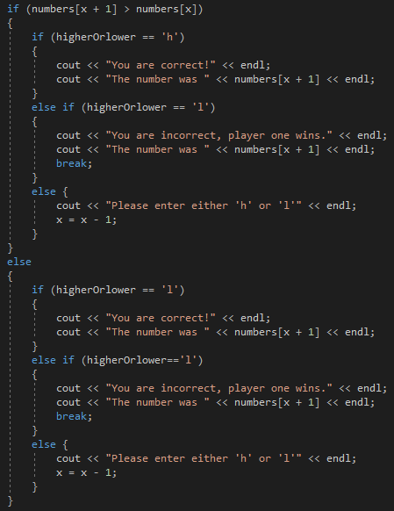
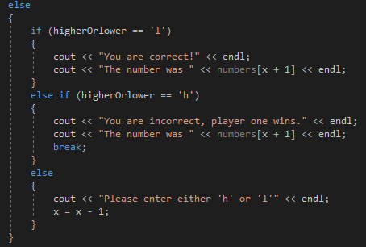
Code:

Output:
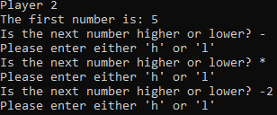
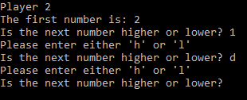

Improvements
Whilst everything was working correctly, I realised my code could be improved even further. I decided to create another function for when the user enters their guesses. I did this by simply creating a function called ‘Player2Guesses’ and copying all the code from the main body, into the ‘Player2Guesses’ function.
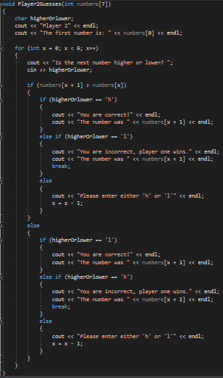
This was all that was left in the main body.
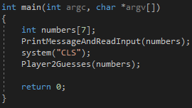

Exercise 2
I created a two-player treasure hunt game where player 1 enters 3 x and y coordinates on an 8x8 grid and player 2 must guess which coordinates player 1 chose on the grid. An ‘N’ is displayed on the grid where player 2 guessed the coordinates if they guessed them wrong, and an ‘X’ is displayed on the grid if player 2 guessed the coordinates correctly. Player 2 has three chances to guess the coordinates and after three guesses, a grid with ‘X’s showing player 1’s coordinates is displayed as the answer and the game ends.
For exercise 2, I created 3 main variables. Firstly, I created a variable to print out a blank hidden treasures grid. I did this using a 2d array and multiple cout to create lines around the array to make it look like a grid. [3]
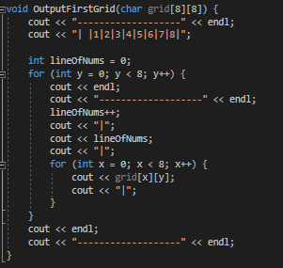

This is what was displayed in the main code:
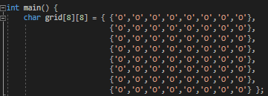

My second function asks player 1 to enter three x and y coordinates and allows player 2 to input values six times. I created an array called ‘treasuregrid’ to display a new grid with ‘X’s displayed on it to show where player 1 entered their coordinates.
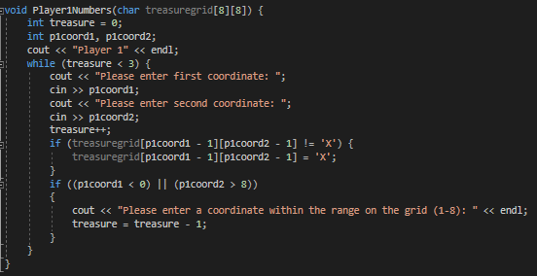
Output:
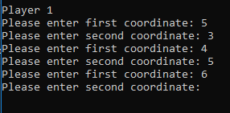
For my third function, I adapted a similar method as I did for player 1’s numbers. This asks player 2 to guess player 1’s coordinates and gives them three attempts to guess. If they guess correctly, an ‘X’ is displayed on the board where they made their guess and if they guess wrong, an ‘N’ is displayed on the grid.
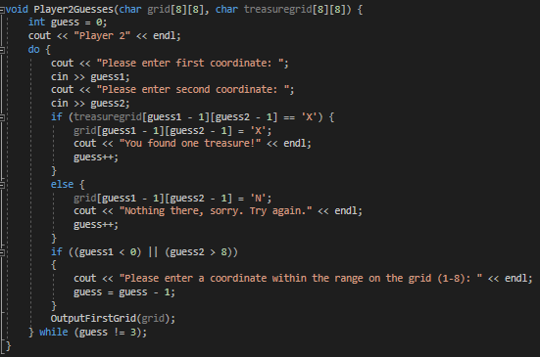

Finally, I created a board to display the answer at the end so player 2 can see where each treasure was hidden by player 1 on the grid.
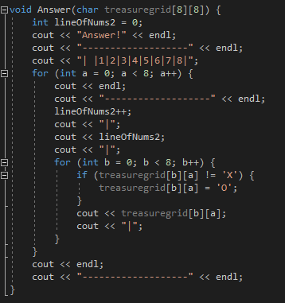

Before Coding
Before I started coding, I planned my code on paper first. I used a similar methodology as I did when I planned exercise 2. Firstly, I wrote down what I knew which I could use to code the game.
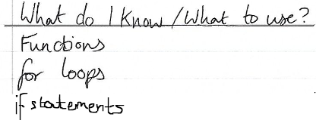
Then I wrote down the main variables I needed to use.
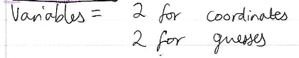
I also wrote down the functions I needed to use.
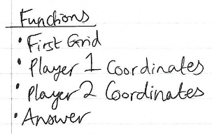

I then wrote a flow chart which helped me work out what I should use when. It also helped me get my head around how the game should work and what it should look like.
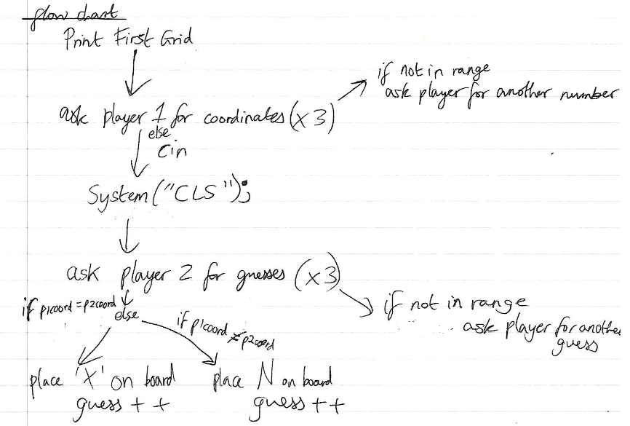

Problem Solving
Whilst coding, I encountered numerous problems. I decided to write the problems I faced in a list:
- Different coordinates are displayed on the grid to the ones player 2 enters when they make their guesses.
- Player 2 is not asked three times to guess the coordinates.
- Player 2 does not have chance to see whether they guessed their last guess correctly or not as the code clears quickly.
I then ordered the problems from easiest to hardest:

Problems (easiest to hardest)
- Player 2 does not have chance to see whether they guessed guess 3 correctly or not as the code clears quickly.
- Player 2 is not asked 3 times to guess the coordinates.
- Different coordinates are displayed on the grid to the ones player 2 enters when they make their guesses.
I included evidence of solving the first two problems in my testing and the third problem I added to improvements.

Testing

Testing Table
Test No | Aim of Test | Input(s) | Expected Output | Actual Output | Does it work as expected?
1 | Does an 8x8 grid get outputted? |  | 8x8 grid. | 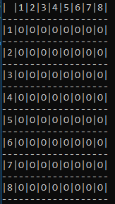 | Yes
2 | Does the program ask player 1 to enter 2 coordinates? |  | Player 1 will be asked to enter 2 coordinates. | 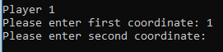 | Yes
3 | Does the program accept a number entered which is not on the grid? | 10, 11  13, 10 | Does not accept input and asks user to enter a different number. | 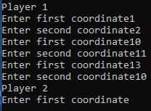 | No
4 | Does the program accept a letter being entered? | 2, y | Does not accept input and asks user to enter a number. | 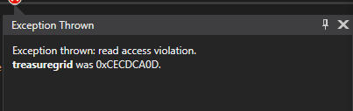 | No
4 | Does the program accept a non-alphanumeric character being entered? | -9, -- | Does not accept input and asks user to enter a number. |  | No
5 | Can the same coordinates be accepted by the program more than once? | (1, 2) x3 | Program asks player 1 to enter coordinates again. | 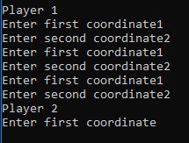 | No
6 | Does the program ask player 1 to enter 2 coordinates 3 times? |  | Player 1 is asked 3 times to enter 2 coordinates. | 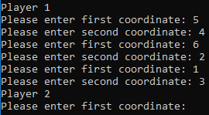 | Yes
7 | Are player 1’s numbers are hidden from player 2? |  | Player 1’s numbers cannot be seen by player 2. | 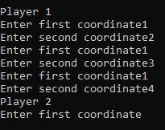 | No
8 | Is an ‘N’ is placed on the grid if player 2 guesses the coordinates wrong? | 1, 2 | An ‘N’ will be placed on the grid. | 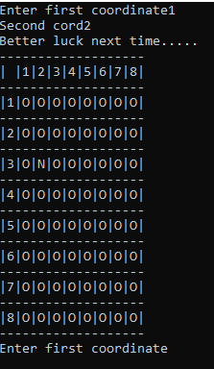 | Yes
9 | Is an ‘X’ placed on the grid if player 2 guesses the coordinates right? |  | An ‘X’ will be placed on the grid. | 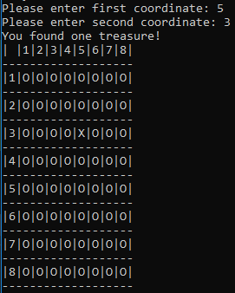 | Yes
10 | Are the right coordinates displayed on the grid when player 2 makes their guesses? |  | An ‘N’ or an ‘X’ will be displayed in the right place on the grid. |  | No
11 | Does the program accept a value to be entered which is not on the grid? | 11, 444 | Does not accept those coordinates and asks player 1 to enter coordinates again. | 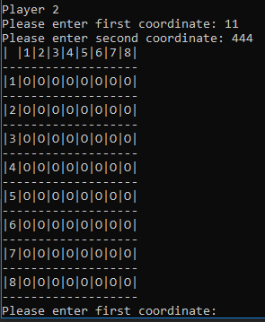 | No
12 | Does the program accept a letter being entered? | L | Does not accept that answer and asks player 1 to enter coordinates again. | 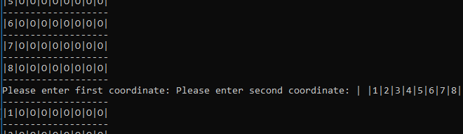 | No
12 | Does the program accept a non-alphanumeric character being entered? | * | Does not accept that answer and asks player 1 to enter coordinates again. |  | No
13 | Does the program ask player 2 to guess 3 times, despite whether they get the answer right or wrong? |  | Player 1 will only be asked to guess 3 times. | 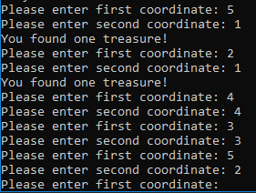 | No
14 | Does an answer get displayed at the end of the game? |  | A grid will be displayed showing where all the treasure was hidden. | 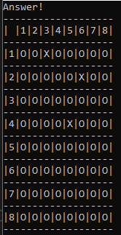 | Yes

Test 3
I tested what the program would do if I typed in a coordinate that wasn’t in the grid. It accepted values that were not on the grid.
Code before:
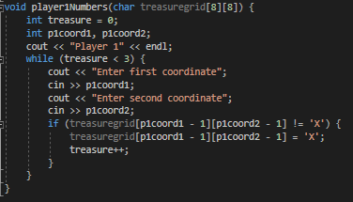
I changed this by using an if statement within the while loop.
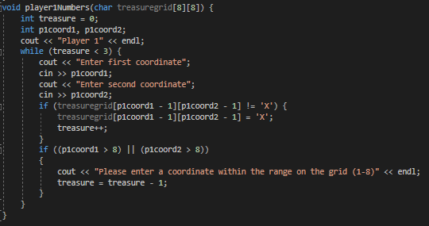

Output:
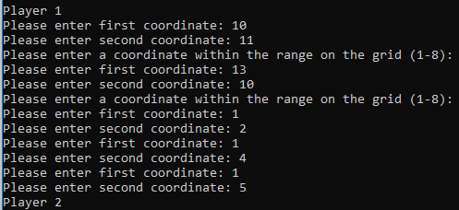

Test 4
I used the same function as I did with exercise 1 to give the player a warning message if they enter a character which isn’t a number e.g. a letter.
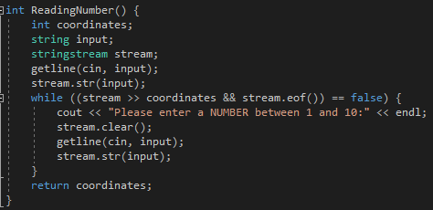
I placed the function into the Player1Numbers function so it will check for invalid data each time player 2 enters their coordinates.
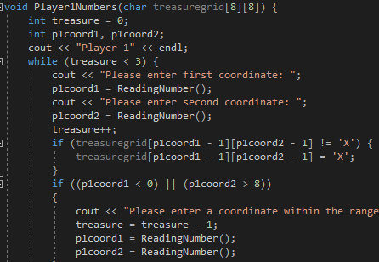

Outputs:
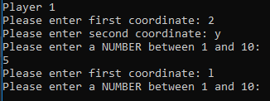
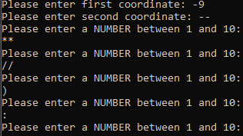

Test 5
I realised it is possible for player 1 to enter the same coordinates more than once. This could cause problems when player 2 guesses the coordinates so I tried to work out how to change that.
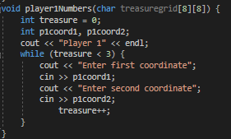

I decided to use an if statement inside the while loop to prevent duplicate coordinates. This means the program will continue asking the user for a different coordinate until an ‘X’ is filled on the grid where there isn’t one.
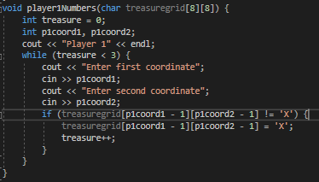
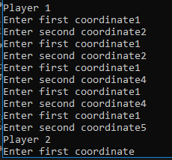
Output:

Test 7
Initially player 1’s numbers were displayed when it was player 2’s turn to guess the numbers.
I learned from exercise 1 that that can be easily solved by using “system("CLS");” in the main body of the code.
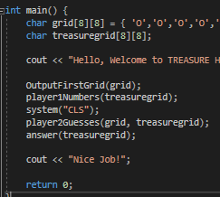

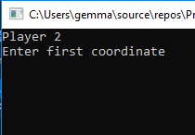
I added another system(“CLS”) to display the answer at the end on a blank screen.
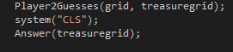

Test 10
When player 2 entered their numbers, it showed the coordinates being higher than they were.
I realised the reason for this was because I forgot to take away 1 from player 1’s guesses as arrays start from the number 0.
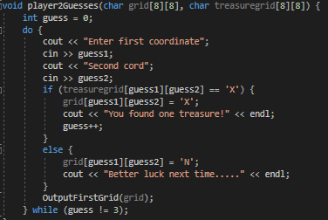
Output:

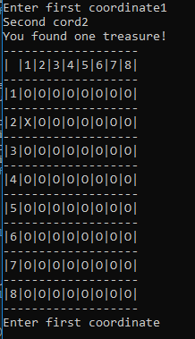

Test 11
I used an if statement within the do while loop so the program will not accept a value which is not within the range 1-8, as that is the side of the board
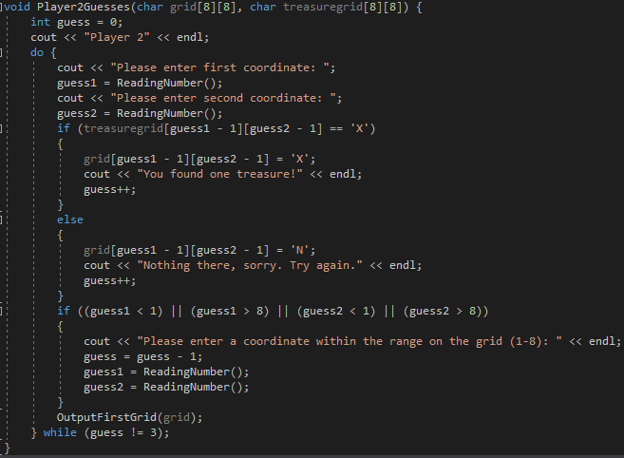

It worked and the program will ask the user to enter a coordinate within the range 1-8 until 3 treasures are entered. Unfortunately, the board will still output the board as it is part of the loop.
Output:
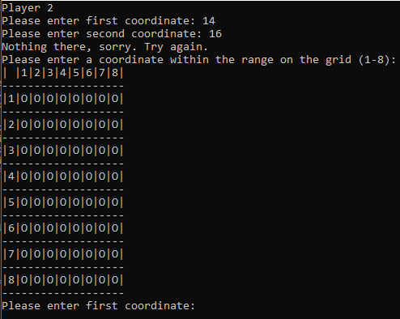

Test 12
The code kept on breaking each time player 2 enters a value which is not a number. To fix this I simply called the function I used for player 1 to prevent invalid input within my player 2 function.
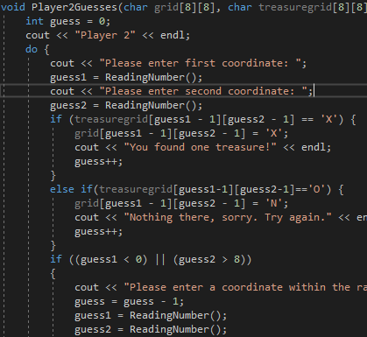

Output:
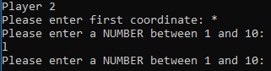

Test 13
I wanted my code to give player 2 three guesses, whether they guess right or wrong. However, when I tested my code the program gave the user as many guesses as possible until they found all three treasures.
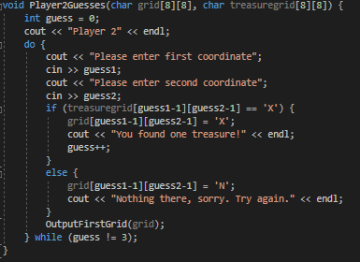
I decided the reason for this is because I forgot to add the “guess++” in the else statement.
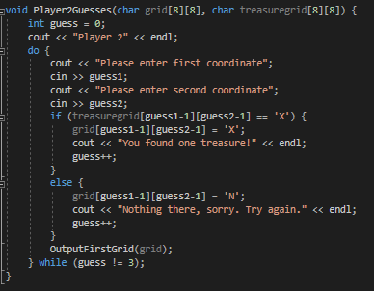

Improvements
I noticed at the end of the game, player 2 does not have chance to see if they guessed the final guess correctly as the code wipes away shortly after they guess to display the grid with the final answer (since I used ‘system(“CLS”)’ in between the variables Player2Guesses and answer).
I searched online to solve this issue and found out it could be solved using ‘system(“PAUSE”);’ [1], which I used just before the code clears.
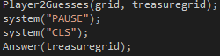
Output:
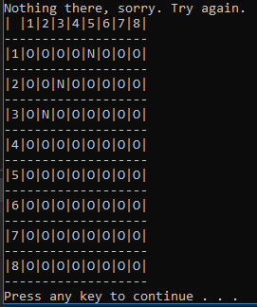
This means player 2 must press a key before the code is cleared and the answer is displayed. This gives the player chance to read whether they had the guess right or wrong.

Exercise 3
For exercise 3, I made a total of 4 functions.
Firstly, I made a function which displayed the connect four board. This was very similar to how I displayed the grid in exercise 2.
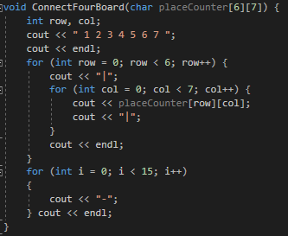
Next, I created a function for when player 1 is asked to choose a column to place their counter.
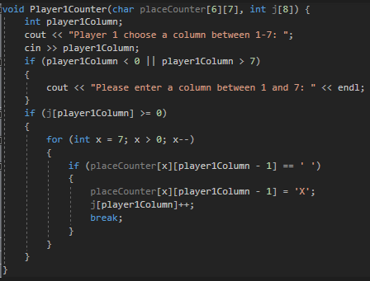

I then created a similar function for player 2.
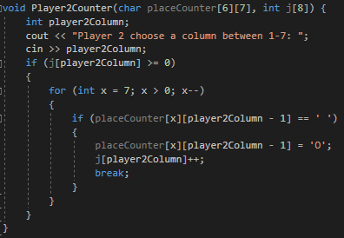
I then created a function to check for connect four horizontally.
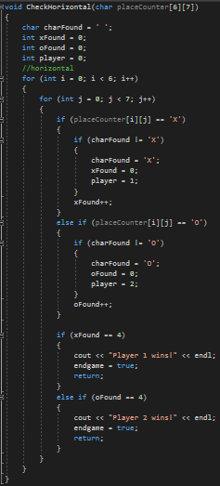
And finally, a function to check connect four vertically.
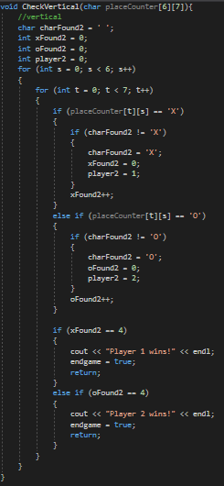
This was what was included in my main body.
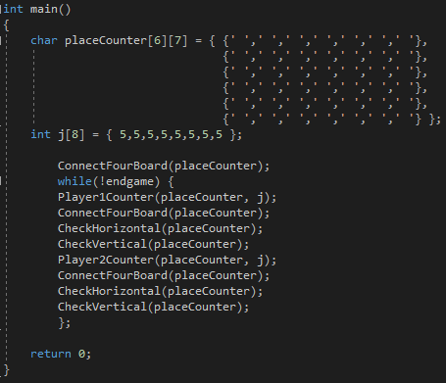

Before coding
Before starting exercise 3, I wrote down the main functions I needed to use, along with the main variables.
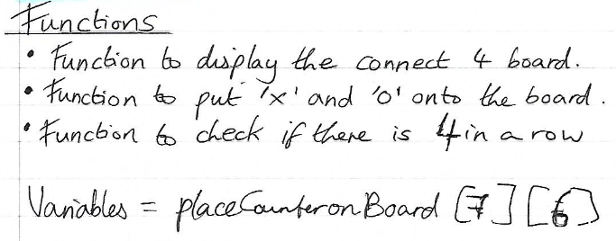

I then created a flow chart of the game:
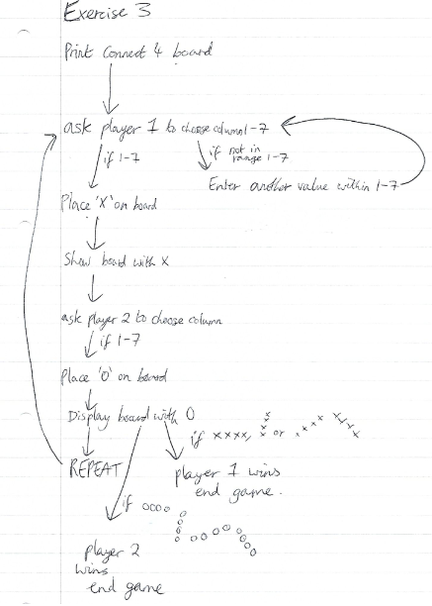

I also drew out the different ways a player could win a game.
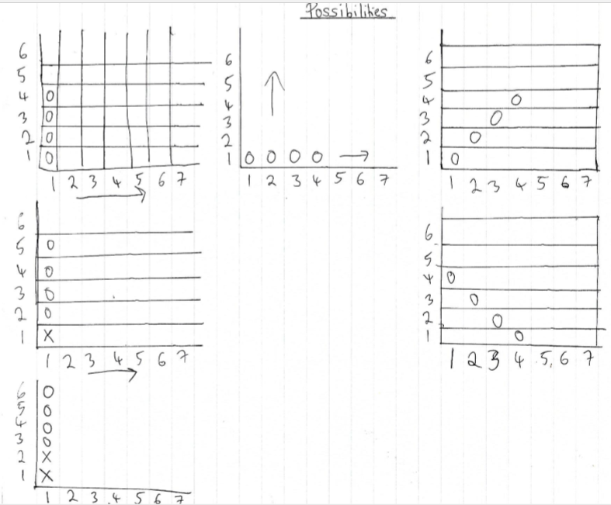
And although I didn’t get that far with my code, I planned out the time bomb and the blitz.
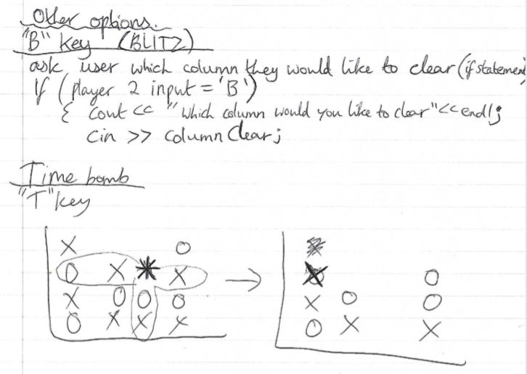

Problem Solving
The main problems I had with exercise 3 was:
- Could not display the connect four board showing counters dropped after a player has chosen a column to place their counter.
- Could not display counters in columns 6-7.
- Could not place counters on top of other counters
I managed to solve all these problems (shown below) however there was numerous problems I didn’t manage to solve. If I had more time, I feel I could have solved these problems.
- Allowing the program to connect four diagonally.
- Preventing invalid inputs such as a letter instead of a number (testing).
- Creating extra features, i.e. Time Bomb and Blitz into the game.

Problem 1
For my first function, I used a similar method as I used to print out a grid in exercise 2.
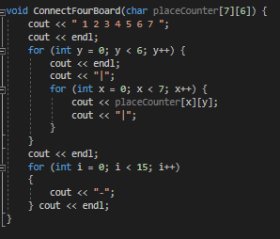
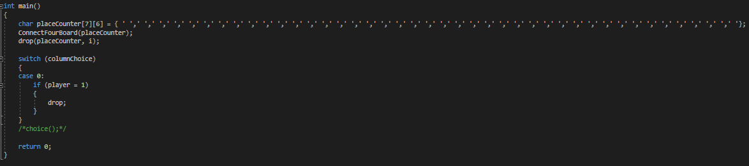
My biggest problem with this exercise was displaying the connect 4 board with the player’s counters. I was able to ask the user to enter the column they would like to drop their counter in, but I could not show the counter on the board. After the player entered their number, the program would just end.
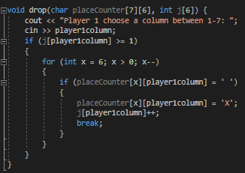
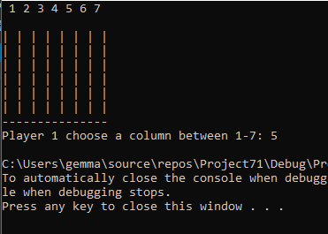

After changing the code around a bit, I managed to get it working and it outputted the grid with the players counter on. I found out the reason it did not work is the array “placeCounter” had faults so was not properly a 2d array. Also, x=6 had to be changed to x=5 to match the rest of the code. I also neatened placeCounter array to make it less confusing.
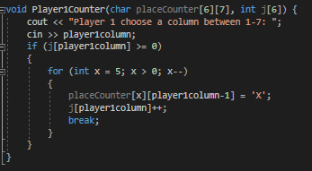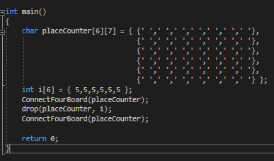
Output:
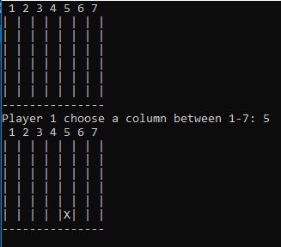

Solving this problem helped me to make the function for player 2 as all I needed to do was copy and paste the code and change the variables slightly.
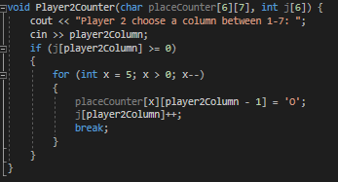
Output:
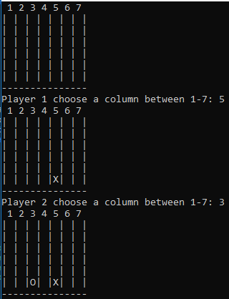

Problem 2
At first the counters would fill columns 1-5 but not columns 6 and 7.
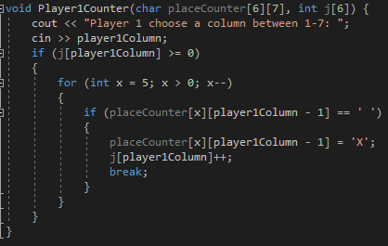
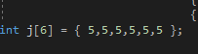
Output:
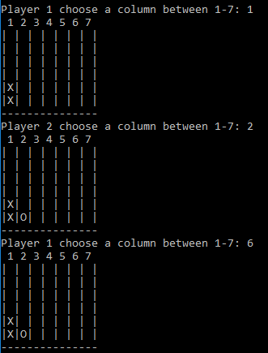
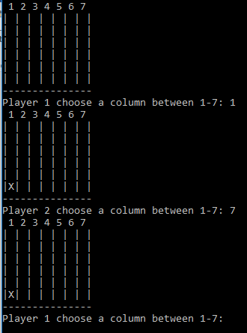
The problem was my array for “j” was set to [6] where it should have been set to 8.

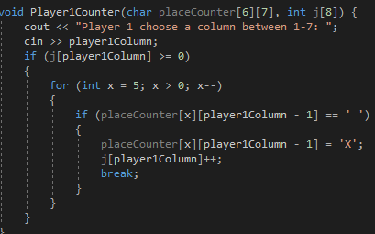
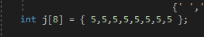
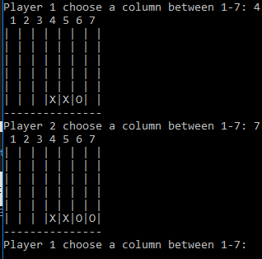
Output:
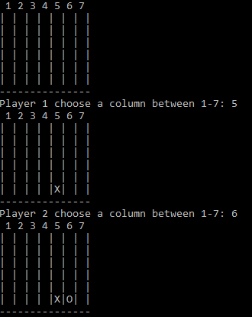

Problem 3
It would also not place counters on top of pre-existing counters.
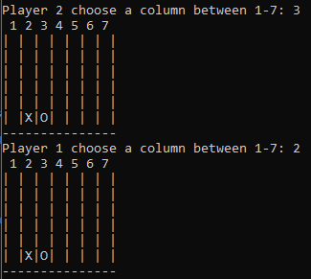
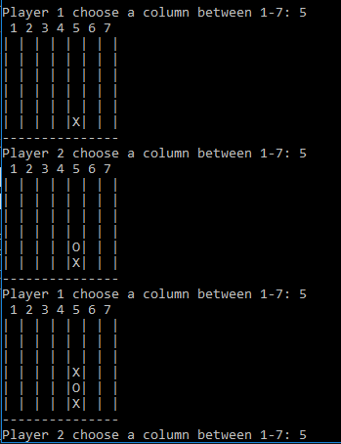
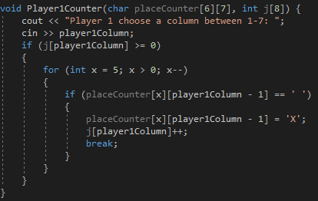
I solved this problem by including an if statement to only place an X (or an O) in places there is nothing in.

Testing

Testing Table
Test No | Aim of Test | Input(s) | Expected Output | Actual Output | Does it work as expected?
1 | Test to see if the connect four board get outputted? |  | Connect four 6x7 grid | 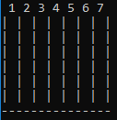 | Yes
2 | Does the program ask player 1 to choose a column? |  | Asks player 1 to choose a column between 1 and 7 |  | Yes
3 | Does the program place an ‘X’ in player 1’s chosen column? | 5 | Places an ‘X’ in column 5 | 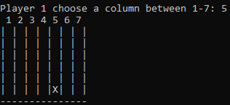 | Yes
4 | Does the program place an ‘O’ in player 2’s chosen column? | 6 | Places an ‘O’ in column 6 | 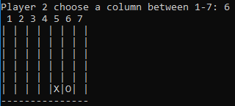 | Yes
5 | Can an ‘X’ be placed on top of another one | 5 | Places an ‘X’ on top of the existing ‘X’ in column 5 | 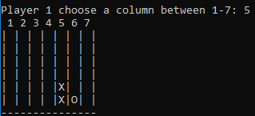 | Yes
5 | Can an ‘O’ be placed on top of another one | 6 | Places an ‘O’ on top of the existing ‘O’ in column 6 | 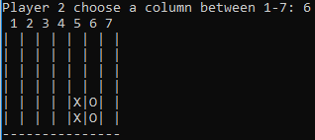 | Yes
5 | Can an ‘X’ be placed on top of an ‘O’ | 4 | Places an ‘X’ on top of the ‘O’ in column 4 | 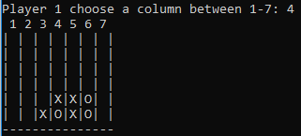 | Yes
5 | Can an ‘O’ be placed on top of an ‘X’ | 3 | Places an ‘O’ on top of the ‘X’ in column 3 | 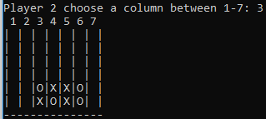 | Yes
6 | Can player 1 enter a value which is not between 1 and 7? | 9 | Does not accept value and displays a warning message asking them to enter a number between 1 and 7 | 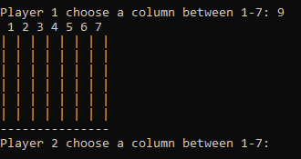 | No
7 | Can player 1 enter a letter? | s | Does not accept value and displays a warning message asking them to enter a number | 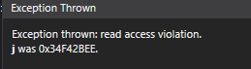 | No
7 | Can player 1 enter a non-alphanumeric character? | * | Does not accept value and displays a warning message asking them to enter a number |  | No
8 | Can player 2 enter a value which is not between 1 and 7? | 12 | Does not accept value and displays a warning message asking them to enter a number | 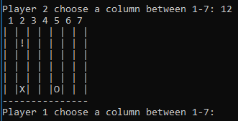 | No
9 | Can player 2 enter a letter? |  | Does not accept value and displays a warning message asking them to enter a number | 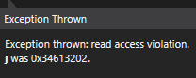 | No
9 | Can player 2 enter a non-alphanumeric character? |  | Does not accept value and displays a warning message asking them to enter a number |  | No
10 | Does it connect 4 horizontally with player 1? |  | Says player 1 has won and ends the game | 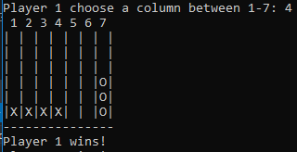 | Yes, except it does not end the game until player 2 makes their guess as that is part of the while loop
10 | Does it connect 4 horizontally with player 2? |  | Says player 2 has won and ends the game | 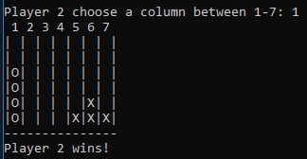 | Yes
11 | Does it connect 4 vertically with player 1? |  | Says player 1 has won and ends the game | 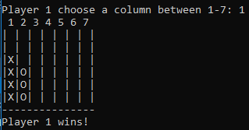 | Yes, except it does not end the game until player 2 makes their guess as that is part of the while loop
11 | Does it connect 4 vertically with player 2? |  | Says player 2 has won and ends the game | 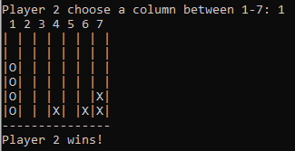 | Yes

Appendix

Bibliography

[1] | M. Bits, “mathbits.com,” [Online]. Available: https://mathbits.com/MathBits/CompSci/Screen/clear.htm.
[2] | “includehelp.com,” Include Help, [Online]. Available: https://www.includehelp.com/c-programming-questions/what-is-difference-between-assignment-and-equalto-operator.aspx.
[3] | H. Agarwal, “geeksforgeeks.org,” GeeksforGeeks, [Online]. Available: https://www.geeksforgeeks.org/multidimensional-arrays-c-cpp/.

Exercise 1
#include <string>
#include <iostream>
#include <sstream>

using namespace std;

int ReadingNumber() {
int numbers;
string input;
stringstream stream;
getline(cin, input);
stream.str(input);
while ((stream >> numbers && stream.eof()) == false) {
cout << "Enter a NUMBER between 1 and 10:" << endl;
stream.clear();
getline(cin, input);
stream.str(input);
}
return numbers;
}

void PrintMessageAndReadInput(int player1Input[])
{
string input;
stringstream stream;
bool range = false;
cout << "Hello and welcome to my game!" << endl;
for (int i = 0; i < 7; i++)
{
cout << i + 1 << ".)";
player1Input[i] = ReadingNumber();
while (range == false)
{
if (player1Input[i] < 1 || player1Input[i]>10)
{
cout << "Invalid input: please enter a number between 1 and 10!" << endl;
cout << i + 1 << ".)";
player1Input[i] = ReadingNumber();
}
else
{
break;
}
}
}
}

void Player2Guesses(int numbers[7])
{
char higherOrlower;
cout << "Player 2" << endl;
cout << "The first number is: " << numbers[0] << endl;

for (int x = 0; x < 6; x++)
{
cout << "Is the next number higher or lower? ";
cin >> higherOrlower;

if (numbers[x + 1] > numbers[x])
{
if (higherOrlower == 'h')
{
cout << "You are correct!" << endl;
cout << "The number was " << numbers[x + 1] << endl;
}
else if (higherOrlower == 'l')
{
cout << "You are incorrect, player one wins." << endl;
cout << "The number was " << numbers[x + 1] << endl;
break;
}
else
{
cout << "Please enter either 'h' or 'l'" << endl;
x = x - 1;
}
}
else
{
if (higherOrlower == 'l')
{
cout << "You are correct!" << endl;
cout << "The number was " << numbers[x + 1] << endl;
}
else if (higherOrlower == 'h')
{
cout << "You are incorrect, player one wins." << endl;
cout << "The number was " << numbers[x + 1] << endl;
break;
}
else
{
cout << "Please enter either 'h' or 'l'" << endl;
x = x - 1;
}
}
}
}

int main(int argc, char *argv[])
{
int numbers[7];
PrintMessageAndReadInput(numbers);
system("CLS");
Player2Guesses(numbers);

return 0;
}

Exercise 2
#include <iostream>
#include <sstream>

using namespace std;

int p1coord1, p1coord2;
int guess1, guess2;
int x;
int y;
int a = 0;
int b = 0;

int ReadingNumber() {
int coordinates;
string input;
stringstream stream;
getline(cin, input);
stream.str(input);
while ((stream >> coordinates && stream.eof()) == false) {
cout << "Please enter a NUMBER between 1 and 10:" << endl;
stream.clear();
getline(cin, input);
stream.str(input);
}
return coordinates;
}

void OutputFirstGrid(char grid[8][8]) {
int lineOfNums = 0;
cout << "| |1|2|3|4|5|6|7|8|";
for (int y = 0; y < 8; y++) {
cout << endl;
cout << "-------------------" << endl;
lineOfNums++;
cout << "|";
cout << lineOfNums;
cout << "|";
for (int x = 0; x < 8; x++) {
cout << grid[x][y];
cout << "|";
}
}
cout << endl;
cout << "-------------------" << endl;
}

void Player1Numbers(char treasuregrid[8][8]) {
int treasure = 0;
int p1coord1, p1coord2;
cout << "Player 1" << endl;
while (treasure < 3) {
cout << "Please enter first coordinate: ";
p1coord1 = ReadingNumber();
cout << "Please enter second coordinate: ";
p1coord2 = ReadingNumber();
treasure++;
if (treasuregrid[p1coord1 - 1][p1coord2 - 1] != 'X') {
treasuregrid[p1coord1 - 1][p1coord2 - 1] = 'X';
}
if ((p1coord1 < 0) || (p1coord2 > 8))
{
cout << "Please enter a coordinate within the range on the grid (1-8): " << endl;
treasure = treasure - 1;
p1coord1 = ReadingNumber();
p1coord2 = ReadingNumber();
}
}
}

void Player2Guesses(char grid[8][8], char treasuregrid[8][8]) {
int guess = 0;
cout << "Player 2" << endl;
do {
cout << "Please enter first coordinate: ";
guess1 = ReadingNumber();
cout << "Please enter second coordinate: ";
guess2 = ReadingNumber();
if (treasuregrid[guess1 - 1][guess2 - 1] == 'X')
{
grid[guess1 - 1][guess2 - 1] = 'X';
cout << "You found one treasure!" << endl;
guess++;
}
else
{
grid[guess1 - 1][guess2 - 1] = 'N';
cout << "Nothing there, sorry. Try again." << endl;
guess++;
}
if ((guess1 < 1) || (guess1 > 8) || (guess2 < 1) || (guess1 > 8))
{
cout << "Please enter a coordinate within the range on the grid (1-8): " << endl;
guess = guess - 1;
guess1 = ReadingNumber();
guess2 = ReadingNumber();
}
OutputFirstGrid(grid);
} while (guess != 3);
}

void Answer(char treasuregrid[8][8]) {
int lineOfNums2 = 0;
cout << "Answer!" << endl;
cout << "-------------------" << endl;
cout << "| |1|2|3|4|5|6|7|8|";
for (int a = 0; a < 8; a++) {
cout << endl;
cout << "-------------------" << endl;
lineOfNums2++;
cout << "|";
cout << lineOfNums2;
cout << "|";
for (int b = 0; b < 8; b++) {
if (treasuregrid[b][a] != 'X') {
treasuregrid[b][a] = 'O';
}
cout << treasuregrid[b][a];
cout << "|";
}
}
cout << endl;
cout << "-------------------" << endl;
}

int main() {
char grid[8][8] = { {'O','O','O','O','O','O','O','O'},
{'O','O','O','O','O','O','O','O'},
{'O','O','O','O','O','O','O','O'},
{'O','O','O','O','O','O','O','O'},
{'O','O','O','O','O','O','O','O'},
{'O','O','O','O','O','O','O','O'},
{'O','O','O','O','O','O','O','O'},
{'O','O','O','O','O','O','O','O'} };
char treasuregrid[8][8];

cout << "Hi and welcome to Hidden Treasures!" << endl;

OutputFirstGrid(grid);
Player1Numbers(treasuregrid);
system("CLS");
Player2Guesses(grid, treasuregrid);
system("CLS");
Answer(treasuregrid);

cout << "Nice Job!";

return 0;
}

Exercise 3
#include <iostream>
#include <sstream>

using namespace std;

bool endgame = false;

void CheckHorizontal(char placeCounter[6][7]);
void CheckVertical(char placeCounter[6][7]);

void ConnectFourBoard(char placeCounter[6][7]) {
int row, col;
cout << " 1 2 3 4 5 6 7 ";
cout << endl;
for (int row = 0; row < 6; row++) {
cout << "|";
for (int col = 0; col < 7; col++) {
cout << placeCounter[row][col];
cout << "|";
}
cout << endl;
}
for (int i = 0; i < 15; i++)
{
cout << "-";
} cout << endl;
}

void Player1Counter(char placeCounter[6][7], int j[8]) {
int player1Column;
cout << "Player 1 choose a column between 1-7: ";
cin >> player1Column;
if (player1Column < 0 || player1Column > 7)
{
cout << "Please enter a column between 1 and 7: " << endl;
}
if (j[player1Column] >= 0)
{
for (int x = 7; x > 0; x--)
{
if (placeCounter[x][player1Column - 1] == ' ')
{
placeCounter[x][player1Column - 1] = 'X';
j[player1Column]++;
break;
}
}
}
}

void Player2Counter(char placeCounter[6][7], int j[8]) {
int player2Column;
cout << "Player 2 choose a column between 1-7: ";
cin >> player2Column;
if (j[player2Column] >= 0)
{
for (int x = 7; x > 0; x--)
{
if (placeCounter[x][player2Column - 1] == ' ')
{
placeCounter[x][player2Column - 1] = 'O';
j[player2Column]++;
break;
}
}
}
}

void CheckHorizontal(char placeCounter[6][7])
{
char charFound = ' ';
int xFound = 0;
int oFound = 0;
int player = 0;
//horizontal
for (int i = 0; i < 6; i++)
{
for (int j = 0; j < 7; j++)
{
if (placeCounter[i][j] == 'X')
{
if (charFound != 'X')
{
charFound = 'X';
xFound = 0;
player = 1;
}
xFound++;
}
else if (placeCounter[i][j] == 'O')
{
if (charFound != 'O')
{
charFound = 'O';
oFound = 0;
player = 2;
}
oFound++;
}

if (xFound == 4)
{
cout << "Player 1 wins!" << endl;
endgame = true;
return;
}
else if (oFound == 4)
{
cout << "Player 2 wins!" << endl;
endgame = true;
return;
}
}
}
}

void CheckVertical(char placeCounter[6][7]){
//vertical
char charFound2 = ' ';
int xFound2 = 0;
int oFound2 = 0;
int player2 = 0;
for (int s = 0; s < 6; s++)
{
for (int t = 0; t < 7; t++)
{
if (placeCounter[t][s] == 'X')
{
if (charFound2 != 'X')
{
charFound2 = 'X';
xFound2 = 0;
player2 = 1;
}
xFound2++;
}
else if (placeCounter[t][s] == 'O')
{
if (charFound2 != 'O')
{
charFound2 = 'O';
oFound2 = 0;
player2 = 2;
}
oFound2++;
}

if (xFound2 == 4)
{
cout << "Player 1 wins!" << endl;
endgame = true;
return;
}
else if (oFound2 == 4)
{
cout << "Player 2 wins!" << endl;
endgame = true;
return;
}
}
}
}

int main()
{
char placeCounter[6][7] = { {' ',' ',' ',' ',' ',' ',' '},
{' ',' ',' ',' ',' ',' ',' '},
{' ',' ',' ',' ',' ',' ',' '},
{' ',' ',' ',' ',' ',' ',' '},
{' ',' ',' ',' ',' ',' ',' '},
{' ',' ',' ',' ',' ',' ',' '} };
int j[8] = { 5,5,5,5,5,5,5,5 };

ConnectFourBoard(placeCounter);
while(!endgame) {
Player1Counter(placeCounter, j);
ConnectFourBoard(placeCounter);
CheckHorizontal(placeCounter);
CheckVertical(placeCounter);
Player2Counter(placeCounter, j);
ConnectFourBoard(placeCounter);
CheckHorizontal(placeCounter);
CheckVertical(placeCounter);
};

return 0;
}

