NAME: Carmen De Luca
STUDENT NUMBER: 2207751
MODULE: LCMB7000
LECTURER: Gladius Kulothungan
COURSE: Human Resources Management
SUBMISSION DATE: 10/09/2022

PART 1 10/09/2022
- INTRODUCTION
- COVID AND BREXIT
  - Impact of labour shortage
  - Attractive wages
  - Reason for shortage labour
- HUMAN RESOURCES STRATEGIES POST COVID
3.1. People-centric workplace
3.2. Rewards and compensation
3.3. Leveraging HR Analytics for Data-Driven Decision making
- HUMAN RESOURCES STRATEGIES POST BREXIT
4.1. Improve employee retention
4.2. Different approach to attract
4.3. Different talents
4.4. Young and students
4.5. Recruitment agencies

- REFERENCES

- INTRODUCTION

In a referendum on 23 June 2016, UK citizens voted to leave the European Union.
The UK officially left the EU on January 31, 2020 and the transition period began at that time and ended on December 31, 2020.

Importantly from a business perspective, the UK will no longer be a member of the EU's Internal Market and Customs Union after the end of the transition period.
These allow the EU member states to act as a single trading territory with no customs or border controls, few import/export document requirements and a combined VAT system.
The UK now has a customs border with the EU that operates at border crossings such as Dover and Holyhead, and a separate VAT system.

The final piece of the puzzle was put together when UK and EU lawmakers ratified the free trade deal just before the transition period ended.
However, due to customs documentation requirements, VAT reporting requirements have changed.

2021 marks the first time since the UK has operated independently outside the European Union that there have been complaints of labour shortages from across the business community.
Coronavirus appears to be having the greatest impact on sectors that rely on free movement of workers within the European Union.

With lockdowns and restrictions due to COVID-19 and Brexit coming into force, many Europeans have returned to their home countries but have not.

- COVID-19 AND BREXIT
On the one hand, Brexit calls into question the sector's ability to continue to tap EU immigrants who have been able to exercise their right to freedom of movement to move to the UK and become a significant part of the UK workforce.

Meanwhile, COVID-19 has closed borders, left many UK-based workers unemployed, suddenly able to take up social work as paid workers or as volunteers, and abruptly but temporarily. created a situation. Hands and bodies ready to support the sector during the most difficult times.

The sector suffers from confusing policies, restrictions, fragmented advice, and a significant number of deaths related to significant deaths among the general elderly population, particularly those using care services.

  - IMPACT OF LABOUR SHORTAGE
Labour shortages occur when employers have difficulty filling vacancies because not enough workers are competing for positions.

Labour shortages can occur by region or in occupations that require specific skills or functions.
Labour shortages can also be seasonal in industries such as retail (Christmas) and agriculture (harvest time).
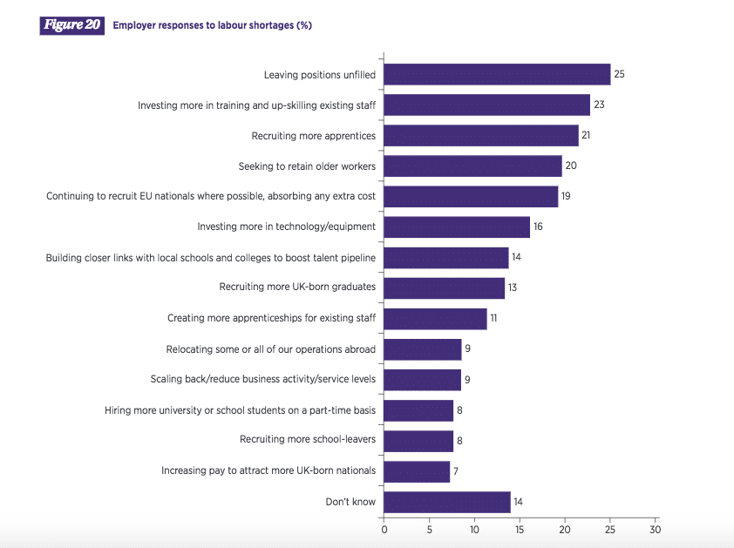
Since Brexit, the UK has recently experienced severe lab or shortages, especially in low-skilled sectors.
This has resulted in both the upside of higher wages in some of these industries and the downside of scarcity of goods and undelivered services.

  - Attractive wages:
The first economic effect is that wages rise when labor supply decreases. It's basic supply and demand, and there's a very severe labor shortage in the industry, with significant wage increases.
Raising wages is the only solution to the labor shortage:

- Make jobs vacant
- Invest more in training/technology
- Hire more apprentices (lower salaries)
- Focus on retention.

  - Reason for shortage labour

- Geographical: Areas with booming economies but poor housing may experience labour shortages sooner than other areas of the economy. In the UK, London has a strong job demand, but high rents make London relatively unattractive to workers, leading to labour shortages.

- Highly qualified jobs: Jobs that require specific skills and qualifications have a limited number of applicants. For example, professions such as doctors/nurses require longer training periods.

- Unglamorous work. In the service sector and agriculture, there are some jobs that are difficult to fill due to non-monetary costs and negative social perceptions of the job. exposed. In developed countries with high expectations, farmers may struggle to fill these low-wage jobs that are viewed as undesirable.

- Social prestige. Occupation is not only concerned with wages, but also with the prestige that comes with it. In the UK, attempts are being made to increase the number of students enrolled in universities. Occupations such as plumbers, electricians, and technicians are considered relatively unattractive to many schools and parents. The retail industry is perceived as only a 'temporary' job, and many want to avoid a career in this industry.

- Fixed salary: Public sector jobs are controlled by governments rather than market forces. For political reasons, governments can impose longer wage freezes, including public service jobs where bottlenecks are occurring. This is often a problem for professions such as education. This occupation is highly skilled but relatively low paid compared to private sector alternatives.

- Economies at full employment: labour shortages in vulnerable sectors become more likely as the macroeconomy approaches full employment.

- HR STRATEGIES POST COVID-19
  - Redefining corporate culture by moving to a people-centric workplace:
Re-establishing organisational culture will emerge as a top priority for HR departments as corporations look to implement more flexible working arrangements. There will in all likelihood be a significant shift toward hybrid working models that capitalise on the benefits of both remote and workplace working.
While this is a wonderful change, the implications of this transition threaten the current organisational culture.
The social dynamic between personnel will no longer be equal due to varying working conditions, such as less face-to-face communication and a more dispersed workforce.

· Organising ordinary check-ins exclusively for work, social interaction, or emotional support is a splendid way to establish a balanced approach to managing a far-off workforce and to give a boost to relationships.

· Promoting open communication and installing direct communication channels between all departments within a corporation will keep leadership informed of employee concerns.

· Finally, introducing diversity, equality, and inclusion insurance policies and programmes will help bolster organisational values and create an environment that promotes trust, unity, empathy, and engagement.

· As firms seem to accelerate the pace of dispersed working in the near future, it is crucial that they make an intentional effort to keep their core values. In addition, they should emphasize constructing a place of work that puts humans at the forefront of every decision.

·Additionally, focusing on employee engagement via pulse and pride surveys is a notable way to gauge their ideas and get their input on navigating the transition to the post-normal work environment.

  - Rewards and compensation:
The impact of COVID-19 has left many businesses with considerable debt levels, surging costs, next to no revenue, and weakened balance sheets.
As such, they have been forced to take measures to cut costs by temporarily deferring or reducing employee compensation and benefits.
Even though this may dictate many organisations' short-term strategies, the pandemic has also opened the door to rethinking employee benefits and rewards.
Many organisations will be looking to attract and compete for top talent to help steer the ship towards a swift and successful post-COVID recovery.
Since many employers may not be able to offer higher salaries, they may look at reducing fixed pay while increasing variable pay. This is directly linked to employee performance and productivity.
This helps incentivise employees to perform at a higher level while maintaining a healthy and competitive environment.
On the other hand, some organisations may consider taking the alternative route of offering flexible compensation and benefits packages that could give them a competitive edge.
There is also the possibility of introducing personalised compensation structures, in which employees can design their own compensation packages based on their individual preferences and needs.
  - Leveraging HR Analytics for Data-Driven Decision making:
Over the last ten of something, we have endorsed a rise in dossier-driven resolution making across all labours, trade subdivisions and organisations, and HR is no various. Workforce analytics authorizes HR to gauge clerk happening, date, and vindication.
In an effort to stay vying in the new and complex trade countryside, specifically on account of COVID-19, organisations should touch influence data to forecast their trained workers necessities and to better optimise revenues and reduce costs. They bear to enhance more dependent on data to measure and monitor workforce act and output.
By commonly analysing and listening staff member performance and date versification, HR can decide the crucial ability acquisition, incident and administration determinations necessary to develop the workforce for the challenges they will face post COVID-19.
- HR STRATEGIES POST BREXIT
  - Improve employee retention
Whilst European workers presently make up 7% of the UK body of workers, research from the Recruitment and Employment Confederation (REC) indicates that following Brexit, fewer of them will pick to fill those roles in the destiny.
Recruiters and employers are concerned approximately satisfying those positions with UK candidates and feature currently had little fulfilment recruiting United Kingdom workers into low- or medium-skill vacancies, both because UK people are overqualified, unwilling or due to disabilities or being concerned responsibilities, not able to do the activity.
The best corporations do not constantly offer the highest pay, 1,33% of personnel recall benefits packages as their maximum important considerations when seeking out a brand-new activity.
Many industries will perform with comparable units of values and ways of operating, but advantages applications are not dictated by way of outdoor forces and might rather be moulded to in shape the want and desires of each everlasting and agreement employees.
Bendy working, paintings-lifestyles balance regulations, vacation incentives, fitness programmes and reductions are among the most famous employee advantages.
A high-quality advantages package can attract new hires and assist current employees feel motivated, valued and concerned in their work, enhancing greater loyalty to their company and enhancing employee retention.
Group of workers perks also make contributions to an effective, dynamic place of work surroundings that allows all personnel thrive at paintings. growing a fine operating tradition involves encouraging personnel to paintings collectively and assist each different, as well as trusting and empowering group of workers to make adjustments and selections.
Freedom and autonomy permit employees the time and area to resolve problems and innovate new ideas, and enables workers experience excellent about themselves and the destiny of their location inside the company.
A positive company way of life can unexpectedly and sustainably increase worker retention, as well as entice new team of workers thru referrals, recommendations and a high-quality logo photograph.

  - Different approach to attract
There is a transition period for immigration from the day the UK leaves the European Union until 31 December 2020.
During the transition period, EU citizens and their families have the right to continue to live and work in the UK.
The UK government plans to introduce a new immigration system that will change the right of EU citizens to work in the UK from January 2021.
Employers who provide current and potential employees with clear guidance on the EU system and their life and work rights will ensure and protect their employees. Aiming to change EU labour and human rights law, the Big Repeal Bill aims to "maintain the protections and standards enjoyed by workers".
In many places, the UK government has extended workers' rights beyond those under EU law, including statutory annual leave, maternity and parental leave and pay.
New post-Brexit immigration rules could reduce the number of EU citizens choosing to live and work in the UK.
In 2019, EU workers decided to work in the UK, giving five reasons:

- ·Connect with friends and family already in the UK
- Pay compared to other EU countries
- Career and career opportunities
- Culture and working conditions
- British culture

At the first task vacancies visualized by potential applicants, business and course moment maybe clearly wrote, tailor-made to the member, and steadily improved during the whole of contracting. HR areas and employing managers can use the vacancies to articulate a clear career course for the posts, to entice EU task applicants who be going to build a course and wait the UK and offer an outlook on the long-term course and gain prospects of EU peasants.
An all-encompassing workplace sophistication maybe worked out by achieving measures to improve institution sophistication and occupied friendships between attendants in the UK, EU and additional nations about the world.
Create and claim favourable assorted workplaces by guaranteeing that management prioritizes and addresses all forms of intolerance and bias by contribution willing English lessons and loyal, orderly travel that specify management and HR support to members from all education.
Employers the one analyses these reasons for employment will appeal to, engage and maintain EU skilful and unskilled traders across all trade functions.
  - Different talents
Current trained workers need can meet current trade needs, but a pliable trained workers procedure is owned by suit to changes in the European and UK markets. During a casual audits of recruitment necessities, few positions concede possibility now lack aptitudes or abilities that counter potential recruitment.
Many abilities maybe well-informed attentive or collected through correct preparation programs.
The reassessment of necessities will use the new ability pool immediately usable in the UK. Candidates outside a quality but accompanying decades of knowledge maybe valuable to the institution, while senior citizens accompanying a various ability pool who lack mechanics abilities but have far-reaching information and retail happening can enhance valuable general hires when prepared.
By personalizing the bringing in process, itself, arrangements have a new ability pool. Group or committee interviews maybe difficult for young or new task applicants, and vocabulary distinctness’s can manage troublesome for skilful female claimants.
Women create as well 50% of the UK state, but only 9% of the UK type of educational institution trained workers, hostile in Europe. Despite ethnic youths creating about 14% of the UK populace, only 6% of UK engineers have a Black and Minority (BAME) training. Employers the one can tap into this new ability pool can influence their resources of new abilities, knowledge and information to gain a back-and-forth competition.
Re-hiring and recovery programs are essential for maintaining clerks later period of being pregnant with child leave, maternal leave and dearth from work on account of watching blames or ailment.
Employees replying to the commission or work need more period to regulate and adopt the demands of their role. For those the one is not certain in requesting for positions, we will recruit applicants accompanying little current knowledge or knowledge troubles by analysing and reconstructing the contender knowledge. Business chiefs can relate to recruiters and non-profits for recommendation on best practices for appropriate roles and ideas for new hires from youth, various, and marginalized groups.
Flexible occupied is a well appealing labourers reward that surpasses head count, enhances member well-being, inspiration and date and costs employers a possession. Consider the employee's current work schedule and decide if they can work from home, share work, or pick their occasion.
Flexible occupied patterns help meet the wants and needs of persons, carers, pupils and long-distance peasants.
  - Young and students
There are less young folk participating in labours to a degree production, engineering, aerospace and automotive.
For example,42% of aerospace trade chiefs and 22% of electronics trade leaders note abilities shortages as their most important business challenge in front of Brexit, mechanics advances and surroundings change.

Furthermore, more than two-three of something of current graduates in the UK voice they are now working in a position independent to their standard, and individual in three graduates say they are not satisfied accompanying their current place. Britain's young population critically need rewarding tasks, UK trades need skilful workers and apprenticeships maybe the answer. Without lyceum deficit or time restraints, our apprenticeships allow gifted individuals, although academic, public and educational background, to expeditiously expand experienced abilities that will prepare ruling class for lasting courses and enter the trained workers valuable to all.
Internships support a various workforce, reconstructing the climbing in status of chiliads of people and reveal new outlooks for trades to resolve problems and draw new consumer groups. Many view apprenticeships as inferior labour rather than a course. Businesses need to lend more time and work in advancing science as a successful course.
Last period, the UK management recruited 8,000 new construction and electronics assistants and spent £84 million in mechanics preparation to address the mechanics skills deficiency.

  - Recruitment Agencies
One of the new strategies is works with other companies and identifies potential employment opportunities in the industry through trade associations and industry associations, and works with local schools and universities to provide examples of workers enjoying their roles and making progress in low-skilled roles.
Regardless of the outcome of Brexit, internationally focused recruitment companies can continue to provide seamless recruitment services to companies in the UK, Europe and around the world.

- REFERENCES
- Uk Labour market remains hot despite stalling economy, Financial Times. https://www.ft.com/content/812f3177-2d4d-47df-9c8a-919681f56946 (accessed 29/08/2022)

- Brexit: the latest implication for HR, Victoria Templeto.
https://www.hrsolutions-uk.com/brexit-the-latest-implications-for-hr/ (accessed 30/08/2022)

- Deloitte, Workforce strategies for a post Covid-19 recovery. (Accessed 29/08/2022)
https://www2.deloitte.com/content/dam/Deloitte/ca/Documents/human-capital/ca-en-human-capital-workforce-strategies-post-covid-19-recovery-workbook-aoda.pdf

- KPMG. (2020). United Kingdom: Government and institution measures in response to COVID-19. (accessed 30/08/2022) https://home.kpmg/xx/en/home/insights/2020/04/united-kingdom-government-and-institution-measures-in-response-to-covid.html

- Chillakuri, B., & Mahanandia, R. (2018). Generation Z entering the workforce: the need for sustainable strategies in maximising their talent. Human Resource Management International Digest, 26(4), 34-38.

- Keogh-Brown, M. R., Jensen, H. T., Edmunds, W. J., & Smith, R. D. (2020). The impact of Covid-19, associated behaviours and policies on the UK economy: A computable general equilibrium model. SSM-population Health, 100651. (Accessed 30/08/2022)

