T-Tests in SPSS

Which One to Use?
First thing’s first! A t-test is what you use to compare the mean average value of two groups. For example, let’s say you want to test whether or not some sort of mulch made of mushrooms makes trees grow more; to prove/disprove it, you have the heights of 50 trees that were mulched, and 50 that weren’t. The t-test will compare these averages and tell you if there is a significant difference or not.
BUT! There are two types of t-test. You need to know whether to use an independent t-test, or a paired t-test.
What’s the difference?

 | Independent  t-test | Paired  t-test
Used on: | Two unrelated study groups | The same study group, measured twice
Example: | One plot of trees that got mulched, and a separate plot of trees that didn’t. Both measured at the start, then after five years; the test compares the height difference between the two separate plots | A plot of trees that was measured over five years, then mulched, then measured again over another five years. The test compares the difference in growth rate before and after mulching

Use this table to work out which you need!
Bear in mind, you will need to make sure your dataset only has two independent variables; that is, you can only compare two groups at a time with a t-test. There can be as many trees as you like in each sample! But only two sample groups: mulched and unmulched, or before and after mulching.
The other thing to remember is that this test is only appropriate for data with a normal distribution. If your data does not have this, you’ll need to use a Mann-Whitney-U test instead.
So! On with the show!

Independent T-Tests

Inputting the Data
First, let’s input our data!
You can, of course, copy and paste from an Excel file, but it’s important to make sure the data is inputted correctly in SPSS so that it can do its thing. So, first set up your variables.
This is a very quick example file I’ve invented to give you an idea.
- First, open up SPSS, and click the “Variable View” button at the bottom of the box
- Name your variables. As you are comparing height difference and the presence/absence of mulch here, these are the most important two to include. Remember that you cannot have spaces between words here; but, you can use underscores instead (e.g. “Height Year 1” won’t work, but “Height_yr1” will). However, you can write them out properly in the Label column.
Note: SPSS will work fine if you don’t use Labels, but the graphs and tables will be harder to read once it gives you your results.
- Define your grouping variable, i.e. whichever variable sorts these numbers into the two groups you want to compare. Here, that’s the plot the trees were in: plot 1 was mulched, and plot 2 was unmulched.
For that column, click “Values”. It will open up the Value Labels box. Click the green plus icon twice to add the two groups. Under “Value” enter the number of the plot, and under “Label” write in what the number represents. Here, 1 is “mulched”, and 2 is ”unmulched.”
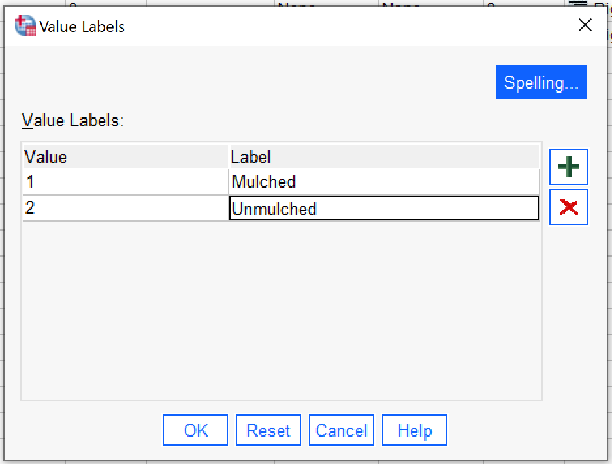
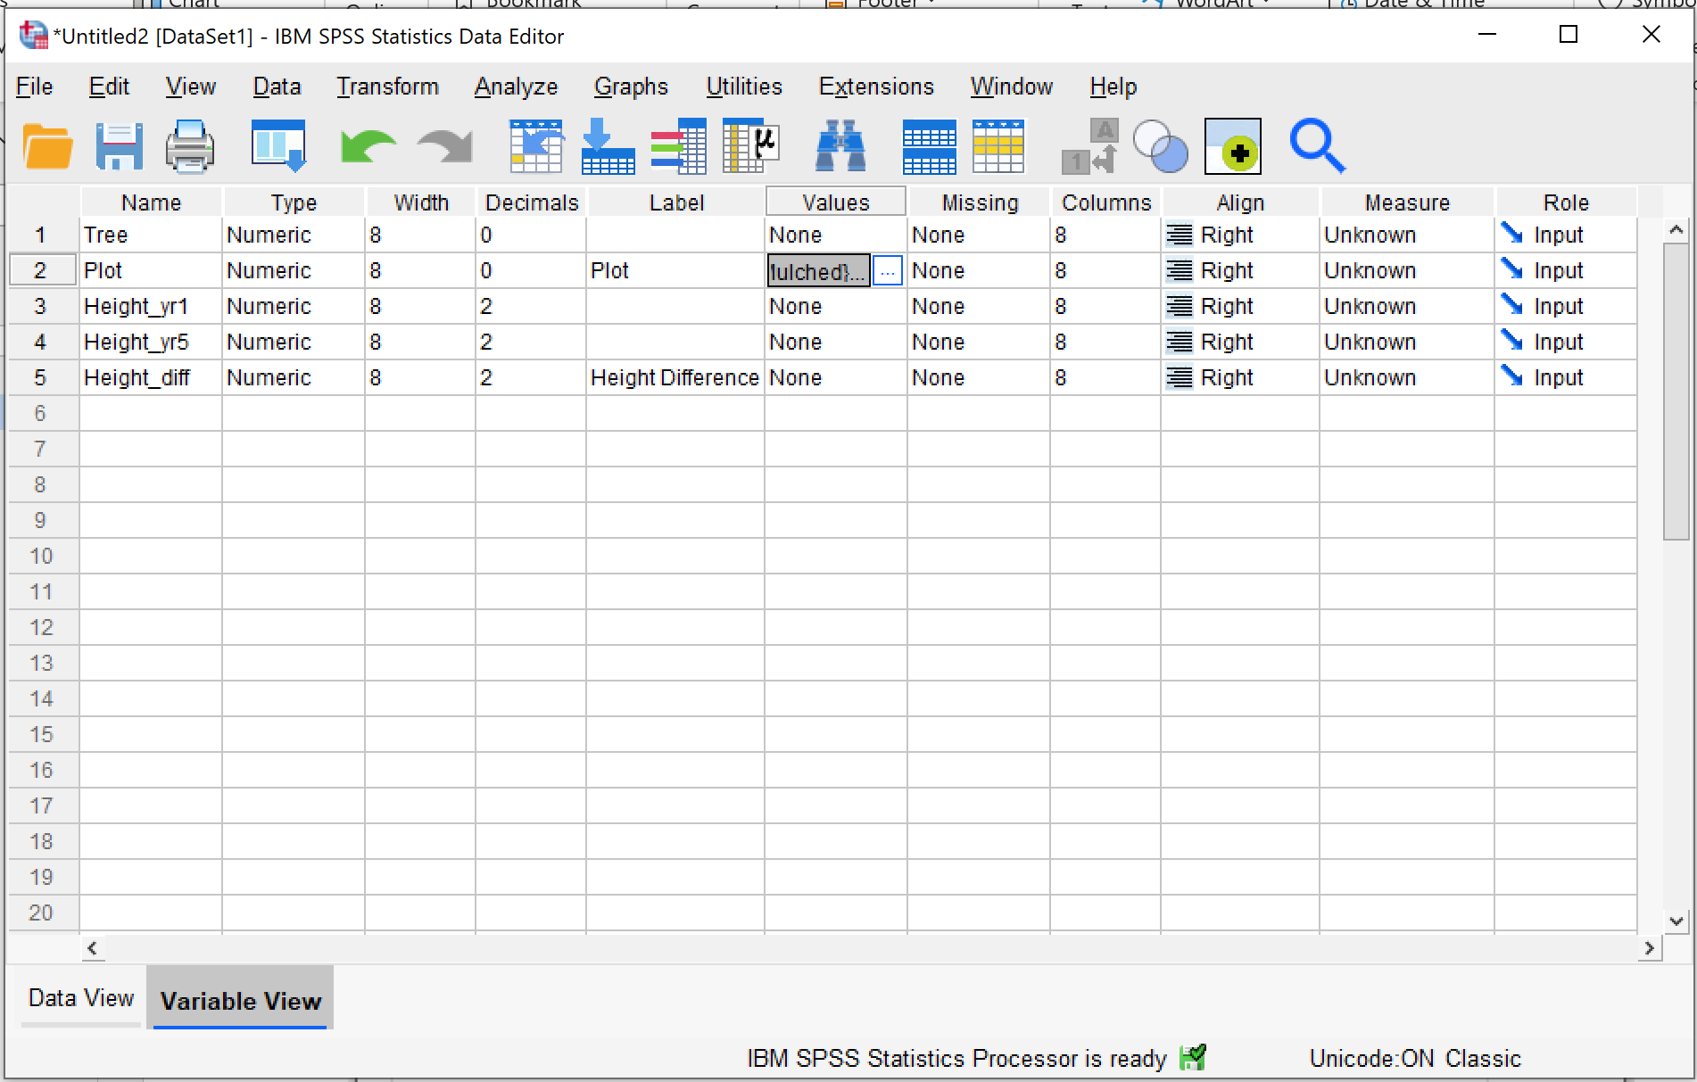
When you switch back to “Data View” at the bottom left, note that there is a button on the top that lets you swap between the values and labels of that variable. This is not essential, but once again, it will make your graphs and tables much, much easier to read.

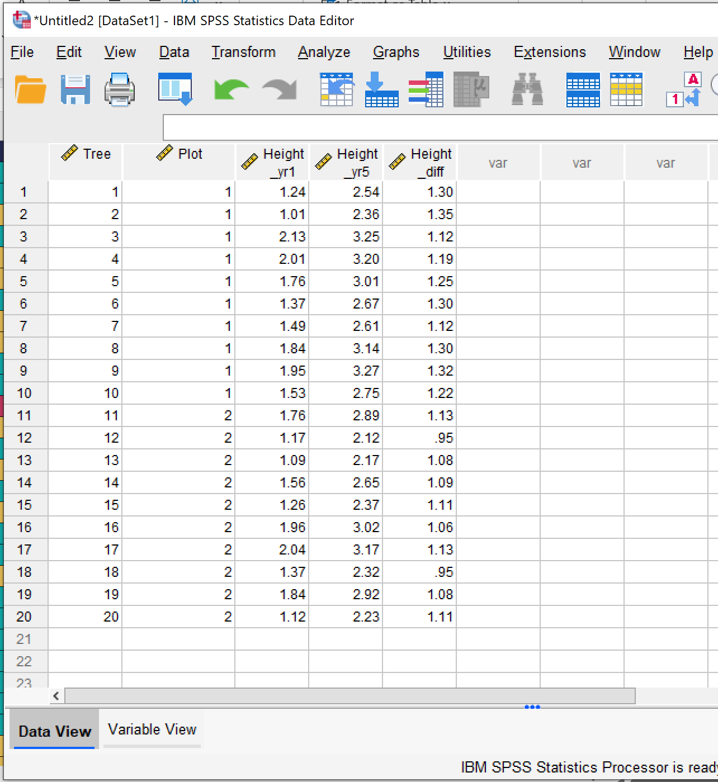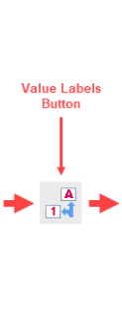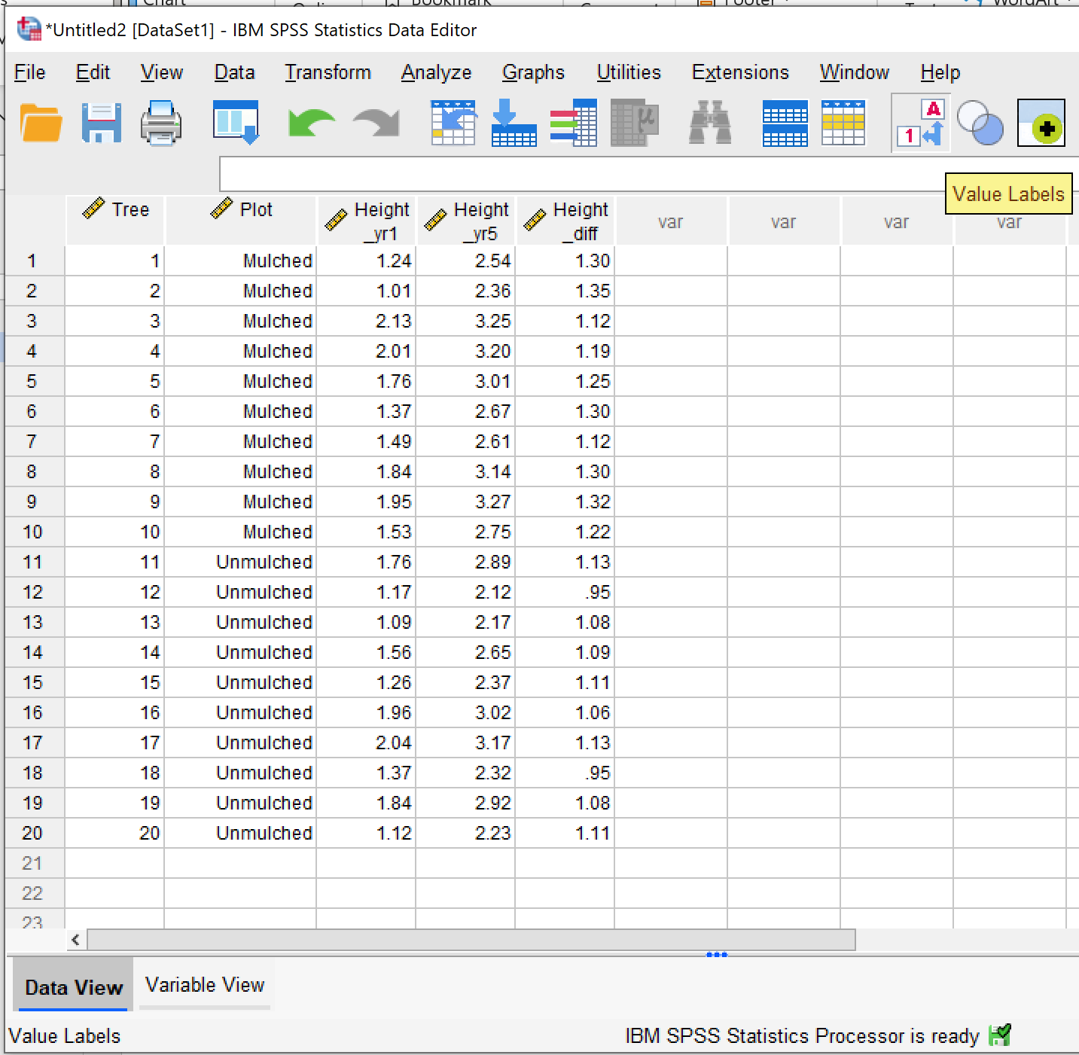

Running the Test
So, the data is in – time to run the test, step by step.

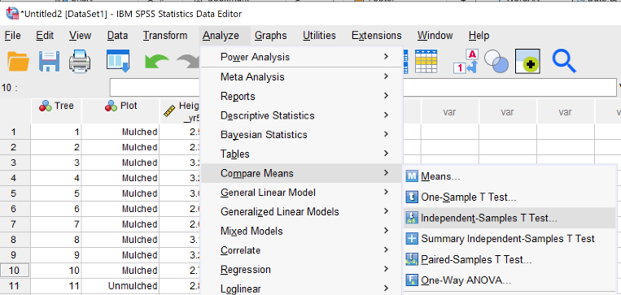
- From the menu along the top, go to Analyze > Compare Means > Independent Samples T Test
- In the dialogue box, select your test variable (the thing that you’re measuring) and click the arrow icon to add it to the Test Variable(s) box
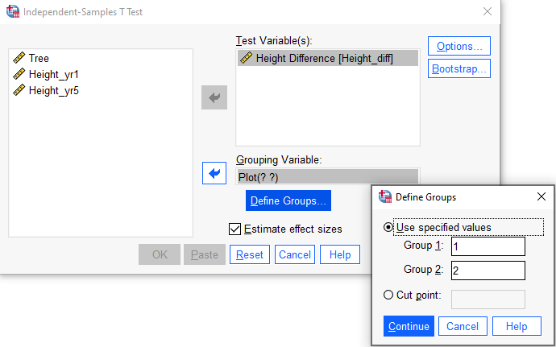
- Repeat the process to add your grouping variable (the thing that sorts your samples into their two groups) to the Grouping Variable(s) box.
- Click Define Groups. In the new dialogue box, add the numeric values for the groups you’re using. Here, it’s a very simple 1 and 2. Click “Continue”.
- Finally, click OK!

What Do the Results Mean?
You will get several tables out of SPSS for this test. The first is a smaller table called group statistics.
This table actually gives you some descriptive statistics about your results; the mean averages, and the standard deviations. You might well want to comment on those, if anything seems out of the ordinary.
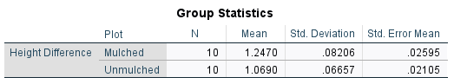

Here, it’s showing us that the mulched trees did have a higher average height difference from the start of the trial to the end than the unmulched trees did; suggesting that the mulch did indeed increase growth rate.
It’s also showing that the standard deviation – the difference between the farthest data points from the mean – is extremely similar between the two groups, and also very small (less than 0.1). If it had been fairly dramatic in one but not the other, you might be able to suggest that the results are less comparable than they first appear. But, in this example, this all looks very normal.
So, the group statistics show us that there is a difference! But, is this difference statistically significant?

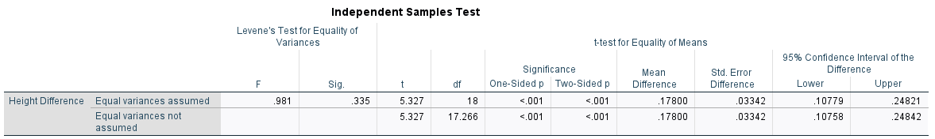

This table is the one that gives the actual result for the test.

- In the section of the table labelled “t-test for Equality of Means”, go to the “Significance” column.
- Look at the number in the Two-Sided box in the Equal variances assumed row.
- If this number is less than 0.05, it is statistically significant.
Here, the number is less than 0.001, so we have a definitive answer – in our study, the mulch almost certainly resulted in greater growth.
- To write up the test statistic (i.e. the result), there are two possible formats used, both of which are outlined here:
  - t=XXX, df=XX, p=XXXX. This is the t-test number, followed by the degrees of freedom, and finally the probability of significance.
In this case, the test statistic would therefore be t=5.327, df=18, p=<0.001.
  - t(XX)=XXX, p=XXXX. This is t with the df number in brackets, then the t-test number, and finally the probability of significance.
In this case, the test statistic would therefore be t(18)=5.327, p=<0.001.

The final write-up:
This study found that mulched trees had a significantly higher average growth rate (1.247 metres) over five years than unmulched trees (1.069 metres), t=5.327, df=18, p=<0.001.
Or
The test statistic (t(18)=5.327, p=<0.001) shows that mulched trees had a significantly higher average growth rate (1.247 metres) over five years than unmulched trees (1.069 metres).

Or something to that effect.

Paired T-Tests

Inputting the Data
Again, let’s input our data!
You can, of course, copy and paste from an Excel file, but it’s important to make sure the data is inputted correctly in SPSS so that it can do its thing. For a paired t-test, you need to remember the golden rule: one person, one row. Remember, this is the test for when you’re studying the same group twice; this means one subject MUST have a row all to itself.
Our new example, therefore, is that you measured tree growth over two years, then mulched, then measured over another two years. You are therefore measuring the same trees. Each tree must therefore have its own row.

- First, open up SPSS, and click the “Variable View” button at the bottom of the box
- Name your variables. Here, you want the two-year growth rate before mulching, and the two-year growth rate after mulching. Remember that you cannot have spaces between words here; but, you can use underscores instead (e.g. “Growth Pre-Mulch” won’t work, but “Growth_pre” will). However, you can write them out properly in the Label column.
Note: SPSS will work fine if you don’t use Labels, but the graphs and tables will be harder to read once it gives you your results.
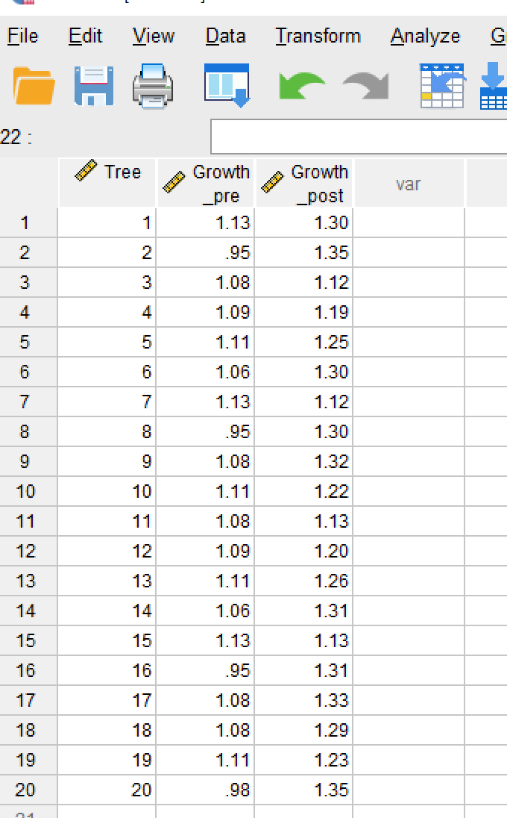
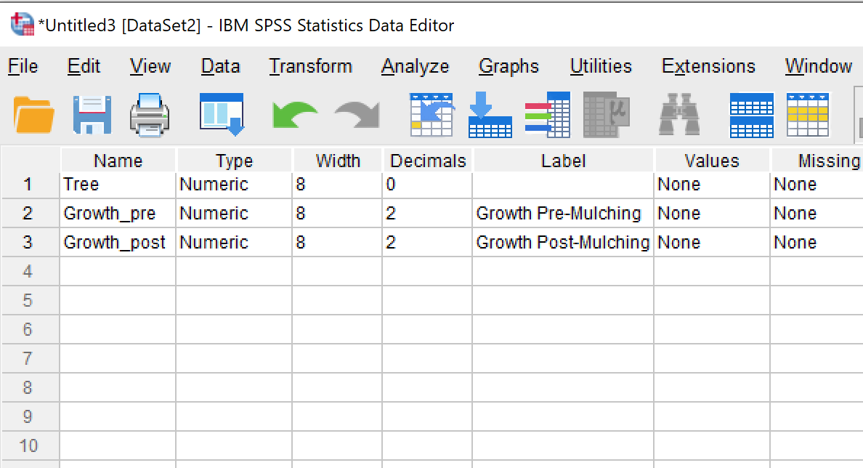

Running the Test
So, the data is in – time to run the test, step by step.
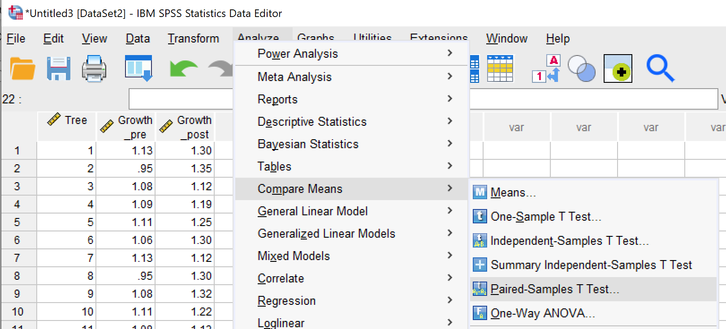
- From the menu along the top, go to Analyze > Compare Means > Paired Samples T Test
- In the dialogue box, select the two variables you’re comparing and use the arrow icon to insert them into the Paired Variables box. You can also drag and drop them into place.
This should put them into the same row as one another, and automatically generate an empty row below.
- Click “OK”!

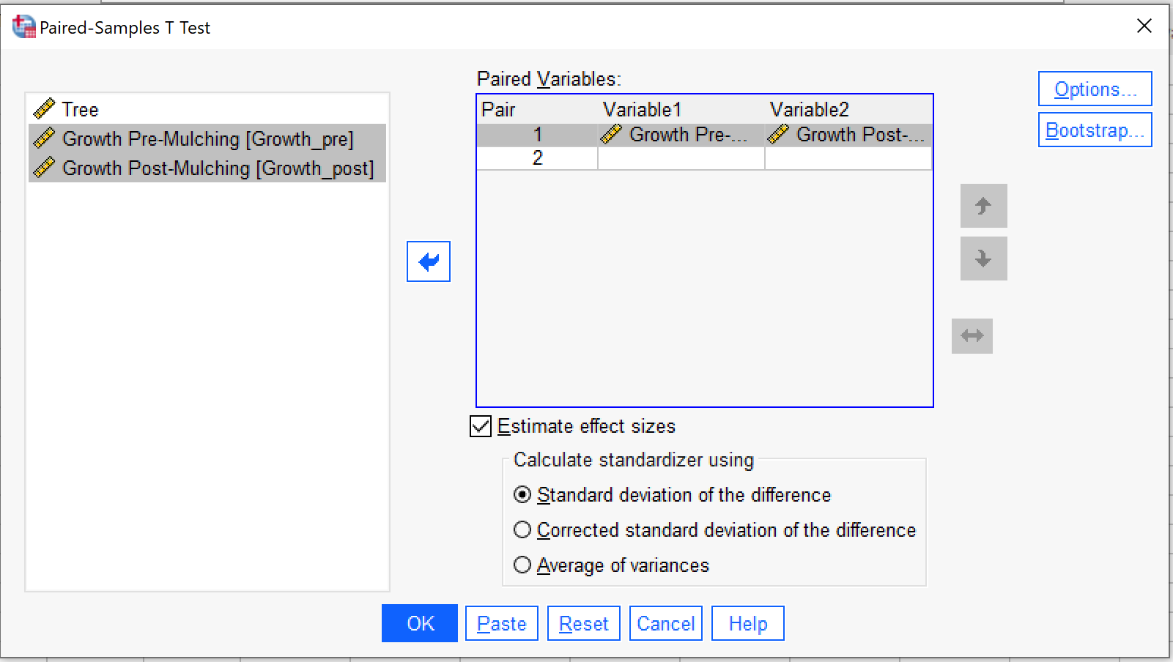

What Do the Results Mean?
As with the Independent t-test, SPSS will spit out multiple tables here. The first is called Paired Samples Statistics, and it will offer your descriptive stats – the means of the two measurements, and the standard deviations.

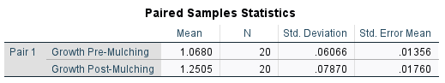

Here, the average growth rate before the mulch was indeed lower than after the mulch; suggesting that the mulch did indeed increase growth rate.
It’s also showing that the standard deviation – the difference between the farthest data points from the mean – is extremely similar between the two groups, and also very small (less than 0.1). If it had been fairly dramatic in one but not the other, you might be able to suggest that the results are less comparable than they first appear. But, in this example, this all looks very normal.
So, the group statistics show us that there is a difference! But, is this difference statistically significant?

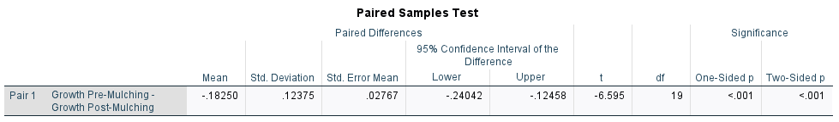

This table is the one that contains the actual test result.
- You’ll note that it’s a simpler table than the one for the independent t-test! Look to the right-hand side, and look for t, df, and two-tailed p.
- If the number for “Two-tailed/Two-Sided p” is less than 0.05, it is statistically significant.
Here, the number is <0.001. This makes it extremely likely that the mulching is what caused the growth rate change.
- To write up the test statistic (i.e. the result), there are two possible formats used, both of which are outlined here:
  - t=XXX, df=XX, p=XXXX. This is the t-test number, followed by the degrees of freedom, and finally the probability of significance.
In this case, the test statistic would therefore be t=-6.585, df=19, p=<0.001.
  - t(XX)=XXX, p=XXXX. This is t with the df number in brackets, then the t-test number, and finally the probability of significance.
In this case, the test statistic would therefore be t(19)= -6.585, p=<0.001.

The final write-up:
This study found that trees after mulching had a significantly higher average growth rate over two years (1.251 metres) than they did prior to the mulching (1.068 metres), t=-6.585, df=19, p=<0.001.
Or
The test statistic (t(19)= -6.585, p=<0.001) shows that trees after mulching had a significantly higher average growth rate over two years (1.251 metres) than they did prior to the mulching (1.068 metres).

Or something to that effect.

