7/21/2026
Assessment 1
Project Proposal Report

Module NaMe: Changemakers, Creativity and Value creation
Module Code: ACCA 5033
Student NAME: Olha kozmenko
Student ID: 2335644
Lecturer: Dr. FAHAD AHMAD
Trinity saint david University of Wales (London Campus)

Dr.FAHAD AHMAD
Student ID: 2335644
Table of Contents
Introduction 2
Task 1: Ideation and Innovation 2
Innovation 2
AI Tools in Action: Scaling and Automating Content and Marketing 3
Ideation 3
Research 4
Task 2: Aim & Objectives and Research Area 4
Q1. Aim & Objectives 4
Q2. Research Philosophy 5
Q3. Search Tools and Research Databases 5
Task 3: Research Strategies 6
Q1. Validity, Reliability, Generalisability and Ethics 6
Q2. Data Collection Methods and Pilot Survey 6
Q3. Quantitative and Qualitative Analysis 7
Conclusion 7
References 8
Appendix A: Pilot Survey 9

Introduction
This work is a project proposal for the module Changemakers: Creativity and Value Creation at the University of Wales Trinity Saint David. The aim of this proposal is to explore how artificial intelligence is transforming business and marketing, and how these changes can help soft niche experts in different professional fields to promote their services online more effectively. The proposal is divided into three parts: ideation and innovation, research area and objectives, and research strategies and data collection methods.

Task 1: Ideation and Innovation

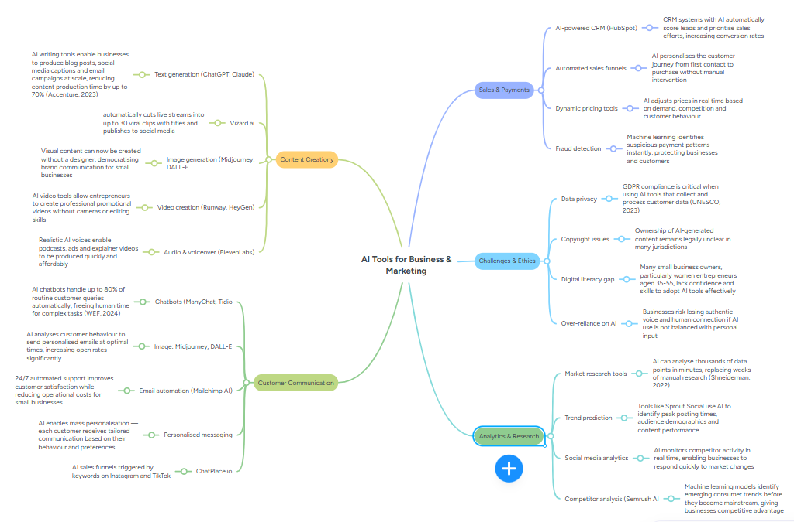
(Figure 1: Mind Map — AI Tools for Business and Marketing — insert here)

Innovation
Innovation has always changed the way people work and live. Today, artificial intelligence is becoming as important an innovation as the internet or the mobile phone once were. According to the World Economic Forum [1], AI is already affecting most professions and industries around the world. Westerman, Bonnet and McAfee [7] argue that digital innovation does not simply automate existing processes — it fundamentally transforms the way value is created for individuals and society.
There is a common misconception that AI will replace people. In reality, AI strengthens and scales those who are already professionals in their field. A psychologist using AI can reach thousands of people instead of ten. A beauty professional can manage social media professionally without hiring a marketing specialist. According to McKinsey [2], professionals who integrate AI tools into their workflow gain the greatest competitive advantage in the market. As Turner [8] suggests, truly innovative individuals use technology not to become less human but to become more effective at what they already do well.
AI tools in marketing and the knowledge economy are opening up opportunities for people who previously could not afford professional promotion. This is especially important for soft niche experts — psychologists, coaches, beauty professionals, nutritionists and other specialists. By delegating routine marketing tasks to AI, they can maintain a balance between work, family and personal development while becoming more visible and in demand. According to Accenture [3], the accessibility of AI tools is changing the very concept of who can successfully promote themselves in the digital space.

AI Tools in Action: Scaling and Automating Content and Marketing
One of the most significant ways AI is transforming marketing for soft niche experts is through automation and scaling of content production and publication. The following examples show how specific AI tools solve real marketing problems.
Vizard.ai automatically cuts a one-hour live stream into up to 30 short viral clips, writes titles and descriptions for each clip and publishes them directly to social media platforms. This means a soft niche expert who runs one live stream per week can have 30 pieces of content published across platforms without spending additional time on editing or writing.
Claude.ai can be used to write posts, stories and video scripts, generate a monthly content plan, create content ideas based on a given topic, write sales funnel texts and answer frequently asked questions from clients. This allows a soft niche expert to produce professional written content in minutes rather than hours.
ChatPlace.io provides AI agents and chatbots for Instagram and TikTok that respond to keyword triggers, build automated sales funnels and guide potential clients from first contact through to purchase without the expert needing to be online. ManyChat and Tidio offer similar functionality — automated responses to client enquiries, booking confirmations and lead follow-ups. These tools act as a personal sales assistant that qualifies leads, answers objections and guides the client to make a booking 24 hours a day, 7 days a week.
According to Nardi [9], critical evaluation of digital tools is essential for making informed decisions about which technologies to adopt — particularly important for soft niche experts choosing AI tools that genuinely fit their specific business needs.

Ideation
Thousands of soft niche experts have deep professional knowledge but remain invisible in the digital space — not because they have nothing to say, but because marketing seems complicated, expensive or too time-consuming. A psychologist with five clients per day and a beauty professional with a fully booked schedule have no time for marketing. Word-of-mouth recommendations do not provide a consistent and scalable flow of new clients. Social media offers visibility 24 hours a day, 7 days a week — but requires time and consistent effort that a busy expert cannot afford. This project investigates how AI marketing tools can help soft niche experts become more visible online and attract new clients without losing balance between work and personal life.
Project Title: AI Tools for Business and Marketing: Empowering Soft Niche Experts in the Knowledge Economy
Aim: To investigate how AI marketing tools can help soft niche experts in service-based businesses to increase their online visibility and attract new clients while maintaining work-life balance.
Objectives:
- To explore the development of AI tools in marketing and the knowledge economy
- To examine how soft niche experts use AI tools to promote their services online
- To identify the main barriers that prevent soft niche experts from using AI marketing tools
- To design and conduct a pilot survey among soft niche experts to collect primary data
- To analyses findings and provide practical recommendations

Research
The following sources were identified using Google Scholar, IEEE Xplore and the UWTSD Library. All sources were selected based on relevance, credibility and publication date no earlier than 2017.
McKinsey [2] and the World Economic Forum [1] provide current data on AI's economic impact and the future of work. Accenture [3] focuses on AI accessibility for small businesses. Shneiderman [4] offers a human-centred perspective on technology adoption. UNESCO [5] addresses digital literacy and inclusion. Westerman, Bonnet and McAfee [7] provide a framework for digital business transformation. Turner [8] and Nardi [9] support critical and innovative thinking about technology. HubSpot [10] offers current marketing industry data directly relevant to soft niche experts.

Task 2: Aim & Objectives and Research Area

Q1. As outlined in Task 1, the aim and objectives of this project remain as stated above.
As established in Task 1, soft niche experts work with a full client schedule every day, leaving very little time for marketing. Word-of-mouth recommendations do not provide a consistent flow of new clients, while social media offers visibility around the clock but demands time and skills that busy professionals often cannot afford.
According to McKinsey [2], experts who integrate AI tools into their workflow significantly reduce time spent on routine tasks while maintaining their output. This project therefore investigates how AI marketing tools can help soft niche experts build a stable online presence and attract new clients without sacrificing time for their core work or personal life.
The aim and objectives of this project are outlined in Task 1 above and remain unchanged throughout this proposal.

Q2. Research Philosophy
For this project an interpretivist research philosophy has been selected. The focus is not only on statistics - it is on the real experience of soft niche experts. A psychologist with a full client schedule and a beauty professional in London may have completely different experiences of using AI marketing tools. Interpretivism allows us to understand these differences and identify common patterns.
This approach was chosen because soft niche experts have unique personal experiences with technology, barriers and motivations vary significantly between individuals, and it is important to understand why people use or do not use AI tools — not just how many of them do.
According to Saunders, Lewis and Thornhill [6], interpretivism is most appropriate when research focuses on understanding social context and the personal experiences of people. This makes it the most suitable philosophy for a project that explores human behavior in relation to technology adoption among soft niche experts.

Q3. Search Tools and Research Databases
The following tools and databases were used to find sources related to AI tools among soft niche experts:
Search Tools: Google Scholar for academic articles on AI and marketing; UWTSD Library for access to paid academic journals; ResearchGate for research papers on AI and entrepreneurship.
Research Databases: IEEE Xplore for technical articles on AI tools; ACM Digital Library for computer science research; Scopus as a broad academic database.
Search Terms Used: "AI tools for marketing soft niche experts"; "artificial intelligence personal brand business"; "generative AI solopreneurs"; "digital marketing automation women entrepreneurs"; "AI content creation service business."
How Source Credibility Was Assessed: Sources were selected if published no earlier than 2017, authored by a recognised expert or authoritative organisation, and published in a peer-reviewed journal or by a reputable institution.

Task 3: Research Strategies

Q1. Validity, Reliability, Generalisability and Ethics
Validity is ensured by designing survey questions that directly reflect the real marketing tasks of soft niche experts — from content creation and video editing to running targeted advertising and building sales funnels. Each question connects directly to the research objectives.
Reliability is achieved through clear and straightforward questions with specific answer options based on real marketing tasks, avoiding double interpretation and making results reproducible in future research.
Generalizability — the results will be applicable to a broad range of soft niche experts who run their businesses through social media. Although the pilot survey involves five participants, the findings will provide initial insights expandable in future larger-scale research.
Ethics — all participants take part voluntarily and anonymously. Data is used for academic purposes only and not shared with third parties. This research complies with GDPR requirements. According to Saunders, Lewis and Thornhill [6], maintaining ethical standards is a fundamental requirement of any academic research involving human participants.

Q2. Data Collection Methods and Pilot Survey
Two data collection methods have been selected for this project.
Online Survey is the primary method. The survey is distributed through Instagram and Telegram among soft niche experts — platforms where the target audience is highly active. It consists of seven questions covering key marketing tasks, barriers to AI adoption and expected outcomes from using AI tools.
Qualitative Interviews are the secondary method for deeper understanding of participants' experiences. Three to five short interviews are planned with soft niche experts who already use AI tools in their marketing, providing real-life examples that numbers alone cannot capture.
A pilot survey was developed and tested with five participants to check clarity and relevance before main data collection. The full pilot survey is presented in Appendix A.

Q3. Quantitative and Qualitative Analysis
Quantitative Analysis involves working with numbers and statistics. It will be used to process survey results — identifying what percentage of soft niche experts use AI tools, how many hours per week they spend on marketing, which tasks they most want to delegate and what results they expect. This produces clear measurable results that can be visualized in charts and tables. According to UNESCO [5], data-driven approaches are essential for understanding digital tool adoption across professional groups.
Qualitative Analysis involves working with personal experiences and opinions. It will be used to analyse interview responses — exploring why experts hesitate to use AI, how their business changed after introducing a chatbot, or which tools helped them scale their content. This provides depth that numbers alone cannot capture.
For this project both methods will be combined. According to Saunders, Lewis and Thornhill [6], a mixed methods approach provides the most complete picture of the topic — particularly relevant where both practical and human aspects of AI adoption matter.

Conclusion
This project proposal has explored how AI tools for marketing and the knowledge economy can help soft niche experts build a stable online presence and attract new clients without sacrificing time for their core professional work and personal life.
The work has shown that AI does not replace experts — it scales and strengthens them. A psychologist with a full client schedule and a beauty professional with appointments booked weeks in advance can delegate routine marketing tasks to tools such as Vizard.ai for content scaling, ChatPlace.io for automated sales funnels and Claude.ai for writing posts and content plans — and remain consistently visible on social media without additional time investment.
The mind map presented in Task 1 showed the broad landscape of AI applications in business and marketing. The aim and objectives are clearly defined and focused on the real experience of soft niche experts. The interpretivist philosophy allows for a deep understanding of the human side of technology adoption. The pilot survey is designed based on real marketing tasks and is ready for testing.
This project has practical value — its findings could help thousands of soft niche experts use AI tools confidently and effectively to grow their businesses while maintaining balance in their personal lives.

References
[1] World Economic Forum, "The Future of Jobs Report 2024," WEF, Geneva, 2024.
[2] McKinsey & Company, "The Economic Potential of Generative AI," McKinsey Global Institute, 2023.
[3] Accenture, "A New Era of Generative AI for Everyone," Accenture Research, 2023.
[4] B. Shneiderman, "Human-Centered AI," Oxford University Press, Oxford, 2022.
[5] UNESCO, "AI and Education: Guidance for Policy-Makers," UNESCO, Paris, 2023.
[6] M. Saunders, P. Lewis and A. Thornhill, "Research Methods for Business Students," 8th ed., Pearson, Harlow, 2019.
[7] G. Westerman, D. Bonnet and A. McAfee, "Leading Digital: Turning Technology Into Business Transformation," Harvard Business Review Press, Boston, 2014.
[8] E. Turner, "Be Less Zombie: How Great Companies Create Dynamic Innovation, Fearless Leadership and Passionate People," John Wiley and Sons, 2020.
[9] P. M. Nardi, "Critical Thinking: Tools for Evaluating Research," University of California Press, 2017.
[10] HubSpot, "State of Marketing Report 2024," HubSpot Research, 2024.

Appendix A: Pilot Survey.

This pilot survey was designed to test the clarity and relevance of the research questions before the main data collection. It was distributed among five soft niche experts via Instagram and Telegram. The feedback received was used to improve the focus of the project. The full survey instrument is presented below.


