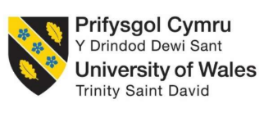

Influence of Sustainability Marketing on Consumer Purchase Intention in the Fashion Retail Industry UK
Master of Business Administration
LCMB7035 - Dissertation

Student Name: Shaan Aboobacker
Student ID:2503771
Supervisor: Shahrukh Irfan
Submission Date: 25/09/2025

Declaration


Master’s Degrees by Examination and Dissertation
Declaration Form.

I, [Shaan Aboobacker], declare that this dissertation has been composed by myself, that the work contained herein is entirely my own except where explicitly stated otherwise in the text, and that this work has not been submitted for any other degree or qualification, in whole or in part, except as specified.

Signature: 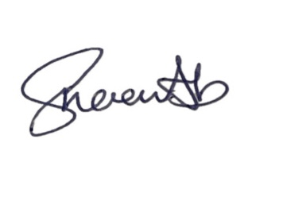

Date: 24/09/2025

AI use Acknowledgements
It is noted that none of the artificial intelligence tools were used in the development of this dissertation. All of the work done in the course of the research process was done by the author. Any outside material that has been used in the dissertation has been duly acknowledged.

Acknowledgements
I would like to start by thanking my supervisor for valuable support and guidance. In addition to that, I am thankful to the respondents of this survey for providing me with valuable data. Finally, I would like to thank my family and friends for their support and encouragement.

Abstract
This study attempts to explore the impact of sustainability marketing on consumer purchase intention and consumer trust in UK fashion retail sector. Also, the study identifies the sustainability marketing strategies that can enhance consumer responses and sustainable purchases.
Quantitative research design has been utilised through a structured survey which has been conducted among 82 participants. Descriptive statistics and regression analysis were used to analyse the consumer perceptions and the relationship between sustainability marketing, consumer trust and purchase intention.
The results show that sustainability marketing positively impacts both consumer purchase intention and consumer trust within the UK fashion retail industry. Generally, consumers viewed sustainability marketing positively and suggested that credible sustainability could affect their perception of the brand and their purchase decision. In addition, consumer trust was found to be critical in that transparency, credible sustainability and independent certification were seen as very important aspects of influencing consumer trust in fashion brands. Furthermore, the results showed that ethical sourcing was the most influential practice of sustainability marketing. At the same time, it has been noted that sustainability marketing does not make the purchasing decision per se since high prices and availability act as barriers to sustainable fashion consumption. Finally, the findings confirm both Theory of Planned Behaviour and Legitimacy Theory while filling the identified gap in terms of lack of research on sustainability marketing, consumer trust and purchase intention in the UK fashion retail industry.
In relation to UK fashion retailers, it is recommended to focus on transparent and evidence-based sustainability communication, independent third-party certification of products, an affordable sustainable product range, ethical sourcing, sustainability labelling, digital traceability, repair and recycling programme and communication of product quality and durability. This will contribute to enhanced credibility, minimised greenwashing concerns and sustainable purchase intention.
Keywords: Sustainability marketing, Consumer trust, Purchase intention, UK fashion retail, Greenwashing, Sustainability certification, Ethical sourcing, Sustainable consumption.

List of Abbreviations
Abbreviation | Full Form
TPB | Theory of Planned Behaviour
UK | United Kingdom
SPSS | Statistical Package for the Social Sciences
SM | Sustainability Marketing
CIT | Consumer Purchase Intention
CT | Consumer Trust
R² | R-Squared
ANOVA | Analysis of Variance
SD | Standard Deviation

List of Glossary
Term | Definition
Sustainability Marketing | Marketing that communicates a firm's environmental, social and ethical practices.
Consumer Trust | Consumers' confidence that a fashion brand's sustainability claims are credible and genuine.
Purchase Intention | A consumer's willingness or likelihood to purchase a product or brand.
Greenwashing | Misleading or exaggerated communication about a company's environmental performance.
Ethical Sourcing | Obtaining materials and products through socially and environmentally responsible supply practices.
Sustainability Certification | Independent verification that a product or organisation meets specified sustainability standards.
Transparency | Providing clear and accessible information about sustainability practices, sourcing and environmental performance.
Sustainable Fashion | Fashion products and practices designed to reduce environmental and social harm.
Third-Party Verification | Independent assessment of a company's sustainability claims by an external organisation.
Attitude–Behaviour Gap | The difference between consumers' positive sustainability attitudes and their actual purchasing behaviour.

Table of Contents
Declaration 2
AI use Acknowledgements 3
Acknowledgements 4
Abstract 5
List of Abbreviations 6
List of Glossary 7
Chapter 1: Introduction 14
1.1 Background of the Study 14
1.2 Problem Statement 17
1.3 Aim and Objectives 17
1.4 Research Rationale 18
1.5 Research Significance 18
1.6 Dissertation Outline 19
Chapter 2: Literature Review 21
2.1 Introduction 21
2.2 Concepts and Theoretical Perspectives 21
2.2.1 Concept of Sustainability Marketing 21
2.2.2 Concept of Consumer Purchase Intention 21
2.2.3 Theory of Planned Behaviour 22
2.2.4 Legitimacy Theory 23
2.3 Sustainability Marketing Practices in the Fashion Retail Industry 24
2.4 The factors that stimulate consumers to respond positively to sustainability marketing 27
2.4.1 Credibility and Transparency of Sustainability Claims 27
2.4.2 Consumer Environmental Values and Brand Trust 29
2.4.3 Perceived Product Quality, Value and Consumer Knowledge 29
2.4.4 Social Influence and Subjective Norms 31
2.5 The Relationship Between Consumer Trust and Purchase Intention Towards Sustainably Marketed Fashion Products 31
2.6 Challenges Affecting Sustainability Marketing and Practical Recommendations to Improve Customer Purchase Intention 33
2.6.1 The Danger of Greenwashing and Consumer Scepticism 33
2.6.2 The Attitude–Behaviour Gap 33
2.6.3 The Absence of a Standardised Sustainability Communication 34
2.6.4 Recommendations to Overcome the Identified Challenges 34
2.7 Conceptual Framework 35
2.8 Research Gap 36
2.9 Summary 36
Chapter 3: Research Methodology 37
3.1 Introduction 37
3.2 Research Design (Saunder’s Onion Framework) 37
3.3 Research Philosophy 38
3.4 Research Approach 39
3.5 Research Strategy 39
3.6 Research Method 40
3.7 Target Population, Sampling Technique and Sample Size 40
3.8 Data Collection Method 41
3.9 Reliability and Validity 41
3.10 Data Analysis Technique 42
3.11 Ethical Considerations 43
3.12 Summary 43
Chapter 4: Data Analysis 44
4.1 Introduction 44
4.2 Overview of the Dataset and Analysis 44
4.3 Descriptive Statistics 44
4.4 Regression Analysis 62
4.5 Reliability Test 65
4.6 Correlation Analysis 66
4.7 Limitations encountered during data analysis 67
4.8 Summary 67
Chapter 5: Discussion 68
5.1 Introduction 68
5.2 Discussion 68
Chapter 6: Conclusion 72
6.1 Introduction 72
6.2 Conclusion 72
6.2.1 Conclusion Based on Objective 1: Influence of Sustainability Marketing on Consumer Purchase Intention 72
6.2.2 Conclusion Based on Objective 2: Factors Encouraging Positive Consumer Responses to Sustainability Marketing 72
6.2.3 Conclusion Based on Objective 3: Relationship Between Consumer Trust and Purchase Intention 73
6.2.4 Conclusion Based on Objective 4: Challenges and Recommendations for Strengthening Sustainability Marketing 73
6.3 Recommendations 74
6.4 Limitations and Future Research Suggestions 75
6.5 Implications 75
6.6 Reflection 76
References 77
Appendix 85
Appendix 1: Survey Questionnaire 85
Appendix 2: Descriptive Statistics 90
Appendix 3: Ethics Form 101
Appendix 4: Survey Response Sheet and Link 102

List of Figures
Figure 1: Sustainability in UK fashion industry. 11
Figure 2: Attitude of UK consumers towards sustainable fashion purchasing. 13
Figure 3: Theory of Planned Behaviour. 18
Figure 4:Key Sustainability Marketing Practices in the Global Fashion Sector 21
Figure 5: Dimensions and Consequences of Perceived Greenwashing on Consumer Responses to Sustainability Marketing. 24
Figure 6: Key Factors Affecting Consumers' Perceptions Towards Sustainable Marketing 26
Figure 7:Conceptual Framework. 31
Figure 8: Responses to question 1st. 40
Figure 9: Responses to question 2nd. 41
Figure 10: Responses to question 3rd. 42
Figure 11: Responses to question 4th. 43
Figure 12: Responses to question 5th. 44
Figure 13: Responses to Question 6th. 45
Figure 14: Responses to question 7th. 46
Figure 15: Responses to question 8th. 47
Figure 16: Responses to question 9th. 48
Figure 17: Responses to question 10th. 49
Figure 18: Responses to question 11th. 50
Figure 19: Responses to question 12th. 51
Figure 20: Responses to question 13th. 52
Figure 21: Responses to question 14th. 53
Figure 22: Responses to question 15th. 54
Figure 23: Responses to question 16th. 55
Figure 24: Responses to question 17th. 56
Figure 25: Responses to question 18th. 57
Figure 26: Regression Test 1. 58
Figure 27: Regression Test 2. 59
Figure 28: Reliability Test.an 61

List of Table
Table 1: Structure of Dissertation 19

Chapter 1: Introduction

1.1 Background of the Study
Over the last decade, the fashion retail sector has undergone a profound shift as sustainability has emerged as a key strategic focus for businesses, governments and consumers (Ikram, 2022). The fashion industry has always been known for its short production cycles, low production prices and high consumption. This has significantly affected the environment, carbon emissions, water consumption, textile waste and unethical working conditions. The rise of fast fashion has intensified these worries as people are buying cheap clothes more often (Papasolomou, et al., 2023). This leads to shorter product lifecycles and more waste. The fashion industry is one of the world's most water-intensive industries who use about 93 billion cubic metres of water each year (Grundy, 2024). It is also responsible for about 8-10% of global carbon emissions. As these environmental and social issues have become more prevalent there is growing pressure on fashion retailers to embrace sustainable business practices.
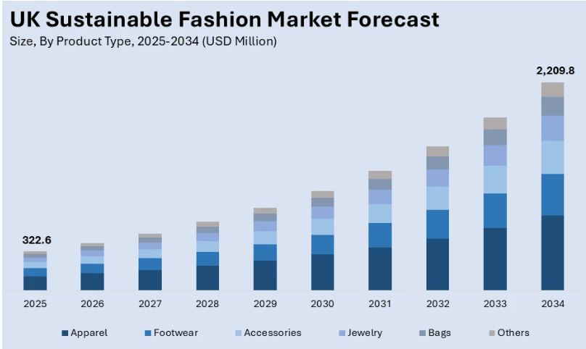
Figure 1: Sustainability in UK fashion industry.
(Source: Imarc, 2025)
The above figure shows a very high potential for growth in the UK sustainable fashion market, as the market value is expected to grow from USD 322.6 million in 2025 to approximately USD 2,209.8 million in 2034 (Imarc, 2025). The projection suggests that there will be an increased demand for products such as apparel, footwear, accessories, jewellery, bags and other fashion products in the market. Sustainability marketing is the use of environmental, ethical and social responsibility messages to help shape consumer attitudes and promote responsible consumer buying (Jia, et al., 2023). Traditional marketing is more about the product's quality, pricing and marketing campaigns. However, sustainability marketing is about the sustainability of the product's production, ethical sourcing, recyclable packaging, fair labour practices, carbon reduction programs and circular economy principles. Furthermore, UK is one of the biggest fashion retail markets in Europe and there has been significant growth in consumer awareness of sustainable consumption (Bueno, 2026).
Moreover, younger consumers especially Millennials and Generation Z are more likely to consider brands' sustainability efforts when making their purchasing decisions alongside other factors like quality, price and design. As a result, it encourages UK fashion brands such as Marks & Spencer, Next, John Lewis, ASOS and Burberry to increase their sustainability efforts by implementing responsible sourcing, recycled materials, resale programmes, repair services and carbon reduction pledges (Timmins, 2021). However, consumer interest in sustainability does not always match their purchasing behaviour which is also known as the attitude–behaviour gap. While, consumers hold positive attitudes towards sustainable fashion, several factors including price, product availability, concerns about product quality, convenience and lack of trust in sustainability claims often prevent consumers from actually buying sustainable fashion (Tran, et al., 2022). Meanwhile, poor or misaligned sustainability messaging can affect brand credibility, consumer trust and negatively impact purchase intent. As a result, it has become increasingly relevant to understand the effects of the various sustainability marketing practices on consumer decision-making (Chen, 2024).
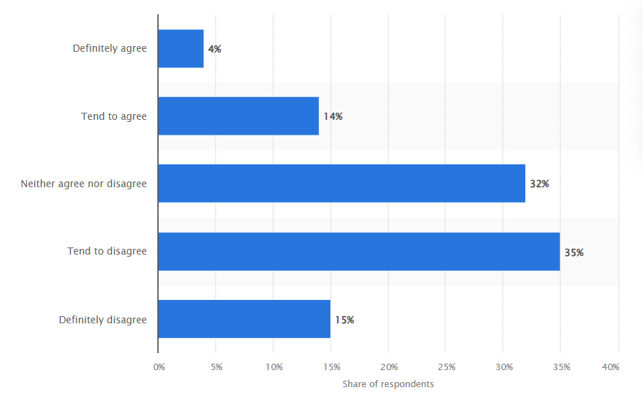
Figure 2: Attitude of UK consumers towards sustainable fashion purchasing.
(Source: Rocco, 2020)
On the other hand, consumer negative views on buying clothes from sustainable brands in the UK are shown in the above figure. It is evident from the results that 50% of the respondents disagreed that they buy only sustainable clothes, 32% were neutral, whereas 18% agreed with the statement (Rocco, 2020). This reveals the existence of a gap between sustainability knowledge and action. However, in the current years, there is increasing importance of sustainable consumption, growing consumer expectations and competition among fashion retailers (Bumin and Bumin, 2024). Therefore, the study of the effect of sustainable marketing on consumer purchase intention is highly relevant in the UK fashion industry. The degree of influence of sustainability marketing on consumer perceptions, trust and purchase intentions gives insights into the effectiveness of existing marketing strategies and would be a part of the ongoing debate concerning sustainable retailing. Thus, the current study examines the connection between sustainability marketing and consumer purchase intention in the UK fashion retail industry. Also, it would offer empirical evidence to inform theoretical frameworks and decision-making processes in sustainable marketing strategies.

1.2 Problem Statement
As consumers become more aware of environmental and ethical concerns, sustainability marketing is becoming a growing strategy for fashion retailers (Ray and Nayak, 2023). Fashion brands are investing in sustainable products, responsible sourcing and environmentally friendly business practices. Also, they are communicating about them through different marketing channels to promote sustainable buying habits. However, within the UK fashion retail sector, the effectiveness of sustainability marketing to affect consumer purchase intention is still unclear (Soe and Datta, 2024). The main issue is that the attitudes of consumers towards sustainability are not always translated into purchase intention in the context of sustainability marketing. Sustainability claims are often not trusted or believed by consumers and traditional attributes like price, quality, style and convenience still play a role in consumer buying (Cho, et al., 2024). As a result, many sustainability marketing campaigns fail to get consumers to buy sustainable fashion which reduces the impact of retailers' sustainability investments and hinders the shift to more sustainable consumption.
Sustainability marketing and consumer behaviour have been explored in previous studies. However, there has been a lack of research that has specifically focused on the impact of sustainability marketing on consumer purchase intention in the UK fashion retail sector (Jiang, et al., 2023; Ray and Nayak, 2023). Hence, the aim of this research is to fill this gap by studying the impact of sustainability marketing on consumer purchase intention. The results also help to enrich the academic literature and give practical insights that can help fashion retailers create more credible, transparent and effective sustainability marketing strategies.

1.3 Aim and Objectives
Aim
This study aims to examine the influence of sustainability marketing on consumer purchase intention in the UK fashion retail industry.
Objectives
- To evaluate the influence of sustainability marketing practices on consumer purchase intention in the UK fashion retail industry
- To investigate the factors that encourage consumers to respond positively to sustainability marketing in the UK fashion retail industry
- To analyse the relationship between consumer trust and purchase intention towards sustainably marketed fashion products
- To identify challenges and develop practical recommendations for UK fashion retailers to strengthen sustainability marketing strategies and improve consumer purchase intention
Research Question
- How does sustainability marketing influence consumer purchase intention in the UK fashion retail industry?
- How does sustainability marketing influence consumer trust towards fashion retail brands?
- What sustainability marketing strategies can UK fashion retailers adopt to enhance consumer purchase intention?

1.4 Research Rationale
As sustainability becomes more relevant in the fashion retail sector, the knowledge of how sustainability marketing influences consumer buying behaviour has become more relevant (Ray and Nayak, 2023). With growing environmental consciousness, fashion companies are putting significant effort into marketing their sustainability efforts. The challenge is that these marketing activities do not always result in increased purchase intention because of issues with credibility, transparency and the role of traditional purchase factors (Cho, et al., 2024). The main reason for the present research is this issue. Knowing the extent to which and the ways in which sustainability marketing affects consumer purchase intention is crucial to determining what factors will improve or diminish the effectiveness of sustainability communication in the UK fashion retail industry.
The study will use primary data collection methods, such as a structured questionnaire to gather data directly from the target population and understand their current perceptions and purchasing intentions. The results are expected to add to the existing academic literature and practical implications that can assist fashion retailers in creating better sustainability marketing strategies and promote more sustainable fashion products.

1.5 Research Significance
As fashion retailers are increasingly committing to sustainability in their business and marketing practices, sustainability marketing has become an important area of research (Cho, et al., 2024). The importance of this study is that it has contributed to the academic knowledge and industry practice. The research also contributes to the current body of knowledge by offering empirical evidence of the relationship between sustainability marketing and consumer purchase intention in the UK fashion retail sector. Practically, the results would help fashion retailers to find the most effective sustainability marketing strategies to build consumer trust and promote sustainable consumption. Furthermore, the study also offers valuable insights for marketing practitioners and business decision-makers who are interested in creating more transparent and credible sustainability campaigns.

1.6 Dissertation Outline
Table 1: Structure of Dissertation
Chapter | Description
Introduction | Introduces the research topic, presents the background, problem statement, research rationale, significance, research aim and objectives, and outlines the overall dissertation structure.
Literature Review | Reviews existing literature on sustainability marketing and consumer purchase intention, examines relevant theories, identifies key themes and highlights the research gap.
Research Methodology | Explains the research philosophy, approach, design, data collection methods, sampling strategy, questionnaire design, ethical considerations and data analysis techniques adopted in the study.
Data Analysis | Presents and analyses the primary data collected from respondents using appropriate statistical techniques to evaluate the research objectives and hypotheses.
Discussion | Interprets the research findings by comparing them with previous studies and theoretical perspectives, explaining their implications within the UK fashion retail context.
Conclusion | Summarises the key findings, addresses the research objectives, discusses practical implications, acknowledges limitations and provides recommendations for future research.

Chapter 2: Literature Review

2.1 Introduction
This chapter presents a review of the relevant and credible existing academic literature in a critical manner. It begins by investigating the important concepts and theoretical frameworks underpinning consumer behaviour and organisational practices of sustainability. It examines previous research about sustainability marketing practices, drivers of consumers' responses and the contribution of consumer trust in driving purchase intention. Moreover, it also highlights the implementation challenges of sustainability marketing within the fashion retail industry. This section also identifies the existing research gap and also aid them provides a conceptual framework and theoretical foundation of the empirical investigation.

2.2 Concepts and Theoretical Perspectives
This study is based on two main concepts including sustainability marketing and consumer purchase intention. These concepts are important for understanding how sustainability-focused marketing activities may influence consumers' willingness to purchase fashion products. The Theory of Planned Behaviour (TPB) and Legitimacy Theory are used to support this study since they offer detailed explanations of consumer behavioural intentions and organisational sustainability practices. These two theories provide a suitable theoretical basis for a study examining the role of sustainability marketing on consumer purchase intention in the global fashion retail sector.

2.2.1 Concept of Sustainability Marketing
In the view of White, et al., (2025), sustainability marketing represents a convergence of environmental, social and ethical factors into marketing processes that generate benefits to the customer and businesses. In the context of the fashion sector, Imdad, et al., (2026), show that the concept of sustainability marketing has gained increasing prominence as a key parameter in shaping consumer purchasing decisions. This is because it improves the image of environmental responsibility and good business practices.

2.2.2 Concept of Consumer Purchase Intention
Wang, et al., (2023), show that purchase intention is the effect of the consideration given to the perceived value of the product and the information surrounding the decision to purchase. Consumer purchase intention is the attitude of the consumer to buy a product or service. In the context of sustainable fashion, Li, et al., (2024), found that the purchase intention of customers is affected by their perception of environmental responsibility, product value, product quality and functional benefits.

2.2.3 Theory of Planned Behaviour
The Theory of Planned Behaviour (TPB) indicates that an individual's behavioural intention is determined by three key constructs including attitude towards the behaviour, subjective norms and perceived behavioural control (Kufaine, 2024). Individuals are more encouraged to engage in a specific behaviour when they hold positive attitudes about that behaviour, perceive encouragement and feel they have sufficient resources and opportunities to perform that behaviour as shown in Figure 3. This type of theory is used to study various aspects of sustainable consumption in detail since it gives a complete understanding of consumer buying behaviour of sustainable products. Similarly, Truong, et al., (2026), demonstrate that purchase intentions towards environmentally friendly products are a function of both environmental attitudes and heightened social awareness along with consumers' confidence in accessing sustainable products. The application of TPB helped to explain the psychological mechanisms that significantly affect sustainable purchasing behaviour.
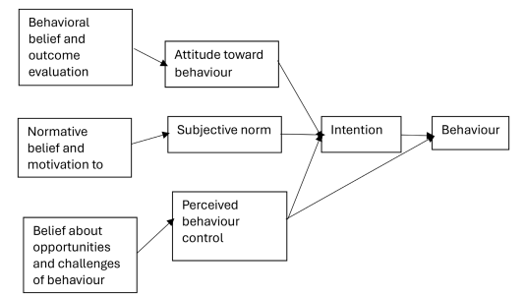
Figure 3: Theory of Planned Behaviour.
(Source: Kufaine, 2024)
In the perspective of the fashion retail sector, Mathew and Spinelli, (2025), show that sustainability marketing greatly influences the constructs of the TPB theory. The consumers' attitudes towards sustainable fashion products are positively influenced by marketing campaigns that demonstrate ethical sourcing, environmentally friendly materials, carbon reduction projects and responsible manufacturing processes. Similarly, Horrich, et al., (2025), indicate that people's concerns about environmental sustainability, family, friends and influencers' recommendations to purchase greener products foster positive subjective norms and encourage consumers towards sustainable consumption. Moreover, Salleh, et al., (2024), show that greater availability, affordability and accessibility of sustainable fashion products enhance consumers' perceived behavioural control by increasing their confidence in making environmentally responsible purchasing decisions. Therefore, sustainability marketing potentially enhances consumers' willingness to buy by strengthening their behavioural intentions. In the present study, TPB acts as the theoretical framework to examine the impact of sustainability marketing on attitude and behavioural intention among consumers within the UK fashion retail industry towards sustainable fashion products. Hence, the TPB theory is essential to the research since it helped to examine the relationship between sustainability marketing and consumers' intention to purchase products.

2.2.4 Legitimacy Theory
The study is also underpinned by the Legitimacy Theory that indicates that organisations continuously attempt to obtain society's approval by aligning their work processes, decisions and communications with society's prevailing norms, values and expectations. The organisational legitimate occurs when they demonstrate responsible corporate behaviour and communicate activities in accordance with the interest of the stakeholders (Olateju, et al., 2021). On the same note, Alsayegh, et al., (2020), highlight that the focus on environmental sustainability has influenced businesses to select to disclose sustainability initiatives. It has necessitated the firms to show accountability, increase transparency and ensure confidence of the stakeholders. The role of sustainability marketing has emerged as an important aspect for organisations to promote sustainability values and build stronger relationships with their consumers and other stakeholders.
From the perspective of the fashion retail industry, Agarwal, et al., (2025), highlight that sustainability marketing allows companies to show their dedication towards ethical sourcing, responsible manufacturing, recycling programs, carbon emission reduction and circular fashion. This type of communication helps to build the legitimacy of organisations by ensuring that sustainability statements are accurate and underpinned by responsible business practices. However, Persakis, et al., (2025), found that excessive, false and unverifiable sustainability assertions increase the risk of allegations of greenwashing. These risk perceptions negatively impact organisational legitimacy, affect consumer trust and purchase intention. Sustainability communication must be credible and transparent to ensure positive consumer perceptions and sustainability growth. Therefore, the legitimacy theory is utilised to examine the role of sustainability marketing practices adopted by fashion retailers in ensuring alignment with society's expectations and stakeholder confidence. Moreover, it also shows the potential influence of credible sustainability communication on consumers' purchase intention through consumers' trust. The Legitimacy Theory balances the application of TPB by providing an organisational perspective alongside the consumer behavioural perspective.
The combined use of these two theories provided a comprehensive theoretical foundation for understanding the influence of sustainability marketing on consumer purchase intention within the global fashion retail industry.

2.3 Sustainability Marketing Practices in the Fashion Retail Industry
In the view of Agarwal, et al., (2025), sustainability marketing has shifted the landscape of fashion retailing from the simple sales of sustainable products to incorporating environmental and ethical concerns and transparency in business practices. Sustainability marketing is increasingly used by fashion retailers to boost their corporate image, gain trust from stakeholders and build long-term relationships with eco-conscious consumers. Sustainability-based marketing provides the ability to promote principles of the circular economy, stimulate responsible consumption in companies and promote the creation of business value. On the same note, Prihatiningrum, et al., (2024), found that sustainability marketing boosts brand value by combining sustainable manufacturing and marketing communication. It further allows the organisations to address two goals including sustainability and consumers' expectations. The proper alignment of the brand values with consumers' increasing demand for environmental responsibility strengthens customer engagement and builds stronger brand loyalty. This indicates that sustainability marketing has shifted firms from traditional marketing efforts toward sustainable practices to generate value within an organisation through responsible corporate actions.

Figure 4:Key Sustainability Marketing Practices in the Global Fashion Sector
(Source: By Author)
Moreover, Thorisdottir and Johannsdottir, (2020), highlight that sustainable marketing practices including ethical sourcing, sustainable materials, recycling programmes and circular fashion are adopted in the global fashion industry. These practices allow fashion retailers to reduce environmental damage and enhance the value of the environment to their stakeholders in terms of corporate sustainability performance. However, Hasan and Shehun, (2022), argue that sustainable initiatives alone are not sufficient since there is a growing demand from consumers for tangible evidence. Global fashion consumers are more sceptical about sustainability claims when the supporting data and actions are not properly shown by the firm. This comparison indicates that sustainability marketing practices positively contribute to positive organisational reputation. However, the provision of authentic environmental outcomes is essential rather than just focusing on sustainability-oriented marketing messages.
In the context of sustainability communication, Zhao, et al., (2026), indicate that effective sustainability marketing needs to ensure transparency in organisational disclosures of their environmental initiatives. The fashion firms demonstrate their commitment through corporate reports, websites and product information that helps to reduce the information gap between business and consumer. The presence of transparent communication allows consumers to effectively judge the sustainability programs with greater certainty which further develops positive perceptions of organisational accountability. However, Rios-Lama, et al., (2026), found the presence of operational problems involved in sustainability communication since many fashion companies continue to overstate and selectively share environmental gains while avoiding meaningful operational changes. These false activities potentially lead to greenwashing which further reduces the trust of the customers and affects the integrity of sustainability marketing. These contrasting results indicate that transparency is not sufficient for successful sustainability marketing unless the sustainability claims reflect the organisational practices coupled with convincing evidence.
The business integration of sustainability marketing has also gained growing significance in today's fashion retailing. Chamorro, et al., (2026), highlight that sustainability marketing is most effective when the sustainability principles are integrated in the entire lifecycle of a product including distribution and post-consumption. The retailers that are taking a comprehensive strategy to sustainability are more encouraged to improve consumer engagement because sustainability is becoming a part of the organisation's key activities. On the other hand, Pricopoaia, et al., (2025), argue that many organisations still use sustainability marketing as a means of product branding to stand out from the competition. The long-term effectiveness of the sustainability messaging depends on the authenticity of the consumers' perceptions towards sustainability commitments. This shows that the strategic value of sustainability marketing is enhanced when environmental responsibility is properly integrated into organisational culture rather than considered as a marketing tool.
In addition, Persakis, et al., (2025), indicate that consumer uncertainty regarding environmental marketing claims is growing due to the critical incidents of greenwashing. The unsupported environmental claims threaten organisations' credibility, affect sustainable buying practices and reduce the success of sustainable marketing efforts. This shows that sustainability marketing potentially enhances consumer perceptions when it relies on transparency, accountability and measurable environmental performance. It is essential for fashion retailers to ensure the alignment between sustainability communication and sustainable business practices in order to maintain the trust of stakeholders and improve the credibility of the company.
The findings of the empirical literature demonstrate that sustainability as a marketing strategy has become an integral part of fashion retail firms' strategic practices. It allows the firms to improve their environmental performance along with enhancing their competitive positioning. Ethical sourcing, circular fashion, sustainable materials and transparency positively impact the organisation's reputation. However, the impact of these practices is highly dependent on the credibility, authenticity and consistent application of sustainability marketing practices. Thus, sustainability marketing is not just a marketing campaign but a unified organisational strategy that should be supported by authentic environmental policies and clear business practices. This indicates that sustainability marketing practices significantly affect consumer attitudes and willingness to buy in the global fashion retail sector.

2.4 The factors that stimulate consumers to respond positively to sustainability marketing

2.4.1 Credibility and Transparency of Sustainability Claims
According to Mollenkopf, et al., (2022), consumers' reactions to sustainability marketing are highly dependent on the credibility and transparency of the marketing message. Making sustainability information transparent, verifiable and consistent from brand to brand makes consumers more receptive to sustainability campaigns. Clear communication helps to eliminate information asymmetry and build confidence in sustainability claims. However, there is some disagreement raised by Mollenkopf, et al., (2022) regarding whether transparency is enough to influence positive consumer reactions. Technical sustainability data is difficult for consumers to understand and too much environmental information can lead to consumer confusion rather than consumer confidence.
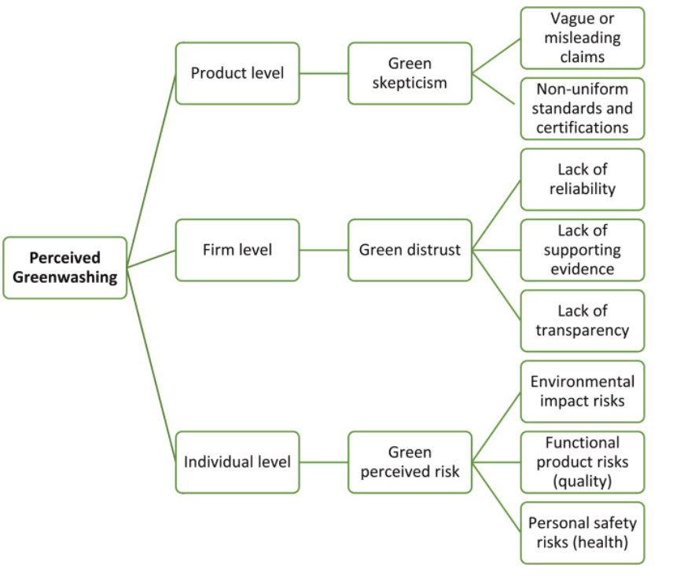
Figure 5: Dimensions and Consequences of Perceived Greenwashing on Consumer Responses to Sustainability Marketing.
(Source: Suphasomboon and Vassanadumrongdee, 2025)
The above figure demonstrates how negative perceptions of greenwashing affect consumer reactions to sustainability marketing at the product level, the company level and the individual level (Suphasomboon and Vassanadumrongdee, 2025). Unclear statements, poor transparency, inadequate evidence and risks associated with the products and environment increase consumer scepticism and distrust which makes sustainability marketing ineffective. Moreover, Rinaldi, et al., (2026) further argued that the rise in greenwashing concerns has raised consumer scepticism. This has caused many consumers to doubt the authenticity of sustainability messages. Therefore, sustainability efforts are not enough to change consumer behaviour, unless backed by credible evidence and consistent organisational actions. Thus, transparency is cited as a key prerequisite of successful sustainability marketing but only if the information is of high value, clear and genuine.

2.4.2 Consumer Environmental Values and Brand Trust
Another significant factor that can drive positive responses to sustainability marketing is consumer environmental values (Taufique, 2022). People who have high environmental awareness value marketing messages that emphasise ethical production, resource conservation and environmentally responsible consumption. Consumers who value sustainability are more likely to engage with brands that are sustainable. Sustainability campaigns often appeal to them because they share the values of the environment and social responsibility. However, Zeng, et al., (2023) argued that positive attitudes towards the environment do not necessarily lead to positive environmental behaviour. Apart from that, Cairns, et al., (2022) stated about attitude–behaviour gap which is a longstanding problem in sustainable fashion as consumers often choose to buy based on price, quality, convenience and the design of the product rather than the environment. This inconsistency suggests that the reaction of consumers to sustainability marketing cannot be attributed to environmental concern. Rather, environmental values seem to enhance the effectiveness of sustainability communication only as long as sustainable products meet consumers' functional and economic expectations (Wang and Su, 2022).
Apart from that, Alhomaid, (2025) noted that trust in the brand has always been cited as an important driver of consumers' acceptance of sustainability marketing. Consumers are more likely to be receptive to sustainability campaigns when they believe brands are trustworthy, ethical and truly dedicated to sustainable business practices. Organisational credibility is reinforced with long-term investments in CSR, responsible sourcing and transparent supply chains which make sustainability messages more convincing. On the other hand, un Nisa, et al., (2022) stated that the trust of consumers in the fashion industry has been eroded because of the numerous sustainability issues and false environmental statements. Therefore, consumers are increasingly judging brands on the consistent actions of the organisation rather than promotional communication alone. This view implies that a sustainable marketing strategy is unable to create positive consumer reactions without sincere corporate actions to support the environmental claims.

2.4.3 Perceived Product Quality, Value and Consumer Knowledge
According to Li, et al., (2024), modern consumers tend to show more favourable attitudes toward sustainable marketing when sustainable fashion products offer high quality, sensory comfort and functional value. The purchase intention of fashion consumers is also determined by their expectations about the product's performance and value for money since the environmental benefits alone are not enough to develop positive consumer responses. Similarly, Schiaroli, et al., (2024), found that fashion consumers are prepared to support sustainable fashion brands when the sustainability levels of the firm align with the product quality and value. This shows that sustainability must be used in addition to the traditional product characteristics.

Figure 6: Key Factors Affecting Consumers' Perceptions Towards Sustainable Marketing
(Source: By Author)
However, Li, et al., (2025), argue that many consumers lack knowledge of sustainability concepts which compromises the ability to differentiate between an authentic sustainability campaign and false sustainability marketing. This lack of understanding often leads to less effectiveness in terms of sustainability marketing strategy which further increases uncertainty while making purchase decisions. Moreover, Truong, et al., (2026), found that increased consumer knowledge and awareness of sustainability increase their capability to assess environmental claims. This type of ability reinforces the positive responses of the fashion consumers to sustainability marketing. These findings demonstrate that sustainability marketing is successful when the consumers believe sustainable products provide higher quality, represent good value and the environmental claims are supported by sufficient sustainability information.

2.4.4 Social Influence and Subjective Norms
Shah and Asghar, (2023), found that social influence is one of the key elements that drive positive consumer responses to sustainability marketing. The consumers' buying decisions are significantly influenced by their family, friends and social circles. Customers are more encouraged to support the sustainable fashion brand when they perceive their environmentally responsible consumption as socially desirable and aligned with social norms. On the same note, Syahribulan, et al., (2025), highlight that social media influencers and digital communities play a major role in raising awareness about sustainability among consumers. The presence of positive recommendations and peer interactions builds consumers' confidence in sustainability marketing which further promotes their willingness to consider sustainable fashion products. However, Sindhuja, et al., (2025), argue that social influence may not necessarily lead to actual purchasing behaviour. This is because the purchasing intentions of the fashion consumers may depend on their actions towards price, convenience and product design. This type of inconsistency highlights the presence of an attitude-behaviour gap within the sustainable consumption of the fashion firms.
These findings demonstrate that social influence and subjective norms have the potential to drive positive reactions to sustainable marketing messages. However, the positive outcomes of these efforts rely on the effective match between social expectations and consumers' personal values, cost values and their real commitment towards sustainable consumption.

2.5 The Relationship Between Consumer Trust and Purchase Intention Towards Sustainably Marketed Fashion Products
Neumann, et al., (2020), represent consumer trust as a core factor that influences purchase intentions for sustainability-advertised items due to uncertainty reduction of claims and the reliable interest in brands' sustainability commitment. Fashion customers are more inclined to buy the products when they believe that the sustainability, social and environmental responsibility actions of the firm are implemented in a proper manner. The aspect of trust increases confidence in the sustainability claims of the organisations which further leads to positive buying intentions. On the other hand, Huo, et al., (2022), show that the involvement of corporate social responsibility increases consumer trust and strengthens the perception of ethical business actions and environmental responsibility. The fashion organisations that invest in responsible sourcing, environmental protection and ethical production are more directed towards building long-term relationships with consumers which further increases their sustainable purchase intention. These findings indicate that sustainability marketing efforts provide positive outcomes when properly integrated with organisational behaviour which helps to build consumer confidence in environmental commitments.
However, Lin and Chen, (2022), argue that consumer trust is not sufficient to understand the factors accounting for the purchase intention of sustainable apparel. This is because global fashion consumers also consider other factors such as the evaluation of the perceived value, environmental awareness and perceived risk before making their final purchasing decisions. They are more willing to buy more sustainably marketed products when the firms offer good quality, function and economic advantages. This indicates that consumers' responses to sustainability marketing vary depending on their priorities for consumption along with environmental awareness between different demographic generations. Moreover, Agarwal, et al., (2025), show that consumer trust is fostered mainly by the authenticity of the fashion brands. This is because the authenticity of organisational sustainability is seen as an indicator of its value instead of just a marketing goal. The presence of authentic sustainability practices reduces doubts and increases consumer confidence in environmental claims. This comparison indicates that consumer trust is developed more effectively through the combination of credible environmental commitments and products that meet functional and economic expectations of the consumers.
In terms of brand authenticity and transparency in sustainability communication, B, et al., (2026), highlight that authentic sustainability practices greatly impact consumer trust. This is because the consistency between environmental claims and the organisational behaviour builds credibility. Customers are more encouraged to buy sustainable fashion products instead of temporary promotional products when the efforts of the firms are equipped with sustainable business strategies in the long-term. The combination of authentic communication, transparent supply chains and responsible sourcing further enhances the trust consumers place in sustainable fashion brands. On the same note, Zhao, et al., (2026), indicate that the availability of transparent sustainability communication reduces the information asymmetry since it delivers credible and verifiable evidence of environmental performance to consumers. The transparency of sustainability assurance promotes trust in the company's sustainability practices which further develops positive buying intention within customers. These findings imply that consumer trust is supported by authenticity and transparency which further supports the implementation of sustainability marketing to build higher purchase intention.
In addition, Al-Abdallah, et al., (2026), found that trust is not the only psychological driver that affects purchase intention in the fashion industry. The symbolic and emotional values continue to influence purchasing behaviour since consumers often demand that brands reflect individuality, uniqueness and personal identity. Sustainability marketing has the potential to build consumer trust however, sometimes consumers may focus on self-expression, prestige and lifestyle preferences over environmental responsibility which may influence their purchase intention. This implies that customer trust plays a key role in shaping their purchase intention. Fashion brands are required to focus their sustainability marketing towards meeting the emotional, social and symbolic needs of the customers in order to offer credible environmental commitments.
These findings demonstrate that the level of trust received by the customers is an important measure for the willingness to purchase sustainable products from the fashion firms. However, the purchase intention is also influenced by a number of factors such as brand authenticity, perceived value, corporate social responsibility and personal motivations. Thus, the fashion retailers need to build consumer confidence in sustainability by following authentic sustainability practices and providing complete information to the consumers.

2.6 Challenges Affecting Sustainability Marketing and Practical Recommendations to Improve Customer Purchase Intention

2.6.1 The Danger of Greenwashing and Consumer Scepticism
According to Daou, et al., (2025), greenwashing is one of the biggest hurdles in the effectiveness of sustainability marketing. Overstated or false environmental statements diminish consumer trust and the effectiveness of sustainability campaigns. Without supporting evidence or measurable outcomes, consumers question brands' actual environmental efforts. However, Eze, (2025) argued that not all consumer scepticism is due to greenwashing because consumer awareness of the environment has also led to a greater study of the sustainability communication, irrespective of whether it is true or not. This indicates that there are two major challenges for sustainability marketing such as misleading corporate practices and growing consumer expectations.

2.6.2 The Attitude–Behaviour Gap
According to Jang and Kim, (2026), a key challenge is the long-standing attitude–behaviour gap as many consumers have positive attitudes towards sustainable fashion and are receptive to sustainability marketing. These attitudes often do not lead to actual consumer purchases. Furthermore, disparity in the price of the products, their scarcity and fashion trends are more important than sustainability. Chen, (2024) believes that the issue is not consumer priorities but rather the lack of effective sustainability marketing that does not deliver real consumer value. Thus, sustainability marketing is not enough to overcome behavioural barriers, unless it takes into account other economic and product-related factors.

2.6.3 The Absence of a Standardised Sustainability Communication
From the perspective of Borges, et al., (2023), sustainability marketing is also limited by the lack of a standardised communication of sustainability. There are conflicting environmental statements, multiple eco-labels, and different sustainability certifications which make it hard for consumers to compare brands or to check the sustainability performance. This inconsistency adds to confusion and diminishes the trust in sustainability messages. However, Gudmundsdottir and Sigurjonsson, (2024) argue that overstandardisation can hinder companies' capacity to convey novel sustainability projects that go beyond current certification systems. Therefore, there is a need for consistency but sustainability communication should not be so rigid because it then does not allow for genuine organisational innovation.

2.6.4 Recommendations to Overcome the Identified Challenges
According to Badhwar, et al., (2024), to combat greenwashing, fashion companies must ensure that their sustainability marketing is more credible by communicating with transparency and evidence. Environmental statements are backed by evidence of environmental metrics, third-party environmental certifications and transparency around sourcing. In this scenario, consumer confidence is further strengthened through regular sustainability reporting and independent verification which can help to ensure that marketing claims are aligned with organisational practices but not promotional agendas. Moreover, Ryding, et al., (2022) indicated that sustainability marketing needs to go beyond just emphasising the environmental advantages and make the case for the full value proposition of sustainable fashion to help close the attitude–behaviour gap.
Product quality, durability, comfort, design and long-term economic value should be promoted in marketing campaigns in addition to sustainability attributes (Huang, et al., 2024). Retailers are also assured of promoting sustainable consumption by providing low-cost product lines, repair options, recycling programs, loyalty programs and educational initiatives. This further helps demonstrate the individual and environmental advantages of sustainable consumption.
Furthermore, Llácer-Falcón, et al., (2026) consider that there is a need for consistency and clarity throughout the fashion industry to improve the sustainability communication. Retailers are required to use simple, easy-to-understand sustainability communications that are backed by accepted industry environmental standards and certifications. Information on sustainability is ensured to be presented to consumers in a simple way by means of product labelling, digital traceability and brief environmental impact statements (Ospital, et al., 2023). Further, industry is required to work with regulatory agencies and certifiers to increase the consistency of sustainability communication and decrease consumer confusion.

2.7 Conceptual Framework
H1: Sustainability marketing has a significant influence on consumer trust in the UK fashion retail industry.
H2: Sustainability marketing has a significant influence on consumer purchase intention in the UK fashion retail industry.

Figure 7:Conceptual Framework.
In the conceptual framework, sustainability marketing is identified as the independent variable that impacts two important dependent variables in the fashion retail sector in the UK. Firstly, it is assumed that successful sustainability marketing will increase the level of trust through improved perceptions of transparency and credibility. Secondly, the increased levels of trust and positive communication regarding sustainability are predicted to increase the purchase intention of consumers.

2.8 Research Gap
Previous research has largely covered aspects like green marketing, environmental awareness, brand reputation, corporate social responsibility and purchase intention (Al-Abdallah, et al., 2026; Daou, et al., 2025). However, the results found in previous literature have been inconsistent in terms of the effectiveness of sustainability marketing in influencing consumer purchase intention especially in the UK fashion retail industry. Another problem is that most of the studies have concentrated on generalised consumer behaviour and the retail industry in general (Sindhuja, et al., 2025; Jang and Kim, 2026). However, very few have considered the role of consumer trust which can be regarded as an important output of sustainability marketing. The research carried out until now has mostly investigated the practices of sustainability independently, but not in combination with each other in order to understand their impact on consumer trust and purchase intention. Thus, the present research needs to be conducted on this issue in order to fill this gap in the academic literature.

2.9 Summary
From the literature, it has been established that sustainability marketing has progressed from being a practice aimed at the promotion of eco-friendly products into a strategy aimed at building consumer trust through sustainable business practices. It is acknowledged in the literature that the success of sustainability marketing not only lies in the implementation of sustainable initiatives but also in the credibility and authenticity with which these initiatives are communicated. From the review, it can be seen that the response of consumers is affected by variables like transparency in sustainability claims, environmental values, brand trust, product quality perceptions, and social influence. However, the positive effects of these variables are limited by issues such as greenwashing, attitude–behaviour gap and inconsistency in sustainability communication. The above literature shows that sustainability marketing works well when there is an organisational commitment to sustainable practice and when sustainability communication is consistent.

Chapter 3: Research Methodology

3.1 Introduction
This chapter describes and justifies the methodological decisions to be used in studying the role played by sustainability marketing on consumer purchase intention within the UK fashion retail market. In line with the research aim and objectives, it describes the research philosophical stance, research approach, research strategy, research design, sampling procedure, data collection instrument and analytical techniques employed to answer the research questions. Every methodological choice is supported with academic explanation to demonstrate its adequacy to understanding the interconnection among the sustainability marketing, consumer trust and purchase intention. Ethics of research are also addressed in the chapter and steps to ensure reliability, validity and overall credibility of the study.

3.2 Research Design (Saunder’s Onion Framework)
The research design is a systematic procedure that addresses research design decisions. The research is based on the Research Onion, created by Saunders et al. (2019). Instead of choosing research methods individually, the framework prompts to proceed in a systematic way across repeated methodological stages where every research decision is rationally aligned with the overall research objectives.

Figure 8: Saunders’ Onion Model.
(Source: Saunders, et al., 2019)
In the current study, the choice of a positivism research philosophy, deductive research approach, quantitative survey strategy and a cross-sectional time horizon are based on the Research Onion (refer to the above diagram). These decisions are indicative of the objective of analysing the relationship between sustainability marketing, consumer trust and purchase intent based on quantifiable data obtained on UK fashion customers. Online questionnaire is the main source of primary data collection and SPSS is used to test the relationships among variables and analyse the data statistically. Adopting the Research Onion assures that every methodological choice is associated and appropriate to perform survey efficiently that can respond to research questions of the study.

3.3 Research Philosophy
Research philosophy provides the foundation for how knowledge is generated and interpreted within a study, influencing decisions related to research design, data collection, and analysis (Ali, 2024). As this study aims to test the relationship between sustainability marketing and consumer purchase intention by quantifying measurable consumer perceptions, a positivism research philosophy has been considered. Positivism presupposes that the reality is independent and social phenomena can be studied objectively with the help of empirical observation and statistical analysis. In turn, it is generally related to quantitative research, where numerical data is used to test hypotheses or theoretical relationships (Maretha, 2023).
The selection of positivism is consistent with the purpose of this study, which is not to explore individual experiences or develop new theory, but to determine whether sustainability marketing has an impact on consumer trust and purchase intention among consumers in the UK fashion retail sector. The study thus needs standardised information which can be analysed objectively and which will provide the patterns and arrangements within a reasonably large sample of the respondents.

3.4 Research Approach
The current research is deductive in nature since it aims to test the established theoretical relationships in the context of the UK fashion retail industry. The deductive reasoning starts with the presence of theories and empirical evidence, based on which hypotheses are made and further analysed with the help of the collected data (Yuwono and Rachmawati, 2023). Instead of coming up with new theoretical explanations, the methodology aims at evaluating the relevance of identified concepts within a given research context.
The deductive approach is aligned with the research objectives. The literature analysis conducted in the above chapter suggests that sustainability marketing can be used to influence consumer trust and purchase intention, and that the Theory of Planned Behaviour (TPB) and the Legitimacy Theory offers a theoretical account of these relations. Expanding on these well-defined perspectives, the present research explores whether consumers who are exposed to sustainability marketing behaviors show a better purchase intention and an increase in trust towards UK fashion retailers. A structured questionnaire will therefore be used to collect primary data that will be statistically analysed in order to find out the presence and direction of these relationships.

3.5 Research Strategy
The research strategy outlines the overall approach by which data is gathered and analysed to respond to the research questions (Mohajan, 2020). Considering the nature of the study, a survey strategy has been adopted. Surveys are commonly used in marketing and consumer behaviour studies since they help to gather standardised information of relatively large population of respondents in a short time span. In the current study, survey method enables to gather data directly from the consumers and how they perceive sustainability marketing, their trust of the fashion retailers and whether they are planning to buy their products. The survey strategy offers a feasible data generation process that can be used to produce data that could be analysed statistically since these constructs can be measured based on structured statements and quantifiable through a Likert scale. Besides, the online administration of the questionnaire enhances the accessibility of the questionnaire to participants in various regions of the UK as well as minimising the cost and time of data collection.

3.6 Research Method
The research is based on the quantitative method since it aims to explore how sustainability marketing can affect consumer purchase intention in the UK fashion retail market. The quantitative research is especially appropriate in the context of studies that are aimed at objectively measuring variables and analysing relations based on the use of numerical data (Lim, 2025). This approach will allow the use of statistical methods to suggest patterns and determine the strength of the relationships between the variables by transforming the perception of respondents into some measurable numeric values.
The selection of a quantitative approach is derived aligned with the research aim to estimate the effect of sustainability marketing, determine how consumer trust and purchase intention are related, and identifying the extent to which these constructs are associated. These objectives demand evidence that can be measured and objectively analysed as opposed to descriptions of personal experience.

3.7 Target Population, Sampling Technique and Sample Size
The target population is a group to which the research data is gathered to respond to the study objectives (Rahman, 2023). The study sample in this research is people of age 18 years and above and who are living in the United Kingdom and who have previously bought any product from fashion retailers. This sample was chosen due to the higher likelihood that these consumers will have encountered sustainability marketing programs such as environmental claims, ethical sourcing movements, recycled goods and recycle programs and circular fashion movements.
A non-probability convenience sampling method has been used to get the participants of this population. Convenience sampling entails choosing the respondents who can be easily contacted and are willing to take part in the research (Hossan, et al., 2023). This method is widely adopted in scholarly studies, especially when there is no complete sampling frame and the time and resource constraints make it impossible to use probability sampling techniques. As no extensive database of all fashion consumers in the UK that meet the inclusion criteria is available, the use of methods like simple random or stratified sampling would be difficult to apply within the scope of this dissertation.
The required sample size was determined using Cochran's formula for an unknown or sufficiently large population. Using a 95 percent confidence (Z = 1.96), a 50 percent population variability (p = 0.5) and a 10 percent margin of error (e = 0.10), it was found that a minimum population sample size was 96 respondents. To reduce the effects of unfinished or non-usable questionnaires and to have adequate valid responses to carry out statistical analysis, the research expects to get 80-100 filled out questionnaires. Nonetheless, while 96 responses were considered to be the minimum number to obtain, only 82 valid responses could be achieved. The number obtained is adequate in the available timeframe and hence all the 82 responses collected were used in the final analysis. However, This sample size is deemed to be sufficient to perform descriptive statistical analysis and regression analysis using SPSS.

3.8 Data Collection Method
A structured online questionnaire is used to collect primary data as this is the most appropriate tool to use in quantitative research that aims at obtaining standardised answers to a relatively small group of respondents (Loomis and Paterson, 2018). As the study examines how sustainability marketing is perceived by consumers, their consumer trust and their consumer purchase intention, first hand responses would ensure that the data are up to date, relevant and applicable to the UK fashion retail setting.
The questionnaire is created with the help of Google Forms and distributed electronically via the social media, personal networks, and online means of communication. An online mode of administration has been selected because it enables respondents from different regions of the United Kingdom to participate conveniently while reducing the time and financial resources associated with face-to-face data collection. Moreover, the electronic format eases automated tabulations of the responses, reducing the possibility of errors in data entry and making the transfer of the dataset into SPSS to perform statistical analysis efficiently.

3.9 Reliability and Validity
The consistency of measurement is known as reliability. An effective questionnaire must yield consistent and steady results when given to similar participants (Ahmad, et al., 2024). Internal consistency reliability in the current research is assessed by using Cronbach Alpha coefficient in SPSS. This statistic is used to determine the extent to which items that represent the same construct are correlated to each other. In line with the accepted research practice, a Cronbachs Alpha of 0.70 and above is regarded as a sign of satisfactory reliability.
Validity is the concern of the appropriateness of the questionnaire in its measurement of the concepts that it is required to measure (Hajjar, 2018). In order to increase the content validity, questions are based on the already published and validated research on sustainability marketing and consumer behaviour. The utilisation of pre-existing measurement scales helps minimise the chances of missing key dimensions of each construct and enhances scholarly soundness of the instrument.

3.10 Data Analysis Technique
The responses will also be coded and analysed using the Statistical Package of the Social Sciences (SPSS) after data collection. The selection of SPSS is made since it is one of the most popular statistical software packages in business and marketing research, providing valid means of organising, managing and analysing quantitative data (Kafle, 2019). It is especially appropriate to investigate the relationships between variables in a structured and objective way due to its capabilities of conducting both descriptive and inferential statistical analysis.
Data screening will start with filling in of the incomplete questionnaires and duplication of the responses and any absence of values that will be taken so that quality of the data set can be assured before statistical testing. When the data have been cleaned, it will produce descriptive statistics which will summarise the demographics of the respondents such as age, gender, education level and buying behaviour. Measures like frequencies, percentages, means, and standard deviations will also indicate an overview of the respondents in relation to their responses towards sustainability marketing, consumer trust and purchase intention.
Linear regression will then be used to determine the relationship between the variables of the study. Regression is considered appropriate because the primary objective of this research is to determine whether sustainability marketing significantly influences consumer purchase intention and to evaluate the contribution of consumer trust within this relationship.

3.11 Ethical Considerations
Ethical standards play a key role in ensuring that the research is done ethically and the rights and well-being of the participants are safeguarded (Drolet, et al., 2023). Since this is a research where human participants are involved and the data is collected using the online survey, the principles of ethics are used during the research process as per the research ethics requirements of the University.
Before participating, the respondents are given a Participant Information Sheet that explain the purpose of the research, the nature of their involvement as well as the intended use of the gathered data. The involvement is voluntary and the informed consent are taken electronically and after obtaining it, the respondents were allowed to fill in the questionnaire. The study also explain to the participants that they can withdraw from the study at any point with no adverse effects.
The questionnaire will not ask the participants any personal identifiable information like names, addresses, contact numbers or email address in order to protect the privacy of the participants. As a result, the research will be conducted anonymously. Moreover, the data obtained will all be treated as confidential and will not be utilised in other non-academic ways. The final version of the dataset will be safely stored in the form of password-protected electronic files, and will be viewed by the researcher and the academic supervisor only. After the dissertation and in line with data management provisions in the University, the research data will be stored safely until the necessary duration before it is permanently deleted.

3.12 Summary
This chapter focuses on the research methodology that was employed in order to study the impact of sustainable marketing on intention to purchase in UK fashion retailing industry. Positivism paradigm and the deductive methodology have been used together with a quantitative survey research method and a cross-sectional research design. The primary data have been collected using online structured questionnaire targeting the UK fashion customers aged 18 years and above. Convenient sampling method has been used in which 82 responses have been received. The data has been analysed using SPSS descriptive analysis, regression and correlation analysis. Reliability and validity issues have been considered in order to maintain the quality of the research and ethical consideration has also been considered.

Chapter 4: Data Analysis

4.1 Introduction
In this chapter, the analysis of the primary data collected to achieve the aim of this study, which is to examine the effect of sustainability marketing on the purchasing intentions of the UK fashion retail industry, is presented. The analysis of the data is conducted in order to answer the research questions and hypotheses through descriptive statistics, reliability tests, and regression analysis using SPSS software. The presentation of the findings is conducted systematically in terms of tables and figures, and the focus is placed on the patterns and relationships that emerged from the respondents' data.

4.2 Overview of the Dataset and Analysis
For this chapter, the data is based on 82 valid responses retrieved from an online questionnaire. The questionnaire was targeted at collecting quantitative data from individuals aged 18 years and above who reside in the United Kingdom and who had purchased products from fashion retailers before. Therefore, the data set includes information concerning the perceptions and purchasing intention of consumers in the UK fashion retail industry. The data include demographic data of the respondents and responses to structured questions on the main variables of this study. Demographic data provides information about the participants and helps in defining the profile of the sample. Age, gender, education level and consumer purchasing behaviour of the participants are considered for providing a good description of the respondents. The main part of the data concerns attitudes of the respondents towards sustainability marketing, consumers' trust and purchasing intention. Consumer perceptions were quantified for statistical tests using structured questions and statements on a Likert scale. This helps to analyse the relationship between the key variables of this study.
The data were analysed by reviewing the responses and organising the data for statistical tests in SPSS. Descriptive statistics were used for summarising the demographic data and the responses. Reliability and regression analyses were conducted to examine the relationships between sustainability marketing, consumer trust and consumer purchase intention. The total number of responses (82) provides the empirical data for this study.

4.3 Descriptive Statistics
Section A: Demographic Information
Q1. Age group
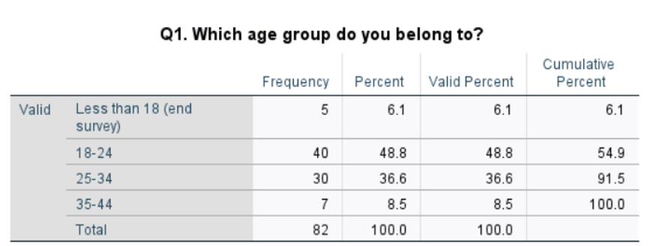
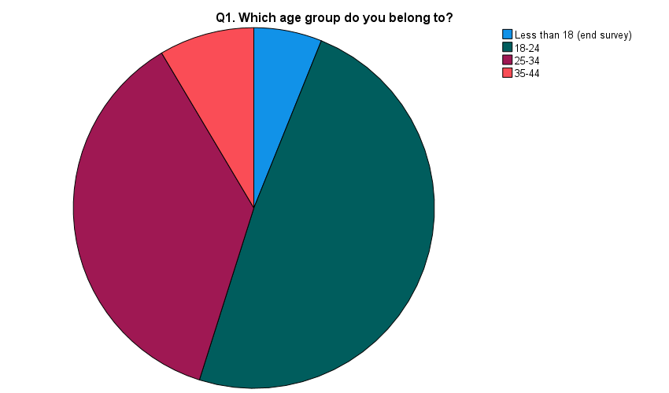
Figure 9: Responses to question 1st.
The frequency results indicate that the majority of the respondents were 18-24 years old which is 40 respondents (48.8%). The second highest was 25-34 years with 30 respondents (36.6%). The 35-44 age group had the smallest number of respondents (7, 8.5%), and 5 respondents (6.1%) were under 18 years old. The mean was 2.4756, the median was 2.00 and the mode was 2.00 which suggests that the most common response was the 18-24 category which was also the central category (refer to appendix 2). The standard deviation of 0.74080 is relatively low which suggests that the responses are relatively close to the average and that there is not a lot of variation across the age categories reported.
Q2. Frequency of purchase fashion products
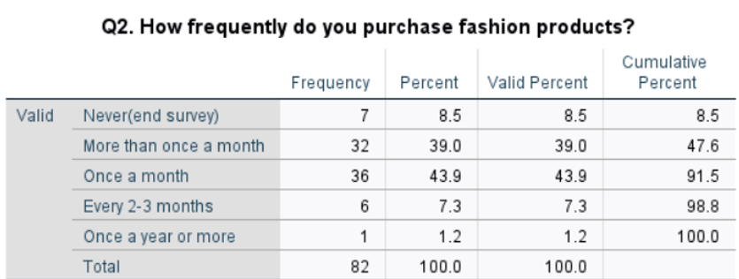
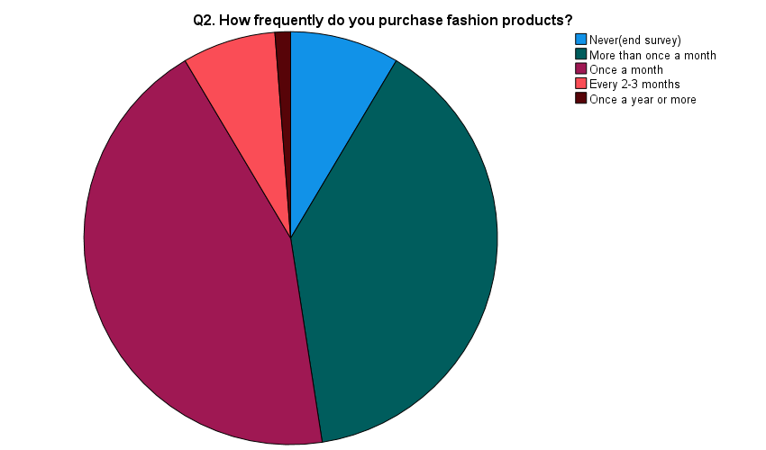
Figure 10: Responses to question 2nd.
The findings show that 36 respondents (43.9%) reported purchasing once a month, which was the most common purchasing frequency. More than once a month was reported by 32 respondents (39.0%) and was closely followed by this. Another 6 respondents (7.3%) said they bought fashion products every 2-3 months and 1 respondent (1.2%) bought once a year or more. In addition, 7 respondents (8.5%) chose never. The mean was 2.5366, the median and mode were both 3.00 which indicates that the third response category was the central and most common response (refer to appendix 2).
Section B: Perceptions of Sustainability Marketing
Q3. Positive impact of Sustainability marketing on consumers' perception of fashion brands
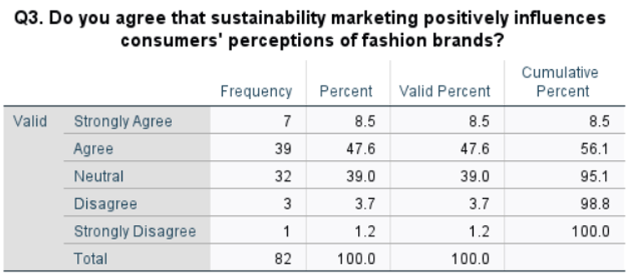
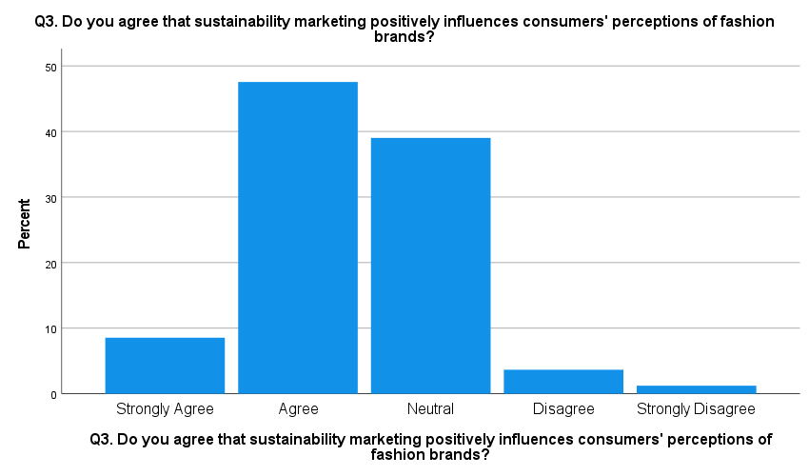
Figure 11: Responses to question 3rd.
The responses indicate that 39 (47.6%) respondents agreed, while 7 (8.5%) respondents strongly agreed. In total, these responses make up 56.1% of the sample. Thirty-two respondents (39.0%) chose the response of Neutral. 3 (3.7%) respondents chose Disagree and 1 (1.2%) respondent chose Strongly Disagree. The mean score was 2.4146 and the median and mode scores were both 2.00 (Agree). The mean was 0.75729 with a standard deviation of 0.75729 which suggests that the responses were not very different from each other (refer to appendix 2). The distribution of responses overall was skewed towards agreement with comparatively fewer respondents choosing disagreement.
Q4. Transparency about sustainability efforts enhances a fashion brand's image
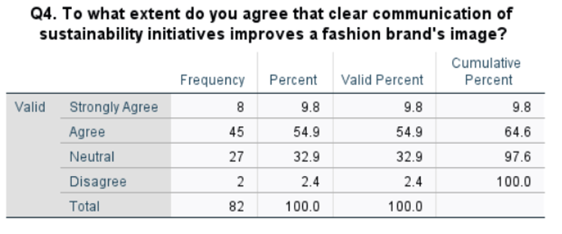
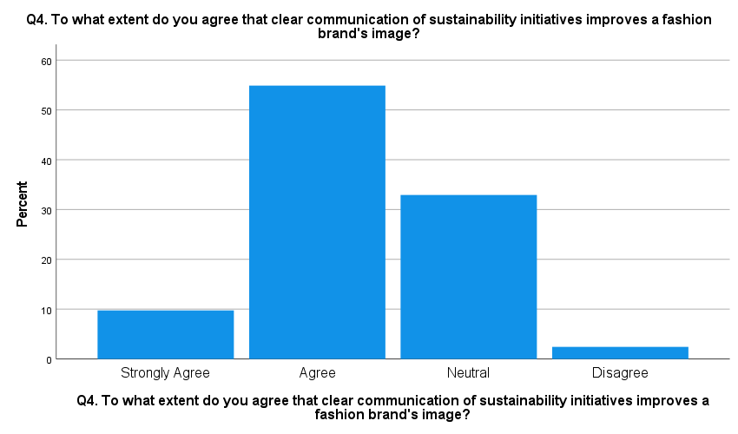
Figure 12: Responses to question 4th.
The most common response was Agree with 45 respondents (54.9%) as indicated in the frequency distribution. 64.7% of respondents agreed with the statement, with 8 (9.8%) respondents choosing Strongly Agree. 27 respondents (32.9%) chose the Neutral option and just 2 respondents (2.4%) chose Disagree. The mean was 2.2805 and the median and mode were both 2.00, which is the Agree category. The standard deviation of 0.67173 signifies that the responses are not too different from each other (refer to appendix 2). Thus, the results indicate that the responses were mostly focused on the agreement with a relatively small number of negative responses.
Q5. Sustainability marketing impacting consumers' decision-making process for fashion brands
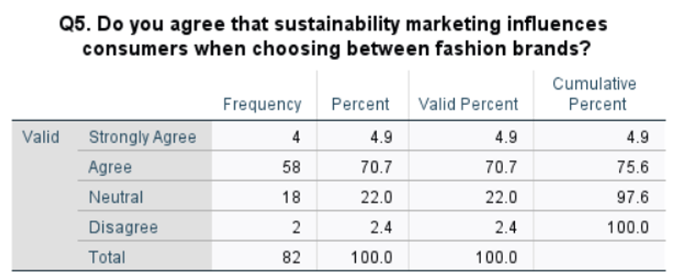
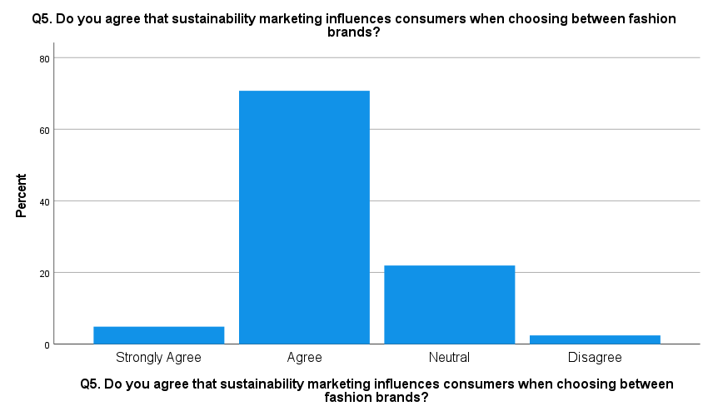
Figure 13: Responses to question 5th.
The findings reveal a significantly large number of responses in the agreement category. 70.7% (58) respondents agreed and 4.9% (4) respondents strongly agreed. Hence, 75.6% agreed with the statement. 22.0% (18 respondents) chose Neutral and 2.4% (2 respondents) chose Disagree. The mean score was 2.2195, the median score was 2.00 and the mode score was 2.00 (Agree). The standard deviation was 0.56709, which suggests that the responses were not very different from each other (refer to appendix 2). As seen in the distribution, the answers were concentrated around the Agree category with few respondents opting for disagree.
Q6. Sustainability marketing is a factor in decision making process between fashion brands
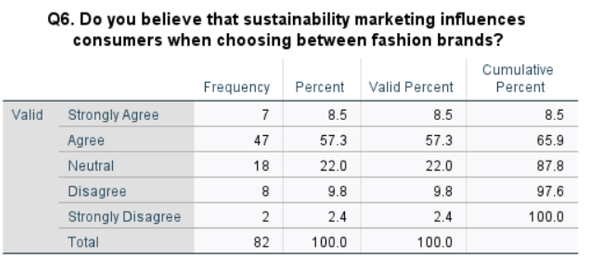
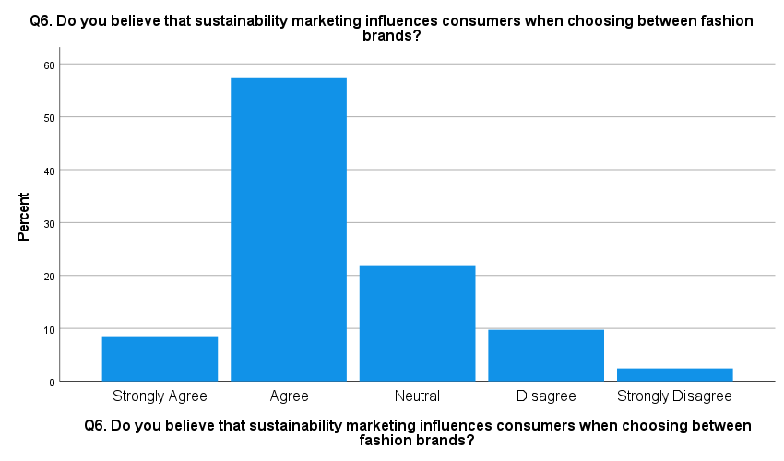
Figure 14: Responses to Question 6th.
The responses show 47 (57.3%) agreed and 7 (8.5%) strongly agreed. The two categories together account for 65.8% of the respondents. Another 18 respondents (22.0%) chose the response Neutral. Eight respondents (9.8%) chose Disagree and 2 (2.4%) chose Strongly Disagree. The mean was 2.4024, the median was 2.00 and the mode was 2.00 which means that the most common response was Agree and it was the central response (refer to appendix 2).
Q7. Sustainability marketing being a sign of a company's true interest in sustainability
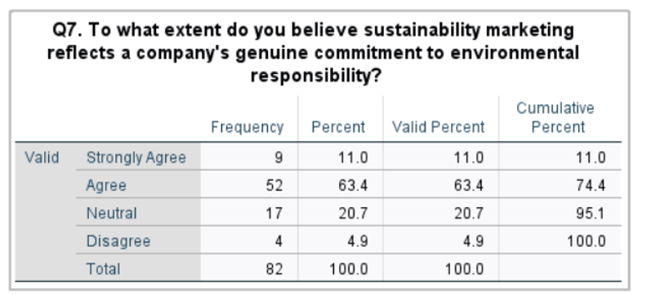
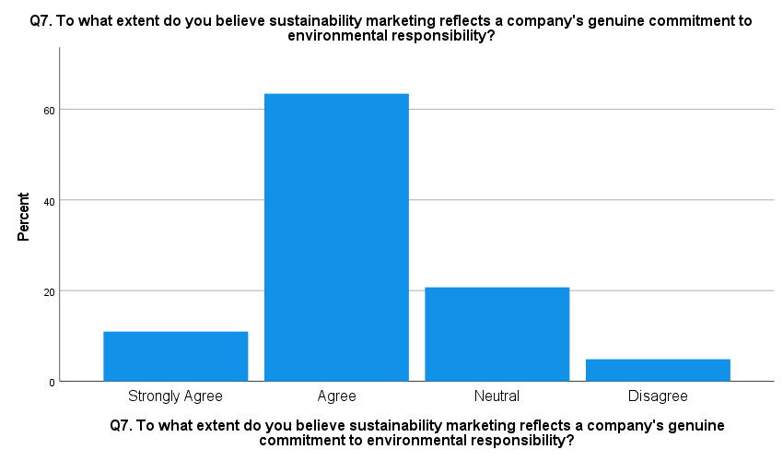
Figure 15: Responses to question 7th.
The responses to the frequency question show that the most common response was Agree (52 respondents, 63.4%). Another 9 respondents (11.0%) chose Strongly Agree which brings the total agreement to 74.4%. 17 respondents (20.7%) chose Neutral and 4 respondents (4.9%) chose Disagree. The mean score was 2.1951 and the median score and mode were 2.00 or Agree. The standard deviation was 0.69280 which suggests that there was not a lot of variation in the responses (refer to appendix 2). The distribution of the responses was thus clearly skewed towards agreement, with neutral and disagreement responses making up smaller percentages of the sample.
Q8. Most important sustainability marketing practice for selecting a fashion brand
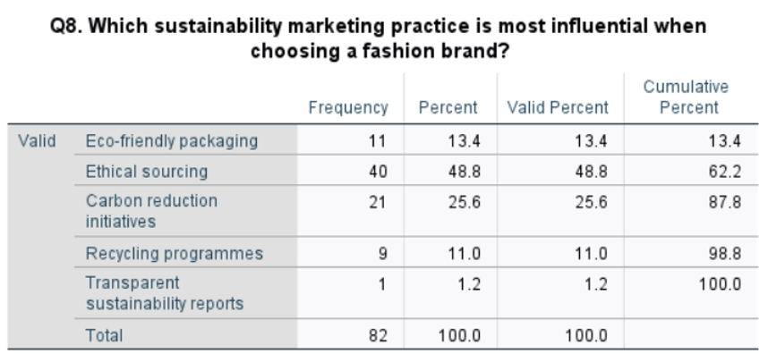
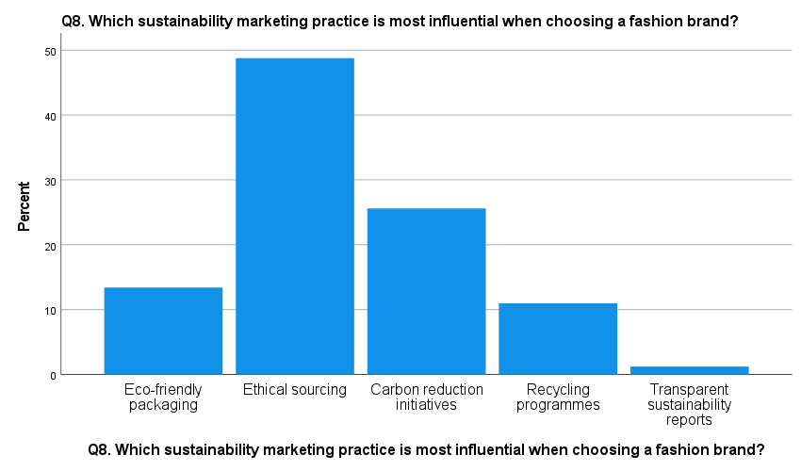
Figure 16: Responses to question 8th.
The responses reveal that the most commonly selected sustainability marketing practice was ethical sourcing with 40 respondents (48.8%) reporting that they do it. Carbon reduction initiatives were the second most selected practice with 21 respondents (25.6%) selecting this practice. This was followed by eco-friendly packaging which was selected by 11 respondents (13.4%) and recycling programmes, selected by 9 respondents (11.0%). Only 1 respondent (1.2%) selected transparent sustainability reports. The mean was 2.3780, and the median and mode were both 2.00 which means that ethical sourcing (the second coded category) was the most common and central response. The standard deviation is 0.89774 which suggests that there is some variation in the selected sustainability marketing practices (refer to appendix 2).
Section C: Consumer Trust
Q9. Transparent Sustainability Information and Trust
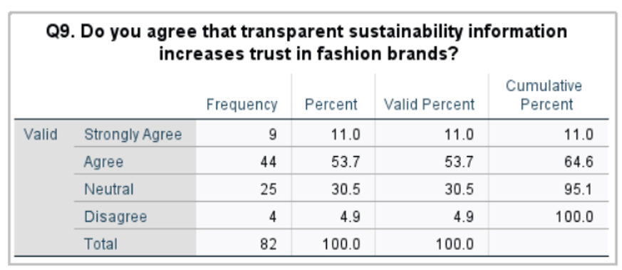
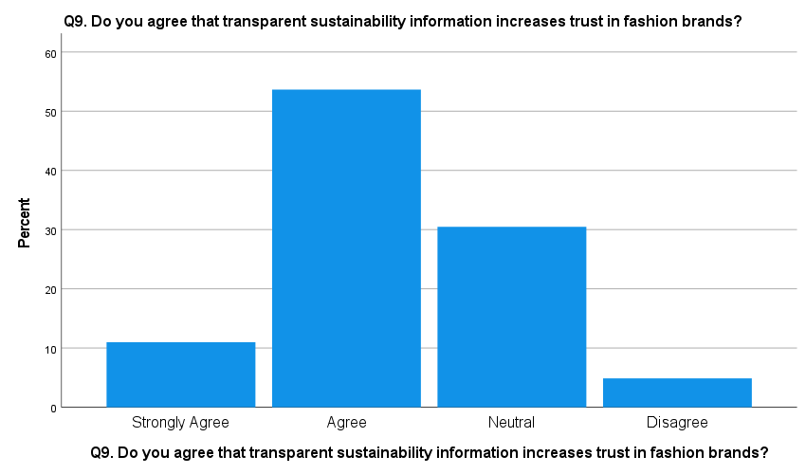
Figure 17: Responses to question 9th.
It was found that Agree has the highest percentage (53.7%) of valid responses. More than half of the respondents indicated that they are sure that the availability of sustainability data contributes to the development of trust in fashion brands. Additionally, 11.0% strongly agreed and 30.5% selected the neutral option. 4.9% disagreed with the statement. The mean score was 2.2927 with a standard deviation of 0.72840, which means that the responses were quite consistent and mostly agreed (refer to Appendix 2). Overall, the tendency of answers is positive, and the majority of the respondents agree on the importance of transparency of the data for building consumer trust. Also, the relatively high neutral answers indicate that more sustainability data is needed to form an opinion of the consumers.
Q10. Independent Sustainability Certifications and Consumer Confidence
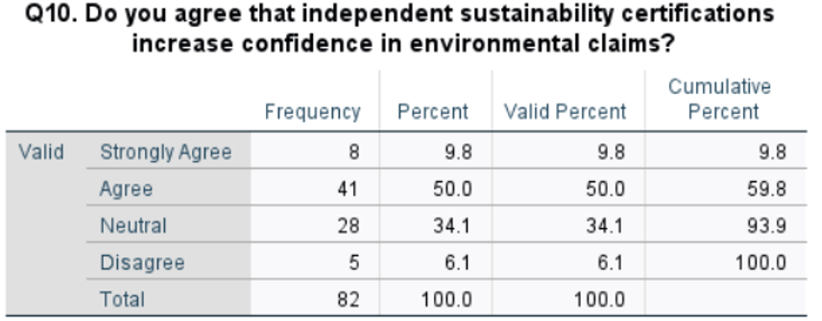
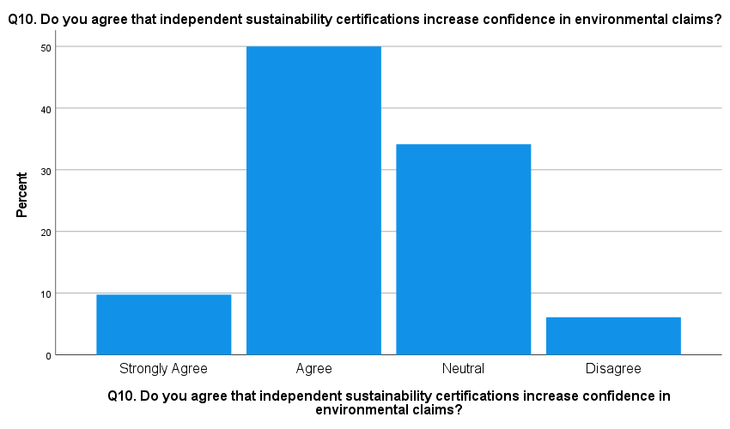
Figure 18: Responses to question 10th.
Agree option had the highest ticked frequency (50.0% of valid responses). This shows that half of the respondents believe that independent sustainability certifications can increase their trust in environmental claims of fashion brands. Additionally, 9.8 per cent of respondents strongly agreed, and 34.1 per cent were neutral. 6.1% disagreed with the statement. Mean score and standard deviation: the mean score was 2.3659 with a standard deviation of 0.74556, which means that responses were moderately consistent (refer to Appendix 2). Thus, the results showed positive attitudes towards independent certifications. However, the relatively high share of neutral responses shows that not all people know about, or are motivated by, sustainability certificates in environmental claims. But the most common answer was agreement.
Q11. Greenwashing and Trust in Sustainability Marketing
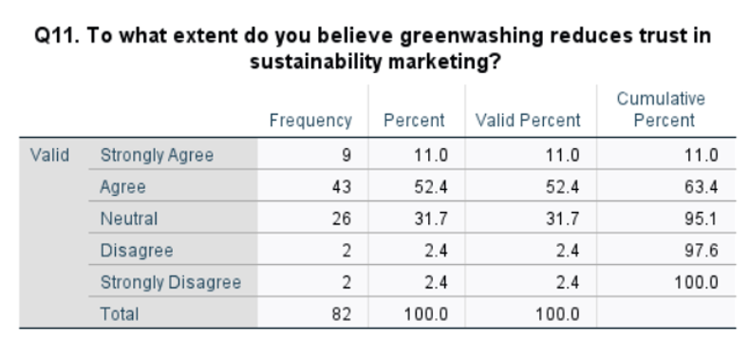
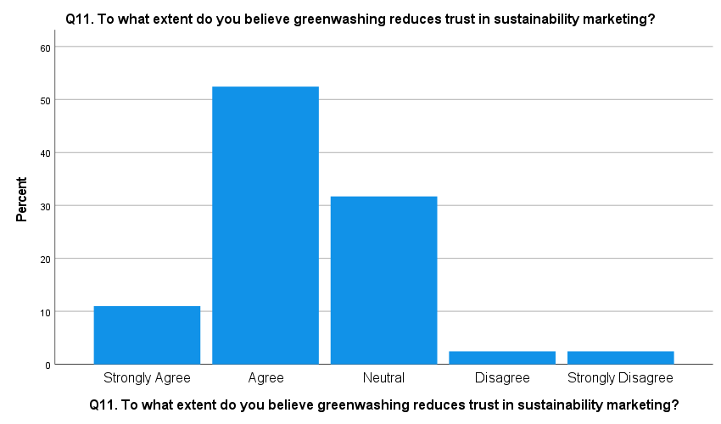
Figure 19: Responses to question 11th.
This question had the highest valid percentage where 52.4% of respondents marking agree. This shows that more than half of the respondents think that greenwashing decreases the level of trust in sustainability marketing. Additionally, 11.0% strongly agreed, and 31.7% strongly disagreed. Only 2.4% disagreed, and another 2.4% strongly disagreed with the statement. The mean score was 2.3293, and the standard deviation was 0.80208, which shows some variation in responses of the respondents (refer to Appendix 2). Overall, the answers have shown some pattern, with agreement as the most common response. The results have indicated that the majority of the respondents consider false or exaggerated sustainability information as a factor that impacts the level of trust in sustainability marketing.
Q12. Most Important Factor for Building Trust in Sustainability Marketing

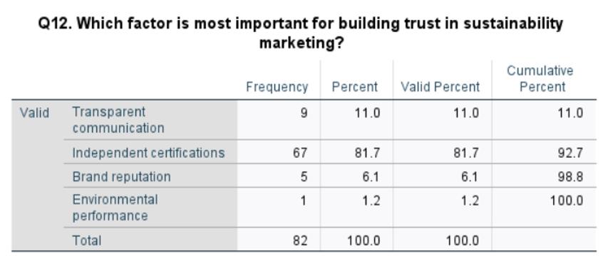
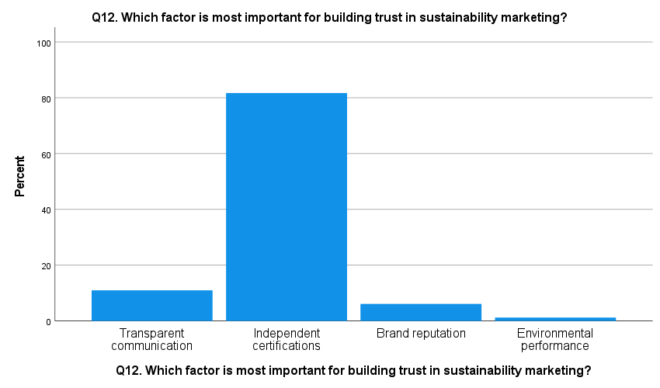
Figure 20: Responses to question 12th.
The results indicated that the choice of Independent was 81.7%, which was the highest valid percentage among all answers. This was the most important factor that was found to be the most crucial for building trust in sustainability marketing. Communication transparency was chosen by 11.0%, brand reputation by 6.1%, while only 1.2% selected environmental performance. The standard deviation was 0.68317, and the mean score was 2.0488, which suggests that the scores were rather low in variation and had a high degree of consistency (refer to Appendix 2). The results showed high levels of responses targeted at independent certifications and, therefore, this choice is highly visible among the other options. Thus, the above pattern indicates that, in the case of credibility of sustainability marketing, the external/independent verification plays an essential role.
Section D: Consumer Purchase Intention and Recommendations
Q13. Influence of Sustainability Marketing on Purchasing Fashion Products
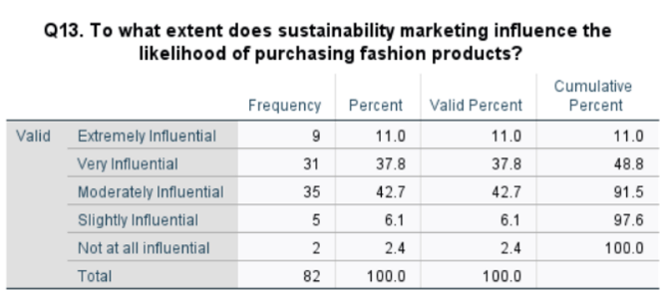
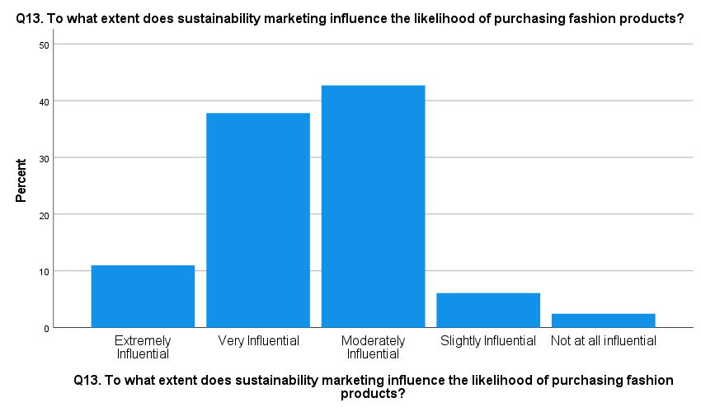
Figure 21: Responses to question 13th.
The valid percentage of the Moderately Influential choice was 42.7%. This means that awareness of sustainability marketing has an influence on the intentions of the majority of the respondents to purchase products. However, in comparison to the other choices, 37.8% considered it to be very influential. The standard deviation (0.86415) and the mean (2.5122) suggested that the opinions of respondents varied considerably (refer to Appendix 2). In general, it is possible to assume that sustainability marketing has an influence on the consumers' purchasing decisions, but the impact can vary depending on individuals.
Q14. Willingness to Purchase from Brands with Credible Sustainability Practices
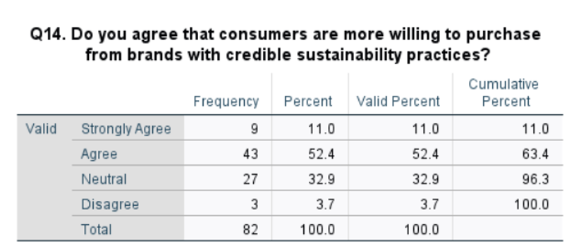
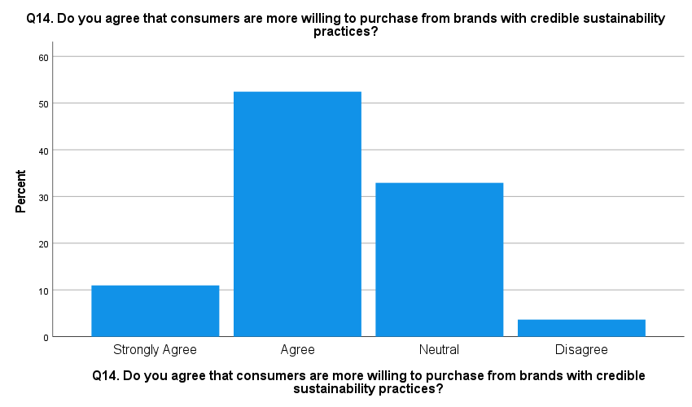
Figure 22: Responses to question 14th.
The highest percentage was 52.4% for the category of Agree. It indicates that the majority of consumers would like to buy from a fashion brand that proves its sustainability. Another portion strongly agrees, with 32.9% being neutral. The mean was 2.2927, and the standard deviation was 0.71125 (refer to Appendix 2). Thus, it is possible to state that the answers were quite uniform. Therefore, the results have shown that the practices of sustainability become an important factor driving consumers' purchase intentions.
Q15. Preference for Sustainable Fashion Brands When Prices Are Similar
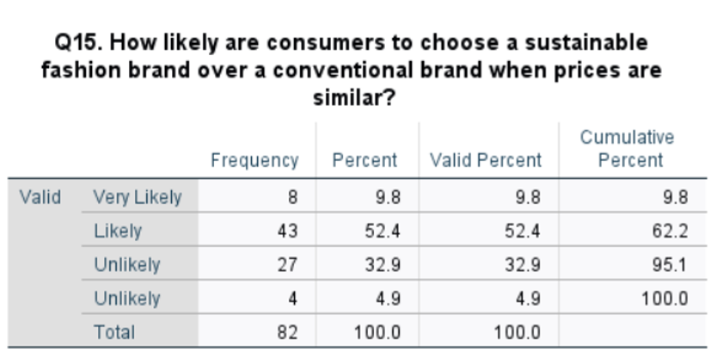
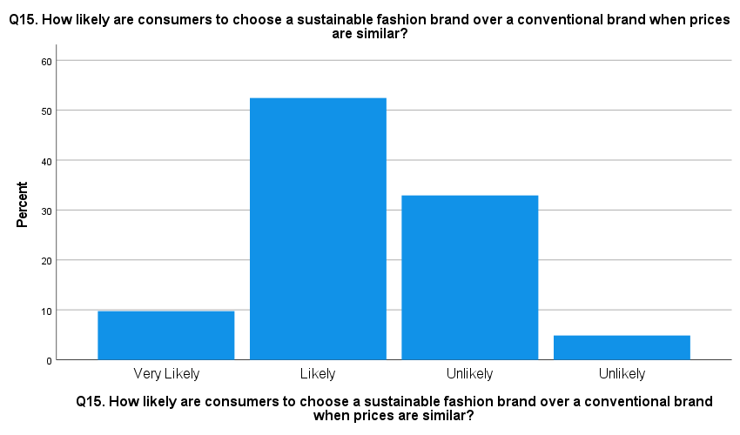
Figure 23: Responses to question 15th.
Among the percentages that were valid, the highest was 52.4% who were likely. The mean for this question was 2.3293, while the standard deviation was 0.72102, which indicates a reasonable degree of consistency in responses (refer to Appendix 2). It is a clear sign that the largest number of individuals will prefer the sustainable fashion brand compared to the conventional brand in case both are priced equally. The discovery indicates that price plays an important role in sustainable purchasing and even affects consumers in selecting sustainable options.
Q16. Effect of Sustainability Marketing on Repeat Purchases
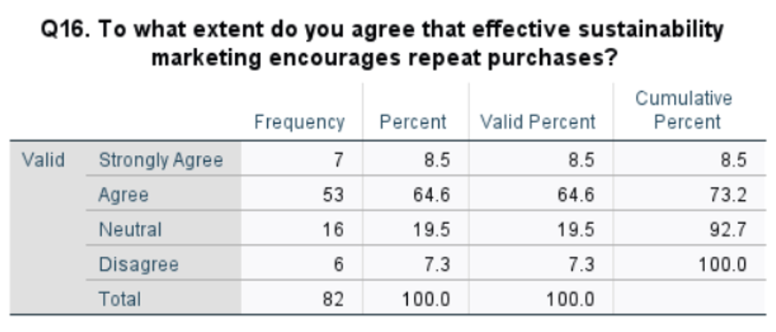
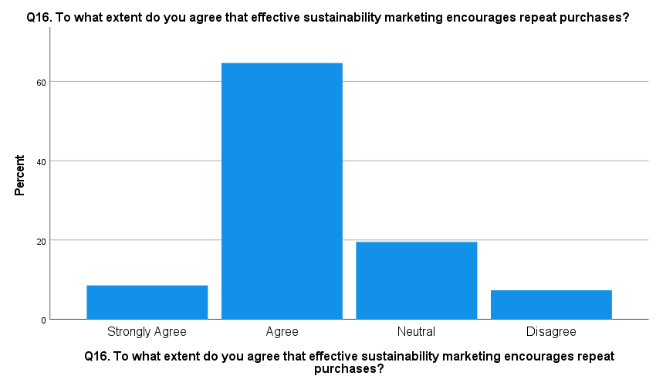
Figure 24: Responses to question 16th.
The percentage that answered agree was very high at 64.6%, which makes it the highest percentage that was valid. The mean response was 2.2561, and the standard deviation was 0.71683, which suggests a relatively small variation in the responses (refer to Appendix 2). It implies that when fashion brands market themselves sustainably, they can be able to secure repeat business from their customers. Findings show that there is a clear pattern of consensus, hence indicating that if consumers are pleased by sustainability-related marketing, it can help them keep on buying.
Q17. Main Challenge Affecting Willingness to Purchase Sustainable Fashion
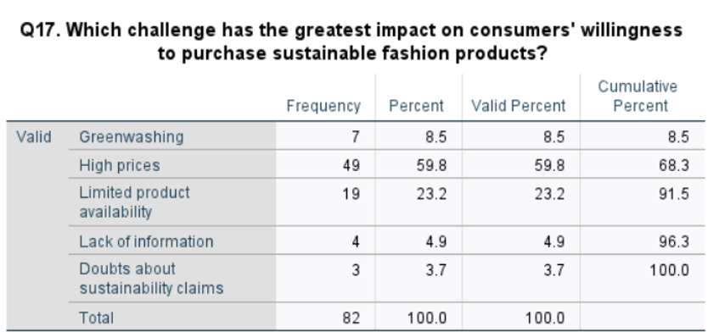
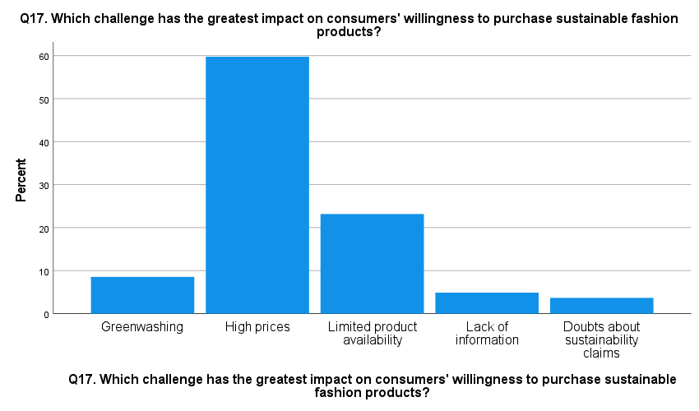
Figure 25: Responses to question 17th.
From the results, it is clear that high prices have the highest valid percentage of 59.8% among respondents. This reveals that price plays a significant role as the key challenge to purchasing sustainable fashion products. Limited availability of products has been cited as the second major problem by 23.2% of respondents. Lack of information and sustainability concerns had relatively lower percentages, with 8.5% selecting them, respectively. Mean was2.3537 and the standard deviation was 0.85161, which means that there was a trend of higher variation of opinions on the challenges to purchasing sustainably (refer to Appendix 2). Overall, from the results, it is evident that affordability is the biggest challenge for sustainable fashion purchasing.
Q18. Action Most Likely to Improve Willingness to Purchase Sustainable Fashion
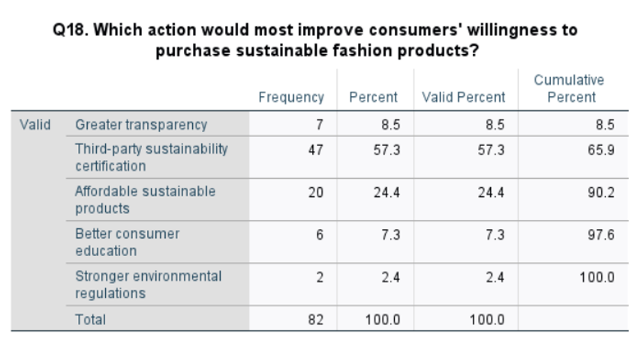
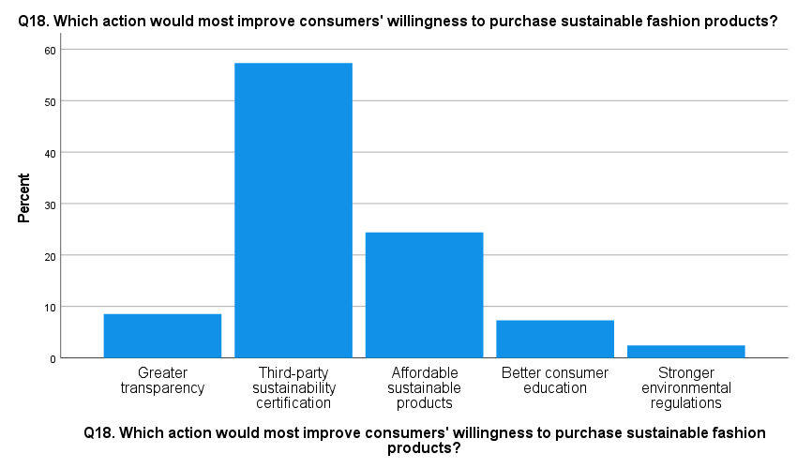
Figure 26: Responses to question 18th.
The highest possible valid percentage is Third-party sustainability certification, with 57.3% picking this action from the list. Independent certification is seen as the most important factor in enhancing consumer intentions towards buying sustainable fashion products. Affordable sustainable products are the next choice where 24.4% choosing this one. The mean is 2.3780 while the standard deviation is 0.84093, and this shows that there was some variation in the selected actions by the respondents (refer to Appendix 2). Lower valid per cent values have been observed for greater transparency, consumer education, and environmental regulation. The findings show that, on average, the respondents perceive the importance of independent validation, hence credible certification can increase the sustainability of fashion products.

4.4 Regression Analysis
H1: Sustainability marketing has a significant influence on consumer trust in the UK fashion retail industry.
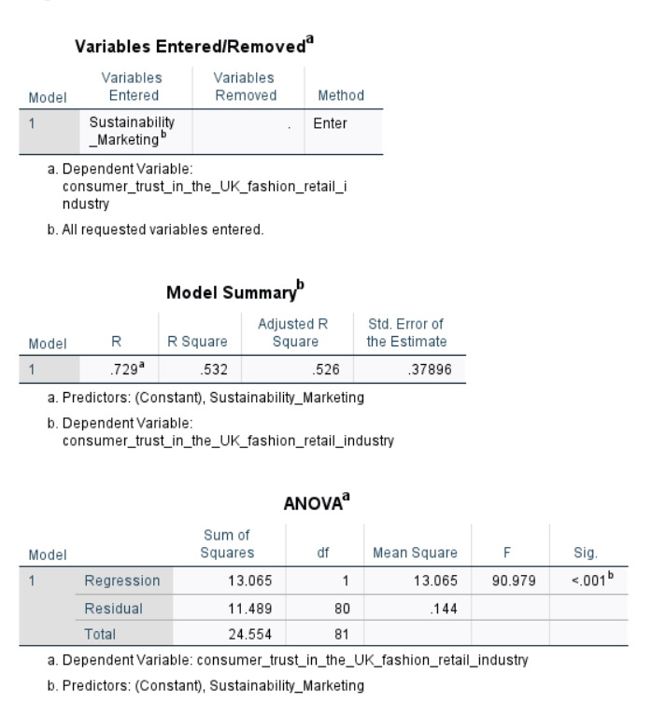
Figure 27: Regression Test 1.
The regression analysis shows that there is a high positive correlation between sustainability marketing and consumer trust, R = 0.729. The R² value of 0.532 means that 53.2% of the variance in consumer trust can be explained by sustainability marketing. Also, the Adjusted R² value of 0.526 means that 52.6% of the variance in consumer trust can be explained after adjustment. This indicates that there is a significant predictive power of sustainability marketing in the consumer trust of the UK fashion retail industry.
The ANOVA results also indicate that the regression model is statistically significant (F(1,80) = 90.979, p < 0.001). Since the significance value is lower than 0.05, it can be concluded that there is sufficient evidence to reject the null hypothesis. Also, it can be concluded that sustainability marketing has a statistically significant effect on consumer trust. The analysis indicates that consumers' trust in fashion retailers is related to the sustainability marketing practices of the companies. This is especially true as the study identified credibility, transparency and consumer confidence to be important issues that impact sustainability communication. In addition, the conceptual framework suggests that successful sustainability marketing can help to build trust in UK fashion retail brands. Thus, it can be concluded that sustainability marketing has a significant impact on consumer trust in the UK fashion retail industry which ensures that H1 is accepted.
H2: Sustainability marketing has a significant influence on consumer purchase intention in the UK fashion retail industry.
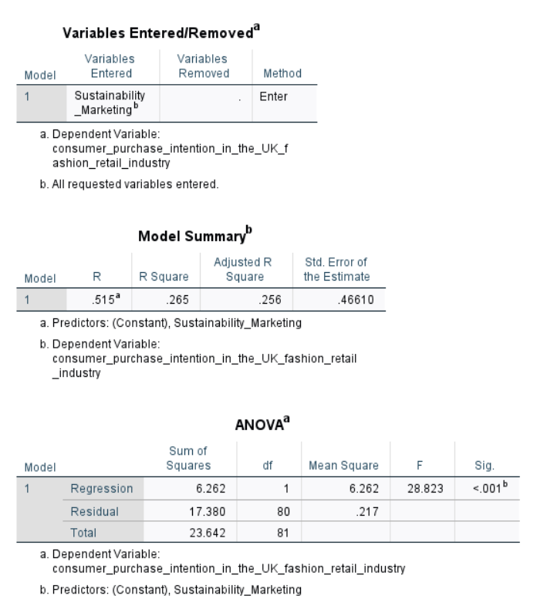
Figure 28: Regression Test 2.
The regression results show that the sustainability marketing has a moderate positive correlation with the purchase intention of the consumers with R value of 0.515. The R² value of 0.265 means that 26.5% of the variance of consumer purchase intention is explained by sustainability marketing. The adjusted R² of 0.256 also indicates that 25.6% of the variance in purchase intention is accounted for after the adjustment. While the explanatory power is less than in the case of consumer trust, the results show that sustainability marketing is still an important factor associated with consumers' purchase intentions.
The ANOVA results show that the regression model is statistically significant with F(1,80) = 28.823, p < 0.001. The results of the significance value are less than 0.05 which means that the null hypothesis is rejected and it can be concluded that sustainability marketing has a statistically significant effect on the intention to buy. The study reveals that sustainability marketing has a positive effect on consumers' purchase intention of fashion products. The R² value also shows that 73.5% of the variance is not explained which indicates that other factors may also affect purchase intention. This aligns with the research findings that price, quality, style, convenience and credibility of sustainability claims are potential drivers of purchasing decisions. Thus, the analysis offers empirical evidence of the goal of the study, which is to assess the impact of sustainability marketing on consumer purchase intention. Therefore, the sustainability marketing has a significant effect on consumer purchase intention in the UK fashion retail industry which makes H2 accepted.

4.5 Reliability Test
Variables | Reliability Test
Sustainability Marketing Perceptions | 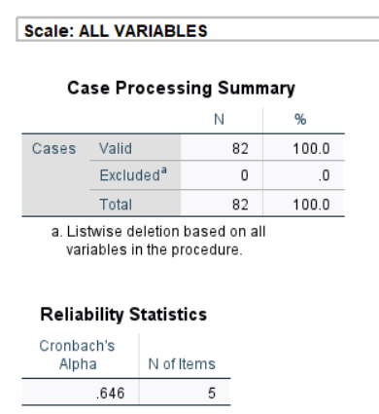
Consumer Trust | 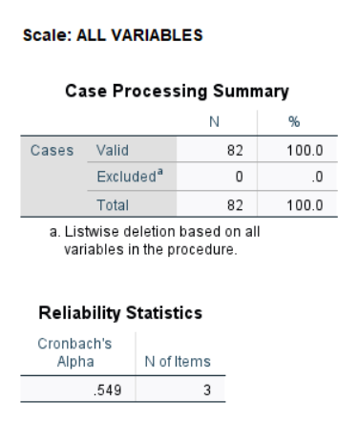
Consumer Purchase Intention | 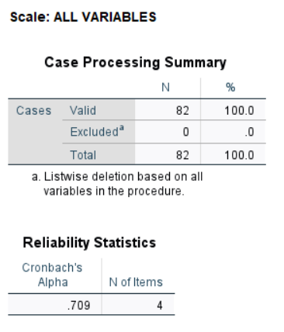
Figure 29: Reliability Test.an
Reliability Analysis (Cronbach’s Alpha) was performed to evaluate the internal consistency of the questions measuring the three research variables. Reliability testing was carried out for 82 valid responses, without any exclusions. sustainability marketing perceptions, based on five questions (Q3-Q7), has been found to have a Cronbach’s Alpha of 0.646. consumer trust, which was measured on the basis of three questions (Q9-Q11) had an Alpha of 0.549. Finally, consumer purchase Intentions, measured by means of four questions (Q13-Q16) showed a Cronbach’s Alpha of 0.709. It is clear that the internal consistency of consumer purchase intentions was acceptable as its Alpha was higher than the generally accepted threshold of 0.70. On the other hand, sustainability marketing perceptions and consumer trust were found to have smaller values of Alpha which indicated relatively low internal consistency of their questions. In general, the results obtained show that different levels of reliability were present in the research variables.

4.6 Correlation Analysis
Pearson correlation analysis was used to explore the relationships between sustainability marketing, consumer trust and consumer purchase intention (refer to the appendix 2). The results show that there is a strong positive correlation between sustainability marketing and consumer trust (r = 0.729, p < 0.001) (refer to the appendix 2). This indicates that perceptions of sustainability marketing are strongly linked to consumer trust in UK fashion retail brands, with higher perceptions leading to higher trust. The relationship is statistically significant at the 0.05 level and therefore the relationship is meaningful. In addition, sustainability marketing was found to have a moderate positive correlation with purchase intention (r = 0.515, p < 0.001). This suggests that the more sustainable marketing perceptions, the more willing to buy sustainable fashion products. Overall, the results show that sustainability marketing is positively linked to consumer trust and purchase intention.

4.7 Limitations encountered during data analysis
Certain limitations occurred while conducting the analysis which is important to be noted. The study involved the use of questionnaires that were completed by the respondents, and hence the findings resulted from the perceptions and opinions of the respondents themselves. Therefore, the answers could not reflect the true shopping behaviour of the respondents. Moreover, the analysis was conducted based on the information obtained from the questionnaire and hence limited to certain variables and categories of answers. Nonetheless, the data was analysed systematically using appropriate statistical techniques, leading to clarity of the discussion of the findings.

4.8 Summary
The findings chapter presents the results based on 82 valid questionnaires filled out by respondents. From the analysis of results, it can be observed that there is a positive correlation between sustainability marketing and consumer trust and consumer purchase intention. It has been found out that the consumer trust had high positive correlations with sustainability marketing (r = 0.729, p < 0.001). On the other hand, consumer purchase intention had moderate positive correlation with sustainability marketing (r = 0.515, p < 0.001). Moreover, from the regression analysis, it was found out that sustainability marketing had impacts on consumer trust and purchase intention. 26.5 percent of sustainability marketing accounted for purchase intention. Purchase intention had acceptable reliability value while others had low reliability values.

Chapter 5: Discussion

5.1 Introduction
This chapter presents an overview of the findings discussed in the previous chapter. It compares the primary findings of the research with the secondary findings that were generated during the literature review phase of the research. This chapter assesses how far the findings provide answers to the research questions which are determined in this study. Also, it examines the validity of the theoretical perspectives proposed in relation to the findings generated through empirical analysis. This chapter also discusses the findings of the survey and their relevance to literature.

5.2 Discussion
The results of the survey offer clear evidence of the positive impact of sustainability marketing on consumers' purchase intention in the UK fashion retail industry. The descriptive results indicate that 56.1% agreed or strongly agreed that sustainability marketing has a positive impact on the perception of fashion brands. Likewise, 74.4% agreed or strongly agreed that sustainability marketing is a reflection of a company's true commitment to sustainability. The results show that sustainability marketing not only noticed by consumers, but it can influence their perception of fashion brands. These results align with the views of Imdad, et al., (2026), who stated that sustainability marketing is a crucial element in the decision-making process of fashion purchase as it conveys environmental responsibility and responsible business practices. It also aligns with the broader research that indicates that ethical sourcing, sustainable materials, carbon reduction and transparency have a positive impact on consumer attitudes and willingness to purchase.
This relationship is better supported by the regression results. The results for sustainability marketing were R = 0.515 and R² = 0.265 which indicates that 26.5% of the variance in consumer purchase intention could be explained by sustainability marketing. The model was statistically significant, F(1,80) = 28.823, p < 0.001 which led to the acceptance of H2. Thus, the survey is not only a proof of positive attitudes of consumers towards sustainability, but it is also a statistically valid proof that sustainability marketing is an important predictor of purchase intention. This finding resolves the research gap as the outcome contributes to the literature by shifting the focus from general statements on sustainable consumer attitudes to empirical findings of a significant relationship in the UK fashion retail setting.
However, sustainability marketing does not completely account for consumer purchase intention. The remaining 73.5% of the variance is not explained, meaning that other factors are still influencing the purchasing decision. This is in line with the views of Cho, et al., (2024) and Lin and Chen, (2022) who highlighted price, quality, style, convenience, perceived value and perceived risk as the factors that influence consumer purchase intentions. Similarly, 52.4% said they would be more inclined to buy from a sustainable fashion brand than a regular brand if the price was the same. Therefore, sustainability marketing can positively influence purchase intention considering that consumers feel sustainable fashion is accessible for economic and functional reasons. The results of this survey are relevant to attitude component of the Theory of Planned Behaviour (TPB) as the general positive responses to the items on the sustainability marketing dimension reflect this component. Also, the results regarding price and availability reflect the importance of perceived behavioural control. Where consumers have positive attitudes, their capacity to translate the intention into action may be limited by their lack of affordability or availability. This also aligns with the perspectives of Salleh, et al., (2024) who stated that the affordability, accessibility and availability of sustainable fashion products increase the perceived behavioural control.
The results on consumer trust produce even stronger relationships. The model for predicting consumer trust had an R = 0.729 and R² = 0.532 and was statistically significant, F(1,80) = 90.979, p < 0.001. Thus, the variation in consumer trust was explained by sustainability marketing to a much greater extent (53.2%) than the variation in purchase intention (26.5%). Moreover, 50.0% agreed and 9.8% strongly agreed that independent sustainability certifications have a positive impact on confidence in environmental claims. This is in line with the conclusions of Mollenkopf, et al., (2022), who claimed that clear, verifiable and consistent sustainability communication can help to minimise information asymmetry and boost consumer confidence.
The survey also validates the negative impact of greenwashing on trust. This supports the findings of Suphasomboon and Vassanadumrongdee, (2025) and Rinaldi, et al., (2026) that consumers are skeptical of the clarity of claims, lack of evidence and poor transparency. The results thus suggest that sustainable communication should be supported with credible evidence and authentic organisational practices. This is significant support for the Legitimacy Theory as the theory suggests that in order to be legitimate, organisations need to be consistent with social expectations and exhibit responsible corporate actions in their activities and communications. The most important factor for building trust in sustainability marketing is independent certification with 81.7% of respondents saying that compared to transparent communication which is said by 11.0%. Therefore, the results support Legitimacy Theory as it seems consumers are evaluating the legitimacy of an organisation based on external evidence and verification.
Another important factor in the explanation of the impact of sustainability marketing on purchase behaviour is the relationship between trust and purchase intention. Neumann, et al., (2020) suggested that consumers are more likely to buy products that are advertised as sustainable if they believe in the company's environmental and social initiatives. The survey results support this argument as respondents indicated a preference for brands that have credible sustainability practices and the regression showed a significantly greater explanatory relationship between sustainability marketing and trust than between sustainability marketing and purchase intention. Therefore, the literature extends the survey results as trust seems to have a positive effect on reducing uncertainty of sustainability claims and on positive purchasing responses. The results also indicate that trust should not be considered as the sole factor influencing purchase intention. The price and availability results show that trust cannot be the sole determinant for sustainable apparel purchasing, which aligns with authors’ claim that functional and economic factors also play a role (Lin and Chen, 2022).
The findings also serve as a foundation to determine the best sustainability marketing strategies for UK fashion retailers. The first step for retailers is to use evidence-based and transparent communication. The statistical results reveal that consumers appreciate sustainability information and that transparency is correlated with trust. However, much technical information can lead to confusion as argued in the literature. Communication should be clear and concise and backed up by measurable evidence. Additionally, independent certification should be given preference. External verification is especially important given that 81.7% said independent certification was the most important trust-building factor and 57.3% said third-party certification was the action most likely to increase willingness to purchase. This aligns with Badhwar, et al., (2024) and Ospital, et al., (2023) who highlighted third-party verification, standardisation, product labelling and traceability.
Furthermore, sustainability marketing must convey value other than environmental. The literature suggests that the attitude–behaviour gap can be bridged through quality, durability, comfort, design, and economic value. Also, the survey results validate these findings with high prices being emphasised. Therefore, retailers are expected to integrate sustainability messages with information on product durability, quality, long-term value and affordability. Sustainable product ranges that are affordable, repair services, recycling schemes and loyalty incentives may boost perceived behavioural control and make sustainable options more feasible. Moreover, retailers are expected to place emphasis on ethical sourcing and responsible production. 48.8% of respondents said ethical sourcing was the most influential sustainability marketing practice which is followed by carbon reduction initiatives at 25.6%. Thus, the survey results extend the literature findings as it suggests that sustainability marketing can be integrated within the organisation's practice instead of just being seen as a marketing campaign. Thus, Legitimacy Theory is further strengthened by the fact that credible marketing requires actual responsible practices.
The results generally address the main research gaps outlined in the research. The findings from previous studies were inconsistent on the ability of sustainability marketing to drive purchase intention and had limited attention on consumer trust and sustainability practices. The current survey aims to close these gaps by showing that sustainability marketing has a strong impact on consumer purchase intention and consumer trust. Also, impact on consumer trust is particularly strong considering 82 responses from the UK. It also integrates several aspects of sustainability instead of addressing each one individually and focuses on the practical conditions such as credibility, independent verification, affordability and availability which influence the change from positive sustainability perceptions to purchase intentions. Thus, the results generally confirm the present body of knowledge and TPB as well as Legitimacy Theory.

Chapter 6: Conclusion

6.1 Introduction
The concluding chapter closes the study through reiteration of the aim to investigate the impact of sustainability marketing on consumers’ purchasing intentions in the fashion retailing industry of the United Kingdom. It recapitulates the major findings in respect of research objectives and research hypotheses, while emphasising the major contribution of the study. In addition, the chapter discusses the theoretical and practical implications of the findings, identifies the limitations of the study, and makes recommendations for fashion retailers and future research.

6.2 Conclusion

6.2.1 Conclusion Based on Objective 1: Influence of Sustainability Marketing on Consumer Purchase Intention
It can be concluded based on the first objective that there is a significant impact of sustainability marketing on the consumer's purchasing intention within the fashion retail industry in the UK. The main results showed that sustainability marketing had a moderate positive correlation with purchase intention, R-correlation = 0.515, and R² = 0.265. The significance level of the regression result was p < 0.001 and H2 was accepted. Also, the results from the description showed that sustainability marketing increases the likelihood of purchasing fashion products and buying from companies that use credible sustainability marketing. Repeat purchasing behaviour was also correlated with sustainable marketing. These results are consistent with the literature review since the latter showed that credibility, transparency and value were the main elements that influenced the responses to sustainability marketing. It should be noted, however, that sustainability marketing is not the only factor influencing purchasing decisions, as factors such as price, quality, style, and convenience are also taken into consideration. In this way, the first aim was achieved since the positive and significant impact of sustainability marketing on purchasing intention was demonstrated.

6.2.2 Conclusion Based on Objective 2: Factors Encouraging Positive Consumer Responses to Sustainability Marketing
Based on the second objective, it is concluded that credibility, transparency and independent verification are the factors which can motivate consumers to react to sustainability marketing. From the conclusions obtained from the main results, it is clear that transparency in sustainability information provides great benefits to enhance trust in fashion brands because the majority of participants agree with this statement. Moreover, there is also a positive view of independent sustainability certifications that help to increase the confidence of consumers in their claims. It was found that independent certification is the most important factor in terms of creating trust in sustainability marketing. On the other hand, the findings have shown that consumers cannot take greenwashing seriously and will doubt sustainability communication. According to the results obtained, it was confirmed that literature-based arguments about the positive consumer reactions to transparency, verifiability and congruence of sustainability claims are true. In addition, it is highlighted that transparency and substantiation of sustainability claims are very important factors to create trust and avoid consumers' scepticism about the claims. Therefore, it is possible to state that the second objective was achieved.

6.2.3 Conclusion Based on Objective 3: Relationship Between Consumer Trust and Purchase Intention
The conclusion derived on the basis of the third objective shows that consumer trust has an essential link with positive purchase-related reactions towards sustainably marketed fashion products. From the regression results, it was seen that there was a significant influence of sustainability marketing on consumers' trust, and this helped in accepting H1. Credibility, transparency and consumer confidence were identified as some essential factors influencing trust in sustainability communication during the analysis. From the descriptive results, it can be said that consumers would prefer buying from those brands that have credibility in terms of sustainability practices and that sustainability marketing can help in increasing repeat purchase. These results are consistent with the literature review in the sense that consumer trust in reducing uncertainty regarding sustainability claims is an essential factor that leads to purchase intention of a product. It was also seen in the literature that trust is not the sole factor that explains consumer buying behaviour, since other factors like values, product quality and economic factors may also play a role. Therefore, the third goal has been achieved through emphasising the role of consumer trust in the concept of sustainability marketing.

6.2.4 Conclusion Based on Objective 4: Challenges and Recommendations for Strengthening Sustainability Marketing
Based on the fourth objective, it can be summarised that there are some challenges in practice that inhibit consumers from buying fashionable products sustainably. The major challenges include the high price and limited availability of the product. There are also some other barriers, such as greenwashing and doubts regarding sustainability claims, as these received relatively fewer responses compared to others. The study has also shown that the most crucial factor in motivating consumers to buy sustainable fashion products is third-party sustainability certification. Another finding that has been made through this research is that affordable sustainable products are also important. All of the findings of this research are consistent with what the literature review had suggested regarding the attitude-behaviour gap in sustainable fashion consumption. This means that even if consumers have positive attitudes towards sustainability, price, and the product itself, this does not necessarily mean that they buy the product. Consumer scepticism has been identified in the literature as an issue due to greenwashing. Thus, this objective was fulfilled by first identifying the challenges and secondly, giving the way forward for the UK fashion retailers in enhancing sustainability marketing and consumer purchase intention.

6.3 Recommendations
Evidence-Based Sustainability Communication: The fashion industry needs to communicate in clear terms about what they are trying to achieve. People would be suspicious about sustainability if the fashion company uses vague terms such as eco-friendly or sustainable. It is, therefore, important for retailers to provide information on sourcing, materials, production processes and environmental factors. Certifications, measurable goals and reporting would go a long way towards increasing the reliability of sustainability communication.
Enhance Consumer Trust through Regular Business Practices: The promotion of sustainability needs to be anchored on the actual business practices of fashion retailers. Promotional claims need to correspond with organisational activities in order to prevent a decline in consumer confidence. The fashion retailer needs to be committed to responsible sourcing and ethical production to increase brand credibility and customer trust with regard to its sustainability claims.
Make Sustainability Part of Product Quality and Value: Promoting the sustainability of fashion products cannot only consider the benefits to the environment. Factors such as quality, design, comfort and value for money would also matter to the consumer. Therefore, the promotion of sustainable fashion products must include the environmental and functional benefits. A strategy that could be used to bridge the gap between attitude and actions when buying sustainable products.
Increase Consumer Knowledge on Sustainability: Consumers need to have a greater understanding of the sustainability information provided by fashion retailers. The use of too much technical language would result in many confusing labels and claims that may confuse the consumer. The use of labels, digital information, traceability tools and clear explanations of environmental benefits can increase the consumer's knowledge and lead to better decision-making.
Make Sustainable Fashion Products Accessible: The problem of accessibility in the sustainable fashion market can be solved by retailers through measures to solve access problems, which may include issues such as cost, availability and convenience. Discount prices on selected product lines, maintenance services, recycling services and loyalty services can motivate buyers to consider sustainable products. The fashion retailer also needs to encourage buyers to purchase sustainable products because they have environmental benefits in the long run.

6.4 Limitations and Future Research Suggestions
There are several limitations in the research, as the research is based on primary data collected using a questionnaire, which is not accompanied by field observations and, therefore, is limited by the personal opinion and perception of the participants. Their answers may be subjective due to their experience and attitude to the sustainability issue and to fashion products. Thus, all the results are a reflection of what respondents believe they do, rather than what they really do. The research limitation can be overcome in future research conducted using a mixed-methods approach, where the data from questionnaires can be compared with the data collected using interviews or other instruments to analyse consumer behaviour, for instance. Comparison of the intentions of the consumers and their actions while buying clothes will also provide valuable insight into the impact of sustainability marketing on consumers in the future.

6.5 Implications
The implications of the study can be both theoretical and practical. First, practically, the results of the research will assist UK fashion companies to develop their sustainability marketing efforts by means of communicating effectively, gaining credibility and conducting sustainable initiatives. Second, another significant implication of the study is the need for increased customer trust and value of the product in order to increase purchase intentions. Theoretically, the results of the study can enable one to gain a better understanding of the connection between sustainability marketing, consumer trust and purchase intention. It also reinforces the applicability of the Theory of Planned Behaviour and Legitimacy Theory in the understanding of consumer reactions and the significance of credible sustainability practices in the UK fashion retail sector.

6.6 Reflection
It can be stated that this research has brought new insights regarding the influence of sustainability marketing on the purchase intention of consumers in the fashion retail industry of the UK. At first, this research was launched on the assumption that although the importance of the sustainability issue is being perceived by fashion companies, positive attitudes do not necessarily mean positive purchase intentions. Second, this research helped to fill the gap in empirical research that has concentrated on the connection between fashion and contemporary business practice in the UK. From the outcome of this study, I came to the conclusion that sustainability marketing can positively affect consumer trust and purchase intention. But the effectiveness of this marketing depends on such aspects as transparency, credibility and independent certification. Also, it became clear that consumers face practical difficulties in terms of purchasing sustainable products because of their limited availability and high prices.
Therefore, the study contributes to the existing literature due to the empirical data obtained from 82 respondents regarding sustainability marketing and its connection to consumer trust and purchase intention in the context of the fashion retail market. Besides, it provides information about the usefulness of the theoretical perspectives used in the study as well as offers guidelines for fashion retailers. Overall, the findings of this research show that in the future, sustainability marketing will be effective provided that it is not only about the communication of the commitment to environmental issues, but also about its credibility, transparency and implementation in the practice of the business. The study has been concentrated on the goal and objectives and the results of future studies can allow studying how consumers' intentions develop into purchase behaviour and how retailers can get rid of barriers preventing sustainable fashion consumption.

References
Agarwal, S., Kweh, Q.L., Goh, K.W. and Wider, W. (2025) Redefining marketing strategies through sustainability: Influencing consumer behavior in the circular economy: A systematic review and future research roadmap. Cleaner and Responsible Consumption, 18, pp. 100298.
Ahmad, N., Alias, F.A., Hamat, M. and Mohamed, S.A. (2024) Reliability analysis: application of cronbach's alpha in research instruments. Pioneering the Future: Delving Into E‐Learning's Landscape, pp.114-119.
Al-Abdallah, G., Khair, N. and Jatto, P. (2026) The Impact of Followers’ Social Identity on Fashion Purchase Intention: The Mediating Role of Source Credibility. Journal of Theoretical and Applied Electronic Commerce Research, 21(3), pp. 82.
Alhomaid, A. (2025) Building Trust in Sustainable Journeys: The Interplay Between Green Marketing, Green Brand Trust, and Tourism Purchase Intentions. Sustainability, 17(18), pp.8464.
Ali, I.M. (2024) A guide for positivist research paradigm: From philosophy to methodology. Idealogy Journal, 9(2).
Alsayegh, M.F., Rahm.k6y6666666an, R.A. and Homayoun, S. (2020) Corporate economic, environmental, and social sustainability performance transformation through ESG disclosure. Sustainability, 12(9), pp. 3910.
B, N., S, B. and Pathak, G. (2026) Brand Authenticity in Sustainable Luxury: Consumer Trust and Purchase Intentions. International Journal for Multidisciplinary Research (IJFMR), 8(1). ‌
Badhwar, A., Islam, S., Tan, C.S.L., Panwar, T., Wigley, S. and Nayak, R. (2024) Unraveling green marketing and greenwashing: A systematic review in the context of the fashion and textiles industry. Sustainability, 16(7), p.2738.
Borges, E., Campos, S., Teixeira, M.S., Lucas, M.R., Ferreira-Oliveira, A.T., Rodrigues, A.S. and Vaz-Velho, M. (2023) How do companies communicate sustainability? A systematic literature review. Sustainability, 15(10), p.8263.
Bueno, P. (2026) British Sustainable Fashion Surges to £1.37 Billion, Driven by Thrift Shopping. [Online]. Available at: https://www.modaes.com/global/markets/the-british-sustainable-fashion-market-reaches-137-billion-driven-by-the-secondhand-market [Accessed on: 23.07.2026].
Bumin, Z. and Bumin, M. (2024) Analysis of consumer preferences in sustainable fashion consumption. Journal of Innovations and Sustainability, 8(3), pp.01.
Cairns, H.M., Ritch, E.L. and Bereziat, C. (2022) Think eco, be eco? The tension between attitudes and behaviours of millennial fashion consumers. International Journal of Consumer Studies, 46(4), pp.1262-1277.
Chamorro, B.P., Flor-Unda, O., Pazmiño, E.F., Arcos-Reina, R. and Arroyo, F. (2026) Advances in Product Design Strategies to Promote Responsible Consumption and Production. Sustainability, 18(13), pp. 6426.
Chen, C.W. (2024) Utilizing a hybrid approach to identify the importance of factors that influence consumer decision-making behavior in purchasing sustainable products. Sustainability, 16(11), pp.4432.
Cho, M., Ko, E. and Borenstein, B.E. (2024) The interaction effect of fashion retailer categories on sustainable labels: the role of perceived benefits, ambiguity, trust, and purchase intention. International Journal of Advertising, 43(6), pp.1016-1038.
Daou, L., Sayegh, E., Atallah, E., Jabbour Al Maalouf, N. and Sarkis, N. (2025) Greenwashing as a barrier to sustainable marketing: Expectation disconfirmation, confusion, and brand–consumer relationships. Sustainability, 17(22), p.9979.
Drolet, M.J., Rose-Derouin, E., Leblanc, J.C., Ruest, M. and Williams-Jones, B. (2023) Ethical issues in research: Perceptions of researchers, research ethics board members and research ethics experts. Journal of Academic Ethics, 21(2), pp.269-292.
Eze, M. (2025) Digital Greenwashing in the Age of Sustainability Marketing: A Meta-Analysis of Consumer Perception, Detection, and Backlash. International Journal of Marketing Studies, 17(2).
Grundy, D. (2024) The staggering water consumption of fast fashion. [Online]. Available at: https://www.bbc.com/news/articles/cpqz9qy7y14o [Accessed on: 23.07.2026].
Gudmundsdottir, S. and Sigurjonsson, T.O. (2024) A need for standardized approaches to manage sustainability strategically. Sustainability, 16(6), p.2319.
Hajjar, S.T. (2018) Statistical analysis: Internal-consistency reliability and construct validity. International Journal of Quantitative and Qualitative Research Methods, 6(1), pp.27-38.
Hasan, M.M. and Shehun, M.T.F. (2022) Implementing sustainable supply chain practices in global apparel retail: A systematic review of current trends. ASRC Procedia: Global Perspectives in Science and Scholarship, 2(1), pp. 332-363.
Horrich, A., Ertz, M. and Bekir, I. (2025) Exploring the role of social media in shaping sustainable consumer behavior: a qualitative study. Cogent Business & Management, 12(1).
Hossan, D., Dato’Mansor, Z. and Jaharuddin, N.S. (2023) Research population and sampling in quantitative study. International Journal of Business and Technopreneurship (IJBT), 13(3), pp.209-222.
Huang, L., Solangi, Y.A., Magazzino, C. and Solangi, S.A. (2024) Evaluating the efficiency of green innovation and marketing strategies for long-term sustainability in the context of Environmental labeling. Journal of Cleaner Production, 450, p.141870.
Huo, C., Hameed, J., Zhang, M., Ali, A.F.B.M. and Hashim, N.A.A.N. (2022) Modeling the impact of corporate social responsibility on sustainable purchase intentions: insights into brand trust and brand loyalty. Economic Research-Ekonomska Istraživanja, 35(1), pp. 1-30.
Ikram, M. (2022) Transition toward green economy: Technological Innovation's role in the fashion industry. Current Opinion in Green and Sustainable Chemistry, 37, pp.100657.
Imarc. (2025) UK Sustainable Fashion Market Size, Share, Trends and Forecast by Product Type, Fabric Type, Distribution Channel, End User, and Region, 2026-2034. [Online]. Available at: https://www.imarcgroup.com/uk-sustainable-fashion-market [Accessed on: 23.07.2026].
Imdad, A., Muhammad, K.K., Ahmed, F. and Ali, I. (2026) Sustainability Marketing in the Fashion Industry: How brands are leveraging Eco _ Friendly Practices to Build Consumer Trust and Drive Profit. Journal for Social Science Archives, 4(1), pp. 116-123.
Jang, W.Y. and Kim, D.H. (2026) Why Do Consumers Hesitate to Buy Green Sports Products? Key Barriers to Sustainable Consumption. Sustainability, 18(7), p.3417.
Jia, T., Iqbal, S., Ayub, A., Fatima, T. and Rasool, Z. (2023) Promoting responsible sustainable consumer behavior through sustainability marketing: the boundary effects of corporate social responsibility and brand image. Sustainability, 15(7), pp.6092.
Jiang, L., Li, Q. and Wu, X. (2023) The impact of clothing e-store image on intention based on search and purchase phases: From the perspective of sustainable marketing. Sustainability, 15(1), pp.871.
Kafle, S.C. (2019) Correlation and regression analysis using SPSS. The OCEM Journal of Management, Technology, and Social Sciences, 1(1), pp.125-132.
Kufaine, N. (2024) Understanding Characteristics of Extended Theory of Planned Behaviour: Systematic Literature Review. Open Journal of Philosophy, 14(04), pp. 848-858.
‌Li, M., Cavender, R. and Lee, M.Y. (2025) Consumer awareness of fashion greenwashing: insights from social media discussions. Sustainability, 17(7), pp. 2982.
Li, M., Choe, Y.H. and Gu, C. (2024) How perceived sustainability influences consumers’ clothing preferences. Scientific Reports, 14(1), pp. 28672-28672.
Lim, W.M. (2025) What is quantitative research? An overview and guidelines. Australasian Marketing Journal, 33(3), pp.325-348.
Lin, P.H. and Chen, W.H. (2022) Factors That Influence Consumers’ Sustainable Apparel Purchase Intention: The Moderating Effect of Generational Cohorts. Sustainability, 14(14), pp. 8950.‌
Llácer-Falcón, S., Vilaplana-Aparicio, M.J. and González-Díaz, C. (2026) Corporate Communication of Sustainability in the Fashion Industry: A Systematic Literature Review. Administrative Sciences, 16(2), p.76.
Loomis, D.K. and Paterson, S. (2018) A comparison of data collection methods: Mail versus online surveys. Journal of Leisure Research, 49(2), pp.133-149.
Maretha, C. (2023) Positivism in philosophical studies. Journal of Innovation in Teaching and Instructional Media, 3(3), pp.124-138.
Mathew, M. and Spinelli, R. (2025) Decoding sustainable drivers: A systematic literature review on sustainability-induced consumer behaviour in the fast fashion industry. Sustainable Production and Consumption, 55, pp. 132-145.
Mohajan, H.K. (2020) Quantitative research: A successful investigation in natural and social sciences. Journal of economic development, environment and people, 9(4), pp.50-79.
Mollenkopf, D.A., Peinkofer, S.T. and Chu, Y. (2022) Supply chain transparency: Consumer reactions to incongruent signals. Journal of Operations Management, 68(4), pp.306-327.
Neumann, H.L., Martinez, L.M. and Martinez, L.F. (2020) Sustainability efforts in the fast fashion industry: consumer perception, trust and purchase intention. Sustainability Accounting Management and Policy Journal, 12(3), pp. 571-590.
Olateju, D.J., Olateju, O.A., Adeoye, S.V. and Ilyas, I.S. (2021) A critical review of the application of the legitimacy theory to corporate social responsibility. International Journal of Managerial Studies and Research, 9(3), pp. 1-6.
Ospital, P., Masson, D., Beler, C. and Legardeur, J. (2023) Toward product transparency: communicating traceability information to consumers. International Journal of Fashion Design, Technology and Education, 16(2), pp.186-197.
Papasolomou, I., Melanthiou, Y. and Tsamouridis, A. (2023) The fast fashion vs environment debate: Consumers’ level of awareness, feelings, and behaviour towards sustainability within the fast-fashion sector. Journal of marketing communications, 29(2), pp.191-209.
Persakis, A., Nikolopoulos, T., Negkakis, I.C. and Pavlopoulos, A. (2025) Greenwashing in marketing: a systematic literature review and bibliometric analysis. International Review on Public and Nonprofit Marketing, 22(4), pp. 957-992.
Pricopoaia, O., Cristache, N., Lupașc, A., Dobrea, R.C., Tureatca, M.V. and Dinulescu, L.G. (2025) The Impact of Marketing Strategies on Promoting Sustainability in the Fashion Sector. Sustainability, 17(12), pp. 5546-5546.
Prihatiningrum, R.Y., Supraptiningsih, J.D., Lutfi, L., Imron, A. and Fithoni, A. (2024) Sustainable Marketing Strategies: Aligning Brand Values with Consumer Demand for Environmental Responsibility. Global International Journal of Innovative Research, 2(9), pp. 2271-2283.
Rahman, M.M. (2023) Sample size determination for survey research and non-probability sampling techniques: A review and set of recommendations. Journal of Entrepreneurship, Business and Economics, 11(1), pp.42-62.
Ray, S. and Nayak, L. (2023) Marketing sustainable fashion: trends and future directions. Sustainability, 15(7), pp.6202.
Rinaldi, F.R., Khatami, F., Cagno, E. and Ferraris, A. (2026) Perceived greenwashing: where does scepticism come from?. Journal of Cleaner Production, 554, pp.148077.
‌Rios-Lama, C.A., Vargas-Merino, J.A., Schmidt-Urdanivia, J., Quispe-Huarancca, J. and Gamarra Flores, C.E. (2026) Complexity and consequences of greenwashing in a SOR framework. A systematic review from consumer literature. Cleaner and Responsible Consumption, 21, pp. 100414-100414.
Rocco, B. (2020) Sustainable clothing purchase behavior in the UK 2020. [Online]. Available at: https://www.statista.com/statistics/1168849/sustainable-fashion-purchase-united-kingdom/?srsltid=AfmBOopbD6HCUSaFCG5HFV1_1psuP9Tn51p_rTABgHJxR9Uq0g2qeSKb [Accessed on: 23.07.2026].
Ryding, D., Caratù, M. and Vignali, G. (2022) Eco fashion brands and consumption: is the attitude-behaviour gap narrowing for the millennial generation?. International Journal of Business and Globalisation, 30(2), pp.131-154.
Salleh, M.S.M., Misron, A. and Musa, N.C. (2024) Examining the mediating effects of perceived behavioral control and purchase intention on sustainable consumer behavior. International Journal of Academic Research in Business and Social Sciences, 14(12), pp. 3951-3972.
Schiaroli, V., Fraccascia, L. and Dangelico, R.M. (2024) How can consumers behave sustainably in the fashion industry? A systematic literature review of determinants, drivers, and barriers across the consumption phases. Journal of cleaner production, 483, pp. 144232.
Saunders, M. N. K., Lewis, P, and Thornhill, A. (2019) Research methods for business students. Pearson.
Shah, S.S. and Asghar, Z. (2023) Dynamics of social influence on consumption choices: A social network representation. Heliyon, 9(6), pp. e17146-e17146.
Sindhuja, P., Kotni, V.D.P., Misron, A., Hakimi, H. and Udandrao, S.D. (2025) Exploring slow fashion consumer buying behavior in the context of sustainability: a systematic literature review using TCCM approach. Cogent Business & Management, 12(1), pp. 2519966.
Soe, T.K.K. and Datta, P. (2024) Corporate Social Responsibility (CSR) and consumer purchase intention in the UK fashion industry. Journal of Business and Retail Management Research, 19(1).
Suphasomboon, T. and Vassanadumrongdee, S. (2025) Perceived greenwashing and its impact on consumer behavior in the cosmetic industry. Cleaner and Responsible Consumption, pp.100377.
Syahribulan, S., Elliyana, E. and Rosmiati, R. (2025) The role of social media influencers in shaping sustainable purchasing behavior: Genuine consumer interest or impulsive trends. Journal of Production Operations Management and Economics, 5(51), pp.63-77.
Taufique, K.M.R. (2022) Integrating environmental values and emotion in green marketing communications inducing sustainable consumer behaviour. Journal of Marketing Communications, 28(3), pp.272-290.
‌Thorisdottir, T.S. and Johannsdottir, L. (2020) Corporate social responsibility influencing sustainability within the fashion industry. A systematic review. Sustainability, 12(21), pp. 9167.
Timmins, B. (2021) Asos and Primark set out new green pledges. [Online]. Available at: https://www.bbc.com/news/business-58575692 [Accessed on: 23.07.2026].
Tran, K., Nguyen, T., Tran, Y., Nguyen, A., Luu, K. and Nguyen, Y. (2022) Eco-friendly fashion among generation Z: Mixed-methods study on price value image, customer fulfillment, and pro-environmental behavior. Plos one, 17(8), pp.e0272789.
Truong, D.D., Mai, N.T., Tam, D.D. and Huan, L.H. (2026) Assessing the effects of ESG awareness on purchase intention of eco-labeled forest products: Mediating role of consumer attitudes and moderating influence of green product knowledge. Cleaner and Responsible Consumption, 21, pp. 100425-100425.
un Nisa, N., Acha, A. and Dharejo, N. (2022) The consequences of upholding deceptive marketing practices and its effect on consumers’ related attitudes including consumer loyalty and consumer trust: Evidence from the fashion industry in the UAE. Journal of Advanced Research in Social Sciences and Humanities, pp.71-82.
Wang, C., Liu, T., Zhu, Y., Wang, H., Wang, X. and Zhao, S. (2023) The influence of consumer perception on purchase intention: Evidence from cross-border E-commerce platforms. Heliyon, 9(11), pp. e21617-e21617.
Wang, S. and Su, D. (2022) Sustainable product innovation and consumer communication. Sustainability, 14(14), pp.8395.
White, K., Cakanlar, A., Sethi, S. and Trudel, R. (2025) The past, present, and future of sustainability marketing: How did we get here and where might we go? Journal of Business Research, 187, pp. 115056-115056.
Yuwono, M.A. and Rachmawati, D. (2023) Combined methods. Can this solve the differences between deductive and inductive methods in qualitative research?. Moroccan Journal of Quantitative & Qualitative Research, 5(3), p.1.
Zeng, Z., Zhong, W. and Naz, S, (2023) Can environmental knowledge and risk perception make a difference? The role of environmental concern and pro-environmental behavior in fostering sustainable consumption behavior. Sustainability, 15(6), pp.4791.
Zhao, J., Zhou, H., Zhou, M., Zheng, C., Zhou, L. and Yang, F. (2026) From greenwashing to green trust: Understanding the consumer behavior in the fashion industry. Acta Psychologica, 267, pp. 106850.

Appendix

Appendix 1: Survey Questionnaire
Section A: Demographic Information
Q1. Which age group do you belong to?
- Less than 18 (end survey)
- 18-24
- 25-34
- 35-44
- 45 and above
Q2. How frequently do you purchase fashion products?
- Never(end survey)
- More than once a month
- Once a month
- Every 2-3 months
- Once a year or more
Section B: Perceptions of Sustainability Marketing
Q3. Do you agree that sustainability marketing positively influences consumers' perceptions of fashion brands?
- Strongly Agree
- Agree
- Neutral
- Disagree
- Strongly Disagree
Q4. To what extent do you agree that clear communication of sustainability initiatives improves a fashion brand's image?
- Strongly Agree
- Agree
- Neutral
- Disagree
- Strongly Disagree
Q5. Do you agree that sustainability marketing influences consumers when choosing between fashion brands?
- Strongly Agree
- Agree
- Neutral
- Disagree
- Strongly Disagree
Q6. Do you believe that sustainability marketing influences consumers when choosing between fashion brands?
- Strongly Agree
- Agree
- Neutral
- Disagree
- Strongly Disagree
Q7. To what extent do you believe sustainability marketing reflects a company's genuine commitment to environmental responsibility?
- Strongly Agree
- Agree
- Neutral
- Disagree
- Strongly Disagree
Q8. Which sustainability marketing practice is most influential when choosing a fashion brand?
- Eco-friendly packaging
- Ethical sourcing
- Carbon reduction initiatives
- Recycling programmes
- Transparent sustainability reports
Section C: Consumer Trust
Q9. Do you agree that transparent sustainability information increases trust in fashion brands?
- Strongly Agree
- Agree
- Neutral
- Disagree
- Strongly Disagree
Q10. Do you agree that independent sustainability certifications increase confidence in environmental claims?
- Strongly Agree
- Agree
- Neutral
- Disagree
- Strongly Disagree
Q11. To what extent do you believe greenwashing reduces trust in sustainability marketing?
- Strongly Agree
- Agree
- Neutral
- Disagree
- Strongly Disagree
Q12. Which factor is most important for building trust in sustainability marketing?
- Transparent communication
- Independent certifications
- Ethical sourcing
- Brand reputation
- Environmental performance
Section D: Consumer Purchase Intention and Recommendations
Q13. To what extent does sustainability marketing influence the likelihood of purchasing fashion products?
- Extremely Influential
- Very Influential
- Moderately Influential
- Slightly Influential

- Not at all influential
Q14. Do you agree that consumers are more willing to purchase from brands with credible sustainability practices?
- Strongly Agree
- Agree
- Neutral
- Disagree
- Strongly Disagree
Q15. How likely are consumers to choose a sustainable fashion brand over a conventional brand when prices are similar?
- Very Likely
- Likely
- Neutral
- Unlikely
- Very Unlikely
Q16. To what extent do you agree that effective sustainability marketing encourages repeat purchases?
- Strongly Agree
- Agree
- Neutral
- Disagree
- Strongly Disagree
Q17. Which challenge has the greatest impact on consumers' willingness to purchase sustainable fashion products?
- Greenwashing
- High prices
- Limited product availability
- Lack of information
- Doubts about sustainability claims
Q18. Which action would most improve consumers' willingness to purchase sustainable fashion products?
- Greater transparency
- Third-party sustainability certification
- Affordable sustainable products
- Better consumer education
- Stronger environmental regulations

Appendix 2: Descriptive Statistics
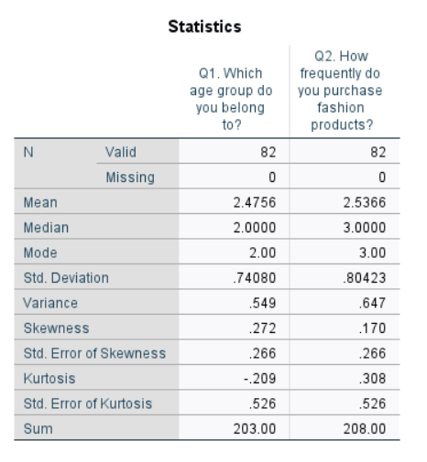
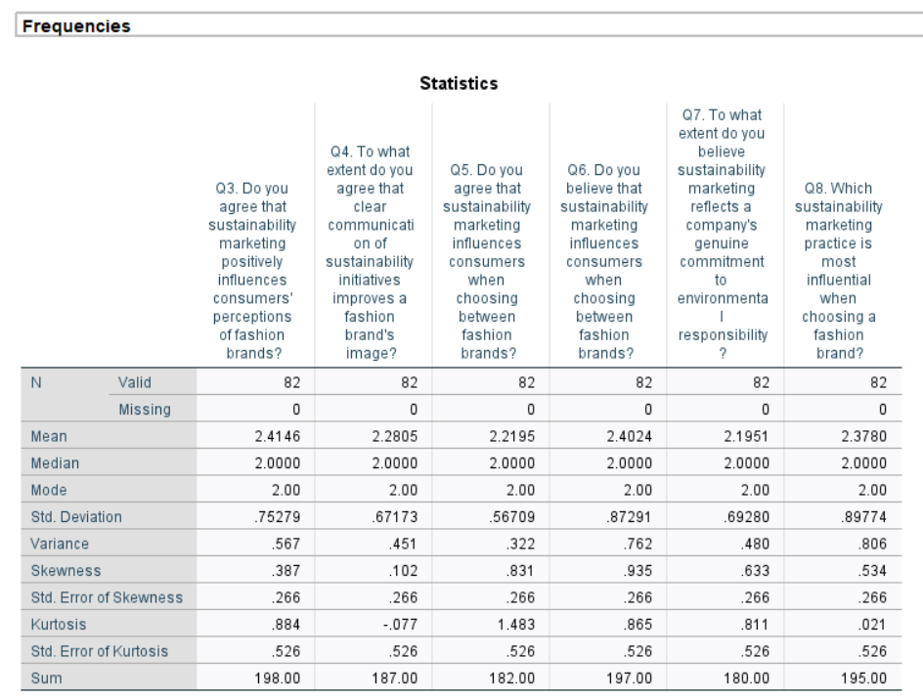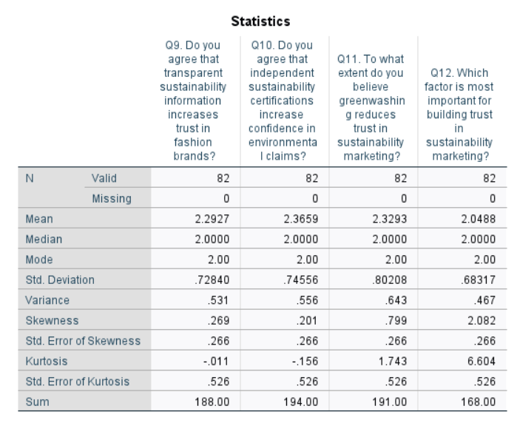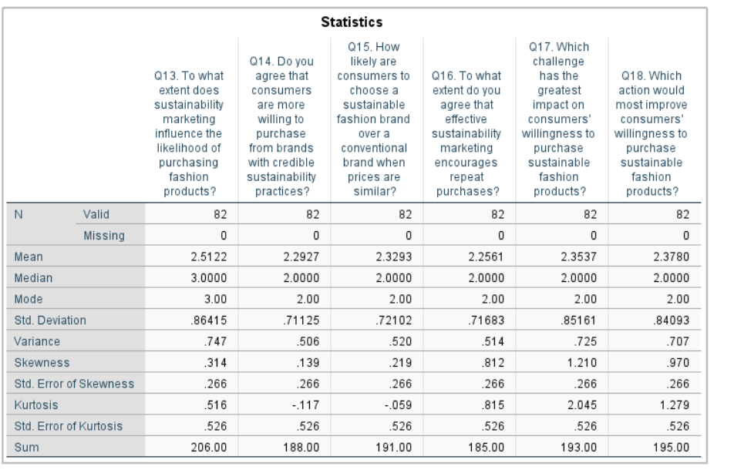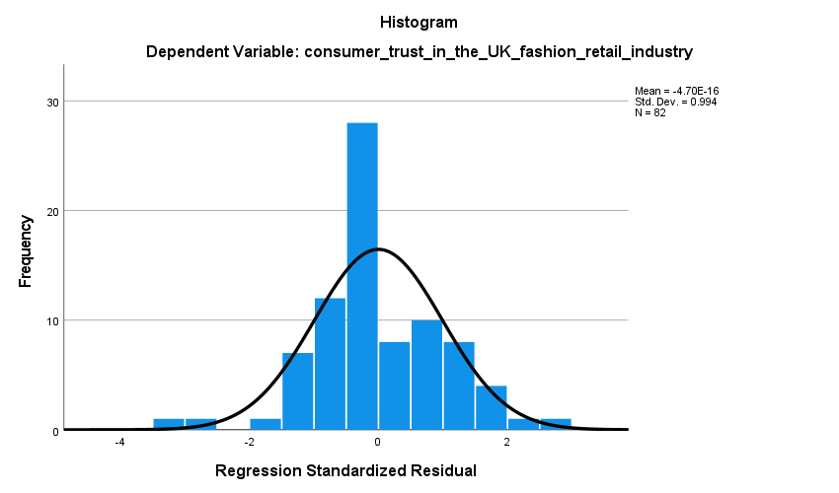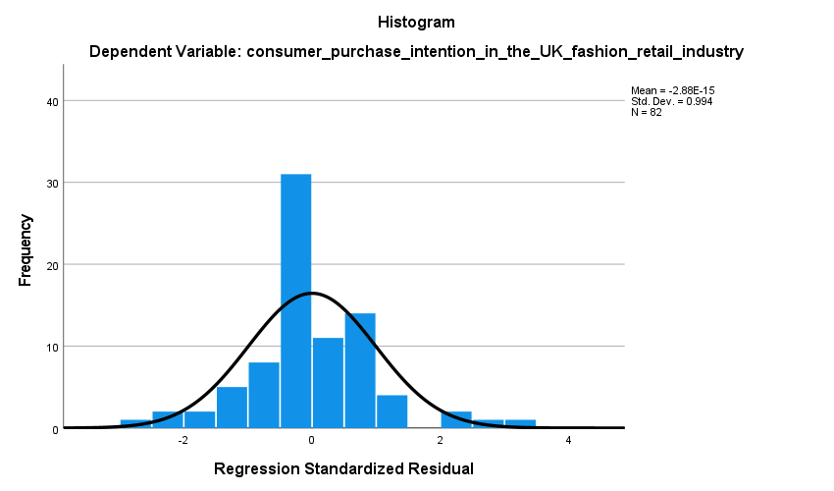

Correlations
 |  |  | Q1. Which age group do you belong to? | Q2. How frequently do you purchase fashion products? | Q3. Do you agree that sustainability marketing positively influences consumers' perceptions of fashion brands? | Q4. To what extent do you agree that clear communication of sustainability initiatives improves a fashion brand's image? | Q5. Do you agree that sustainability marketing influences consumers when choosing between fashion brands? | Q6. Do you believe that sustainability marketing influences consumers when choosing between fashion brands? | Q7. To what extent do you believe sustainability marketing reflects a company's genuine commitment to environmental responsibility? | Q8. Which sustainability marketing practice is most influential when choosing a fashion brand? | Q9. Do you agree that transparent sustainability information increases trust in fashion brands? | Q10. Do you agree that independent sustainability certifications increase confidence in environmental claims? | Q11. To what extent do you believe greenwashing reduces trust in sustainability marketing? | Q12. Which factor is most important for building trust in sustainability marketing? | Q13. To what extent does sustainability marketing influence the likelihood of purchasing fashion products? | Q14. Do you agree that consumers are more willing to purchase from brands with credible sustainability practices? | Q15. How likely are consumers to choose a sustainable fashion brand over a conventional brand when prices are similar? | Q16. To what extent do you agree that effective sustainability marketing encourages repeat purchases? |  | Q17. Which challenge has the greatest impact on consumers' willingness to purchase sustainable fashion products? |  | Q18. Which action would most improve consumers' willingness to purchase sustainable fashion products?
Q1. Which age group do you belong to? |  | Pearson Correlation | 1 | .499** | .373** | .250* | -.075 | .254* | .274* | .302** | .242* | .150 | .253* | .124 | .483** | .248* | .189 |  | -.046 |  | .258* |  | .203
 |  | Sig. (2-tailed) |  | .000 | .001 | .024 | .502 | .021 | .013 | .006 | .028 | .177 | .022 | .266 | .000 | .025 | .090 |  | .680 |  | .019 |  | .067
 |  | N | 82 | 82 | 82 | 82 | 82 | 82 | 82 | 82 | 82 | 82 | 82 | 82 | 82 | 82 | 82 |  | 82 |  | 82 |  | 82
Q2. How frequently do you purchase fashion products? |  | Pearson Correlation | .499** | 1 | .281* | .198 | -.018 | .163 | .342** | .211 | .213 | .122 | .163 | .109 | .275* | .175 | .075 |  | .058 |  | .278* |  | .134
 |  | Sig. (2-tailed) | .000 |  | .011 | .075 | .874 | .142 | .002 | .057 | .054 | .277 | .144 | .329 | .013 | .115 | .504 |  | .602 |  | .011 |  | .228
 |  | N | 82 | 82 | 82 | 82 | 82 | 82 | 82 | 82 | 82 | 82 | 82 | 82 | 82 | 82 | 82 |  | 82 |  | 82 |  | 82
Q3. Do you agree that sustainability marketing positively influences consumers' perceptions of fashion brands? |  | Pearson Correlation | .373** | .281* | 1 | .182 | .334** | .494** | .529** | .313** | .451** | .452** | .405** | -.064 | .372** | .485** | .269* |  | .098 |  | .115 |  | .061
 |  | Sig. (2-tailed) | .001 | .011 |  | .101 | .002 | .000 | .000 | .004 | .000 | .000 | .000 | .569 | .001 | .000 | .015 |  | .380 |  | .303 |  | .584
 |  | N | 82 | 82 | 82 | 82 | 82 | 82 | 82 | 82 | 82 | 82 | 82 | 82 | 82 | 82 | 82 |  | 82 |  | 82 |  | 82
Q4. To what extent do you agree that clear communication of sustainability initiatives improves a fashion brand's image? |  | Pearson Correlation | .250* | .198 | .182 | 1 | .096 | .184 | .173 | .231* | .385** | .286** | .124 | .024 | .154 | .291** | .138 |  | .182 |  | .127 |  | .247*
 |  | Sig. (2-tailed) | .024 | .075 | .101 |  | .393 | .098 | .121 | .036 | .000 | .009 | .266 | .833 | .168 | .008 | .215 |  | .101 |  | .257 |  | .025
 |  | N | 82 | 82 | 82 | 82 | 82 | 82 | 82 | 82 | 82 | 82 | 82 | 82 | 82 | 82 | 82 |  | 82 |  | 82 |  | 82
Q5. Do you agree that sustainability marketing influences consumers when choosing between fashion brands? |  | Pearson Correlation | -.075 | -.018 | .334** | .096 | 1 | .318** | .141 | .296** | .291** | .392** | .301** | -.028 | .246* | .206 | .244* |  | .255* |  | .067 |  | .264*
 |  | Sig. (2-tailed) | .502 | .874 | .002 | .393 |  | .004 | .206 | .007 | .008 | .000 | .006 | .803 | .026 | .063 | .027 |  | .021 |  | .548 |  | .017
 |  | N | 82 | 82 | 82 | 82 | 82 | 82 | 82 | 82 | 82 | 82 | 82 | 82 | 82 | 82 | 82 |  | 82 |  | 82 |  | 82
Q6. Do you believe that sustainability marketing influences consumers when choosing between fashion brands? |  | Pearson Correlation | .254* | .163 | .494** | .184 | .318** | 1 | .175 | .323** | .376** | .378** | .373** | .008 | .427** | .325** | .218* |  | .248* |  | .155 |  | -.025
 |  | Sig. (2-tailed) | .021 | .142 | .000 | .098 | .004 |  | .116 | .003 | .001 | .000 | .001 | .943 | .000 | .003 | .049 |  | .025 |  | .165 |  | .825
 |  | N | 82 | 82 | 82 | 82 | 82 | 82 | 82 | 82 | 82 | 82 | 82 | 82 | 82 | 82 | 82 |  | 82 |  | 82 |  | 82
Q7. To what extent do you believe sustainability marketing reflects a company's genuine commitment to environmental responsibility? |  | Pearson Correlation | .274* | .342** | .529** | .173 | .141 | .175 | 1 | .098 | .350** | .362** | .194 | -.046 | .367** | .359** | .241* |  | .196 |  | .133 |  | .147
 |  | Sig. (2-tailed) | .013 | .002 | .000 | .121 | .206 | .116 |  | .380 | .001 | .001 | .081 | .679 | .001 | .001 | .030 |  | .077 |  | .235 |  | .187
 |  | N | 82 | 82 | 82 | 82 | 82 | 82 | 82 | 82 | 82 | 82 | 82 | 82 | 82 | 82 | 82 |  | 82 |  | 82 |  | 82
Q8. Which sustainability marketing practice is most influential when choosing a fashion brand? |  | Pearson Correlation | .302** | .211 | .313** | .231* | .296** | .323** | .098 | 1 | .206 | .344** | .374** | .171 | .432** | .347** | .206 |  | .078 |  | .259* |  | .119
 |  | Sig. (2-tailed) | .006 | .057 | .004 | .036 | .007 | .003 | .380 |  | .063 | .002 | .001 | .125 | .000 | .001 | .064 |  | .487 |  | .019 |  | .287
 |  | N | 82 | 82 | 82 | 82 | 82 | 82 | 82 | 82 | 82 | 82 | 82 | 82 | 82 | 82 | 82 |  | 82 |  | 82 |  | 82
Q9. Do you agree that transparent sustainability information increases trust in fashion brands? |  | Pearson Correlation | .242* | .213 | .451** | .385** | .291** | .376** | .350** | .206 | 1 | .391** | .171 | .169 | .524** | .309** | .378** |  | .233* |  | .050 |  | .160
 |  | Sig. (2-tailed) | .028 | .054 | .000 | .000 | .008 | .001 | .001 | .063 |  | .000 | .124 | .128 | .000 | .005 | .000 |  | .035 |  | .656 |  | .152
 |  | N | 82 | 82 | 82 | 82 | 82 | 82 | 82 | 82 | 82 | 82 | 82 | 82 | 82 | 82 | 82 |  | 82 |  | 82 |  | 82
Q10. Do you agree that independent sustainability certifications increase confidence in environmental claims? |  | Pearson Correlation | .150 | .122 | .452** | .286** | .392** | .378** | .362** | .344** | .391** | 1 | .312** | -.254* | .472** | .354** | .347** |  | .261* |  | .183 |  | .170
 |  | Sig. (2-tailed) | .177 | .277 | .000 | .009 | .000 | .000 | .001 | .002 | .000 |  | .004 | .022 | .000 | .001 | .001 |  | .018 |  | .101 |  | .126
 |  | N | 82 | 82 | 82 | 82 | 82 | 82 | 82 | 82 | 82 | 82 | 82 | 82 | 82 | 82 | 82 |  | 82 |  | 82 |  | 82
Q11. To what extent do you believe greenwashing reduces trust in sustainability marketing? |  | Pearson Correlation | .253* | .163 | .405** | .124 | .301** | .373** | .194 | .374** | .171 | .312** | 1 | .083 | .341** | .392** | .237* |  | .302** |  | .568** |  | .344**
 |  | Sig. (2-tailed) | .022 | .144 | .000 | .266 | .006 | .001 | .081 | .001 | .124 | .004 |  | .459 | .002 | .000 | .032 |  | .006 |  | .000 |  | .002
 |  | N | 82 | 82 | 82 | 82 | 82 | 82 | 82 | 82 | 82 | 82 | 82 | 82 | 82 | 82 | 82 |  | 82 |  | 82 |  | 82
Q12. Which factor is most important for building trust in sustainability marketing? |  | Pearson Correlation | .124 | .109 | -.064 | .024 | -.028 | .008 | -.046 | .171 | .169 | -.254* | .083 | 1 | .208 | -.055 | .318** |  | .176 |  | .097 |  | .247*
 |  | Sig. (2-tailed) | .266 | .329 | .569 | .833 | .803 | .943 | .679 | .125 | .128 | .022 | .459 |  | .061 | .623 | .004 |  | .114 |  | .384 |  | .025
 |  | N | 82 | 82 | 82 | 82 | 82 | 82 | 82 | 82 | 82 | 82 | 82 | 82 | 82 | 82 | 82 |  | 82 |  | 82 |  | 82
Q13. To what extent does sustainability marketing influence the likelihood of purchasing fashion products? |  | Pearson Correlation | .483** | .275* | .372** | .154 | .246* | .427** | .367** | .432** | .524** | .472** | .341** | .208 | 1 | .416** | .459** |  | .344** |  | .338** |  | .223*
 |  | Sig. (2-tailed) | .000 | .013 | .001 | .168 | .026 | .000 | .001 | .000 | .000 | .000 | .002 | .061 |  | .000 | .000 |  | .002 |  | .002 |  | .044
 |  | N | 82 | 82 | 82 | 82 | 82 | 82 | 82 | 82 | 82 | 82 | 82 | 82 | 82 | 82 | 82 |  | 82 |  | 82 |  | 82
Q14. Do you agree that consumers are more willing to purchase from brands with credible sustainability practices? |  | Pearson Correlation | .248* | .175 | .485** | .291** | .206 | .325** | .359** | .347** | .309** | .354** | .392** | -.055 | .416** | 1 | .315** |  | .384** |  | .235* |  | .246*
 |  | Sig. (2-tailed) | .025 | .115 | .000 | .008 | .063 | .003 | .001 | .001 | .005 | .001 | .000 | .623 | .000 |  | .004 |  | .000 |  | .034 |  | .026
 |  | N | 82 | 82 | 82 | 82 | 82 | 82 | 82 | 82 | 82 | 82 | 82 | 82 | 82 | 82 | 82 |  | 82 |  | 82 |  | 82
Q15. How likely are consumers to choose a sustainable fashion brand over a conventional brand when prices are similar? |  | Pearson Correlation | .189 | .075 | .269* | .138 | .244* | .218* | .241* | .206 | .378** | .347** | .237* | .318** | .459** | .315** | 1 |  | .360** |  | .291** |  | .484**
 |  | Sig. (2-tailed) | .090 | .504 | .015 | .215 | .027 | .049 | .030 | .064 | .000 | .001 | .032 | .004 | .000 | .004 |  |  | .001 |  | .008 |  | .000
 |  | N | 82 | 82 | 82 | 82 | 82 | 82 | 82 | 82 | 82 | 82 | 82 | 82 | 82 | 82 | 82 |  | 82 |  | 82 |  | 82
Q16. To what extent do you agree that effective sustainability marketing encourages repeat purchases? |  | Pearson Correlation | -.046 | .058 | .098 | .182 | .255* | .248* | .196 | .078 | .233* | .261* | .302** | .176 | .344** | .384** | .360** |  | 1 |  | .295** |  | .452**
 |  | Sig. (2-tailed) | .680 | .602 | .380 | .101 | .021 | .025 | .077 | .487 | .035 | .018 | .006 | .114 | .002 | .000 | .001 |  |  |  | .007 |  | .000
 |  | N | 82 | 82 | 82 | 82 | 82 | 82 | 82 | 82 | 82 | 82 | 82 | 82 | 82 | 82 | 82 |  | 82 |  | 82 |  | 82
Q17. Which challenge has the greatest impact on consumers' willingness to purchase sustainable fashion products? |  | Pearson Correlation | .258* | .278* | .115 | .127 | .067 | .155 | .133 | .259* | .050 | .183 | .568** | .097 | .338** | .235* | .291** |  | .295** |  | 1 |  | .380**
 |  | Sig. (2-tailed) | .019 | .011 | .303 | .257 | .548 | .165 | .235 | .019 | .656 | .101 | .000 | .384 | .002 | .034 | .008 |  | .007 |  |  |  | .000
 |  | N | 82 | 82 | 82 | 82 | 82 | 82 | 82 | 82 | 82 | 82 | 82 | 82 | 82 | 82 | 82 |  | 82 |  | 82 |  | 82
Q18. Which action would most improve consumers' willingness to purchase sustainable fashion products? |  | Pearson Correlation | .203 | .134 | .061 | .247* | .264* | -.025 | .147 | .119 | .160 | .170 | .344** | .247* | .223* | .246* | .484** |  | .452** |  | .380** |  | 1
 |  | Sig. (2-tailed) | .067 | .228 | .584 | .025 | .017 | .825 | .187 | .287 | .152 | .126 | .002 | .025 | .044 | .026 | .000 |  | .000 |  | .000
 |  | N | 82 | 82 | 82 | 82 | 82 | 82 | 82 | 82 | 82 | 82 | 82 | 82 | 82 | 82 | 82 |  | 82 |  | 82 |  | 82
**. Correlation is significant at the 0.01 level (2-tailed).
*. Correlation is significant at the 0.05 level (2-tailed).

Appendix 3: Ethics Form

APPLICATION FOR ETHICAL APPROVAL

In order for research to result in benefit and minimise risk of harm, it must be conducted ethically.

The University follows the OECD Frascati manual definition of research activity: “creative work undertaken on a systematic basis in order to increase the stock of knowledge, including knowledge of man, culture and society, and the use of this stock of knowledge to devise new applications”. As such this covers activities undertaken by members of staff, postgraduate research students, and both taught postgraduate and undergraduate students working on dissertations/projects.

The individual undertaking the research activity is known as the “principal researcher”.

This form must be completed and approved prior to undertaking any research activity.

SECTION A: About You (Principal Researcher)
1 | Full Name: | Shaan Aboobacker
2 | Student Number: | 2503771
3 | Email address: | Shaanab8767@gmail.com
4 | Programme of Study: | Master of Business Administration
5 | Supervisor: | Shahrukh Irfan

SECTION B: Internal and External Ethical Guidance Materials
 | Please list the core ethical guidance documents that have been referred to during the completion of this form (including any discipline-specific codes of research ethics, location-specific codes of research ethics, and also any specific ethical guidance relating to the proposed methodology). Please tick to confirm that your research proposal adheres to these codes and guidelines. You may add rows to this table if needed.
1 | UWTSD Research Ethics & Integrity Code of Practice | ☒
2 | UWTSD Research Data Management Policy | ☒
3 |  | ☐
4 |  | ☐

SECTION C: Details of Research Activity
1 | Indicative title: | Influence of Sustainability Marketing on Consumer Purchase Intention in the Fashion Industry Fashion Retail UK
2 | Proposed start date: | 07/07/26 | Proposed end date: | 20/07/26
Introduction to the Research (maximum 300 words in each section)
- Purpose of Research Activity
- Proposed Research Question
- Aims of Research Activity
- Objectives of Research Activity
Demonstrate, briefly, how Existing Research has informed the proposed activity and explain

3 | Purpose of Research Activity  The purpose of this study is to investigate the influence of sustainability marketing on consumer purchase intention in the UK fashion retail industry. Since the concept of sustainability has emerged as one of the strategic priorities of fashion retailers, companies are becoming more concerned with marketing environmentally and socially responsible actions to appeal to consumers. Nonetheless, the issue of the legitimacy of the sustainability arguments and the prevalence of greenwashing has raised questions on the impact of such marketing activities on consumer buying behaviour. This study aims to analyse the effectiveness of sustainability marketing campaigns in motivating consumers to buy fashion products and to investigate the influence of consumer trust on the decision-making process. The study aims to provide a better understanding of the factors that influence consumers' responses to sustainability marketing, including perceptions of transparency, ethical business practices, and environmental responsibility. In order to do this, primary data will be gathered using an online questionnaire that will be administered to consumers who have already purchased products with UK fashion retailers. The data obtained will be analysed with the help of proper statistical methods to determine the relationships between sustainability marketing, consumer trust, and purchase intention. The results of this study will also add to the current body of literature, as they will give empirical evidence in the framework of the UK fashion retail industry. The study will also provide useful suggestions that fashion retailers can use to create more believable and effective sustainability marketing plans, build consumer trust, and promote sustainable consumer behaviour. Finally, the study aims to advance academic and industrial practice in ensuring responsible and transparent marketing initiatives.
4 | Research Question  How does sustainability marketing influence consumer purchase intention in the UK fashion retail industry?  (this box should expand as you type)
5 | Aims of Research Activity  To examine the influence of sustainability marketing on consumer purchase intention in the UK fashion retail industry by investigating consumer trust, identifying key influencing factors, and providing practical recommendations for improving sustainability marketing strategies.
6 | Objectives of Research Activity  - To evaluate the influence of sustainability marketing practices on consumer purchase intention in the UK fashion retail industry  - To investigate the factors that encourage consumers to respond positively to sustainability marketing in the UK fashion retail industry  - To analyse the relationship between consumer trust and purchase intention towards sustainably marketed fashion products  - To identify challenges and develop practical recommendations for UK fashion retailers to strengthen sustainability marketing strategies and improve consumer purchase intention.  The objectives of this research are to examine how sustainability marketing influences consumer purchase intention in the UK fashion retail industry and to understand the factors that shape consumers' responses to sustainable marketing practices. These objectives will be achieved by collecting primary data through an online questionnaire distributed to consumers who have previously purchased products from UK fashion retailers. The study will assess participants' perceptions of sustainability marketing, consumer trust, and purchase intentions using structured survey questions. The collected data will be analysed using statistical techniques to identify relationships between the variables and generate evidence-based recommendations for improving sustainability marketing strategies within the UK fashion retail industry.  (this box should expand as you type)
 | Proposed data collection methods (maximum 600 words)
7 | The primary data that will be used to conduct this study will be an online questionnaire that will be distributed to consumers who have already purchased products with UK fashion retailers. The questionnaire will be created in such a way that it will collect data on the perceptions of the participants concerning sustainability marketing, trust, and purchase intention of the participants in relation to fashion products. An online survey has been chosen as it allows an efficient and organised gathering of the responses of a fairly large number of respondents and preserves the anonymity of the participants.  The questionnaire will be based on the structured closed-ended questions with the five-point Likert scale. These questions will measure opinions and experiences of participants regarding sustainability marketing practices, trust in sustainability claims made by fashion retailers and their intention to purchase sustainably marketed fashion products. Moreover, few demographic questions will be added like the age group, gender and frequency of buying fashion products to describe the characteristics of the sample. No questions that would require name, address, telephone numbers, or any other clearly identifiable personal data will be asked. In this respect, about 80-100 respondents will be sampled using convenience sampling. The online method will be used to identify the participants by using social media networks and any other relevant online community where the UK fashion consumers can be found. Respondents will be informed before taking part that they must be over 18 years old and have already bought products with UK fashion retailers. Those people who fail to satisfy these eligibility criteria will not take the survey.  Prior to completing the questionnaire, participants will be provided with a Participant Information Sheet explaining the purpose of the research, the nature of their involvement, the estimated time required to complete the questionnaire, and the voluntary nature of participation. An electronic consent statement will appear before the survey begins, and participants will only be able to access the questionnaire after confirming that they have read the information and voluntarily agree to participate. Participants will also be told that they can refuse to respond to any question and they can also drop out of the study any time they want without submitting their filled questionnaire by leaving the survey.  The questionnaire will be administered electronically using a secure online survey platform. The responses will be gathered on anonymity and all measures will be taken to ensure that the participants remain confidential during the research process. Data collected from the questionnaire will be downloaded and stored in password-protected electronic files on the researcher's secure computer and, where available, the University's approved cloud storage system. The data will be limited to the researcher and the academic supervisor to use it academically. Therefore, this study will not use interviews, focus groups, participant observation, audio, video, or other primary data collection methods. Once data collection has been completed, the responses will be exported into SPSS for statistical analysis. The demographic profile and response patterns of the participants will be summarised with the help of descriptive statistics, and the relationship between sustainability marketing and consumer purchase intention will be analysed with the help of regression analysis. The data collected will be stored in a secure place until the dissertation and any necessary evaluation period is completed and then it will be destroyed and it will not be accessible again as per the data management and ethical code of the University.  (this box should expand as you type)

SECTION D: Scope of Research Activity
 | Will the research activity include: | YES | NO
1 | Use of a questionnaire or similar research instrument? | ☒ | ☐
2 | Use of interviews? | ☐ | ☒
3 | Use of focus groups? | ☐ | ☒
4 | Use of participant diaries? | ☐ | ☒
5 | Use of video or audio recording? | ☐ | ☒
6 | Use of computer-generated log files? | ☐ | ☒
7 | Participant observation with their knowledge? | ☐ | ☒
8 | Participant observation without their knowledge? | ☐ | ☒
9 | Access to personal or confidential information without the participants’ specific consent? | ☐ | ☒
10 | Administration of any questions, test stimuli, presentation that may be experienced as physically, mentally or emotionally harmful / offensive? | ☐ | ☒
11 | Performance of any acts which may cause embarrassment or affect self-esteem? | ☐ | ☒
12 | Investigation of participants involved in illegal activities? | ☐ | ☒
13 | Use of procedures that involve deception? | ☐ | ☒
14 | Administration of any substance, agent or placebo? | ☐ | ☒
15 | Working with live vertebrate animals? | ☐ | ☒
16 | Procedures that may have a negative impact on the environment? | ☐ | ☒
17 | Other primary data collection methods. Please indicate the type of data collection method(s) below. | ☐ | ☒
 | Details of any other primary data collection method:  NA | ☐ | ☒

If you have ticked NO to every question then the research activity is (ethically) low risk and you may skip section E and continue to section F.

If YES to any question, then no research activity should be undertaken until full ethical approval has been obtained.

SECTION E: Intended Participants
 | Who are the intended participants: | YES | NO
1 | Students or staff at the University? | ☐ | ☒
2 | Adults (over the age of 18 and competent to give consent)? | ☒ | ☐
3 | Vulnerable adults? | ☐ | ☒
4 | Children and Young People under the age of 18? (Consent from Parent, Carer or Guardian will be required) | ☐ | ☒
5 | Prisoners? | ☐ | ☒
6 | Young offenders? | ☐ | ☒
7 | Those who could be considered to have a particularly dependent relationship with the investigator or a gatekeeper? | ☐ | ☒
8 | People engaged in illegal activities? | ☐ | ☒
9 | Others. Please indicate the participants below, and specifically any group who may be unable to give consent. | ☐ | ☒
 | Details of any other participant groups:  NA (this box should expand as you type) | ☐ | ☒

Participant numbers and source
Provide an estimate of the expected number of participants. How will you identify participants and how will they be recruited?
10 | How many participants are expected? | Approximately 80–100 participants will be recruited using convenience sampling. Participants will be identified through online platforms and social media and invited to complete an anonymous online questionnaire. Participation will be entirely voluntary, and no incentives or payments will be offered.  (this box should expand as you type)
11 | Who will the participants be? | Participants will be adults aged 18 years or above who have previously purchased products from UK fashion retailers. They will represent consumers with experience of purchasing fashion products and awareness of sustainability marketing practices within the UK fashion retail industry.  (this box should expand as you type)
12 | How will you identify the participants? | Participants will be identified through convenience sampling and recruited using online platforms, social media, and personal networks. Before participating, they will be screened to confirm that they are at least 18 years old and have previously purchased products from UK fashion retailers.  (this box should expand as you type)

 | Information for participants: | YES | NO | N/A
13 | Will you describe the main research procedures to participants in advance, so that they are informed about what to expect? | ☒ | ☐ | ☐
14 | Will you tell participants that their participation is voluntary? | ☒ | ☐ | ☐
15 | Will you obtain written consent for participation? | ☒ | ☐ | ☐
16 | Will you explain to participants that refusal to participate in the research will not affect their treatment or education (if relevant)? | ☒ | ☐ | ☐
17 | If the research is observational, will you ask participants for their consent to being observed? | ☐ | ☐ | ☒
18 | Will you tell participants that they may withdraw from the research at any time and for any reason? | ☒ | ☐ | ☐
19 | With questionnaires, will you give participants the option of omitting questions they do not want to answer? | ☒ | ☐ | ☐
20 | Will you tell participants that their data will be treated with full confidentiality and that, if published, it will not be identifiable as theirs? | ☒ | ☐ | ☐
21 | Will you debrief participants at the end of their participation, in a way appropriate to the type of research undertaken? | ☒ | ☐ | ☐
22 | If NO to any of above questions, please give an explanation
NA

(this box should expand as you type)

 | Information for participants: | YES | NO | N/A
24 | Will participants be paid? | ☐ | ☒ | ☐
25 | Is specialist electrical or other equipment to be used with participants? | ☐ | ☒ | ☐
26 | Are there any financial or other interests to the investigator or University arising from this study? | ☐ | ☒ | ☐
27 | Will the research activity involve deliberately misleading participants in any way, or the partial or full concealment of the specific study aims? | ☐ | ☒ | ☐
28 | If YES to any question, please provide full details
NA
(this box should expand as you type)

SECTION F: Anticipated Risks

 | Outline any anticipated risks that may adversely affect any of the participants, the researchers and/or the University, and the steps that will be taken to address them.
1 | Risks to participants  For example: sector-specific health & safety, emotional distress, financial disclosure, physical harm, transfer of personal data, sensitive organisational information. If you have identified in section D that there are no participants, then enter N/A and go skip to question 3.
 | Risk to participants:  The research presents minimal risk to participants. Some participants may experience minor inconvenience due to the time required to complete the questionnaire or slight discomfort when expressing their opinions about sustainability marketing and purchasing behaviour. There is also a small risk of confidentiality concerns if participants believe their responses could be identified. | How you will mitigate the risk to participants:  Participation will be entirely voluntary, and participants will receive clear information about the study before providing informed consent. The questionnaire will not request names or other directly identifiable personal information. Participants may skip any question they do not wish to answer and may withdraw from the survey at any time before submitting their responses. All responses will remain anonymous and confidential and will be stored securely in password-protected files.
2 | If research activity may include sensitive, embarrassing or upsetting topics (e.g. sexual activity, drug use) or issues likely to disclose information requiring further action (e.g. criminal activity), give details of the procedures to deal with these issues, including any support/advice (e.g. helpline numbers) to be offered to participants. Note that where applicable, consent procedures should make it clear that if something potentially or actually illegal is discovered in the course of a project, it may need to be disclosed to the proper authorities
This research does not involve sensitive, illegal, embarrassing, or emotionally distressing topics. The questionnaire focuses only on consumer perceptions of sustainability marketing and purchasing behaviour. Therefore, no additional support procedures are anticipated. If any participant feels uncomfortable, they may stop completing the questionnaire or withdraw before submitting their responses.

(this box should expand as you type)
3 | Risks to the investigator  For example: personal health & safety, physical harm, emotional distress, risk of accusation of harm/impropriety, conflict of interest
 | Risk to the investigator:  The research presents minimal risk to the researcher. Potential risks include accidental loss of research data, unauthorised access to electronic files, or delays in obtaining the required number of questionnaire responses. | How you will mitigate the risk to the investigator:  All research data will be stored securely in password-protected electronic folders with regular backups. Data collection will take place online, reducing personal safety risks. The researcher will follow the University's ethical and data protection requirements throughout the project and allow sufficient time for participant recruitment.
4 | University/institutional risks  For example: adverse publicity, financial loss, data protection
 | Risk to the University:  Potential risks include accidental disclosure of participant information, non-compliance with ethical or data protection requirements, or damage to the University's reputation if research is conducted improperly. | How you will mitigate the risk to the University:  The study will comply with the University's Research Ethics and Integrity Code of Practice and relevant GDPR and Data Protection Act 2018 requirements. Participant confidentiality will be maintained, data will be securely stored, and the research findings will be reported honestly, accurately, and without fabrication or misrepresentation.
5 | Environmental risks  For example: accidental spillage of pollutants, damage to local ecosystems
 | Risk to the environment:  No environmental risks are anticipated because the study will use an online questionnaire and will not involve fieldwork, laboratory activities, or procedures that could negatively affect the environment.  (this box should expand as you type) | How you will mitigate the risk to environment:  Data collection will be conducted electronically to minimise paper usage and travel. No hazardous materials or environmentally harmful procedures will be used during the research.  (this box should expand as you type)

SECTION G: Feedback, Consent and Confidentiality

If you have identified in section D that there are no participants, then enter skip this section and continue to section H.

1 | Feedback  What de-briefing and feedback will be provided to participants, how will this be done and when?
Participants will receive a brief debriefing statement at the end of the online questionnaire thanking them for their participation and reminding them of the purpose of the research. The debriefing will also provide the researcher's university email address so that participants may request further information or ask questions about the study. Participants may also request a summary of the research findings once the study has been completed.
(this box should expand as you type)
2 | Informed consent  Describe the arrangements to inform potential participants, before providing consent, of what is involved in participating. Describe the arrangements for participants to provide full consent before data collection begins. If gaining consent in this way is inappropriate, explain how consent will be obtained and recorded in accordance with prevailing data protection legislation.
Before accessing the questionnaire, participants will be presented with a Participant Information Sheet explaining the purpose of the research, what participation involves, the estimated completion time, the voluntary nature of participation, confidentiality arrangements, and their right to withdraw before submitting their responses. An electronic consent statement will appear before the questionnaire begins, and participants will only proceed after confirming that they have read the information and voluntarily agree to participate. Only adults aged 18 years or above who have previously purchased products from UK fashion retailers will be eligible to participate.
(this box should expand as you type)
3 | Confidentiality / Anonymity  Set out how anonymity of participants and confidentiality will be ensured in any outputs. If anonymity is not being offered, explain why this is the case.
The questionnaire will be completed anonymously, and participants will not be asked to provide names, addresses, telephone numbers, or any other directly identifiable personal information. All responses will be treated confidentially and used solely for academic research purposes. The collected data will be stored securely in password-protected electronic files and accessed only by the researcher and the academic supervisor where necessary. Research findings will be reported only in aggregated form, ensuring that individual participants cannot be identified in the dissertation or any related publications.
(this box should expand as you type)

SECTION H: Data Protection and Storage

 | Does the research activity involve personal data (as defined by the General Data Protection Regulation 2016 “GDPR” and the Data Protection Act 2018 “DPA”)? | YES | NO
1 | “Personal data” means any information relating to an identified or identifiable natural person (‘data subject’). An identifiable natural person is one who can be identified, directly or indirectly, in particular by reference to an identifier such as a name, an identification number, location data, an online identifier or to one or more factors specific to the physical, physiological, genetic, mental, economic, cultural or social identity of that natural person. Any video or audio recordings of participants is considered to be personal data. | ☐ | ☒
 | If YES, provide a description of the data and explain why this data needs to be collected:
2 | NO  (this box should expand as you type)
 | Does it involve special category data (as defined by the GDPR)? | YES | NO
3 | “Special category data” means sensitive personal data consisting of information as to the data subjects’ –  (a) racial or ethnic origin,  (b) political opinions,  (c) religious beliefs or other beliefs of a similar nature,  (d) membership of a trade union (within the meaning of the Trade Union and Labour Relations (Consolidation) Act 1992),  (e) physical or mental health or condition,  (f) sexual life,  (g) genetics,  (h) biometric data (as used for ID purposes), | ☐ | ☒
 | If YES, provide a description of the special category data and explain why this data needs to be collected:
4 | NO  (this box should expand as you type)

 | Will data from the research activity (collected data, drafts of the thesis, or materials for publication) be stored in any of the following ways? | YES | NO
5 | Manual files (i.e. in paper form)? | ☐ | ☒
6 | University computers? | ☒ | ☐
7 | Private company computers? | ☐ | ☒
8 | Home or other personal computers? | ☒ | ☐
9 | Laptop computers/ CDs/ Portable disk-drives/ memory sticks? | ☒ | ☐
10 | “Cloud” storage or websites? | ☒ | ☐
11 | Other – specify: | ☐ | ☒
12 | For all stored data, explain the measures in place to ensure the security of the data collected, data confidentiality, including details of backup procedures, password protection, encryption, anonymisation and pseudonymisation:
All electronic research data will be stored in password-protected folders on the researcher's computer and, where available, on the University's secure OneDrive/Office 365 cloud storage. Access to the data will be restricted to the researcher and the academic supervisor where necessary. Files will be backed up regularly and protected against unauthorised access. The questionnaire responses will be anonymised before analysis, and all findings will be reported in aggregated form. The data will be retained until the dissertation has been assessed in accordance with University requirements and will then be securely deleted.

(this box should expand as you type)

 | Data Protection
 | Will the research activity involve any of the following activities: | YES | NO
13 | Electronic transfer of data in any form? | ☒ | ☐
14 | Sharing of data with others at the University outside of the immediate research team? | ☐ | ☒
15 | Sharing of data with other organisations? | ☐ | ☒
16 | Export of data outside the UK or importing of data from outside the UK? | ☐ | ☒
17 | Use of personal addresses, postcodes, faxes, emails or telephone numbers? | ☐ | ☒
18 | Publication of data that might allow identification of individuals? | ☐ | ☒
19 | If YES to any question, please provide full details, explaining how this will be conducted in accordance with the GDPR and Data Protection Act (2018) (and/or any international equivalent):
Questionnaire responses and dissertation drafts will be stored in password-protected electronic folders on the researcher's computer and, where available, on the University Office 365/OneDrive system. Any electronic transfer of data will be conducted through secure, password-protected methods. Only the researcher and the academic supervisor will have access to the data. Participants will not be asked to provide names or other directly identifiable personal information, and all responses will be anonymised before analysis. The data will be handled in accordance with the UK GDPR and the Data Protection Act 2018, retained securely until the completion of the dissertation and any required assessment period, and then permanently deleted. Participants may request access to or withdrawal of their data before anonymisation, in accordance with applicable data protection legislation.

(this box should expand as you type)
20 | List all who will have access to the data generated by the research activity:
The research data will be accessible only to the principal researcher and the academic supervisor where necessary for academic supervision and assessment. If required by University regulations, authorised examiners may access the dissertation, but not identifiable participant data.
(this box should expand as you type)
21 | List who will have control of, and act as custodian(s) for, data generated by the research activity:
 | The principal researcher will act as the custodian of all research data and will be responsible for ensuring its secure storage, confidentiality, and appropriate disposal in accordance with University policies and GDPR requirements.
22 | Give details of data storage arrangements, including security measures in place to protect the data, where data will be stored, how long for, and in what form.
All research data will be stored electronically in password-protected folders on the researcher's computer and, where available, on the University's secure OneDrive/Office 365 cloud storage. Access will be restricted to the researcher and the academic supervisor where necessary. The data will be backed up securely, retained until the dissertation has been assessed in accordance with University policy, and then permanently deleted. No paper records or identifiable participant information will be retained.
(this box should expand as you type)
22 | Confirm that you have read the UWTSD guidance on data management (see https://www.uwtsd.ac.uk/library/research-data-management/) | ☒
23 | Confirm that you are aware that you need to keep all data until after your research has completed or the end of your funding | ☒

SECTION I: Use of AI tools
Use of generative AI and other AI-based tools  There are a number of ethical issues relating to the use of generative AI and other AI-based tools, including data security, output bias, and output errors. In general you should assume that any generative AI or other AI-based tool that you pay to use is more secure and accurate than one which is free to use.  Will the research use AI tools to do any of the following: |  | YES | NO | N/A
1 | Capture data? | ☐ | ☒ | ☐
2 | Generate and/or edit text? | ☐ | ☒ | ☐
3 | Generate graphics? | ☐ | ☒ | ☐
4 | Generate video? | ☐ | ☒ | ☐
5 | Generate sound/music? | ☐ | ☒ | ☐
6 | Generate code? | ☐ | ☒ | ☐
7 | Generate synthetic data? | ☐ | ☒ | ☐
8 | Analyse data? | ☐ | ☒ | ☐
9 | Analyse personal or sensitive data? | ☐ | ☒ | ☐
10 | Classify data? | ☐ | ☒ | ☐
11 | Do you intend to use the free version of any AI tools? | ☐ | ☒ | ☐
If you have answered YES to any of questions O1-O11, please provide justification detailing why this is necessary for the research.
12 | NA  (this box should expand as you type)

SECTION J: Declaration
The information which I have provided is correct and complete to the best of my knowledge. I have attempted to identify any risks and issues related to the research activity and acknowledge my obligations and the rights of the participants.

In submitting this application I hereby confirm that I undertake to ensure that the above named research activity will meet the University’s Research Ethics and Integrity Code of Practice which is published on the website: https://www.uwtsd.ac.uk/research/research-ethics/
1 | Signature of applicant: |  | Date:22/07/2026
2 | Supervisor: | Shahrukh Irfan |  | Date: 27/07/2026
3 | Signature: |  |  | Date: 27/07/2026

Appendix 4: Survey Response Sheet and Link
Survey Link: https://forms.gle/Z9PZK9fEgjzS2jyx8

