Module Title: Managing Projects in the Organisation
Student Name-Daniela Luncasu
Student Id-2119889
Executive Summary
This report has emphasized the total concept of project management that deals with human resource management. The important features and the identified tasks that are necessary for this project work have been described in this part of the report. Furthermore, this report has also included the risk assessment, and the outline of the project schedule will be provided in this report.
Table of Contents
Introduction 4
Basic project outline 5
Stakeholders analysis 7
Overview 7
Significance 7
Analysis 7
Work breakdown structure 12
Cost and use of resources 14
Consideration of resources 15
Gantt Chart 16
Risk assessment 17
Overview 17
Significance in the Organisation 17
Assessment 18
Conclusion 20
References 21

Introduction
This report will highlight the basic requirements of the human resource in the field of project management. The stakeholder analysis will be provided in this report including the analysis of the investors for the chosen business organisation. The work breakdown structure will be also provided in this report describing the tasks that must be identified in the work field along with the consideration of the resources. Furthermore, this report will also include the risk assessment, and the outline of the project schedule will be provided in this report.

Basic project outline
A Spa salon human resource strategy is recognised with the creation of the workload distribution of employees working, the requirement of the understanding of the employees along with their responsibilities that would support the chosen business organisation for its further growth and development in the ‘profit centersThis will support the staff as well as the organisation to improve its abilities and willingness for the better performance of their own duties for the specific business organisation. Spa management includes overseeing all the perspectives that help in ensuring the business organisation more smoothly and gives the optimal experience to all the consumers of the business enterprise.
The proper human resource management in the chosen business requires the appropriate training and development of the recruits that can help the consumer fulfill their needs and requirements. Moreover, it includes overseeing the training of the staff so that every employee should know about their tasks and responsibilities. Many aspects support the business organisation in its management that are discussed below.
- Status- This part deals with two different aspects that work as a response to conventional workplace practices and performance along with the feedback conversations. These workforce dynamics imply extreme care that must be taken care of in the conduct of reviews and giving proper feedback that would help the chosen business organisation to boost its performance. This will help the business organisation to gain attention from the new consumers and create a common workplace in which the interpersonal status is heightened and reduced (Gomes et al., 2022).
- Certainty- The significance of certainty can be displayed with sufficient energy that helps the business organisation to grow smoothly. This can be done with successful predictions and operations that can make the work more accurate. The lack of certainty and lack of production would hamper the nature of the chosen business organisation. That would become one of the reasons for the economic downturn of the business organisation (Permatasari et al., 2024).
- Autonomy- The perception of the ability of the environment that exert control over the business environment and hurt the life of the individuals. The two major aspects of the human resource of the Spa saloon are the autonomy that is interwind by the greater sense of certainty in the future perspectives. The part of status is also subtle the perception of autonomy that can support the increment of the sense of the importance and the feelings of the individual toward the business organisation (Yogana and Latief, 2021).

Stakeholders analysis

Overview
Stakeholder analysis can be referred to as the procedure of the collection of different kinds of information about any components that are known to have deeper impacts on the performance of an organisation or project that has been undertaken (Stanitsas et al., 2021).
With the help of this analysis, an organisation is able to get a better understanding of its stakeholders as well as the magnitude of the impacts and influence. There are four primary stakeholders including the employees, investors, customers and the suppliers of the organisation. The two secondary stakeholders can be referred to as the Government and the environment (Nicholas and Steyn, 2020).

Significance
With the help of the stakeholder analysis, the management of the organisation, here SPA Salon, will be able to make appropriate discovery of the wants and needs of the stakeholders present in the business for the organisation. These stakeholders are essential for influencing the functionality of the organisation and influencing the overall productivity (Work, 2022).
It is also essential for suggesting strategies that are helpful for the development of the measures helpful to enhance the productivity of the premises of the organisation. Increasing the brand value of the business and expansion of the customer base are the other important activities that are being contributed by the methods of stakeholder analysis (Stanitsas et al., 2021).

Analysis
- Employees
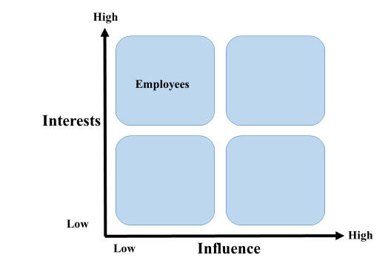
Source: (author)
Employees, in an organisation can be referred to as one of the most important components that are helpful in impacting the effectiveness of the operations to be done within the premises of an organisation, here SPA Salon. It can be understood from the above analysis of stakeholders that the interests of the employees are quite HIGH, however, the influence is comparatively LOW (Pinto, 2020).
- Investors
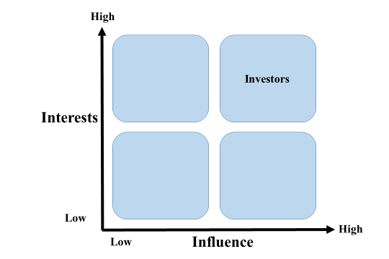
Source: (author)
It needs to be understood that investors are referred to the individuals or the organisations that are responsible for making investments in the organisation, here SPA Salon. With the investments made, the management of the business is able to conduct their daily operations and increase their assets. Thus, it can be understood that both the interests as well as the influence of the Investors are much HIGH (Rowe, 2020).
- Customers
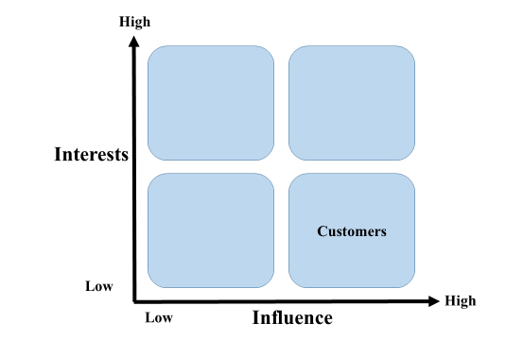
Source: (author)
The customers of the organisation, here SPA Salon, are comprised as the most influential factor that is helpful in the conduction of the operations in a business scenario. The United Kingdom is a location with many similar organisations. The management needs to provide good quality services to the customer with the introduction of technology and other kinds of innovation. Thus, it can be said that the interests of the customers are LOW while the influence is said to be HIGH (Nicholas and Steyn, 2020).
- Suppliers
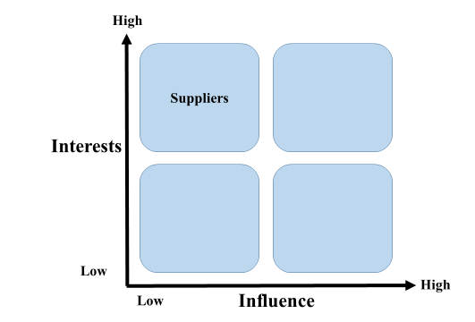
Source: (author)
Suppliers are comprised of the people and organisations that are responsible for the provision of the different raw materials and various kinds of equipment that are used for the conduction of many operations within the organisation. Based on the availability of the many suppliers and other properties, the analysis has stated some points. The interests of the suppliers are HIGH, however, the influence is said to be quite LOW (Work, 2022).
- Government
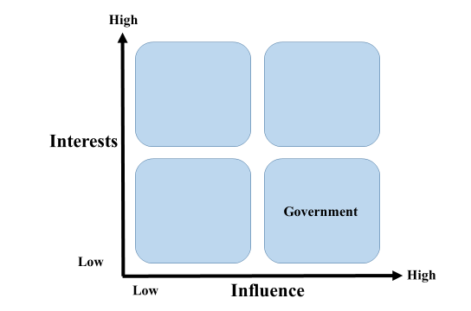
Source: (author)
The government is responsible for setting various measures and regulations. These rules and methods are essential in directing the way an organisation is able to function within the business market of the United Kingdom. Thus, it can be said that the Government is having HIGH influence and LOW interests (Rowe, 2020).

Work breakdown structure
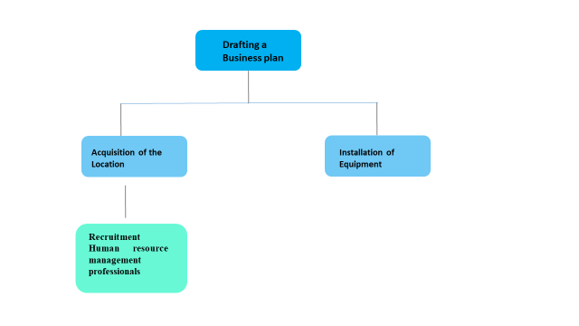
Source- (Author)
The work breakdown structure in the project management displays a difficult and multi-step project. It breaks the structure of the work that needs to be finished. A WBS is a kind of divide-and-win approach that helps the managers of the project to deal with their projects on a few deliverable time, rather than finishing the total project at a time. The WBS is made up of the deliverables that result in the finishing of the assignment or the project. These smaller portions are known as the work packages or sub-tasks that need to be finished. Having the improvement in the WBS makes the business enterprise more successful. Making one part of the WBS clear leads to the total failure of the total project work. The Work breakdown structure in the WBS is the tool to finish the project management infrastructure (Agistin et al., 2021).
Project
This is the first level of project management that includes the blueprint or the basic framework that derives the objectives of the project manager regarding the project. Hence, it stands alone for the whole project team to be at the top of the WBS hierarchy. For example, the objective of the project is to open a SPA salon (Nadison et al., 2022).
Task
It includes the plan of the business, location, equipment, marketing, and human resources.
Drafting a Business plan
The business plans to pen up a Spa salon, with a strategy of affordable prices with premium quality. The main business plan includes spa treatment that would require the cost of employees, equipment, and many more.
Acquisition of the Location
The location must be consumer friendly with an eye-catching look that will help in attracting the consumers toward the business organisation.
Installation of Equipment
The cost of equipment that is required in the beauty and spa salon includes hair trimmers, beauty parlor chairs, electric shaver, massage equipment, hair styling equipment, beauty therapy machines, and many other equipment that are necessary for the spa salon.
Recruitment Human resource management professionals
It includes the hiring of the perfect individuals that would help in the smooth performance of the business organisation. The choice of human resources is one of the major parts of project management. The workers must know how to deal with different kinds of consumers with different mentalities. The main aim of the staff will be to satisfy the demands of the consumer. It will depend on the proper training and recruitment of the staff affecting the human resource management.

Cost and use of resources
Above all the task, the cost of equipment and the expense that will be utilized by the staff for a brand new total set of a hair spa salon including all the cost and expenses of equipment and the other sufficient products will be 30000 euros. The total number of pieces of equipment will decide the actual cost of the salon depending on the nature of the business organisation. The proper human resource management in the chosen business requires the appropriate training and development of the recruits that can help the consumer fulfill their needs and requirements (Putra and Latief, 2020).

Consideration of resources
It is quite essential that the management of the organisation should be able to consider the resources present within the plan to be able to conduct the activities and methods of implementation that are involved in the development of the project that is undertaken. With the proper observation and methods, the management team of the organisation, here at SPA Salon, will be able to understand the challenges that may be faced by the premises (Bishop et al., 2021).
With the consideration of the human resources, the management of the organisation will be able to strategise methods for development that will lead to overall growth in the business market. It is also known to have played a key role in the development of methods for resource allocation in the overall process of Project management and development (Stanitsas et al., 2021).
Planning and strategising will also be positively impacted with the help of this method of consideration of the resources that are involved in the project undertaken, in this case, the development of the SPA Salon. These may include procedures such as the provision of alternative analysis and publishing of estimated data and other similar measures (Thesing et al., 2021).

Gantt Chart
Activities | Month 1-2 | Month 2-3 | Month 3-4 | Month 4-5 | Month 5-6
Observing the Challenges faced
Development of Strategies
Designing Implementation Method
Action Plan Implementation
Recording Reviews

Risk assessment

Overview
Risk Assessment can be referred to as a general term that is made to use across different sectors for the determination of hte likelihood of a loss that has been made on an asset, investment or a loan. It can be also referred to as the analysis of all the potential events that may be resulting in the change of events and pattern of events (Crawford, J.K., (2021).
These are the procedures undertaken by an organisation or the government before making the decision of getting involved with a new business or project. There can be two distinct kinds of risk assessment that are namely based on the Qualitative and the Quantitative data (Burggräf et al., 2022).

Significance in the Organisation
There are various benefits that can be incurred by the premises of the organisation, here SPA Salon, that have been discussed in this section of the report. One of the most notable significance can be referred to the management of the company being able to identify the likelihood of the potential risk (Rowe, 2020).
The assessment of the margins of the potential risk that can be faced by the premises of the SPA Salon is also included in it. After this assessment, the management will be able to design and determine the activities that are to be required to be carried out on the premises of the said organisation to be able to enhance the functionality of the business (Crawford, J.K., (2021).

Assessment
Company name: SPA Salon Assessment carried out by: XXXX XX
Date of next review: XX.XX.XXXX Date assessment was carried out: XX.XX.XXXX
What are the hazards? | Who might be harmed and how? | What are you already doing to control the risks? | What further action do you need to take to control the risks? | Who needs to carry out the action? | When is the action needed by?
Lack of growth in the business premises and activities. | The various stakeholders such as the investors, management and the suppliers work with the organisation (Layton et al., 2020). | Much attention has been given to the productivity of the operations that are occurring on the premises of the organisation. | The observation of the trends and make use of technology to increase the efficiency of the organisation. | The management and the team leaders that look after the work occurring on a daily basis. | The action is to be taken on the premises of the organisation itself (Layton et al., 2020).
Lack of Human Resources on the premises of the organisation. | The management and the authorities of the organisation as well as the customers attending the services. | Many different regulations and rules are being implemented on the premises of the organisation (Layton et al., 2020). | The issues and challenges faced by the employees working in the organisation need to be observed. | The management of the organisation that are keeping a watch on the various functions. | The action needs to be taken on the premises of the organisation itself (Layton et al., 2020).
Lack of motivation among the employees working in the organisation. | The employees working in the organisation (Burggräf et al., 2022). | Taking informed decisions and maintaining communication with the employees that are operative on the premises of the organisation. | Introduction of attractive bonuses and rewards to the employees for their better performance as a form of encouragement. | The management of the organisation that is responsible for keeping a watch on the various activities. | The action is to be done on the premises of the organisation itself (Burggräf et al., 2022).

Conclusion
The above report has been based on the assumption of the necessary changes that are to be done based on the feedback of the presentation/pitch that is included in the content of Task 1. The start of the assignment has provided a basic description or outline of the project that is going to be the base content of this report. Thereafter, a detailed stakeholder analysis has been included in the project with the proper structure. A typical WBS or Work Breakdown Structure has also been provided in this assignment. A draft of the costing and resources has been included along with the consideration of those resources. There has been a provision of a Gantt Chart that is responsible for showcasing the outline of the project schedule. Finally, the project is concluded with the presentation of the Risk Assessment and its analysis.

References
Agistin, V., Riantini, L.S. and Latief, Y., (2021). Development of Risk-Based Standardized WBS (Work Breakdown Structure) for Civil and Structural Works of Coal-Fired Steam Power Plant Construction Project in Indonesia to Improve Time Performance. In Proceedings of the International Conference on Industrial Engineering and Operations Management (pp. 661-672).
Bishop, B.W., Nobles, R. and Collier, H., (2021). Research Integrity Officers' Responsibilities and Perspectives on Data Management Plan Compliance and Evaluation. Journal of Research Administration, 52(1), pp.76-101.
Burggräf, P., Adlon, T., Schupp, S. and Salzwedel, J., (2022). Risk Assessment in Factory Planning Projects–An Empirical Evaluation of Industrial Practice. In Towards Sustainable Customization: Bridging Smart Products and Manufacturing Systems: Proceedings of the 8th Changeable, Agile, Reconﬁgurable and Virtual Production Conference (CARV2021) and the 10th World Mass Customization & Personalization Conference (MCPC2021), Aalborg, Denmark, October/November 2021 8 (pp. 543-550). Springer International Publishing.
Crawford, J.K., (2021). Project management maturity model. Auerbach Publications.
Gomes, J.O., Backes, F.G., da Silveira, J., Gonçalves, L., Trein, T., da Cruz, H.L. and Moraes, C.A.M., (2022). Cleaner production applied at beauty salon: considerations and opportunities. Ciência e Natura, 44, pp.e2-e2.
Layton, M.C., Ostermiller, S.J. and Kynaston, D.J., (2020). Agile project management for dummies. John Wiley & Sons.
Nadison, M., Flamm, L.J., Roberts, A., Staton, T., Wiener, L., Locke, J., Bullock, E., Loftus, B., Carpenter, C., Sadler, M. and Horberg, M.A., (2022). Kaiser Permanente's Good Health & Great Hair Program: Partnering With Barbershops and Beauty Salons to Advance Health Equity in West Baltimore, Maryland. Journal of Public Health Management and Practice, 28(2), pp.E369-E379.
Nicholas, J.M. and Steyn, H., (2020). Project management for engineering, business and technology. Routledge.
Permatasari, H., Purwanto, E. and Triyono, T., (2024). Enhancing Customer Experience and Satisfaction through Mobile-Based Salon and Spa Reservations on Android Platforms. IJEEIT: International Journal of Electrical Engineering and Information Technology, 7(1), pp.12-21.
Pinto, J.K., (2020). Project management: achieving competitive advantage. Pearson.
Putra, A.S.P. and Latief, Y., (2020), April. Analysis of safety cost structure in infrastructure project of cable stayed bridge based on Work Breakdown Structure (WBS). In IOP Conference Series: Materials Science and Engineering (Vol. 830, No. 2, p. 022075). IOP Publishing.
Rowe, S.F., (2020). Project management for small projects. Berrett-Koehler Publishers.
Stanitsas, M., Kirytopoulos, K. and Leopoulos, V., (2021). Integrating sustainability indicators into project management: The case of construction industry. Journal of Cleaner Production, 279, p.123774.
Thesing, T., Feldmann, C. and Burchardt, M., (2021). Agile versus waterfall project management: decision model for selecting the appropriate approach to a project. Procedia Computer Science, 181, pp.746-756.
Work, D., (2022). What is Project Management?. Project Management.
Yogana, E. and Latief, Y., (2021), April. Development of system information of building code checking in the planning and permitting phase to improve building code compliance based on work breakdown structure (WBS) using building information modeling (BIM). In Journal of Physics: Conference Series (Vol. 1858, No. 1, p. 012091). IOP Publishing.

