Module Name: Learning In the Digital Era
Module Code: ACCA 4025

Student Name: Imran sharif
Student ID: 2538385
Group: 1

Lecturer’s Name: Koushik Modak

Learning in The Digital Era Assignment 1

Table of Contents
Learning in The Digital Era Assignment 1 0
Introduction 2
Main Body 2
Task 1: Essential Academic and Employment Skills for the future career Path 2
Task 1 (a): Report on Essential Academic and Employment Skills 2
Task 1 (b): Evaluation of Task 1 (a) based on Similarity report 2
Task 2: Collaborative Mind Map and Individual Poster 2
Mind Map (Collaborative) 2
Poster (Individual) 2
Task 3: Virtual Collaboration and RefWorks 2
Report on Virtual Collaboration 2
Step-by-step process of using RefWorks with visuals 2
Task 4: E-Portfolio Creation and Evaluation 2
Task 4 (a): E-Portfolio Creation 2
Task 4 (b): Illustrative Review of E-Portfolio tool Selection 2
Conclusion 2
References 2
Task 1 References: 2
Task 3 References: 2
Task 1 (a): Report on Essential Academic and Employment Skills 3
3
Task 1 (b): Evaluation of Task 1 (a) based on Similarity report 4

Introduction

Main Body

Task 1: Essential Academic and Employment Skills for the future career Path

Task 1 (a): Report on Essential Academic and Employment Skills

Task 1 (b): Evaluation of Task 1 (a) based on Similarity report

Task 2: Collaborative Mind Map and Individual Poster

Mind Map (Collaborative)

Poster (Individual)

Task 3: Virtual Collaboration and RefWorks

Report on Virtual Collaboration
Put your Chosen topic here

Step-by-step process of using RefWorks with visuals

Task 4: E-Portfolio Creation and Evaluation

Task 4 (a): E-Portfolio Creation

Task 4 (b): Illustrative Review of E-Portfolio tool Selection

Conclusion

References

Task 1 References:

Task 3 References:

Task 1: Essential Academic and Employment Skills for the future career Path

Task 1 (a): Report on Essential Academic and Employment Skills

An Essential academic skill that’s very important to help you in the future would be basic math and data analysis which are very important in many jobs across many sectors across the country. Another essential academic basic skill would be reading and writing. Basic reading and writing skills help with a lot, especially when it comes to basic communication such writing an email or reading instructions in documents. The Uk government published a book about the importances of having essential academic skills for the economic of the country. They stated:
“Education and skills are important drivers of productivity. Higher levels of educational
attainment and skills raise productivity directly by expanding an individual’s economic
capabilities” [1]

Employment skills that are very important in every sector and field across the country is communication. Communication is one the of basic skills an employer would be looking for. One example would be writing a report to your manager or verbally talking to your co-worker about a project you are working with. Another employment skill that’s essential is teamwork. Employers very are adamant on teamwork reasons to why is they need to see if you work well with your co-workers on projects that would be vital to the company you work for. Cambridge published an article about the importance of employment skills especially communication to be vital. Cambridge stated:
“In the workplace, people need to be able to express themselves clearly and appropriately when speaking and writing, to listen actively to others, and to be able to use nonverbal communication appropriately.” [2]
Pictures of essential and employments skills
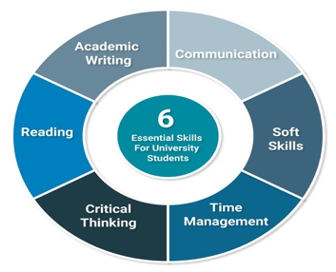
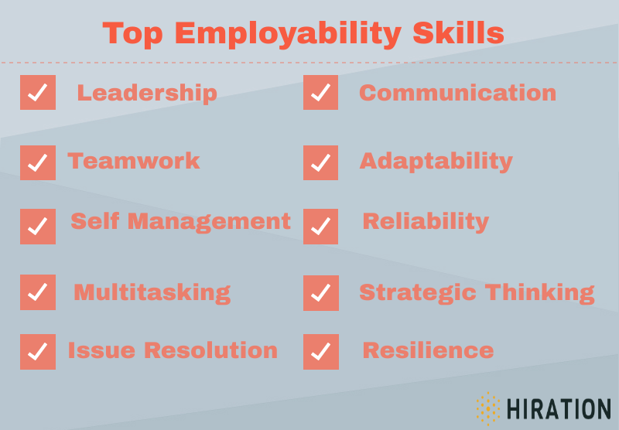

[3]

[3]
Both essential and employment skill are very important for anyone progress in the career path. You can’t have one and lack the other and try to progress in the career path. Employers look for people that have more than one or two set of skills that to stand out among other.

Task 1 (b): Evaluation of Task 1 (a) based on Similarity report

