UNIVERSITY OF WALES TRINITY SAINT DAVID
MSc Data and Artificial Intelligence
Module Title:
Data Security, Governance and Compliance
Module Code:
ACCA7028
Assignment Title:
A Strategic Approach to Data Security, Governance and Compliance: A Case Study of FinSure Bank
Student Name:
Shivam Sanjivkumar Patel
Student ID:
2435900
Lecturer:
Dr Vijeyananthan Thayananthan

Abstract
The current report is an analysis of data security principles and practices, data security governance, and data security compliance as applied to FinSure Bank (FSB), a cloud-based digital financial services company. The paper will start by comparing existing security frameworks, such as ISO 27001 and ITIL, with an aim of learning how they take care of information security and organisational governance. Based on this analysis, it is suggested to take a comprehensive and unified approach to solve the current issues faced by FSB, namely, the absence of unified governance and risk management, as well as exposure to cyber threats through BYOD and cloud setups. The recommended model ensures that security policies, risk management plan, compliance committee, and technical protection systems are implemented according to the standards of the industry. Moreover, the report is also critical of the significance of the constant review of regulations and standards, incorporating changing cybersecurity threats. The results indicate that in contemporary banking systems, a clear governance framework and effective security policies are critical to safeguarding sensitive financial information and guaranteeing compliance with regulations.
TABLE OF CONTENTS
1. Introduction 5
2. Case Scenario Overview: FinSure Bank (FSB) 6
3. Research on Security Frameworks and Models 7
3.1 Overview of Security Frameworks 7
3.2 ISO 27000 Series 8
3.3 ITIL Framework 9
3.4 Comparison of Frameworks 11
3.5 Other Supporting Models 11
4. Proposed Security, Governance and Compliance Approach 12
4.1 Assumptions 12
4.2 Governance and Strategic Security Planning 12
4.3 Security Policies Framework 13
4.4 Risk Management Strategy 14
4.5 Compliance and Legal Requirements 15
4.6 Security Management Models and Practices 16
4.7 Protection Mechanisms 16
4.8 Contingency and Incident Response Planning 17
4.9 Service Level Agreements (SLA) 17
5. Critical Analysis: Need for Updated Regulations and Standards 17
6. Conclusion 18
Reference List: 19
Appendices 22
Appendix 1: Comparison of Security Frameworks 22
Appendix 2: Risk Assessment Matrix for FinSure Bank 22

1. Introduction
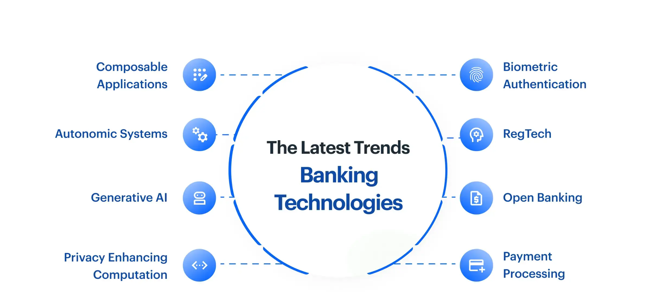
Figure 1: Latest Banking Technologies
(Source: John, 2020)
The growing reliance on digital technologies in the banking industry has increased the relevance of the concept of data security, control, and compliance to a considerable degree. Financial institutions are sensitive entities in which individuals and financial information are handled in large volumes; hence, they are the best targets of cyberattacks. According to Durgaraj et al. (2025), modern organisations are facing difficult security issues due to the high rate of cyber threats, such as ransomware, phishing, and advanced persistent threats, which have posed complicated and difficult security challenges to organisations. Therefore, organisations need to have systematic strategies to safeguard information resources and achieve compliance with the regulations.
Governance structures, in this regard, are important in aligning the security strategies with the objectives of the organisations as well as ensuring adherence to the legality, such as data protection laws. According to Wali et al. (2023), governance structures should be effective to increase accountability and minimise vulnerability through the introduction of roles and accountabilities. Nevertheless, there are numerous digital-first banking companies that are unable to combine security practices with governance and compliance needs.
This project is in the case of FinSure Bank (FSB), a fast cloud-based financial service provider on its way to rapid growth. The organisation is largely dependent on cloud infrastructure, and it supports BYOD access, a factor that puts the organisation at risk of cyber attacks. Simultaneously, the lack of coordination of governance and formal controls on compliance increases these risks further.

2. Case Scenario Overview: FinSure Bank (FSB)
FinSure Bank (FSB) is an online-based financial entity that extensively uses cloud-based services to provide banking services in various regions. This model of operation is highly scaled and more accessible at the same time, posing a major security challenge. According to Hossain (2022), distributed architectures and external dependencies play a part in exposing cloud-based banking environments to cyber risks. Moreover, FSB provides access to internal systems by employees, contractors and partners using personal devices with a BYOD model, which further increases the complexity of managing security.
The organisation does not have consistent governance and formal security policies, leading to incoherent data protection and risk management methods. Such a lack of structure introduces gaps in identity management, access control, and regulatory compliance. Gudepu and Jaladi (2021) have put it that compliance mechanisms are usually ineffective and do not prevent breaches of data protection laws that expose organisations to both legal and financial penalties.
The main issues that are present in FSB are the risk of higher data privacy rates, the probability of cyberattacks, and the lack of formal compliance procedures. These two (reliance on clouds and poor governance) increase the threat environment, and the organisation is vulnerable to fraud, data breaches, and insider threats. Therefore, it is essential to pay attention to these problems in order to keep operations safe and stakeholders able to trust this business. This puts into focus the urgent necessity of having an integrated and systematic approach to security.

3. Research on Security Frameworks and Models

3.1 Overview of Security Frameworks
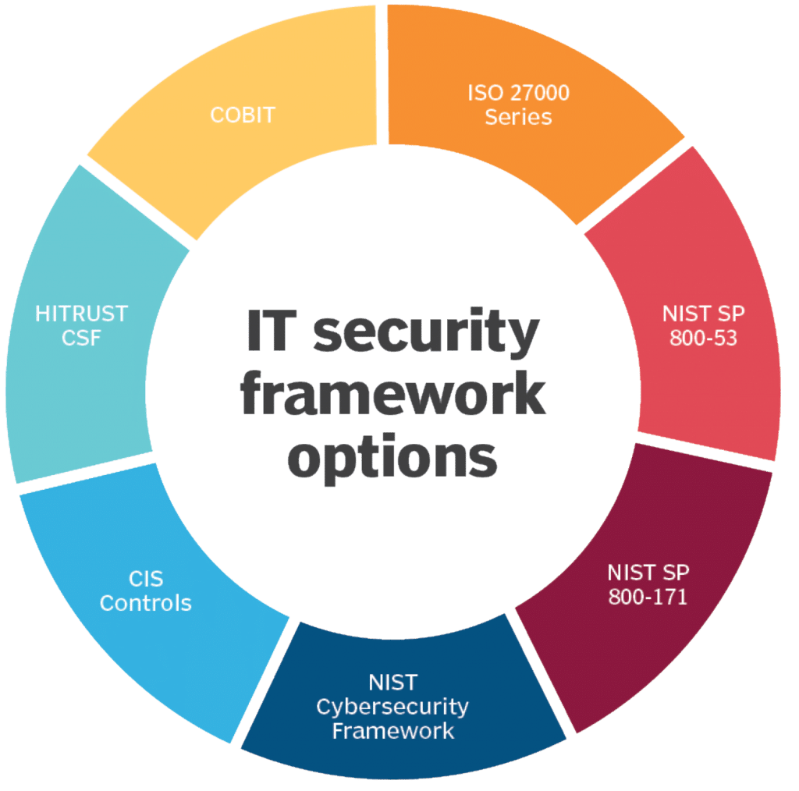
Figure 2: IT Security Framework Options
(Source: Satori, 2023)
Security frameworks offer organised procedures in the handling and security of organisational information systems. These frameworks outline policies, procedures and controls that help organisations to attain confidentiality, integrity and availability of data. According to Rusman et al. (2022), ISO, ITIL, and COBIT are frameworks that assist organisations to streamline the alignment of security practices with governance goals and regulatory imperatives.
In addition, the frameworks help organisations to apply uniform security controls and keep track of compliance. They are also used as a basis for risk assessment and constant improvement. In the absence of this infrastructure, organisations tend to depend on diffused practices, thereby exposing them to cyber threats. Thus, security frameworks are needed to develop a proactive and systematic approach to information security management.

3.2 ISO 27000 Series
The widely recognised standards of information security management are the ISO 27000 series and especially ISO 27001. It offers a holistic model of implementing an Information Security Management System (ISMS) that involves the embedding of security practices in the organisational procedures. According to Ryanto and Tundjungsari (2024), ISO 27001 has a risk-based methodology, which allows organisations to systematically detect, evaluate, and avoid potential threats.
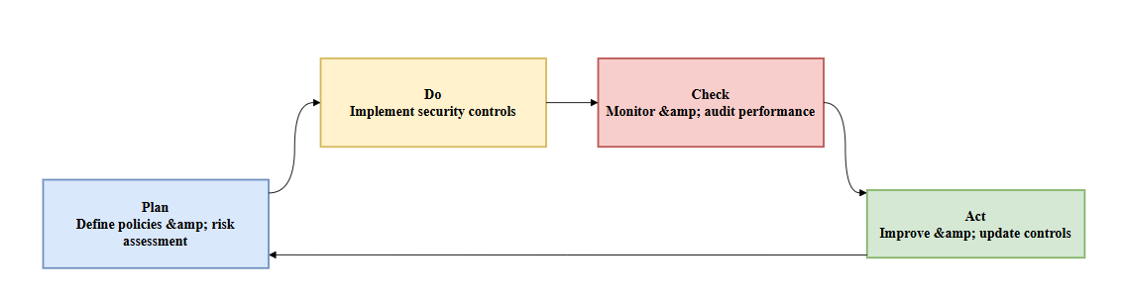
Figure 3: ISO 27001 ISMS (PDCA Cycle)
(Source: Self-Created in Draw.io )
This Figure demonstrates the PDCA cycle, which is a continuous enhancement of information security through the implementation of planning, evaluation, correction, and implementation of information intended to ensure adaptive risk management and long-term compliance in the dynamic organisational environment.
Another important characteristic of ISO 27001 is that it focuses on continuous improvement, using the Plan-Do-Check-Act cycle. This would mean that security controls would be regularly reviewed and revised to accommodate new risks. According to Legowo and Juhartoyo (2022), the framework assists organisations in structuring risk assessment exercises to enable them to prioritise important assets and make effective resource allocation decisions.
ISO 27002 is a supplement to ISO 27001 that provides more specifications for implementing security controls, such as access management, encryption, and incident response. Also, the standard encourages accountability through role and responsibility definition within the organisation.
Implementation of ISO 27001, however, is resource-intensive and therefore needs a lot of investment in training and infrastructure. Nonetheless, the framework has a significant number of advantages, such as risk management, data security, and stakeholder trust. Thus, ISO 27001 continues to be an important element for organisations aiming at developing a sound security and governance culture.

3.3 ITIL Framework
Information Technology Infrastructure Library (ITIL) is a framework which dwells upon the IT service management and its orientation to organisational objectives. ITIL also offers information to give efficient and reliable IT services, unlike ISO 2700,1 which has more focus on security controls. According to Ernawati and Wang (2023), ITIL improves the quality of the service as it streamlines and standardises processes, including incident management, change management, and service delivery.
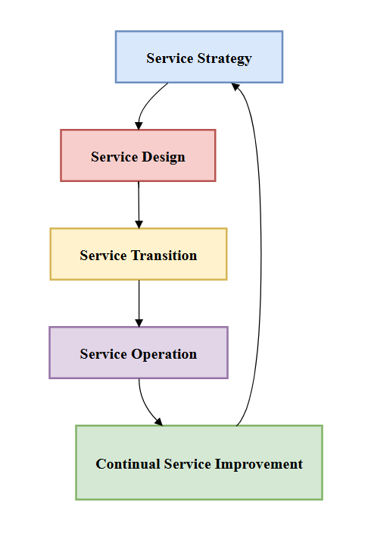
Figure 4: ITIL Service Lifecycle
(Source: Self-Created in Draw.io )
This Figure presents the ITIL lifecycle in ways that structured service stages incorporate operational processes, along with governance, so that organisations can be able to provide secure and efficient service through continuous improvement in performance, as well as the alignment of performance to the business objectives.
ITIL can help in the context of security by incorporating security practices into service management procedures. This will guarantee that the issue of security is incorporated in the day-to-day activities, and it is not taken as an isolated operation. Moreover, ITIL aids in governance, as it establishes the roles, duties, and responsibilities of IT services.
ITIL, however, lacks detailed security controls, thus restricting its usefulness as an all-purpose security framework. Instead, it works best when it is integrated with some other models like ISO 27001. This is not the case with ITIL, which is very important in enhancing efficiency in operations and the delivery of uniform services. It can thus be used as a good addition to security-oriented frameworks.

3.4 Comparison of Frameworks
An evaluation of the ISO 27001 and the ITIL reveals that they are complementary in the area of organisational security. The ISO 27001 is aimed at controlling information security by offering a structured control and risk-based methodology, whilst ITIL targets business efficiency and service management. According to Sholeh and Pramudya (2025), the integration of these frameworks has the benefit of improving governance and service delivery in organisations.
The ISO 27001 is a highly risk assessment and compliance-based tool, and thus suitable for the process of dealing with data protection requirements. ITIL, conversely, promotes stability of operations and constant service enhancement. Nevertheless, ISO 27001 is very intensive in resources and implementation, whereas ITIL is not elaborate in security controls.
In the case of FinSure Bank, the ISO 27001 would be more appropriate as an initial framework because it deals with risk management and adherence. However, the incorporation of ITIL can lead to improvement in the service delivery and governance of operations. Thus, an integrated solution will be a well-balanced and effective solution.

3.5 Other Supporting Models
Others like the COBIT and the NIST Cybersecurity Framework can also be of great help in governance and risk management, in addition to the ISO and ITIL. According to Rusman et al. (2022), COBIT is aimed at balancing IT governance and business goals, accountability and performance measurement.
On the same note, the NIST framework offers information on how to determine, safeguard, detect, react to, and recover from cyber threats. The models help organisations improve their abilities through organised risk management and governance. As a result, a combination of frameworks would help organisations to deal with complex security challenges better.

4. Proposed Security, Governance and Compliance Approach

4.1 Assumptions
The suggested strategy is created with a number of assumptions about the operational context of FinSure Bank, as well as its operational security maturity. The assumption made is that the organisation is sufficiently large and depends on the cloud-based infrastructure extensively to provide its services to a variety of geographical areas. According to Azura et al. (2025), cloud-based banking platforms necessitate integrated and dynamic security frameworks to be able to deal with distributed risks.
What is more, the organisation is presumed to deal with very sensitive financial and personal information, which must be subject to strict regulatory demands like GDPR. The organisation has also been said to have moderate financial capacity to invest in security, and little governance maturity that exists. That is why it is necessary to organise the enforcement of security, governance and compliance systems in order to manage all these issues.

4.2 Governance and Strategic Security Planning
Clear governance functions are the basis of aligning organisational security strategies with the business goals and regulatory demands. According to Wali et al. (2023), good governance increases organisational resilience by creating accountability, transparency, and roles during security management procedures. Due to FinSure Bank, a centrally governed governance model would be applicable, and uniformity and control would be established in all operational areas.
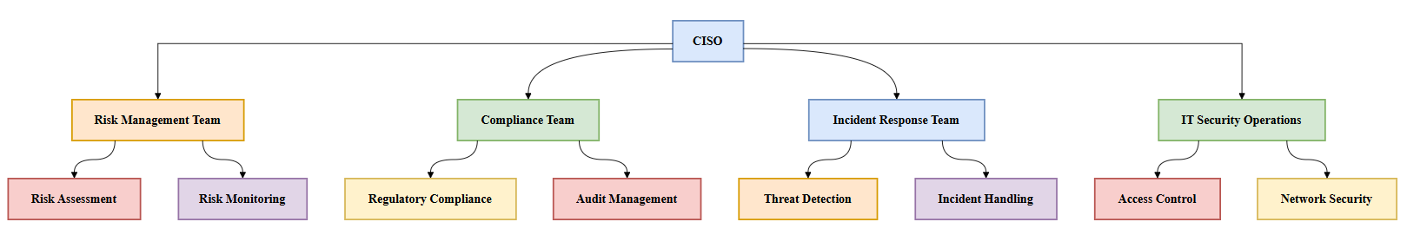
Figure 5: Security Governance Architecture
(Source: Self-Created in Draw.io )
This Figure is a governance architecture, emphasising hierarchical control and distribution of roles, being accountable, making decisions coordinated and communicating efficiently among security functions, enhancing the organisational resilience and strategic security alignment.
A Chief Information Security Officer (CISO) should head this structure, and they will ensure the management of the general security posture of the organisation. In line with this mandate, risk management, compliance monitoring, and incident response teams ought to have been put in place to support this role. Such teams should be able to work within well-stipulated reporting lines so that there are effective communication lines and need to take timely decisions.
Strategic security planning is supposed to entail constant assessment of risks, frequent revision of policy, and alignment with organisational objectives. The governance policies should aim at making sure that security measures do not limit the performance of the business but support efficiency. Moreover, performance indicators and measurement systems must also be applicable to assess the efficiency of security programs.
Thus, it is possible to reinforce organisational control and make sure that the security strategies are in tandem with the dynamic technological and regulatory realities through the structured model of governance.

4.3 Security Policies Framework
Security policies offer the basis for the formation of unified and reasonable security practices in an organisation. These policies need to take care of critical points like access control, data protection, and use of BYOD so as to provide comprehensive coverage of the possible vulnerabilities. According to Al Batayneh et al. (2021), governance systems are an important factor in promoting the effectiveness of diverse policies as they promote alignment between the organisational goal and the security imperatives.
The access control policies are to be used in defining user roles, permissions, and authentication controls to avoid unauthorised access to confidential systems. The policies used in data protection should also guarantee safe storage, transfer, and processing of data using encryption and other preventive strategies. Also, the BYOD policies must specify the admissible behaviour of the personal devices, the security settings, and the monitoring processes, which will alleviate the risk of the individual devices.
These policies are supposed to be formalised and reviewed frequently in order to ensure that they remain relevant in the rapidly changing threat contexts. An overall policy framework, therefore, provides consistency, accountability and proper execution of security practices within the organisation.

4.4 Risk Management Strategy
Risk management strategy is also a powerful solution in identifying, analysing and mitigating the actions that could pose great threats to the organisational activities. According to Azura et al. (2025), integrated risk management frameworks are able to help organisations to deal with complex cybersecurity issues by integrating threat identification with structured mitigation measures.
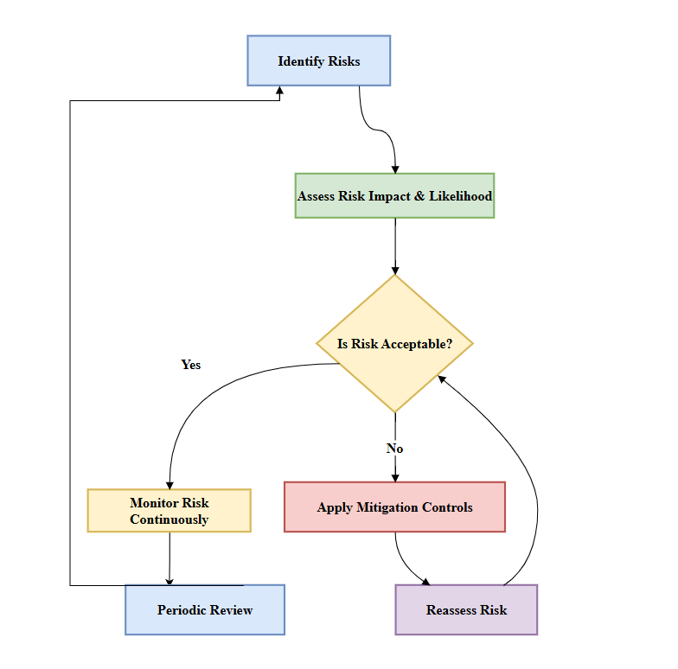
Figure 6: Risk Management Process Flow
(Source: Self-Created in Draw.io)
This figure shows the analytical evaluation of threats based on decision-making by risk-taking through the conduct of assessment and mitigation loops, where organisations are able to arrange the prioritisation of risk-taking procedures and maintain constant vigilance and responsive security measures.
Traditional risks that FinSure Bank must focus on in risk identification include the following: data breaches, insider attacks, phishing, and cloud infrastructure-related vulnerabilities. Identified risks need to be followed by risk assessment procedures that determine the probability and potential severity of the identified risks so that priorities can be made depending on the level of severity and exposure to the organisation.
The application of technical controls, awareness programmes to the employees, and regular monitoring systems should be included within mitigation measures. Detection mechanisms are important to identify anomalies and control threats in real time. Also, the risk management must be incorporated into the decision-making of organisations, where security considerations should be included in any strategic initiative.
The risk management framework should be effective, as the risk level should be assessed and audited regularly. Thus, resilience to risk management is developed through a systematic and comprehensive risk management strategy that minimises the chances of a security breach and improves organisational resilience.

4.5 Compliance and Legal Requirements
Conformity to laws and regulations is a major element of organisational security, especially in the financial sector. According to Gudepu and Jaladi (2021), compliance with GDPR guarantees the safety of personal information and minimises the threat of facing court fines related to data theft.
FinSure Bank should adopt effective data protection and security systems, such as data storage systems, data access controls, and explicit breach notification. These precautions will be taken to make sure that the personal and financial information is processed as per the regulations. Data management practice also needs to be ethically considered in order to foster openness and responsible use of information.
Monitoring processes and regular compliance audits are necessary to detect the gaps and guarantee the observance of regulatory norms. Also, organisations have to be abreast with the changing legal frameworks to ensure that they are still compliant. So by putting compliance systems in place in governance systems, this is a way of ensuring that it not only complies with the law, but chances are also high that information is being managed ethically.

4.6 Security Management Models and Practices
Realisation of security frameworks necessitates the incorporation of laid-down models like ISO 27001 and ITIL into organisational operations. According to Ryanto and Tundjungsari (2024), ISO 27001 offers a systematic system of handling risks and carrying out security controls within a properly organised framework.
ITIL adapts this method by improving the service management procedures and by making sure that the security practices are incorporated in operations. The combination of these models will therefore aid in governance as well as service delivery, hence a holistic perspective to information security management.

4.7 Protection Mechanisms
Guards are needed to protect data and infrastructure in organisations against cyber incursion. Al-Dosari et al. (2024) have indicated that such technologies as artificial intelligence are useful to substantially improve threat detection and response capabilities of a banking system.
The security measures encompass encryption to protect data, multi-factor authentication, and network security measures in order to block unauthorised access. There is also a need to implement cloud security controls to solve vulnerabilities of external service providers.
Besides, continuous monitoring systems can help identify suspicious activity in real time, and therefore, the organisations can respond effectively to the possible threat. Hence, it is paramount to have effective protection systems in place in order to ensure data integrity and security.

4.8 Contingency and Incident Response Planning
Good contingency planning can be used to make organisations resilient in times of security Incidents. Durgararaju et al. (2025) indicated that four types of incident response strategies reduce the effects of cyberattacks proactively. Backup systems, recovery mechanisms and organised disaster recovery strategies should be in place to guarantee quick recovery and keep the business running in case of some unforeseen interruptions.

4.9 Service Level Agreements (SLA)
The SLAs establish security expectations between external cloud service providers and FinSure Bank. According to Thompson (2022), cloud-based systems must have clearly stated contractual agreements to hold them accountable. The SLA should comprise security requirements, performance indicators and responsibilities to guarantee stability, reliability, and safety of service provision across the outsourced infrastructure environments.

5. Critical Analysis: Need for Updated Regulations and Standards
The high pace of digital technology development has changed the cybersecurity environment tremendously and made the constant development of regulations and norms necessary. According to Durgararaju et al. (2025), the new cyber threats are increasingly becoming advanced and therefore, organisations need to assume dynamic and flexible security. However, they are effective in previous settings; traditional frameworks are often not able to cope with the new provisions presented by modernity, which include cloud computing, artificial intelligence and mobile banking that create new vulnerabilities and attack surfaces.
Moreover, technology has caused more complications in data processing and storage; current regulatory structures are not sufficient. According to Al-Dosari et al. (2024), the introduction of artificial intelligence into the banking system presents new risks, such as the problem of data privacy and the bias of the algorithm. These changing risks introduce the constriction of such regulative frameworks that are not always sufficient to accommodate dynamic threats. As a result of the existing fights, outdated rules may lead to security loopholes, which may lead to the theft of data and loss of money.
The frequent revising of regulations has a number of benefits. It improves the safeguarding of valuable financial data and resilience to cyber threats in the organisation. New standards also provide better ways of introducing effective security controls and making certain that the legal requirements are met. Furthermore, current legislative changes promote the development of new technologies and practices in organisations, which enhance the level of security maturity in general.

6. Conclusion
In the present report, the authors discussed the significance of data security, governance, and compliance in the framework of FinSure Bank. The review has indicated how frameworks like ISO 27001 and ITIL performed at bringing systematic measures towards information security and processes going on in an organisation.
The suggested solution revealed the way the combination of the governance systems, security principles, and risk management policies can successfully solve the problems of FSB. Through an all-inclusive security strategy and aligning with the new regulatory necessities, organisations will be able to improve on resilience and secure sensitive information.
Moreover, it was noted in the critical discussion that it is important to constantly revise regulations and standards to consider changing cyber threats. The digital environment of banking is increasingly becoming complex, and organisations need to embrace responsive and anticipatory approaches to ensure their security and compliance.
On the whole, the results support the necessity of a systematic and holistic approach to security governance, as a guarantee of sustainability in the long term and confidence in financial systems.

Reference List:
Al Batayneh, A.A., Qasaimeh, M. and Al-Qassas, R.S., 2021. A scoring system for information security governance framework using deep learning algorithms: a case study on the banking sector. ACM Journal of Data and Information Quality (JDIQ), 13(2), pp.1-34. https://dl.acm.org/doi/abs/10.1145/3418172
Al-Dosari, K., Fetais, N. and Kucukvar, M., 2024. Artificial intelligence and cyber defence system for the banking industry: A qualitative study of AI applications and challenges. Cybernetics and systems, 55(2), pp.302-330. https://www.tandfonline.com/doi/abs/10.1080/01969722.2022.2112539
Azura, Y.T.Y., Azad, M.A. y Ahmed, Y., 2025. An integrated cyber security risk management framework for online banking systems. Journal of Banking and Financial Technology, 9(1), pp.85-104. https://link.springer.com/article/10.1007/s42786-025-00056-3
Durgaraju, S., Vel, D.V.T. and Madathala, H., 2025, January. The evolution of cyber threats and defences: a review of innovations and challenges. In 2025, the 6th International Conference on Mobile Computing and Sustainable Informatics (ICMCSI) (pp. 117-123). IEEE. https://ieeexplore.ieee.org/abstract/document/10883230/
Ernawati, Y. and Wang, G., 2023. Assessing IT services management with ITIL framework V3: A case study. Journal of System and Management Sciences, 13(4), pp.152-164. https://www.aasmr.org/jsms/Vol13/No.4/Vol.13.No.4.09.pdf
Gudepu, B.K. and Jaladi, D.S., 2021. GDPR Compliance Challenges and How to Overcome Them. International Journal of Modern Computing, 4(1), pp.61-71. http://yuktabpublisher.com/index.php/IJMC/article/view/263
Holler, M., van Giffen, B., Benzell, S. and Ehrat, M., 2020. The General Data Protection Regulation in financial services industries: how do companies approach the implementation of the gdpr and what can we learn from their approaches? Proceedings of the 82nd Jahrestagung des Verbands der Hochschullehrer für Betriebswirtschaft (VHB), pp.1-11. https://dataprivacy.vn/wp-content/uploads/2013/08/GDPR_VHB_FINAL.pdf
Hossain, M.N., 2022. Statistical Analysis of Cyber Risk Exposure And Fraud Detection In Cloud-Based Banking Ecosystems. ASRC Procedia: Global Perspectives in Science and Scholarship, 2(1), pp.289-331. https://global.asrcconference.com/index.php/asrc/article/view/62
Legowo, N. and Juhartoyo, Y., 2022. Risk management; risk assessment of information technology security system at a bank using ISO 27001. Journal of System and Management Sciences, 12(3), pp.181-199. http://www.aasmr.org/jsms/Vol12/JSMS%20June%202022/Vol.12.No.03.10.pdf
Rusman, A., Nadlifatin, R. and Subriadi, A.P., 2022. Information system audit using COBIT and ITIL framework: literature review. Sinkron: jurnal dan penelitian teknik informatika, 6(3), pp.799-810. https://www.jurnal.polgan.ac.id/index.php/sinkron/article/view/11476
Ryanto, K. and Tundjungsari, V., 2024. Standardisation of information security management in the banking sector using the iso 27001: 2022 framework. Journal La Multiapp, 5(4), pp.361-379. https://newinera.com/index.php/JournalLaMultiapp/article/view/1399
Serrado, J., Pereira, R.F., Mira da Silva, M. and Scalabrin Bianchi, I., 2020. Information security frameworks for assisting GDPR compliance in the banking industry. Digital Policy, Regulation and Governance, 22(3), pp.227-244. https://www.emerald.com/dprg/article/22/3/227/74349
Setyoso, F.A.A., Mulyana, R. and Nugraha, R.A., 2024. Utilising ISO 27001: 2022 In Information Security Design For BPRCCo SME Digital Transformation. Ranah Research: Journal of Multidisciplinary Research and Development, 6(6), pp.2544-2553. https://www.jurnal.ranahresearch.com/index.php/R2J/article/view/1121
Sholeh, M.B. and Pramudya, N.D., 2025. Comparative study of information system governance frameworks: foundations for IT risk management using COBIT 2019 and ITIL. Jurnal Transformatika, 22(2), pp.73-80. https://journals.usm.ac.id/index.php/transformatika/article/view/9269
Thompson, A., 2022. AI-Driven Insights for Risk Management in Banking: Leveraging Cloud-Native Technologies for Scalability. International Journal of AI, BigData, Computational and Management Studies, 3(4), pp.1-10. https://ijaibdcms.org/index.php/ijaibdcms/article/view/43
Wali, K., van Paridon, K. and Darwish, B.K., 2023. Strengthening banking sector governance: challenges and solutions. Future Business Journal, 9(1), p.95. https://link.springer.com/article/10.1186/s43093-023-00279-0
Websites
John (2020). 15+ Banking Technology trends to watch out for 2023. [online] kissflow.com. Available at: https://kissflow.com/solutions/banking/banking-technologies/.
Satori (2023). Cybersecurity Frameworks. [online] Satori. Available at: https://satoricyber.com/data-protect-guide/cybersecurity-frameworks/.

Appendices

Appendix 1: Comparison of Security Frameworks
Framework | Primary Focus | Key Features | Strengths | Limitations
ISO 27001 | Information Security Management | Risk-based ISMS, security controls, and continuous improvement | Strong compliance support, structured risk management | High implementation cost, resource-intensive
ITIL | IT Service Management | Service lifecycle, incident management, and change management | Enhances operational efficiency and service quality | Limited direct security controls
COBIT | IT Governance | Governance alignment, performance measurement, and control objectives | Strong governance and audit capabilities | Complex implementation requires expertise
NIST Framework | Cybersecurity Risk Management | Identify, Protect, Detect, Respond, Recover model | Flexible and adaptable to different organisations | Less prescriptive, requires customisation

Appendix 2: Risk Assessment Matrix for FinSure Bank
Risk Type | Description | Likelihood | Impact | Mitigation Strategy
Data Breach | Unauthorised access to customer financial data | High | High | Encryption, access control, and monitoring systems
Insider Threat | Employees misusing access privileges | Medium | High | Role-based access, activity logging, and audits
Cloud Vulnerability | Weaknesses in third-party cloud infrastructure | High | High | Secure cloud configuration, SLA enforcement
Phishing Attacks | Fraudulent attempts to steal credentials | High | Medium | Employee training, multi-factor authentication
System Downtime | Service disruption due to cyber incidents | Medium | High | Backup systems, disaster recovery planning

