
Applied Leadership and Management in the Workplace
Module Assignment Submission
Student Name: | Lisa Williams
Student Number: | 2309068
Module No: | BMSK4013
Module Title: | Management Communication

Statement of Confirmation of Authenticity
By the act of making this submission, the student declares that this is the work of the student named above. The work has not, in whole or in part, been knowingly presented elsewhere for assessment, or where assessment has been built on a previous assessment, this has been identified. Where materials have been used from other sources it has been properly acknowledged. If this statement is untrue, the student acknowledges that an assessment offence has been committed.
Attention is drawn to the plagiarism and unfair practice policies of both the University and of ILM.

Contents

Introduction 3
What are Communication models and how do they work? 3
A Communication Cycle 3
The Shannon-Weaver Mathematical Model (1949) 3
The Schramm’s Model of Communication (1954) 4
Berlo’s SMCR communication cycle (1960) 4
Why is Tone, formality, language, content, and modes of communication important? 5
Tone 5
Formality 6
Language 6
Content and different modes of communication 6
Structure 6
Range of Verbal and written communication in the workplace 6
Motivation theories and their affects. 8
Maslow’s Hierarchy of Needs (1943) 8
McClelland’s Three Needs Theory (1961) 9
Herzberg Two Factor Theory (of Motivation Hygiene) 9
McGregor X – Y Theory 10
What factors can affect motivation in the workplace? 10
Conflict in the workplace 11
Personal Communication (PDP) 12
References 13
Appendix A - Personal Development Plan 14
Appendix B – Personal Communication Questionnaire 16

Introduction
Management communication is a key factor to a successful organisation. Looking at strengths and weaknesses on the different communication and motivational theories used and how the different factors of communication and motivation can affect organisations. Including conflict resolution and the different ways of communicating in the workplace.

What are Communication models and how do they work?
In looking at management communication we look at 4 communication models including strengths and weaknesses of each one.

A Communication Cycle
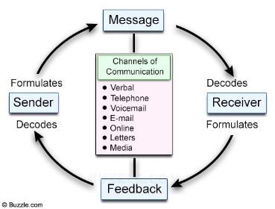
This communication model focuses on the different communication channels used to send and receive a message. For example, if a manager was to send a (message) to a colleague (receiver) using one of the above channels, the receiver would then process the information and (feedback) to the manager (sender) again using one of the above channels. The strengths show there are several different ways to communicate a message. An important point to consider is that the communication cycle does not include external noise, psychological obstacles, the different list of factors that can affect the communication between the (sender) and (receiver) such as attitudes, knowledge, and culture etc. Poor communication in the workplace will inevitably lead to unmotivated staff that may begin to question their own confidence in their abilities and inevitably in the organisation. (Page, 2019)

The Shannon-Weaver Mathematical Model (1949)
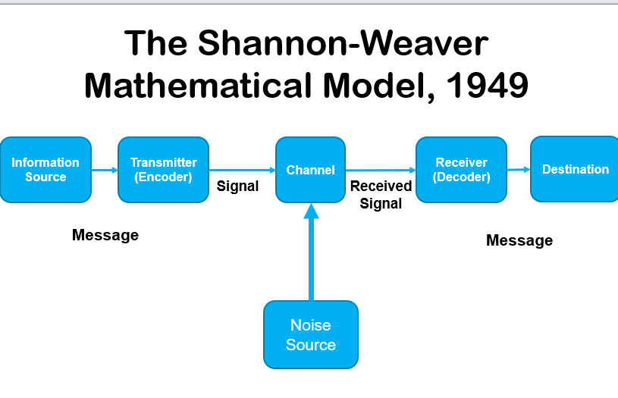
This model was developed by Claude Shannon and Warren Weaver who were both mathematicians. There are five components that make up this communication model. First being an information source that generates the message, a transmitter that encodes the message into signals, a receiver that decodes (reconstructs) the message from the signal, and a destination that receives the message. The sixth component, noise, is a dysfunctional factor. It is any interference that prevents the message from flowing along the channel, like static on a phone or radio, and can cause the signal to be received to differ from the signal that was transmitted. (Chandler & Munday, 2011). For example, when a manager (Information source) uses a Teams meeting to relay a message (transmitter encoder) regarding a new policy, it travels through the (channel) which includes any (noise sources) which is then decoded by the employee (Receiver decoder) who processes that information to then have their understanding of the message (destination). The strengths show a structured framework, clarity, and simplicity. It’s also applicable across contexts and it has technological relevance. The weaknesses for this model include the lack of cultural and contextual considerations, limited focus on emotional and psychological aspects, and inadequate representation of noise.

The Schramm’s Model of Communication (1954)
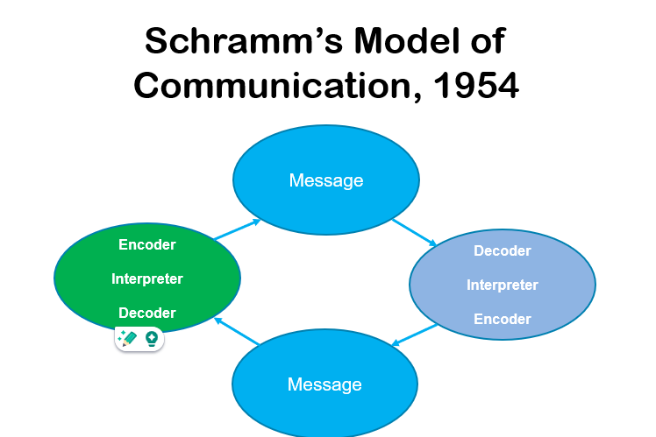
This model was created by Wilbur Schramm in 1954. There are three key components that form the basis of his model. A source, a message, and a destination. The source has a concept at the beginning of the process. Next, utilising signs, this concept is encoded into a message and delivered to the targeted destination. Three key components form the basis of his model: a source, a destination, and a message. The source has a concept at the beginning of the process. Next, utilising signs, this concept is encoded into a message and delivered to the targeted destination.

Berlo’s SMCR communication cycle (1960)
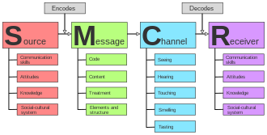
Berlo’s SMCR communication cycle (1960), was developed by Berlo in 1960. The cycle is a structure that focuses on the connection between source, message, channel, and receiver. To ensure efficient communication, this linear communication model highlights the significance of the social structure, cultural backgrounds, and communication abilities of both the sender and the recipient. (Lists shown under each component). For example, when a manager (source) explains a new task (message) in detail with broad knowledge using a presentation (channel). Employees (receivers) from different cultural backgrounds and different knowledge will determine their understanding of the subject (message) based on their own individual skills and character traits. Taking into consideration all the components under each of the ‘SMCR’. Berlo’s SMCR communication strengths are that it’s list of factors that affect the sender and receiver are detailed which demonstrates how several factors affect good communication. It would seem clear that this communication cycle does not include several factors such as external noises, non-verbal communication, and psychological barriers. This can cause a substantial impact on how communications are interpreted.
In comparing all 4 models they all explain the process of communication with emphasising on different barriers in the different components. Two are linear and two are circular. The linear describes a straightforward one-way communication and the circular emphasizes equal and mutual roles for sender and receiver showing the importance of feedback. They all include encoding and decoding. Encoding is when information is transmitted verbally or nonverbally, it describes how the sender changes the message, meaning, intention, or point of view into a symbolic code or information form that follows predetermined guidelines and is simple to comprehend and translate. (Xie et al., 2022a). Decoding is the process by which the information's recipient deciphers the code and/or replicates the concept that is being sent. The complexities of communication and the diversity of society were reflected in the decoders' decoding or interpretation tasks. (Xie et al., 2022b). Noise being one of the biggest obstacles in clear communication is not included in every communication cycle above. Noise in communication is any interruption, disruption, or distortion that affects a message's transmission, receipt, or interpretation between a sender and a recipient. Different types of noise could interfere with clear communication. Therefor there are strengths and weaknesses for each one.

Why is Tone, formality, language, content, and modes of communication important?
How communication is delivered in the workplace is extremely important. Tone, language, formality, structure, and content are the key elements to good communication.

Tone
Using the correct tone in conversation is vital. Maintaining an organizations image requires a professional tone. Within the organisation, changing the tone can be helpful in addressing various team dynamics and expressing the appropriate emotional undertone (encouraging, focused, supportive, reprimanding, etc.). In my workplace there was a colleague who used an angry tone when she was overwhelmed with workload. Instead of discussing matters calmly she would make sure everyone knew how displeased she was which caused a lot of anxiety amongst the team and an uncomfortable and unenjoyable environment to work. She would even speak to the manager in this tone. My manager dealt with this in a calm tone which helped defuse the situation. This clearly shows how someone’s tone impacts on communication and the effects it has.

Formality
Respect and professionalism between colleagues and senior management is extremely important which means a higher level of formality is required. Contrary to this, when a new member of staff joins the team, a softer and less formal approach would make them feel at ease and more welcome. In my experience building a good and understanding relationship with both my managers has had a positive impact on me. Finding the balance and knowing when it’s appropriate to change the level of formality is important.

Language
Depending on the audience it is important to use the correct language. When discussing a matter with a colleague or manager, technical language is appropriate. Technical language is a specialised vocabulary used by a particular profession, industry, or group. This approach wouldn’t work when discussing a work topic with someone who doesn’t understand the field. For example, having been a dental nurse for several years I learnt a lot of technical terms that I would use when discussing treatments with the dentists and other staff. When it came to explaining the procedures to the patients, I would then have to use a different language for them to understand.

Content and different modes of communication
It is important to understand that the content of a message and how it is conveyed is crucial. Information, ideas, knowledge, and pictures that are sent to other people via various communication channels are referred to as content. For example, a message to a manager would have different content to a message to family. There are also different methods of communication such as verbal, nonverbal, and written. Accessibility and formality should be taken into consideration while selecting communication channels. In my experience when communicating a task between my team I would use the portal Teams, this can be used for messaging, phone, and video calls. When communicating updates on a task to my manager I would then use emails. The content of my message would be different to my employees due to familiarity and open communication. With a more formal written content to my manager.

Structure
A structured conversation is a technique for the transmission of certain informative components, usually through cooperative communication. Formality and having clear points are essential for managers discussing business etc. On an internal level, a more conversational approach might work better, particularly during group discussions. In my experience when a manager failed to have a structured conversation and discussed issues in front of the office regarding certain staff, it caused a lot of conflict and unfortunately people to leave the company. Therefor it’s extremely important as a manager to prepare and have structure to avoid such outcomes.

Range of Verbal and written communication in the workplace
Below are some verbal and written procedures used in my workplace. I look at the advantages and disadvantages for each component.
Verbal Communication | Advantages | Disadvantages
Phone call | Able to gage tone, formality, language, and content clearly. Having instant feedback. | Not gaging body language and facial expressions can be a barrier to how the other person perceives the conversation.
Face to face meeting | Instant feedback with clear conversation. Showing body language, being able to pick up on feelings and emotions, where you may not if you weren’t face to face. | Some may not feel comfortable talking and expressing feelings. It can also be intimidating when meeting with a manager face to face.
Teams Video Call | Instant feedback. Gaging  Body Language, tone, and formality.  Clear conversation. | Wi-fi issues  Interference to the call causing mis communication.

Written Communication | Advantages | Disadvantages
Emails | Can be formal and structured with appropriate content. Can be sent straight away. | Not being able to gage tone, body language causing communication difficulties. No guaranteed instant correspondent. Emails not always accessible. Typing errors. Internet issues.
Text | Quick and easy. Can be structured with formality. Message can be sent and accessed quite quickly. | Not being able to gage tone, body language causing communication difficulties. No guaranteed instant correspondent. Network connection not guaranteed. Typing errors.
Letters | Formal, informative with structure and content. | Time consuming. No instant correspondent.  No body language or tone.  Possibility of letter getting lost.

In analysing the above communication avenues used at my workplace, I would improve using letters to communicate with students’ parents by using both emails and texts to relay the same message to ensure they receive the information. If I was a manager in my workplace, I would have more face-to-face meetings with staff to ensure clarity and clear communication. I would also use teams videocall more than phone call if accessible, to benefit from body language ensuring a positive and clear conversation. Ensuring calls take place in a quiet setting to avoid noise barriers. As well as less emails for conversations and more for informative content. Using less written communication where possible to avoid any possible miscommunication.

Motivation theories and their affects.
Human motivation is a complicated aspect of psychology and behaviour that affects how people choose to spend their time, how much effort they put into a task, how they feel and think about the work, and how long they stay on it (Bakar, 2014). The 2 types of motivation factors are intrinsic and extrinsic. According to (Oudeyer & Kaplan, 2007). When someone is motivated by something other than a tangential gain, they are said to be acting with intrinsic motivation. When someone is intrinsically driven, they behave out of enjoyment or challenge rather than in response to demands, incentives, or goods from other sources. Another source said, behaviour that is essentially dependent on achieving a result that can be separated from the activity itself is referred to as extrinsic motivation. It is carried out to achieve a different goal. (Legault, 2020). Intrinsic motivation is long term because it’s the drive that comes from within yourself. Extrinsic motivation is short term because it is based on external factors such as rewards or punishments. Research suggests, motivated employees support an organisation in achieving its goals and objectives. As a result, it is now the responsibility of leadership teams and company managers to determine the motivating factors that will have a significant impact on their workforce. (Rahaman et al., 2020).

Maslow’s Hierarchy of Needs (1943)
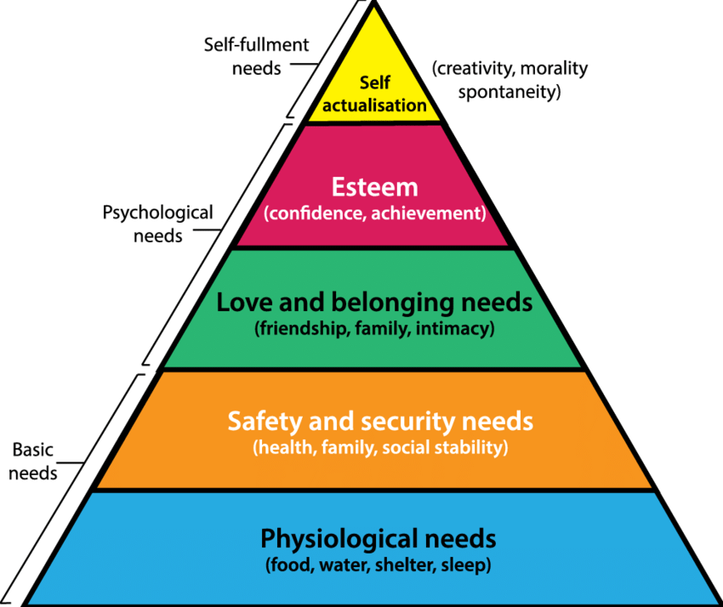
D
This theory was developed by American psychologist Abraham Maslow in his 1943. This theory has 5 levels. According to the theory, human needs vary in importance from more creative and intellectually stimulating "self-actualization" needs at the top to more physiological (survival) needs at the bottom. Maslow said that before a person can satisfy their higher wants, their survival requirements must be met. Only a small percent of people reaches the state of self-actualisation. Strengths of this theory are its easy to understand and is applicable to a variety of fields. Not forgetting it can be used for personal development. One weakness is, that it doesn’t consider different cultures. Evidence also suggests that you can switch between needs meaning not completing one need before the next. Maslow's theory is universal in nature, including all human needs, which makes it useful for anticipating certain actions in an organisational setting. Taking these into consideration I believe this theory can work but isn’t appropriate for everyone.

McClelland’s Three Needs Theory (1961)
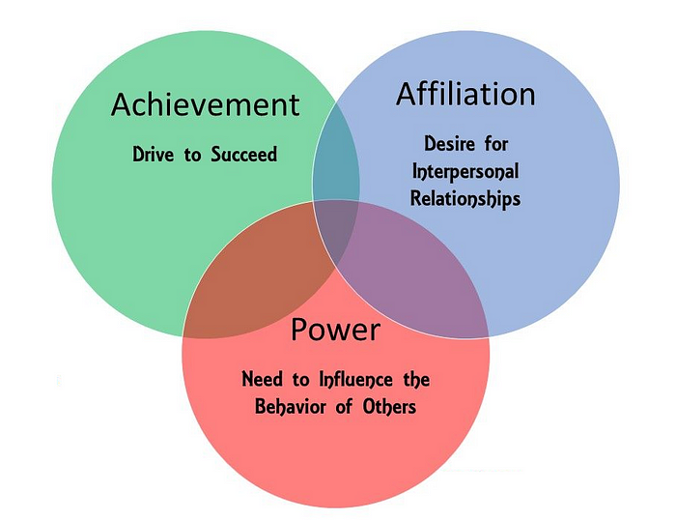
This theory was created by Harvard professor David McClelland in 1961. This theory suggests that everyone has three key needs such as affiliation, achievement, and power. Strengths include, it is beneficial worldwide as it partially acknowledges that cultural backgrounds might impact the importance of these demands. It’s incredibly precise in determining the main sources of motivation. makes it possible to implement focused interventions in team composition and leadership development. Managers can modify their approach by having a better understanding of each person's present demands. For example, workers motivated by a need for connection may react better in work settings that emphasise teamwork. On the other hand, it’s mostly still grounded in industrialised Western environments. While acknowledging that culture is important, it could not completely reflect the motivating aspects significant in non-Western civilizations. It divides motivation to only three primary demands. Therefore, not everyone's demands can be met by this idea. McClelland's theory is helpful in environments where achieving goals and performance are valued since it helps determine the best motivational strategy to apply for various people.

Herzberg Two Factor Theory (of Motivation Hygiene)
This theory was created by Frederick Herzberg in 1958. According to the two-factor theory, certain factors at work influence job satisfaction while other factors, which operate independently of one another, produce dissatisfaction. The motivating factors are as shown in the green arrows and the hygiene factors are the red arrows. To avoid unhappy employees and turnover, the hygiene factors are crucial. By addressing these issues, you can guarantee a steady and dedicated workforce. They might not, however, have the same impact on motivation and work satisfaction as the motivators. Strengths include clear factors that prevent job dissatisfaction and those that promote it, helps managers in understanding what motivates their workforce. Also encourages employers to create positions that increase employee motivation. Even though these can be seen as strengths, it ignores the idea that something that motivates one person may be a hygienic factor for another and assumes that all people are driven in the same way. It’s apparent that interpersonal relationships are categorised under the hygiene factors which ignores how beneficial relationships can be in boosting motivation and work happiness. The theory of Herzberg is helpful for designing and reorganising jobs.

McGregor X – Y Theory
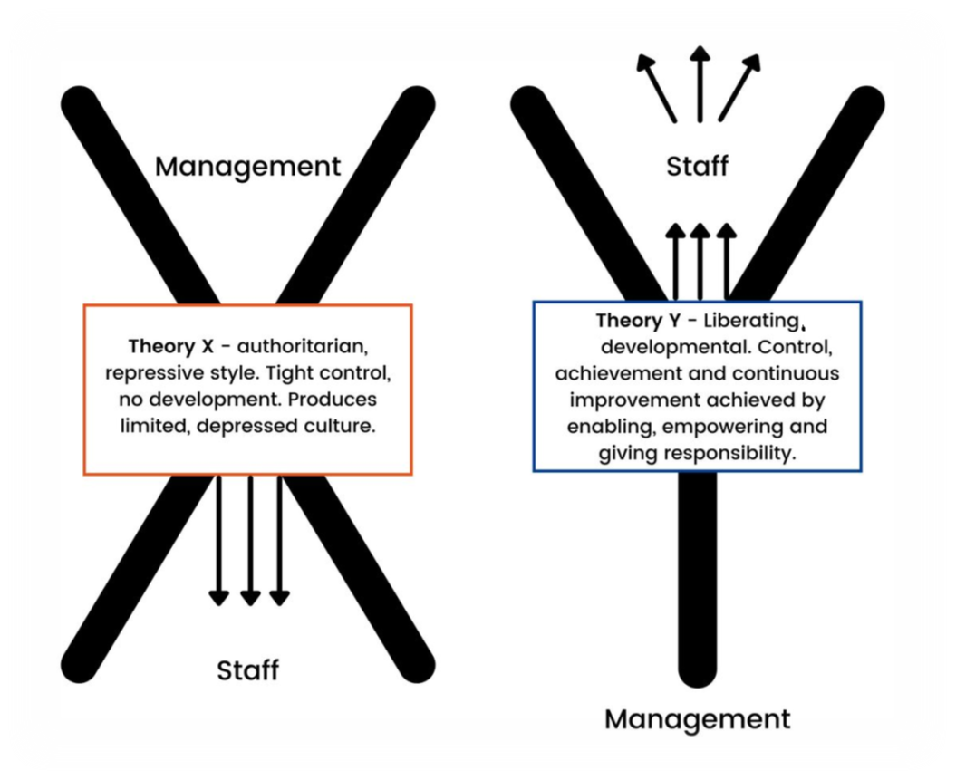
The McGregor X-Y theory, was created by Douglas McGregor in the 1960’s. This theory highlights two opposing theories that clarified how managers' perceptions of what motivates their workforce might impact their approach to management. ‘X’ being seen generally as negative, and ‘Y’ being seen as positive. ‘X’ managers believe that employees are passive, dislike their jobs, avoid responsibilities, and require direction. While ‘Y’ managers assuming they are creative, capable of problem-solving, and motivated by things like accomplishment, recognition, and personal development. They also don't necessarily detest their jobs. In looking at the strengths of this model, it promotes self-reflection among managers, which may result in more effective management that is suitable for the requirements of their team. It also gives managers flexibility by enabling them to implement Theory X or Theory Y ideas based on the circumstances. This allows for dynamic management styles that can adjust to changing employee requirements and organisational goals. Although Managers who assign employees to either X or Y may unintentionally "pigeonhole" them into these categories and make decisions based on that information. Also, theory founded on presumptions derived from industrialised Western viewpoints. may alter dramatically depending on the cultural setting, since managerial techniques and motives might differ. McGregor's theory relates to organisational culture, leadership style, and management practices.
It is evident from examining all four motivational theories that they differ from one another. Though they don't apply to everyone, I believe to properly comprehend and inspire people, good management usually requires blending components from several theories. From my personal experience, the McGregor’s X-Y theory is more relevant to my workplace. My manager is more of a ‘Y’ manager which motivates me. For instance, I took up a task that had accumulated significantly and hadn't been maintained. Because she had developed that interpersonal relationship, my manager understood that I would be the best person for this assignment. It took several months to complete, but the outcome was worthwhile. She not only acknowledged what I needed, but she also gave me credit my accomplishments. Considering that, my manager likewise can use the "X" theory when necessary. Another instance is that certain co-workers don't treat my manager with the respect she deserves as they don't think take her seriously. This is a result of her apparent over friendliness. Therefor I believe a well-balanced McGregor X-Y theory can work in many organisations.

What factors can affect motivation in the workplace?
There are many factors that can motivate and demotivate a person in the workplace.

Motivational Factors
- Work-life balance is extremely important. According to a recent review, improved work-life balance promotes life and family happiness in addition to job satisfaction, job performance, and organisational commitment. Additionally, stress-related outcomes including psychological distress, emotional exhaustion, anxiety, and depression are decreased by work-life balance. (Sirgy, 2002). In my experience, having a work-life balance and being able to do some remote working helps with my mental health. Having the opportunity to work remotely and from the comfort of my own home breaks up the hours of being in the office. Less distractions from surrounding noises and time to keep on top of house chores between tasks. Having the extra time to do this certainly helps with my stress levels.
- Relationships at work help with motivation. According to (Okello & Gilson, 2015), A review found that relationships built on trust in the workplace affect intrinsic motivation. In my experience, having good interpersonal relationships in the workplace help me feel motivated because it’s more fun when you understand people and build trust to support each other. When working with employees who aren’t friendly or rude, it has made me feel very anxious and demotivated.
- Job Satisfaction is another motivator. This is supported by (Paais & Pattiruhu, 2020), who said social connections inside the workplace, including intrinsic and extrinsic motivators, the standard of supervision, and an individual's performance at work all have an impact on their degree of job satisfaction. It is thought that when people are very satisfied with their jobs and are well-motivated and feel devoted to the company, they are more likely to act in ways that contribute to the success of the business. I

Demotivational Factors.
- According to (Khera, 2018), a hostile or toxic work environment is another major demotivating aspect in an organisation. This has proven to be a strong demotivator for me. I used to work in a toxic workplace, which made me feel anxious and stressed which made me reluctant to go to work.
- Feeling unappreciated is another demotivational factor. According to a recent survey Respondents were requested to list up to three factors, the most often mentioned demotivating cause was inadequate compensation. (Wajda & Janus, 2020). For me, one of the biggest demotivators has been not feeling valued for my efforts and accomplishments. when another employee claimed my work and it wasn't acknowledged as my own. This happened on several occasions, causing me to leave my job.

Conflict in the workplace
Within organisational life, conflict is inevitable and common. described as the perception of differences in compatibility between two or more people. Employee performance generally suffers when there is conflict since it tends to make workers less happy and productive. As a result, it is often believed that conflict is detrimental for both companies and employees. (Kay & Skarlickib, 2020). There are several factors that can contribute towards workplace conflict, including Poor communication, misunderstandings, unclear expectations, poor management, unfair treatment, and different values or goals. For example, an employee at my workplace felt frustrated when the manager gave her extra workload that came from a different team. She felt the employees from that team were being lazy and were fully capable of completing this work themselves. She was very vocal about it whilst muttering and swearing under her breath and voicing her frustrations to other team members. This caused conflict between her and other employees which was brought to my managers attention. A meeting was called for a team discussion to voice concerns. This employee seemed to be very aggressive and annoyed. During the meeting, other employees’ feelings were discussed whilst the manager kept calm and made sure everyone was able to get their point across. She was able to defuse the conflict and explain why the work distributed was necessary. Such conflict can create negative emotions, stress, poor communications, lack of commitment to the teams’ goals and essentially poor decision making. The continuing behaviour of this employee caused me to take inappropriate sick leave due to stress and anxiety. The diagram below indicates the reality of conflict and the underlying issues that can cause conflict. As a manager I would ensure interpersonal relationships are built, understanding different cultures, and backgrounds of my employees. Building trust promotes cooperation and teamwork and is essential for effective leadership. Building trust requires openness, constancy, honesty, and transparency. Nonverbal clues, feedback, and team dynamics can all be used to gauge someone's degree of trust. It takes a leader who sets an example, honest communication, responsibility, and acknowledgment to establish and preserve confidence. This foundation will help towards dealing with conflict. I would comprehend the problem, find the underlying reason, and employ good communication techniques while actively listening to prevent conflict. In the process of identifying a solution that all parties can agree on, compromise, and teamwork are prioritised to produce a successful outcome. Ensuring a calm tone with formality and structure. Voice tone, facial expression, and body language all help convey a message more effectively. Vocalics, or extra-verbal communication, is the study of vocal (and occasionally non-vocal) messages in paralinguistics.

What you see The Event

What you get!
Perceptions
Attitudes Values Culture
Interests Gender Style
Communication Feelings
Needs Mood Expectations Assumptions Suspicions

Personal Communication (PDP)
In assessing my own communication, I have produced a Personal Development Plan see (Appendix A). To produce this, I created a questionnaire for feedback see (Appendix B). By doing this I found some factors in my communication which need improving. I have included these in the PDP.

References
Bakar, R. (2014). THE EFFECT OF LEARNING MOTIVATION ON STUDENT’S PRODUCTIVE COMPETENCIES IN VOCATIONAL HIGH SCHOOL, WEST SUMATRA. International Journal of Asian Social Science, 4(6), 722–732. http://repository.unp.ac.id/2518/1/ijass-2014-4%286%29-722-732%20%28Ramli%29%201.pdf
Chandler, D., & Munday, R. (2011). A Dictionary of Media and Communication . Oxford Reference . https://www.oxfordreference.com/display/10.1093/oi/authority.20110803100459436
Kay, A. A., & Skarlickib, D. P. (2020). Kay, A.A., & Skarlicki, D.P. (2020). Cultivating a conflict-positive workplace - How mindfulness facilitates constructive conflict management. OBHDP, 159, 8-20.pdf. Google Docs. https://drive.google.com/file/d/17-R1i_9ASvaaqE0XZFchkEexPYuEcw8A/view
Khera, S. (2018, February 28). The 4 Stages from Motivation to Demotivation. Training. https://trainingmag.com/the-4-stages-from-motivation-to-demotivation/
Legault, L. (2020, January 1). Intrinsic and Extrinsic Motivation. Https://Link.springer.com/Referenceworkentry/10.1007/978-3-319-24612-3_1139. https://www.researchgate.net/profile/Lisa-Legault/publication/311692691_Intrinsic_and_Extrinsic_Motivation/links/59d68704458515db19c4fd10/Intrinsic-and-Extrinsic-Motivation.pdf
Okello, D. R. O., & Gilson, L. (2015). Exploring the influence of trust relationships on motivation in the health sector: a systematic review. Human Resources for Health, 13(1). https://doi.org/10.1186/s12960-015-0007-5
Oudeyer , P.-Y., & Kaplan, F. (2007, November 2). What is intrinsic motivation? A typology of computational approaches. Frontiersin. https://www.frontiersin.org/articles/10.3389/neuro.12.006.2007/full?ref=jcbaillie.net
Paais, M., & Pattiruhu, J. R. (2020). Effect of motivation, leadership, and organizational culture on satisfaction and employee performance. The Journal of Asian Finance, Economics and Business, 7(8), 577–588. https://koreascience.kr/article/JAKO202026061031735.page
Page, M. (2019). The importance of good communication in the workplace. Michael Page. https://www.michaelpage.co.uk/advice/management-advice/development-and-retention/importance-good-communication-workplace
RAHAMAN, Md. A., ALI, Md. J., WAFIK, H. M. A., MAMOON, Z. R., & ISLAM, Md. M. (2020). What Factors Do Motivate Employees at the Workplace? Evidence from Service Organizations. The Journal of Asian Finance, Economics and Business, 7(12), 515–521. https://doi.org/10.13106/jafeb.2020.vol7.no12.515
Sirgy, M. J. (2002). The psychology of quality of life (Vol. 12). Dordrecht: Kluwer Academic Publishers.
Wajda, A., & Janus, E. (2020). Work motivating and demotivating factors in the perspective of occupational therapists. Advances in Rehabilitation, 34(3), 29–36. https://doi.org/10.5114/areh.2020.98642
Wikipedia Contributors. (2023, August 15). Source–Message–Channel–Receiver model of communication. Wikipedia; Wikimedia Foundation. https://en.wikipedia.org/wiki/Source%E2%80%93Message%E2%80%93Channel%E2%80%93Receiver_model_of_communication
Xie, Y., Al Imran, M., Yasin, B., Syed, A., Bin, S., Alsagoff, L., & Ang. (2022a). Multicultural Education an Overview of Stuart Hall’s Encoding and Decoding Theory with Film Communication. Multicultural Education, 8(1). https://doi.org/10.5281/zenodo.5894796
Xie, Y., Al Imran, M., Yasin, B., Syed, A., Bin, S., Alsagoff, L., & Ang. (2022b). Multicultural Education an Overview of Stuart Hall’s Encoding and Decoding Theory with Film Communication. Multicultural Education, 8(1). https://doi.org/10.5281/zenodo.5894796

Appendix A - Personal Development Plan

Personal Development Plan (SMART Based)
Developmental Areas | Desired Outcome | Actions I will take | Resources | Success Criteria | Target Date
Confidence | Being more confident in group discussions. | Prepare thoroughly. Initiate conversation with confidence and positive tone. Structure points. Stop comparing self to others. | Using headspace app, to help build positive mindfulness, decrease stress, and practice self love. Using Ted talks eg How to build your confidence -- and spark it in others | Brittany Packnett Cunningham | TED. Ask colleagues, family, and friends for feedback. | Being able to initiate conversations with confidence without being overly aggressive or passive. Feeling confident in myself and what I do. | 3 months
Active Listening | Engaging more in active listening. | I will practice active listening without interrupting. Being fully present in the in the conversation, paying full attention to the speaker. (noises). Showing interest by using body language and eye contact. | Ask colleagues, family and friends for feedback. Using active listening videos on youtube. Taking videos and self reflecting on body language. | Active listening and being present at all times. | 3 months
Story telling | Being able to use stories to illustrate points. To form a connection, builds trust, and motivate others. Captivate attention. Clarify complex ideas. To provide context and relevance. | Understanding my audience. Practice continuously. Prepare points and how to turn into stories. | Ask my tutor for advice on how she does her storytelling.  Use google to look for tips. Watch ideas.ted.com on storytelling tools. Practicing on family and friends. | Being able to story tell with confidence. | 6months
Clarity and Conciseness | Ensuring clear communication. | Prepare in advance. Practice being concise and to the point. Being efficient with clear language. | Ask for feedback from tutor and friends. Using Linkdin communication articles and training to develop. | Clarity and conciseness in my communication, being precise using good language. | 6 months

Appendix B – Personal Communication Questionnaire
My Communication Questionnaire

- On a scale of 1 to 10, how effectively do I convey my thoughts clearly and succinctly during verbal communication?
  - 1 (Very Ineffective) - 2 - 3 - 4 - 5 - 6 - 7 - 8 - 9 - 10 (Very Effective)
- How frequently do you find my tone of voice appropriate and conducive to constructive conversation?
  - 1 (Rarely) - 2 - 3 - 4 - 5 - 6 - 7 - 8 - 9 - 10 (Always)
- How often do I maintain good eye contact during our interactions?
  - 1 (Rarely) - 2 - 3 - 4 - 5 - 6 - 7 - 8 - 9 - 10 (Always)
- On a scale of 1 to 10, how well do I adapt my communication style to different audiences or situations?
  - 1 (Very Poorly) - 2 - 3 - 4 - 5 - 6 - 7 - 8 - 9 - 10 (Very Well)
- How would you rate my non-verbal cues, such as facial expressions and gestures, in aiding communication?
  - 1 (Very Poor) - 2 - 3 - 4 - 5 - 6 - 7 - 8 - 9 - 10 (Very Good)
- Can you recall a recent instance where my body language positively or negatively influenced our communication?
  - 1 (Strongly Negative) - 2 - 3 - 4 - 5 - 6 - 7 - 8 - 9 - 10 (Strongly Positive) - Not Applicable
- How easy do you find it to follow my explanations of complex ideas or concepts?
  - 1 (Very Difficult) - 2 - 3 - 4 - 5 - 6 - 7 - 8 - 9 - 10 (Very Easy)
- How well do I listen during conversations, making you feel heard and understood?
  - 1 (Very Poorly) - 2 - 3 - 4 - 5 - 6 - 7 - 8 - 9 - 10 (Very Well)
- Have you experienced instances where my communication style led to unintentional misunderstandings or conflicts?
  - 1 (Frequently) - 2 - 3 - 4 - 5 - 6 - 7 - 8 - 9 - 10 (Rarely)
- Overall, how would you rate my communication skills in the workplace or in social settings?
  - 1 (Very Poor) - 2 - 3 - 4 - 5 - 6 - 7 - 8 - 9 - 10 (Excellent)

