
jamie dorrell - 1802683 BMSP 4002 - Comtemporary management approaches



Introduction

For this assignment I am required to choose a company and assess them based on their management approach and organizational functions. Due to working with Debenhams, therefore having first hand experience with life in the workplace, I have chosen to assess them. But firstly, who are Debenhams?
Debenhams is a leading international multi-channel store, with over 241 stores in over 22 countries. Debenhams specializes in menswear, womenswear, home furniture, concessions, Food services and much more. In the UK, Debenhams has a top 5 market share in mens/womenswear, as well as a top 10 share in childrenswear and is the market leader in health and beauty, showing how Debenhams is very much a leader in its industry.

Management approach

Management theory shows 4 principle approaches:
- ‘Classical’
- Human Relations
- Systems
- Contingency

What management theory implies is that any business’ style of management can and will fall under one of these 4 branches. In this assignment, these will be discussed and compared in relation to how Debenhams is managed, from departmental level all the way to corporate level.

This analysis will focus primarily on The Food Services department of Debenhams Carmarthen, however, based on my experiences as an employee of Debenhams, this analysis is satisfactory for the entire company.

Debenhams Carmarthen

Having worked in Debenhams for over a year, Debenhams Carmarthen seemed the best place to start.

For the purposes of this analysis, the department of choice will be Food Services, having worked there recently.

The Food Services Department consists of 1 manager, 3 supervisors and 15 ‘Food Services Advisors’. Figure 1.1 will demonstrate this

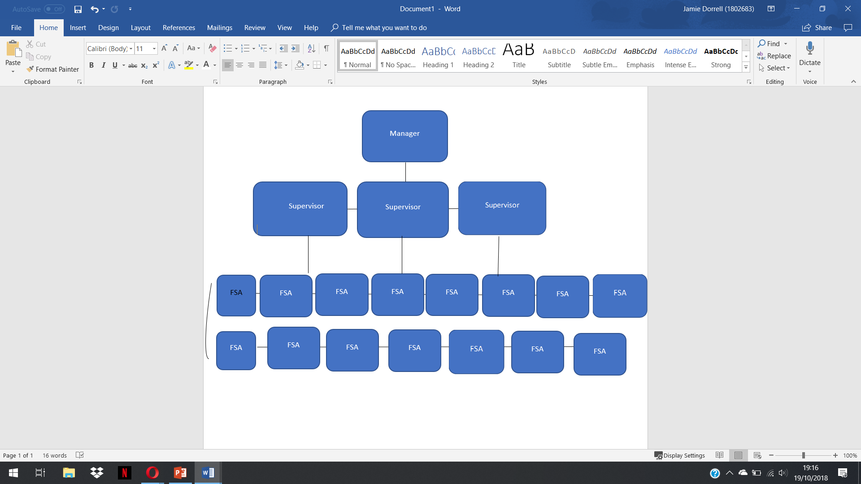

As one can see, there is a distinct scalar structure within this department, with the few dictating to the many, as is with most formal organizations. This is evidence to show that the
Management style for Debenhams is ‘classical’. And I would argue that this is how Debenhams is managed, at least at departmental level. Classical management describes an organization based on purpose and formal structure. Emphasized by:
planning of work,
the technical requirements of the organization,
principles of management,
assumption of rational and logical behavior.
Classical management theorists include writers as Taylor and Fayol. The most simplistic way of explaining the classical management approach is ‘Organization over People’, meaning that emphasis is placed on the structure more than the employees.

However, it is not enough to simply label this department as a classical management approach. This is due to there being two primary sub-categories within the classical approach, as listed below;

- Scientific management,
In 1909, Frederick Winslow Taylor published "The Principles of Scientific Management”, in which he proposed that through optimization and simplification of jobs, productivity would increase. This was implemented in the early 1900’s, and it could be argued that Taylor was correct. Take Henry Ford for example. He was a manufacturing pioneer, famous for installing the first automatic production line in 1913. He took Taylor’s theory of simplifying and optimizing factory jobs, and in doing so, created something that factories use to this day. He optimized the factory line, giving one person one job to focus on, thus creating a quick and efficient assembly line. Scientific management is highly effective, even L.J Mullins wrote that ‘It might be that the study of organizations is moving towards a more scientific approach’, signifying how important scientific management is, even 109 years after its conception

- Bureaucratic,
The ideas and principles of the classical writers were derived mainly from practical experience. Writers on bureaucracy, however, tend to take a more theoretical view. Weber, a German sociologist, showed particular concern for what he called ‘bureaucratic structures’, although his work in this area came almost as a side issue to his main study on power and authority. He suggested that ‘the decisive reason for the advance of bureaucratic organization has always been its purely technical superiority over any other form of organization’. Weber pointed out that the definition of tasks and responsibilities within the structure of management gave rise to a permanent administration and standardization of work procedures notwithstanding changes in the actual holders of office.

The management style of Debenhams food services department is bureaucratic. This is evident as the manager dictates solely to the employees. There is no two-way communication, therefore we can rule out Human Relations. Bureaucratic management is about power and authority, as explained by Weber. In Debenhams, the authority is consolidated, and, although there are 3 supervisors, showing a small handing down of power, the manager holds nearly all authority. Scientific management does not work here either as there is no optimization of jobs.

Organizational Structure

Debenhams is a private limited company or Ltd. This means that Debenhams operates in the private sector, the part of the national economy that is not under direct state control. These businesses are owned by shareholders. They answer to their owners or members. The main aim is profit.

There are ways of analyzing a business, the main two being using a SWOT, and PESTLE analysis.

SWOT

Strengths -
1. Strong Financial Performance
2. Strategic progression.
3. Developing channels through Partnership.
4. Strong digital Growth.

Weaknesses -
1. Dip in in-store sales.
2. Weak UK market adversely affecting Earnings.

Opportunities -
1. Prospective partnerships to increase market share.
2. Upcoming Restructuring Policies.

Threats -
1.Increasing costs may lead to shutting down of many stores.
2. Growing Competition.

PESTLE

Political -
1. Adverse impact on sales due to Brexit.
2. Positive impact of decrease in corporation tax.

Economic -
1. Hedging against Currency Fluctuations.
2. Prudent strategizing for inflationary situations.

Social -
1. Growing smartphone users globally to increase sales.
2. Keeping Pace with Changing Customer Demands.

Technological -
1. Constantly improvising in-store Technology.
2. Making more efficient mobile technology.

Legal -
1. Working Legal & regulatory bodies within organization.
2. Tweak in laws due to Brexit to affect sales.

Environmental -
1. Sustainable prices leading to decrease in CO2 emissions.
2. Increase in usage of efficient sources of energy.

These analyses show how Debenhams has many strengths, but also weaknesses and threats to match them. It also, when looking at the PESTLE analysis, illuminates how Debenhams’ presence has Political, Environmental, Social, Technological, Legal and Economic benefits on the local community and country.

Conflict & Stress

In the workplace, especially during busy environments, stress and conflict is prevalent. There are many causes for stress and conflicts, such as;
- Team members with a poor ethic.
- Overbearing manager.
- Job insecurity.
- Long hours.
- Heavy workload.
- Organizational changes.

These causes of stress, if not alleviated, cause conflict amongst team members, and it is important for managers to identify and combat these causes of stress. There is a plan to combat conflict in the workplace.
- Talk with employees to see if they have any issues.
- If there are any problems or a disagreement, identify them, and discuss them.
- Develop a plan to combat the conflict.
- Understand the relationship between the people in conflict.
- WIIFM (What’s in It for Me) - How will this affect/benefit you?

Having said this, managers also cause conflict at times, or at least make it worse, as stated by D. Boddy, when saying that ’Managers often say that they do not have enough time to do their job as well as they would like’. This shows how even managers can cause stress, therefore it is up to the employees at this point to understand how much the manager must do, and up their performance to help the manager, just as the manager should help employees by alleviating stress.

However, conflict and stress aren’t bad things, The Health and Safety Executive even says that ‘We all experience pressure regularly – it can motivate us to perform at our best’, and even Ghandi said this, saying ‘Honest disagreement is often a good sign of progress’ It helps to change and make things easier in the workplace. Townsend said this, saying how ‘A good manager doesn’t try to eliminate conflict; he tries to keep it from wasting the energies of his people… If you’re the boss and your people fight you openly when they think you’re wrong – that’s healthy. If your people fight each other openly in your presence for what they believe in – that’s healthy.’

Debenhams Carmarthen does have conflict at times, and the manager, supervisors do use this system when conflict arises. Therefore, Debenhams helps to relieve tension and conflict in the workplace.

Perception and communication

Communication is key in any organization. For example, Paul J. Meyer said “Communication - the human connection - is the key to personal and career success”. Meyer was a leader in the study of goal setting, motivation and personal and professional development, emphasizing the importance of this quote.

Perception is quite a complicated factor to consider, however, the quote by Meyer can be used with perception too. Perception is unique in the sense that no-one sees the same thing. Optical illusions are an excellent example of this, as shown in figures 2.1 through 2.2.

Look at figure 2.1. What do you see? A young woman or an older woman. The answer will surprise you.


The answer is down to your perception. Some people only see the old lady, some the young lady, and some see both. Another example of this is shown in figure 2.2. The middle circle on the left looks smaller than that on the right side, however they are the same size. This is an example of how visual perception is affected by different things, in this case, as the circles around the middle circle are different sizes, the perceived size of the middle circles are different.

Figure 2.2
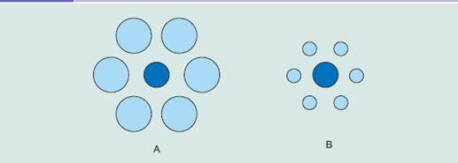

Perception not only stems from imagery, but from language itself. For example, if person 1 asks ‘Did you like that film?’ to person 2, who replies ‘It wasn’t bad’, person 1 may perceive that as person 2 liking the film, however person 3 could perceive this as person 2 not liking the film. This shows how language is interpreted differently by different people, signifying just how important it is to communicate with 100% transparency, especially in the workplace. Without transparent conversation, language pitfalls occur. A quotation by George Bernard Shaw, is: ‘England and America are two countries divided by a common language.’ The author gives numerous personal testimonies to this, for example ‘I am just going to the trunk (boot of the car) to get my purse (handbag), fanny bag (bum bag) and money wallet (purse).’
Robert McCrum, an English writer, gives examples of other conversational pitfalls:
Australia: talking negatively towards Aboriginal people
China: human rights; Tibet and Taiwan political issues
Far East: confusing Japanese, Chinese or Korean in any combination
Greece: South Cyprus asking for Turkish coffee
Looking at these two examples, it is evident that pitfalls are prevalent, and sometimes insulting. This is seen in day to day conversation. We all use slang in our language, and slang differs from region to region, for example;
Fag - Cigarette
Bap - Burger Bun
Even though the two words mean the same thing, the fact that there are two words can cause confusion in conversation. Another example is in the following case study.

A manager asks their team leaders to report on their team’s performance over the past year.

- Leader 1 sees this as reasonable and welcome. They are happy to provide information.

- Leader 2 sees this as unreasonable. They begrudge doing this
.
- Leader 3 has no objection to providing the information. However, they are suspicious.

The 3 leaders perceive the email communication differently based on their own experiences. Their perception and understanding of the situation invoke different reactions.

As shown above, it is important for a manager to have complete transparency when talking to employees. If not, employees may perceive managers in a different way than intended, meaning that tasks may not be done in the way a manager needs it to be done. Managers must be aware that their own body language creates a certain perception. For example, Kennett states how we take signals from our leaders. If managers are exhibiting signs of anxiety their body language, the employees will notice.

Motivation

Motivation in the workplace is very important. If your team members aren’t motivated, then workplace functionality is significantly reduced. There are 4 primary motivation theories, each of which give their own motivational theory.

Maslow
Maslow’s Hierarchy of Needs states the 5 stages of human needs;
- Physiological Needs
- Safety and security
- Love
- Self-esteem
- Self-actualization

The motivational theory states how needs lower down the triangle must be satisfied before one can fulfill needs higher up. This triangle has 5 levels, split into 3 sections: Basic needs, psychological needs and Self-fulfillment needs. Maslow stated how these needs are arranged hierarchically, saying;

"It is quite true that man lives by bread alone — when there is no bread. But what happens to man’s desires when there is plenty of bread and when his belly is chronically filled?
At once other (and “higher”) needs emerge and these, rather than physiological hungers, dominate the organism. And when these in turn are satisfied, again new (and still “higher”) needs emerge and so on. This is what we mean by saying that the basic human needs are organized into a hierarchy of relative prepotency" (Maslow, 1943, p. 375).

In business, the ‘hierarchy of needs’ is very important, for example, the basic needs of an employee are, for example:
- Friendly environment
- Fair pay,
- Praise,
- Promotion chances,
- Regular hours

These ‘basic’ needs must be met, and it’s a manager’s job to make sure they deliver these needs to their employees otherwise workers will not even want to work there. Even if these basic needs are met, however, there are still other needs that must be met. It is important that each stage is met before attempting to progress to the next stage. Progress is disrupted by not meeting lower level needs. Often, changes in life such as a divorce or job loss may cause someone to fluctuate between levels of the hierarchy. Thus, it is up to the manager to make sure that employees can achieve these needs, from basic, all the way to self-fulfillment, although an employee must make most of the effort at this final stage.

Elton Mayo

Mayo theorized that the employee performance is affected by their surroundings and the people with whom they work, saying “What social and industrial research has not realized as yet is that… minor irrationalities of the “average normal” person is cumulative in their effect. They may not cause “breakdown” in the individual, but they do cause “breakdown” in the industry.”
In the late 1920’s, Mayo conducted experiments with six female workers, referred to as the Hawthorne experiments.

How?
Mayo’s team changed the workers’ working conditions and monitored how these changes affected the workers morale and productivity. These changes included:
changes to working hours,
breaks,
Lighting,
humidity,
temperature.

Results
n. As expected, morale and productivity rose during the experiments, yet after the experiment, without supervision, these levels dropped to their original state.

Now, although the working conditions reverted after the experiment, it is important to note that initially, Elton Mayo’s theory was correct, and that with the right physiological changes, conditions can improve, and efficiency can be increased. The only thing needed is to ensure that these changes are held after implementation. This is where a manager comes in, making sure that they keep working conditions at an optimal state, thus increasing efficiency.

From my personal experience, this is an area that Debenhams lacks in, as through looking at employee reviews, their satisfaction rates are not high. Although it is true that staff receive a 20% discount in store, but this is the only motivational idea they have. I know this from my personal experience also. The managers do not interact on the ground level, as well as not lacking on some of the most basic needs addressed by Maslow.

Conclusion

Debenhams are not a bad company, as mentioned earlier, Debenhams are a top 5 in their market, globally. They are a private limited company; therefore, they must adhere to the shareholders. Their SWOT and PESTLE Analyses show how Debenhams does benefit the community.
Debenhams’ management is that of a bureaucratic style, with a scalar hierarchy, with 1 manager, 3 supervisors, 15 employees.
Debenhams does have ways to combat stress, such talking to employees and resolving stress, and treating conflict in a way comparable to Gandhi. Whilst it’s true that there is conflict in the workplace, the same could be said of any workplace, it’s how one deals with it that’s important, and the manager of the food services department of Debenhams deals with stress and conflict well.
The only weakness Debenhams is their motivation. As written earlier, the only motivational scheme used is a 20% discount. When talking to staff, the manager does not help to motivate staff, a massive flaw in its management. Overall, Debenhams is not badly run, quite the opposite, the only thing it lacks is more motivation of staff.

Bibliography

Taylor, F. (1911). The Principles of Scientific Management. New York: Harper & Brothers.

Maslow, A. (1943). A Theory of Human Motivation. Lanham: Dancing Unicorn Books.

Esar, E. (1951). The treasury of humorous quotations. London: Phoenix House.

Gandhi, & Sinha, S. (2002). Words of wisdom from Mahatma Gandhi. Edmonton, Alta.: SKS Pub.

Townsend, R. and Bennis, W. (2007). Up the organization. San Francisco, Calif.: Jossey-Bass.

Kennett-Hensel, P. (2009). Developing sustainable tourism: managers' assessment of Jamaica's ten‐year master plan. New Orleans.

McCrum, R. (2011). Globish. London: Penguin Books.

Karmakar, A. (2012). Principles and Practices of Management and Business Communication. 1st ed. Pearson,

Weber, M. (2015). PROTESTANT ETHIC AND THE SPIRIT OF CAPITALISM. [S.l.]: Skyros Publishing.

Health and Safety Executive (2018). Working together to reduce stress at work. [online] Health and Safety Executive. Available at: http://www.hse.gov.uk/pubns/indg424.pdf [Accessed 12 Nov. 2018].

Mullins, L.J. (2016). Management and Organizational Behavior. 11th edn. Harlow: Pearson

Boddy, D. (2014.) Management: an Introduction. 6th edn. Harlow: Pearson.

