Name– Morgan Westlake
Student No – 0452528
Level 7 Dissertation – BMMB7003 2024-2025
University – University of Wales Trinity St Davids
Topic: Can Electrified Micro-mobility (EMM) positively impact social mobility in Swansea, by improving access to employment and education?
Date of Submission: 12/12/2025
Declaration/Statements page

DECLARATION

This work has not previously been accepted in substance for any degree and is not being concurrently submitted in candidature for any degree.


Signed ...................................................................... (candidate)
Date ......... ...............................................................

STATEMENT 1

This work is the result of my own investigations, except where otherwise stated.

Other sources are acknowledged by footnotes giving explicit references. A bibliography is appended.

Signed ..................................................................... (candidate)
Date ........................................................................

STATEMENT 2

I hereby give consent for my work, if accepted, to be available for photocopying and for inter-library loan, and for the title and summary to be made available to outside organisations.

Signed ..................................................................... (candidate)
Date ........................................................................

NB: Candidates on whose behalf a bar on access has been approved by the University (see Note 1), should use the following version of Statement 2:

I hereby give consent for my work, if accepted, to be available for photocopying and for inter-library loans after expiry of a bar on access approved by the University.

Signed ..................................................................... (candidate)
Date ........................................................................
Candidate’s signature ..................................................... Date .........................................

Contents
Executive Summary 5
1 – Introduction 6
  - – Background and context 6
  - – Research problem and rationale 7
  - – Research aims and objectives 8
  - – Overview of literature review 8
  - – Overview of Methodology 9
  - - Overview of Data Analysis 9
  - - Overview of Conclusion and Recommendations 10
2 – Literature Review 11
2.1 – Introduction to chapter 11
2.2 - Electrified micro-mobility (EMM) defined 11
2.3 - Electrified Micro-mobility infrastructure as a blended transport system 12
2.4 - E-bikes and their position as part of Electrified Micro-mobility 12
2.5 - E-scooters and their position as part of Electrified Micro-mobility 13
2.6 - Impacts of EMM (Electrified Micro Mobility) on EU Cities 15
2.7 – Social mobility defined 17
2.8 - Social mobility in Swansea 20
3 – Methodology 22
3.1 – Introduction to chapter 22
3.2 - Research philosophy 23
3.3 - Research approach 23
3.4 - Research strategy 24
3.4.1 - Survey design 25
3.5 - Sampling strategy 25
3.6 - Data collection 26
3.6.1 - Primary data collection 26
3.6.2 - Data management 27
3.7 - Validity, Reliability, and Credibility 27
3.7.1 – Validity 27
3.7.2 – Reliability 27
3.7.3 - Credibility and Triangulation 28
3.8 - Ethical considerations 28
3.9 - Limitations of methodology 28
4 - Data Analysis and Findings 30
4.1 – Introduction 30
4.2 - Quantitative analysis 30
4.3 - Qualitative analysis of quantitative data 30
4.4 - Key findings in relation to research questions 31
5 – Conclusion and recommendations 46
5.1 – Introduction 46
5.2 - Key findings 46
5.3 - Conclusions of both primary and secondary research 46
5.3.1 - Travel habits 46
5.3.2 - Blended travel using public transport 47
5.3.3 - Demographics & safety 47
5.3.4 - Infrastructure and legal 48
5.3.5 – Cost 48
5.3.6 - Limited exposure to EMM and lack of existing cycling heritage 49
5.3.7 – Does EMM improve access to employment 49
5.4 – Discussion and recommendations 50
6 – Appendixes 52-57

7 – Bibliography 59-70

Executive Summary
This dissertation examines the feasibility and social value of Electrified Micro-Mobility (EMM) in Swansea, a mid-sized UK city characterised by high car dependency, fragmented cycling infrastructure, and apparent transport poverty. European cities such as Paris, Copenhagen, and Berlin have demonstrated that EMM can reduce congestion, enhance multimodal transport connectivity, and improve access to employment and education. The UK remains constrained by inconsistent regulation, limited cultural acceptance, and infrastructural deficits. Against this environment, the study investigates whether EMM could serve as an additional transport alternative in Swansea by assessing its potential to improve social mobility, particularly for residents in deprived areas with limited access to public transport.
By adopting a positivist, deductive research design, the study collected quantitative survey data on travel behaviours, perceptions of EMM, and willingness to adopt new mobility modes. The findings reveal strong theoretical suitability for Electric Micro-mobility most journeys fall within the optimal 1-3-mile range, yet significant barriers remain. These include pronounced safety concerns among women, limited prior exposure to EMM, low willingness to pay, and a persistent preference for private car use even for short trips. The dissertation concludes that while EMM could meaningfully enhance access to employment and education, realising these benefits will require infrastructure-first investment, coordinated multimodal integration, culturally targeted pilots, and pricing models sensitive to local economic conditions.
Chapter 1: Introduction
1.1 Background and Context
Modern urban mobility has seen radical changes in the last two decades. Many cities across the globe have seen significant changes as governments, environmentalists and citizens respond to increased travel congestion, environmental changes, and improved commuter preferences. Populations globally are continuing to increase, and existing infrastructure is crumbling under demand. Where possible urban environments are looking towards Electric Micro-Mobility (EMM) including shared service e-scooters, e-bikes and e-cargo as a means of providing cost effective, flexible, efficient and perceivably environmentally sustainable for transport. EMM has now gained popularity as an alternative solution for the “first and last mile” problem, associated with public transport, and private transport to an extent. Furthermore, EMM is seen as a vital enhancement to accessing employment, education, and other services. When public transport in urban environments is disjointed, inefficient, rigid and costly, EMM appears to be a solution that satisfies many issues and improves the user experience.
Paris, Copenhagen, Berlin, and Stockholm have already integrated large-scale EMM schemes, supported by protected cycle lanes, multimodal transport hubs, and clear use guidelines and regulation. The success of these implementations demonstrates improved accessibility, reduced travel times, and increased mobility for low-income populations (Buehler & Hamre, 2015). Micro-mobility has also become rooted into urban development strategies, by supporting labour markets, widening the catchment areas for employment opportunities (IAA Mobility, 2024).
Despite these successes, EMM adoption in the UK remains fragmented and heavily dependent on the quality of local infrastructure, cultural acceptance, affordable pricing models, weather climate, and regulation. As the is no official legislation change in the UK for e-scooters, Schemes in cities such as Bristol, Milton Keynes, and London exist as ‘trial schemes’ and will so until major changes in the law are made (DfT, 2022). Swansea, the focus of this dissertation, demonstrates many of these national challenges. Despite being Wales’s second-largest city (Swansea Council, 2020), Swansea exhibits high car dependency, limited protected cycling infrastructure, and a dispersed urban geography that has not historically supported alternatives to personal car or public bus use. With 52% of residents travelling to work or study by car (West of England Combined Authority, 2023). and a general proportion of people commuting distances over 15 miles (Sherriff et al., 2022), the city faces structural barriers to EMM adoption. At the same time, Swansea has an urban core and inner-suburb footprint in which from the primary research and understanding of the urban topography, 1-3-mile journeys are common. This mirrors the conditions for which EMM can be, efficient and effective.
For EMM schemes to work effectively, operators and local councils need to work in partnership to ensure effective funding, support and implementation is carried out correctly (LEVA-EU, 2025). As Swansea Council explores strategies to improve transportation, reduce congestion, and stimulate urban regeneration, EMM has emerged as a potentially viable concept. However, no comprehensive research has yet examined this feasibility, likely uptake, social mobility impact, or cultural acceptance of EMM in the City and County of Swansea as a region. This dissertation aims to address this gap.

1.2 Research Problem and Rationale
While interest in EMM is growing in the UK, its potential in smaller cities such as Swansea remains under-explored. The existing research and case study is mainly dominated by the larger, more mature European cities, thus making direct comparisons to Swansea quite challenging for the researcher. Therefore, policy discussions and investment decisions are also at risk of being decided upon assumptions and guesswork.
The central research problem informing this dissertation is therefore: Can Electrified Micro-mobility (EMM) positively impact social mobility in Swansea, by improving access to employment and education?
To what extent is Electric Micro-Mobility (EMM) a viable and socially beneficial transport alternative in Swansea, and what factors would influence its adoption? This research also aims to explore how EMM could enhance social mobility by improving access to employment, education, and essential services for residents, especially in under privileged areas. The underlying problem is composed of several issues identified in both UK and European literature. These include infrastructure limitations, safety concerns, cost barriers, and varying levels of public awareness and cultural acceptance, all of which may influence both uptake and the potential for EMM to support access to opportunities:
- Infrastructure capabilities: Where existing infrastructure is possible to adapt, successful EMM scheme routes still require additional protection, docking hubs and charging facilities, clear designated parking, and clear consistent planning for both users and non-users. Swansea currently lacks infrastructure to support this adoption which questions whether investment could deliver to expectation.
- Cultural acceptance and general perceptions: Evidence suggests that women, older adults, and less-capable riders express strong concerns about safety and legal clarity. Swansea’s demographic profile and historically low cycling culture amplify these concerns.
- Cost sensitivity: Since Swansea and its surrounding areas have seen impoverished times, pricing is also a determinant of adoption. Early evidence from Swansea shows a population highly sensitive to cost, with 42% unwilling to pay more than £20 per month.
- Transport poverty and social mobility: Swansea contains several areas, Townhill, Penlan, Blaen-y-Maes characterised by lower-than-average incomes, poor public transport, and limited access to employment. The potential role of EMM in reducing transport poverty has not been studied locally.
- Weather and topography: Swansea’s climate and hilly geography may present barriers that differ from those in cities with higher EMM uptake.
- Limited exposure: With 83% of Swansea residents having never used an EMM scheme, behavioural change may be slow.

1.3 Research Aim and Objectives
The aim of this dissertation is to evaluate the feasibility, potential benefits, and likely adoption of Electric Micro-Mobility in Swansea and to determine how an EMM scheme can positively support social mobility and employment access within the City and County of Swansea.
These objectives as follows:
    - Critically review the literature on EMM adoption, infrastructure requirements, regulatory frameworks, user behaviour, and socio-economic impacts in European and UK contexts.
    - Determine how social mobility as a concept can be positively influenced by the implementation of shared EMM services.
    - Examine residents’ travel behaviours, attitudes, and willingness to adopt EMM using primary quantitative survey data.
    - Analyse the alignment and contradictions between Swansea residents’ responses and established patterns in the literature.
    - Propose recommendations for the potential design, implementation, and optimisation of an EMM scheme in Swansea, based on empirical evidence and best practice.
    - Produce recommendations for how future investigations can be conducted to attain in depth strategic knowledge on developing EMM schemes for Swansea.
1.4 Overview of the Literature Review
1.4.1 Travel Behaviour and Short-Distance Mobility - Evidence indicates that EMM is most effective for distances of 1-3 miles, with typical European journeys averaging 1.8 km (6t-Bureau, 2025). These short trips often replace walking, public transport, or car commutes, contributing to reduced congestion and increased flexibility (Bretones et al., 2023).
1.4.2 Integration with Public Transport - Multi-modal integration consistently appears as a critical success factor. The literature suggests EMM can close last-mile gaps and broaden access to employment hubs, particularly when railway and bus interchanges host docking stations and charging infrastructure (Li, Gao, Zhao & Axhausen, 2024).
1.4.3 Gendered and Demographic Factors - Women continue to express greater concerns about safety, lighting, and infrastructure quality (Bean, Pojani and Corcoran, 2024). Older age groups show slower adoption but demonstrate meaningful uptake of e-bikes where infrastructure is robust.
1.4.4 Infrastructure Requirements - The literature emphasises that safe cycling lanes, physical docking controls, clear signage, and regulatory coherence must precede or coincide with scheme deployment. Without such infrastructure, uptake remains low (Kong, Chao, Liu & Chen, 2025).
1.4.5 Regulatory and Legal Considerations - Countries with clear legislation (e.g., Germany, Sweden, France) have experienced rapid adoption. In contrast, the UK’s regulatory environment has created uncertainty and halted cultural change (Driver and Vehicle Standards Agency Department for Transport, 2024).
1.4.6 Socio-Economic Impacts - EMM has been shown to improve urban mobility under the concept of social mobility. Access to employment has improved, particularly for low-income groups, reduces travel times, and contributes positively to individuals lives. Transport poverty is also a recurring theme in comparable European cases, and therefore not limited to the UK or Swansea in Isolation (Bambra, 2011).
1.4.7 Weather, Topography, and Cultural Factors - Climate suitability and historical cycling culture influence adoption patterns. Cities with harsh climates or weak cycling heritage typically require longer lead times and stronger policy intervention (Grant-Muller et al., 2023).
1.5 Overview of the Methodology - The primary research in the dissertation adopts a positivist philosophy and deductive approach, and a need to test established theories in a new contextual setting. The study employs a quantitative research design, using an online structured questionnaire distributed to Swansea residents.
This approach offers several advantages:
1. Permits measurement of attitudes, behaviours, and demographic variables at scale.
2. Aligns with existing EMM research, which frequently relies on survey-based methods.
3. Supports generalisability within the target population.
The survey collected data on travel habits, commuting distance, current mode of transport, perceptions of EMM, willingness to pay, safety attitudes, and socio-demographic characteristics. Data was analysed using descriptive statistics, cross-tabulations, and thematic interpretation.
1.6 Overview of the Data Analysis
The analysis gives several important findings:
- Demand Potential: While strong interest in EMM exists, opinions are divided, and willingness-to-pay remains low.
- Demographic Differences: Women expressed significantly higher safety concerns, while men prioritised convenience and cost.
- Travel Patterns: A large proportion of residents undertake short daily journeys ideal for micro-mobility, though a significant share still rely on cars for very short trips.
- Public Transport Users are Early Adopters: Those already using public transport showed higher openness to EMM adoption.
- Cost Sensitivity: Almost one-third were unwilling to pay anything, and 42% would not exceed £20 per month.
- Infrastructure Expectations: 85% believed that safe infrastructure would significantly increase responsible usage, yet Swansea lacks the infrastructure to support these expectations.
- Limited Exposure: With 83% never having used EMM, public perception is shaped more by abstract attitudes than lived experience.
1.7 Overview of the Conclusions
The conclusions synthesise primary and secondary research, identifying the following overarching themes:
- Swansea has a latent demand for EMM but lacks infrastructure, cultural readiness, and regulatory clarity.
- Travel patterns strongly align with typical micro-mobility use cases.
- Public transport integration and targeted promotion to younger commuters, students, and regular bus users offer the highest potential for early adoption.
- Safety, particularly for women, is a critical determinant of uptake and must be addressed through infrastructure and design.
- EMM could meaningfully enhance access to employment, particularly in deprived areas where transport poverty persists.
- However, low willingness to pay presents investment challenges that must be mitigated through subsidies, staged deployment, or blended pricing models.
1.8 Overview of the Recommendations
Drawing on the research findings, the dissertation provides strategic recommendations for policymakers and potential EMM operators, including:
- A staged infrastructure-first approach, prioritising protected routes along core commuting corridors.
- Multimodal integration, with docking stations at train stations, bus interchanges, and park-and-ride sites.
- Targeted pilot trials, focusing on students and public transport users to build awareness and behavioural familiarity.
- Formal partnerships between Swansea Council, public transport operators, employers, and an EMM provider to co-ordinate investment and implementation.
- Pricing strategies aligned with local cost sensitivities while ensuring commercial viability.
- Strategic deployment in deprived neighbourhoods, supporting access to employment and social mobility.
- How next stages of research could be conducted to further investigate the initiation and integration of EMM in a city like Swansea.

Chapter 2: Literature Review
2.1 - Introduction
In this chapter, the researcher reviews the literature on Electrified Micro-Mobility (EMM) and its influence on social mobility. The discussion covers the definition and evolution of EMM, as well as how e-bikes and e-scooters have been integrated into UK and European urban transport systems. The researcher examines how customer demand and shared mobility operators have shaped the incorporation of these modes into existing city infrastructure. The chapter also considers how EMM offers faster, more affordable, and flexible access to employment, education, and essential services, thereby reducing travel barriers and enhancing employment opportunities for individuals across different socioeconomic groups.
2.2 - Electrified micro-mobility (EMM) defined
Since the early 2000s, traditional forms of manual micromobility such as bicycles, scooters, and cargo bikes have been transformed through the integration of electric motors. (Pettersson & Johansson, 2022). These adaptations have provided a significant boost in performance and helped shape the rise of electrified micromobility (EMM). Since 2015, EMM has grown in popularity at an exponential rate (Gössling, 2020). Advances in technology, have enhanced performance, reliability, accessibility, and influenced legislation, infrastructure, and even safety (von Pape et al., 2024). The popularity of EMM has also come from the perceived benefits of improved social mobility, lower carbon emissions, lower congestion and improved air quality (Shaheen & Cohen, 2019).
The European EMM market is mainly made up of 3 segments, 90% E-scooters (See Image 1), 9.5% e-bikes (See image 2) and 0.5% consisting of electric cargo bikes (See image 4) and others (Mondesir, 2024). Of the two largest segments, the European EMM market for bikes and scooters have very different stories attached to their success in growth. (Pettersson & Johansson, 2022). In Europe, users either own or short-term hire them using web-based apps that charge users by time or by distance (Musa, 2025). Where longer term trials have existed, additional methods such four wheeled cargo bikes that have large item capacity, that can be transported as part of a courier service have become more popular (Sherriff et al., 2022).
Image 1 Image 2 Image 3 Image 4
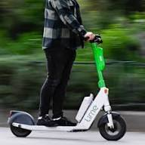 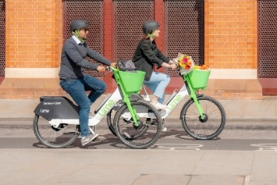 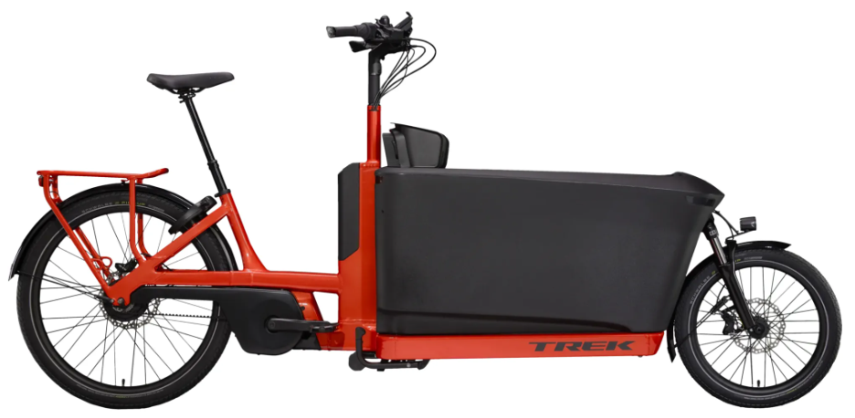 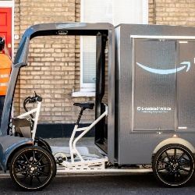

2.3 - Electrified Micro-mobility infrastructure as a blended transport system
As part of the Integration of EMM in European cities, the infrastructure has needed to change and adopt the existing system for a more blended approach to transport. Bus lanes have inherited cyclists, and cycle lanes have naturally inherited e-scooters and e-bikes (Li, Gao, Zhao & Axhausen, 2024). In studies by the Journal of transport, findings have suggested that the most successful integration of EMM services in urbanised areas have predominantly been alongside existing bicycle infrastructure, (Kong, Chao, Liu & Chen, 2025). There is also debate that while investment of cycle and EMM infrastructure is concentrated within city centres, the investment should also extend to sub-urbanised areas. Studies of docked and dockless e-bikes found that 50% of people discontinued their use mainly because the services were focused around users in city centres, and not for people travelling to and from city centres (Fishman, 2016).
Table as follows compiled from multiple sources
2.4 – E-bikes and their position as part of Electrified Micro-mobility
Electrified bikes were designed as an adaptation to the modern bicycle that encourages ease of use with power assisted pedal technology. This means that the user needs to pedal the bike to activate the electric onboard motor. Once the user stops pedalling, the bike will disengage the motor (Shah et al., 2021). The technology of EMM has been continuously developed where it has increased in power, run-time and has also reduced in price, making it more accessible to a greater number of users (Buehler & Hamre, 2015). The electric bike market in Europe extends far beyond options for simply commuting. There is an enormous and continuously growing market for mountain, gravel, and pleasure riding for elderly and physically impaired (Musa, 2025). The European transport safety council claimed that in a study of e-bike users in the Netherlands, around half of all the e-bike miles covered were by those aged 65+. What was more surprising was that 63% of the users were 75+ years old (Carson et al., 2023, p. 9). In addition, much larger cargo bikes have been developed to transport food, groceries, large and heavy items, and even children (see image 3). While the popularity of cargo bikes is increasing, models are either privately purchased or acquired by private fleet for courier service providers (Ponchon, Rérat & Tillo, 2024).
Many European cities have invested in operator fleets of pure pedal bikes that are available for short term hire, over a defined limited geographical area (Appendix 1). Users can access these bikes as part of a pay-as-you-go system, usually app-based (Musa, 2025). The strong uptake of shared micromobility has led to bike fleets being replaced by e-bikes and e-scooters. In cities such as Bristol, contracts have been renewed or taken over by operators including Lime, Voi, and Nextbike (West of England Combined Authority Committee, 2024). PBSC Urban Solutions is among the largest e-bike operators, with around 8,000 bikes deployed across several cities, including 500 e-bikes operating under the Santander Cycles scheme in London (Pinheiro, 2023). The success of e-bike adoption across Europe is largely due to minimal changes to road infrastructure are required to integrate these vehicles into existing urban environments (Grant-Muller et al., 2023). Long term vision of councils such as Cardiff have committed to replace and increase their current Nextbike fleets with new E-bike fleets in 2026, a decision that was made seven years previously in 2019 (Everett, 2019).
International Journal of Sustainable Transport interviewed e-bike users in the city of Bristol around their use of EMM. The study found that only 30% of users were female, 78% of users were 41 years+ and were mainly using their e-bikes as a form of transport for exercise, enhanced riding distance, hill climbing and carrying items due to aging physical ability (Melia & Bartle, 2021). In a separate survey at Bristol, e-scooter users were surveyed and found that only 22% of users were 41 years+, similar gender split at 34%, female, and predominantly used them for pleasure riding (Grant-Muller et al., 2023). In contrast to many other studies, research from three major European cities, Manchester, Malmo and Utrecht found that 55% of users were female, the largest age groups were 18-29 and 30-39. The study also saw that the top travel reasons were employment and child transport (Buehler & Hamre, 2015). Other cities such as Osaka, Amsterdam and Munich see very high cycle usage by females (See Appendix 10), often in relation to existing infrastructure and cycling heritage of the region (Grant-Muller et al., 2023).
In Europe and the UK, E-bike users can either own or hire, yet many users choose to own them, likely due to cost and design preference (Tern Bicycles, 2025). In Germany 59% of e-bike users privately own them, while the other 41% hire as part of shared bike schemes. NIHR Open Research (2025) reports that ownership of e-bike in Bristol UK, was 45%. E-scooter ownership was similar at 40% (NIHR Open Research, 2025). Despite the popularity and cultural acceptance of e-bikes in Europe (Grant-Muller et al., 2023), it is estimated that e-bike use, still only contributes 10% of the EMM market for the EU (Mondesir, 2024). NIHR Open Research (2025) says that of those who do not own or use any form of EMM in Bristol, only 50% would be likely to use an e-bike and only 37% would use an e-scooter (NIHR Open Research, 2025).
2.5 - E-scooters and their position as part of Electrified Micro-mobility
E-scooters, the other major share of EMM originally came from the design of petrol-powered scooters in 1915, also known as the Autoped (See Image 5 and 6). Much later in the 1970’s came the modified, 2 stroke petrol engines (OnlineBicycleMuseum.co.uk, 2025). The global market for these petrol-powered scooters soon died out due to noise, maintenance, air pollution, and culturally perceived as a nuisance (TransportPolicy.net, 2002). In the UK this was also linked to legislation put in place by the driver standards agencies. (Driver and Vehicle Standards Agency Department for Transport, 2024).

Image 5 Image 6
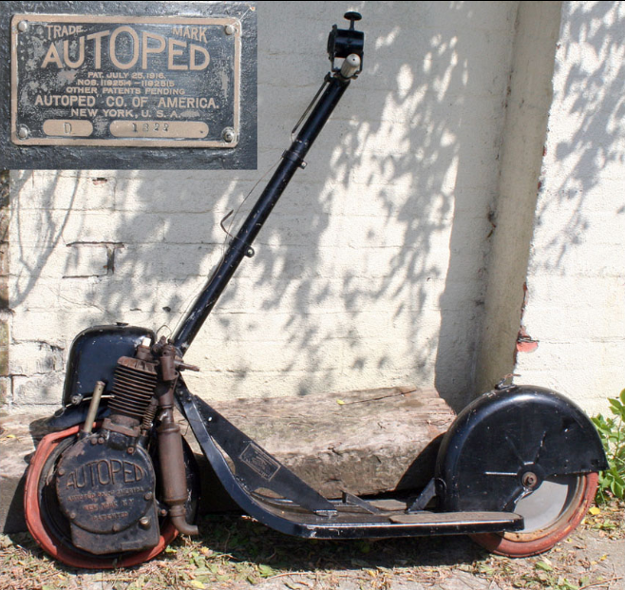 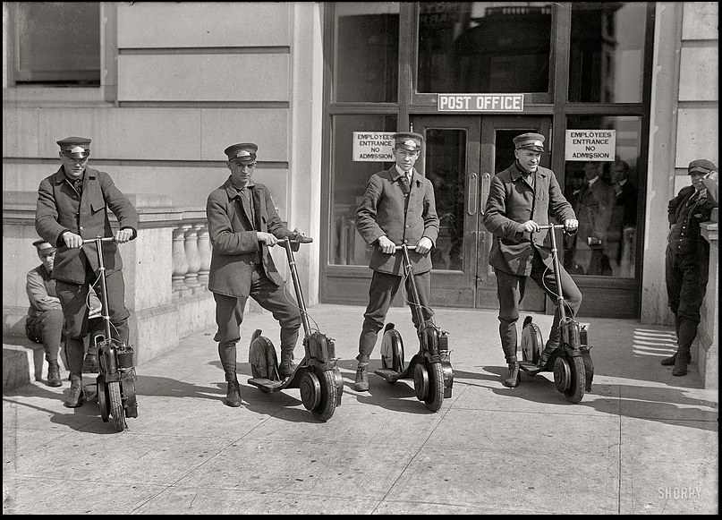
By the late 90’s manufacturers of Lithium-Ion batteries and electric motors had developed technology that was powerful, smaller and had much greater run time capacities (Grant-Muller et al., 2023). Naturally this technology has worked its way down to motorised mobility products (EUROBAT, 2024). This has led to the creation of the modern e-scooter, a sleek, compact electric scooter with regenerative brakes, LED lights, navigation system and enough power to transport the rider long distances (Xie & Hensher, 2020), (See Image 1). It is important to note that despite these EMM or LEV (Light electric vehicles) types, unless used under a temporary scheme operator, they remain illegal to use on public roads in the UK, thus significantly limiting their use (Driver and Vehicle Standards Agency Department for Transport, 2024).
When looking at the use of shared services of EMM schemes across Europe, it is mainly made up of e-scooters, with over 700,000 vehicles in operation (Mondesir, 2024). However, this number doesn’t factor in the use of privately owned e-scooters, whether used legally or illegally. Ownership of e-scooters is estimated at nearly 10 million users across Europe (Mondesir, 2024). Despite the enormous private ownership of EMM, personally owned micro mobility options doesn’t manage to capture much user data since the use of owned e-scooters is often untracked, and the distance covered is likely to be short, unsafe and irregular (Budnitz et al., 2025). Also, when it comes to the integration of e-scooters, the main challenges are around safe use, battery charging, cultural acceptability, life cycle, including the complexities of road infrastructural changes required, due to existing legislation in many countries (Buehler & Hamre, 2015).
In France in 2016, the number of privately owned e-scooters was around 101,700 vehicles. (European Transport Safety Council, 2024) Around this time, the French government allowed development of dedicated lanes in urbanised areas for both bicycles and e-scooters are part of their EMM directive (France, 2020). By 2021, e-scooter ownership in Europe had increased to an estimated 908,000 vehicles. However, in 2022 the ownership of personal scooters decreased by 16% even though e-scooter use increased (LEVA-EU, 2025). This is because shared e-scooter and e-bike schemes from several EMM operators came into effect where infrastructure was in place. This has continued to pave the way for rapid development in other European towns and cities. (Pinheiro, 2023). In comparison research carried out by NIHR open research indicated that Bristol’s success of integrating EMM came from adjusting legislation and infrastructure before implementation of trials (NIHR Open Research, 2025).
In Germany, personal ownership of e-scooters comprises of 45% of the market, the remaining 55% are users of shared schemes provided by VOI, Tier and Lime (LEVA-EU, 2025). In the same studies of German cities covering Copenhagen, Berlin, Munich, Hamburg and Cologne, some shared service use was as high as 84% (IAA Mobility, 2024). The trend of e-scooters and EMM in Germany was quickly sewn into the culture, and Germany made rapid provisions and nationalised their legality with clear standards for user criteria. (Nikiforiadis et al., 2021). Berlin already had excellent cycling infrastructure and an already positive cycling culture (Grant-Muller et al., 2023). In the UK, Rochdale Borough Council and Salford City Council have managed to integrate EMM by partnering with Lime, reporting 400,000 trips covering 700,000 miles since 2020 across the Salford area of Manchester (Greater Manchester Combined Authority, 2022).
For further reference to operators of E-scooters by city in the UK (See Appendix 1).
2.6 - Impacts of EMM (Electrified Micro Mobility) on EU Cities
In Europe, Paris is considered the first EU city to begin integrating electric scooters as part of its transport Infrastructure (de Bortoli & Christoforou, 2021). The infrastructure of Paris was already in a suitable state to begin minor alterations allowing more priority to bicycles, e-bikes and e-scooters (Wysling & Purves, 2022). The French government were quick to identify that changes were required to facilitate the rapid use of privately used and owned electric scooters. (Bozzi and Aguilera, 2021)
Soon several shared electric scooter operators were quick to capitalise on such a rapidly growing trend in EMM. E-scooters in Paris and other cities of Europe are considered part of a broad family of electrified and connected mobility services. According to NUMO (2020) by 2020, e-scooters were available for short term hire by various operators in 390 EU cities. Part of the success and appeal of using this method of travel is due to the instant availability of travel within a city. While there is limited data on trip distance per journey, it is estimated that internal EU city travel by EMM is around 1.8km or 15minutes. The rider culture considers this a distance too far for walking, and too short to hail a cab, or ride another method of transport. Since the operators created zones to pick up and drop off, the boom in e-scooter hire became exponential. (6t-Bureau De Recherche, 2025) Fast forwarding to April 2023, a Paris referendum was held where a 90% of the vote was to ban the operation of e-scooter hire. The residents of Paris were enraged about the littering, and poor behaviour of riders of e-scooters throughout the city. Since the referendum, privately owned e-scooters are allowed to be used. An almost complete contradiction to the culture and integration of e-scooter operators, legislation and culture to that of the UK.
It is anticipated that there will likely be a further increase of 5-10% in EMM use by 2030 (GRV 2025). When considering the positive impact of EMM on Europe, it is very difficult to define whether the use of EMM in cities will directly improve social mobility by looking at a single metric. From research carried out by the Journal of Urban health, it is likely that EMM will continue to reduce car dependency and therefore improve financial impact of transportation costs. It is reported that one of the top reasons for choosing EMM as a mode of transport is to reduce travel time and cost of public transport. Research according to Journal of Urban Health suggests that there is not yet enough data on the positive effects of EMM, especially the improvement of access to employment. (Bretones et al., 2023). Although a slightly biased view, ZAG Daily, the digital magazine for all things EMM claims that there are significant benefits to EMM across Europe. Musa (2025) states that EMM is a powerhouse of public value. E-bike sharing prevents 46,000 tons of CO₂ emissions, reduces 1,000 chronic diseases, and delivers 40Million EUR in healthcare savings across Europe. NIHR Open Research (2025) even suggests that 67% of users reported “no health concerns what so ever” (NIHR Open Research, 2025).
In a study of EMM for Bristol, VOI, the largest operator of shared e-micromobility (EMM) services in the UK operating across Bristol, Birmingham, Liverpool, Oxford, and Southampton a 2023 study found that users travelled 47% further than they would have by walking. The report also noted that 24% of low-income users began and ended their journeys in some of the country’s most deprived areas, and that 30% of all trips were made for commuting purposes. While VOI’s report may carry some bias, it nonetheless provides strong evidence that e-scooters have positively influenced users’ ability to access employment opportunities more easily (EV Powered, 2022). Although Manchester has created safe mobility networks across the city A high number of non-users still perceive the idea of EMM as “available” but not to them because of pathways to and from their place work (Sherriff et al., 2023). That said, other users claim that the use of EMM in Manchester has also extended the use of other services such as buses, trains & trams (Greater Manchester Combined Authority, 2022).
In a study conducted by Salford university, research discovered significant improvements for the users of e-scooters and e-bikes in access to employment and educational services. The research recognised that public sector, shift workers, were able to use e-scooters when public transport was unavailable or inconvenient at certain times of day. (Sherriff et al., 2022). Similarly, a 2022 Department for Transport evaluation of e-scooter trials across both Manchester and Bristol found that users reported better access to employment directly because of EMM availability (Robeyns, 2022). The survey, which included adults aged 16 to 55+, revealed that access to work improved by 20% (See Appendix 7), medical services by 11%, leisure activities by 48%, and essential shopping by 18%, all of which users said they would not have been able to access as easily without the ability to travel further and faster at a lower cost (Department for Transport, 2022). (See Appendix 7).
Similar studies of EU cities have found that multi-model transport modes can prove a stronger integration for e-bikes and e-scooters. Where a user may drive the first or longest part of the journey, the completion of the journey can be made by EMM, known as last-mile transport (Bretones et al., 2023). Some reduction of car dependency may prove beneficial (Buehler & Hamre, 2015; Diana & Mokhtarian, 2009). In a study of e-scooter costs across Manchester in the UK, Utrecht in the Netherlands and Malmo in Sweden. E-scooters were significantly less than that of other transport methods (Buehler & Hamre, 2015). In the same study, users were asked about how they felt they benefited from the use of EMM. The respondents noted that the main benefit was how it streamlined connections between public transport, (Buehler & Hamre, 2015; Diana & Mokhtarian, 2009). Elements of transportation often over-looked such as waiting time, walking time, and in and out of vehicle time. While these are greatly accepted by most people travelling by public transport, the experience and exposure to these issues while using EMM is potentially less (Limtanakool, 2006).
2.7 - Social mobility defined:
This section explores the concept of social mobility and how it is defined. Given that social mobility can be measured using a variety of indicators, the aim is to identify evidence that both supports and challenges contemporary theories of social mobility for EMM as a concept.
Social Mobility can be defined as “Changing positions in income and occupational status”. Economic mobility is usually the main category considered; however, occupation type, education, healthcare and wellbeing are other factors (OECD, 2018). It is considered that positive social mobility, not only helps the individual, but it creates well rounded economic and positive societal development (Fields, Gary S. 2019
Social mobility became formally identified as a concept in 1927 by the sociologist Pitrim Sorokin. His work “Social Mobility” identified individuals and groups that move both vertically and horizontally in a social hierarchy (Sorokin, 1927). In the research of WECA, although upward or downward mobility change is not recognised, lateral mobility change can be identified, as flexible work options, and have become available in conjunction with EMM to form part of flexible transport options (West of England Combined Authority, 2023). By the 1970’s the concept of social mobility considered other elements like occupation, intergenerational, individual, structural, absolute, horizontal and vertical, and Health mobility. The belief that people should be able to improve their lives by ability and effort and not defined by their birth or class (Goldthorpe, 1980). The modern vision of social mobility is broken down into 4 areas earning, occupation, education and health. (OECD, 2018). When examining the different areas of social mobility, it is important to cover and review many of the affecting elements. For example, income can be assessed on a Micro and macro analysis (Department for Transport, 2023).
Appendix – 13 -
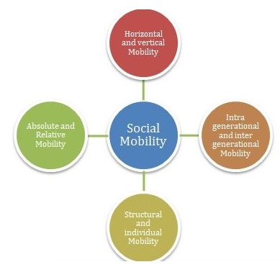
In 2023, the social mobility commission caried out research to explore the publics opinions of how aspects of social mobility have improved their lives. It indicates that having a better life than your parents mean being healthier (57%), happier (52%) and having a better education (44%), while income is an important factor it was not the focus for most participants of the survey. (Department for Transport, 2023). In relation to happiness, key findings from a report by the West of England combined Authority found that users of shared EMM trials said that while they appreciated the convenience of shorter travel times, they generally enjoyed the experience of EMM to that of travelling by car and felt much happier arriving at their destination (West of England Combined Authority, 2023).
Earnings of a person or group of people may be measured from a starting income. Micro income mobility analysis may consider specific changes that individuals have experienced as part of an income group, geographic location, gender and any other specifics (Fields 2001). When measuring income for social mobility at a macro level, the groupings or demographics of the data will often only show a basic Insights. Even at a micro level, the income data may be more specific, however the measurement still lacks detail (Smith, Fernández-Montalvo & White, 2005). To understand income figures better, it is also worth analysing it as residual income, as the difference between living costs and salary can further define a person or demographics financial status and buying power (Fields 2001).
Although income can be measured as a metric to indicate progress in social mobility as a whole, it is critical to also factor the possibility that previous income, can have a significant bearing on future income (Brunetti & Fiaschi, 2023). Another consideration to acknowledge, is how income data is affected by no mobility, and more mobility (Longley et al., 2021). If income data is reviewed over a set period at a macro level, is there a clear vertical, lateral, or zero mobility differential (Smith, Fernández-Montalvo & White, 2005). Research by Salford University indicates that users of shared EMM services had greater flexibility for travel and were able to use EMM as part of their work travel and did not need to use a car for their complete journey. This means that increased residual income improved their employment options due to lower travel expenses needed to obtain higher paying jobs (Sherriff et al., 2022). This benefit, therefore, creates lateral or horizontal work mobility, however it is difficult to measure against economic cycles (Fields, 2001).
Change can also come from much broader circumstances such as economic changes in a region or market affecting exchange, growth, transfer, and dispersion (Fields 2001). In contrast to this, since financial circumstances of groups and individuals is difficult to assess at a granular level. Financial analysts will say that the effect of social mobility is only assessed properly, when economic growth is removed from the calculation and is analysed over an extended period (Fields 2001).
The research document titled ’A Broken Social Elevator? How to Promote Social Mobility’ by OECD, the authors state that education should be considered the main priority for governments to create better overall social mobility. (OECD, 2018). However, the research data as per (Appendix 2) doesn’t always correlate education levels to income. Neither do the levels of health or occupation. Denmark, Sweden and Canada appear to have both high education and income levels, Korea, Japan, USA and China have high education status yet, medium to low income. Although this doesn’t appear to show correlation against income, the individual segments of mobility where governments of countries have invested shows clear positive improvements. Not all but most, (Appendix 2) show the positive improvement because of public spending on education by country since the 90’s. A 2020, review of educational mobility in the UK shows that overall, other countries where education received high investment, individuals achieved higher qualifications than their parents. This also correlated against other countries with public spending and their educational scoring. (Social Mobility Commission, 2020). Towns and cities in the UK & Europe that have seen substantial educational investment by their governments, have attracted EMM operators with successful integration and adoption (Dias et al., 2024).
Where EMM operators such as Lime and VOI have been critical in implementing improved services and infrastructure, university campuses in Manchester have seen greater numbers of students travelling to and from the campus by means of EMM. The research shows that these students have used EMM in addition to public transport and claim they were less likely to participate in their studies if EMM was not an available option (Sherriff et al., 2022). In the UK, ‘Absolute education mobility’ shows clear trends where people whose parents had degrees, were 64% more likely to have a degree themselves, than people whose parents had no university degree. Although this is not the full picture, it does indicate that generational education mobility has its inevitable outcomes (Social Mobility Commission, 2020
As a result of education the opportunity for a broader range of occupation types and levels increases (TASO, 2020). Although occupation usually tends to have a direct influence on income, this is not always the case. According to the 2018 report by the OECD, (See Appendix 4) countries such as Finland, Spain and Italy have low occupational scoring yet high-income scoring. (OECD, 2018). In isolation, class jobs in Finland can pay much higher than the equivalent in northern Europe. In both Spain and Italy class mobility is considered restrictive, however working for a family businesses can often achieve higher earnings and stability, than University graduates who could also be limited to occupational categories (Brunetti & Fiaschi, 2023). It is also considered that while some countries have perceived limited social mobility in terms of occupation, the level of income can relate back to the levels of residual income. In the case of high income and low occupation mobility, the residual income is often much higher. For those working in family business, expenses such as outgoings for travel, accommodation, eating and childcare is much lower, providing a high quality of life (Raitano & Vona, 2015).
Health mobility has gained much more coverage as a factor of social mobility. Beyond physical health, mental health and wellbeing features on of the main topics for assessing key metrics for social mobility (Currie & Stabile, 2003). By ensuring that mental health is addressed, employers and government are aiming to improve the public’s health mobility and social wellbeing by ensuring access to quality services for those that require it the most (OECD, 2021). Health mobility is not solely linked to access and services. Since Health can correlate to working environments and income, the OECD 2018 report suggests that low wages and low occupational score can also correlate with Low health rankings (See Appendix 3). The report suggests that Poland and Portugal may have low Health scoring, relating to lower occupational and income scores (OECD, 2018). It may also be that there has been insufficient expenditure on healthcare since the 90’s (TASO, 2020). In a study of riders of e-bikes in Portugal by the European Journal of Applied Physiology, there is strong evidence to support that users of e-bikes had saw improved general health, and enjoyed travelling to work (Alessio et al., 2024).
2.8 - Social mobility in Swansea
Swansea like many cities has a diverse historic aftermath from the industrial revolution. The scars from the demise of industrialisation have led to the outlying neighbouring areas being dependant on welfare subsidies and experience high unemployment throughout the last 50 years (Swansea Council, 2020). In terms of infrastructure, which is an important part of physical social mobility, or urban mobility (Currie & Stabile, 2003), existing train and tram lines and canal paths have been adopted for major road networks. (von Pape et al., 2024). Swansea introduced bus lanes in 1994 as a trial for giving priority of way to ease with congestion of traffic and allow for workers commuting by bus a faster more efficient service. (Evans and Withill, 1994, p. 83). By 2009, there were bus lanes running through the centre of Swansea to support commuters even better. (Evans and Withill, 2009). Despite improvements to social mobility, (Coach & Bus Weekly, 2025) the introduction of bus lanes sparked significant public concern. (The Best of Swansea, 2014). Since the integration of bus lanes in Swansea, there is no credible evidence to suggest that there a more users of buses, only that there are less buses, and improved efficiency of services and subsequent users such as Taxis and cyclists (Evans and Withill, 1994).
The areas of Townhill, Penlan, Blaen-y-maes and Bon-y-maen that were once the major catchment areas for workers, appear to be neglected, under resourced and underfunded (Williams and Doyle, 2016). The area of Town Hill has a mean average household income of around £31,700 (See Appendix 5) which is well below the national average (Reuters, 2025). Although income is a key factor influencing social mobility, access to quality education, healthcare, and supportive social environments are equally important (OECD, 2018). Areas such as Townhill, Penlan, Blaen-y-Maes, and Bon-y-maen fall within several LSOAs (Lower Layer Super Output Areas) that contribute to Swansea’s social mobility statistics (Welsh Government, 2023). These areas rank among the most deprived on the Welsh Index of Multiple Deprivation (See Appendix 6). Education outcomes in these areas are also significantly below the national average, which are considered critical for breaking cycles of intergenerational disadvantage (Social Mobility Commission, 2020).
Indicators for health, housing quality, transport, safety, environmental quality and social capital, also fall below national averages. Overcrowding, poor housing, and limited transport options contribute to persistent cycles of low living standards and restricted mobility (Bambra, 2011). In comparison, Mumbles and West Cross are relatively affluent areas however the average income for the area is less than that of the national average (Welsh Government, 2023). Due to gentrification of the area, lower incomes in Mumbles and Newton may restrict access to certain services and therefore isolate and push out the existing population (Sheppard & Pemberton, 2023). This also limits the intergenerational social mobility as younger people are likely to move out of the area due to housing affordability (Social Mobility Commission, 2020).
The other areas being Dunvant, Waunarlwdd, Gowerton, Llangyfelach, Clydach and Birchgrove are considered to have good schools, stable middle-income populations and affordable housing. Despite a reasonable standard of key factors assessing social mobility, public transport and infrastructure are limited and can be considered a major barrier for transport as an important element of social mobility in Swansea. Areas like Birchgrove, Clydach and Llangyfelach may see an upturn in many aspects of social mobility compared to the other regions of Swansea, however this can be due to proximity of motorway access and the reliance of commuters working either in Swansea, or much further away (Swansea City & County Council, 2015).
According to Swansea council’s own surveys, 88% Working residents of Swansea’s LSOA’s (Lower layer super output area) commute and work in the Swansea area. (Swansea City & County Council, 2015) In a comparative city like Bristol, 89% of the working residents of Bristol and its LSOA’s, commute and work in Bristol and its LSOA’s. (Opinion Research Services, 2015, p. 42) That same metric for Swansea’s neighbouring county borough of Neath & Port Talbot is much lower at 63% (Welsh Government, 2024). In relation to the topography of both Swansea and Bristol, both cities have a similar coastal plain, rivers, valleys, ridges and have average terrain heights of 70 meters and 55 meters respectfully (Topographic-map.com, 2025).
Chapter 3: Methodology
3.1 Introduction
The primary research looks at the links between electrified micro mobility and transport infrastructure and social mobility within the city of Swansea and or other applicable urbanised areas. The Methodology explains the philosophical status and research design, strategy data collection and analysis methods. Ethical considerations will also be considered to ensure that the primary and research is carried out appropriately.
The primary directive of the research is to find out whether electrified micro mobility can potentially improve individuals access to employment and or furthering their employment options. This may also be in the form of accessing education and training for furthering their employment options. The primary research in the form of a 12-question survey is intended to build upon the findings from the secondary research in the literature review. The aim is to understand if the introduction of electrified micro mobility into smaller cities and urbanised areas such as Swansea, will benefit users for additional employment.
This chapter follows the onion model of research by Saunders, Lewis and Thornhill (2019). This model is intended to be used to make sure that alignment avoiding crossover with philosophical personal assumptions and methodological choices are recorded and analysed correctly.
Figure 1: The Research Onion Model (adapted from Saunders et al., 2019) (Appendix 9)
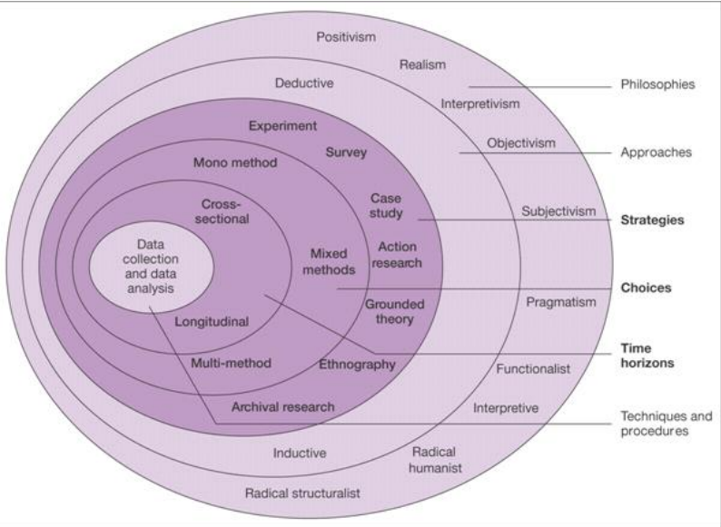
3.2 Research Philosophy
According to the Research Onion model, the outer layer represents research philosophies reflected by the researcher and the participants of the primary research, worldview and underlying assumptions, knowledge and reality (Bell and Walters, 2018). For the purpose of the primary research into people perceptions and usage, this perspective combines personal understanding and experience of the topic with the informed insights and interpretations of others (Gill and Johnson, 2010, p. 41). In this chapter, the researcher draws upon their own familiarity with the subject of EMM from the secondary research. While adopting a balanced and pragmatic stance primary research is undertaken and compiled objectively (Creswell, 2014; Saunders et al., 2019).
When Identifying trends and patterns, philosophies in the outer region of the onion model are based on subjective perceptions. This means that primary research can be dependent on criteria such as participants location and understanding. (Nikiforiadis et al., 2021). The pragmatic knowledge of how people’s opinions can impact positively or negatively, depends on an individuals applied understanding of real-world problems. Firsthand knowledge, misinformation and lies of a topic also creates multiple realities for one or many persons (Creswell and Plano Clark 2011). To understand the question at hand, subjectivism needs additional consideration as participants of primary research have their own truths about theirs and others objective reality (Babbie, 2014, p. 41).
By following the research onion model, the study adopts the pragmatic, subjectivist approach to identify the specific usage and individuals opinions by means of survey, experiment, case study, and possibly action research (Saunders, Lewis & Thornhill, 2019). The aim of the researcher is to avoid the elements of radical structuralist or radical humanist. What is known as the conflict paradigm is the philosophy that the researcher may become over interested in proving a personal theory, that it creates strong bias in the approach and design of the primary research (Babbie, 2014, p. 34).
3.3 Research Approach
By understanding elements of the philosophy layer, in Figure 1, and once a suitable collection of information from multiple sources is compiled, the researcher can be ‘deductive, inductive or abductive’ according to the layer inside of approaches (Saunders, Lewis & Thornhill, 2019).
The deductive approach can be used where the researcher has started with a theory or hypothesis. The secondary research conducted is used to suitably build and create questions that test, compare, contrast and develop the theories of both the researcher and the secondary research discovered in the literature review (Bryman, 2016). An inductive approach can be used where the researcher looks to develop new theories based on the secondary research. In this case the researcher uses only a deductive approach since the literature review has found continuous similarity throughout, therefore the primary research is an adaptation that is likely to create plausible, predictable evidence and repetitive concepts (Bryman & Bell, 2018).
From the secondary research in the literature review, there are key discoveries in Electrified Micro Mobility adoption, perception and integration. The Mobility Transition Theory (Schwanen et al., 2012) provides a critical foundation, suggesting that micro-mobility represents significant cultural shift from car-centric planning toward more human-scaled, environmentally friendly transport modes. Similarly, the Diffusion of Innovation Theory (Rogers, 2003) helps explain the rate and way new transport technologies like EMM contribute to different UK and European urban settings, influenced by social norms, infrastructure readiness, and perceived benefits.
Drawing on consistent and detailed evidence from urban environments comparable to Swansea, the researcher theorises how cities with similar topography, employment patterns, and infrastructure have successfully implemented comparable EMM systems and services (Creswell, 2014). Building on this deductive reasoning, the researcher formulates a hypothesis that comparable outcomes could be achieved in Swansea (Bell and Walters, 2018). This hypothesis stimulates the development of a symmetrical primary research strategy aimed at generating additional knowledge, first-hand evidence, and theoretical insight into how EMM in Swansea, may influence individuals’ access to employment opportunities through the lens of social mobility theory (Bretones et al., 2023).
Based on the secondary research and understanding of social mobility evidence, theory and models, the researcher pragmatically conducts primary research in the form of either experiment, interview and or survey (Bell, Bryman, & Harley, 2022, p. 390). In this case the survey is the most suitable option as data, patterns and sequences can be deducted from this primary research to form supporting, neutral or conflicting evidence to that of the secondary research in the literature review (Sukamolson, 2007). The researcher maintains that the purpose of the primary research is to explore, describe and explain (Babbie, 2014).
The primary research in the form of the survey should be conducted with a neutral direction of questioning (Babbie, 2014, p.123). The questions should be clear unambiguous to identify true opinions, behaviours of participants. The questions in the are designed to be clear and honest about the researcher’s direction of enquiry. E.g. “Do you think that e-bikes and e-scooters have a positive impact on city transport and accessibility?” This approach can be perceived with biased intent, and a constructivist view of the researcher (Bryman & Bell, 2018).

3.4 Research Strategy
With the philosophy and approach in mind, the researcher considers which method or strategy will best collect valid, reliable and credible evidence to test the theory or concepts found in the secondary evidence in the literature review (Saunders, Lewis & Thornhill, 2019).
Quantitative research has its benefits of mass, scale, reach and cost including analytical concepts and patterns that can be deducted (Creswell, 2014). The researcher understands that interpretivism and constructionism are also contradictory concepts that create additional bias (Bryman & Bell, 2018). The researcher is clear of the strategy and design in the knowledge that the constructionism view of the primary research design, must also consider the interpretivism of the participants (Babbie, 2014). See also limitations 3.9. This means that when creating the chosen method of survey, qualitative questions can be constructed with quantitative design. This means that qualitive analysis can be deducted from quantitative data and evidence (Bryman & Bell, 2018).
Qualitative strategy for primary research is a consideration as in-depth discussions with participants via an interview will bring valid, qualitative insights that are likely to be overlooked with a quantitative strategy (Bell and Waters, 2018, p. 220). The benefits of the interviews are that perceptions, interpretations, beliefs, feelings and evaluations can be drawn out from the participant, however answers can be inconsistent, limited, unmeasurable and evaluation can lack comparability (Cameron & Price, 2009, p. 364-373).
Based on this understanding, the chosen research strategy is quantitative, using a survey to collect measurable data that identifies relationships between electrified micro-mobility usage and access to employment opportunities.
3.4.1 Survey Design
In the research design stage the researcher needs to understand what they want to explore, discover, describe, and explain. The survey strategy is led with positivism and the survey design therefore is required to be reflective of the secondary research, to test by generating quantifiable primary data. (Bryman & Bell, 2018)
The researcher maintains the question, “What are the potential positive impacts of electrified micro-mobility, for a city like Swansea?” This question leads to survey design that must be ethical, measurable, reliable and credible (Babbie, 2014, p. 123)
In the first instance, the researcher obtains some of the key identifiers of the participant. While the primary research maintains participants anonymity it is important to identify key demographics and features of the respondents to cross examine the results in the analysis (Ziegenfuss, 2021). By capturing the basic demographics, additional data capture leads on to insights and further theory development and conceptualisation (Kozlovskyi et al., 2020).. Groupings of data, also known as dimensions, can compare fixed vs variable and variable vs variables to identify multi-dimensional concepts (Ruscio, 2008)
To create ease of completion the questions of the survey must be general and concise (Sociology.Institute, 2023). The initial questions of demographics are relatively fixed accurate questions. The survey then leads on to travel behaviour, attitudes toward EMM and affordability. These latter questions are constructed using Likert scale design (Babbie, 2014, p. 185-186). The boundaries of these answers are confined to “Strongly Agree”, “Agree”, “Neutral”, “Disagree” and “Strongly Disagree”. These 5 options are kept the same so that the data from multiple questions could be collated and analysed so that relative viewpoints could be deducted from the survey as consistent quantitative data. (Likert, 1932).
3.5 Sampling Strategy
Before the questionnaire is submitted to the wider audience, a pilot of 5 tests is carried out to ensure that the questionnaire creates valuable feedback in the initial stages. This also qualifies that the questionnaire is designed correctly and allows the respondents to answer effectively, honestly, compliantly and confidentially SOURCE. Any adaptations and changes can be made after the initial test sample (Teddlie & Yu, 2007).
Sampling strategy requires understanding who, when, and why the survey sample is chosen to be administered (Bryman, 2016, p166). To fulfil the expectations of the primary research the survey is administered with a purposeful approach. The rational for this approach is to capture a broad range of results but from a group of respondents that would possess relevant experience of the research topic (Bell, Bryman, & Harley, 2022, p. 390). Within purposive sampling additional measures can be considered such as sequential and non-sequential strategies. A sequential strategy begins with the researcher conducting the survey with a limited number of purposeful participants (Ziegenfuss, 2021). The survey is then extended to a larger purposeful group to obtain more data regarding the topic. A non-sequential strategy is used where the survey is administered to a fixed group and there is no additional sampling of participants (Teddlie & Yu, 2007). For this survey, the sample strategy included a sequential approach as the initial round of surveys created a limited number of responses, therefore additional purposeful groups of people were contacted via social media to increase sample size and therefore improve survey credibility. (Bell, Bryman, & Harley, 2022, p. 390)
Due to time constraints the sampling strategy incorporates some elements of convenience sampling. As this may be ‘convenient’, it may also be unrepresentative (Cameron & Price, 2009, p. 228). Since social media plays a significant strength in reach, speed and cost to digital surveys, (Bryman, 2016, p184). Snowball sampling is also a consideration as recipients can forward the survey to their own connections who could then possibly pass it on to others and so on (Teddlie & Yu, 2007). Snow balling however can possibly limit the accuracy and reliability when forming theories and conclusions (Cameron & Price, 2009, p. 229).
The sample size and time frame is determined with consideration of the survey’s practical limitations. The research sample is aimed at 150-200 participants over a three-week period. To ensure a broad and diverse range of participants, the survey is distributed to various social media community groups. These online groups are non-paid, non-member communities that encompass pockets of residents in and around the city and county of Swansea. (See appendix 12). As previously noted, this approach reflects purposive, convenience, and potentially snowball sampling techniques. By targeting this population, varied demographics, locations, and occupations. the method also aligns with the principles of cluster or multistage sampling (Cameron & Price, 2009, p. 229).
The selection of participants expects that the results will yield a relatively equal mix of demographics due to social media communities having a variety of gender and age (Giorgi et al., 2019). The sample is also purposive due to location of residence and probability of employment trends (Swansea City & County Council, 2015). Furthermore, the sample is purposive since the participants are likely to have first-hand experience of local infrastructure and road networks in their areas. From this assumption the participants are also more likely to have exposure and existing knowledge and opinions of electrified micro-mobility (Campbell et al., 2020).
3.6 Data Collection Methods
3.6.1 Primary Data Collection
The data is collected via an online questionnaire using Survey monkey at https://www.surveymonkey.com/r/5ZRSNNG this method is chosen for its accessibility, ease of use and effective distribution to a large population, cost effectiveness and flexibility for respondents to do so in their own time and comfort. (Saunders et al., 2019).
Paper questionnaires will not be used, either hand out or postal as they are an outdated method of gathering data and responses by questionnaire. Printing, distribution, limited reach, limited response rates, lost responses, and generally long processing cycles are several reasons that email, or digital administration is much more favourable. (Bell, Bryman, & Harley, 2022, p. 226)
3.6.2 Data Management
All quantitative responses have been downloaded and compiled within Microsoft excel for refinement. This is so that the data can be easily reviewed and to rule out any potential errors, non-completeness and errors such as double counting. This data will then be compiled under sections relating to demographics, opinions and infrastructure.
All electronic files were stored securely in password-protected folders in compliance with GDPR and institutional guidelines.
3.7 Validity, Reliability, and Credibility
3.7.1 Validity
“Validity refers to the extent to which the research measures what it intends to measure” (Creswell, 2014). Validity needs is considered in three parts by construct, content and pilot testing.
Construct validity ensures that the questions in the survey are designed around the theory and data found in the literature. Content validity ensures that the data and suggestion of theory and applied data, is supported with credible sources and clear data (Cameron & Price, 2009, p. 216). This means that further suggestions from established sources are reliable to compare the data found in the primary research as the survey (Babbie, 2014, p. 154). Pilot testing has also been used to ensure validity so that questions are clear, unambiguous and flow in a direction that makes the results as accurate to the experience of the participant as possible. (Creswell, 2014)
3.7.2 Reliability
When conducting a survey, the design of the questions needs to obtain consistent and stable results. (DeVellis, 2017). By standardising the questions, a survey is most reliable when it can reproduce the same results, under consistent conditions (Field, 2018). Reliability can also be tested in several ways. Mainly, repetitive testing that repeats the same results under the same conditions, should create similar results SOURCE. similarity between observers and raters and split-half testing that shows consistency on both halves of a test and scale (Bryman, 2016).
In obtaining reliability, part of the design of questions that factor people’s opinions is often suited better when including a Likert scale. The reliability of overall results is also most accurate when the variables per question are consistent. E.g. Strongly agree, Agree, Neutral, Disagree, Strongly Disagree.

3.7.3 Credibility and Triangulation
Credibility of course is an important factor of any research. It means that primary research has been carried out correctly, methodically and can also be used for other additional research or adaptation (Babbie, 2014, p. 431).
The credibility of primary research can also be triangulated by use of additional similar research. This can be literature of other research, data trends, that cross reference comparable findings that enhance the confidence of the conclusions while ensuring academic transparency. (Denzin, 2012). While referring to other research in the analysis stage, it is important to avoid bias. The primary research should also avoid any bias as “A careful selection of data, to present a point of view” (Bell and Waters, 2018, p. 156).
3.8 Ethical Considerations
Ethical considerations during the primary research must upheld while interacting with participants ensuring ethical, practices, behaviours, transparency, anonymity, consent, right to withdraw, intellectual property, confidentiality and security are met with integrity (Gill and Johnson, 2010, p. 145).
Informed consent is conducted appropriately where the participants will be made aware of the purpose of the research, and the participation of the survey is voluntary before completion. No personal data will be obtained that would have any bearing on the participants identity and would not affect them in anyway. The participants will be informed that they can withdraw from the survey at any point without prejudice or any obligation (Bell, Bryman and Harley, 2022, p.126-127). Although the survey will not be recording any personal data that could be used to identify or affect the participant in any way, all information will be securely stored on a password protected computer. The researcher must also carry out the necessary acknowledgements that disclose what the survey will be used for to ensure transparency and openness (Gill and Johnson, 2010, p. 145-146).
Intellectual property will be considered ensuring that any of the secondary research from any authors including, texts, conclusions, data graphs, and analysis models are referenced using the Harvard reference style. This is to avoid plagiarism, give adequate credit, suitable argumentation and provide further reading and trace of source materials (Bell and Waters, 2018).
3.9 Limitations of the Methodology
As the primary research will be conducted using a digital survey, The researcher must be able to mitigate or at least understand the limitations of the methodology. This will aim to ensure credibility, reliability and validity are met in this part of the research (Babbie, 2014, p. 294).
Sampling bias will restrict participants since some participants may not have access to the survey because of digital constraints and or digital literacy. This will also reduce representation of the widest population (Saunders et al., 2019). Part of the sampling bias also extends to self-selection or convenience sampling. Since there are also limitations of time, expense and resource, the researcher will use additional social circles via social media platforms which could also affect the geographical reach (Bryman, 2022).
Although the digital survey allows for a virtually unlimited geographical reach, the access to administer the survey may be restricted by the persons connection to willing participants, in particular, limited reach by the researchers own location (Bethlehem,2010). Geographic limitations not only dictate the researchers reach but also the understanding of the participants exposure to the survey topic (Couper, 2000). Some participants in rural areas may have little to no understanding of what EMM is, whereas participants in city centres are likely to have a better understanding that will further introduce geographical bias (Busby, 2020).
Part of the limitations of a digital survey, compared to that of a face-to-face interview is that some participants may not even complete the survey. This means that the target or purposive sample needs to be extended to increase the range of respondents, however this can potentially create convenience sampling and affect the integrity of the data (Bryman & Bell, 2018, p. 190). Since the sampling time frame is that of three weeks, the temporal limitations could restrict the broader population from being recorded (Babbie, 2014, p. 207). Since trends in EMM change at a rapid pace it is important to note that participants understanding of EMM needs to further consider technology, regulation, demand and operational models up to the time of administering the survey (Micromobility Industries, 2023.
Self-reporting bias is a needed consideration since participants of online surveys may not answer the same questions in their own private time and environment compared to the survey being conducted by asking the questions verbally and then recording the answers (Bell and Waters, 2018, p. 210). Self-reporting could lean towards the participant being more honest, however they may also answer the question incorrectly or ignore it if they are unable to clarify any uncertainty (Bell, Bryman and Harley, 2022, p.256-257).

Chapter 4: Data Analysis and Findings
4.1 Introduction
This chapter analyses primary survey findings to explore public perceptions, potential user behaviour, and factors influencing Electrified Micro-Mobility (EMM) adoption specifically shared e-bikes and e-scooters in Swansea. Data is collected via an online questionnaire distributed through local social media groups, targeting residents engaged with community, social and transport topics.
4.2 - Quantitative Analysis
The mass data extracted from the primary research, is analysed so that descriptive views can also confirm if additional analysis can be derived. (Guetterman, 2019) Descriptive statistics can be deducted, providing that the evidence is clear and supportive, known as divisive indicators (Bryman, 2016, p151). Even with just a few questions, inferential statistics can also provide evidence that can be used to describe and predict other outcomes from selected data in the primary research. (Bradley University, 2025)
The data will be compiled within the analysis tool within Survey Monkey. Frequency distributions and mean scores will derive from cross data analysis within the Survey Monkey interface. Basic correlation in the form of matching opinions to that of Likert sale scoring.
Data is visualised using bar charts and scatter graphs. Pie charts and line charts are also used to review interpretations and theoretical frame works can also be introduced to deduct further opinions and suggestions from correlating secondary sources (Ohlert & Weißenberger, 2021).
4.3 - Qualitative Analysis of Quantitative Data
Qualitative data can be extracted from secondary sources and analysed using thematic synthesis. If parallel similarities in research are found, then further contrasting evidence may be required. (Braun & Clarke, 2006).
The primary research gathers respondents’ opinions of EMM using the Likert scale design. In doing so, these opinions are analysed, and qualitative analysis and assumptions can be made, based on the correlating demographic data (Bell, Bryman and Harley, 2022). When analysing the data, the researcher must be clear about which data is being compared, so that emerging trends, patterns or theories maintain validity and credibility. Some questions have additional fields to gain more evidence and insights (Cameron & Price, 2009, p. 216). By cross examining data sets, the variables such as demographics, experiences, and contextual backgrounds also provide a comparative perspective and support of the secondary research (Noyes et al., 2019).
4.4 Key findings in relation to research questions
Question 1 - What is your age group?
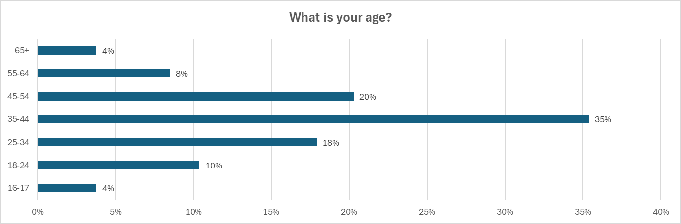
The age data from the survey offers useful insight into how different age groups engage with or show interest in EMM. The largest result in this section is the 35-44-year-old category at 75 people and 35% of the overall population of the sample. It is likely that this group of people represent the largest working population (HM Revenue & Customs, 2025) and are likely to be one of the largest group of individuals out of the population, using social media groups and communities (See Appendix 8). This suggests that mid-career adults could be particularly engaged with innovative transport solutions that improve daily commuting, reduce travel costs, or offer flexible alternatives to car use.
Following this group, the two other largest respondents came from the 45–55-year-old and the 25–34-year-olds at 20% and 18% respectively. These findings could indicate that EMM appeals across early to mid-adulthood, aligning with the commuting years where people are most likely to seek practical, reliable transport options (Schwanen, Banister and Anable, 2012).
The smallest groups of participants is the 65 years+ and the 16-17 year olds, which is common as they are also the least active participants across these digital social groups (Sprout Social, 2025). It is notable that the results in the age groups represent a strong bell curve in responses, this is also relatively in-line with usage of EMM services in Europe (Mesimäki and Lehtonen, 2023).

Question 2 - Are you male or female?

The results of this question show that a higher proportion of males at 59% in the population sample responded compared to that of the females at 41%. Generally, females will find a greater number of barriers to using EMM (Bean, Pojani and Corcoran, 2024). Because males make up nearly 60% of respondents, the overall results may lean toward perspectives typical of male users. This means that males will prioritise speed, efficiency, and convenience over safety or accessibility concerns that females would otherwise. In relation to the divide of opinion of males compared to females, question 10 showed a strong division of how males and females prioritise what would discourage them from using an EMM service. Of the sample population that choose poor weather, safety concerns, and lack of safe routes or infrastructure, nearly 73% of the female population choose these three options as their main discouragement of using EMM services. This clearly marks major concerns of safety within the female population and is a vital consideration for implementing inclusive EMM services in urbanised areas.
When considering personal safety, confidence of use, perceptions of risk and infrastructure limitations. Generally, the uptake by females will be less than that of males (Goel et al., 2021). Also see in appendix as follows, only 7% of males were concerned about safety, compared to females that considered it the most important aspect at 31%.
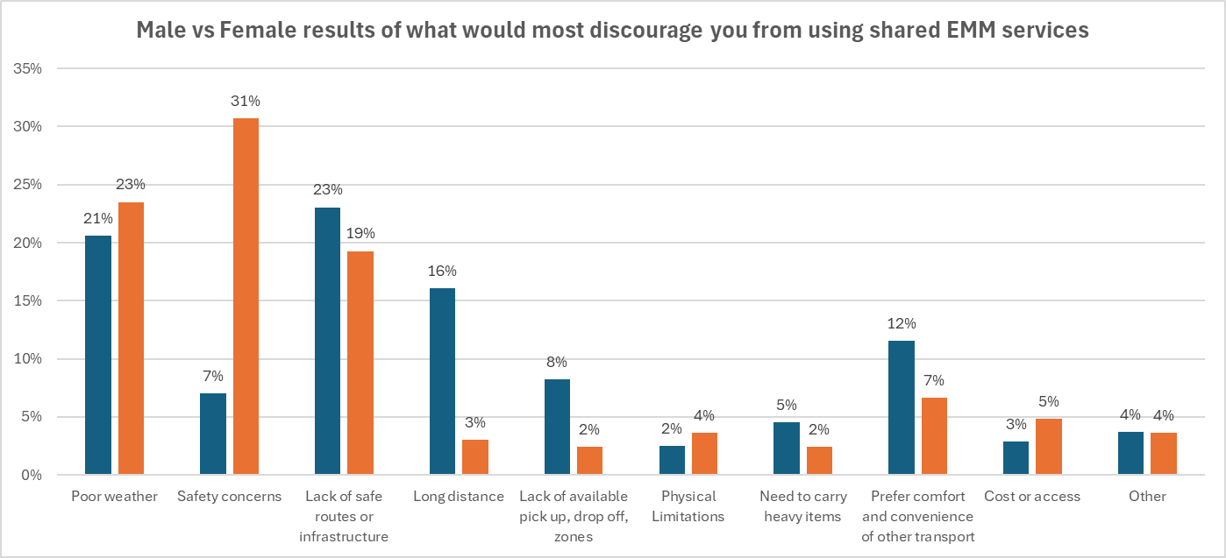

Question 3 – What is your location of residence
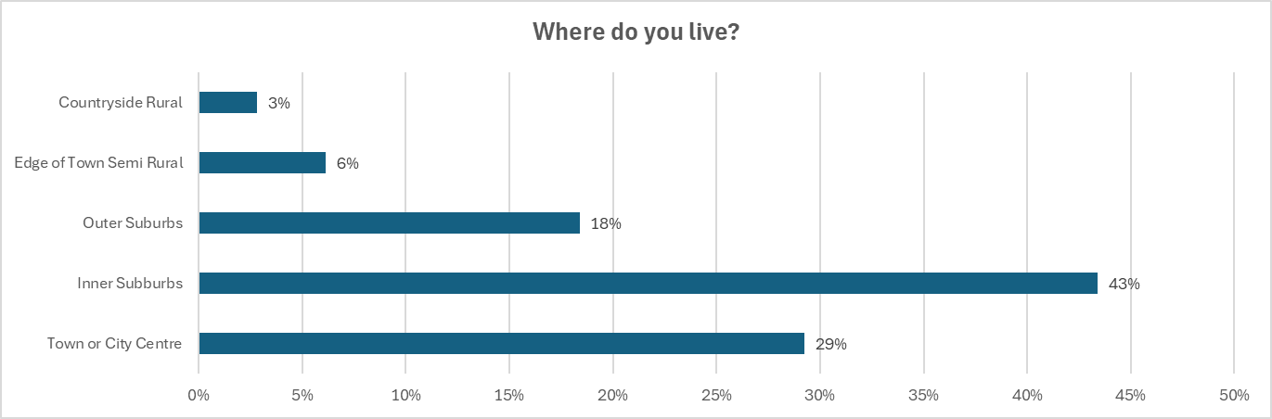
To understand people’s opinions of EMM shared services, this question is designed to know where people are based in relation to the city or town centre. This gives furthermore understanding of engagement or This question shows that the largest group at 43% of respondents are living in the Inner suburbs. The second largest group at 29% are living in the ‘Town or City centre’. When combined, the two largest groups make up 74% of the respondents. This group at nearly three quarters of the sample population are considered some of the most likely, and highest users of EMM (Reck et al., 2021). The remaining locations of where participants of the sample live at 26% live in the countryside at 3%, semi-rural at 6% and outer suburbs at 18%. It is important to note that this question is a consideration of the participant and not an actual or defined answer. Therefore, it is likely that participants may or may not be further or closer to town than they are (Bryman, 2022).
When considering opinions of EMM from these groups of the sample population, given that 74% of respondents are from relatively urbanised areas, the opinions of EMM could be more positive since they are likely to appreciate the perceived benefits that such a concept can offer. That said, this would also generally be the target location of the population for use of EMM.

Question 4 – Employment Status
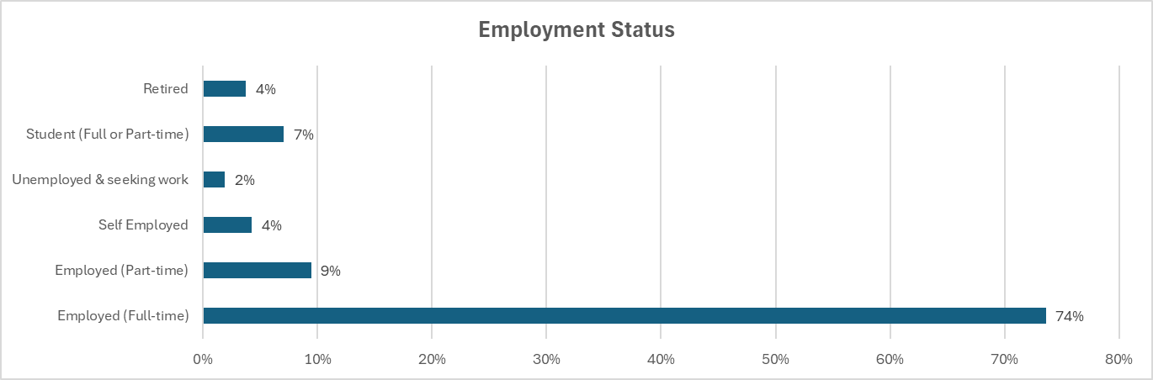
Although a sensitive question for some respondents (Mavletova & Couper, 2013. The rate of response to this question is 100%. The largest response at 74% is of people who are employed, 9% of people are unemployed and 4% of people are self-employed. The unemployed figure of 2% was the lowest, although this figure could also be considered as a grouping (Swansea Council, 2025) with Students at 7%. This would suggest that the non-working population of the study accounted for 9%, with the additional 4% of retired people. As a comparison of unemployment rates, the labour market statistics by the city and county of Swansea state that the count total is a rate of 3.4% (Swansea Council, 2025). This would suggest a reasonable accuracy and fair representation of the general population from which the sample was taken from.
The high number of employed respondents highlights the relevance of EMM in addressing workplace accessibility, and last-mile travel in the active working population. Of the population of students and part-time workers, 85% strongly agreed that they would use a shared EMM scheme if one was available and that that they strongly agreed that it would improve access to employment opportunities. As per appendix.
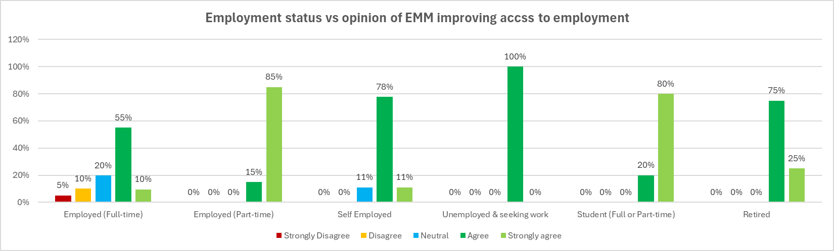

Question 5 - Main method of travel for work or study?
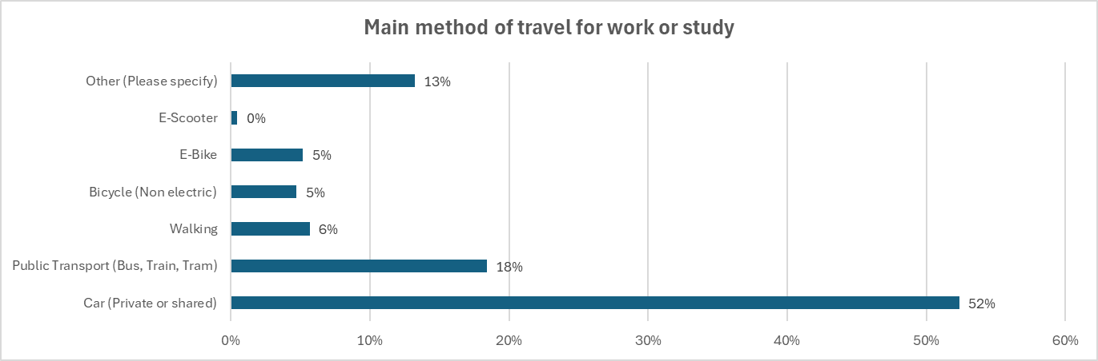
This question looks at the main method of travel for the participants of the population sample. As expected, car journeys make up the most travel type at 52%, while 18% of responses account for public transport.
Of population of those who responded with walking to work or study at 6%, 83% of them travelled less than 3 miles or less. Judging by most societal norms (See Appendix 11), this makes a lot of sense (ONS, 2022). Travel by other means including E-Scooter at 0.5% (one person), E-Bike at 5%, and Bicycle Non-electric at 5%. These four groups including walking, make up 16% of the travel type and contribute to 34 people or 36% of those travelling 3 miles or less for work or study. The other 5 people who walked or rode bikes and e-bikes travelled between 4-15 miles. No participants of these travel types travelled over 15 miles, and there were no walkers over 3 miles.
Those participants who travel using public transport are considered some of the most targetable and influential people in the survey since they are some of the highest users of shared urban EMM services (Kong et al., 2025). The respondents that used public transport as their main travel method could have also been using bikes and e-bikes at the start and end of their journey to the train or bus stations. This is a gap in the data that isn’t captured that needs to be considered when concluding or evaluating certain aspects of the primary research.
28 people or 13% of the participants choose other as a travel method. This question also gave the participant and option to state what their travel method was. Some people stated, taxi, or were of the retired and unemployed, but the rest were those who were working from home. This was not anticipated; therefore, this is an important point mentioned in the conclusion.
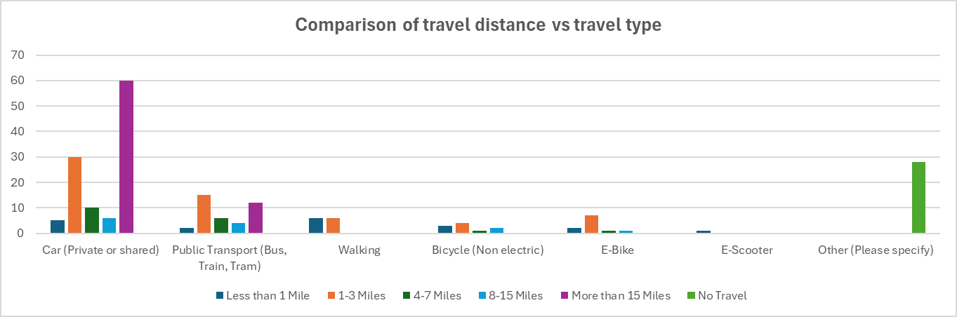

Question 6 – How far do you typically travel to your place of work or study
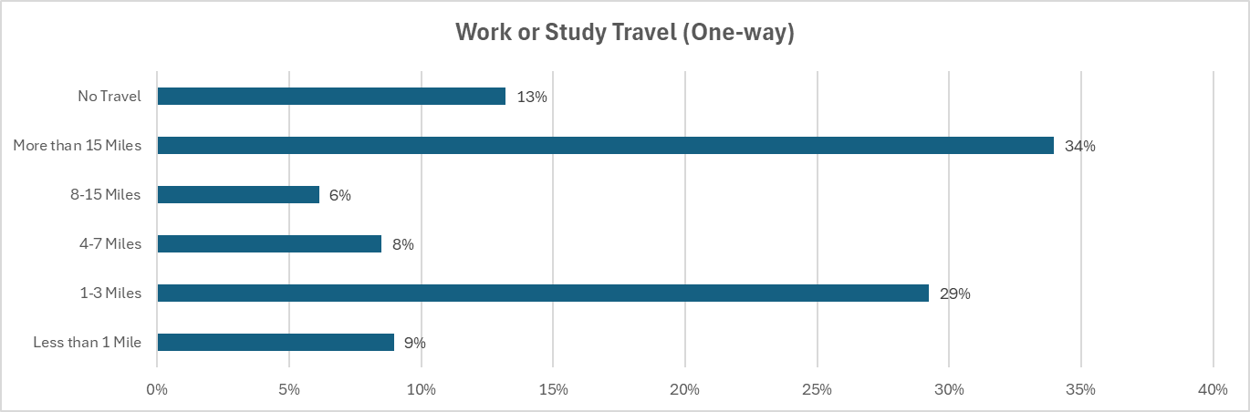
The second largest travel group covers 1-3 miles (29%), while the largest travels more than 15 miles (34%), aligning with the profile of longer-distance commuters (Department for Transport, 2024). Those travelling over 15 miles are almost certainly commuting beyond Swansea and are therefore less likely to be suitable users of urban EMM. However, their perspectives remain valuable, as they are Swansea residents and could still become future users.
Of the 15+ mile travellers, 83% of this group, drove cars as their main method of travel making up 28% of the combined travel category. The remainder of the 15 mile+ commuters are made up of the other 8% who used public transport. This figure is also in line with the UK national average at 8% (Department for Transport, 2024). The 3rd largest category for travel was the No travel at 13% of respondents, this is made up of those who are working from full and part-time, students and retired.

Question 7 – Where do you consider your place of work
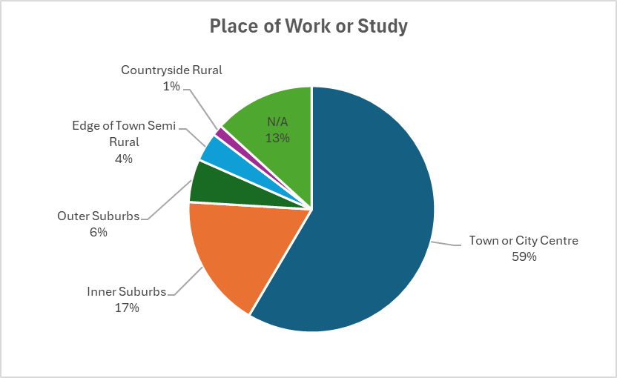

Most respondents work or study in a town or city centre (59%), followed by the inner suburbs (17%) and outer suburbs (4%), giving 82% located in broadly urban areas. While this aligns with the wider statistic that 89% of Swansea residents also work within Swansea (Swansea City & County Council, 2015), the survey does not specify which town or city these respondents travel to. Notably, 23% travel more than 15 miles, suggesting that a substantial share likely commute outside Swansea. Even so, the majority identifying urban work or study locations provides a relevant base for assessing how EMM could enhance access within denser urban environments.
A surprising number of respondents at 13% of the sample population have selected ‘Not applicable’. Of the 13% of participants that have no travel, 93% of them selected ‘Not applicable’ as their location of work. Since the survey did not ask whether people worked from home, it is highly suggestable that this 13% of people are either retired, or working from home. This 13% of both travel and work or study location, could almost be ignored, since they require no travel and are unlikely to have valuable input to the primary research, other than their opinion of shared EMM as a concept in their area.

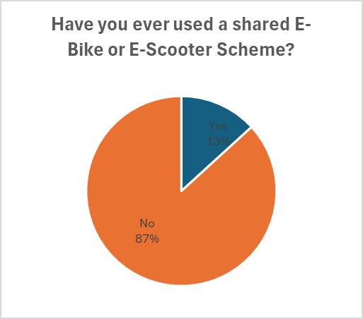
Question 8 – Have you ever used a shared E-Bike or E-scooter Service / Scheme

Of the population of the sample of participants, only 13% of said that they have tried some form of EMM scheme, while 87% of participants responded that they haven’t. Of the 13% of participants who have used a form of shared scheme EMM, it is likely that they have used this in another town or city where the scheme runs. Possibly they may have used it on holidays. There is also a possibility that they may have used an e-scooter or e-bike and may be confusing an official scheme and a privately owned.

Question 9 – Would you use an EMM scheme in your area if one was available?
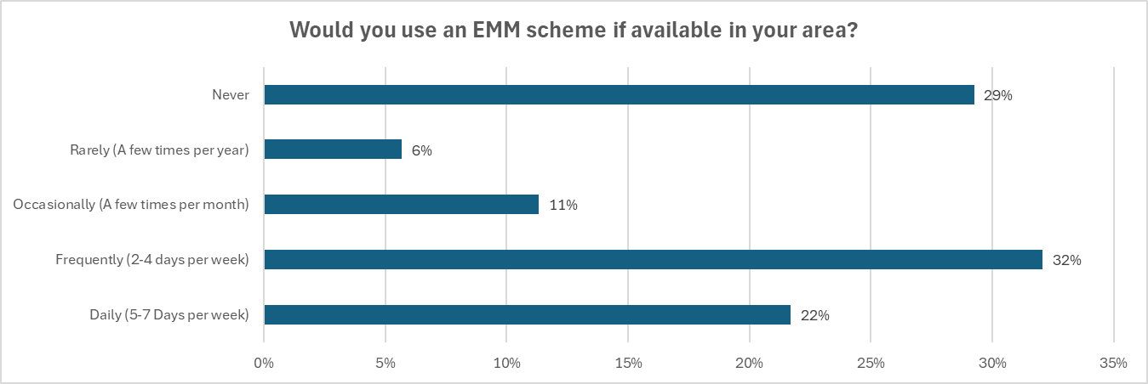
When asked if the respondents of the population sample would use an EMM scheme in the area if one was available, 32% of the participants said that they would use it two to four days per week. 22% of the population sample said that they would use it five to seven days per week. The second largest sample at 29% said that they would never use a shared EMM scheme if it was available in their area. Based on the 29% of participants who said that they would never use the scheme this segment of the population sample is made-up of retired, 55+ years of age, their place of work was made-up of the edge of town semi-rural, countryside rural.

Question 10 - What would discourage you from using a shared EMM scheme in your area?
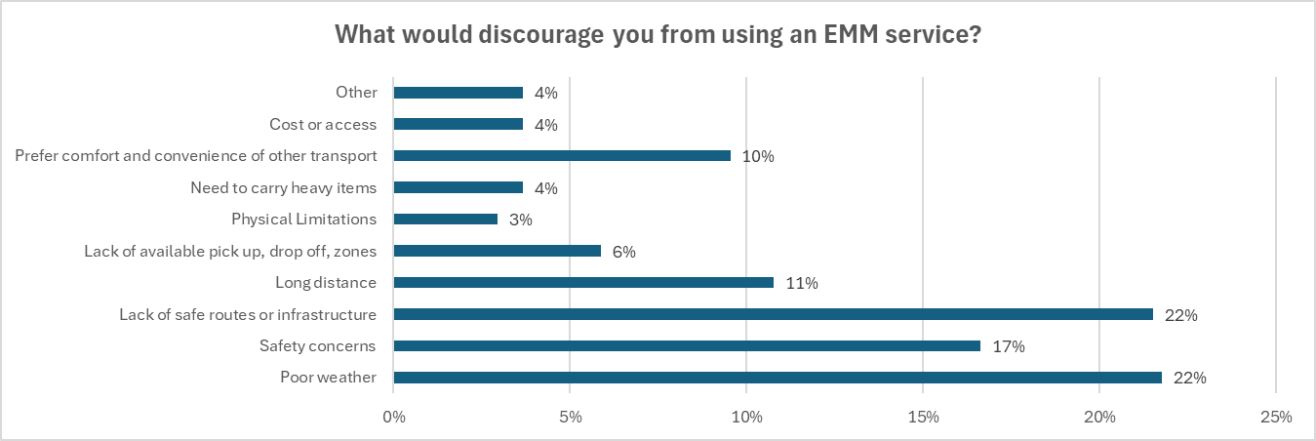
In this question the respondents are asked what would be the main elements of using a shared EMM scheme that would discourage you from using it? The question was end at understanding the viability of implemented EMM scheme in the Swansea area. The benefit of this question is to understand how the infrastructure and execution of a shade ENN scheme in Swansea would be best implemented. The two most popular selected element word the lack of safe routes or infrastructure and poor where the conditions both at 22%. The next largest discouragement was that of safety concerns at 17%. Further down the list of discouraging elements is the length of distance to travel at 11%, the convenience and comfort of other transport at 10%, lack of available pick-up and drop-off zones at 6%, need to carry heavy items at 4%, and cost of access at 4%.

Question 11 - Do you think that a shared EMM scheme in your town or city would positively impact your city's transport and accessibility?
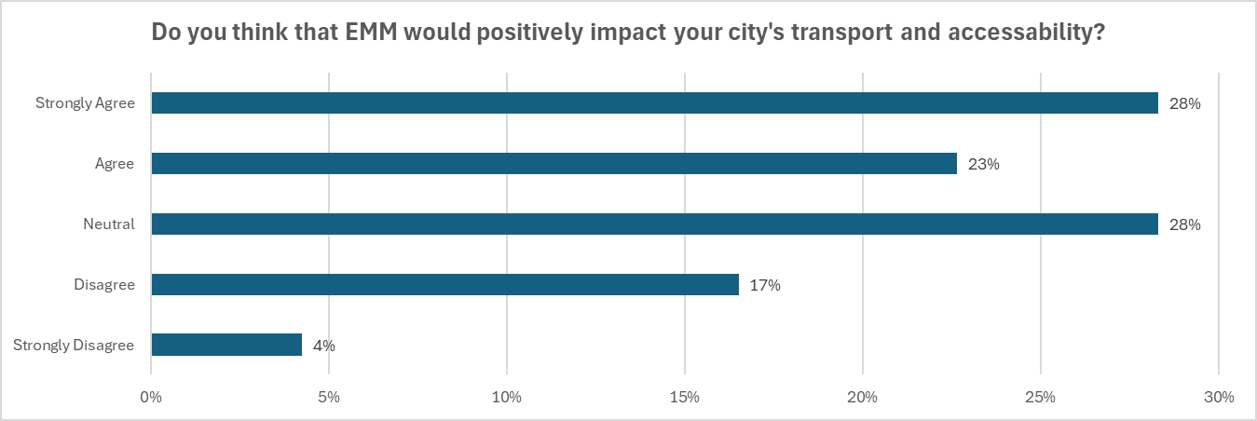
The importance of this question is designed to find perspective of how users and even non-users perceive the concept of shared EMM working in their town or city. Since not all people in the survey are going to be users or even frequent uses of the service, they are likely to be affected by the integration and infrastructural changes required to make shared EMM services work within their town or city. This question is designed to lead on to the next question about infrastructure, and then the next regarding access to employment. This series of questions is designed to find out the opinions, based on the Likert scale (Babbie, 2014, p. 185-186).
The highest response to this question was strongly agree at 28%. It is also important to note that Neutral was also equal in terms of response at 28%. The next most popular answer is agreed at 23%, which when combined with strongly agree shows a positive opinion to the concept by 51% as a slight majority. Disagree was 17% and strongly disagree was 4% of the responses by the participants.
Although most of the responses are generally positive and participants perceive EMM as a potentially positive concept for their city or town, there are still a high number of participants within the population that have a neutral opinion. This could be down to not understanding properly what EMM schemes are, and or they haven’t been exposed enough to the infrastructure, service and physical product.

Question 12 - Do you think that shared e-bike and e-scooter schemes, with correct infrastructure and legislation, would encourage safe and responsible use?
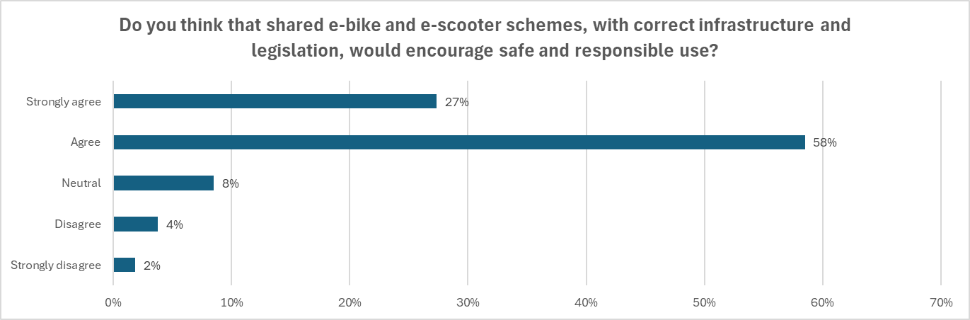
By looking at the results from this question, there is a clear distinction that participants are of the opinion that shared EMM schemes with the correct infrastructure and legislation, would encourage safe and responsible use. 58% of the population agreed, and 27% strongly agreed to this statement. Since the question does outline the positive elements of an implementation standard for an EMM scheme integration, it is possible that the responses could be somewhat encouraged with their answers being positive (Bryman & Bell, 2018). Only 2% strongly disagreed, and 4% disagreed with the statement. 8% of the sample population have a neutral opinion to the statement. Again, this selection of answer could also show the number of participants that don’t fully understand the concept of shared EMM Schemes and what the infrastructural requirements or standards represent.
Of the population of participants, 100% of the people who selected disagree or strongly disagree to question 12, also chose either disagree or strongly disagree to question 11.

Question 13 - Do you think e-bikes and e-scooters can help people access employment or study opportunities they might otherwise find difficult?
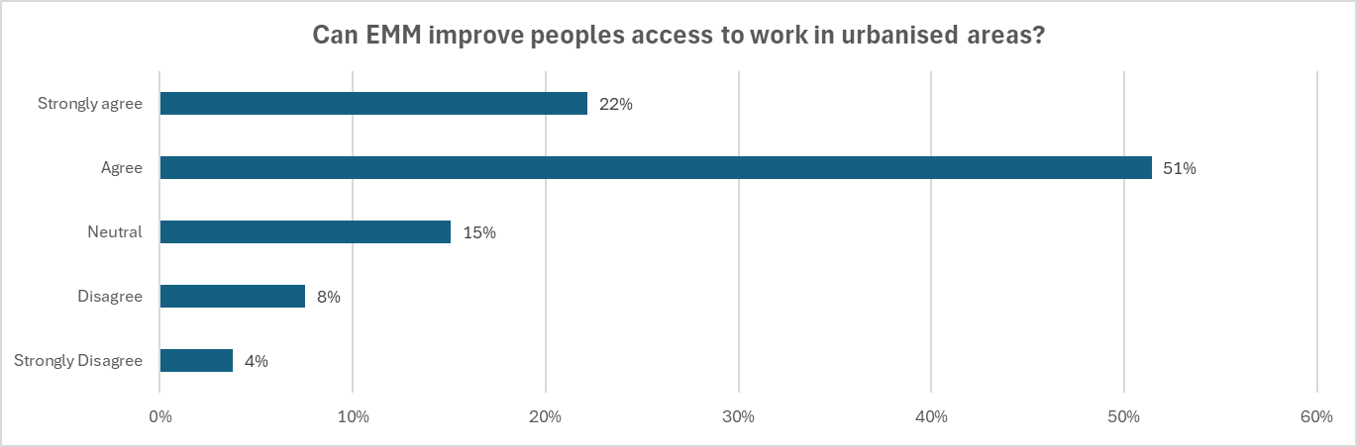
The results of this survey suggest a clear overall suggestion that e-bikes and e-scooters could play an important role in actively helping people access employment, or study opportunities that might otherwise be difficult to reach. Although opinions vary, the distribution of responses shows a strong positive lean. More than half of respondents at 51% selected Agree, and a further 22% selected Strongly Agree. Combined, this means 73% of participants hold a positive view of the role these forms of transport can play in urbanised areas.
At the same time, the results also show that not all participants of the survey are fully convinced. 15% selected Neutral, suggesting uncertainty or a belief that the benefits may depend on individual circumstances, infrastructure, or safety considerations. Meanwhile, 12% (8% Disagree, and 4% Strongly Disagree) expressed a negative view, which may reflect concerns about cost, safety, road conditions, or the limited practicality of these vehicles for certain journeys.

Question 13 - How much would you realistically be willing to spend per month on a shared e-bike or e-scooter service?
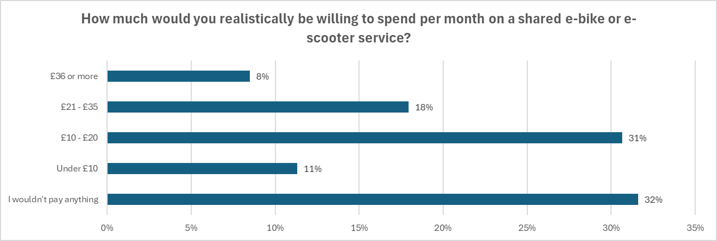
The largest group of the population sample at 32% said they wouldn’t pay anything for an EMM service. This is a significant proportion and suggests that a substantial segment of the population is either uninterested in shared micromobility, or most likely unconvinced of its value. As in question 5, the greatest proportion of ‘car users’ contributed to this answer selection.
The next two most common groups, £10–£20 at 31%, and under £10 at 11% show that while many people are willing to pay, they are generally only comfortable with lower monthly costs. Together, these two groups account for 42% of respondents, indicating moderate demand at accessible price points. The £10–£20 bracket remains a key threshold where most users are likely to see value for money. It is important to note although this is an opinion, at least it shows a strong consideration about the use of it.
The higher spending bracket, all be it a smaller part of the sample population, 18% would pay £21–£35, and just 8% would pay £36 or more. These groups likely consist of individuals who expect to use the service frequently or who see strong functional value in having flexible transport. Of the respondents that selected these two higher price brackets, 54% of them have already used a shared EMM scheme before. This suggests that pricing models from other successfully integrated EMM schemes could be used in a similar way.
Despite what this indicates, since 87% of the participants indicated that they haven’t ever used a shared EMM scheme, then it is also likely that they may not understand the value proposition of what the service can offer.

Chapter 5. Conclusions
5.1 - Introduction
In this chapter the researcher reviews the primary research and analysis conducted. The researcher then compares the conclusions against those found in the secondary research. The researcher also concludes any new ideas, hypotheses and present alternative solutions and outliers from doing so.
5.2 - Key Findings
The findings indicate strong potential demand for EMM, though opinions are divided. While results suggest EMM could be a viable transport alternative in Swansea, limited prior usage raises questions about the time and investment required to shift perceptions among resistant residents. The data shows EMM is best suited to urban environments: 74% of respondents live in city centre or inner-suburb areas that favour short trips and high service visibility. Gender-based differences highlight that women experience greater safety and infrastructure concerns, underscoring the need for inclusive design and protected routes.
Price sensitivity is significant: most respondents would pay only £10–£20 per month, and nearly a third would pay nothing. Travel patterns show many respondents typically make short journeys of 1-3 miles, aligning with EMM’s target use case. Public transport users at 17% and short-distance commuters 30% appear to be the strongest potential user groups, although further research is needed to fully understand their adoption likelihood..
5.3 - Conclusions and Discussion
5.3.1 Travel habits
When looking at the work habits of participants 28% work from home or have no travel requirements for employment or education. The question to ask could be, is EMM needed in regions if less travel requirements in general are needed. When looking at travel type and distance, 52% as the majority travel to work or study by means of car, and 34% travel over 15 miles. There may be significant challenge for EMM operators to get people out of cars and on to EMM alternatives for last mile travel.
For those travelling over 15 miles and working in the town or city centre can be ignored to some degree, as those in this category are not likely to use EMM in Swansea, however, could be considered for a similar study of potential EMM in other city centres. Further research could be conducted to establish the 15+ mile car users, who are living outside of Swansea, but working inside Swansea. Could these people use EMM as a last mile alternative, or as part of a multi-method travel type. Maybe they could use public transport, instead of a car as part of broader transport networks (Buehler & Hamre, 2015; Diana & Mokhtarian, 2009).
In review of the territory coverage of EMM, the survey found most commutes are 1–3 miles, ideal for micro-mobility. The literature observes typical EU EMM journeys are 1.8 km (≈1.1 miles) or 15 minutes a perfect match (6t-Bureau, 2025). The deduction from this is that Swansea’s urban shape and topography and expected trip length, align strongly with current successful EMM integration in European cities.
In both primary and secondary research, the most popular travel distances are Ideal for EMM, yet car dependency remains extremely high. The primary research indicates 29% travel only 1-3 miles being optimal for micro-mobility, yet 52% still drive, even for very short journeys. Unlike many larger European cities, car congestion certainly helps additional uptake of EMM for convenience. Swansea shows unusually high car dependency, contradicting the expectation from literature that short-distance commuters would be the easiest segment to convert.
This conclusion satisfies objective 1.3.1 as evidence of EMM adoption, infrastructure requirements, regulatory frameworks, user behaviour, and socio-economic impacts has been researched and adequately assessed.
5.3.2 Blended travel using public transport
In regard to public transport, would there be enough users attracted to an EMM scheme that could be used both sides of the commute, or at least on one side of their work or study travel. The evidence from the survey and literature supports this theory as it has worked in many other EU cities and seems as though similar behavioural patterns could be expected in this context, provided the scheme is designed to be accessible, affordable, and properly integrated with existing public transport networks. The primary research shows public transport users are more open to EMM than drivers. Along-side this the literature emphasises multimodal integration EMM which reduces the ‘last-mile’ gap (Bretones et al., 2023), enhances bus/train accessibility, and is used heavily by commuters (Buehler & Hamre, 2015; Robeyns, 2011). Both research points would indicate that early adopters in Swansea will likely be public transport users, younger residents, and short distance commuters, consistent with European evidence.
5.3.3 Demographics and Safety
The survey showed that Females view safety and infrastructure as a main requirement, while males view, convenience, efficiency and cost as their main requirements. These results suggest that potential operators of EMM in Swansea would need to create safer environments and measures to attract more female use of EMM. The literature review also compliments these findings as many sources report the same opinions for female users of EMM.
In view of aging populations, EMM may not seem a likely alternative to the older population. From the Primary research, the data suggests that this is true, however in comparison to the literature review of EMM schemes in Europe, many older age groups are adopting forms of EMM but mainly under e-bike schemes. As part of the adoption in the older age categories, these users are opting for e-bikes since they are a form of exercise that they may not participate in otherwise. Furthermore, EMM options give additional benefits to the older working age categories that may decide to e-cycle or use an e-scooter to travel to work. Since the effects of e-bikes pose less exertion for older users, this maturing demographic is the unlikely, but likely users.
5.3.4 Infrastructure and Legal
Looking at where EMM is used is one of the main starting points for EMM integration. A question to ask is, do operators, in conjunction with highways agency and local authority, need to build infrastructure in the centre outwards, or first or from suburban areas, inwards. If EMM infrastructure is built from the inside of an urban environment outwards, does this lend its hand more to use for pleasure. If the infrastructure is built from the outside (suburbs) inwards, does this create greater uptake for those looking to increase employment opportunities by travelling using a form of EMM. In relation to weather, there are some EU cities that are fortunate in the sense that they have favourable weather conditions that allow for EMM to be better accepted.
Poor existing infrastructure of Swansea and strong legislation of the UK remain difficult challenges for any provider of EMM services to overcome. The survey matches almost identical trends to existing research that highlights concern about legality and safety. Literature shows that adoption skyrockets where legislation is clear (Germany, France, Sweden). UK literature shows muddled legislation significantly slows culture change. It is safe to say that like Cardiff and many other Urban areas of the UK that don’t currently have an EMM policy, the investment needs to combine both local authority and operator to successfully replicate European adoption success.
In contradiction many Swansea residents believe Infrastructure will enable safe use, but Swansea lacks that infrastructure. The primary research says that 85% agree that with the right infrastructure, responsible and safe use would follow. In the secondary research Swansea lacks the protected lanes, density, and route networks as seen in successful cities. Literature shows infrastructure must exist before adoption can possibly happen.
This conclusion satisfies objective 1.3.2 as it has been deducted from the primary and secondary research covering the positive influence fo implemented EMM services as a concept.
5.3.5 Cost
Operators thinking of investing infrastructure and services in Swansea would also need to consider the effectiveness of EMM in Swansea as it generally has much less favourable weather conditions to support adoption. Cardiff council have taken seven years to decide before investing into electric bikes from regular bikes. Due to the stalling of such investment until 2026 it seems likely that use of EMM for work purposes in Cardiff city will continue to stagnate.
The primary data shows cost is a major barrier, with 42% only willing to pay up to £20/month. The literature highlights low-cost schemes as a major contributor to success, especially for lower-income users (Buehler & Hamre, 2015; Musa, 2025). The deduction is that Swansea’s feasibility hinges on price structure, particularly if targeting deprived areas like Townhill, Penlan and Blaen-y-maes.
The primary data indicates which groups and demographics are likely to use EMM services, but the literature shows where adoption could have the most impact. Areas in Swansea such as Townhill, Penlan, Blaen-y-Maes and Bon-y-maen face poor transport options, low incomes, poor health, low education, all of which restrict mobility. Swansea’s most deprived areas match similar findings across EU states, where transport poverty reinforces social immobility, and EMM could reduce this if infrastructure became available. Successful European schemes show users are willing to pay when benefits are clear (e.g., £25-£35/month in Paris, Copenhagen).
This conclusion satisfies objective 1.3.3 as it indicates the acceptance and rejection of EMM through costs willing to be paid for services.
5.3.6 Limited exposure to EMM and lack of existing cycling heritage
With Swansea having such a low exposure of EMM, operators would need significant time for the population to adopt such a radical change in infrastructure, culture, and non-user acceptance. Although there are large splits in potential use, in general, the population favour the concept and would potentially benefit from additional employment options. Despite such as positive response to the idea of EMM shared services in Swansea, would those who claim it as such a good thing, use it themselves is very debateable. Based on the understanding that cost is a considerable factor of whether people would adopt shared EMM into their travel arrangements is important to consider. When looking at successful implementation in the UK, Bristol has seen a seemingly smooth transition however this has only been for e-bikes, and somewhat more challenging for e-scooters. The transition of users trying e-bikes has led to the use of e-scooters, thus increasing value perception much more quickly after hands-on exposure.
While 32% said that they would not pay anything, this is likely to suggest the group of people that simply will not use EMM at all. It is important to note that since 83% have never used an EMM scheme then a high proportion of these do not understand the concept nor the value of shared EMM services. As per the secondary research, this mirrors the literature, which shows rapid adoption across Europe once schemes become visible, normalised, and infrastructurally supported.
Despite the high interest from the primary research, there is a contradiction in the sense: There is a high interest in usage but a low willingness to pay, which contradicts how adoption trends typically behave once schemes operate successfully in other cities.
5.3.7 Does EMM improve access to employment?
Of the students surveyed, 85% agreed that EMM would improve access to employment, however, would this group type size be large enough to significant enough to attract EMM schemes and EMM investment into the Swansea area. If only 10% of the sample population are already using a bike or e-bike, would this also be enough of a potential market to convert to using an EMM scheme instead of personal investment.
The primary findings show 73% believe EMM would improve job or study access. The existing research shows similar outcomes: 20% improved access to work in UK trials (DfT, 2022) 24% of low-income users travel to and from deprived areas (VOI, 2023) EMM reduces waiting time, walking gaps and travel barriers. From this joint analysis, both sets of research strongly indicate EMM can directly support social mobility, particularly in cities with fragmented public transport like Swansea. Again, the argument of how EMM can influence a populations ability to increase social mobility is difficult to determine over a short period.
In contradiction, 73% of the sample population believe EMM can improve access to employment/study, 51% believe it would benefit the city, yet 87% have never used any EMM scheme at all. Could this mean that the only way to truly understand the benefits is if a pilot scheme was run. In the secondary research, it highlights that users of e-bike schemes have had limited long-term users, therefore operators need to consider that the schemes are implemented with precise execution to maximise on usage. It appears that Swansea residents are optimistic despite having almost no exposure, which contradicts behavioural patterns seen in cities where EMM was initially met with scepticism until trialled.
This conclusion satisfies objective 1.3.4 as it covers the alignment and comparison of opinions of residents of Swansea. The primary research also mirrors the evidence found in the literature review conducted, ensuring well rounded investigation from various sources for investigation.
5.4 - Recommendations
Since there is a high number Swansea residents working in Swansea are there enough work opportunities within Swansea to attract more people into the centre of town by means of EMM. Like Bristol, Swansea has a high number of similarities, it would be sensible to suggest that an integration of EMM in Swansea could be modelled on what has been learned in Bristol city as follows:
1. Develop a staged approach with a focus on establishing protected routes along key commuter corridors, like bus lanes across the city. These routes must connect both suburban and central urban areas, ensuring that short-distance travel is fully supported. Integrating e-bike and e-scooter docking and charging stations at critical locations for last-mile travel and strengthen links to major transport hubs. Additionally, by designing routes that are well lit, monitored, and perceived as safe, the scheme would address female safety concerns and encourage wider participation across wider demographics.
2. Target early adopters through discounted, integrated travel offers for public transport users. EMM operators could provide vouchers or usage credits to individuals holding eligible travel passes such as students, regular commuters, and older travellers. This approach could incentivise blended travel, support multimodal commuting, and encourage early adoption among groups most likely to benefit from improved access to work and study.
3. To initiate the scheme, raise awareness, and assess real-world uptake, targeted pilot trials should be implemented in high-traffic commuter locations. These trials should focus on the most likely early adopters such as students and individuals transitioning from bus and train services on weekdays to generate visibility, encourage first-time use, and provide robust data on user behaviour and demand patterns. (See appendix 14)
Appendix 14 (Designed from the conclusions of this dissertation by the researcher)
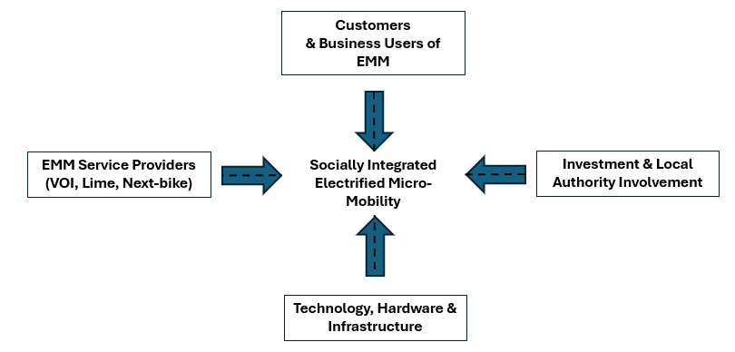
4. Establish a formal collaboration between Swansea Council, public transport operators (such as First Cymru), and an EMM provider (e.g., Lime or Nextbike) should be created to coordinate infrastructure, pricing, and multimodal integration. This partnership can be strengthened through promotional support from major local employers and organisations including Admiral, Swansea City Football Club, and Sinclair Motor Holdings helping to raise awareness, increase trial use, and embed EMM within everyday travel to work and study. This recommendation satisfies 1.3.5 as it advises on potential design, implementation, and optimisation of an EMM scheme in Swansea.
5. For further research to be carried out as an additional investigation, the researcher should look to attain further details from the demographics of other successful regions such as Bristol or Manchester. The researcher could interview users, sponsors and obtain further information from EMM operators, and interview members of the Swansea council to discuss future logistics, planning and social mobility projects they may undergo in the future. This recommendation satisfies objective 1.3.6 as it covers recommendations produced from conclusions found in both secondary and primary research for additional investigations to be conducted.

Appendixes
Appendix 1 – Collected from
Appendix 2
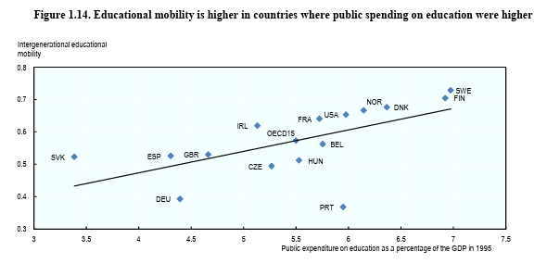
Appendix 3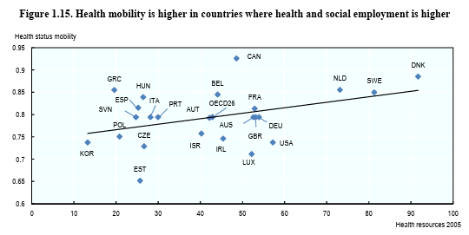
Appendix - 4
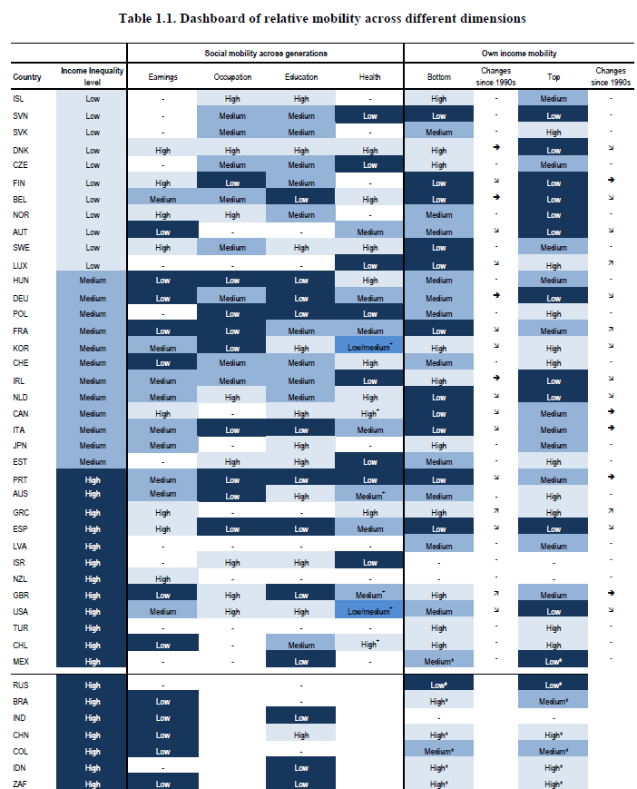
Appendix 5 – Taken from Swansea City Council 2024.
Appendix 6
- https://statswales.gov.wales/Catalogue/Business-Economy-and-Labour-Market/People-and-Work/Employment/Commuting/commutingpatterns-by-welshlocalauthority-measure
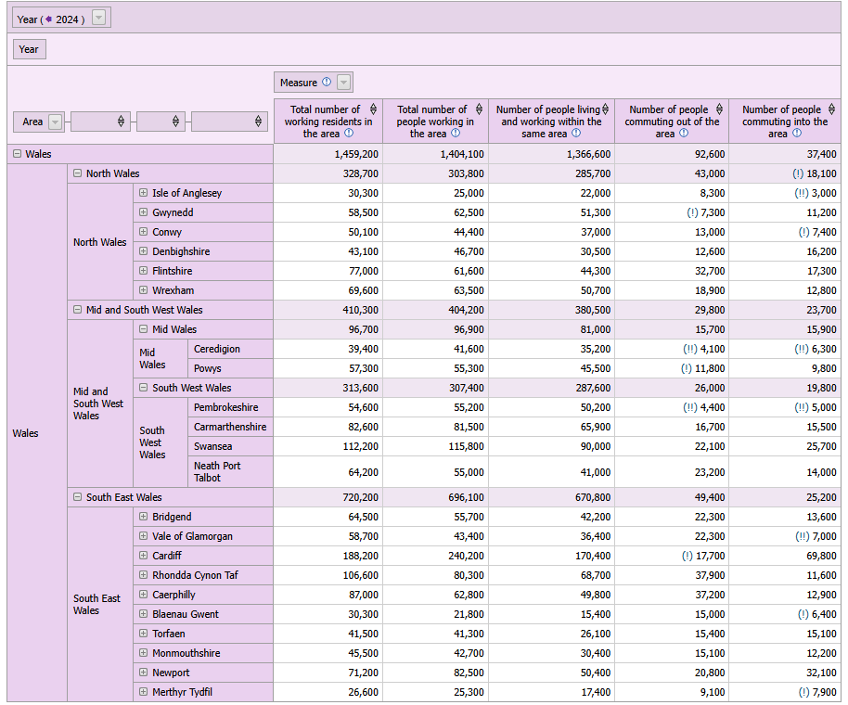

Appendix 7 – Study of EMM use by Department for Transport 2022 for Manchester & Bristol
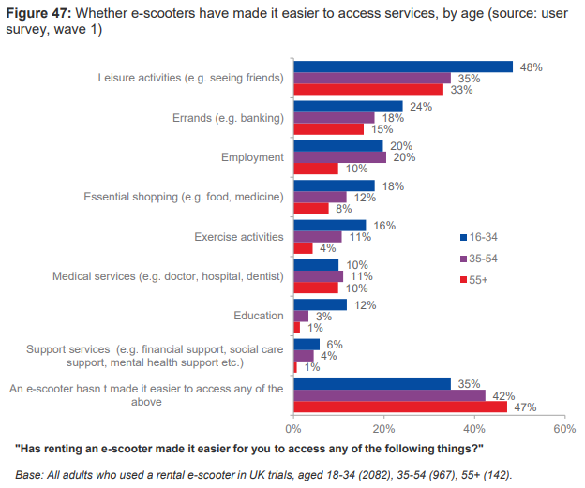
Appendix 8 - Available at https://www.statista.com/statistics/1401021/uk-social-media-users-by-age/ Accessed:27/11/2025.
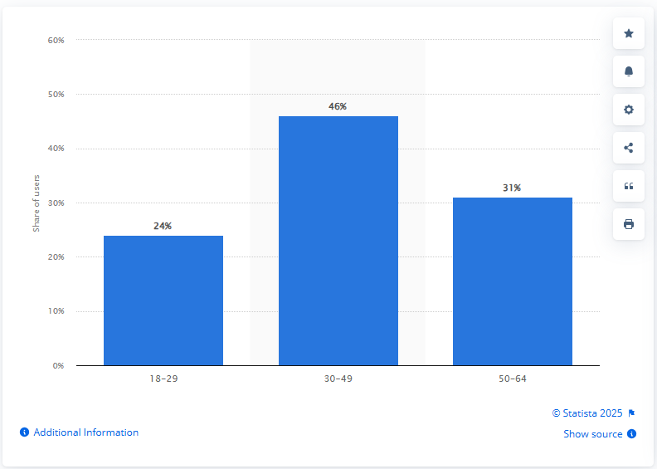
Appendix 9
Appendix 10
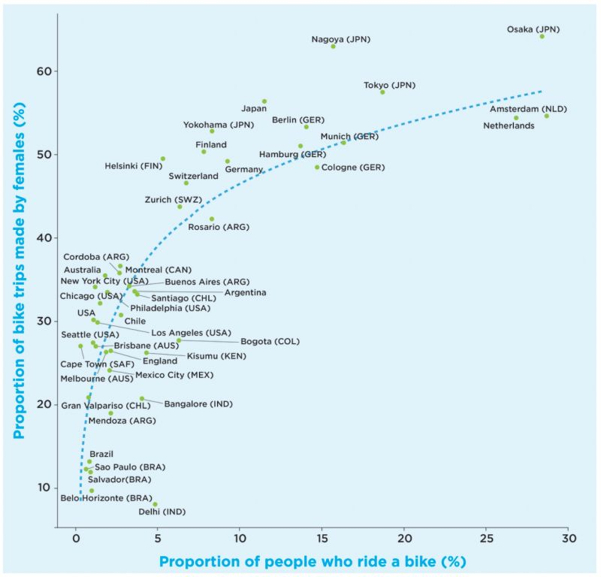

Appendix - 11 https://www.ons.gov.uk/employmentandlabourmarket/peopleinwork/employmentandemployeetypes/bulletins/traveltoworkenglandandwales/census2021 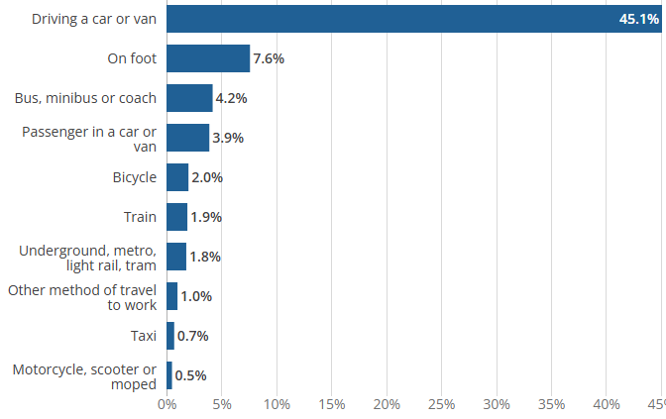
Appendix 12 – A collection of facebook groups for Swansea

Appendix – 13 – Taken from https://www.sociologyguide.com/social-mobility/types-of-mobility.php
Map 1

Map 2
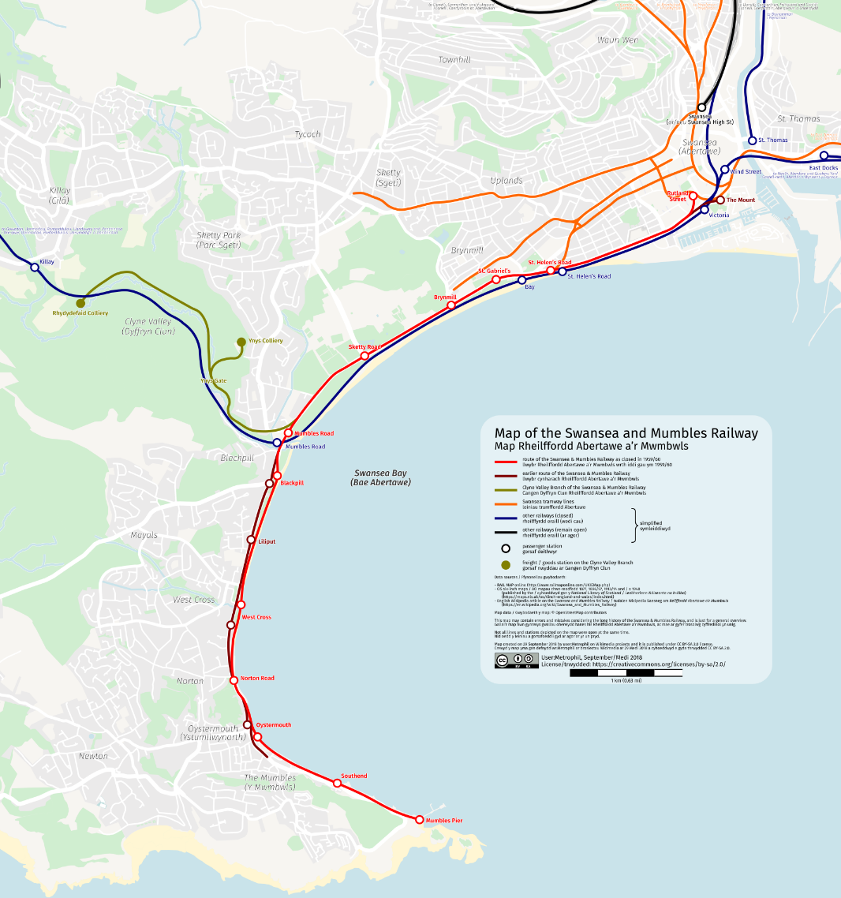
7 - Bibliography
Alessio, H. M., Ballard, K. D., Reidy, P. T., Hayward, K. M., Bagg, A. M., Cooley, R. A., O’Connell, M. J., Montoye, A. H. K. & Timmerman, K. L. (2024) ‘Short term e-bicycle riding results in favorable cardiometabolic shifts in moderately active adults’, European Journal of Applied Physiology, 124(7), pp. 1969–1977. Available at: https://link.springer.com/article/10.1007/s00421-024-05418-1 (Accessed:03/12/2025)
Babbie, E. (2014) The Basics of Social Research. 6th edn. Belmont, CA: Wadsworth, Cengage Learning.
Badia, H. and Jenelius, E. (2023) ‘Shared e-scooter micromobility: review of use patterns, perceptions and environmental impacts’, Transport Reviews, 43(5), pp. 811–837. Available at: https://www.tandfonline.com/doi/full/10.1080/01441647.2023.2171500 (Accessed: 20 August 2025).
Bambra, C. (2011) Health Inequalities and the Social Determinants of Health. Oxford: Oxford University Press.
Bean, R., Pojani, D. and Corcoran, J. (2024) ‘Natural barriers facing female cyclists and how to overcome them: A cross national examination of bikesharing schemes’, Journal of Cycling and Micromobility Research, 2, 100025.
Bechara, J.P. & Van de Ven, A.H., 2011. Triangulating philosophies of science to understand complex organizational and managerial problems. In: H. Tsoukas & R. Chia, eds. Philosophy and Organization Theory. Research in the Sociology of Organizations, Vol. 32. Bingley: Emerald Group Publishing Limited, pp. 343–364.
Bell, J. and Waters, S. (2018) Doing your research project: A guide for first-time researchers. 7th edn. Maidenhead: Open University Press.
Bell, E., Bryman, A. and Harley, B., 2022. Business research methods. 6th ed. Oxford: Oxford University Press.
Bethlehem, J. (2010) Selection bias in web surveys. The Hague: Statistics Netherlands. Available at: https://www150.statcan.gc.ca/n1/en/catalogue/12-001-X201000211152 (Accessed: 11 November 2025)
Bradley University (n.d.) ‘What’s the difference between descriptive and inferential statistics?’ Bradley University Online. Available at: https://onlinedegrees.bradley.edu/blog/whats-the-difference-between-descriptive-and-inferential-statistics (Accessed: 24 October 2025).
Bretones, A., Marquet, O., Daher, C., Hidalgo, L., Nieuwenhuijsen, M., Miralles-Guasch, C. & Mueller, N. (2023) ‘Public health-led insights on electric micro-mobility adoption and use: a scoping review’, Journal of Urban Health, 100, pp. 612–626. doi:10.1007/s11524-023-00731-0.
Bristol City Council (2022) Bristol e-scooter trial evaluation report. Bristol: Bristol City Council. Available at: https://www.bristol.gov.uk/transport/e-scooter-trial (Accessed: 23 October 2025).
Brunetti, I. and Fiaschi, D. (2023) ‘Occupational mobility: theory and estimation for Italy’, Journal of Economic Inequality, 21(3), pp. 641–661. https://link.springer.com/article/10.1007/s10888-023-09568-8
Bryman, A. (2022) Social Research Methods. 6th edn. Oxford: Oxford University Press.
Budnitz, H., Li, X., Morrissey, H. and Schwanen, T. (2025) 'Understanding the uneven use of rental e-scooters and implications for equity: Evidence from England’s largest e-scooter trial', Case Studies on Transport Policy, 19, pp. 1–13. Available at: https://doi.org/10.1016/j.cstp.2025.02.001 (Accessed: 25 August 2025).
Buehler, R. and Hamre, A. (2015) ‘The multimodal majority? Driving, walking, cycling, and public transportation use among American adults’, Transportation, 42(6), pp. 1081–1101. https://link.springer.com/article/10.1007/s11116-014-9556-z (Accessed: 19 August 2025).
Busby, A. (2020) Public attitudes to the use of e-scooters in the UK: report. Department for Transport. Available at: https://assets.publishing.service.gov.uk/media/616009438fa8f5297b643ed9/public-attitudes-to-the-use-of-e-scooters-in-the-uk-report.pdf (Accessed: 11 November 2025).
Bishop, J.D.K., Doucette, R.T., Robinson, D., Mills, B. and McCulloch, M.D. (2011) 'Investigating the technical, economic and environmental performance of electric vehicles in the real-world: A case study using electric scooters', Journal of Power Sources, 196(23), pp. 10094–10104. Available at: https://www.sciencedirect.com/science/article/abs/pii/S0378775311015205?via%3Dihub (Accessed: 30 August 2025).
Bosworth, G. (2020) ‘Unequal futures of rural mobility: Challenges for a “Smart” mobility transition’, Journal of Rural Studies (or associated publisher PDF). Available at: https://researchportal.northumbria.ac.uk/files/40499853/0269094220968231.pdf (Accessed: 11 November 2025).
Bozzi, A.D. and Aguilera, A., 2021. Shared e-scooters: A review of uses, health and environmental impacts, and policy implications of a new micro-mobility service. Sustainability, 13(16), p.8676. Available at: https://www.mdpi.com/2071-1050/13/16/8676 (Accessed:13/10/2025
Bonizzoni, P., Romito, M., & Cavallo, C. (2016). Teachers’ guidance, family participation and track choice: The educational disadvantage of immigrant students in Italy. British Journal of Sociology of Education, 37(5), 702–720. https://www.tandfonline.com/doi/full/10.1080/01425692.2014.982860 (Accessed: 19 October 2025).
Bukodi, E. and Goldthorpe, J.H. (2019) Social Mobility and Education in Britain: Research, Politics and Policy. Cambridge: Cambridge University Press.
Button, K., Frye, H. & Reaves, D. (2020) ‘Economic regulation and E-scooter networks in the USA’, Research in Transportation Economics, 84, p.100973
Cameron, S., & Price, D. (2009). Business Research Methods: A practical approach. London: CIPD.
Carson, J., Jost, G., Meinero, M., Stipdonk, H., & Ward, H. (2023) Reducing Older People’s Deaths on European Roads: PIN Flash Report 45, Brussels: European Transport Safety Council, p.9. Available at: https://etsc.eu/wp-content/uploads/ETSC_PINFLASH_45-Digital-Mar-2024.pdf (Accessed: 18 October 2025)
Campbell, S., Greenwood, M., Prior, S., Shearer, T., Walkem, K., Young, S., Bywaters, D. & Walker, K. (2020) ‘Purposive sampling: complex or simple? Research case examples’, Journal of Research in Nursing.
Chen, H. and Zhao, J. (2022) ‘Design and control of brushless DC hub motors for e-scooters’, IEEE Transactions on Transportation Electrification, 8(4), pp. 552–563.
Coach & Bus Weekly (2025) ‘First Cymru to withdraw bendy buses from Swansea’, Coach & Bus Weekly, 4 July. Available at: https://cbwmagazine.com/first-cymru-to-withdraw-bendy-buses-from-swansea/ (Accessed: 13 October 2025).
Cottrill, C. D. (2020). “MaaS surveillance: Privacy considerations in mobility as a service.” Transportation Research Part A: Policy and Practice, vol. 131, pp. 50–57
Couper, M.P. (2000) Web surveys: A review of issues and approaches. Public Opinion Quarterly, 64(4), pp. 464–494.
Creswell, John W., and Vicki L. Plano Clark. 2011. Designing and Conducting Mixed Methods Research, 2nd ed. Thousand Oaks: Sage.
Creswell, J. W. (2014). Research Design: Qualitative, Quantitative, and Mixed Methods Approaches (4th ed.). Thousand Oaks, CA: SAGE Publications.
Currie, J. and Stabile, M. (2003) ‘Socioeconomic status and child health: why is the relationship stronger for older children?’, American Economic Review, 93(5), pp. 1813–1823.
de Bortoli, A. and Christoforou, Z. (2021) ‘Consequential LCA for territorial and multimodal transportation policies: method and application to the free-floating e-scooter disruption in Paris’, Sustainability, 13(8), 8676. Available at: https://elue.univ-gustave-eiffel.fr/fileadmin/contributeurs/ELUE/Ref_Biblio/sustainability-13-08676.pdf (Accessed: 24 October 2025).
Department for Transport, 2024. Transport Statistics Great Britain: 2023 Domestic Travel. GOV.UK. Available at: https://www.gov.uk/government/statistics/transport-statistics-great-britain-2024/transport-statistics-great-britain-2023-domestic-travel (Accessed:27 November 2025).
Department for Transport, 2024. Transport Statistics Great Britain: 2023 Domestic Travel. GOV.UK. Available at: https://www.gov.uk/government/statistics/transport-statistics-great-britain-2024/transport-statistics-great-britain-2023-domestic-travel (Accessed:27 November 2025).
Department for Transport (2022) National evaluation of e-scooter trials: Findings report. Available at: https://assets.publishing.service.gov.uk/government/uploads/system/uploads/attachment_data/file/1179786/national-evaluation-of-e-scooter-trials-findings-report.pdf (Accessed: 13 October 2025).
Department for Transport (2023) State of the Nation 2023. (online) London: UK Government. Available at: https://assets.publishing.service.gov.uk/media/64f853399ee0f2000fb7bf80/state-of-the-nation-2023.pdf (Accessed: 20 October 2025).
Dickinson, K. (2024) ‘What went wrong with the Paris referendum on e-scooters?’, CityChangers.org. Available at: https://citychangers.org/e-scooters-referendum-paris/ (Accessed: 13 October 2025)
Driver and Vehicle Standards Agency / Department for Transport (2024) Electrically assisted pedal cycles (EAPCs). GOV.UK. Available at: https://www.gov.uk/government/publications/electrically-assisted-pedal-cycles-eapcs (Accessed: 02/10/2025).
Dunne, J. (2024) ‘City of London Police seize more illegal e-bikes than any other force with one modified to hit 70 mph’, Evening Standard, 24 September. Available at: https://www.standard.co.uk/news/crime/city-of-london-police-seize-illegal-ebikes-70mph-b1183739.html (Accessed: 18 October 2025).
EV Powered (2022) ‘E-scooters boost local economies by £53 million, report finds’, EV Powered, 2 November. Available at: https://evpowered.co.uk/news/e-scooters-boost-local-economies-by-53-million-report-finds (Accessed: 13 October 2025).
Evans, G. & Withill, R.A. (1994) ‘Carmarthen Road, Swansea Bus priority within SCOOT’, in Seventh International Conference on Road Traffic Monitoring and Control (IEE Conference Publication 391), 26–28 April 1994, IEE, pp. 81–88. Available at https://trid.trb.org/Results?q=&serial=%22SEVENTH%20INTERNATIONAL%20CONFERENCE%20ON%20ROAD%20TRAFFIC%20MONITORING%20AND%20CONTROL%2C%2026-28%20APRIL%201994.%20%20PROCEEDINGS.%20%20(IEE%20CONFERENCE%20PUBLICATION%20391)%22#/View/413491 (Accessed: 13/10/2025)
Evans, C. & Miskell, L. (2020) Swansea Copper: A Global History. Johns Hopkins University Press. Summary at: https://www.press.jhu.edu/newsroom/swansea-copper-global-history (Accessed: 25/09/2025).
Everett, H. (2019) ‘nextbike & Welsh Cycling partner to get Cardiff public pedalling’, CyclingIndustry.news, 5 July. Available at: https://cyclingindustry.news/nextbike-welsh-cycling-partner-to-get-cardiff-public-pedalling/ (Accessed: 4 December 2025).
EUROBAT (2024) Batteries innovation roadmap 2035: Technical Annex (White Paper). (online) Available at: https://www.eurobat.org/wp-content/uploads/2024/11/white-paper-innovation-roadmap-2024-Tech-Annex_web_version-3.pdf (Accessed: 20 October 2025).
Faraday Institution (2023) Faraday Insights – Issue 16: The micromobility revolution gathers momentum. Available at: https://www.faraday.ac.uk/wp-content/uploads/2023/02/Faraday_Insights_16_FINAL.pdf (Accessed: 28 August 2025).
Fields, G. S. (2019) Concepts of Social Mobility, WIDER Working Paper No. 2019/106, UNU-WIDER, Helsinki.
Fielt, E., 2013. Conceptualising business models: definitions, frameworks and classifications. Journal of Business Models, 1(1), pp.85–105
Fishman, E. (2016) ‘Bikeshare: A review of recent literature’, Transport Reviews, 36(1), pp. 92–113. Available at: https://www.sciencedirect.com/org/science/article/abs/pii/S0144164722002525 (Accessed: 3 December 2025).
Foley, D. (2023) ‘Assessing the carbon footprint: scooter emissions vs car emissions’, Unagi Scooters. Available at: https://unagiscooters.com/scooter-articles/scooter-emissions-vs-car-emissions/ (Accessed: 31 August 2025).
France. Ministère de la Transition écologique & territoriale (2020) Trottinettes électriques et EDPM : la réglementation en vigueur. (Online) Available at: https://www.ecologie.gouv.fr/politiques-publiques/trottinettes-electriques-edpm-reglementation-vigueur
Friedman, S. and Macmillan, L. (2020) ‘Is London really the engine-room? Migration, opportunity hoarding and regional social mobility in the UK’, The British Journal of Sociology, 71(1), pp. 1–24. \30 August 2025).
Gill, J. and Johnson, P. (2010) Research methods for managers. 4th edn. London: SAGE Publications Ltd.
Giorgi, S., Lynn, V. E., Gupta, K., Ahmed, F., Matz, S., Ungar, L. H., & Schwartz, H. A. (2019). Correcting Sociodemographic Selection Biases for Population Prediction from Social Media.
Gogarty, C. (2024) Cardiff and Swansea formally express interest in e-scooter trials. WalesOnline, 26 November. Available at: https://www.walesonline.co.uk/news/wales-news/cardiff-swansea-formally-express-interest-30447550 (Accessed: 11 September 2025).
Goel, R. et al. (2021) ‘Cycling behaviour in 17 countries across 6 continents: levels of cycling, who cycles, for what purpose, and how far?’, Transport Reviews, 42(1), pp. 58–81. doi: 10.1080/01441647.2021.1915898.
Gössling, S. (2020) ‘Integrating e-scooters in urban transportation: Problems, policies, and the prospect of system change’, Transportation Research Part D: Transport and Environment, 79, article no. 102230. https://www.sciencedirect.com/science/article/abs/pii/S1361920919312829 .2020.102230.
Grand View Research, 2025. Europe Micro-mobility Market Size & Outlook, 2024–2030. (online) Available at: https://www.grandviewresearch.com/horizon/outlook/micro-mobility-market/europe (Accessed:28 November 2025).
Grant-Muller, S., Yang, Y., Panter, J. & Woodcock, J., 2023. Does the Use of E-Scooters Bring Well-Being Outcomes for the User?: A Study Based on UK Shared E-Scooter Trials. Active Travel Studies, 3(1). Available at: https://activetravelstudies.org/article/id/1298/ (Accessed:19 October 2025).
Greater Manchester Combined Authority (n.d.) Micromobility trial evaluation report. Manchester: GMCA. Available at: https://greatermanchester-ca.gov.uk/media/1705/travel-to-work-patterns-in-greater-manchester.pdf (Accessed: 24 October 2025).
Guetterman, T.C. (2019) ‘Basics of statistics for primary care research’, Family Medicine and Community Health, 7(2), e000067. https://pmc.ncbi.nlm.nih.gov/articles/PMC6583801/ (Accessed: 24 October 2025).
Hardcastle, S.J. and Hagger, M.S. (2016) Psychographic profiling for effective health behaviour change interventions. Frontiers in Psychology, 6, article 1988.
Haftor, D.M. (2023). 'Five Dimensions of Business Model Innovation: A Multi-Dimensional Approach', Technological Forecasting and Social Change, p. 188.
Hughes, S. (2000) Copperopolis: Landscapes of the Early Industrial Period in Swansea. Aberystwyth: Royal Commission on the Ancient and Historical Monuments of Wales (RCAHMW).
HM Revenue & Customs. (2025) UK payrolled employments by nationality, region, industry, age and sex, from July 2014 to December 2024. GOV.UK. Available at: https://www.gov.uk/government/statistics/uk-payrolled-employments-by-nationality-region-industry-age-and-sex-from-july-2014-to-december-2024 (Accessed: 27 November 2025).
Hollingsworth, J., Copeland, B. and Johnson, J.X. (2020) 'Are e-scooters polluters? The environmental impacts of shared dockless electric scooters', Environmental Research Letters, 15(10), pp. 1040b1. Available at: https://doi.org/10.1088/1748-9326/ab2da8 (Accessed: 30 August 2025).
IAA Mobility, 2024. The E‐scooter trend – A popular mobility alternative. (online) Available at: https://www.iaa-mobility.com/en/newsroom/news/smart-infrastructure/trend-t-scooter. (Accessed:19 October 2025).
John W. Creswell (2014). Research Design: Qualitative, Quantitative, and Mixed Methods Approaches (4th ed.). Thousand Oaks, CA: SAGE Publications.
Kozlovskyi, S., Pasichnyi, M., Lavrov, R., Ivanyuta, N. & Nepytaliuk, A., 2020. ‘An empirical study of the effects of demographic factors on economic growth in advanced and developing countries’. Comparative Economic Research. Central and Eastern Europe, 23(4), pp. 45-63. Available at https://www.econstor.eu/bitstream/10419/259248/1/1745643702.pdf
(Accessed: on 13/11/2025)
Kong, H., Chao, H., Liu, Y., & Chen, Z., 2025. Relationship between shared micromobility and public transit: The differences between shared bikes and shared e-bikes. Journal of Transport Geography, 123, 103528. Available at: https://www.sciencedirect.com/science/article/abs/pii/S0966692325000407 (Accessed:27 November 2025).
Li, A., Gao, K., Zhao, P. and Axhausen, K. W. (2024) ‘Integrating shared e-scooters as the feeder to public transit: A comparative analysis of 124 European cities’, Transportation Research Part C: Emerging Technologies, 154, 104496. Avalable at: https://doi.org/10.1016/j.trc.2024.104496 (Accessed: 03/12/2025)
Lee, C. E. (1988) The Swansea & Mumbles Railway. Oakwood Press. For online overviews:
Limtanakool, N., 2006. The influence of socioeconomic characteristics, land use and travel characteristics on mode choice in the Greater Manchester area. Transportation Research Part A: Policy and Practice, 40(4), pp. 335–348. https://www.sciencedirect.com/science/article/abs/pii/S0965856405001011?via%3Dihub (Accessed: 17/10/2025).
LEVA-EU (2025) ‘French e-scooter market declines for third year in a row’, 2 June. Available at: https://leva-eu.com/french-e-scooter-market-declines-for-third-year-in-a-row/ (Accessed: 23 October 2025).
Swansea & Mumbles / Oystermouth Railway webpages (e.g. Story of Mumbles; TFW Wales). Available at: https://en.wikipedia.org/wiki/Swansea_and_Mumbles_Railway and https://sites.google.com/site/ahistoryofmumbles/train-or-railway/the-mumbles-passenger-railway-from-march-1807-until-january-1960-by-carol-powell-ma (Accessed: 25/09/2025).
Sherriff, F., et al. (2022) E-scooters in Greater Manchester: final report. (online) Salford: Salford University / relevant publisher. Available at: https://salford-repository.worktribe.com/preview/1503164/2022%20Sherriff%20et%20al%20E-scooters%20in%20Greater%20Manchester%20Final%20Report%20Main%20body.pdf (Accessed:1 December 2025).
Sherriff, G., Lomas, M. J., Blazejewski, L. & Larrington-Spencer, H. (2023) ‘A Micromobility Buffet: E-Scooters in the Context of Multimodal Spaces and Practices in Greater Manchester’, Active Travel Studies, 3(1). https://activetravelstudies.org/article/id/1194/
Longley, P.A., van Dijk, J., & Lan, T. (2021) ‘The geography of intergenerational social mobility in Britain’, Nature Communications, 12(1), article 6616. Available at: https://www.nature.com/articles/s41467-021-26185-z (Accessed: 24 October 2025).
Likert, R., 1932. A technique for the measurement of attitudes. Archives of Psychology, 140, pp.1–55.
Lozar Manfreda, K., & Vehovar, V. (2002) ‘Web survey dropout rates: a review of empirical research’, Journal of Official Statistics, 18(2), pp. 313–328.
NUMO. Micromobility Map. Available online: https://www.numo.global/new-mobility-atlas (Accessed:on 19/09/2025).
Nikiforiadis, A., Paschalidis, E., Stamatiadis, N., Raptopoulou, A., Kostareli, A. & Basbas, S. (2021) ‘Analysis of attitudes and engagement of shared e-scooter users’, Transportation Research Part D: Transport and Environment, 94, 102790. doi:10.1016/j.trd.2021.102790.
NIHR Open Research (2025) Health impact of e-bikes and e-scooters: survey findings in Bristol, Noyes, J., Booth, A., Cargo, M., Cochrane, L., Glenton, C., Grupp, L., Magdale, A., Mays, N., Oliver, S., Pantoja, T., Valaitis, R., & Thomas, J. (2019) ‘Synthesising quantitative and qualitative evidence to inform guideline development: methodology and examples of application in health systems’, Systematic Reviews, 8(1), pp. 1-17. doi:10.1186/s13643-019-1073-3.
Bath, Plymouth and other UK cities. NIHR Open Research. Available at: https://eprints.whiterose.ac.uk/id/eprint/229185/1/da126254-b902-4eb9-97bb-1599db9bcbbd13857-paper.pdf (Accessed: 23 October 2025).
Office for National Statistics (ONS), 2022. Travel to work, England and Wales: Census 2021. ONS. Available at: https://www.ons.gov.uk/employmentandlabourmarket/peopleinwork/employmentandemployeetypes/bulletins/traveltoworkenglandandwales/census2021 (Accessed:27 November 2025).
Opinion Research Services (2015) Wider Bristol HMA: Strategic Housing Market Assessment. Swansea: Opinion Research Services. Available at: https://www.westofengland-ca.gov.uk/wp-content/uploads/2019/02/2015-07-28-Wider-Bristol-HMA-FINAL-report.pdf (Accessed: 12 October 2025).
Ponchon, J., Rérat, P., & Tillo, T. (2024) ‘Cargo bikes for personal transport: a user segmentation based on motivations for use’, International Journal of Sustainable Transportation, 18(9), pp. 751–764. doi: 10.1080/15568318.2024.2402753.
Mavletova, A. & Couper, M.P., 2013. Sensitive topics in PC web and mobile web surveys: Is there a difference? Survey Research Methods, 7(3), pp.191–205. Available at: https://ojs.ub.uni-konstanz.de/srm/article/view/5458/5293 (Accessed:27 November 2025).
Melia, S. & Bartle, C., 2021. Who uses e-bikes in the UK and why? International Journal of Sustainable Transportation, 16(11), pp.965-977. Available at: https://www.tandfonline.com/doi/full/10.1080/15568318.2021.1956027 (Accessed:19 October 2025).
Mesimäki, J. and Lehtonen, E. (2023) ‘Light electric vehicles: the views of users and non-users’, European Transport Research Review, 15, article no. 33. Available at: https://link.springer.com/article/10.1186/s12544-023-00611-3 (Accessed: 27 November 2025).
Micromobility Industries (2023) ‘Evolving consumer trends in micromobility’. Micromobility Industries. Available at: https://micromobility.io/news/evolving-consumer-trends-in-micromobility (Accessed: 24 October 2025).
Musa, S. (2025) 'Voi’s VP: Why the UK is Europe’s largest “growth engine” for micromobility', Zag Daily, 6 August. Available at: https://zagdaily.com/featured/vois-vp-why-the-uk-is-europes-largest-growth-engine-for-micromobility (Accessed: 23 August 2025).
Mondesir, H. (2024) E-scooters in France: a new category since 2019 (PowerPoint presentation). ETSC / French Road Safety Observatory. Available at: https://etsc.eu/wp-content/uploads/5.-2024-11-15-E-scooters-in-France.pdf (Accessed:07/10/2025).
OnlineBicycleMuseum.co.uk. (n.d.) 1918 Eveready Autoped Scooter. Available at: https://onlinebicyclemuseum.co.uk/1918-eveready-autoped-scooter/ (Accessed: 28 November 2025).
Organisation for Economic Co-operation and Development (OECD) (2018) A Broken Social Elevator? How to Promote Social Mobility. Paris: OECD Publishing. Available at: https://www.oecd.org/content/dam/oecd/en/publications/reports/2018/06/a-broken-social-elevator-how-to-promote-social-mobility_g1g8e196/9789264301085-en.pdf (Accessed: 20 October 2025).
Organisation for Economic Co-operation and Development (OECD) (2021) Health at a Glance 2021: OECD Indicators. Paris: OECD Publishing. Available at: https://doi.org/10.1787/ae3016b9-en
Pettersson, R. & Johansson, T., 2022. Integration of electric drives in micromobility vehicles: design and control of hub motors. Journal of Electric Vehicle Engineering, 8(3), pp.241–258.
Pinheiro, Y. (2023) ‘Europe’s shared e-scooter fleet more than doubled in 2022’, Zag Daily, 19 June. Available at: https://zagdaily.com/trends/europes-shared-e-scooter-fleet-more-than-doubled-in-2022/?utm (Accessed: 24/09/2025).
Raitano, M. & Vona, F. (2015) ‘Measuring the link between intergenerational occupational mobility and earnings: evidence from eight European countries’, Journal of Economic Inequality, 13(1), pp. 83-102. https://link.springer.com/article/10.1007/s10888-014-9286-7
Ruscio, J., 2008. Categories and Dimensions: Advancing Psychological Science Through the Study of Latent Structure. Measurement: Interdisciplinary Research and Perspectives, 6(3), pp.167-205. Available at: https://pmc.ncbi.nlm.nih.gov/articles/PMC2736067 (Accessed:14 November 2025).
Reck, D.J., Haitao, H., Guidon, S. & Axhausen, K.W., 2021. Explaining shared micromobility usage, competition and mode choice by modelling empirical data from Zurich, Switzerland. Transportation Research Part C: Emerging Technologies, 124, 102947. doi:10.1016/j.trc.2020.102947.(Accessed: 27/11/2025)
Reuters (2025) ‘UK median full-time salary rises 4.3% in 2025, official figures show’, Reuters, 23 October. Available at: https://www.reuters.com/sustainability/sustainable-finance-reporting/uk-median-full-time-salary-rises-43-2025-official-figures-show-2025-10-23/ (Accessed: 24 October 2025).
Saunders, M.N.K., Lewis, P. and Thornhill, A. (2019) Research Methods for Business Students. 8th edn. Harlow: Pearson Education, https://ebookcentral.proquest.com/lib/trinity/reader.action?docID=5774742&c=UERG&ppg=1
Schneider, J., Crul, M. & Pott, A. (eds.) (2022) New Social Mobility: Second Generation Pioneers in Europe. Basingstoke: Palgrave Macmillan.
Schwanen, T., Banister, D. and Anable, J. (2012) ‘Rethinking habits and their role in behaviour change: The case of low-carbon mobility’, Journal of Transport Geography, 24, pp. 522–530.
Shah, S. et al., 2021. Comparative analysis of mid-drive and hub-drive e-bike systems. Energy Conversion and Management, p. 245.
Smith, R. & Coxhead, J. (2024) ‘Policing and investigating criminal activities by gangs using e-bikes, e-scooters and e-motorcycles in the UK’, in Albrecht, J. F. & den Heyer, G. (eds.) Special Topics in Policing: Critical Issues and Global Perspectives, Volume 1. Cham: Springer, pp. 161–184. Available at: https://repository.uel.ac.uk/item/8x256 (Accessed: 23/09/2025).
Sociology.Institute (2023) Evaluating Survey Research: Strengths and Limitations. Sociology.Institute, 16 January. Available at: https://sociology.institute/research-methodologies-methods/evaluating-survey-research-strengths-limitations/ (Accessed: 07/09/2025)
Social Mobility Commission (n.d.) ‘Absolute educational mobility: Latest data’, Social Mobility Data (online). Available at: https://social mobility.data.gov.uk/mobility_outcomes/education/absolute_educational_mobility/latest (Accessed: 20th October 2025).
Sorokin, P. A. (1927). Social Mobility. New York: Harper & Brothers.
This is the foundational text introducing the concept of social mobility in sociology. Sorokin defined types of mobility (vertical and horizontal) and analyzed how societies enable or restrict movement between classes.
Smith, S., Fernández-Montalvo, J. and White, J. (2005) ‘Intergenerational persistence in income and social class: the effect of within-group inequality’, Journal of the Royal Statistical Society: Series A (Statistics in Society), 176(2), pp. 541–556. https://doi.org/10.1111/j.1467-985X.2012.01043.x
Sprout Social (2025) Social Media Demographics UK. Available at: https://sproutsocial.com/insights/social-media-demographics-uk (Accessed: 27 November 2025).
Sukamolson, S. (2007) “Fundamentals of Quantitative Research,” Language Institute, Thammasat University.
Swansea Council (2025) Fabian Way park and ride. Available at: https://swansea.gov.uk/fabianway?lang=en (Accessed: 13 October 2025).
Swansea Council (2025) Transport schemes in Swansea given a boost. Available at: https://swansea.gov.uk/article/37472/Transport-schemes-in-Swansea-given-a-boost (Accessed: 13 October 2025).
Swansea Council (2020) Income estimates (online). Available at: https://www.swansea.gov.uk/incomeestimates?lang=en (Accessed: 07/10/2025).
Swansea City & County Council (2015) Local Housing Strategy 2015-2020. Available at: https://democracy.swansea.gov.uk/documents/s21693/Local%20Housing%20Strategy.pdf (Accessed: 12 October 2025).
Swansea University Archives (n.d.) Mumbles Railway Records (LAC/85). Available at: https://archives.swan.ac.uk/Record.aspx?id=LAC%2F85 (Accessed: 28/09/2025).
Tilly, C. (2012) Inequality: A contemporary approach to race, class, and gender. Cambridge: Cambridge University Press, pp. 294–333. https://doi.org/10.1017/CBO9780511842986.010
Pinheiro, Y. (2023) ‘Europe’s shared e-scooter fleet more than doubled in 2022’, Zag Daily, 19 June. Available at: https://zagdaily.com/trends/europes-shared-e-scooter-fleet-more-than-doubled-in-2022/?utm (Accessed: 01/10/2025).
Teddlie, C. & Yu, F., 2007. Mixed methods sampling: A typology with examples. Journal of Mixed Methods Research, 1(1), pp.77–100.
Tern Bicycles (2025) 2024–2025 E-Bike Incentive Programs in Europe. Available at: https://www.ternbicycles.com/en/explore/more-from-tern/2024-2025-e-bike-incentive-programs-europe (Accessed: 20 October 2025).
The Best of Swansea (2014) Swansea Kingsway to change direction. Available at: https://www.thebestof.co.uk/local/swansea/community-hub/blog/view/swansea-kingsway-to-change-direction (Accessed: 13 October 2025).
Topographic-map.com (no date) Free topographic maps, elevation, terrain (online). Available at: https://en-gb.topographic-map.com/ (Accessed: 4 December 2025).
UK Government (n.d.) E-scooter trials: guidance for users. Available at: https://www.gov.uk/guidance/e-scooter-trials-guidance-for-users (Accessed: 30 August 2025).
Von Pape, T., Domenget, J-C., Equoy-Hutin, S., Mariani-Rousset, S. & Buhler, T. (2024) ‘An integrative conception of micromobility: Its technical tendency, its appropriation, and the role of mobile interfaces’, International Journal of Communication, 18, pp. 2760–2779. Available at: http://ijoc.org (Accessed: 05/10/2025).
Welsh Government (2024) Commuting patterns by Welsh local authority and measure. Available at: https://statswales.gov.wales/Catalogue/Business-Economy-and-Labour-Market/People-and-Work/Employment/Commuting/commutingpatterns-by-welshlocalauthority-measure (Accessed: 12 October 2025).
West of England Combined Authority (2023) West of England e-scooter trial evaluation final report. (online) Bristol / Bath: West of England Combined Authority. Available at: https://www.westofengland-ca.gov.uk/what-we-do/transport/future-transport-zone/public-e-scooters-trial/evaluation-report/ (Accessed:1 December 2025).
West of England Combined Authority (2025) E-bikes and e-scooters expand across region. Published 18 June 2025. Available at: https://www.westofengland-ca.gov.uk/news/e-bikes-and-e-scooters-expand-across-region/ (Accessed: 28 August 2025).
West of England Combined Authority Committee (2024) Public reports pack: West of England Combined Authority Committee, 20 September 2024. Bristol: West of England Combined Authority. Available at: https://westofengland-ca.moderngov.co.uk/documents/g673/Public%20reports%20pack%2020th-Sep-2024%2013.00%20West%20of%20England%20Combined%20Authority%20Committee.pdf (Accessed: 20 October 2025).
Wikipedia contributors (2025) 'Motorized scooter', Wikipedia: The Free Encyclopedia. Available at: https://en.wikipedia.org/wiki/Motorized_scooter (Accessed: 20 October 2025).
Wysling, L. & Purves, R.S. (2022) ‘Where to improve cycling infrastructure? Assessing bicycle suitability and bikeability with open data in the city of Paris’, Transportation Research Interdisciplinary Perspectives, 12, 100648. https://doi.org/10.1016/j.trip.2022.100648
Zag Daily (n.d.) Zag Daily: The Business of Sustainable Mobility. Available at: https://zagdaily.com/ (Accessed: 23 August 2025).
ITF (2021) Micromobility, Equity and Sustainability: Summary and Conclusions, ITF Roundtable Reports, No. 185, OECD Publishing, Paris. Available at: https://www.itf-oecd.org/sites/default/files/docs/micromobility-equity-sustainability.pdf (Accessed: 25 August 2025).
6t-Bureau De Recherche. Uses and Users of Free-Floating Electric Scooters in France. Available online:https://www.mobilservice.ch/admin/data/files/news_section_file/file/4908/6t_trottinettes_synthese_eng.pdf?lm=1581430095 (Accessed: on 13/10/2025).
Xie, L. and Hensher, D.A. (2020) ‘The technology of shared micromobility’, Transportation Research Part D: Transport and Environment, p.85
Ziegenfuss, J. Y., 2021. ‘Impact of demographic survey questions on response rate and measurement: a randomized experiment’, Survey Practice, 14(2). Available at: https://www.surveypractice.org/article/26126‐impact‐of‐demographic‐survey‐questions‐on‐response‐rate‐and‐measurement (Accessed:14 Nov 2025).

