Module code and title: LCBB5004 Managing People
Individual Report
Lecturer name: Imo Engang
Student name: Viorica Birloiu
Student number: 2227895

Table of Contents
Introduction 2
Benefits of Implementing Flexible Working Strategies 3
Enhanced Employee Satisfaction and Work-Life Balance 3
Improved Productivity and Performance 4
Attraction and Retention of Top Talent 4
Reduction in Operational Costs 4
Considerations for Implementation 4
Nature of Work 4
Technological Infrastructure 5
Communication and Collaboration 5
Performance Measurement 5
Reconfiguring Pay Structure 5
Shift from Time-based to Output-based Compensation 6
Implement Flexible Compensation Packages 6
Review Wage Differentials 6
Strategies for Promoting Employee Engagement 7
Foster a Culture of Trust and Autonomy 7
Foster Virtual Social Connections 7
Conclusion 8
References 9

Introduction
One thing that has made groups strong and successful since the COVID-19 pandemic is their ability to adapt. This has caused a big change in how modern workplaces work (Ferrell, et al., 2023). As the customers’ and employees' needs change, FitLyfe knows how important it is to change how the business is run. They are the best at making personalised plans for training and diet. FitLyfe just hired a new HR manager whose job it is to weigh the many pros and cons of a work-life mix that includes more flexible scheduling choices.
At FitLyfe, they think that people need flexible work plans in order to meet their professional goals and adapt to a business world that is always changing. In order to make its company more resilient, FitLyfe wants to give workers more control over their work hours, make employees happier, and encourage a culture of innovation and efficiency.
This report describes FitLyfe's method for adopting flexible working, which includes several steps meant to maximise benefits and minimise risks. To successfully handle the change to a more flexible work model, FitLyfe will carefully consider how to put the benefits of flexible work arrangements into action, rethink pay, and start programmes to get employees more involved with their work.

Benefits of Implementing Flexible Working Strategies
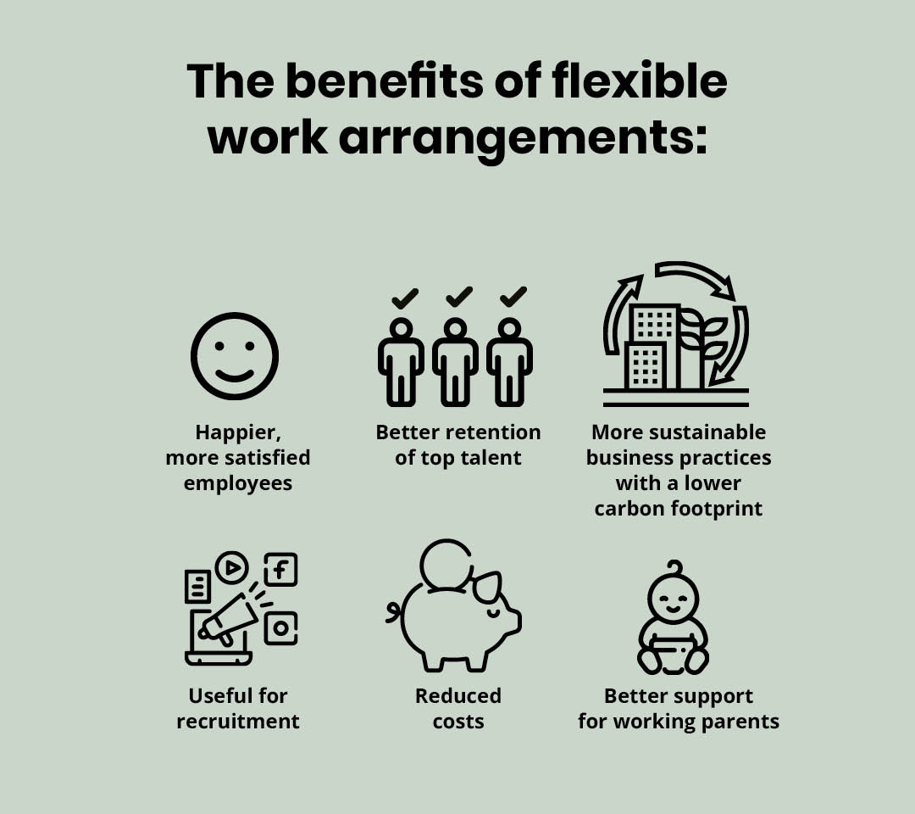
Figure 1: The Benefits of Flexible Working Arrangements (Fifield, 2012)
Flexible work plans are quickly becoming an important part of managing today's workforce, and for good reason. In some cases, they may be good for both workers and businesses. When FitLyfe starts using flexible work plans, it will help the company's productivity and the health and happiness of its workers, among other things.

Enhanced Employee Satisfaction and Work-Life Balance
When employees have more control over their work plans, they are happier and more satisfied with their jobs (Hasanaj & Kuqi, 2019). This helps them handle their work and personal lives better. FitLyfe workers will feel valuable and supported as they try to find a good work-life balance because they can make their own plans to fit in with family obligations, hobbies, and other interests that are not related to work. Organisations that care about their employees' well-being and treat them with respect are more likely to keep them on board, which could mean lower unemployment rates.

Improved Productivity and Performance
The study shows that workers are more productive and do a better job when they have more control over when and how they work. FitLyfe encourages its employees to work during their natural processes and times when they are most productive. This helps the company reach top performance in every area of its operations (Hidalgo & Albors, 2008). Additionally, when the strict time limits of regular office plans are removed, individuals can be given more freedom to work in settings that support focus and creativity. This will make them more productive and help the organisation reach its goals.

Attraction and Retention of Top Talent
In today's competitive job market, companies can gain a lot by giving workers more choices about when and how they do their work. By changing its rules to meet the changing needs of potential workers, Fitness Lyfe could become a top company known for its open and friendly workplace (Išoraitė, 2009). The business may be able to keep its competitive edge and improve its talent pool by hiring smart people who value being independent and flexible on the job.

Reduction in Operational Costs
Companies may be able to save a lot of money on rent, utilities, gas and carpool fees for their employees if they allow employees to work from home or other flexible locations. FitLyfe makes it easier to share resources and work together from afar so that money can be put back into important projects that boost growth, innovation, and value creation. Companies are more likely to follow rules for sustainability and corporate duty if they lessen the damage they do to the earth.

Considerations for Implementation
Before implementing flexible work arrangements, FitLyfe and its HR staff need to look at a number of factors to make sure the process goes smoothly and the best results are achieved.

Nature of Work
The jobs of FitLyfe's chefs and personal trainers decide whether or not they can work from home. For some jobs, people may be able to work from home or have more flexibility with their schedule, but for others, they may need to be there in person or talk to clients (Morgan, et al., 2019). An in-depth look at the tasks and responsibilities at work is needed to figure out how much change is okay without hurting customer happiness or service standards. It might be necessary to make flexible work plans fit the needs of each job in the company so that there is a balance between what needs to be done and what the employees want.

Technological Infrastructure
In order for flexible job plans to work, there needs to be stable access to the right technology infrastructure. FitLyfe is responsible for making sure that its online workers have everything they need to do their jobs well. Some things that may need to be thought about are a stable internet link, safe ways to access business systems and data, and the right communication platforms and tools (Rey-Merchán, et al., 2021). It is important to spend money on new technologies and make sure that workers get the right training and support so that they can work from home and stay productive and linked.

Communication and Collaboration
Open communication and trust are necessary for a remote work connection to work well. Having reliable ways to talk and work together is important for FitLyfe so that team members in different places can do their jobs well. There are programs that can help you keep track of projects, share files, hold video calls, and chat right away (Wibowo, et al., 2020). When working from home, it is important to set rules for how to talk to each other, answer messages, and encourage honesty and accountability.

Performance Measurement
Set up clear performance measures and review methods to keep an eye on staff productivity. This is the only way to find out how flexible work arrangements affected business results. FitLyfe should set key performance indicators (KPIs) that are in line with their strategic goals and job tasks. Shankar et al. (2012) say that this method makes it possible to accurately track an employee's progress no matter where they are. It is important to do performance reviews and feedback sessions on a regular basis to keep employees motivated, find areas where they can improve, and reward great work. FitLyfe should be able to hold workers accountable for their work even if employees have freedom at work.

Reconfiguring Pay Structure

Shift from Time-based to Output-based Compensation
One way to change how pay is structured is to replace pay based on hours worked with rewards that are directly linked to results and performance (Smith, et al., 2019). One thing that FitLyfe does to encourage efficiency, productivity, and goal achievement is to shift the attention from hours spent to results achieved. With this strategy, all workers, no matter where they work or how long their shift is, are promised a fair wage. The strategy also encourages a results-driven and accountable work culture. The long-term goals of the company should guide pay plans. One way is to have a pay plan that is based on success and is linked to clear business goals. A bonus, a fee, or a profit-sharing plan could all be used as forms of payment.

Implement Flexible Compensation Packages
FitLyfe's management should think about giving their employees pay plans with flexible perks so that they can meet all of their different needs and wants. Changes to policies, like the creation of flexible spending accounts, have given workers more power over their own health, pensions, and childcare income (Subramanyam, 2014). If FitLyfe has remote workers, they might want to give them wellness stipends to help pay for things like gym memberships, mental health treatments, and the right tools. Giving workers more leave or paid time off could make them happier with their jobs and keep them there. This will help them get their work and home life in better order.

Review Wage Differentials
FitLyfe needs to look into how likely it is that people will be paid differently based on things like location, job duties, and individual success when they have flexible work arrangements. This is to reduce unfair workplace situations and promote fairness in the workplace. Pay levels may need to be changed so that the company stays competitive and fair in all of its places or markets (Swart, et al., 2023). This is because living costs and market conditions can change. Because every job is different in terms of how hard it is, what skills are needed, and how well it is done, it may be necessary to use different pay scales or adjustments based on performance to fairly identify and pay workers. In order to create an open, fair, and welcoming workplace at FitLyfe, we regularly look into wage gaps. This way, we can take care of any problems before they get worse.
Putting it all together, changing FitLyfe's pay system to allow flexible work plans in a way that is fair, clear, and in line with the company's goals needs a planned and smart approach. FitLyfe is changing its pay and perks to better meet the changing needs and wants of its workers and to encourage involvement, performance, and retention across the board.

Strategies for Promoting Employee Engagement
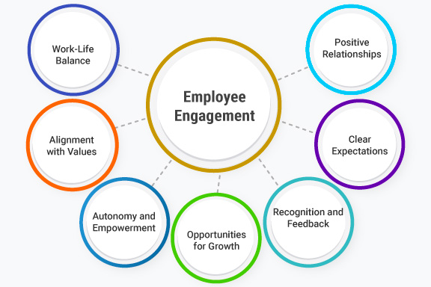
Figure 2: Employee Engagement (Varadarajan, 2015)

Foster a Culture of Trust and Autonomy
Getting people to believe in themselves and be proud of what they have done is the first thing that needs to be done to make the workplace trustworthy and responsible. Along with giving each employee room to grow and achieve, FitLyfe should also be clear about what is expected of them and what their goals are.

Foster Virtual Social Connections
One way to keep team spirit and attitude high when working from home is to lead online meetings. FitLyfe might set up team-building events like quizzes, games, and virtual coffee breaks to help employees talk to each other and get along (Walker, 2015). Staff meetings, town hall meetings, and internet networking events are held regularly by the company so that workers can meet each other, work on projects together, and talk about their own lives. This makes them feel like they are part of the company and its goals.
Recognise and Reward Achievements
Formal reward schemes are needed to pay and recognise workers who work in a flexible setting. It is important for FitLyfe to have clear criteria for marking successes and goals, whether they choose to do so through company-wide prizes, peer-to-peer recognition, or manager praise. Virtual ceremonies, emails, and social media are all public ways to show respect for workers. This can inspire them to keep up the great work and promote good behaviour.
To keep workers interested during the change to flexible work, it is important to build trust, keep lines of communication open, make social links, and show appreciation (Wensley, 2016). FitLyfe workers value personal responsibility, constant contact and support, making it easy for people to meet with each other online, and being recognised for their work. These values make them feel valued, inspired, and a part of the company's goal and vision.

Conclusion
Flexible work plans should be a top goal for FitLyfe because they can help the company in many ways and make workers' lives easier. One of these benefits is that giving workers more control over their own plans through flexible work arrangements could greatly improve mood and productivity. When employers change employees' work hours to fit their needs and hobbies, it gives workers the freedom to balance their job and personal lives. In addition to making them happier at work, this also makes them happier and more fulfilled in their personal lives.
FitLyfe can also become a more open business by allowing employees to work from home. In this way, they can quickly take advantage of new chances and adapt to changing market conditions. The company promotes itself as a leader in a fast-paced and competitive field by allowing its employees to work without standard office hours and encouraging a culture of freedom and creativity.
FitLyfe might be able to save a lot of money if employees could set their own hours. This is because there will be real cash benefits from having lower costs for things like office space, energy, and commuter allowances. If these saves are carefully re-invested, they could help the company's ability to compete, and support programmes for employee growth, and new ideas.

References
Ferrell, O., Hartline, M., Hochstein, B. & Boivin, M., 2023. Marketing strategy. s.l.:Cengage Canada.
Fifield, P., 2012. Marketing strategy. s.l.:Routledge.
Hasanaj, P. & Kuqi, B., 2019. Analysis of financial statements.. Humanities and Social Science Research, 2(2), p. 17.
Hidalgo, A. & Albors, J., 2008. Innovation management techniques and tools: a review from theory and practice. R&d Management, 38(2), pp. 113-127.
Išoraitė, M., 2009. Theoretical aspects of marketing strategy. Ekonomika ir vadyba: aktualijos ir perspektyvos: mokslo darbai, Issue 1, pp. 114-125.
Morgan, N., Whitler, K., Feng, H. & Chari, S., 2019. Research in marketing strategy.. Journal of the Academy of Marketing Science, Volume 47, pp. 4-29.
Rey-Merchán, M., Gómez-de-Gabriel, J., López-Arquillos, A. & Choi, S., 2021. Analysis of Falls from Height Variables in Occupational Accidents. International journal of environmental research and public health, 18(24), p. 13417.
Shankar, V., Carpenter, G. & Farley, J., 2012. Handbook of marketing strategy. s.l.:Edward Elgar Publishing.
Smith, L., Ibn‐Mohammed, T., Koh, L. & Reaney, I., 2019. Life cycle assessment of functional materials and devices: Opportunities, challenges, and current and future trends. Journal of the American Ceramic Society, 102(12), pp. 7037-7064.
Subramanyam, K., 2014. Financial statement analysis. s.l.:McGraw-Hill.
Swart, L., Claassen, N. & Buys, T., 2023. Mapping the evidence on assessment of fitness to work at heights: a scoping review protocol. BMJ open, 13(5), p. e067847.
Varadarajan, R., 2015. Strategic marketing, marketing strategy and market strategy. AMS review, Volume 5, pp. 78-90.
Walker, A., 2015. Project management in construction. s.l.:John Wiley & Sons..
Wensley, R., 2016. The basics of marketing strategy. In: The marketing book. s.l.:Routledge, pp. 53-85.
Wibowo, T., Sukaryawan, I. & Hatmoko, J., 2020. Identifying Causal Factors of Accidents Related to Working at Height: A Case Study of a Construction Company. Proceedings of the 2020 International Conference on Engineering and Information Technology for Sustainable Industry, pp. 1-7.

