IWD
Assignment 2: Website design and development
16/12/2025
.

UNIVERSITY OF WALES TRINITY SAINT DAVIDLONDON CAMPUS
london campus
Module Name: Introduction to Web and Database Concepts

Module Code: ACCA4023

Student Name: Ravindra
Student ID: 2428517
Group: 3

Lecturer’s Name: Suneth Fernando

Table of Contents
Introduction to your case study which you choose 2
User Requirements 4
Website Implementation 4
Home page 4
Fresh-Fish 5
seafood 5
Price 6
Contact-us 6
Validating my website 7
Self-evaluation of my website 8
Usefulness (usability and utility): 8
Search Engine Optimisation (SEO): 8
Website Accessibility: 8
Reference list 8

Introduction to your case study which you choose
Please explain what type of business which you have chosen and what type of business function which you are going to consider when you design and develop required website. Referents

Home Page
First page you see, shows the best of our fish market. Big picturs of fresh fish, simple words about quality. Make people want to buy fish now.
Fresh Fish Page
All the fish we have, good for different ways of cooking:
• Fish for grill (salmon, tuna)
•Fish fry (cod, halibut)
• Fish for soup (trout, white fish)
• Fish for sushi (special quality)
•Whole fish for celebratory feasts
Seafood Page
Everything from sea that's not fish:
•Shrimp of all sizes
•Lobster live and fresh
•Crabs (ready to cook)
•Scallops and mussels
•Squid and octopus for experts
Prices Page
What everything costs, clear to see:
•Today's prices on board
•Specials of the week
•Family pack discounts
•Bulk buying cheaper
•Fresh or frozen prices
Contact-Us Page
How to find us and get fish:
• Our address and locations
• Phone number big and clear
• Store opening hours
• Email for larger requests
• Asking questions with simple form

User Requirements
List down user requirements. In other words, please identify what user is expecting from your website. This should include, type pages required, each page, what type of content which you need to include.
I used HTML to make the structure thing and CSS to make it look good. HTML was what I used to make the frame of every single page. Like the Home page where people start, the Fresh Fish page where all the fish options are, the Seafood page where everything else from the ocean is, the Prices page so people know what things cost and the Contact-Us page for getting in touch with us, plus how I arranged all the stuff on each page so it makes sense. CSS was my tool for all the visual parts - like making it pretty on the screen, the colors scheme, how much space between things. I used several diferent colors and I made color variables because if we decide to change the colors later on, it will be more easy to do, plus I put in some shadow effects, some smooth transitions when you hover over things, some borders around elements, and that's basically the way I constructed this whole website thing.

Website Implementation
Please explain what type of text editor (Visual studio code) used and what type of scripting languages use used to develop your website. Then provide screenshots of each page.

Home page
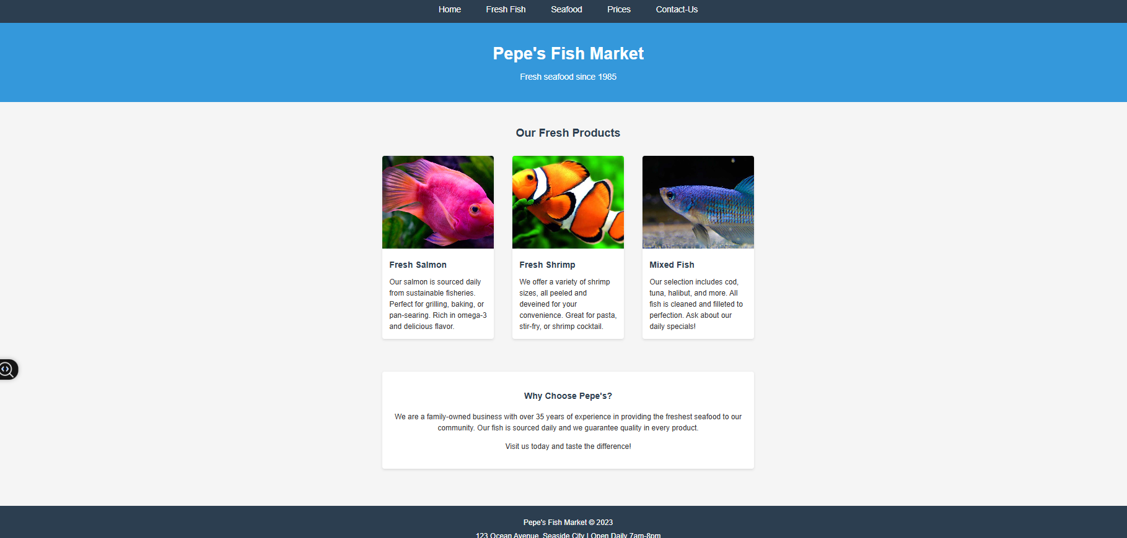

Fresh-Fish
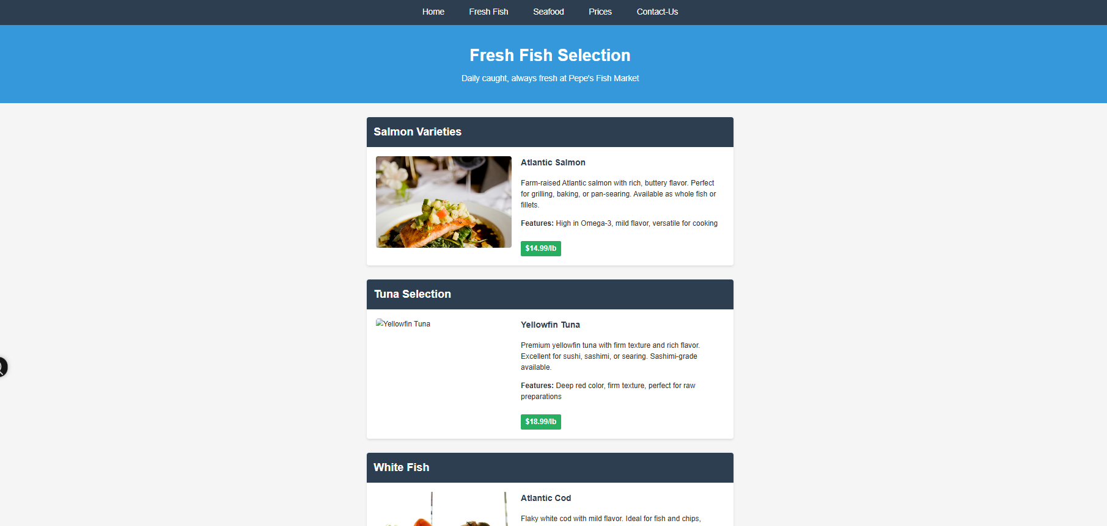

seafood
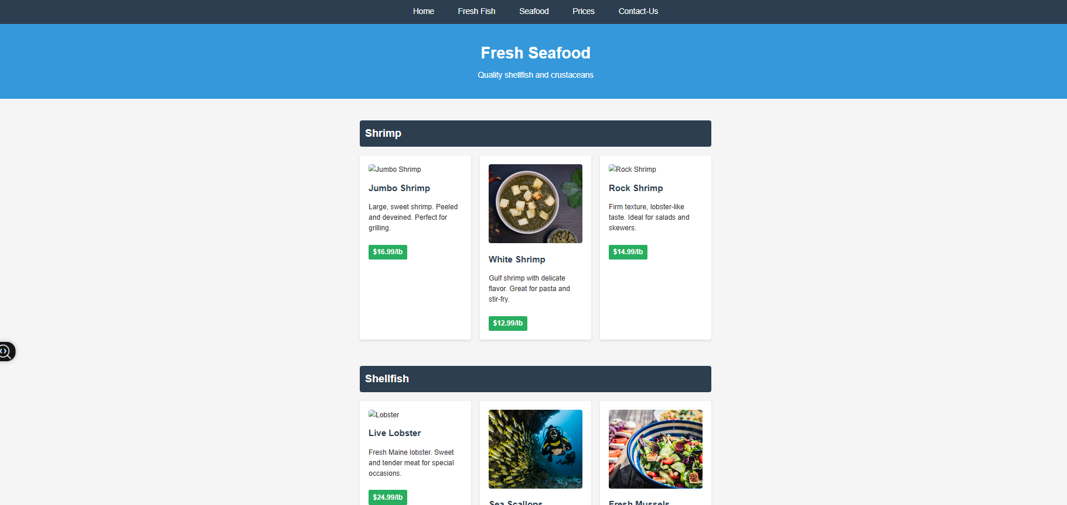

Price
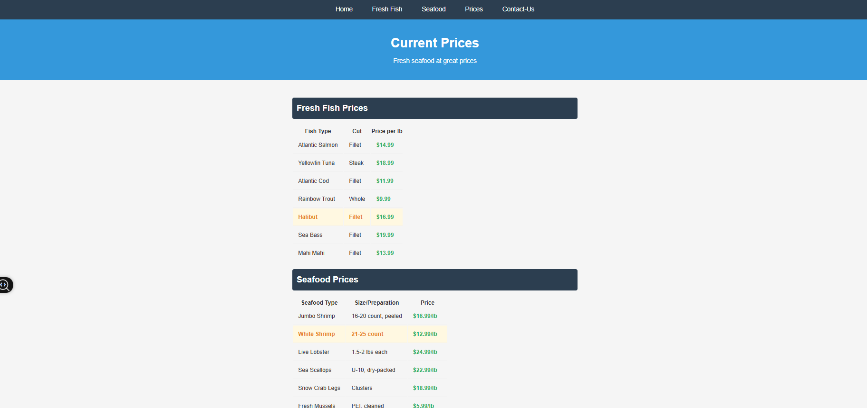

Contact-us
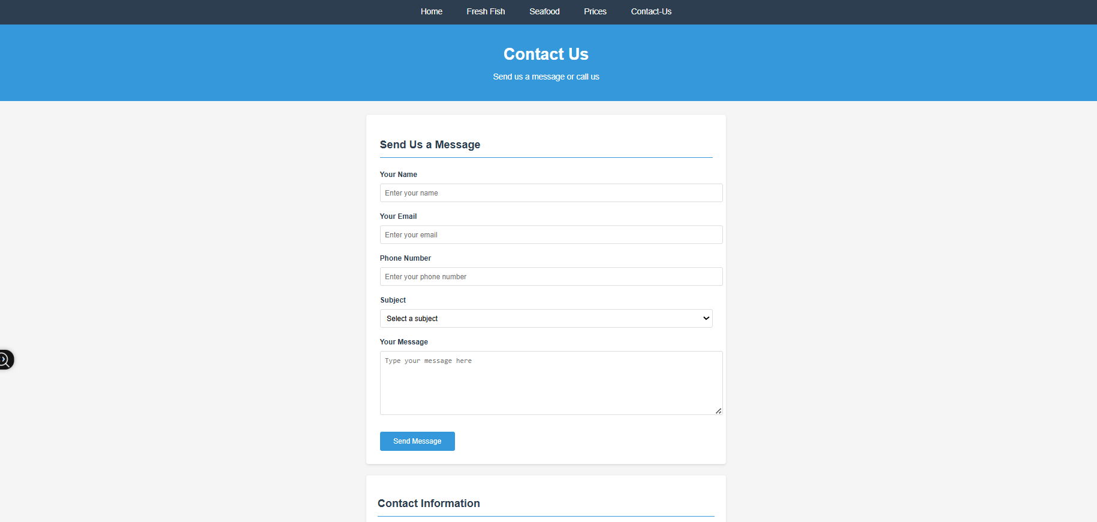

Validating my website
Please use the links provided in assignment brief to validate ONE HTML PAGE AND ONE CSS PAGE
HTML VALIDATION LINK: https://validator.w3.org/
CSS VALIDATION LINK: https://jigsaw.w3.org/css-validator/

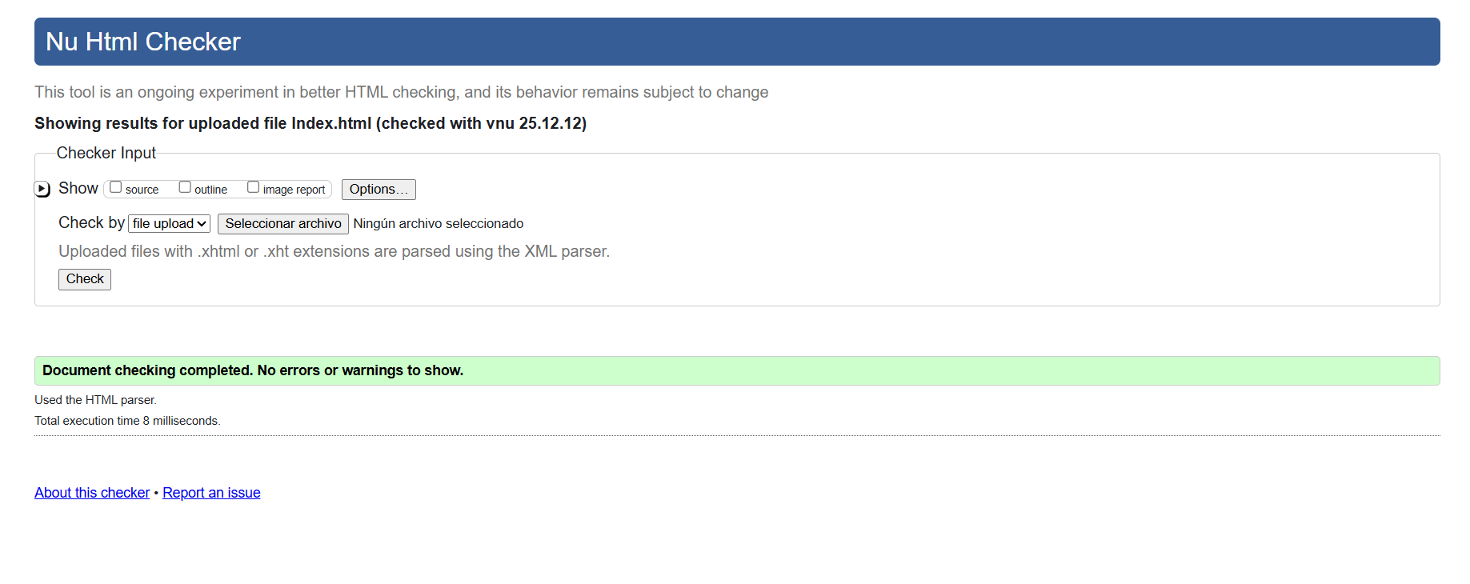
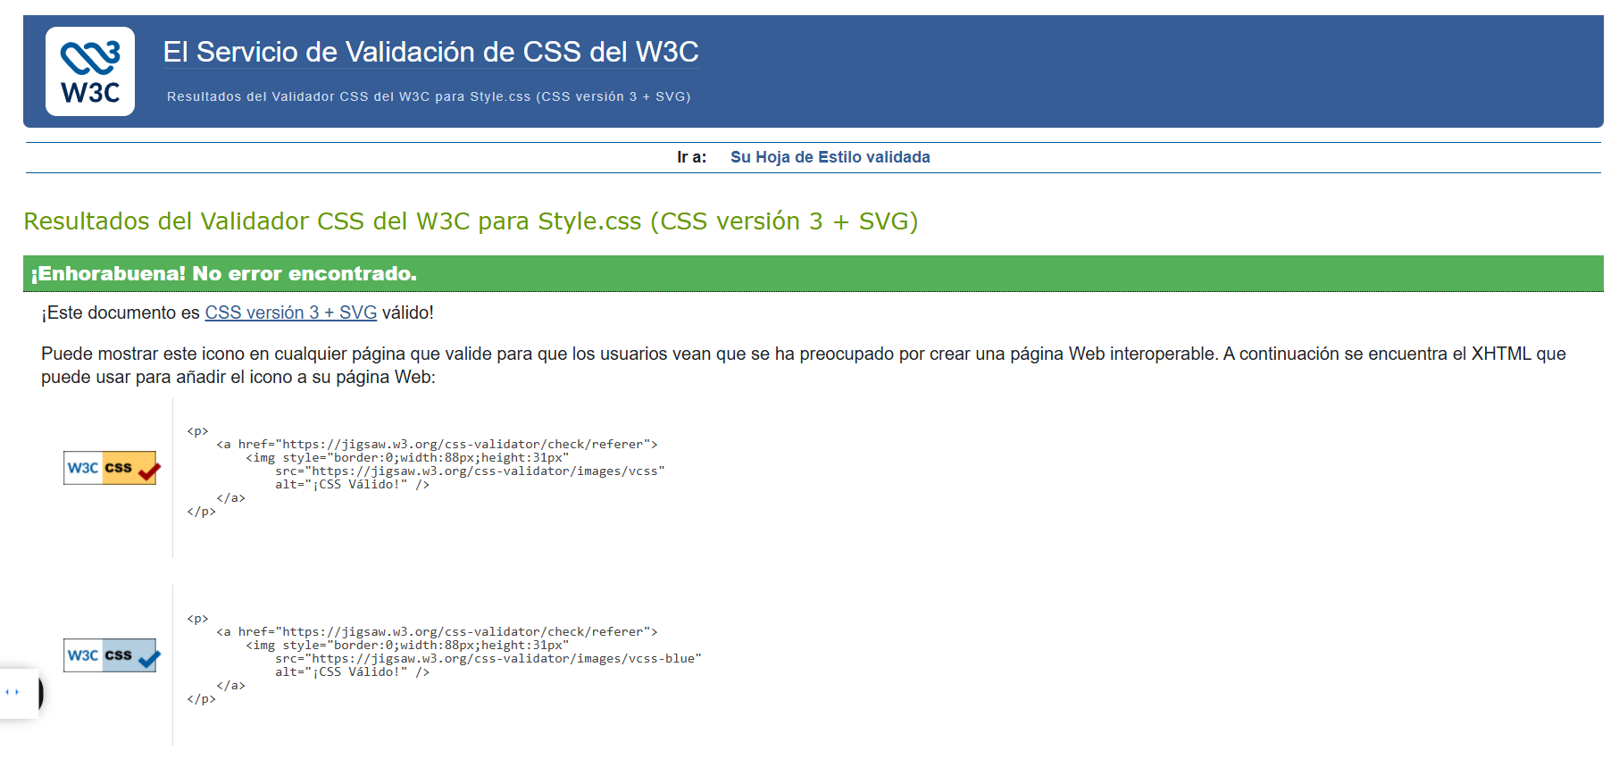

HTML
Everything is fine there are not problem with file-HTML.
CSS
And file-CSS is fine too

Self-evaluation of my website
Usefulness (usability and utility): Referents
Use academic sources to identify what website usability means and compare your website with this criterion, whether you have met this criterion or not.

Search Engine Optimisation (SEO):
The purpose of this study was to examine the role of Search Engine Optimisation (SEO) in internationalization of higher education, and provide empirical and theoretical understanding for the use of SEO as a digital marketing strategy. The main research question in this study was how can higher education institutions use SEO as digital marketing strategy to increase their internationalization? Google search engine platform was used to retrieve relevant data from Halmstad university website for analysis. In addition, other online tools such as “searchmetrics”, “google trend”, “mozbar” and “yakarferci” were used for analysis. (Iddris, 2019)

Website Accessibility:
The evaluations were conducted using both automated and manual checking against the Web Accessibility Initiative (WAI) Guidelines [1] and user-based testing with a User Panel of 51 people with a range of disabilities. Surveys of website accessibility have been conducted before. However, these have all relied on automated and manual testing against the WAI Guidelines, rather than user testing. (Petrie, Hamilton, & King, 2004)

Reference list

Reference
Iddris, F. (2019). Search Engine Optimisation (SEO) As Digital Marketing Strategy for Internationalisation of Higher Education. ResearchGate.
Petrie, H., Hamilton, F., & King, N. (2004). Tension, what tension? Website accessibility and visual design. New York, New York, USA: ACM.

